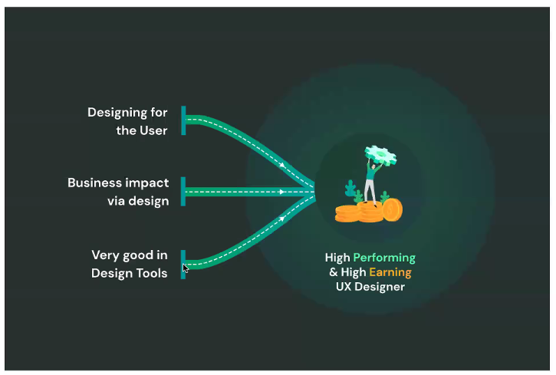

Heurestcs nisson and norman

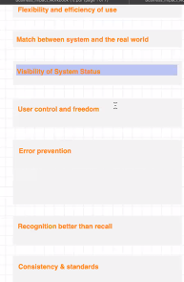

User journey mapping

Paper prototyping

Component based figma

Animated prototyping