Cross-Account Access Grant Display
Final Project Report
Project Domain | Cloud Computing and AWS Monitoring
Cloud Platform | Amazon Web Services (AWS)
Region | US East (N. Virginia) — us-east-1
Dashboard Technology | Python and Streamlit
Data Storage | Amazon S3
Messaging Service | AWS IoT Core MQTT
Bucket | access-grant-demo-150202114394-2026
Prefix | access-results/
Architecture diagram | Refer to architecture/AWS_Architecture_Diagram.png.

1. Abstract
The Cross-Account Access Grant Display project focuses on developing a cloud-based prototype for processing access-related requests, recording their results, and presenting request information through a monitoring dashboard.
The prototype uses AWS IoT Core to receive MQTT requests and trigger an AWS Lambda function through an IoT rule. The Lambda function inspects the current AWS caller identity using AWS Security Token Service (STS), performs an Amazon S3 access check, stores request results as JSON objects in an S3 bucket, and publishes a response through an MQTT topic.
A Python Streamlit dashboard retrieves the stored JSON results from Amazon S3 and presents request statistics, request history, individual request details, and exportable reports. The dashboard automatically reruns at 30-second intervals.
Testing demonstrated the main request-processing, storage, and monitoring workflow. However, successful cross-account role assumption into a separate target AWS account has not been verified. Therefore, the current implementation is documented as an access-monitoring prototype rather than a fully verified cross-account authorization system.

2. Introduction
Cloud computing enables organizations to access computing resources and services through scalable, remotely managed infrastructure. In environments involving multiple AWS accounts, administrators may need to understand access requests, monitor their processing status, and maintain records for auditing and troubleshooting.
Cross-account access generally requires appropriate IAM roles, trust relationships, and permissions. Monitoring such workflows can become difficult when request information is distributed across cloud services and logs.
This project explores a software-based approach to request processing and visibility using AWS IoT Core, AWS Lambda, Amazon S3, and Streamlit.
The system collects request information, processes it through a serverless function, stores structured results, and displays those results through a centralized dashboard.
The prototype was developed within an AWS Academy learning environment, where IAM restrictions limited the ability to configure and verify a complete cross-account role-assumption workflow.

3. Problem Statement
Cloud access-related requests require a consistent method of processing, recording, and monitoring results.
Without a centralized monitoring interface, users may need to inspect different AWS services to understand whether a request was processed, whether an S3 access check succeeded, and whether a result was stored.
The project addresses this monitoring problem by creating a workflow that processes MQTT requests, stores structured JSON results, and presents request information through a single dashboard.
A separate challenge is distinguishing ordinary AWS identity and resource-access checks from genuine cross-account authorization. The prototype must clearly report what it verifies and what remains unimplemented or unverified.

4. Project Objectives
The primary objectives are:
1. Receive request messages through AWS IoT Core MQTT.
2. Trigger request processing through an AWS IoT rule.
3. Process incoming requests using AWS Lambda.
4. Inspect the current AWS caller identity using STS.
5. Perform an S3 access check.
6. Store request results as JSON objects in Amazon S3.
7. Publish processing results through an MQTT response topic.
8. Develop a Streamlit dashboard for monitoring request information.
9. Implement automatic dashboard refresh at 30-second intervals.
10. Support request-history filtering, detailed inspection, and CSV export.
11. Document testing results, system limitations, and potential enhancements.

5. Scope of the Project

5.1 Included Functionality
The current prototype includes:
- MQTT request publishing and response handling.
- AWS IoT rule integration with Lambda.
- Lambda-based request processing.
- AWS caller-identity inspection.
- S3 access checking and JSON result storage.
- Streamlit-based request monitoring.
- Automatic dashboard refresh.
- Request statistics and history.
- Individual request inspection.
- CSV export of request-history data.

5.2 Excluded or Unverified Functionality
The following capability has not been verified:
- Successful assumption of a role in a separate target AWS account.
- Validation of a complete cross-account trust and authorization configuration.
- Live testing of an S3 access-denied scenario.
These limitations arose partly from IAM restrictions in the AWS Academy environment.

6. Technologies Used
Technology | Purpose
Amazon Web Services | Cloud infrastructure
AWS IoT Core | MQTT messaging and request routing
AWS IoT Rules Engine | Routing matching MQTT messages to Lambda
AWS Lambda | Serverless request processing
AWS Security Token Service (STS) | Retrieving the current AWS caller identity
Amazon S3 | Storing request-result JSON files
Python | Application and processing logic
Streamlit | Monitoring dashboard
Boto3 | Python interface for AWS services
Pandas | Processing tabular request data
Plotly | Interactive dashboard charts
streamlit-autorefresh | Periodic dashboard reruns
JSON | Structured request-result format
CSV | Exportable request-history format

7. System Architecture
The prototype contains a messaging and processing workflow connected to a monitoring dashboard.

7.1 Architecture Components

7.1.1 MQTT Client
The AWS IoT Core MQTT test client is used to publish requests and subscribe to responses.
The request topic is:
crossaccount/request
The response topic is:
crossaccount/response

7.1.2 AWS IoT Core
AWS IoT Core provides the MQTT messaging endpoint used by the prototype.
Requests published to the configured topic are evaluated by the IoT rules engine.

7.1.3 AWS IoT Rule
The rule CrossAccountTriggerRule routes matching request messages to the Lambda function.
This connects the messaging layer to the request-processing layer.

7.1.4 AWS Lambda
The function CrossAccountAccessLambda processes incoming request data.
Its responsibilities include validating request fields, retrieving the current AWS caller identity for valid requests, checking S3 access, storing JSON results, and publishing an MQTT response.

7.1.5 AWS Security Token Service
The Lambda function uses STS GetCallerIdentity to retrieve information about the AWS identity associated with its execution credentials.
This operation identifies the caller; it does not, by itself, establish cross-account role assumption.

7.1.6 Amazon S3
The S3 bucket stores JSON request results.
Bucket:
access-grant-demo-150202114394-2026
Prefix:
access-results/
The dashboard reads these stored results to display request information.

7.1.7 Streamlit Dashboard
The dashboard provides a centralized interface for inspecting stored request results.
Its features include summary metrics, request history, request details, status charts, CSV export, and automatic refresh.

7.2 Data Flow
The implemented workflow follows these steps:
1. A user publishes an MQTT request.
2. AWS IoT Core receives the request.
3. The configured IoT rule routes the request to Lambda.
4. Lambda processes the request and retrieves the current AWS caller identity.
5. Lambda performs the configured S3 access check.
6. Lambda stores the request result as a JSON object in S3.
7. Lambda publishes a response to the MQTT response topic.
8. The Streamlit dashboard retrieves stored JSON results from S3.
9. The dashboard displays request information and refreshes periodically.
Architecture diagram: Refer to architecture/AWS_Architecture_Diagram.png.
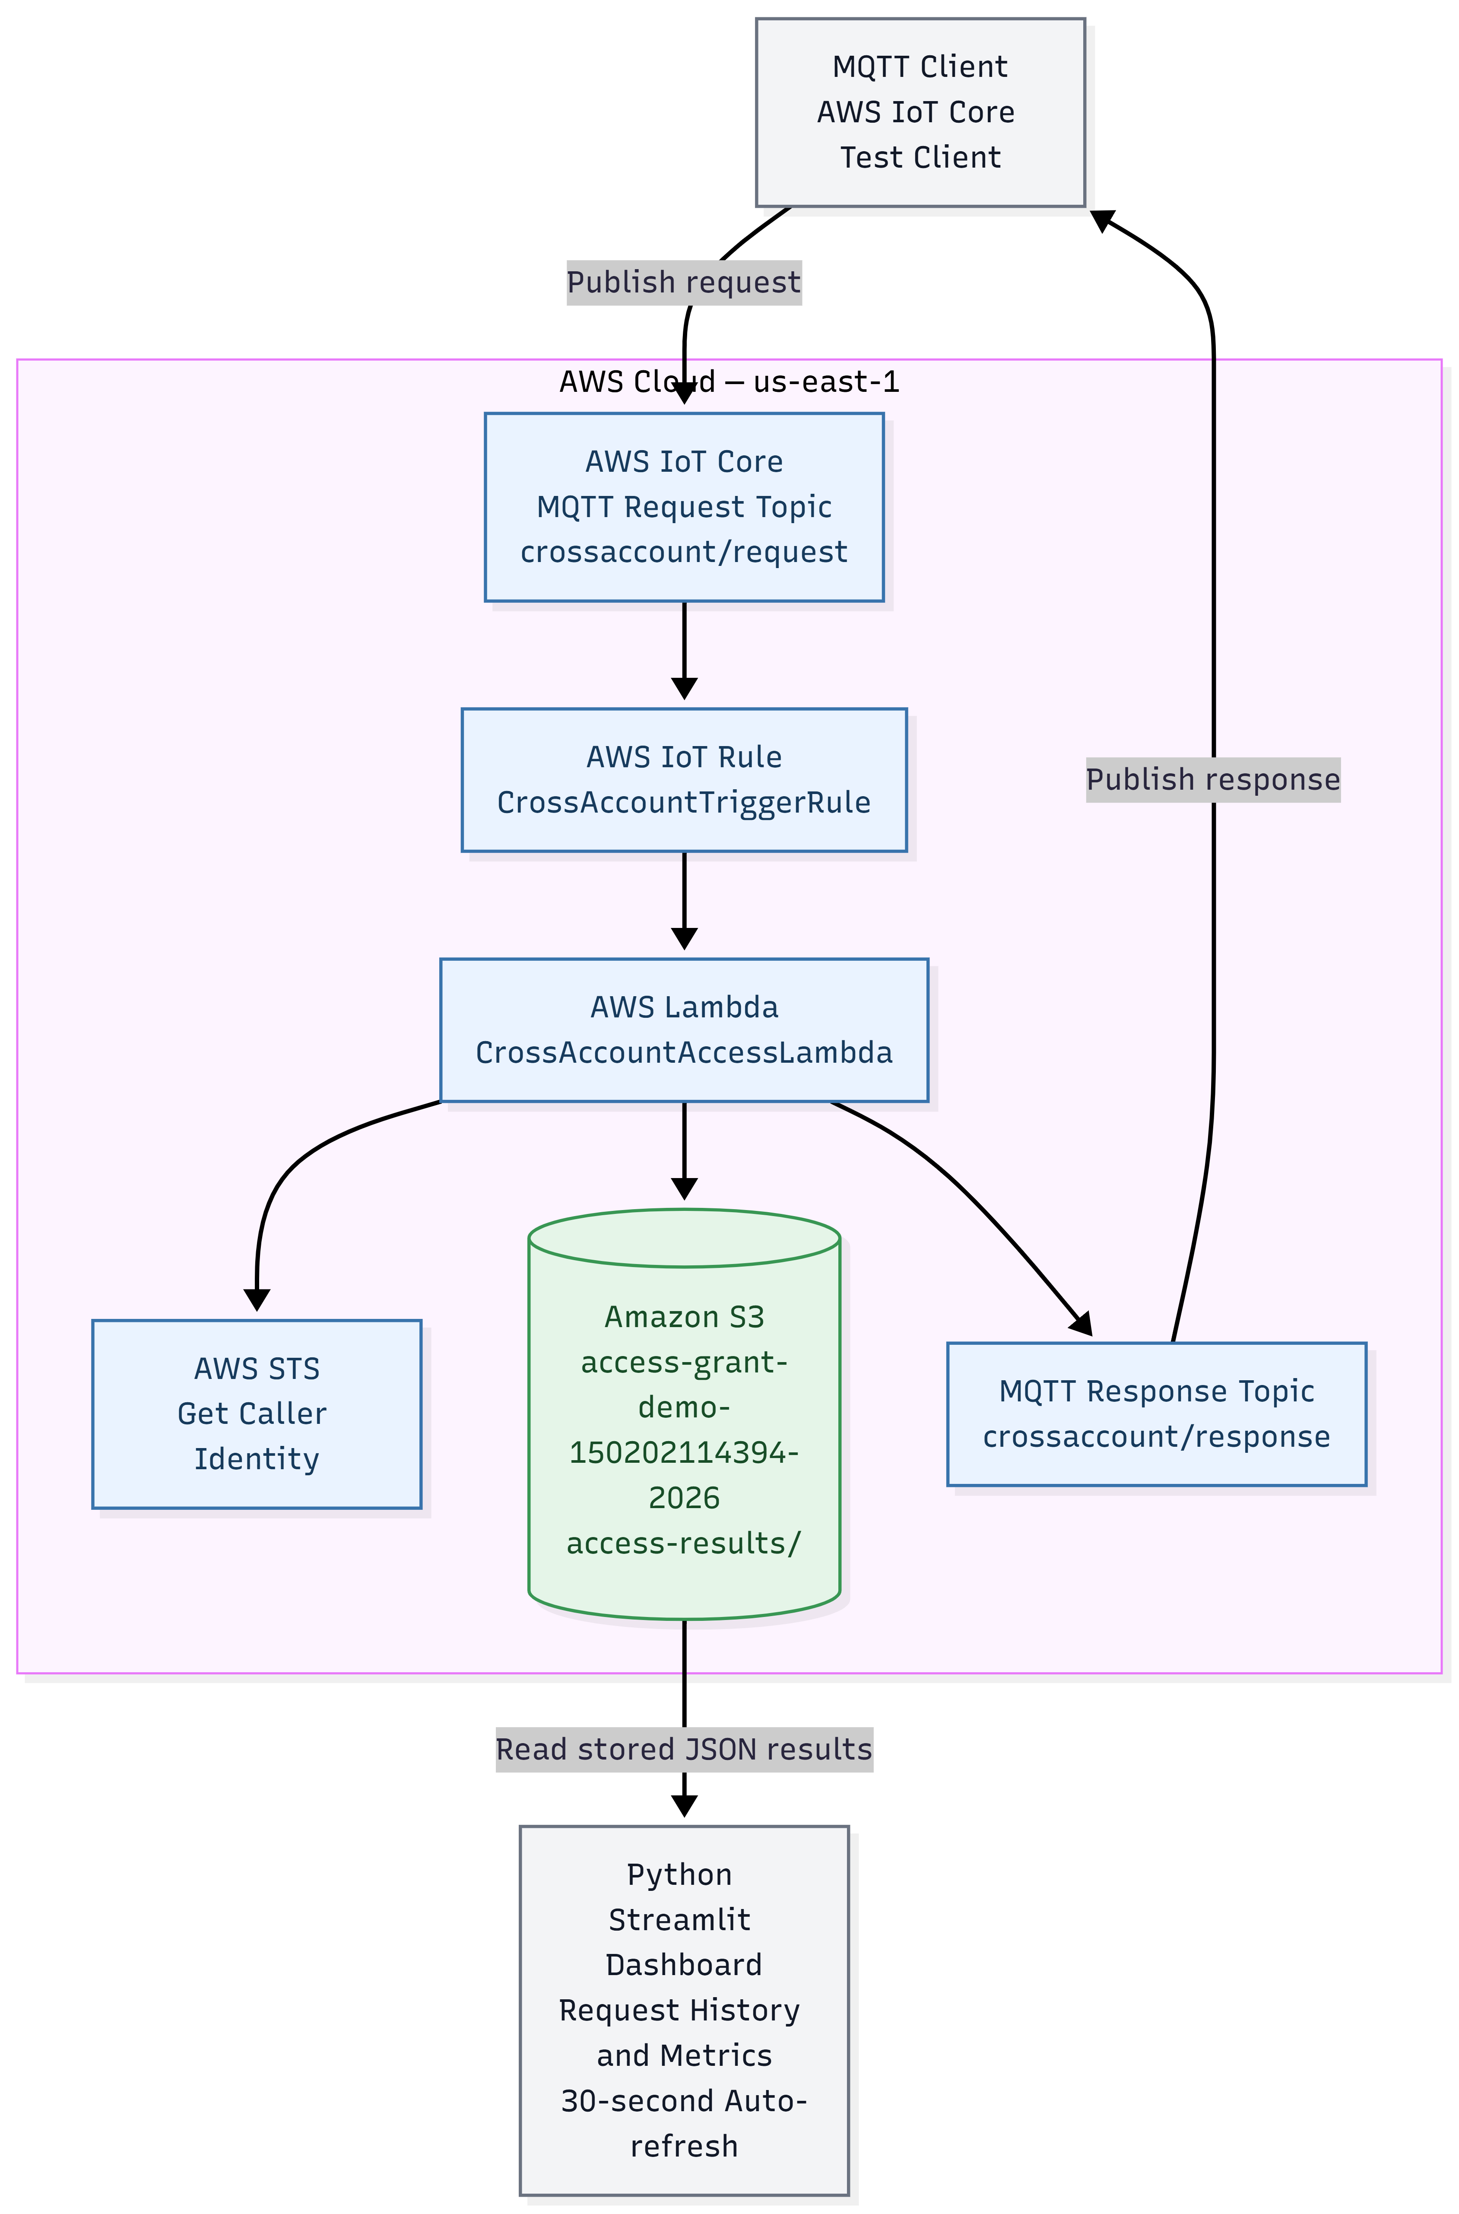
Figure 1. AWS architecture diagram

8. AWS Resource Configuration
The following resources were used in the prototype.
Resource | Configuration
AWS Region | us-east-1
Source AWS Account | 150202114394
Intended Target AWS Account | 330390248952
Lambda Function | CrossAccountAccessLambda
Lambda Execution Role | LabRole
IoT Rule | CrossAccountTriggerRule
S3 Bucket | access-grant-demo-150202114394-2026
S3 Prefix | access-results/
MQTT Request Topic | crossaccount/request
MQTT Response Topic | crossaccount/response

These values describe the configured project environment. They do not establish that cross-account authorization between the two accounts was successfully configured.

9. Implementation Details

9.1 MQTT Request Processing
The MQTT client publishes JSON messages containing request information.
An example request is:
{
"requestId": "REQ-001",
"message": "Access monitoring test"
}
The request ID supports identification of individual requests. The message field contains the incoming request message.

9.2 Lambda Processing
The Lambda function receives the request through the IoT rule.
For valid requests, the processing logic handles request information, retrieves the current AWS caller identity, performs the configured S3 check, and prepares a result object. Request validation occurs before the identity and S3 checks.
The updated implementation requires requestId to be a non-empty string. Requests with a missing, null, empty, or numeric request ID are rejected with status FAILURE. For these invalid requests, the S3 access check is not performed and s3Access is recorded as NOT_TESTED. If the failure report is saved successfully, storageStatus is SUCCESS; this indicates successful storage of the failure report, not successful processing of the original request.
The implementation also distinguishes the incoming request message from the processing summary.

9.3 JSON Result Storage
The Lambda function writes request results to Amazon S3 under the access-results/ prefix.
A result can contain fields such as:
- requestId
- message
- timestamp
- status
- s3Access
- storageStatus
- account
The exact contents depend on the result generated by the function.
These records provide the dashboard with persistent request information.

9.4 MQTT Response
After processing, the Lambda function publishes a response to crossaccount/response.
The MQTT response allows the request-processing result to be inspected independently of the dashboard.

9.5 Dashboard Implementation
The dashboard is implemented in Python using Streamlit.
Boto3 retrieves the stored objects from Amazon S3, and Pandas organizes their contents for presentation.
The dashboard includes:
- Request summary metrics.
- Request-history table.
- Request details.
- Overall-status and S3-access information.
- Charts summarizing request results.
- CSV export.
- AWS and S3 configuration information.

9.6 Automatic Refresh
The dashboard uses streamlit-autorefresh to rerun periodically.
The configured interval is 30,000 milliseconds, equivalent to 30 seconds.
The S3 results are cached for 30 seconds. Consequently, a dashboard rerun does not necessarily trigger an immediate fresh S3 retrieval if valid cached data remains available.

10. User Interface and Dashboard Features
The dashboard provides a centralized interface for viewing stored request information.

10.1 Summary Metrics
The dashboard displays metrics such as total requests, successful requests, failed requests, and successful S3 checks.

10.2 Request History
The request-history table presents identifying information and status fields for stored results.

10.3 Request Details
Users can select a request and inspect its recorded details, including the request ID, incoming message, processing status, AWS account information, and stored result.

10.4 Charts
Charts provide a visual summary of request-status information.

10.5 CSV Export
The dashboard allows the request-history table to be exported as a CSV file for further analysis or reporting.

10.6 Automatic Refresh
The dashboard reruns at the configured 30-second interval, helping keep the displayed information reasonably current.

11. Testing and Results
The prototype was tested using valid MQTT requests, missing and invalid request IDs, the empty JSON object case, multiple requests, duplicate request IDs, S3 result inspection, dashboard auto-refresh, CSV export, request-detail inspection, and end-to-end workflow verification. TC-04 was retested: publishing an empty JSON object produced the expected Lambda validation failure, and the failure report was stored successfully in S3. Malformed JSON testing remains inconclusive: two malformed publishes produced no observed Lambda invocation or MQTT response, but the exact rejection component was not established.

11.1 Test Summary
Test ID | Scenario | Result
TC-01 | Valid MQTT request | PASS
TC-02 | Requests with different IDs | PASS
TC-03 | Missing request ID | PASS — rejected; failure report stored
TC-04 | Empty JSON object {} | PASS — `{}` returned the expected validation failure; failure report stored in S3.
TC-05 | Malformed JSON | INCONCLUSIVE — no Lambda invocation or MQTT response observed; IoT logging disabled and ParseError metric unavailable. Exact rejection point unconfirmed.
TC-06 | S3 access-denied handling | NOT EXECUTED — code inspected only
TC-07 | Automatic dashboard refresh | PASS
TC-08 | Multiple requests | PASS
TC-09 | Final end-to-end validation | PASS
TC-10 | Missing request ID validation | PASS
TC-11 | Empty-string request ID | PASS
TC-12 | Numeric request ID | PASS
TC-13 | Multiple valid requests | PASS
TC-14 | Dashboard auto-refresh with a new request | PASS
TC-15 | CSV export | PASS
TC-16 | Successful and failed request details | PASS
TC-17 | Final MQTT-to-S3-to-dashboard verification | PASS
TC-18 | Repeated request ID / duplicate-ID storage | PASS — unique S3 storage keys; both MQTT responses and both dashboard records verified
Across 18 listed test cases: 16 are confirmed PASS (TC-01 through TC-04 and TC-07 through TC-18), TC-05 is INCONCLUSIVE, and TC-06 was NOT EXECUTED. TC-04 passed after a dedicated empty-object retest. For TC-05, no Lambda invocation or MQTT response was observed after two malformed publishes; however, AWS IoT logging was disabled, ParseError was not available in the inspected Rule Metrics view, and the TopicMatch time series was not examined. Therefore, the exact rejection point remains unconfirmed. TC-18 confirms that repeated requests using the same request ID are stored as separate S3 objects and appear as separate dashboard records. The confirmed test results are documented in test-results/test_cases.md.

11.2 Final End-to-End Validation
The final end-to-end validation used a unique test request ID (the final test was confirmed by the user; the workflow was checked across MQTT, S3, and the deployed Streamlit dashboard). Earlier testing also used the request ID:
FINAL-E2E-008 (or another unique ID selected during testing)
The message was:
Final end-to-end system verification
The user confirmed that the request-processing workflow worked across MQTT, S3, and the Streamlit dashboard. Additional checks confirmed validation of missing, empty, and numeric request IDs; processing of multiple valid requests; automatic dashboard refresh; CSV export; and inspection of successful and failed request details. A separate duplicate-ID verification also confirmed that two requests sharing the same requestId received separate storage keys, both MQTT responses were received, and both records appeared in the dashboard.
This demonstrated the primary request-processing and monitoring workflow within the configured environment.
The test did not establish successful cross-account role assumption.

11.3 Duplicate Request ID Verification
A duplicate-ID test sent two separate MQTT requests using the same requestId. The Lambda function generated a unique S3 storage key for each request while preserving the original requestId in the result. The user confirmed that both MQTT responses were received, both JSON objects existed separately in S3, and both records appeared separately in the Streamlit dashboard. This verifies the fix for the tested duplicate-ID scenario.

11.4 Evidence
Supporting screenshots are stored in the screenshots/ directory.
The test-case document is available at:
test-results/test_cases.md

12. Limitations
The current implementation has the following limitations.
1. Cross-account role assumption: Successful role assumption into the intended target account has not been verified.
2. IAM restrictions: AWS Academy permissions limited the ability to configure or modify the IAM roles and policies needed for full cross-account verification.
3. Malformed input testing: two malformed JSON publishes produced no observed Lambda invocation or MQTT response. AWS IoT account-level logging was disabled and the ParseError metric was not available in the inspected Rule Metrics view. The TopicMatch metric was listed but its time-series value was not examined; therefore, rejection by the IoT Rules Engine is plausible but not confirmed.
4. S3 denial testing: A real access-denied scenario was not executed.
5. Monitoring scope: The dashboard displays stored request results; it is not a complete IAM authorization audit platform.
6. Credential dependency: The deployed dashboard uses temporary AWS credentials for the demonstration. These credentials expire and must be refreshed using the applicable AWS Academy workflow.
7. Refresh behavior: Automatic reruns and caching can introduce a delay between new S3 data becoming available and that data being displayed.

13. Future Enhancements
The following improvements could extend the prototype.
1. Configure and verify a genuine cross-account role-assumption workflow in an authorized AWS environment.
2. Add more comprehensive input validation and explicit handling of malformed requests.
3. Perform controlled tests of access-denied and other AWS service errors.
4. Add stronger request correlation and structured logging.
5. Introduce more detailed filters and date-range analysis.
6. Improve dashboard accessibility and responsive layout.
7. Add monitoring alerts for failed requests.
8. Introduce appropriate authentication and access controls if the dashboard is deployed for multiple users.
9. Add automated tests and deployment documentation.
10. Evaluate production security, logging, retention, and cost requirements before wider deployment.

14. Conclusion
The Cross-Account Access Grant Display prototype demonstrates how AWS IoT Core, AWS Lambda, STS, Amazon S3, and Streamlit can be combined to process requests and present their recorded results through a centralized monitoring dashboard.
The implementation supports MQTT request handling, Lambda-based validation and processing, caller-identity inspection for valid requests, S3 result storage, MQTT responses, dashboard visualizations, CSV export, and periodic refresh. Tests confirmed that missing, empty, and numeric request IDs are rejected and that failure reports can still be stored successfully.
The completed functional tests provide evidence that the principal request-processing and monitoring workflow operates in the configured environment.
However, successful cross-account role assumption into the intended target account remains unverified because of the IAM restrictions in the AWS Academy environment.
The project therefore serves as a working cloud request-monitoring prototype and a foundation for further development of a fully verified cross-account authorization system.

15. References
1. Amazon Web Services — AWS Documentation.
2. AWS IoT Core Developer Guide.
3. AWS Lambda Developer Guide.
4. AWS Identity and Access Management Documentation.
5. AWS Security Token Service Documentation.
6. Amazon S3 User Guide.
7. Boto3 Documentation.
8. Streamlit Documentation.
9. Pandas Documentation.
10. Plotly Python Documentation.
11. streamlit-autorefresh package documentation.
12. Mermaid Diagramming Documentation.

