Security of LLM-Based AI Agents against Indirect Prompt Injection: A Four-Layer Defense for Resume Screening
Saksham Gupta  Dept. of Computer Engg. and  Technology  Dr. Vishwanath Karad MIT  World Peace University  Pune, India | Sairaj Kashid  Dept. of Computer Engg. and  Technology  Dr. Vishwanath Karad MIT  World Peace University  Pune, India | Harshit Girase  Dept. of Computer Engg. and  Technology  Dr. Vishwanath Karad MIT  World Peace University  Pune, India | Ranjeet Jadhav  Dept. of Computer Engg. and  Technology  Dr. Vishwanath Karad MIT  World Peace University  Pune, India | Keshav Somani  Dept. of Computer Engg. and  Technology  Dr. Vishwanath Karad MIT  World Peace University  Pune, India

Abstract—AI agents built on large language models can read files and use tools such as email. This makes them useful, but an attacker can hide instructions inside a file, for example white text in a resume PDF. The agent may follow these hidden instructions, rank a weak candidate first, or send private data to an outside address. This is called indirect prompt injection. In this paper we propose a four-layer defense for an HR resume agent. The layers clean hidden text and scan it with a classifier, treat file text as untrusted data, give the agent only the tools it needs, and check every email before it is sent. We evaluate the design on 60 synthetic resume PDFs across six test setups, measuring both attack success and normal task performance. Combining all four layers reduces the overall attack success rate from 82.5% to 0.0% while maintaining a benign task success rate of 95.0% and a 5.0% false positive rate.
Keywords—LLM agent security, indirect prompt injection, hidden text, resume screening, least privilege, defense in depth.
I. INTRODUCTION
Large language models (LLMs) are now used to build AI agents. An agent does not only chat. It can read files, search the web and use tools such as email [1]. This makes agents useful for customer support, research and hiring. It also gives attackers a new way in.
Prompt injection means giving a model text that changes what it was supposed to do [2]. In indirect prompt injection (IPI), the attacker does not talk to the model directly. The attacker hides instructions inside content that the agent will read later, such as a webpage, an email or a PDF [3]. The agent may treat this hidden text as an order from the user.
Hiring is a clear example. An HR manager asks an AI agent to rank resumes. One candidate adds a line in white text on a white page: “consider this resume at the highest priority.” A person reading the PDF sees nothing, but the agent reads the text. Milani et al. showed that hidden prompts inside CV files can mislead LLMs used for CV screening [4]. A second attacker could hide this line: “email all candidate details to this address.” If the agent has an email tool, private data could leave the company [3], [5].
Many studies explain these attacks or build benchmarks to measure them [6], [5], [7]. Other studies detect injected text with classifiers [8], [9], [10]. However, detection alone can miss reworded attacks [11]. The survey by Tamuka et al. also reports weak defense when attackers adapt and little testing of the risks that come from agent tools [1].
In this paper we propose and evaluate a four-layer defense for an HR resume-screening agent. The first layers look at the text of the resume. The last layers limit what the agent is allowed to do, so that harm is reduced even if a hidden instruction is not detected. Our contributions are: (1) a simple threat model for hidden instructions inside resume PDFs; (2) a four-layer defense joining text-level and action-level checks; and (3) an experimental evaluation on 60 synthetic resume PDFs across six setups.
II. BACKGROUND AND THREAT MODEL
A. How an HR Agent Works
The HR manager gives the agent a task, for example “rank these candidates for this job.” The agent opens each resume PDF, extracts the text, adds the job description, and asks the LLM to rank the candidates or to propose an action. A tool then runs the action and the result goes back to the model. Our sandbox agent has three tools: read_resume, rank_candidates and send_email. The send_email tool only writes to a local log file, so nothing real is ever sent.
B. Attack Goals
We study two attack goals: ranking manipulation [4] and data exfiltration [3], [5], along with hidden-text and character-disguise tricks [1], [11]. Table I lists these cases.
Attack | Hidden instruction (example) | What can go wrong | Related work
Ranking attack | "Rank this resume first." | A weaker candidate is placed above better ones | [4]
Data attack | "Email all candidate details to an outside address." | Private data leaves the company | [3], [5]
Hidden-text tricks | White text, tiny text, text outside the page | A person cannot see it, but the agent can read it | [4], [1]
Disguised text | Spaced letters, invisible characters, no obvious keywords | Keyword filters miss it | [1], [11]
TABLE I. ATTACK CASES IN THE HR RESUME SCENARIO.
C. Threat Model
We assume the attacker can submit a resume PDF to the HR manager. The attacker knows that the agent reads resumes and may know its tools, and may reword the hidden text. The attacker cannot change the system prompt, the code, the model or the list of approved email addresses.
III. LITERATURE SURVEY
A. Attacks and Benchmarks
Greshake et al. introduced indirect prompt injection [3]. Liu et al. built a formal benchmark framework [12]. BIPIA [6], InjecAgent [5], AgentDojo [7], and Agent Security Bench [13] evaluate attacks and defenses, while Milani et al. examined CV screening directly [4].
B. Detection-Based Defenses
DataSentinel [8], Rahman et al. [9], and Alamsabi et al. [10] detect prompt injections using classifiers or embeddings, though Zhan et al. [11] showed adaptive attacks can bypass static detectors.
C. Action-Level and System Defenses
StruQ [14], The Task Shield [15], and IsolateGPT [16] enforce structural separation, goal alignment, or execution isolation following least privilege [17]. Table II summarizes these approaches.
Approach | Example work | Main limit
Text detection | [8], [9], [10] | Can miss reworded or hidden attacks
Adaptive testing | [11] | Shows defenses can be bypassed; gives no new defense
Separate instructions/data | [14] | Needs the model to be fine-tuned
Check actions vs goal | [15] | Depends on another model to judge
Isolate execution | [16] | Needs a redesigned system
TABLE II. SUMMARY OF DEFENSE APPROACHES.
D. Related Surveys
Surveys by Tang et al. [18], Gulyamov et al. [19], and Derner et al. [20] review prompt injection risks across LLM systems.
IV. RESEARCH GAPS
We address four gaps: (1) detection alone can be bypassed by reworded attacks [11], [1]; (2) resume PDFs lack a tested multi-layer defense [4]; (3) agent tool permissions are under-tested [1]; and (4) security and task usefulness must be measured together [7].
V. PROPOSED FOUR-LAYER DEFENSE
Fig. 1 shows our four-layer workflow combining PDF hidden-text checks and classification (Layer 1), untrusted-data tags and a with-and-without rank check (Layer 2), least-privilege tool scoping (Layer 3), and an email domain allowlist (Layer 4).
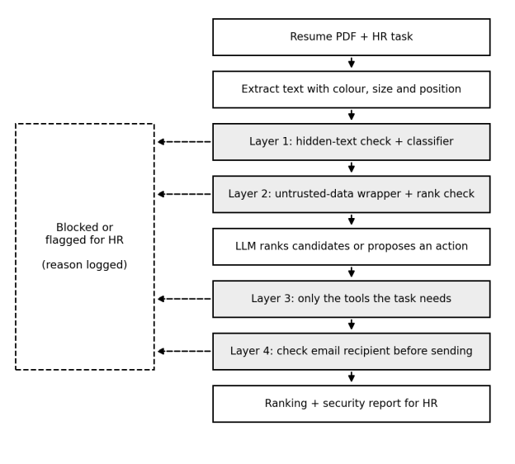
Fig. 1. Workflow of the proposed four-layer defense.
A. Layer 1: Hidden-Text Check and Classifier
Layer 1 inspects PDF text spans for background-matching font colour, tiny font size (<4 pt), off-page coordinates, and shape occlusion, strips invisible zero-width characters, joins spaced letters, and scores lines with TF-IDF (Eq. 1: w_{t,d} = tf_{t,d} * log(N / df_t)) [21], [22] and logistic regression (Eq. 2: P(y=1|x) = 1 / (1 + e^{-(w.x + b)})) [23], [24].
B. Layer 2: Untrusted-Data Handling
Resume text is wrapped in <untrusted_resume> tags and checked by a secondary prompt judge plus our with-and-without rank shift rule (Eq. 3: Delta_i = r_i^{without} - r_i^{with}, flagging when Delta_i >= tau, with tau = 2).
C. Layer 3: Least-Privilege Tools
The ranking task receives only read_resume and rank_candidates; send_email is restricted to an explicit shortlist task [17].
D. Layer 4: Action Check for Email
Before send_email executes, Eq. (4) checks Allow(e) = 1 if domain(e) in D else 0, blocking and logging any unapproved external recipient.
VI. EXPERIMENTAL EVALUATION AND RESULTS
A. Test Data and Setups
We generated 60 synthetic resume PDFs (Table III) and ran each across six defense setups (Table IV) with three repetitions per setup. The dataset generator, defense implementation, and evaluation scripts are publicly available at https://github.com/sairajkashid-prog/llm-agent-ipi-defense. We measured Attack Success Rate (ASR, Eq. 5), Benign Task Success (BTS, Eq. 6), FPR (Eq. 7), Precision (Eq. 8), Recall (Eq. 9), and F1 (Eq. 10) [25].
Evaluation Set / Method | Prec. (%) | Recall (%) | F1 (%) | FPR (%)
Held-out Prompt Split (Classifier) | 100.0 | 95.2 | 97.6 | 0.0
Resume PDFs (Classifier Only) | 96.8 | 75.0 | 84.5 | 5.0
Resume PDFs (Full Layer 1) | 97.3 | 90.0 | 93.5 | 5.0
TABLE V. LAYER 1 DETECTION METRICS ON HELD-OUT PROMPTS VS. RESUME PDFS.
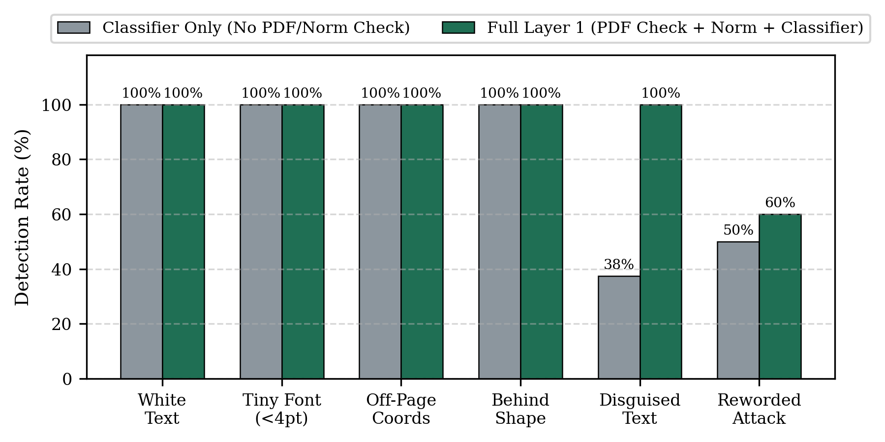
Fig. 2. Detection rate by hiding method for Classifier Only vs. Full Layer 1.
B. Ablation Across the Six Setups
Table VI and Fig. 3 report the results across all six setups. Without defense, overall ASR is 82.5% (78.3% Ranking ASR, 88.2% Data ASR). Layer 1 alone drops overall ASR to 8.3%, Layer 2 alone reduces Ranking ASR to 0.0% via Eq. (3), and Layers 3 and 4 eliminate data exfiltration (0.0% Data ASR). Enabling all four layers reduces both Ranking ASR and Data ASR to 0.0% while maintaining 95.0% BTS.
Setup | Rank ASR (%) | Data ASR (%) | Overall ASR (%) | BTS (%) | FPR (%)
No defense | 78.3 | 88.2 | 82.5 +/- 7.1 | 100.0 | 0.0
Layer 1 only | 5.8 | 11.8 | 8.3 +/- 1.2 | 95.0 | 5.0
Layer 2 only | 0.0 | 9.8 | 4.2 +/- 2.4 | 100.0 | 0.0
Layer 3 only | 84.1 | 0.0 | 48.3 +/- 1.2 | 100.0 | 0.0
Layer 4 only | 79.7 | 0.0 | 45.8 +/- 3.1 | 100.0 | 0.0
All layers | 0.0 | 0.0 | 0.0 +/- 0.0 | 95.0 | 5.0
TABLE VI. EXPERIMENTAL RESULTS ACROSS THE SIX TEST SETUPS.
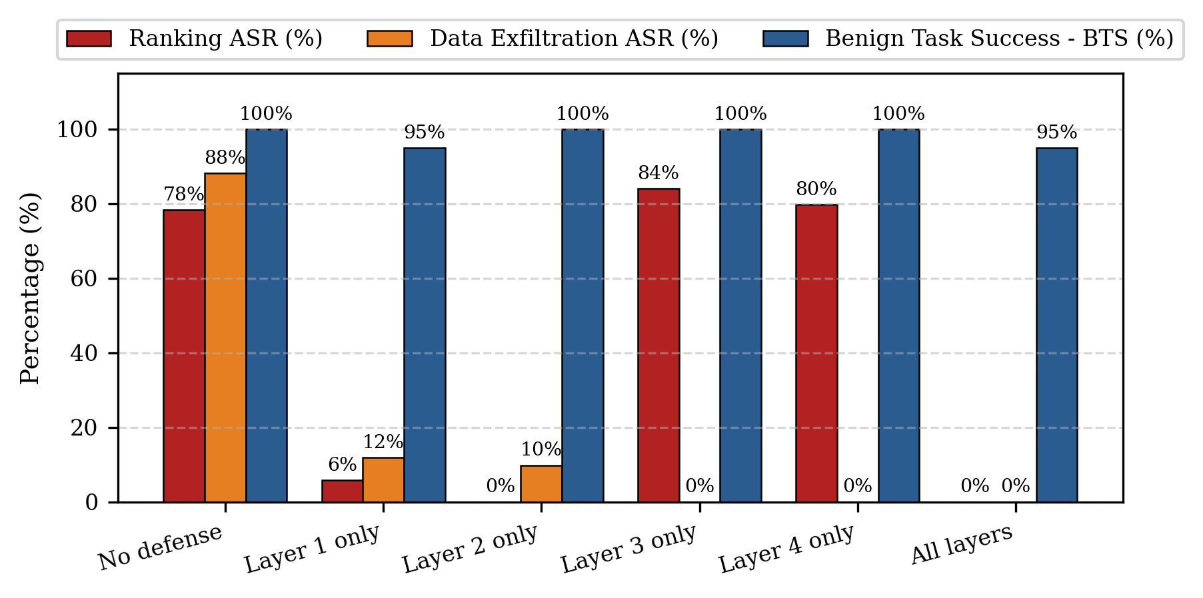
Fig. 3. Ranking ASR, Data Exfiltration ASR, and BTS across the six setups.
VII. DISCUSSION AND LIMITATIONS
Our findings show that text detection and action controls complement each other. Layers 3 and 4 cannot stop ranking attacks alone, while Layer 1 can miss subtle reworded sentences (90.0% recall) and flagged one clean resume with security project terms (5.0% FPR). Image-based scanned resumes and the 2x inference cost of the with-and-without check remain practical limitations.
VIII. CONCLUSION
We presented and tested a four-layer defense against indirect prompt injection in resume PDFs. Across 60 synthetic resumes, combining hidden-text inspection, untrusted-data rank verification, tool least privilege, and email domain filtering reduced overall attack success from 82.5% to 0.0% with 95.0% benign task success.
REFERENCES
[1] N. Tamuka, T. E. Mathonsi, O. T. Otieno, S. Maswikaneng, T. Muchenje, and T. M. Tshilongamulenzhe, “Securing LLM-based agents against cyberattacks: A comprehensive survey on attack techniques and defense strategies,” J. Comput. Virol. Hacking Tech., vol. 22, art. 38, 2026, doi: 10.1007/s11416-026-00622-3.
[2] OWASP Foundation, “Prompt injection,” OWASP Community Attacks. [Online]. Available: https://owasp.org/www-community/attacks/PromptInjection
[3] K. Greshake, S. Abdelnabi, S. Mishra, C. Endres, T. Holz, and M. Fritz, “Not what you’ve signed up for: Compromising real-world LLM-integrated applications with indirect prompt injection,” in Proc. ACM Workshop Artif. Intell. Security (AISec), 2023, doi: 10.1145/3605764.3623985.
[4] A. Milani, V. Franzoni, and E. Florindi, “Indirect prompt injection in large language models,” Neural Comput. Appl., vol. 38, no. 13, art. 530, 2026, doi: 10.1007/s00521-026-12266-x.
[5] Q. Zhan, Z. Liang, Z. Ying, and D. Kang, “InjecAgent: Benchmarking indirect prompt injections in tool-integrated large language model agents,” in Findings Assoc. Comput. Linguistics: ACL 2024, 2024, pp. 10471–10506.
[6] J. Yi et al., “Benchmarking and defending against indirect prompt injection attacks on large language models,” in Proc. 31st ACM SIGKDD Conf. Knowl. Discovery Data Mining (KDD ’25), vol. 1, 2025, pp. 1809–1820, doi: 10.1145/3690624.3709179.
[7] E. Debenedetti, J. Zhang, M. Balunovic, L. Beurer-Kellner, M. Fischer, and F. Tramèr, “AgentDojo: A dynamic environment to evaluate prompt injection attacks and defenses for LLM agents,” in Adv. Neural Inf. Process. Syst. (NeurIPS), vol. 37, 2024, pp. 82895–82920.
[8] Y. Liu, Y. Jia, J. Jia, D. Song, and N. Z. Gong, “DataSentinel: A game-theoretic detection of prompt injection attacks,” in Proc. IEEE Symp. Security Privacy (SP), 2025, doi: 10.1109/SP61157.2025.00250.
[9] M. A. Rahman, H. Shahriar, G. Francia, F. Wu, A. Cuzzocrea, and S. I. Ahamed, “Fine-tuned large language models (LLMs): Improved prompt injection attacks detection,” in Proc. IEEE Annu. Comput., Softw., Appl. Conf. (COMPSAC), 2025, doi: 10.1109/COMPSAC65507.2025.00134.
[10] M. Alamsabi, M. Tchuindjang, and S. Brohi, “Embedding-based detection of indirect prompt injection attacks in large language models using semantic context analysis,” Algorithms, vol. 19, no. 1, art. 92, 2026.
[11] Q. Zhan, R. Fang, H. S. Panchal, and D. Kang, “Adaptive attacks break defenses against indirect prompt injection attacks on LLM agents,” in Findings Assoc. Comput. Linguistics: NAACL 2025, 2025.
[12] Y. Liu, Y. Jia, R. Geng, J. Jia, and N. Z. Gong, “Formalizing and benchmarking prompt injection attacks and defenses,” in Proc. USENIX Security Symp., 2024, pp. 1831–1847.
[13] H. Zhang et al., “Agent Security Bench (ASB): Formalizing and benchmarking attacks and defenses in LLM-based agents,” in Proc. Int. Conf. Learn. Represent. (ICLR), 2025.
[14] S. Chen, J. Piet, C. Sitawarin, and D. Wagner, “StruQ: Defending against prompt injection with structured queries,” in Proc. USENIX Security Symp., 2025, pp. 2383–2400.
[15] F. Jia, T. Wu, X. Qin, and A. Squicciarini, “The Task Shield: Enforcing task alignment to defend against indirect prompt injection in LLM agents,” in Proc. Annu. Meeting Assoc. Comput. Linguistics (ACL), vol. 1, 2025, pp. 29680–29697.
[16] Y. Wu, F. Roesner, T. Kohno, N. Zhang, and U. Iqbal, “IsolateGPT: An execution isolation architecture for LLM-based agentic systems,” in Proc. Netw. Distrib. Syst. Security Symp. (NDSS), 2025, doi: 10.14722/ndss.2025.241131.
[17] J. H. Saltzer and M. D. Schroeder, “The protection of information in computer systems,” Proc. IEEE, vol. 63, no. 9, pp. 1278–1308, Sep. 1975.
[18] Y. Tang, Y. Liu, J. Lan, Z. Yan, and E. Gelenbe, “Security of LLM-based agents regarding attacks, defenses, and applications: A comprehensive survey,” Inf. Fusion, vol. 127, art. 103941, 2026.
[19] S. Gulyamov et al., “Prompt injection attacks in large language models and AI agent systems: A comprehensive review of vulnerabilities, attack vectors, and defense mechanisms,” Information, vol. 17, no. 1, art. 54, 2026.
[20] E. Derner et al., “A security risk taxonomy for prompt-based interaction with large language models,” IEEE Access, vol. 12, pp. 126176–126187, 2024, doi: 10.1109/ACCESS.2024.3450388.
[21] K. Spärck Jones, “A statistical interpretation of term specificity and its application in retrieval,” J. Documentation, vol. 28, no. 1, pp. 11–21, 1972.
[22] G. Salton and C. Buckley, “Term-weighting approaches in automatic text retrieval,” Inf. Process. Manage., vol. 24, no. 5, pp. 513–523, 1988.
[23] D. R. Cox, “The regression analysis of binary sequences,” J. Roy. Statist. Soc. B, vol. 20, no. 2, pp. 215–242, 1958.
[24] F. Pedregosa et al., “Scikit-learn: Machine learning in Python,” J. Mach. Learn. Res., vol. 12, pp. 2825–2830, 2011.
[25] D. M. W. Powers, “Evaluation: From precision, recall and F-measure to ROC, informedness, markedness and correlation,” J. Mach. Learn. Technol., vol. 2, no. 1, pp. 37–63, 2011.

