Grouping

h6 , p {
font- size :14px;

}
/* commenting */

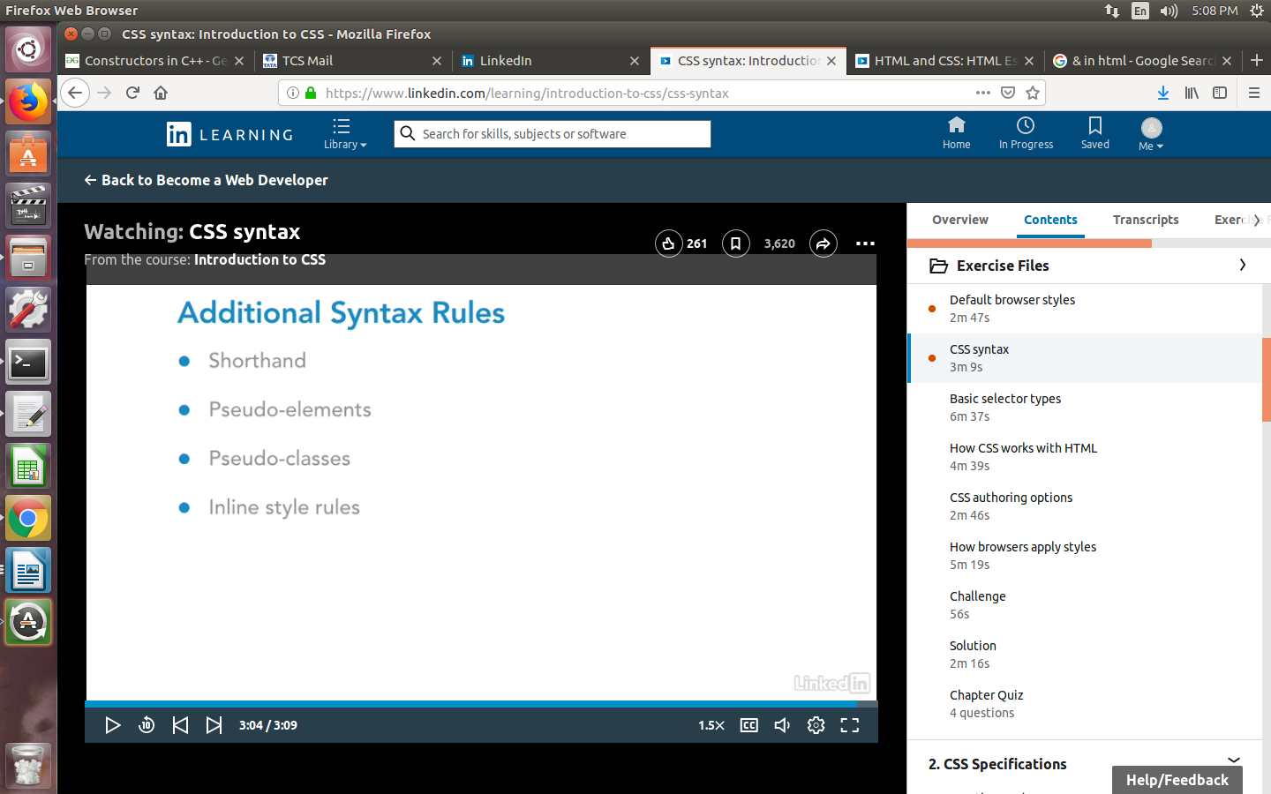

Basic Selector types

Element selector

p hi
ul {color : red}

Class selector
.error {color : red}
h1.error {color : red} (more specific Element specific)

ID selector

no other element in the page should have the same ID.

#error{color : red}

div#error{color : red}

Descendant Selector

div p a {color : blue}

div parent > p >a

h1, p, .content {color : blue;}

STYLE LOCATIONS

External stylesheet
in an external file (style.css)
<link rel="stylesheet" type="text/css" href="theme.css">

Embedded styles
placed in the head of the existing file

<style>
</style>

In line styles

<h1 style = “color : red;”></h1>

specificity

CSS – Fonts

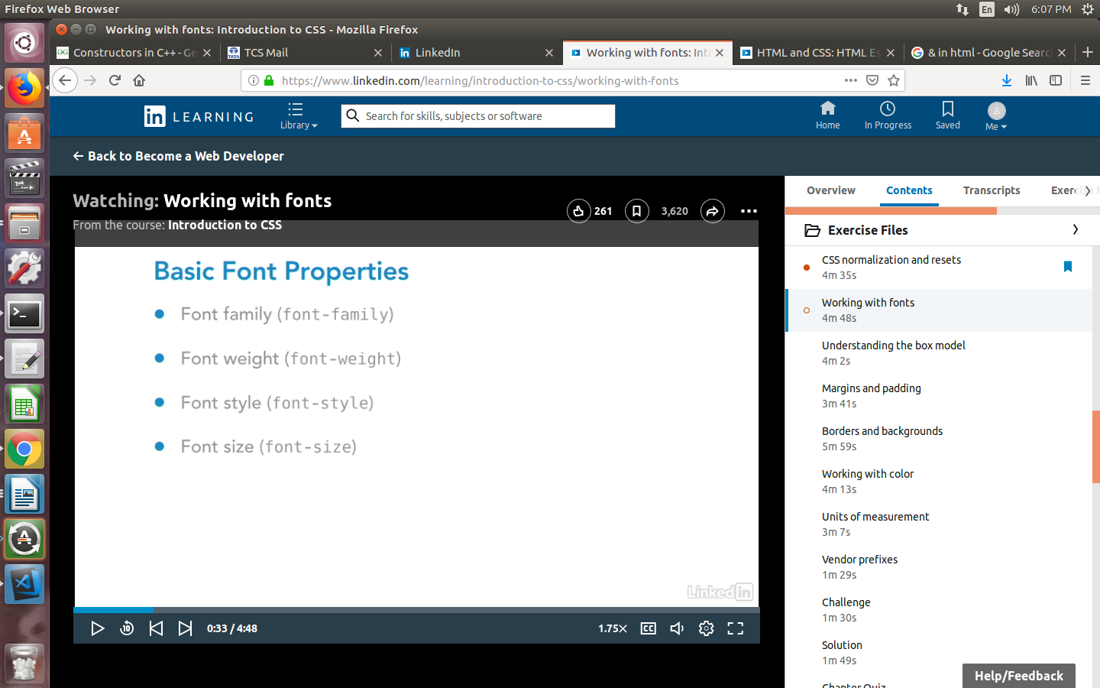

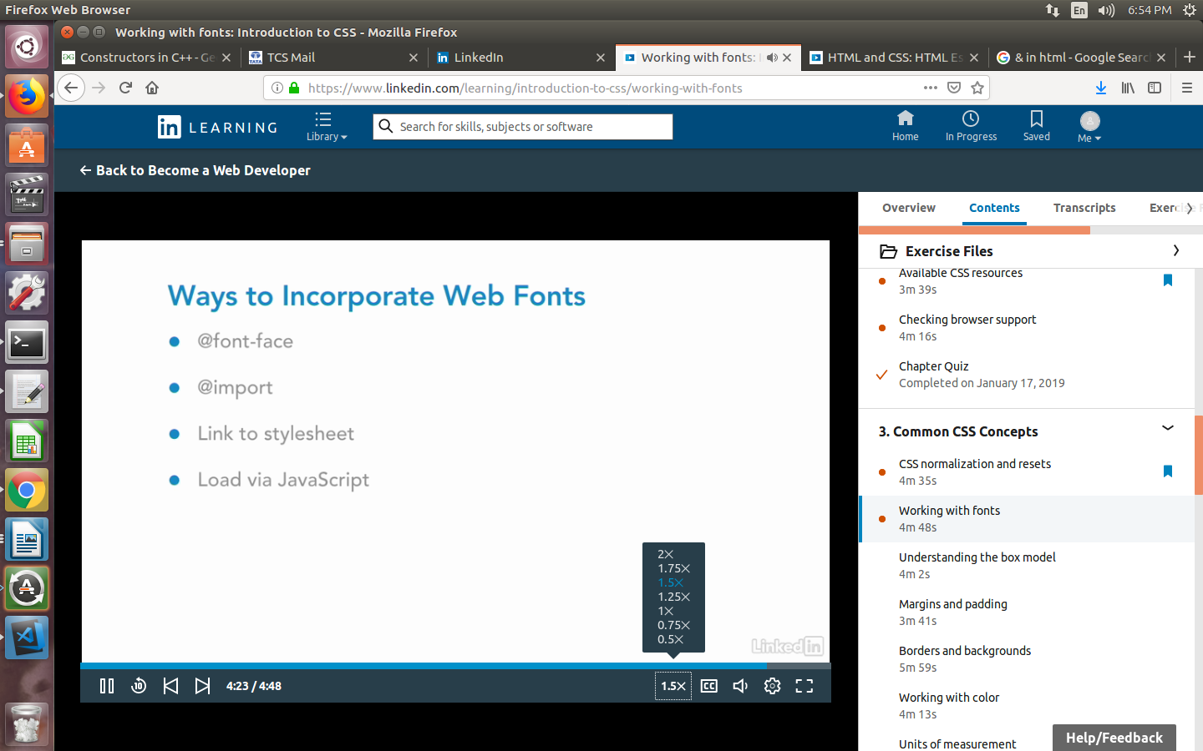

The box model

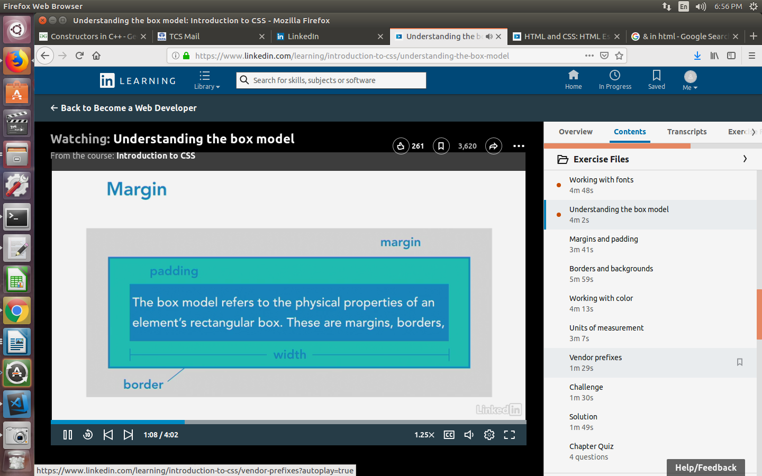

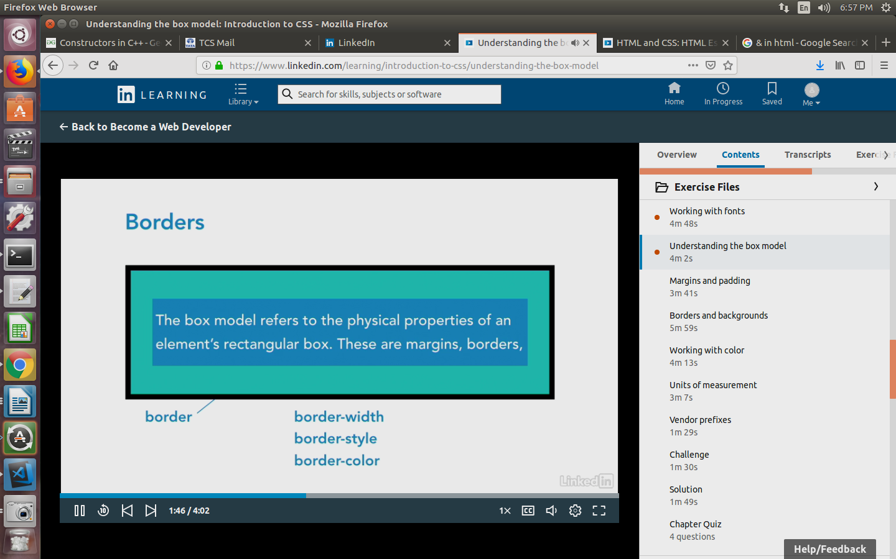
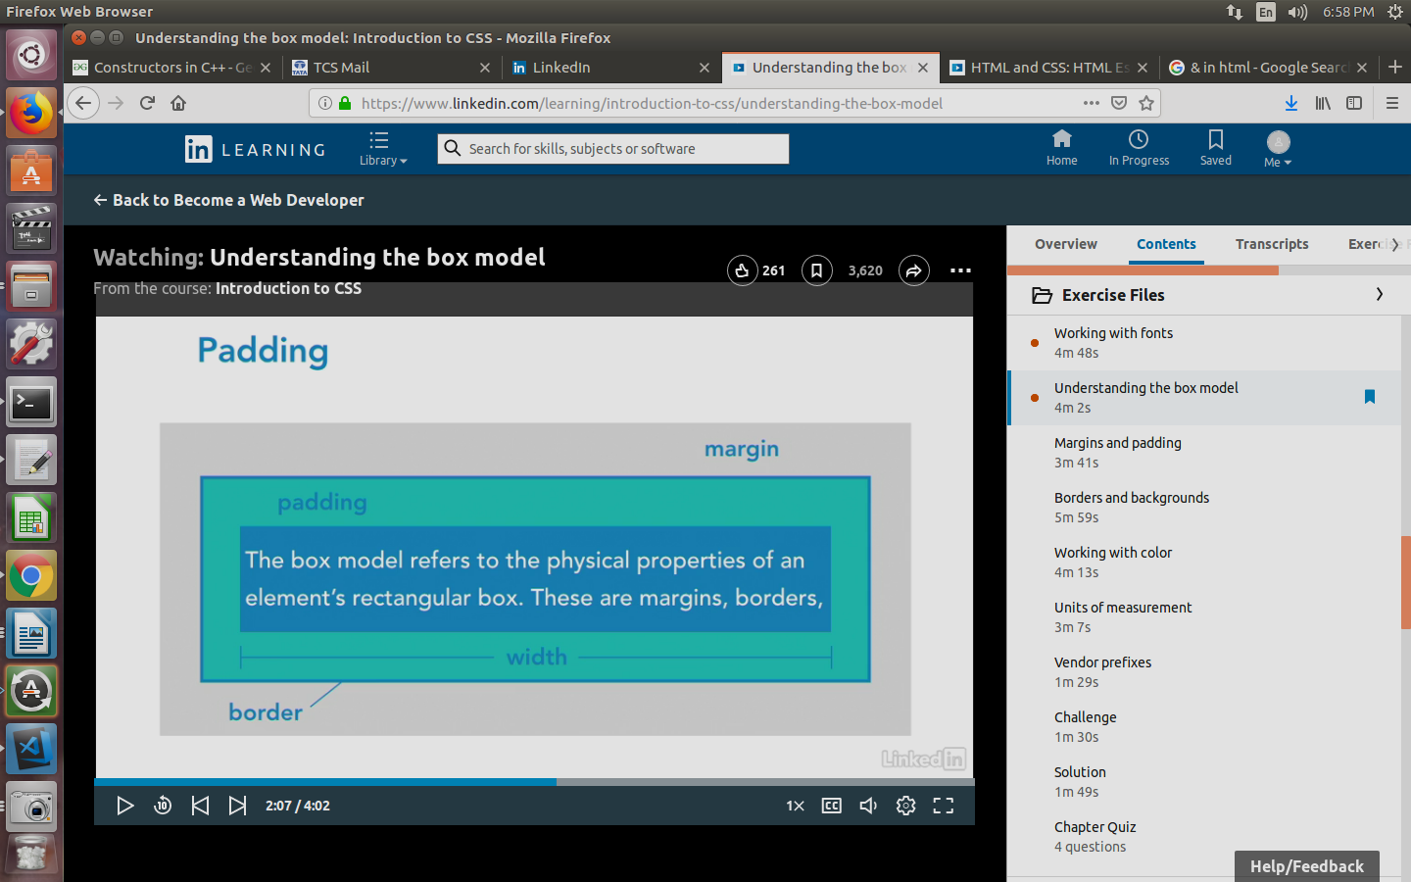

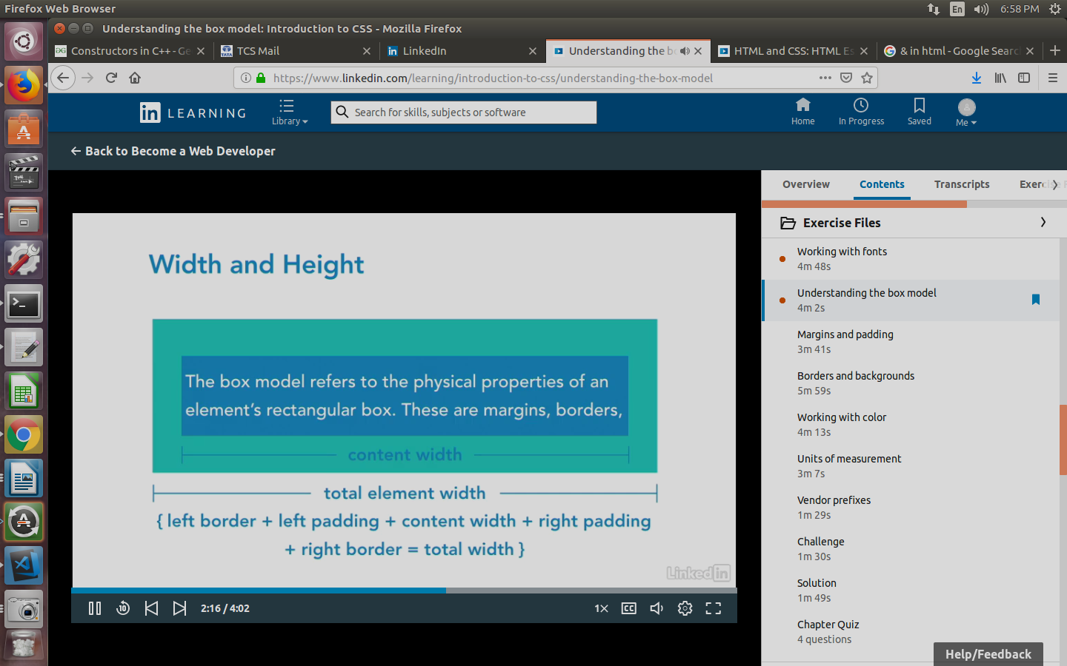

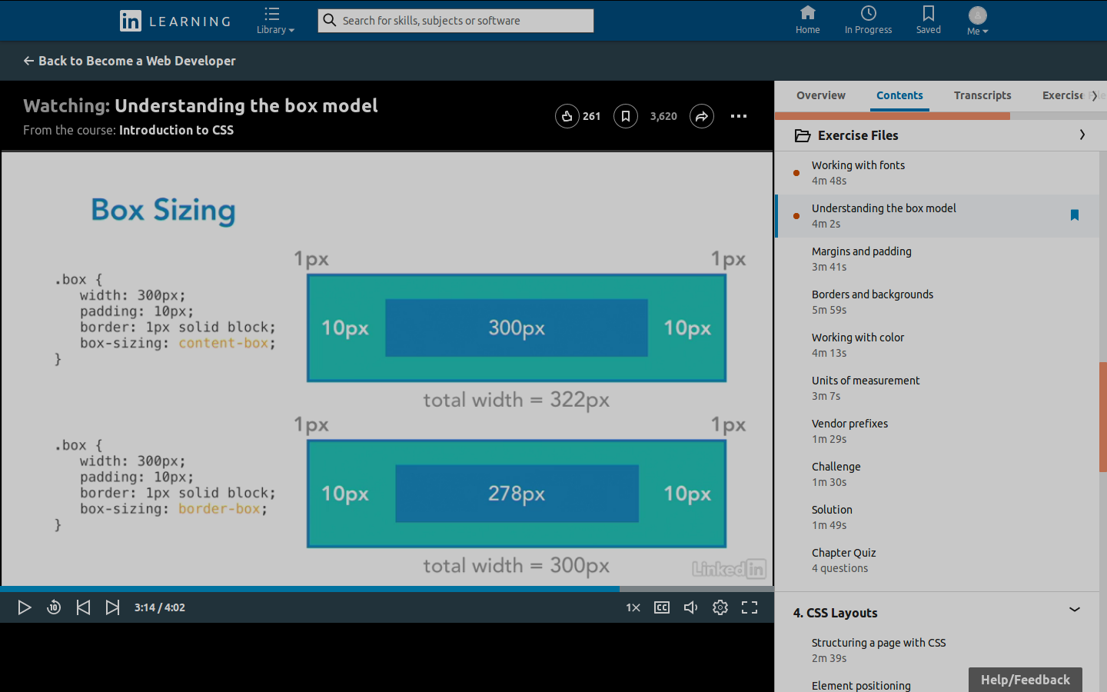

TRBL

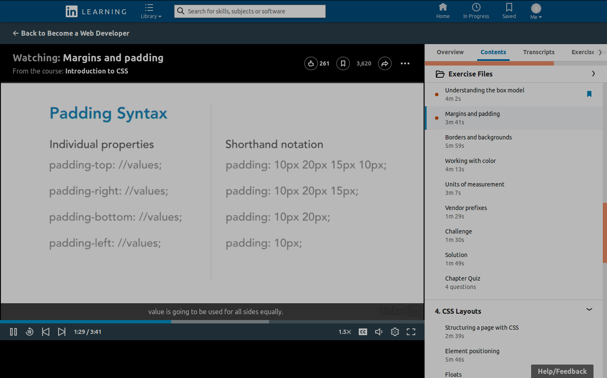

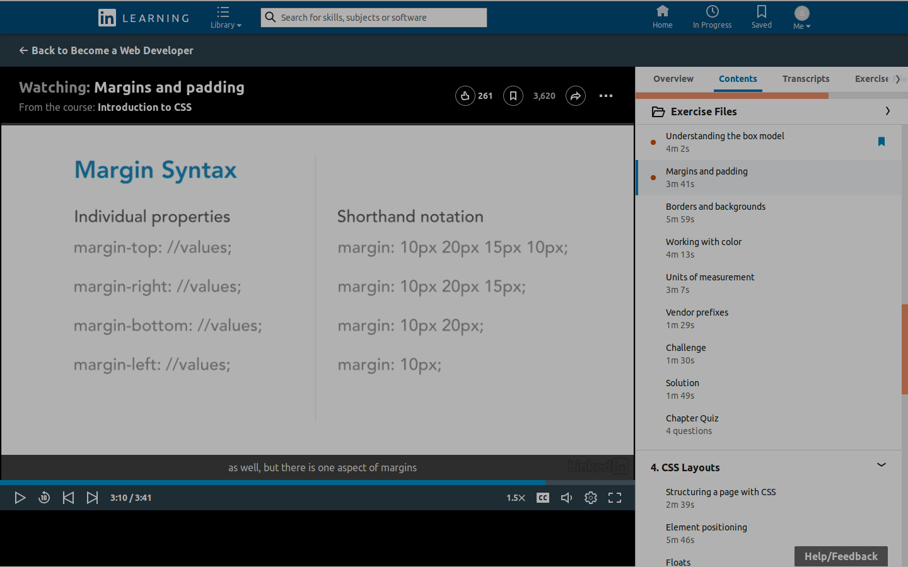

transparent -- opacity

em -relative to font size of parent element
rem - relative to font size of root element
FLEX BOX LAYOUT

CSS GRID

CSS POSITIONING ------ ELEMENT POSITIONING

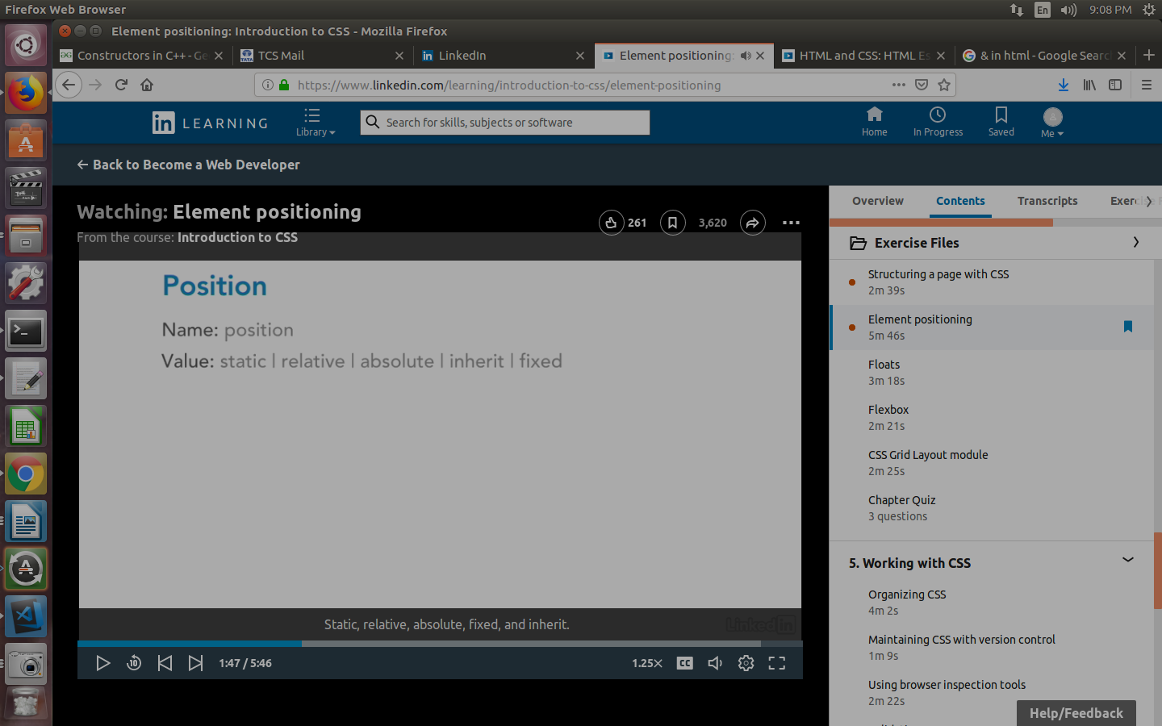

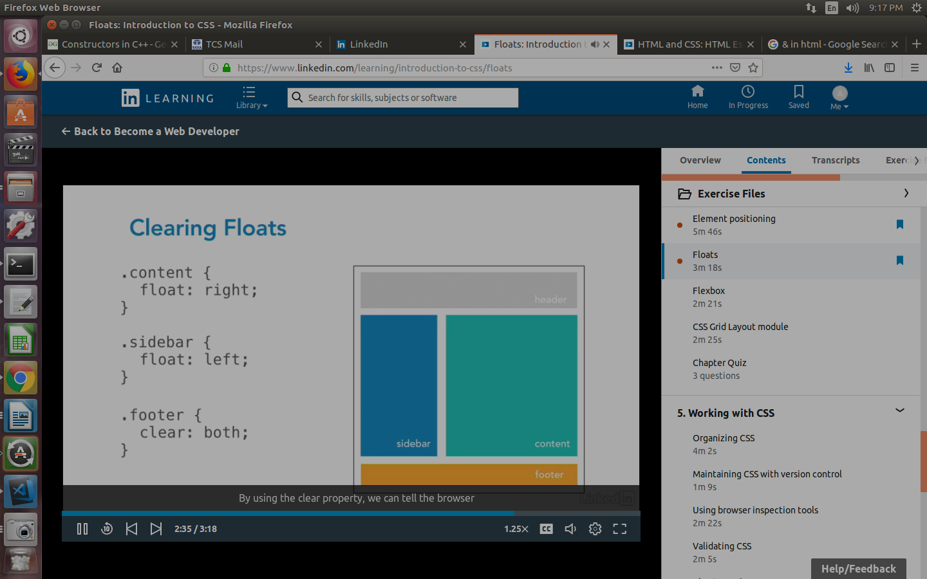

RESPNSIVE WEB LAYOUT *************8

