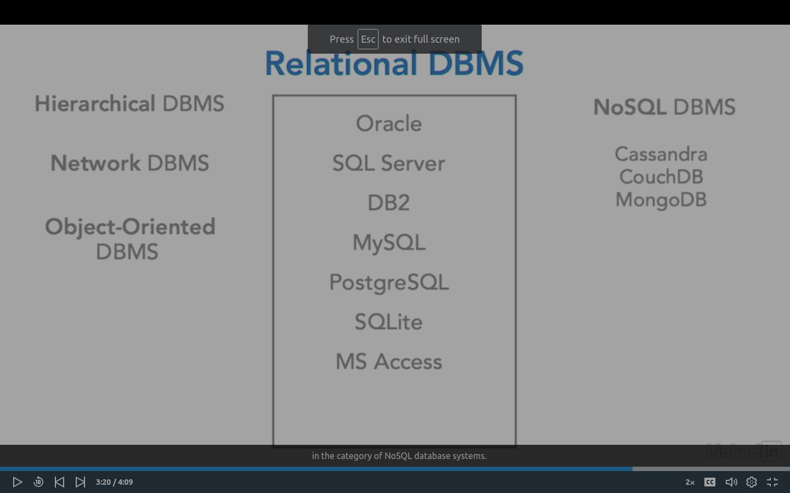

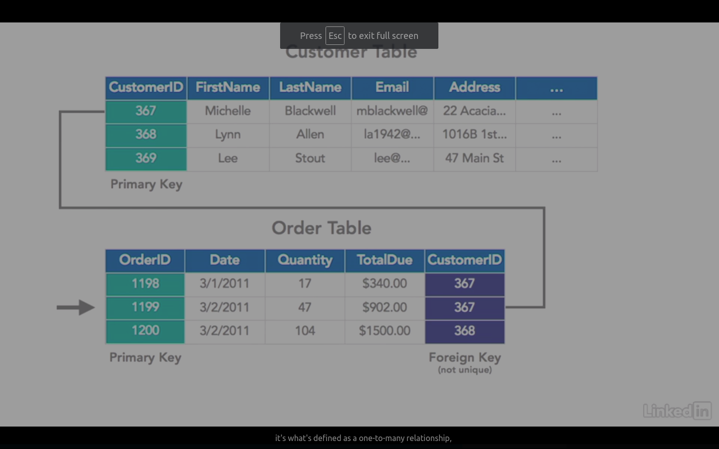

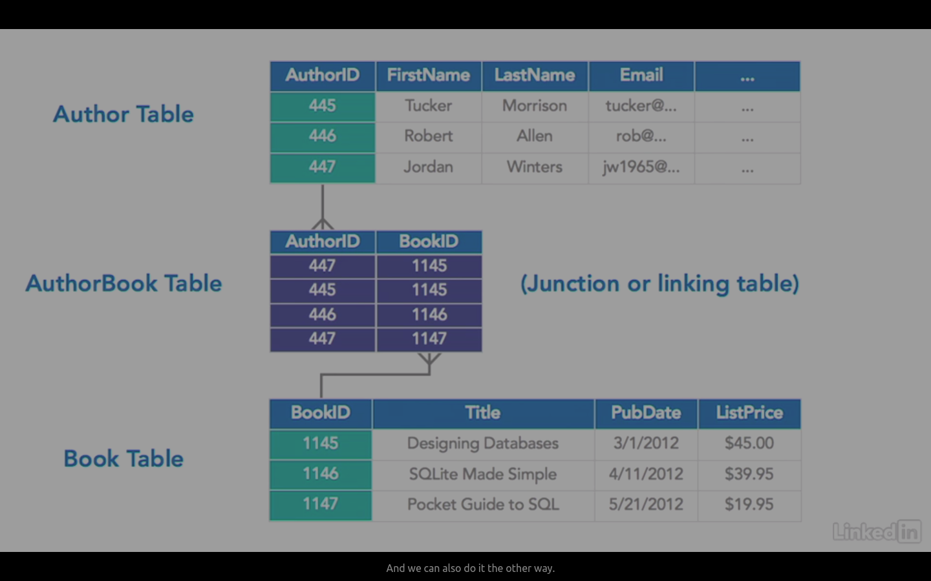
ACID

CID, A-C-I-D.
A transaction must be atomic, consistent,isolated, and durable. Being atomic, and this is the Greek word atom meaning an indivisible unit. It refers to the core idea that this transaction must completely happen or not at all. So whether there are two steps in the transaction or 20 steps, they're all contained within the transaction. They either all complete successfully or they all return to the original state. There is no such thing as a transaction that halfway occurs. Now whether the reason for the transaction failing is that the database had a power failure or ran out of space to hold the new data or there was an application error, it doesn't matter.
Atomic is the all or nothing rule. Now consistency means that any transaction must take the database from one valid state to another valid state based on the rules of the database. So even if a transaction is successfully atomic, it still cannot result in a situation that violates any of the integrity rules defined in the database. Isolation refers to the data and the transaction beingessentially locked for that moment in which the transaction is occurring.
So while we're trying to change a balance on one of our account records, another part of the system must not be allowed to access that data until the first transaction has finished. And durability refers to the transaction being considered robust. If it happens and the database says this transaction has happened successfully, then the transaction is guaranteed. Say if you go to a travel website, purchase a flight on an aircraft and you're guaranteed seat two A,then you should be able to regard that transaction as being durable, even if half a second later the database suffers a power failure and shuts down.
When it reboots, that transaction will have survived that failure, and they are not going to sell that seat to someone else simply because there was a glitch in the system half a second after you made your purchase. Now the great thing about working with most database management systems is these capabilities are built into the system. You don't have to worry about how to program these, you just need to know when to tell the database, now this is a transaction, these three things, these four things, these 10 things must be done together.
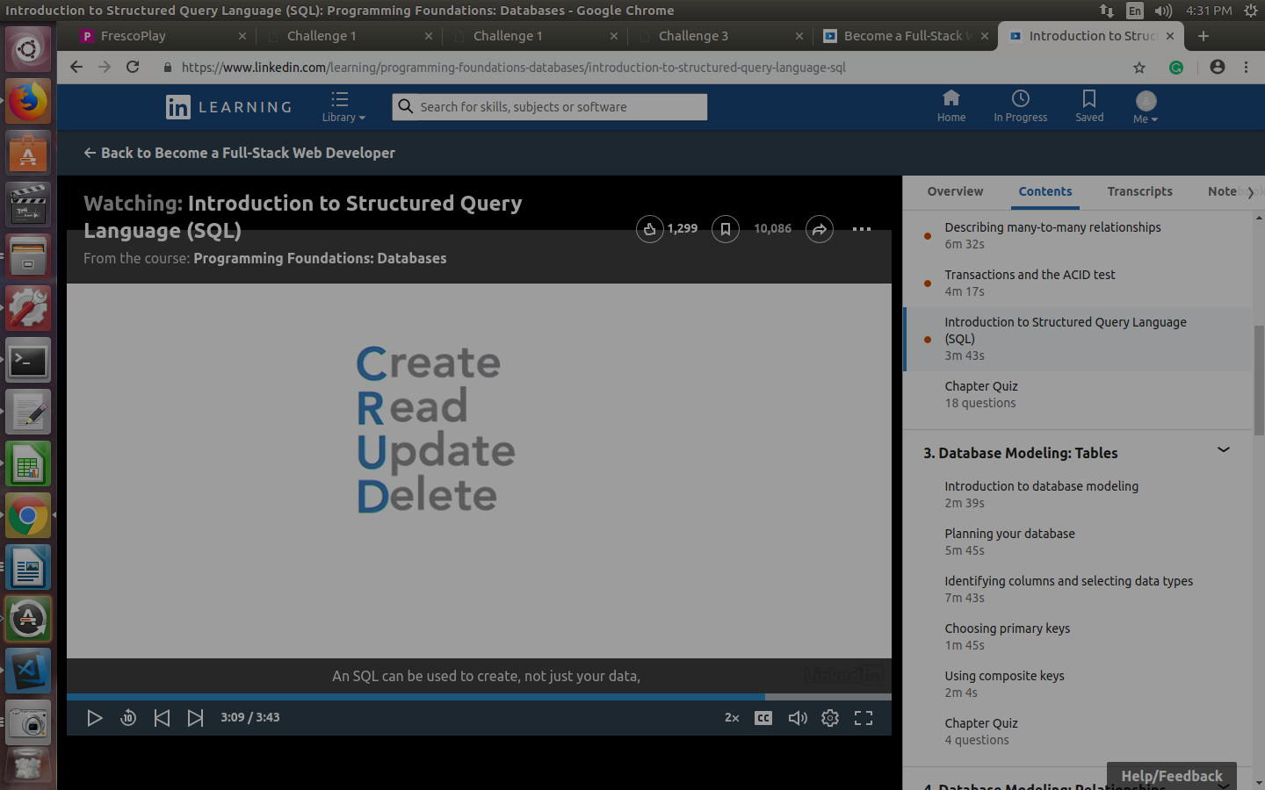

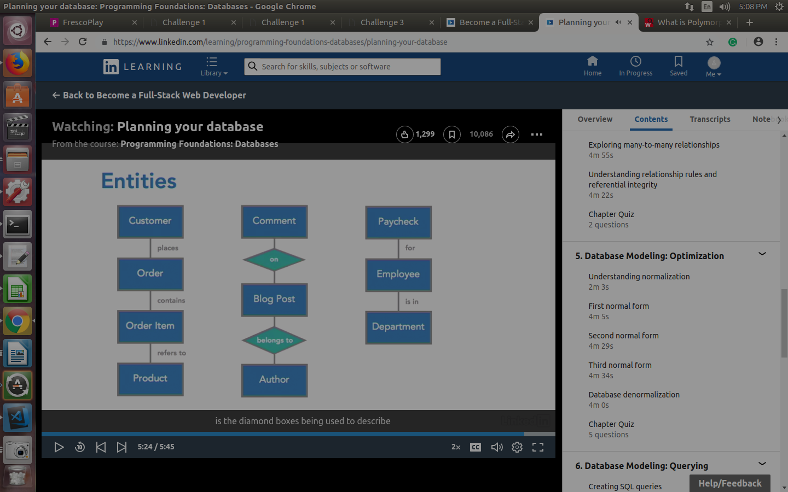

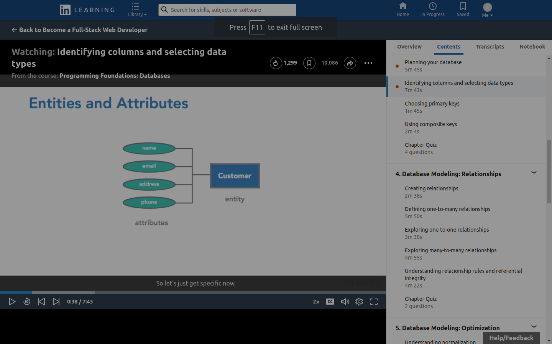
Entities becomes rows , attributes become coloumns
BLOBS – Binary Large Objects
CLOBS – charecter large objects

COMPOSITE KEY – Two valuse combined to form the Primary key.
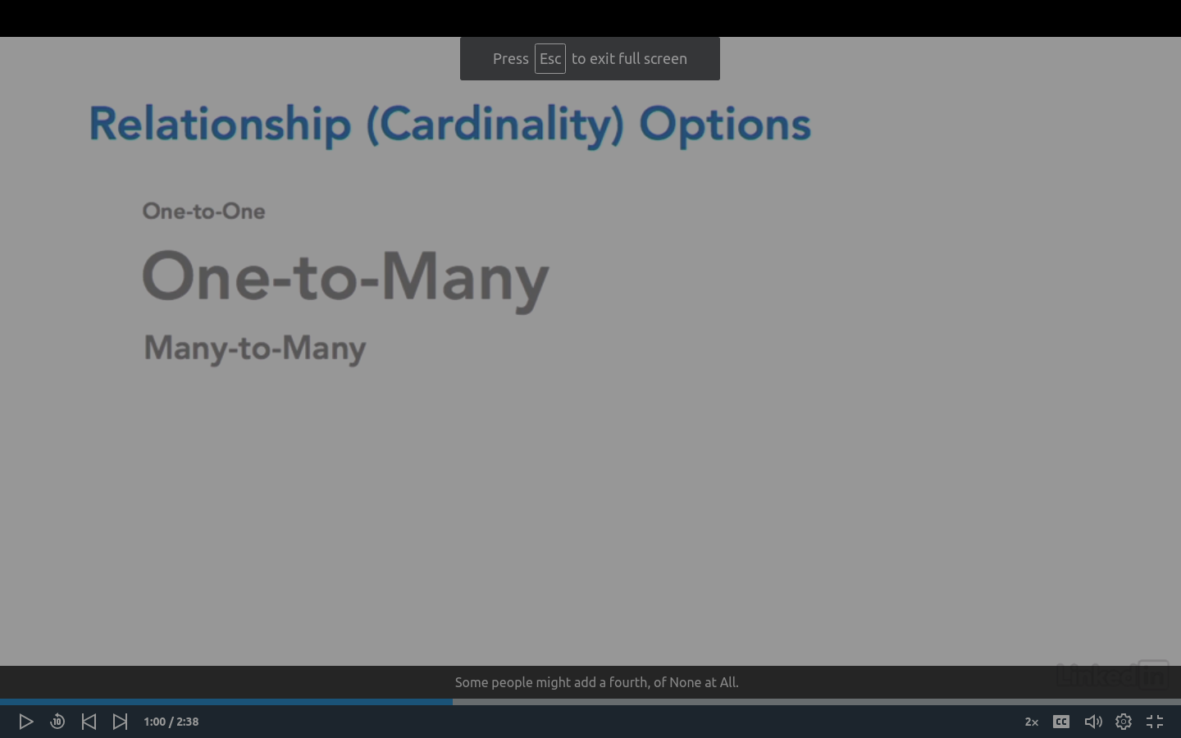

One to Many:

New column(Primary key of first table) to the many table is added
This column acts as a key for the many table ----> one table .
Us different coloum name for the primary key column while using in many table .

DATA BASE NORMALOZATION

1st Normal Form
No repeating coloumns, no repeating values,no repeating group

Relationship between columns tha
2nd Normal Form
can be a problem only when we create a composite key.

All the coloumns which are not the part of the composite key must be related to the composite key.
{all the coloumns should be related.}

Solution: remove the colums that are not related to the composite key and create a new table.

3rd Normal Form
No non key field is dependent on another non key field.

DENORMALIZATION
For performance improvement
