TASK 1: Repository Setup

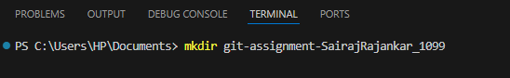
- Create a folder named git-assignment-yourfullname

- Navigate into the folder

- Initialize Git repository

- Create a file named index.txt

- Check repository status
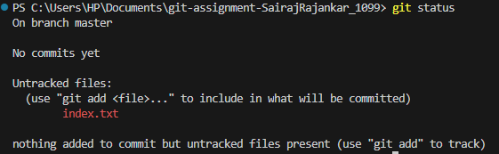
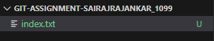

- Stage the file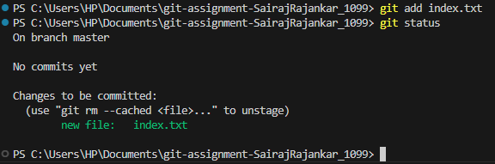

7. Commit with message:
Initial project setup
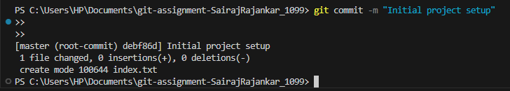

TASK 2: Branch Creation & Work
1. Create a branch named feature-header

2. Switch to feature-header

3. Create a file named header.txt
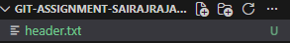

4. Stage the file
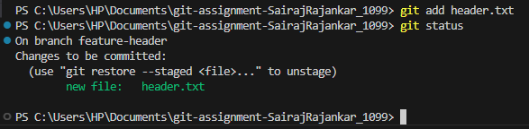

5. Commit with message:
Added header section
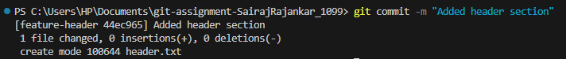

TASK 3: Branch Switching Observation

1. Switch back to master

2. List files and observe
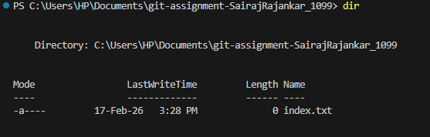

3. Switch again to feature-header

4. List files and observe
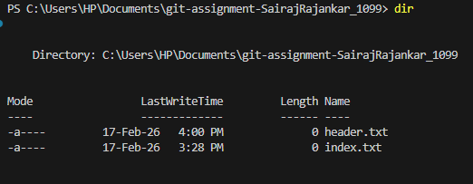

TASK 4: Undo a Mistake
1. In feature-header, modify index.txt

2. Check repository status
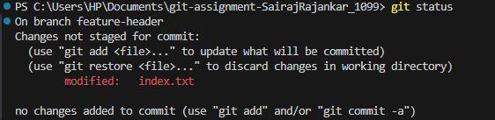

3. Undo the change using Git

4. Verify status again
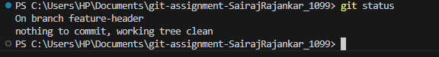

TASK 5: Merge Feature Branch

1. Switch to master
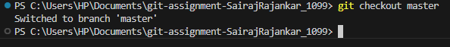

2. Merge feature-header
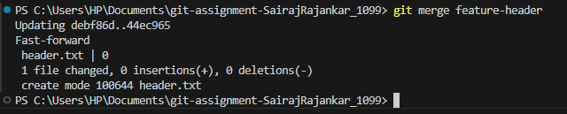

3. Verify merged files
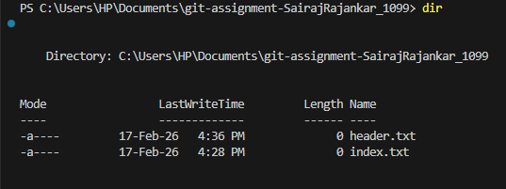
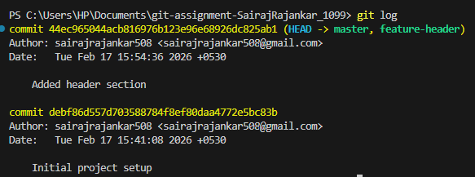
4. Check commit history
TASK 6: Checkout a Commit (Detached HEAD)
1. View commit history
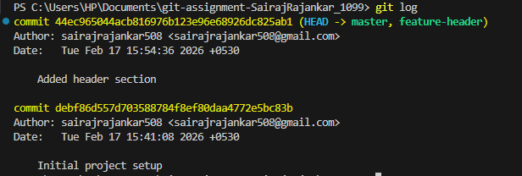

2. Checkout any older commit
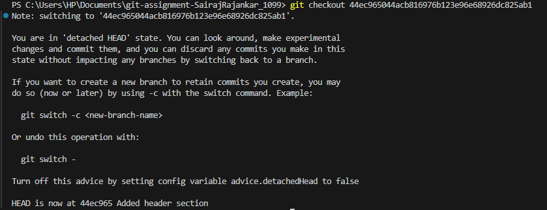

3. Check current branch status
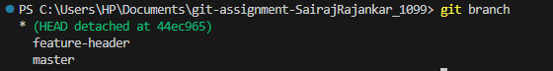

4. Switch back safely to master

