SBC/SOM with Wi-Fi, BLE, Ethernet, (NBIoT or LoraWAN)
Sensors

Date – 5/01/2021
What is SBC?
A Single Board Computer (SBC) is a computer built on a single circuit board with microprocessor, memory I/O and other several other features of a functional computer.
Most common example – Raspberry Pi

What is SOM?
A System on Module (SOM) is a board that integrates the main elements of a processing subsystem or CPU and plugs them into a carrier board. Application specific functionalities such as I/O connections can then be implemented on the carrier board.

SBCs/SOMs with Wi-Fi, Bluetooth, Ethernet –
- Raspberry Pi 4 Model B – https://static.raspberrypi.org/files/product-briefs/Raspberry-Pi-4-Product-Brief.pdf
- Latest in the Raspberry Pi range of computers
- High performance 64-bit quad-core processor
- Dual display support
- 4GB of RAM
- Dual-band 2.4/5.0 GHz wireless LAN
- Bluetooth 5.0
- Gigabit Ethernet

Connectivity –
2.4 GHz and 5.0 GHz wireless LAN, Bluetooth 5.0, BLE
Gigabit Ethernet
2 × USB 3.0 ports 2 × USB 2.0 ports.

- Rock Pi 4 Model C – Similar to Raspberry Pi 4 Model B in terms of connectivity (LAN, Bluetooth 5.0, Ethernet) , but with a higher Processing power. Also, it has a neutral processing unit (NPU) which is useful for offloading some of the processing in AI applications.

- Asus Tinker Board 2S – Similar to Raspberry Pi 4 Model B. It is a ideal for IoT, edge computing, desktop computing, maker projects, etc.

- Orange Pi 4B -Best for Machine learning

- Processor: Rockchip RK3399 (2x 1.4Ghz Cortex-A72, 4x 1.4GHz Cortex A53)
- Architecture: ARM, 64-bit
- GPU: Mali T864
- Memory: 4 GB LPDDR4
- Inbuilt Storage: 16 GB eMMC
- Expandable Storage: MicroSD
- Networking & Connectivity: 2.4/5 GHz Wi-Fi, Bluetooth 5.0 (BLE), Gigabit Ethernet
- I/OHDMI 2.0, DP 1.2, DSI, CSI, 2x USB 2.0 host, USB 3.0 C, UART, 24-pin PCIe, RTC, 40-pin GPIO
- Power5V @3A (via USB C)
- Market Price (approx., USD) $109
Orange Pi 4B is an all-rounder in terms of features and it can run distributions such as Android 8.1, Ubuntu 18 or Debian. What makes this Raspberry Pi alternative special is its neural-networking co-processor (NPU), which can max out crunching data at 9.3Tops/W in ultra-high-performance mode, making it an ideal match for machine learning.

IoT networks – LTE-M, NB-IoT, LORAWAN, SIGFOX
NB IoT –
- Narrowband IoT
- A IoT network that helps different devices to connect to internet.
- Narrowband stands for the low bandwidth. Low bandwidth is an advantage as when we send a string of data through broadband environment the bandwidth of these broadband and wideband goes unutilized and bandwidth has a high cost. Therefore, low bandwidth is an advantage.
- NB IoT is a part of lower power wide area network (LPWAN). LPWAN is a type of network which connects devices over large area and allows long range of communication at a lower bit rate, low cost and greater power efficiency. LPWAN supports a large number of devices over wide areas in comparison to cellular services.
- NB IoT also has a high interference resistance.
- Advantages of NB IoT are low power consumption, low bandwidth, low costs, higher range and geographical coverage.
- The only disadvantage is higher transmission latency (It takes long time for data transfer)
- Cellular networks like 3G, 4G, 5G are not optimized for IoT.
- Coexist with 5G
- Modes of Operation of NB-IoT –
- In-band operation – Uses free frequency spectrum of LTE channel
- Guard-band operation – LTE channels have guard band between them, and these guard bands have enough bandwidth to accommodate NB IoT channel.
- Stand Alone operation – NB IoT occupies the channels which were previously occupied by GSM

LoRaWAN –
- Long Range Wide Area Network
- securely connects LoRa devices to the internet
- consumes very less battery power, devices can run for years on a small battery
- Similar to NB IoT it also has very low bandwidth

Date – 6/01/2021
Objectives –
- Compare different SBCs
- NB IoT/LoRaWAN example devices
- Sensors
Comparison between Raspberry Pi 4B vs Orange Pi 4B

 | Orange Pi 4B | Raspberry Pi 4B
Processor | Rockchip RK3399 ARM Cortex-A53/A72-  Rockchip RK3399 is a low power, high performing processor for computing, personal mobile internet devices and other smart device operations. | BCM2711 ARM Cortex-A72
Memory | RAM – Size-4096MB, Type-LPDDR4  It supports eMMC(embedded Multimedia Card) of size 16GB which can be used for extra storage. | RAM – Size-4096MB, Type-LPDDR4  It does not support eMMC.
Connectivity | Both are same in terms of ethernet speed, Bluetooth  version and WiFi.
General Input/Output | Same for both
Video, Camera, Audio  interface | Similar for both.  But the GPU used for Orange Pi 4B is better in terms of performance.
Power | Same for both
DEV | Supported OS – Android 8.1, Ubuntu 16.04, Ubuntu 18.04, Debian 9  Languages – JAVA, Python, C, C++ | Supported OS – Raspbian  Languages – JAVA, Python, C, C++
Price | ₹10,010.00 (134.58 $)  https://www.fabtolab.com/orange-pi-4b-open-source-single-board-computer-rockchip-rk3399?search=Orange%20Pi%204%20B | ₹5,149.00 (69.23 $)  https://robu.in/product/raspberry-pi-4-model-b-with-4-gb-ram/?gclid=Cj0KCQiAoNWOBhCwARIsAAiHnEg_LGuINLMHdqTZzwluIDOBk-hAq8GbfZxHMAAd5MbVmAiWVXSkJ60aApJ6EALw_wcB
Orange Pi 4 B –
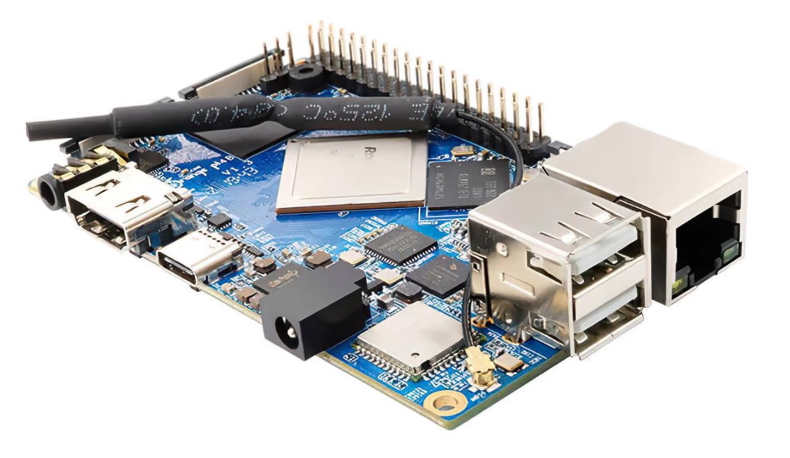
Raspberry Pi 4 B –
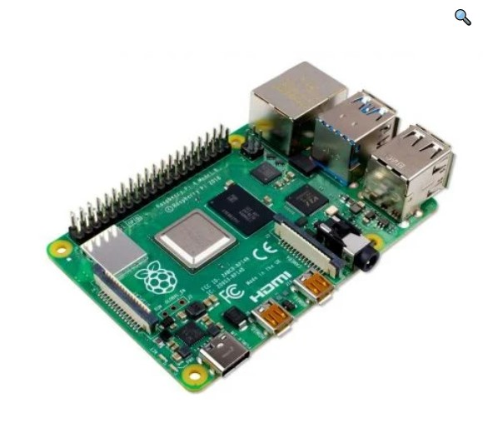
Orange Pi 4 B and Raspberry Pi 4 B are almost similar, but Orange Pi 4 B is better specifically for AI/ML and computation.
Raspberry Pi 4B used in Digital Twin project - https://search.abb.com/library/Download.aspx?DocumentID=9AKK107492A3437&LanguageCode=en&DocumentPartId=&Action=Launch

LoRaWAN device -https://youtu.be/_I4c-Al9hCI
NB IoT example - https://youtu.be/U-yPdrDwE9E

Temperature sensors –
The type of temperature sensor we can use will vary according to the temperature range under which the sensor would be placed, accuracy and stability which we want and also the size.
For example – For cold storage truck carrying frozen food items we can use PT1000-S sensor.
https://www.electronicscomp.com/pt1000-s-waterproof-1m-30mm-stainless-steel-pole-probe-temperature-sensor?gclid=Cj0KCQiAw9qOBhC-ARIsAG-rdn5XuBizUxPeOmvyJ9rm6TPrL12qbWKHmeg1FlUQkWIFn9fSlUa3BY8aAmB2EALw_wcB

Date – 07/01/2022
Objectives –
- NB IoT modules for Orange Pi 4B/Raspberry Pi 4B
- Sensors

NB IoT modules –
All the NB IoT modules available currently support Raspberry Pi series of boards.

SIM 7080G, SIM7020E, SIM7070G, SIM7000E, SIM7600G-H
- SIM 7080 G - https://www.waveshare.com/sim7080g-cat-m-nb-iot-hat.htm
Features-
- Standard Raspberry Pi 40PIN GPIO extension header, supports Raspberry Pi series boards
- Supports communication protocols such as TCP/UDP/HTTP/HTTPS/TLS/DTLS/PING/LWM2M/COAP/MQTT
- Supports GNSS positioning (GPS, GLONASS, BeiDou, and Galileo)
- Onboard USB interface, to test AT Commands, get GPS positioning data, and so on
- Breakout UART control pins, to connect with host boards like Arduino/STM32
- Onboard voltage translator, 3.3V by default, allows to be switched to 5V via onboard jumper
- SIM card slot, supports ONLY 1.8V SIM card (3V SIM card is not available)
- 3x LED indicators, easy to monitor the working status
- Baud rate: 300~3686400 bps
- Common baud rate auto-negotiation: 9600/19200/38400/57600/115200 bps
- Comes with development resources and manual (examples for Raspberry Pi/Arduino/STM32)

- SIM 7070G - https://www.waveshare.com/sim7070g-cat-m-nb-iot-gprs-hat.htm
Features –
- Standard Raspberry Pi 40PIN GPIO extension header, supports Raspberry Pi series boards
- Supports communication protocols such as TCP/UDP/HTTP/HTTPS/TLS/DTLS/PING/LWM2M/COAP/MQTT
- Supports GNSS positioning (GPS, BeiDou, GLONASS, Galileo)
- Onboard USB interface, to test AT Commands, get GPS positioning data, and so on
- Breakout UART control pins, to connect with host boards like Arduino/STM32
- SIM card slot, supports ONLY 1.8V SIM card (3V SIM card is not available)
- 2x LED indicators, easy to monitor the working status
- Baud rate: 300~3686400 bps
- Common baud rate auto-negotiation: 9600/19200/38400/57600/115200 bps
- Comes with development resources and manual (examples for Raspberry Pi/Arduino/STM32)

- SIM 7000E - https://www.waveshare.com/sim7000e-nb-iot-hat.htm
Features –
- Standard Raspberry Pi 40PIN GPIO extension header, supports Raspberry Pi series boards
- Supports TCP, UDP, PPP, HTTP, FTP, MQTT, SMS, Mail, etc.
- Supports GNSS positioning (GPS, BeiDou, GLONASS, Galileo)
- Onboard USB interface, to test AT Commands, get GPS positioning data, and so on
- Breakout UART control pins, to connect with host boards like Arduino/STM32
- Onboard voltage translator, 3.3V by default, allows to be switched to 5V via 0Ω resistor
- SIM card slot, compatible with both normal SIM card and NB-IoT specific card
- 2x LED indicators, easy to monitor the working status
- Baud rate: 300bps~3686400bps
- Control via AT commands (3GPP TS 27.007, 27.005, and SIMCOM enhanced AT Commands)
- Supports SIM application toolkit: SAT Class 3, GSM 11.14 Release 98, USAT
- Comes with development resources and manual (examples for Raspberry Pi/Arduino/STM32)

On comparing the features of these three, SIM7070G was the best one as compared to SIM7080G this module supports GPRS (General Packet Radio Services is a best-effort packet-switching protocol for wireless and cellular network communication services) and as compared to SIM7000 E, SIM7070G is more generic due to global bands support.

SIM 7070G
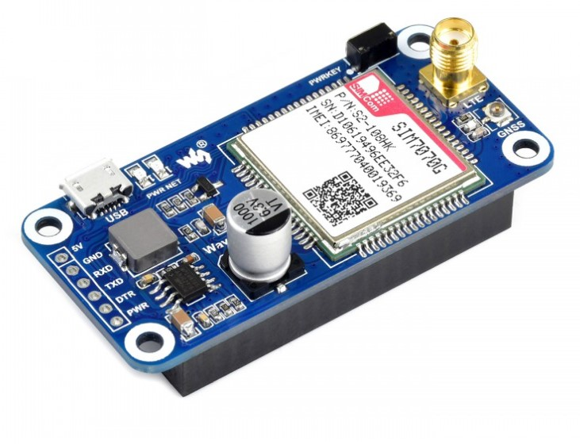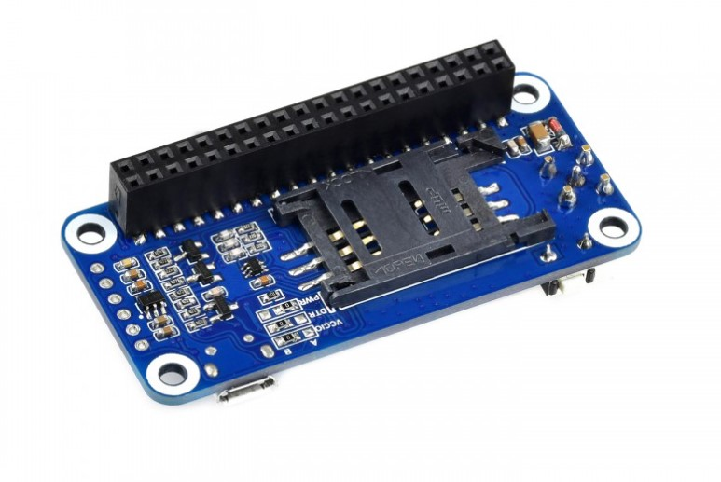
Price - $32.99 (https://www.waveshare.com/sim7000e-nb-iot-hat.htm)

Where exactly this module would be used?


Temperature sensors –

Thermocouples | RTDs | Thermistors | Infrared | Semiconductor  sensors
Extremely rugged | Most accurate | Highly sensitive | Non-contact based (suitable for moving objects) | Come in the form of ICs
Low cost | Good stability | Fast response | Longer operating lives | Highly linear
Self-powered | Consistent | Easy to use | More detail | Highly accurate
Best for high temperatures | High temperature ranges | Small temperature  ranges
Range –  $95-{1260}^{o}C$ | Range-  $$-270 to{ 850}^{o}C$$ | Range –  $$-40 to{ 125}^{o}C$$ | Range-  $$-18 to{ 538}^{o}C$$ | Range –  $$55 to{ 150}^{o}C$$
The type of temperature sensor to use will depend upon the range of temperature to be measured and the application areas of the device.
For example, in cold storage truck –
Engine Temperatures | Thermistors / RTDs (because of the range)
Exhaust gas temperatures | Thermocouples (high temperatures)
Tire and Brake Disc Temperatures | Infrared (direct contact with these elements is not desirable)
Climate control systems | RTDs

Humidity sensors –
Capacitive Humidity sensor | Resistive Humidity sensor | Thermal Humidity sensor
measure Relative humidity. | Relative Humidity | Absolute Humidity
Low Power consumption | Small Sized and low cost | Exceptionally durable
Stable results over long usage | Long term stability | Suitable for environments with high temperatures
The distance from the sensor and signalling circuit is limited. | Distance between the sensor and signal circuit can be large which make it suitable for remote operations | High resolution compared to other types.
Can measure Relative Humidity from 0% to 100% RH | Range – 5% to 95% RH

Capacitive sensors are more accurate and stable while producing repeatable results. Therefore, capacitive humidity sensors can be used in our project.
Cost – ₹ 731 https://in.rsdelivers.com/product/te-connectivity/hpp801a031/te-connectivity-hpp801a031-humidity-sensor-60-to-c/8937082

Speed and Position sensors –
They are of different types -
  - Potentiometer
  - Hall effect sensors
  - Reed switch
  - Optical encoder
  - Inductive encoder

Potentiometer | Hall effect sensors | Reed switch | Optical encoder | Inductive encoder
Low cost | Cost effective+ Long lifetime,  Small size + ruggedness | Cost effective + high cycle life | High accuracy,  Lifetime of 80k-100k hours | High accuracy,  Safe and reliable operation in tough conditions
No internal electric components required | High speed operations | Zero power consumption (no external power required) | Low sensor weight | Contactless and free from wear
High resolution and accuracy | Highly repeatable operations can be done |  | Rotary encoders can achieve 50 – 5,000 counts per revolution | For wide and small measuring ranges
Operating temperature range up to ${250}^{o}C$ | Broad temperature range | Operating temperature ranges up to ${200}^{o}C$ | Operating temperature range ${70}^{o}C$ maximum | Operating temperature range up to ${150}^{o}C$
Susceptible to wear in high vibration environments | Continuous current consumption | Susceptible to vibrations | Susceptible to vibrations | Cost is high
Limited lifetime | Handles only DC loads | Speed measurement limited to operations below 1kHz | Little or no warning of imminent failure | Not suitable for low-speed measurements
Not suitable for operation in liquids
Not suitable for high accelerations
In our project, optical and inductive sensors are used.
Inductive sensor can be used as engine or wheel speed sensor, diesel injection pump, cam shaft sensor and cranked shaft frequency sensor.

Accelerometers-
  - AC accelerometer (dynamic acceleration)
  - DC accelerometer (static + dynamic)
DC accelerometers –
    - Capacitive
    - Piezoresistive
Capacitive DC accelerometer | Piezoresistive DC accelerometer
Low cost | Bandwidth is high.
Offers Good linearity and high output stability | Can measure high acceleration levels.
Poor signal to noise ratio | Commonly used in automotive.
Limited Dynamic range
Bandwidth is limited due to its physical geometry
Favours low range acceleration measurements.

In our case we can use Piezoresistive accelerometer – ADXL335 Triple Axis Linear accelerometer.
Cost - ₹ 379 (https://www.electronicscomp.com/adxl335-triple-axis-linear-accelerometer?gclid=CjwKCAiA5t-OBhByEiwAhR-hmybJzQemcoqkrtP9m6Wuh1JoSwfQxAKWfEqqvbWowOzongMyi0swyhoCr5wQAvD_BwE)
