PROJECT TITLE: MARKET BASKET INSIGHT

DISCRIPITION:

we can explore innovative techniques such as ensemble methods and deep learning architectures to improve the prediction system's accuracy and robustness.

ENSEMBLE METHODS:

Ensemble methods can be valuable in generating market basket insights, which involve understanding the relationships between items that customers tend to purchase together. Market basket analysis is a common technique in retail and e-commerce to optimize product recommendations, inventory management, and pricing strategies. Ensemble methods can help improve the accuracy and robustness of market basket insights. Here's how:

**1.Random Forests**:

Random forests are an ensemble method that can be used for market basket analysis. Each tree in the forest is built on a random subset of the data, and the results are combined to make predictions. In the context of market basket analysis, this can help in identifying the most important items that are frequently purchased together.

**2.Gradient Boosting**:

Gradient boosting techniques like XGBoost or LightGBM can also be applied to market basket analysis. They work by training multiple weak models sequentially and combining their predictions. This can improve the accuracy of identifying item associations and uncover hidden patterns.

**3.Stacking**:

Stacking is another ensemble technique that combines the predictions of multiple models to create a meta-model. In market basket analysis, you can stack different models that identify item associations to generate more accurate insights.

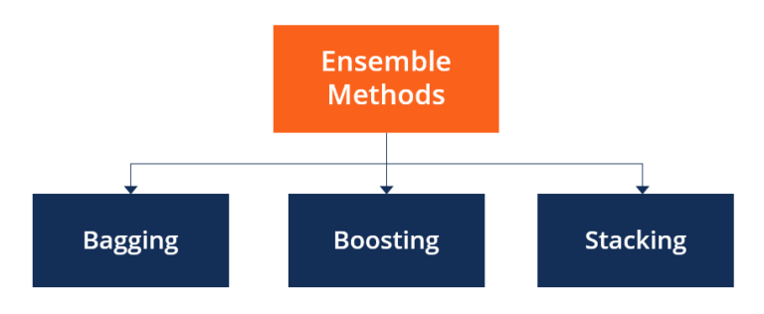

**4.Feature Engineering**:

Ensemble methods can be used to combine features from various models, such as association rule mining (e.g., Apriori) and collaborative filtering. This can help in creating more informative features for market basket analysis.

**5.Model Selection**:

Ensemble methods can also help in selecting the best model for market basket analysis. You can train multiple models using different algorithms and then use an ensemble technique to determine which model or combination of models performs the best.

**6.Robustness**:

Ensembles are generally more robust to overfitting, noise, and outliers. In market basket analysis, where the dataset might have noisy or sparse data, ensemble methods can help improve the stability and reliability of insights.

**7.Interpretability**:

Ensemble methods can combine the outputs of different models, making it easier to interpret the results of market basket analysis. You can understand the relationships between items more clearly.

**8.Scalability**:

Some ensemble methods can be parallelized, making them suitable for handling large datasets commonly found in e-commerce and retail.

To implement ensemble methods for market basket analysis, you'll need to:

**1.Collect and Preprocess Data**:

Gather transaction data, clean it, and prepare it for analysis.

**2.Choose Ensemble Techniques**:

Select the ensemble methods that are most appropriate for your specific analysis, such as random forests, gradient boosting, or stacking.

**3.Train and Evaluate Models**:

Train different models on your data and evaluate their performance using metrics relevant to market basket analysis (e.g., lift, confidence, support).

**4.Combine Model Outputs**:

Use the ensemble method to combine the predictions of the individual models.

**5.Interpret Results**:

Analyze the ensemble results to derive insights into item associations, which can inform business decisions, such as product placement, recommendations, and pricing strategies.

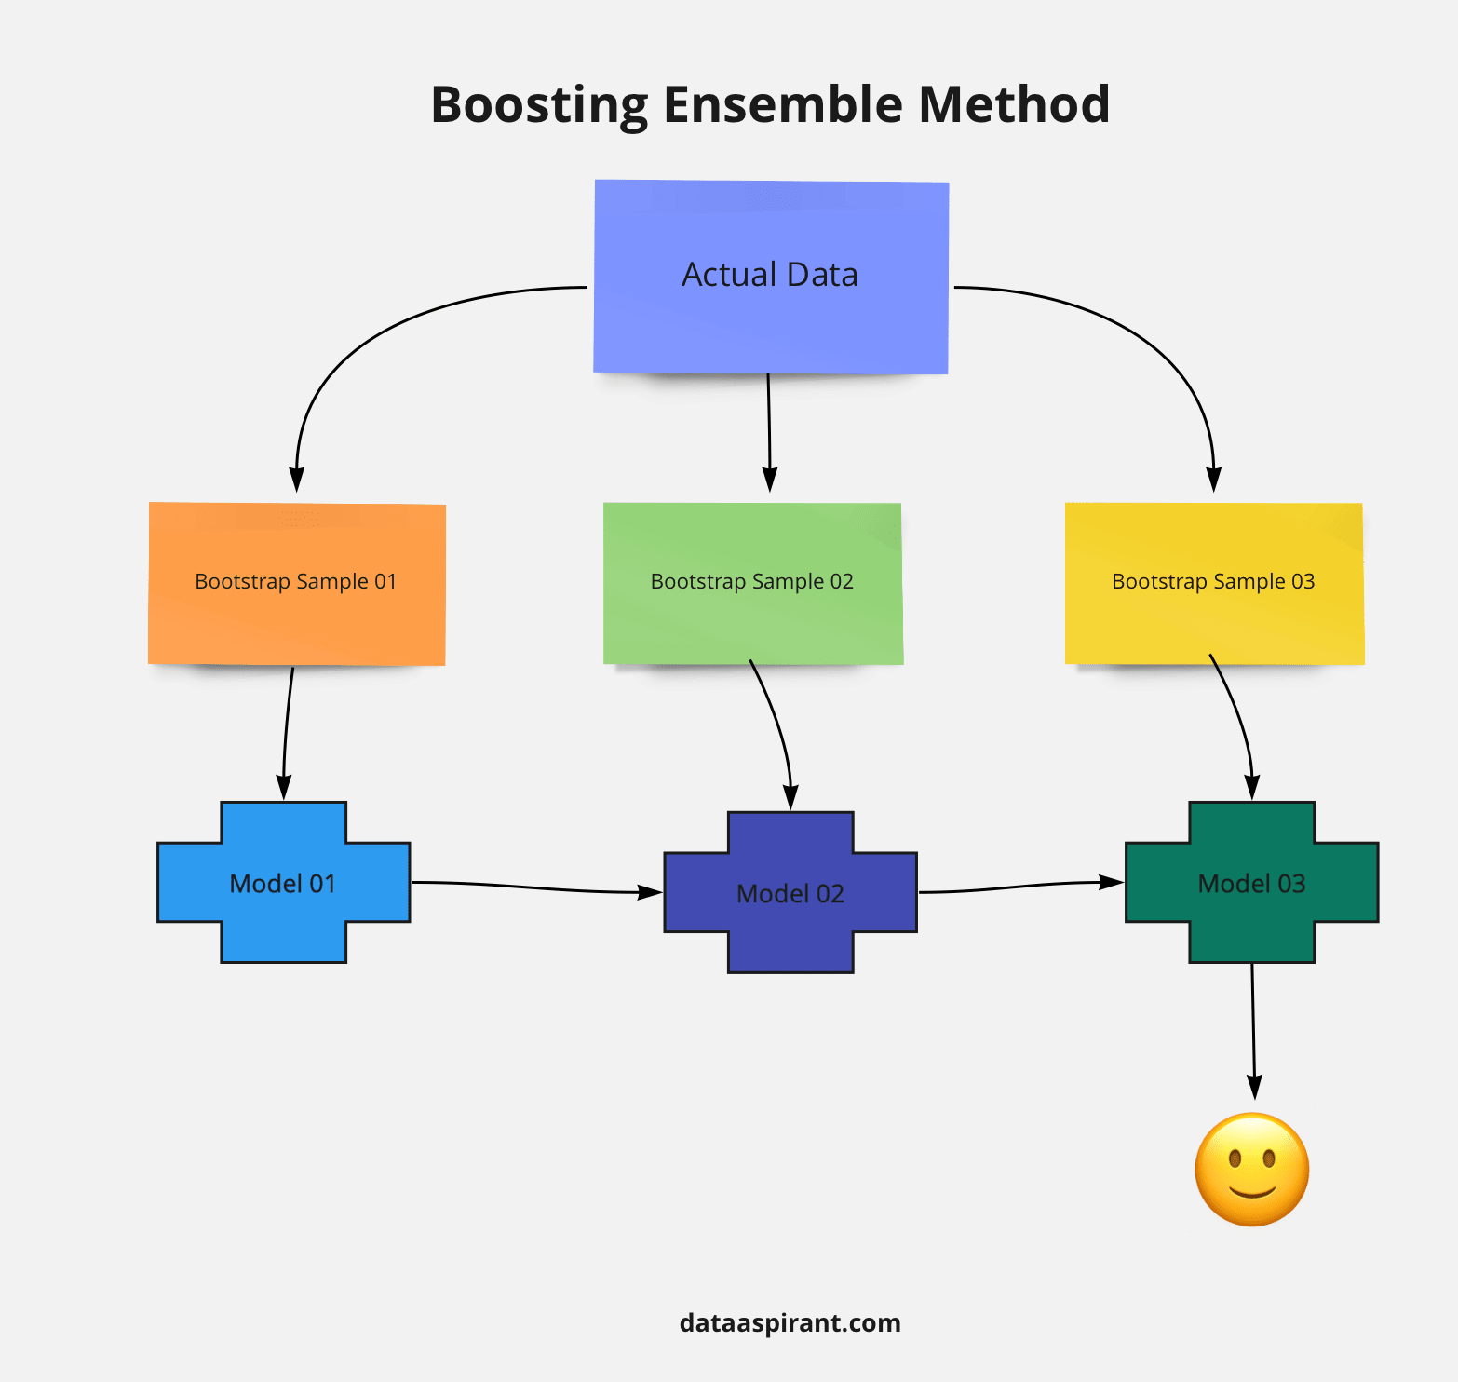

Ensemble methods can significantly enhance the quality and reliability of market basket insights, helping businesses make data-driven decisions to optimize their operations and improve customer satisfaction.Top of Form

DEEP LEARNING ARCHITECTURES:

Deep learning architectures can be effectively applied to market basket analysis to extract complex patterns and insights from large transaction datasets. Market basket analysis using deep learning typically involves the use of neural networks. Here are some key ways deep learning architectures can be used in this context:

**1.Recurrent Neural Networks (RNNs)**:

RNNs are well-suited for sequential data like transaction history. You can use RNNs to capture the temporal dependencies in customer purchase behavior. Each transaction sequence can be considered as a time series, and an RNN can be employed to model the sequence of items purchased over time.

**2.Long Short-Term Memory (LSTM) Networks**:

LSTMs are a type of RNN that is particularly effective in capturing long-range dependencies in sequential data. They can be used to model the purchase history of customers and discover patterns in their buying behavior.

**3.Sequence-to-Sequence Models**:

These models are useful for generating sequences, and they can be employed to recommend additional items to customers based on their previous purchases. You can train a sequence-to-sequence model to predict the next item a customer is likely to buy, given their historical purchase sequence.

**4.Convolutional Neural Networks (CNNs)**:

While CNNs are commonly used for image analysis, they can also be applied to market basket analysis by treating transaction data as a grid or image-like structure. For example, you can represent each product as a one-hot encoded vector and use CNNs to find patterns and associations in the purchase history.

5. **Hybrid Models** :

Combining deep learning architectures with traditional techniques such as association rule mining can be powerful. For example, you can use deep learning models to pre-process the data and extract features, and then apply association rule mining on the transformed dataset to identify item associations.

**6.Attention Mechanisms**:

Attention mechanisms, often used in sequence-to-sequence models, can be employed to focus on specific items or parts of the purchase history that are most relevant for making predictions or generating recommendations.

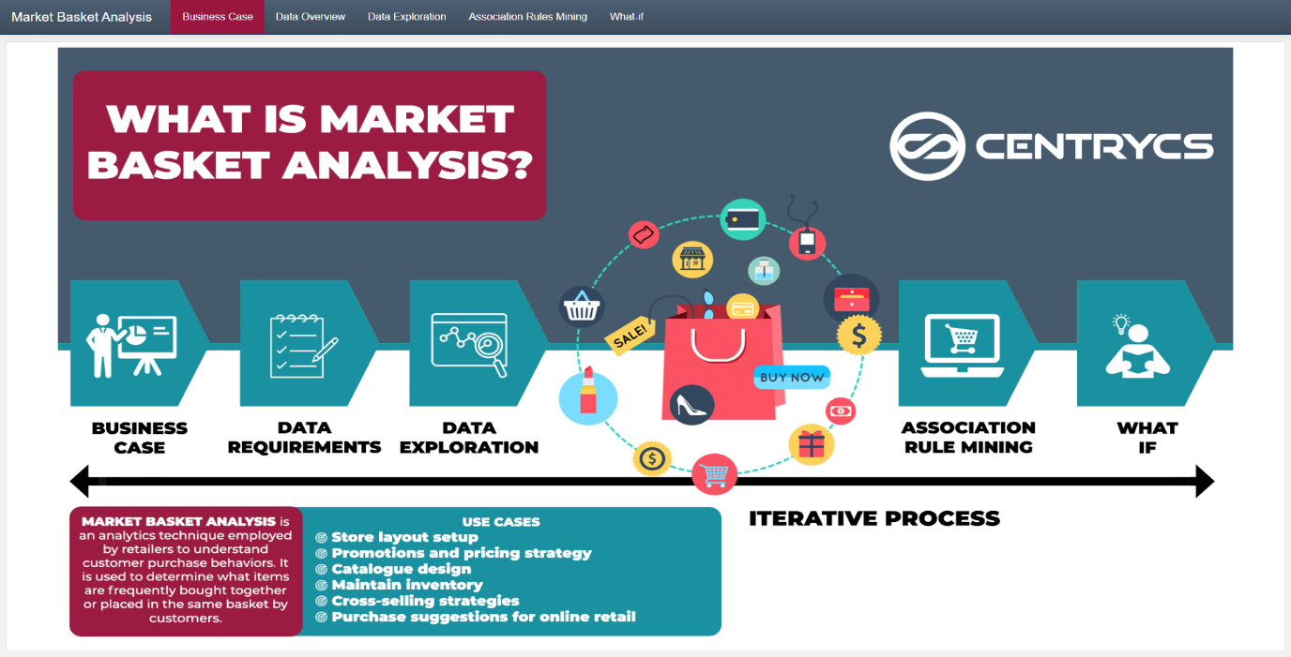

To implement deep learning architectures in market basket analysis, you would typically follow these steps:

**1.Data Preparation**:

Preprocess and format the transaction data for input into your deep learning model. This might involve one-hot encoding products, creating sequences, or applying other relevant transformations.

**2.Model Design**:

Select the appropriate deep learning architecture for your task (e.g., RNN, LSTM, CNN), design the architecture, and configure the hyperparameters.

**3.Training**:

Train the deep learning model on your historical transaction data. Ensure that you have appropriate loss functions and evaluation metrics for your specific task, such as recommendation accuracy or prediction error.

**4.Evaluation**:

Evaluate the model's performance using appropriate metrics. Common metrics for market basket analysis include lift, support, confidence, and recommendation accuracy.

Deep learning architectures can offer the advantage of capturing intricate patterns and relationships in large-scale transaction data, enabling more accurate and personalized market basket insights and recommendations for customers. However, it's important to keep in mind that deep learning models often require substantial amounts of data and computational resources for training and may be more complex to implement compared to traditional methods like association rule mining.

Top of Form