Multi-Agent RAG Legal Compliance System – Updated End-to-End Documentation
1. Overview
The Multi-Agent RAG Legal Compliance System automates compliance review of legal documents (MOUs) using Azure OpenAI for NLP tasks and Azure Cognitive Search for storing and retrieving legal rules.
The system is modular, with multiple agents for ingestion, clause extraction, rule retrieval, and compliance validation, plus an optional chat-bot interface for interactive queries.

2. Storage & Index Setup
- Azure Blob Storage:
  - Legal rules are stored as plain text files (.txt) in Blob Storage.
  - Each .txt file represents a single clause rule with descriptive content.
  - Example: purpose.txt, confidentiality.txt.
- Azure Cognitive Search Index & Indexer:
  - An index was created with fields like id (unique identifier) and content.
  - Indexer reads the .txt files from Blob Storage and automatically converts them into JSON documents in the index.
    - The id is generated (from filename or metadata).
    - content contains the text of the rule.
  - This allows rules to be searchable by clause name.

3. Multi-Agent Architecture
Agent | Purpose | What it does | Output
Ingestion Agent | Load MOU | Reads user-uploaded MOU text | Raw MOU text
Clause Extraction Agent | Identify key clauses | Uses OpenAI to extract clauses in strict JSON format | Dictionary of clauses: purpose, parties_responsibilities, confidentiality, term_termination
RAG Rule Retrieval Agent | Retrieve rules for clauses | Searches Cognitive Search index by clause name | Rule content for each clause
Compliance Agent | Validate clauses against rules | Compares clause text with retrieved rules using OpenAI | JSON with Compliant/Non-compliant and issues

4. Workflow
Step 1: MOU Upload
- User uploads an MOU text file.
- Ingestion Agent reads the file and logs the word count.
Step 2: Clause Extraction
- Clause Extraction Agent sends the MOU text to Azure OpenAI.
- OpenAI identifies the key clauses and returns them as JSON.
- If JSON parsing fails, a fallback mechanism ensures the system continues processing.
Step 3: Rule Retrieval
- For each extracted clause, RAG Retrieval Agent queries the Azure Cognitive Search index.
- The index contains rules that were converted from .txt files to JSON documents via the indexer.
- Each search returns the matching rule content.
- If no rule is found, the agent logs a warning but continues processing.
Step 4: Compliance Validation
- Compliance Agent sends each clause and its corresponding rule to OpenAI for validation.
- OpenAI outputs a JSON object containing:
  - status: Compliant or Non-compliant
  - issues: List of detected violations
Step 5: Generate Report
- The system compiles results into a Final Compliance Report:
  - Overall compliance status
  - Detailed findings for each clause

5. Semantic Embedding & RAG
- RAG (Retrieval-Augmented Generation) enhances compliance accuracy by:
  - Retrieving relevant rules from the Cognitive Search index.
  - Using the retrieved rules to guide OpenAI’s validation reasoning.
- This ensures that MOUs are compared against up-to-date rules dynamically.

6. Interactive Bot Layer
- After the compliance report is generated, users can interact via a chat-bot style interface.
- Users can ask:
  - Why a clause is non-compliant
  - What issues were found
- The bot references the structured compliance report for natural language answers.

7. Handling Updates & New Rules
- Adding new rules:
  - Add new .txt files to Blob Storage.
  - Indexer automatically ingests the new files and converts them to JSON in the Cognitive Search index.
- Adding a new MOU:
  - Upload the MOU text file.
  - Agents automatically extract clauses, retrieve rules, and validate compliance.
  - RAG ensures all comparisons use the latest rules.
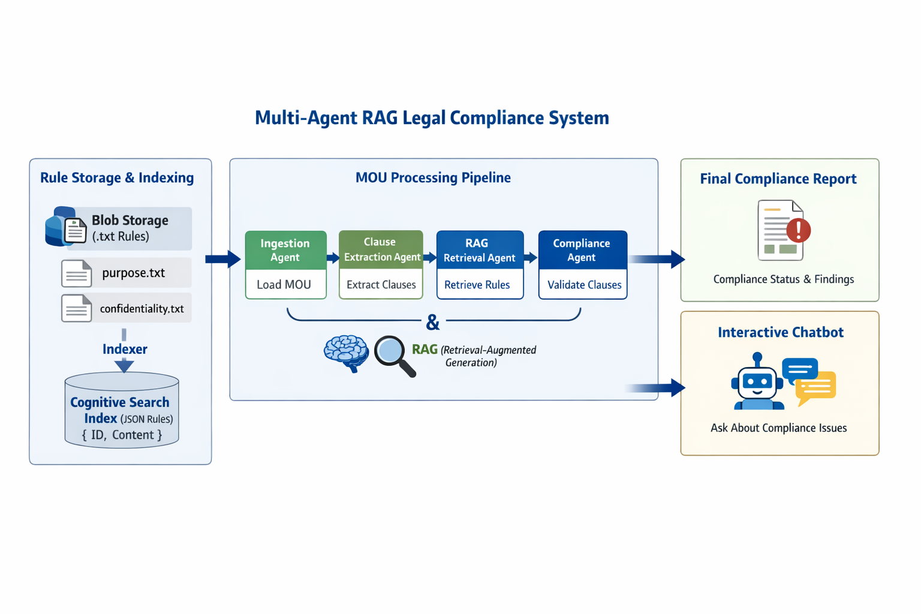

8. Benefits
- Modular & Scalable: Agents are independent, easy to extend, and new clauses/rules can be added seamlessly.
- Explainable: Each agent logs its activity for traceability.
- RAG-Driven: Combines semantic search and generative AI for accurate, rule-based compliance validation.
- Automated Rule Conversion: .txt rules in Blob Storage are automatically converted to JSON in Cognitive Search for retrieval.

9. System Output
example-1
mou:
[Clause: Purpose and Scope]
The purpose of this MOU is to establish a collaboration between Party A and Party B to jointly develop, market, and distribute software solutions in India. The scope includes software development, marketing, and joint sales initiatives.

[Clause: Parties and Responsibilities]
Party A is responsible for providing technical expertise, software development, and project management. Party B is not responsible for anything.
[Clause: Confidentiality]
All proprietary information shared between Party A and Party B will remain confidential. No information will be disclosed to third parties without prior written consent.

[Clause: Term and Termination]
This MOU will remain effective for 2 years from the effective date. Either party may terminate with 30 days’ written notice.

[Clause: Dispute Resolution]
Any disputes arising from this MOU shall be resolved through arbitration in accordance with Indian laws.

[Clause: Governing Law]
This MOU shall be governed by and interpreted under the laws of India.
