CRUD GENERATOR

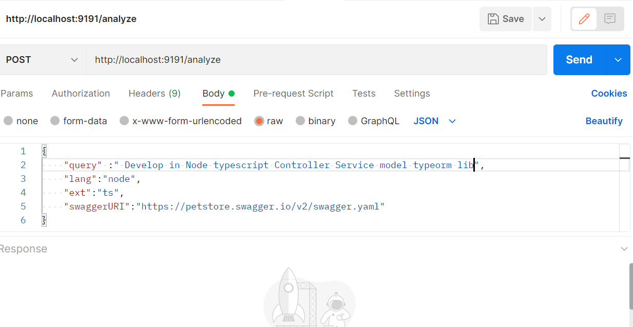

It will call the API controller

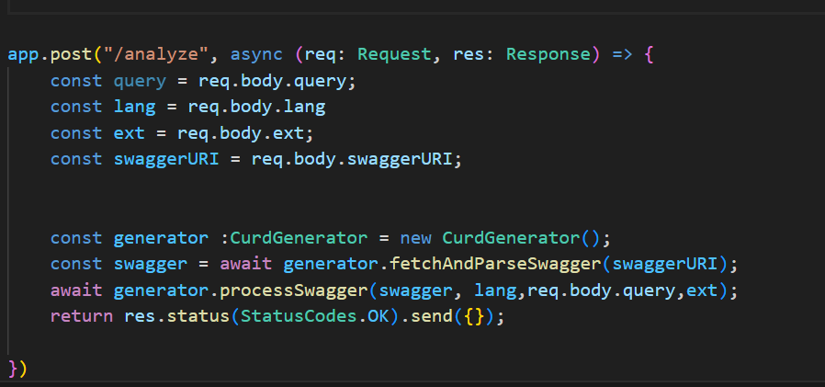

Process the swagger path nothing but each api and generate the code with particular extension .

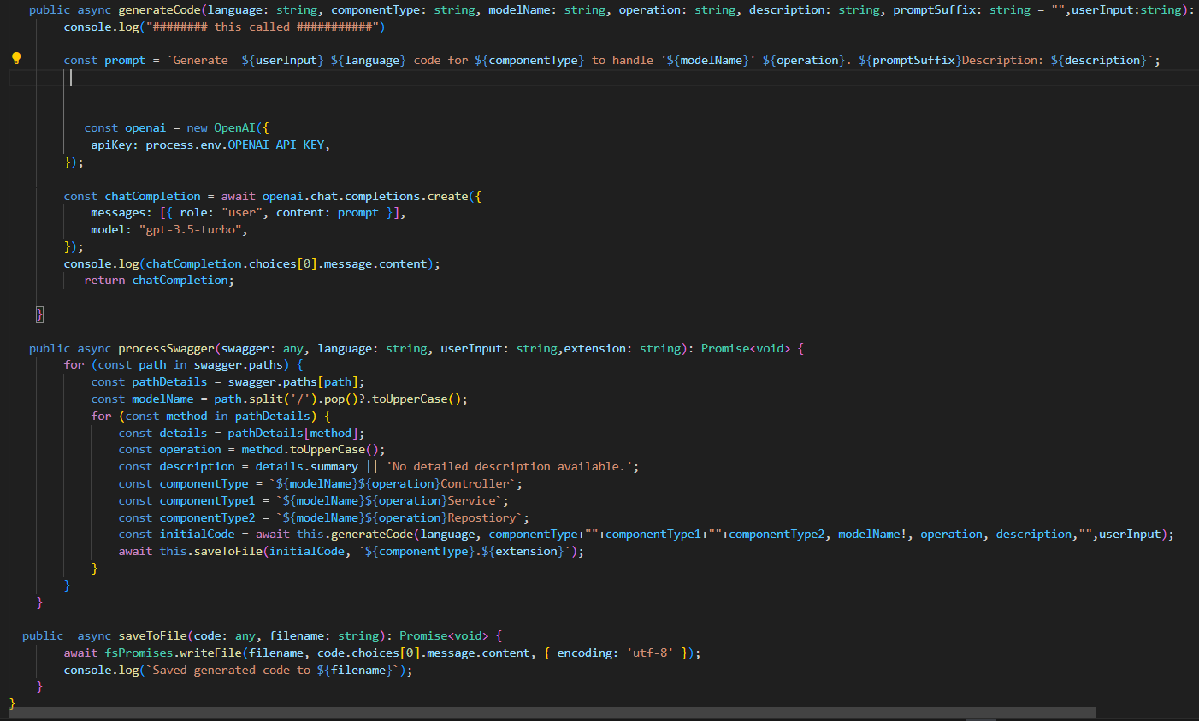

Outptut :

Generate Ouput in console .

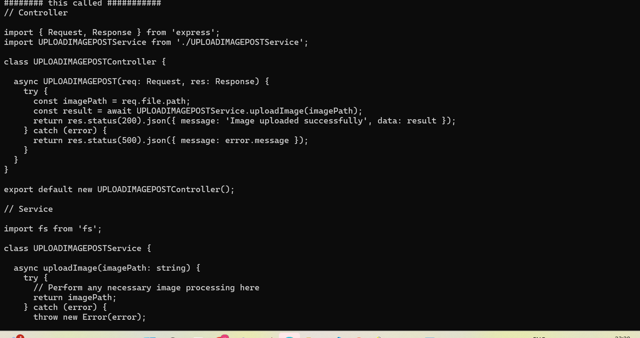

Imemdiately application will Storing in the desk.Sample Generate File are Attached.



