**5. HARDWARE IMPLEMENTATION OF CONTROLLER**

**5.1 INTRODUCTION**

This project requires that the speed of a permanent magnet dc motor is digitally controlled using a digital signal processor ATMEGA2560 (ARDUINO)

A feedback system for the speed control system is to be provided. This was achieved using a device that converts the speed to a voltage signal (square pulses) whose frequency is proportional to the speed of the motor.

**5.2 SPEED DRIVE REQUIREMENTS**

Different components were use in the design of the speed control system. These include a permanent magnet dc motor, a QUADRATURE ENCODER, ARDUINO MEGA2560, TRANSISTOR switch and its gate drive and a H-Bridge converter. The flow chart of figure 3.1 below shows how the different components inter-operated to complete the project:

Figure 5.1 Flow chart of the project

**5.3 CIRCUIT DIAGRAM OF THE DRIVE**

The figure shown below is the circuit diagram of the DC drive, it is capable of controlling both the speed and direction of motor.

Figure 5.2 Circuit diagram of the drive

The main components are mentioned in the circuit diagram with number

1. ARDUINO MEGA 2560
2. Opto-Coupler 4N35
3. NPN Transistor TIP41c
4. Encoder Motor

The detailed description of each component is given below.

**5.3.1 ARDUINO MEGA 2560**

**5.3.1.1 OVERVIEW**

The Mega 2560 is a microcontroller board based on the ATmega2560. It has 54 digital input/output pins (of which 15 can be used as PWM outputs), 16 analog inputs, 4 UARTs (hardware serial ports), a 16 MHz crystal oscillator, a USB connection, a power jack, an ICSP header, and a reset button. It contains everything needed to support the microcontroller; simply connect it to a computer with a USB cable or power it with a AC-to-DC adapter or battery to get started. The Mega 2560 board is compatible with most shields designed for the Uno and the former boards Duemilanove or Diecimila.

The Mega 2560 is an update to the Arduino Mega, which it replaces.

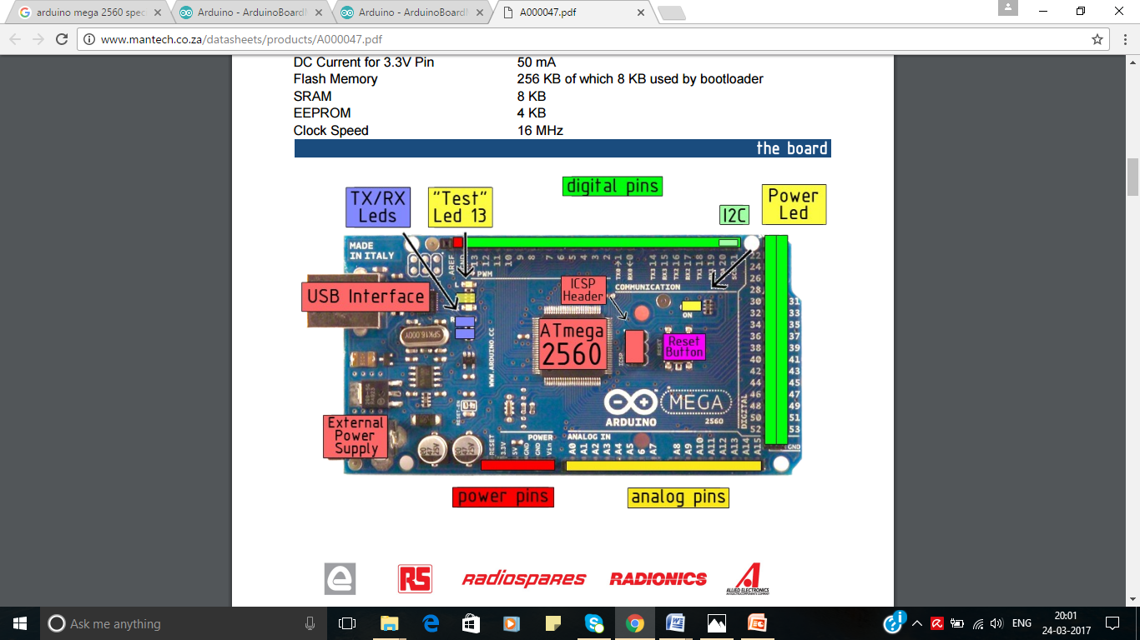

Figure 5.3 ARDUINO MEGA 2560 Developer Board

**5.3.1.2 TECHNICAL SPECS**

|  |  |
| --- | --- |
| Microcontroller | ATmega2560 |
| Operating Voltage | 5V |
| Input Voltage (recommended) | 7-12V |
| Input Voltage (limit) | 6-20V |
| Digital I/O Pins | 54 (of which 15 provide PWM output) |
| Analog Input Pins | 16 |
| DC Current per I/O Pin | 20 Ma |
| DC Current for 3.3V Pin | 50 Ma |
| Flash Memory | 256 KB of which 8 KB used by bootloader |
| SRAM | 8 KB |
| EEPROM | 4 KB |
| Clock Speed | 16 MHz |
| LED_BUILTIN | 13 |
| Length | 101.52 mm |
| Width | 53.3 mm |
| Weight | 37 g |

Table 5.1 Specification of Arduino MEGA2560

The ATmega2560 on the Mega 2560 comes pre programmed with a boot loader that allows you to upload new code to it without the use of an external hardware programmer. It communicates using the original STK500 protocol (reference, C header files).

We can also bypass the bootloader and program the microcontroller through the ICSP (In-Circuit Serial Programming) header using Arduino ISP or similar; see these instructions for details.

The ATmega16U2 (or 8U2 in the rev1 and rev2 boards) firmware source code is available in the Arduino repository. The ATmega16U2/8U2 is loaded with a DFU bootloader, which can be activated by:

* On Rev1 boards: connecting the solder jumper on the back of the board (near the map of Italy) and then resetting the 8U2.
* On Rev2 or later boards: there is a resistor that pulling the 8U2/16U2 HWB line to ground, making it easier to put into DFU mode. You can then use Atmel's FLIP software (Windows) or the DFU programmer (Mac OS X and Linux) to load a new firmware. Or you can use the ISP header with an external programmer (overwriting the DFU bootloader). See this user-contributed tutorial for more information.

**5.3.1.3 POWER**

The Mega 2560 can be powered via the USB connection or with an external power supply. The power source is selected automatically.

External (non-USB) power can come either from an AC-to-DC adapter (wall-wart) or battery. The adapter can be connected by plugging a 2.1mm centre-positive plug into the board's power jack. Leads from a battery can be inserted in the GND and Vin pin headers of the POWER connector.

The board can operate on an external supply of 6 to 20 volts. If supplied with less than 7V, however, the 5V pin may supply less than five volts and the board may become unstable. If using more than 12V, the voltage regulator may overheat and damage the board. The recommended range is 7 to 12 volts.

The power pins are as follows:

* Vin. The input voltage to the board when it's using an external power source (as opposed to 5 volts from the USB connection or other regulated power source). You can supply voltage through this pin, or, if supplying voltage via the power jack, access it through this pin.
* 5V. This pin outputs a regulated 5V from the regulator on the board. The board can be supplied with power either from the DC power jack (7 - 12V), the USB connector (5V), or the VIN pin of the board (7-12V). Supplying voltage via the 5V or 3.3V pins bypasses the regulator, and can damage your board. We don't advise it.
* 3V3. A 3.3 volt supply generated by the on-board regulator. Maximum current draw is 50 mA.
* GND. Ground pins.
* IOREF. This pin on the board provides the voltage reference with which the microcontroller operates. A properly configured shield can read the IOREF pin voltage and select the appropriate power source or enable voltage translators on the outputs for working with the 5V or 3.3V.

**5.3.1.4 MEMORY**

The ATmega2560 has 256 KB of flash memory for storing code (of which 8 KB is used for the bootloader), 8 KB of SRAM and 4 KB of EEPROM (which can be read and written with the EEPROM library).

**5.3.1.5 INPUT AND OUTPUT**

Each of the 54 digital pins on the Mega can be used as an input or output, using pinMode(), digitalWrite(), and digitalRead() functions. They operate at 5 volts. Each pin can provide or receive 20 mA as recommended operating condition and has an internal pull-up resistor (disconnected by default) of 20-50 k ohm. A maximum of 40mA is the value that must not be exceeded to avoid permanent damage to the microcontroller.

In addition, some pins have specialized functions:

* Serial: 0 (RX) and 1 (TX); Serial 1: 19 (RX) and 18 (TX); Serial 2: 17 (RX) and 16 (TX); Serial 3: 15 (RX) and 14 (TX). Used to receive (RX) and transmit (TX) TTL serial data. Pins 0 and 1 are also connected to the corresponding pins of the ATmega16U2 USB-to-TTL Serial chip.
* External Interrupts: 2 (interrupt 0), 3 (interrupt 1), 18 (interrupt 5), 19 (interrupt 4), 20 (interrupt 3), and 21 (interrupt 2). These pins can be configured to trigger an interrupt on a low level, a rising or falling edge, or a change in level. See the attachInterrupt() function for details.
* PWM: 2 to 13 and 44 to 46. Provide 8-bit PWM output with the analogWrite() function.
* SPI: 50 (MISO), 51 (MOSI), 52 (SCK), 53 (SS). These pins support SPI communication using the SPI library. The SPI pins are also broken out on the ICSP header, which is physically compatible with the Arduino /Genuino Uno and the old Duemilanove and Diecimila Arduino boards.
* LED: 13. There is a built-in LED connected to digital pin 13. When the pin is HIGH value, the LED is on, when the pin is LOW, it's off.
* TWI: 20 (SDA) and 21 (SCL). Support TWI communication using the Wire library. Note that these pins are not in the same location as the TWI pins on the old Duemilanove or Diecimila Arduino boards.

The Mega 2560 has 16 analog inputs, each of which provide 10 bits of resolution (i.e. 1024 different values). By default they measure from ground to 5 volts, though is it possible to change the upper end of their range using the AREF pin and analogReference()function.  
There are different pins on the Arduino Board:

* AREF. Reference voltage for the analog inputs. Used with analogReference().
* Reset. Bring this line LOW to reset the microcontroller. Typically used to add a reset button to shields which block the one on the board.

**5.3.1.6 COMMUNICATION**

The Mega 2560 board has a number of facilities for communicating with a computer, another board, or other microcontrollers. The ATmega2560 provides four hardware UARTs for TTL (5V) serial communication. An ATmega16U2 (ATmega 8U2 on the revision 1 and revision 2 boards) on the board channels one of these over USB and provides a virtual com port to software on the computer (Windows machines will need a .inf file, but OSX and Linux machines will recognize the board as a COM port automatically. The Arduino Software (IDE) includes a serial monitor which allows simple textual data to be sent to and from the board. The RX and TX LEDs on the board will flash when data is being transmitted via the ATmega8U2/ATmega16U2 chip and USB connection to the computer (but not for serial communication on pins 0 and 1).

A SoftwareSerial allows for serial communication on any of the Mega 2560's digital pins.

The Mega 2560 also supports TWI and SPI communication. The Arduino Software (IDE) includes a Wire library to simplify use of the TWI bus; see the documentation for details. For SPI communication, use the SPI library.

**5.3.1.7 PHYSICAL CHARACTERISTICS AND SHIELD COMPATIBILITY**

The maximum length and width of the Mega 2560 PCB are 4 and 2.1 inches respectively, with the USB connector and power jack extending beyond the former dimension. Three screw holes allow the board to be attached to a surface or case. Note that the distance between digital pins 7 and 8 is 160 mil (0.16"), not an even multiple of the 100 mil spacing of the other pins.

The Mega 2560 is designed to be compatible with most shields designed for the Uno and the older Diecimila or Duemilanove Arduino boards. Digital pins 0 to 13 (and the adjacent AREF and GND pins), analog inputs 0 to 5, the power header, and ICSP header are all in equivalent locations. Furthermore, the main UART (serial port) is located on the same pins (0 and 1), as are external interrupts 0 and 1 (pins 2 and 3 respectively). SPI is available through the ICSP header on both the Mega 2560 and Duemilanove / Diecimila boards. Please note that I2C is not located on the same pins on the Mega 2560 board (20 and 21) as the Duemilanove / Diecimila boards (analog inputs 4 and 5).

**5.3.1.8 AUTOMATIC (SOFTWARE) RESET**

Rather then requiring a physical press of the reset button before an upload, the Mega 2560 is designed in a way that allows it to be reset by software running on a connected computer. One of the hardware flow control lines (DTR) of the ATmega8U2 is connected to the reset line of the ATmega2560 via a 100 nanofarad capacitor. When this line is asserted (taken low), the reset line drops long enough to reset the chip. The Arduino Software (IDE) uses this capability to allow you to upload code by simply pressing the upload button in the Arduino environment. This means that the bootloader can have a shorter timeout, as the lowering of DTR can be well-coordinated with the start of the upload.

This setup has other implications. When the Mega 2560 board is connected to either a computer running Mac OS X or Linux, it resets each time a connection is made to it from software (via USB). For the following half-second or so, the bootloader is running on the ATMega2560. While it is programmed to ignore malformed data (i.e. anything besides an upload of new code), it will intercept the first few bytes of data sent to the board after a connection is opened. If a sketch running on the board receives one-time configuration or other data when it first starts, make sure that the software with which it communicates waits a second after opening the connection and before sending this data.

The Mega 2560 board contains a trace that can be cut to disable the auto-reset. The pads on either side of the trace can be soldered together to re-enable it. It's labeled "RESET-EN". You may also be able to disable the auto-reset by connecting a 110 ohm resistor from 5V to the reset line; see this forum thread for details.

**5.3.1.9 REVISIONS**

The Mega 2560 does not use the FTDI USB-to-serial driver chip used in past designs. Instead, it features the ATmega16U2 (ATmega8U2 in the revision 1 and revision 2 Arduino boards) programmed as a USB-to-serial converter.  
Revision 2 of the Mega 2560 board has a resistor pulling the 8U2 HWB line to ground, making it easier to put into DFU mode. Revision 3 of the Arduino board and the current Genuino Mega 2560 have the following improved features:

* 1.0 pinout: SDA and SCL pins - near to the AREF pin - and two other new pins placed near to the RESET pin, the IOREF that allow the shields to adapt to the voltage provided from the board. In future, shields will be compatible both with the board that use the AVR, which operate with 5V and with the board that uses ATSAM3X8E, that operate with 3.3V. The second one is a not connected pin, that is reserved for future purposes.
* Stronger RESET circuit.
* Atmega 16U2 replace the 8U2.

**5.3.2 OPTO-COUPLER 4N35**

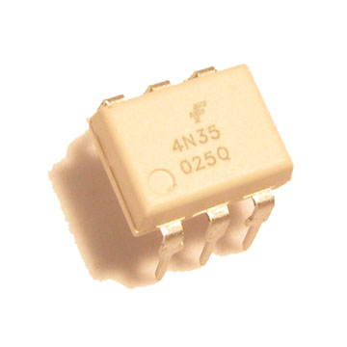

Figure 5.4 Optocoupler 4N35

4N35 is an optocoupler integrated circuit in which an infrared emitter diode drives a phototransistor. They are also known as optoisolators since they separate two circuits optically. These are used to couple two circuits without any ohmic contact. They allow one of the circuits to switch another one while they are completely separate. The first circuit is connected to IR diode while the other circuit with the phototransistor. The isolation ensures that no damage occurs in either of the circuits while the other one has a fault.

  An optocoupler is analogous to a relay which isolates two circuits magnetically. They differ with relays in the sense that they are smaller in size and allow fast operation. 4N35s are commonly used in interfacing an electronic circuit with the parallel port of a computer.

**Pin Diagram**:

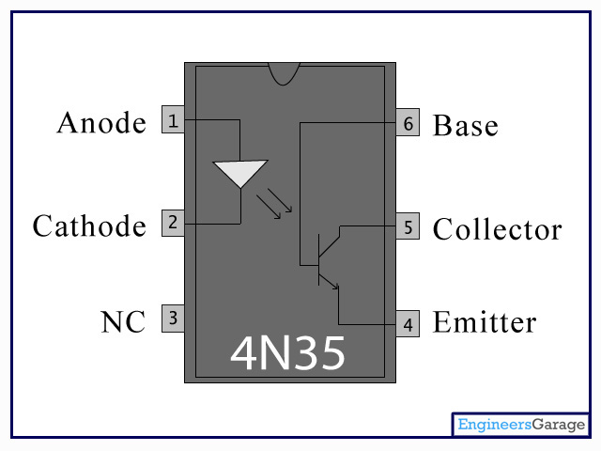

Figure 5.5 Pin Diagram of Optocoupler 4N35

**Pin Description:**

|  |  |  |
| --- | --- | --- |
| Pin No | Function | Name |
| 1 | IR diode’s anode | Anode |
| 2 | IR diode’s cathode | Cathode |
| 3 | Not connected | NC |
| 4 | Phototransistor’s emitter | Emitter |
| 5 | Phototransistor’s collector | Collector |
| 6 | Phototransistor’s base | Base |

Table 5.2 Pin Description of Optocoupler 4N35

**5.3.3 TRANSISTOR TIP41C**

**Texas Instruments power**, known more popularly by its acronym, **TIP** is series of bipolar junction transistors manufactured by Texas Instruments. The series was introduced in 1969, and still sees some use today due to their simplicity, their durability, and their ease of use.

Figure 5.6 TRANSISTOR TIP41C

**Absolute maximum ratings**

|  |  |  |  |
| --- | --- | --- | --- |
| **Symbol** | **Parameter** | **Value** | **Unit** |
| VCBO | Collector-Base Voltage | 100 | V |
| VCEO | Collector-Emitter Voltage | 100 | V |
| VEBO | Emitter-Base Voltage | 5 | V |
| IC | Collector Current(DC) | 6 | A |
| ICP | Collector Current(Pulse) | 10 | A |
| IB | Base Current | 2 | A |
| TJ | Junction Temperature | 150 | oC |
| TSTG | Storage Temperature Range | -65 to 150 | oC |

Table 5.3 Absolute maximum ratings of TIP41c transistor

**5.3.4 ENCODER MOTOR (SPG30-20K)**

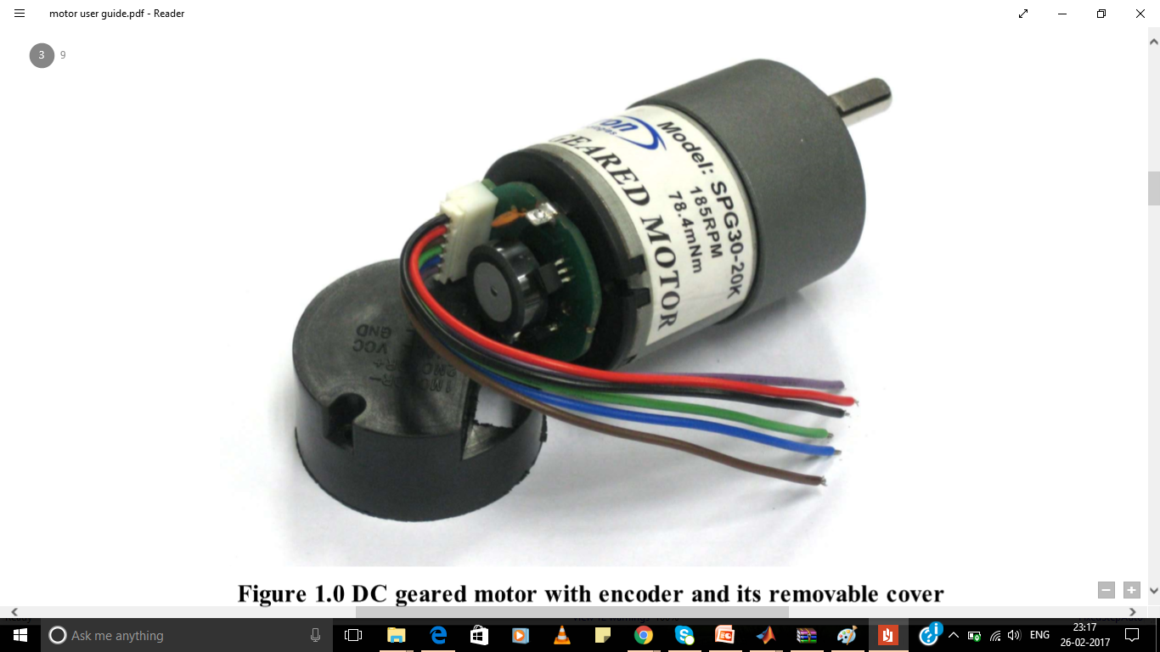

Figure 5.7 DC Motor with Encoder with its removable cover

SPG30 is 1.1W DC brushed motor with compact size, a low cost solution for projects such as medium size robot, omni drive robot, mechanism, etc.

This model of SPG30 brushed motor comes with 20:1 gearbox attached. The gearbox output shaft is a D-shaped with 15.5mm long and 6mm in diameter.

  All SPG30 motors are DC brushed motor with gearbox. The rated voltage is 12V (except stated), yet we can drive this motor from 9V to 15V. Lower voltage might not have enough torque to drive the wheel or mechanism; higher voltage will provide higher torque and higher speed, but it will shorten the life of the motor.

**5.3.4.1 SPECIFICATIONS AND FEATURES:**

* Rated voltage: 12VDC
* No load current (mA) : < 100
* No load speed (r.p.m) : 225 ± 23
* Rated load torque (kgf.cm) : 1.3
* Rated current (mA) : < 680
* Rated load speed (RPM) : 169 ± 17
* Weight: 160g
* Gear ratio: 20:1
* Shaft: D-shaped with 6mm diameter, 15.5mm in length
* Motor dimension: 37 x 37 x 75.5mm
* Sample Application: lightweight mechanism such as: bank note machine, handling machine, educational robot, etc

**5.3.4.2 ENCODER DETAILS**

This DC Geared Motor with Encoder is formed by a quadrature hall effect encoder board which is designed to fit on the rear shaft of Cytron’s SPG-30 Geared Motor series. Two hall effect sensors are placed 90 degree apart to sense and produce two output A and B which is 90 degree out of phase and allowing the direction of rotation to be determined. This encoder provides 3 counts per revolution of the rear shaft. Please note that the encoder is mounted at the rear shaft. The minimum resolution depends on the Motor’s gear ratio.

*The actual gear ration for SPG30E-20K is 20:1

**5.3.4.3 FEATURES** **OF QUADRATURE HALL EFFECT ENCODER:**

* + Operating Voltage: 4.5 V to 5.5 V
  + Two digital outputs (Quadrature waveform)
  + Small in size and light in weight
  + Resolution: 3 pulses per rear shaft revolution, single channel output.
  + 60 counts per main shaft revolution for 1:20 geared motor

**5.3.4.4 STATE DIAGRAM AND WAVEFORMS**

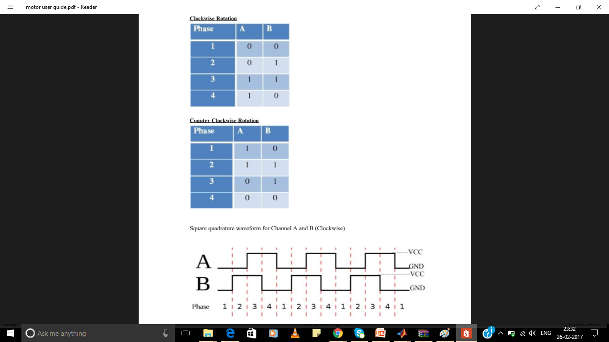

Figure:5.8 State Diagram And Waveform

**5.3.4.5 PIN DESCRIPTION**

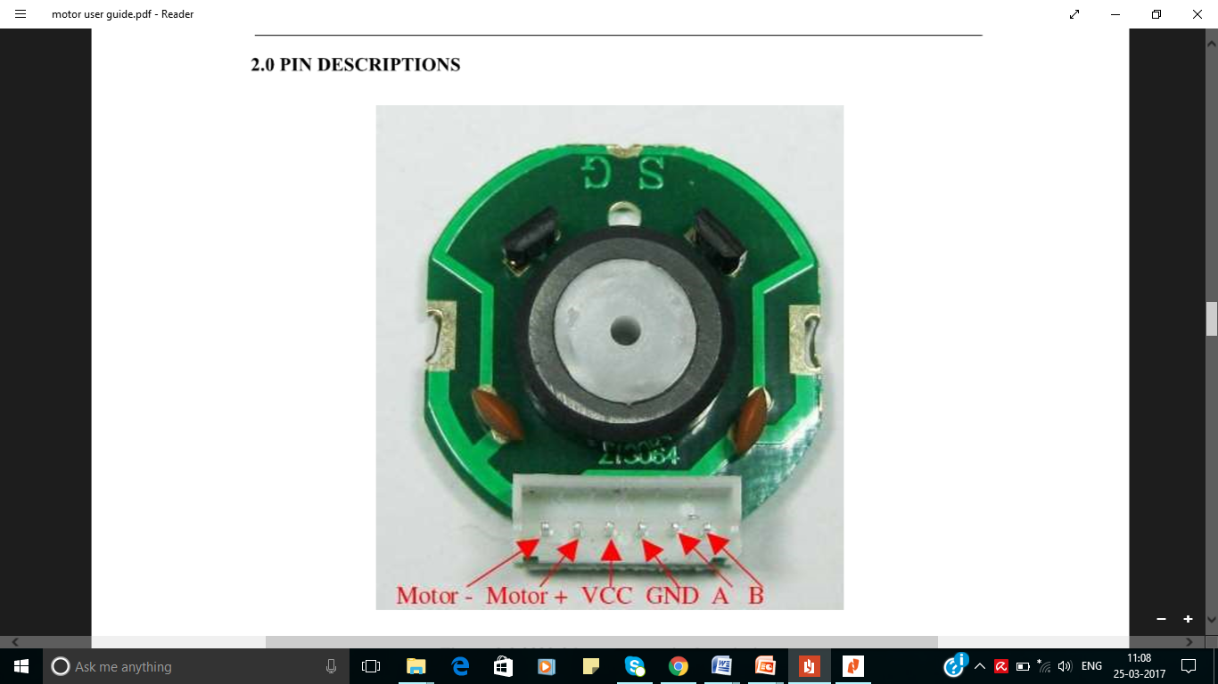

Figure 5.9 Pin Description of Encoder Motor

|  |  |  |
| --- | --- | --- |
| **Pin** | **Name** | **Description** |
| 1 | Motor - | Output of motor driver |
| 2 | Motor + | Output of motor driver |
| 3 | Hall effect sensor VCC | Supply voltage for the sensor circuit (4.5 V to 5.5 V) |
| 4 | Hall effect sensor GND | Ground |
| 5 | Channel A | Output of the encoder |
| 6 | Channel B | Output of the encoder |

Table 5.4 Pin Description of Encoder

**5.4 COMPLETE DEVELOPED KIT**

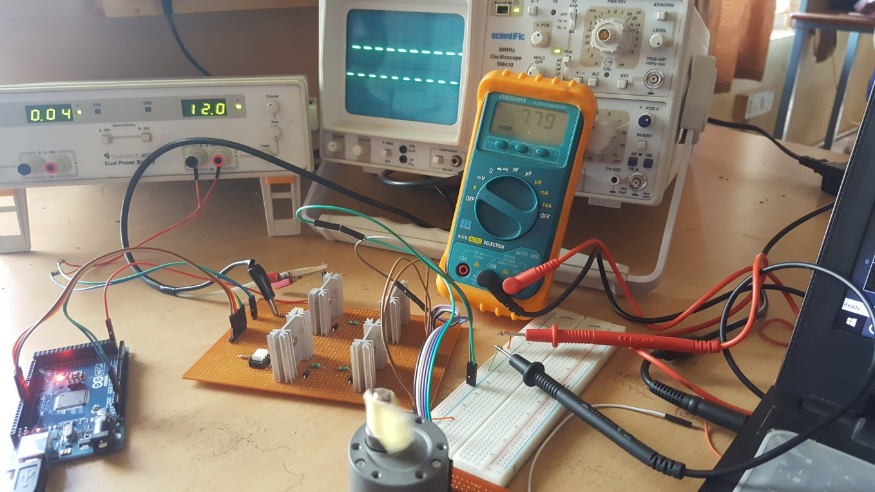

Figure 5.10 Complete lab setup of developed kit

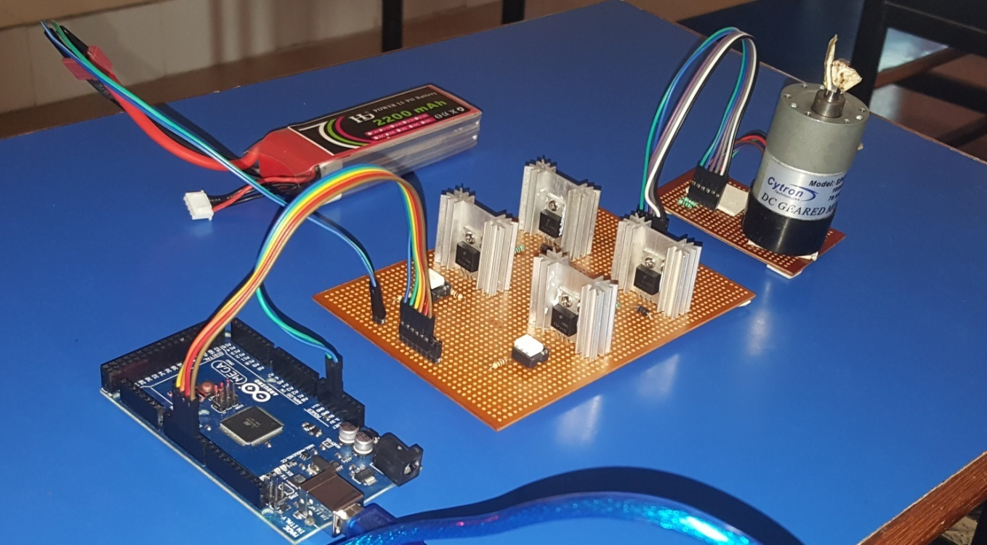

Figure 5.11 Developed H-Bridge drive connected to Arduino and Motor