**6. SIMULINK CODE FOR ARDUINO**

**6.1 INTRODUCTION**

The Simulink a product of MATLAB is majorly used for analysis of mathematical model analysis based on block diagram programming technique. It has a more number of varieties of libraries.

Simulink has launched the Simulink support packages for ARDUINO. By using these support packages, we can program Arduino Boards directly from Simulink model.

There are two methods of programming Arduino Boards from Simulink

1. External Mode
2. Stand alone Mode

In External mode we can control the outputs of Arduino from Simulink model and we can log sensor data in the Simulink scope, which is helpful in analyzing the real system. In our project we have used external mode which helped in logging of the Set values and the Actual Speed of the motor.

In Standalone mode we can use the Arduino separately from PC; it is helpful developing a independent system.

Here in our project we have developed models for both

1. Open-Loop Control
2. Closed-Loop Control

**6.2 SIMULINK MODEL FOR OPEN LOOP CONTOL**

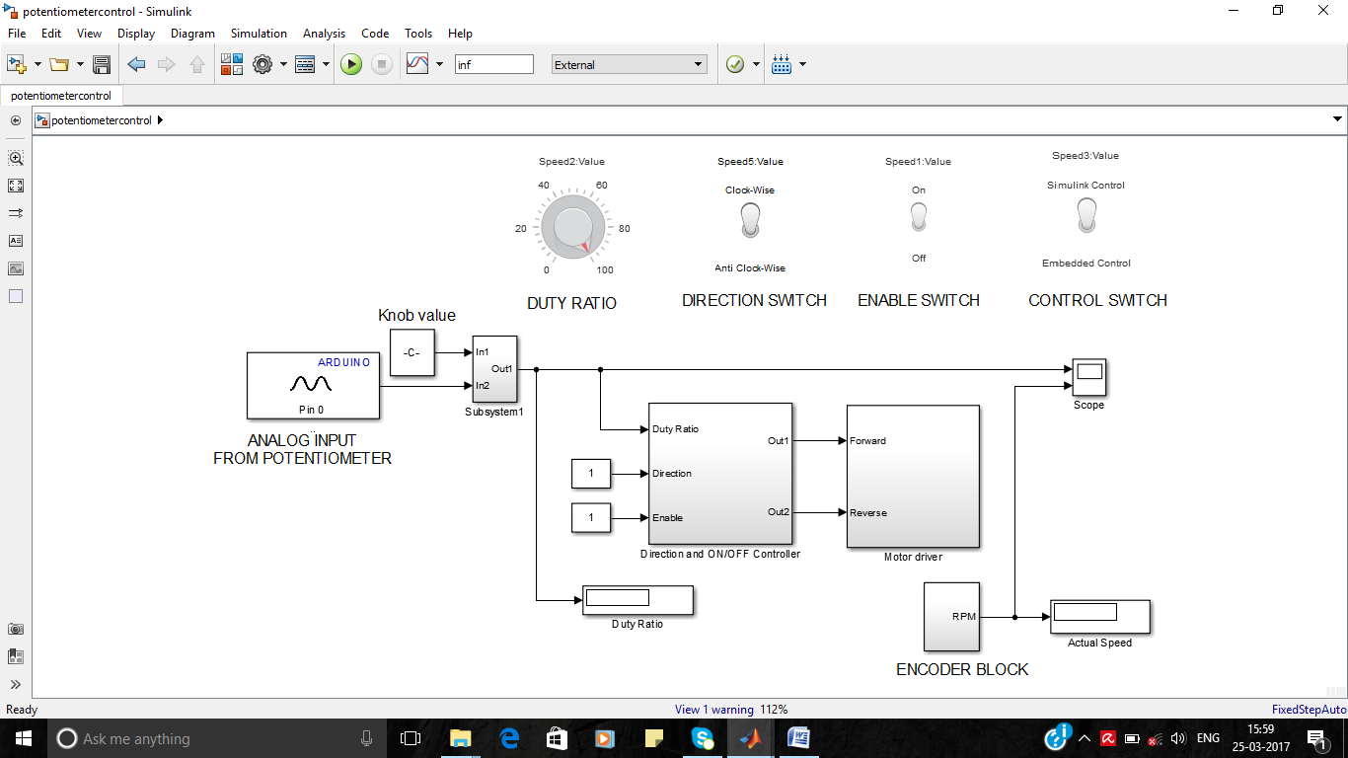

Figure 6.1 Simulink Code for Open-Loop control system

In this model the duty ratio can be taken from two sources but using control switch related to subsystem1 either of the source is selected based on the requirement. The duty ratio is given to the Direction and ON/OFF controller and based on the direction and enable switches it forwards the duty ratio to the motor driver then motor drives gives duty ratio to the Arduino PWM block.Then Arduino produces PWM signals to the optocoupler in the real time model. The detailed description of each block is explained below.

**6.2.1 DIRECTION AND ON/OFF CONTROLLER BLOCK**

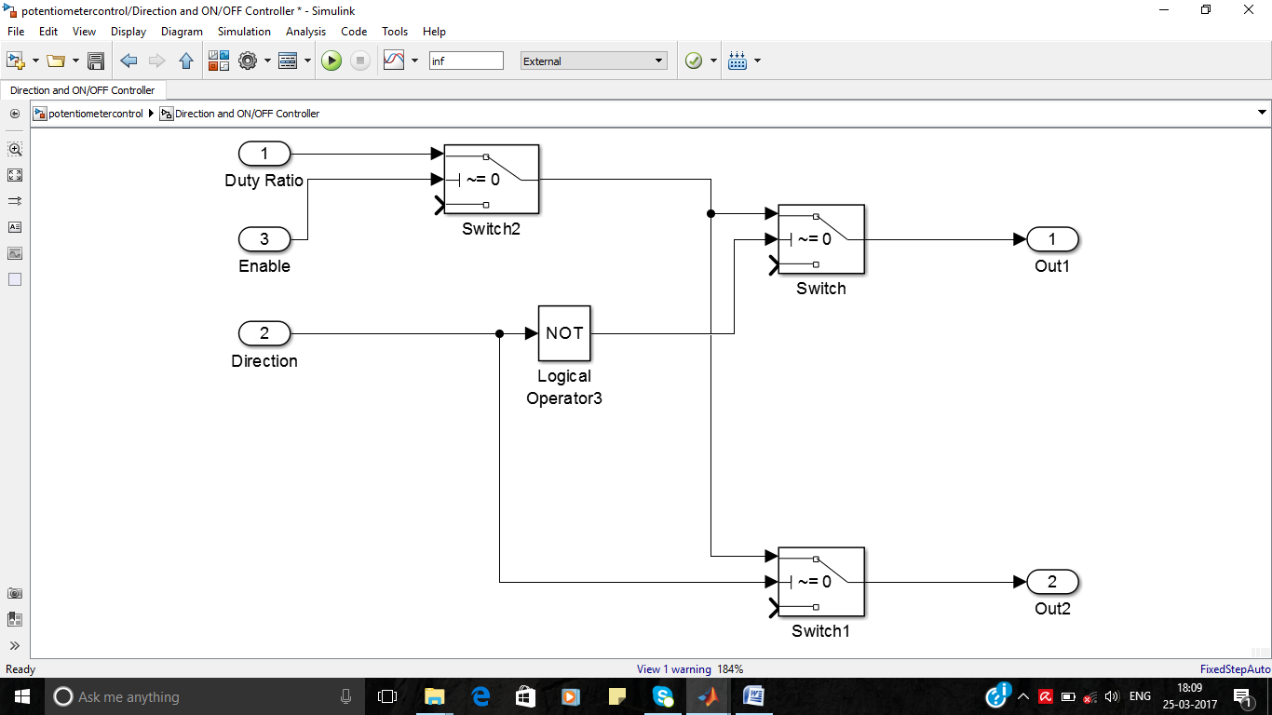

Figure 6.2 Directions and ON/OFF Controller block

In this block the duty ratio from either Simulink constant source or potentiometer is fed to out1 or out2 port based on the condition of ENABLE and DIRECTION input port values, which are controlled by the switches ENABLE SWITCH and DIRECTION SWITCH.

**6.2.2 MOTOR DRIVER BLOCK**

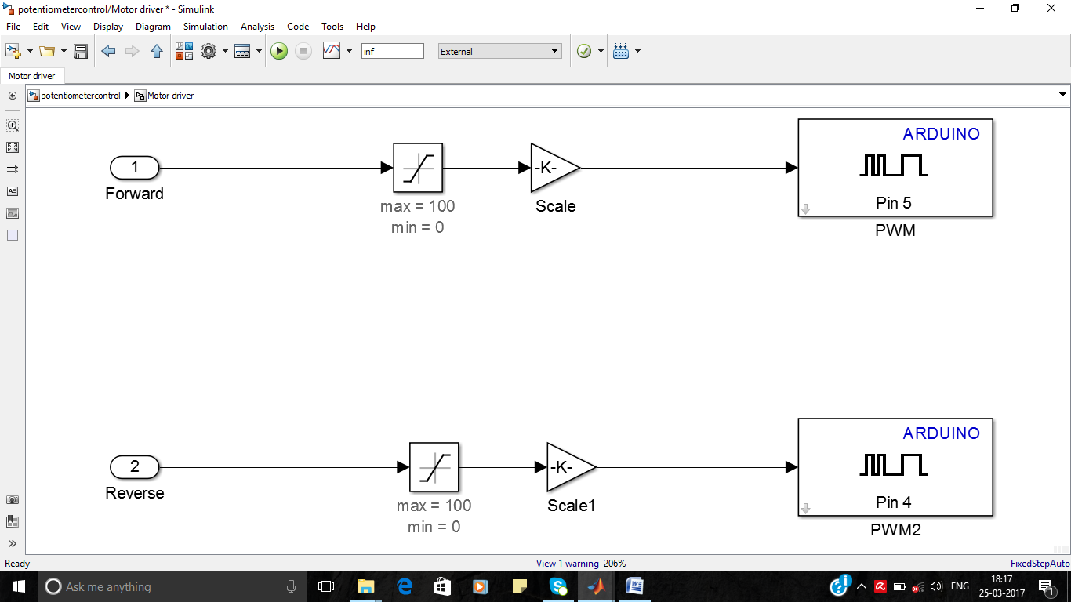

Figure 6.3 Motor Driver block

In this block the duty ratio is send to PWM block of Simulink Support packages; it is the heart of the project. In between that a limiter is used to limit duty ratio value in between 0 & 100. Then a Gain block is placed with a value of ‘2.55’ ,it helps in conversion of duty ratio (0 to 100) to PWM block working range of 0 to 255. E.g. If we want produce a PWM signal of duty ratio 25% , then 25*2.55 is fed to the PWM block.

**6.2.3 ENCODER BLOCK**

Encoder block is used to calculate the speed of the motor from the real time system using Hall Effect sensor data (Square Pulse).

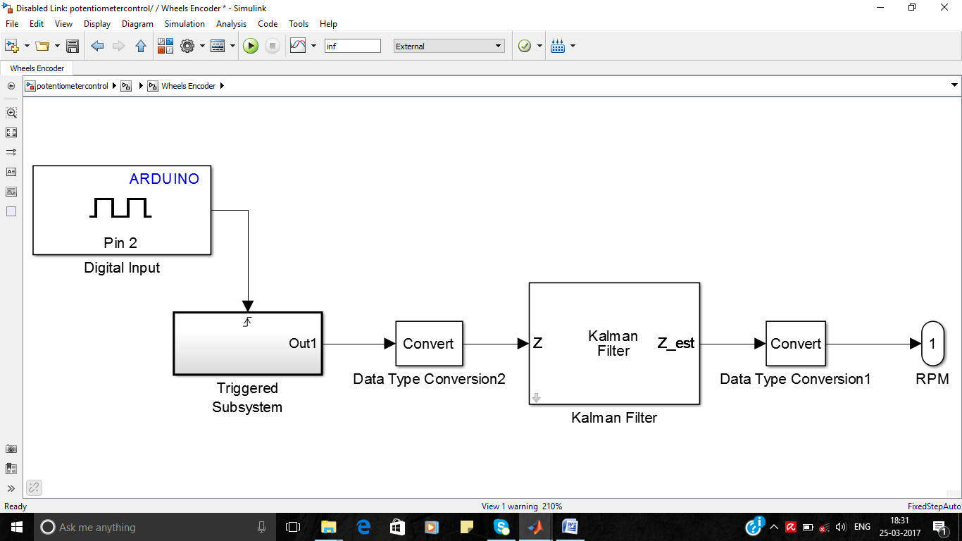Figure 6.4 Ecoder Block

Digital Input block (Pin2) is used to take digital data from real time system, here It is used to read the Hall Effect sensor’s data (Square Pulse).

During positive edge of the square pulse from motor encoder the TRIGGERED SUBSYSTEM is activated, it calculates the speed of the motor for every cycle of square wave by using the formulae

Speed = $\frac{60}{ T*N}$ RPM …( 6.1)

Where T = Time period of square wave

N = No. Of Counts per revolution = 60 for the DC Motor used.

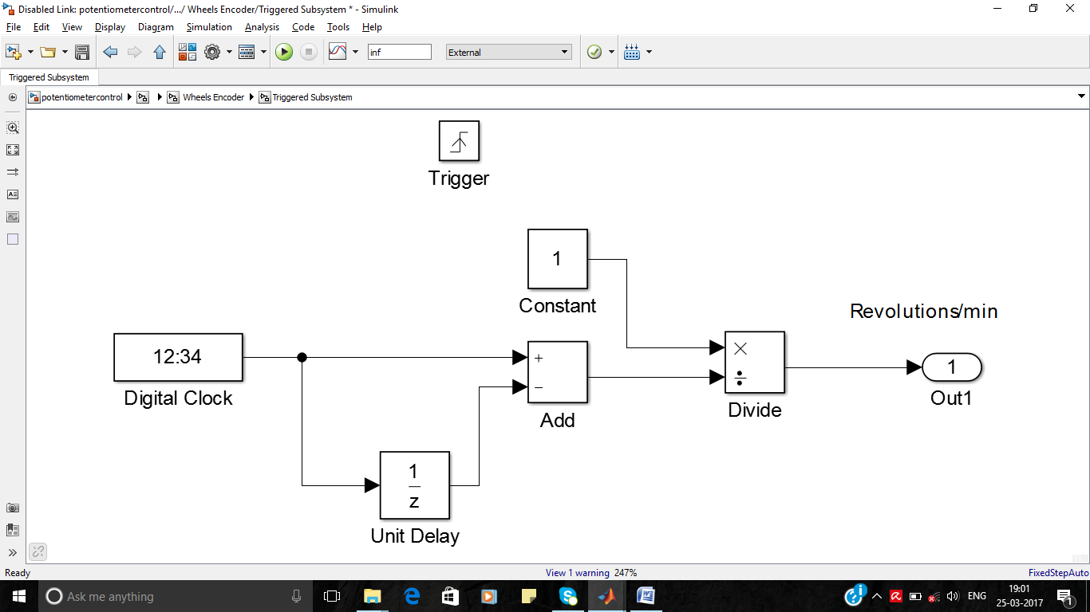

Figure 6.5 Triggered Subsystem in Encoder block

In this Triggered subsystem the time period ‘T’ is calculated using digital clock, unit delay and comparator block. Here unit delay block gives time of previous positive edge of square wave and digital clock give the current time for the next positive edge, but calculating the difference between them, Time period of the square wave is calculated and substituted in the Eq: 6.7 , to calculate the speed of the motor.

Output of the encoder has very high oscillations because the improper square wave received from the real time system, to damp out the oscillations a adaptive discrete filter is used. Kalman filter is readily available filter in the Simulink discrete adaptive filter library, it satisfies our requirement, and produced output very accurately.

**6.3 SIMULINK MODEL FOR CLOSED LOOP CONTROL**

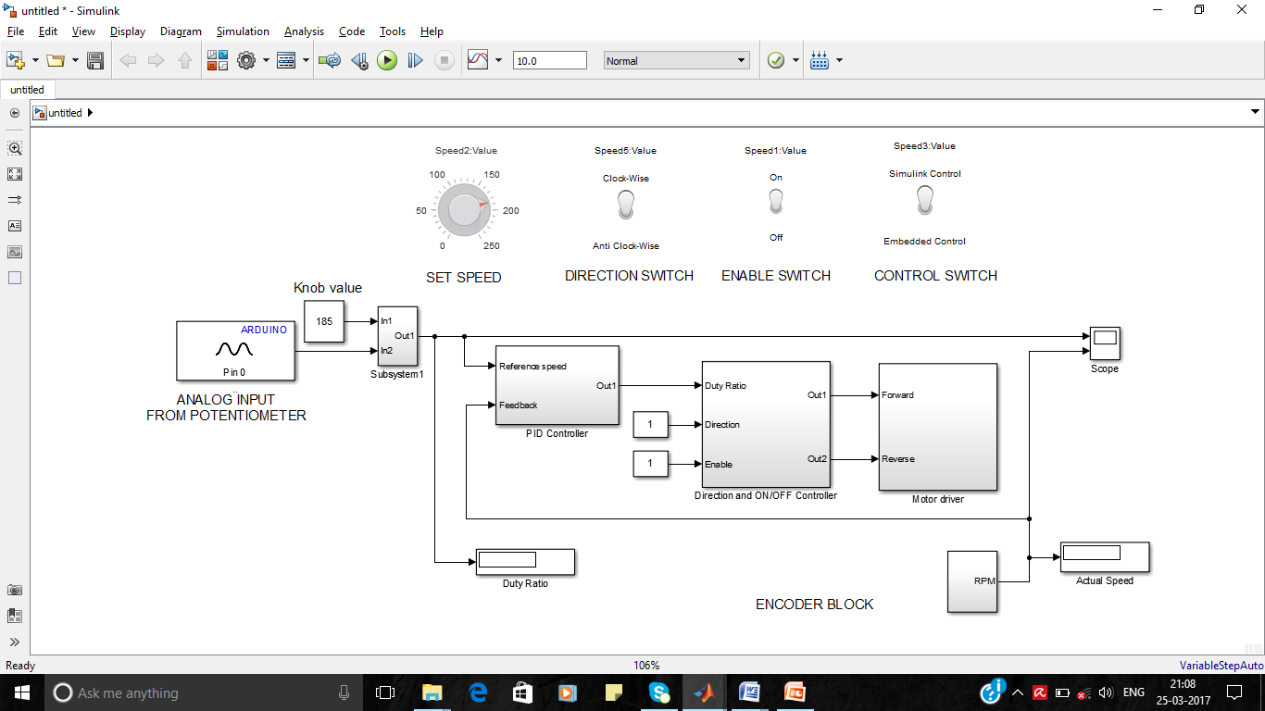

Figure 6.6 Simulink Model for Closed-Loop control with variable input

In this model everything is similar to the open loop controller but the duty ratio is calculate by the PID controller by comparing set value and actual speed of the motor. The PID controller bock is shown in the below Figure 6.7

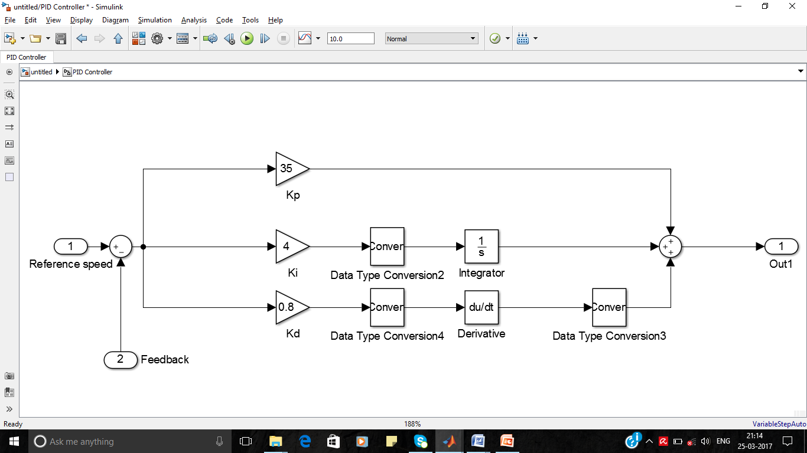

Figure 6.7 PID Controller Subsystem

In this subsystem PID controller is designed in a easy way, P-Controller is designed by using a gain block it carries a value of KP, PI-Controller is designed by using a gain block it carries a value of KI followed by a integrator block and PID-Controller is designed by using a gain block it carries a value of KD followed by differentiator block. In between Data Type converters are used to match data types for their next blocks processing.

**6.4 SIMULINK MODEL FOR CLOSED LOOP CONTROL WITH FIXED INPUT**

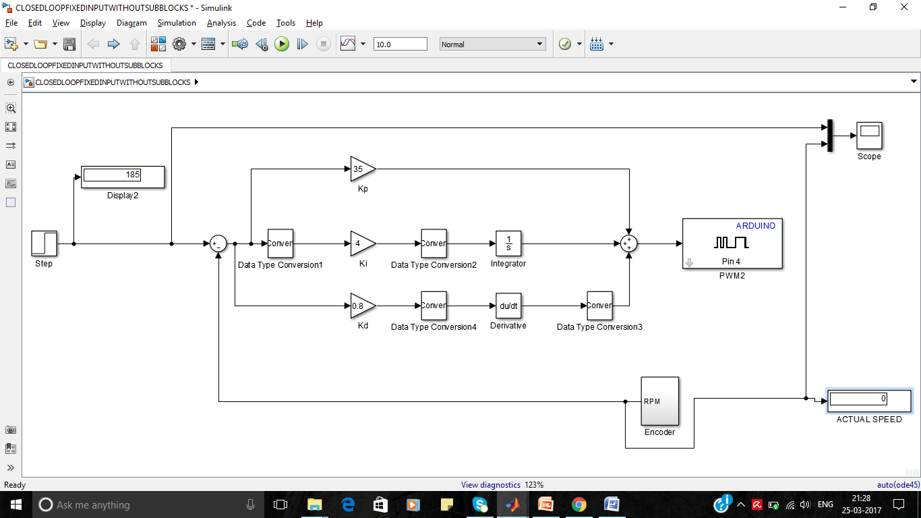

Figure 6.8 Simulink model for closed loop control with fixed input

This model is considered for the calculation of fixed input response of real time system, here a step signal is used as a fixed input, it steps to a value of 185RPM (rated speed) after 5 seconds.