LL101

Low Level Design
Document (LLD)
<Requirement Name>

Author: <Author Name>
Last Updated Date: <Updated Date>



Plot 520, Road # 27
Jubilee Hills, Hyderabad - 33
www.indussoftware.com

[Note: Text displayed in <brackets> in this template is included to provide guidance to the author and should be deleted before publishing the document. Text displayed in black color may be used as it is by the author of the documents. However, the author is expected to go through this content in the black color and change it as may be required before publishing the document. Author also has to delete this Note before publishing the document.]

Document Status Sheet

Originated by: |  | Approved by:
Issue (Draft/Regular) | Revision | Date | Reason for change

Process Introduction:
Entry Criteria:
- Signed-off High-Level Design Document (HLD)
- Look and feel of the solution
- Test scenario documents

Exit Criteria:
Low-Level Design Document (LLD) along with the:
- modified and navigable GUI wireframes,
reviewed and signed-off ahead of coding and
- special code planning, if any, for optimized and high-performance code and
- base lined after the release of software.

Key Activities:
- Converting the requirements and specification into the solution format
- Detailed internal technical analysis
- Split the required solution into one or more sub-systems and do the technical planning for each of these sub-systems, at a detailed level
- Technical analysis to address both the functional and non-functional requirements like scalability, performance and security
- Generation of special code planning document, as may be applicable and capture the corresponding instructions to the coder in the LLD Document
- Impact analysis on the existing system
- Compatibility analysis of the systems: both internal and external systems
- Modification of the Solution look and feel , as may be changed from HLD
- Document (Drafts) Distribution
- Review and Sin-off of the Documents
- Closure analysis (for measurements)
- Base line the document

Table of Contents

1. References 4
2. Requirement Details 4
2.1. Functional Requirements: 4
2.2. Non-Functional Requirements: 4
3. Sub-Systems of the System 4
4. User Interfaces 5
5. Technical Design of the System 5
5.1. <Sub-System 1> 5
5.1.1. Class Diagram 5
5.1.2. Action Particulars: 7
5.1.3. Object Particulars: 7
5.2. ER Diagram 8
5.3. DB Additions/Modifications 9
5.4. Reusable Components 9
5.5. Pseudo Code 9
5.6. Configuration Needs 9
5.7. Architectural/Technology Stack Changes 9
5.8. Coding Standards 9
5.9. Modifications Done 9
5.10. Initiatives for Non-Functional Requirements 10
6. Impact Analysis 10
7. Test Cases 11
8. Comments exchange for review / sign-off: 11
9. Status 11
10. Exit Criteria 12

References

The following are the references that are to be offered as a pre-cursor to writing this document:

Requirement Specification Document: <Requirement Document Reference>
High-Level Design Document: <HLD Reference>
Database Definition Document: <Data Base Document Reference>

Requirement Details
<Carry the goals of this design work, both from the functional perspective and the non-functional perspective. The requirement has to include all those design goals from the high-level design document. Different diagrams of the HLD have to be clearly understood, before moving on for the low-level design of the system. Should there be a need for changing the diagrams and the content of the HLD, the HLD document has to be modified, involving the stakeholders.>

Functional Requirements:

<Present here the functional requirements from the preceding level documents. This has the purpose of reminding the designer, all those requirements that need to be taken care. Special mention has to be made for the driving or important requirements for this design.>

Non-Functional Requirements:

<Present here the non-functional requirements from the preceding level documents. This has the purpose of reminding the designer, all those requirements that need to be taken care. Special mention has to be made for the driving or important requirements for this design.>

Sub-Systems of the System
Here are the distinctly identifiable sub-systems that make-up the system being built. Sub-systems are identified from the perspectives of the objects/actions/components, with clear inputs, process and outputs. That means, each of these sub-systems will have clear tasks to perform. When all such tasks are performed together, they will meet the goals of the system being built.

S.No | Sub-System | Purpose / Description | User Interface(s) referred in the Document
1 | <Sub-System 1>
2 | <Sub-System 2>

User Interfaces
<Carry here all the User Interfaces developed at requirements specification level or the high-level design level, with reference to the sub-systems and the functionality from each of those user interfaces.>

Technical Design of the System

<Sub-System 1>
<Present here the detailed requirement description of this sub-system>

Class Diagram
<The class diagram is the main building block of object oriented modeling. It is used both for general conceptual modeling of the systematics of the application, and for detailed modeling translating the models into programming code. Class diagrams can also be used for data modeling. The classes in a class diagram represent both the main objects, interactions in the application and the classes to be programmed.
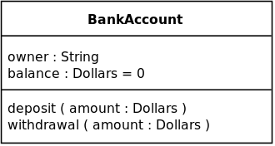
An example class with three sections is shown in this picture.
In the diagram, classes are represented with boxes which contain three parts:
- The top part contains the name of the class. It is printed in bold and centered, and the first letter is capitalized.
- The middle part contains the attributes of the class. They are left-aligned and the first letter is lowercase.
- The bottom part contains the methods the class can execute. They are also left-aligned and the first letter is lowercase.
In the design of a system, a number of classes are identified and grouped together in a class diagram which helps to determine the static relations between those objects. With detailed modeling, the classes of the conceptual design are often split into a number of subclasses.

An example Class Diagram :>

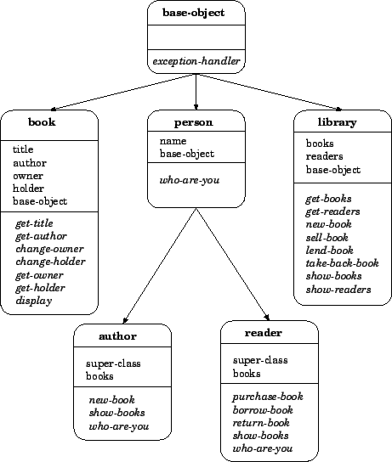

Action Particulars:

Subject | Particulars
Input
Process including UI Validations
Output

Object Particulars:

Part 1:
Subject | Particulars
Existing Classes used
Classes added
Existing Methods used
Methods added
Existing JSPs used
JSPs added
Existing DB Functions used
DB Functions added
Existing Stored Procedures used
Stored Procedures added

Part 2:
Retrieve / Insert / Update | Table Name | Column Name | For UI Field
 |  |  | .

ER Diagram
<An entity–relationship model (ER model) is a data model for describing the data or information aspects of a business domain or its process requirements, in an abstract way that lends itself to ultimately being implemented in a database such as a relational database. The main components of ER models are entities (things) and the relationships that can exist among them, and databases.
An ER model is typically implemented as a database. In the case of a relational database, which stores data in tables, every row of each table represents one instance of an entity. Some data fields in these tables point to indexes in other tables; such pointers represent the relationships.

The physical model is normally instantiated in the structural metadata of a database management system as relational database objects such as database tables, database indexes such as unique key indexes, and database constraints such as a foreign key constraint or a commonality constraint. Note that an ER Model may sometimes be dependent on the DBMS systems.

An example ER Diagram :>

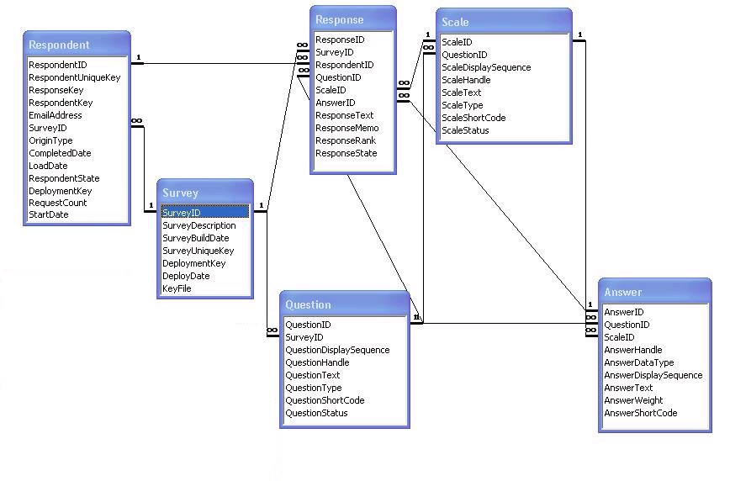

DB Additions/Modifications

<Present here all those database tables added and modified to achieve the requirements of the system. These particulars shall be presented in a tabular format, with a table as the reference.>

Reusable Components

<Present here the reusable components across the systems of this project requirement and also considering the components from the existing product(s). This exercise has to avoid duplication of effort for the things that are already available with us. This will obviously increase the productivity of the teams and many teams the quality, as well. The project manager has to make a clear statement about the reusable components, with the help of his staff, other project managers and the other senior staff.>

Pseudo Code

<Pseudo code is a kind of structured English for describing algorithms. It allows the designer to focus on the logic of the algorithm without being distracted by details of language syntax. At the same time, the pseudo code needs to be complete. It describes the entire logic of the algorithm so that implementation becomes a task of translating line by line into source code. Refer to some good documentation available on the Internet to be effective with this pseudo code writing.>

Configuration Needs

<Mention here the various configuration needs for certain features and the services to achieve the desired functionality of the system. Sometimes, this may have relation to the cross-product operation.>

Architectural/Technology Stack Changes

<Present here any kind of architecture related changes in the areas of design patterns or deployment etc. Also present any new technologies that are planned for usage for this task. For both the cases, mention any kind of risk involved, with the plans for risk mitigation.>

Coding Standards

Follow the IDC guidelines and standards document for this purpose. The name of the document to follow is: LD Program – Coding Guidelines.

Modifications Done

This section shows the various files, packages, classes, methods, tables and stored procedures that are modified in this implementation. For each changed item, the change description and change reasons are also presented. Please note that a deletion of an item also amounts to a modification and would be captured here, if any:

Item Type | Item Name | Change Description | Change Reason

Initiatives for Non-Functional Requirements

<Present here all those design initiatives that ensure meeting all kinds of non-functional requirements, including the performance and security related ones. To ensure that the designer does not lose track of the primary non-functional requirements, they are being presented in a tabular format. The designer can add to this list, based on the requirement.

Non-Functional Requirement | Design Initiatives | Comments
User Interface
Usability
Performance
Security
Maintainability

>.

Impact Analysis
This section presents the impact created by this implementation. Impacted items may include a specific transaction or the whole system. The impact can be of the types of UI, transaction logic, report output, corruption of existing data in the system, scalability and performance. When the impact type is: Impact on existing data/scalability/performance, impacted item is given as ‘The System’. In other cases, the respective transaction or report is given for the Impacted Item.

Impacted Item | Impact Type | Why Impacted | Resolution Plan
 | <User Interface/Report/Business Logic> |  | <Since this is a value addition to the solution, this can be adopted for the regular PMS Product as well.  Existing customers need to be educated, when we bring this change for regular PMS.>

(Impact Types: Impact in UI, Impact in Transaction, Impact in Report output, Impact on existing data, Impact on Scalability, Impact on Performance)

Test Cases
Present here all those test cases that need to be run, both at the unit level and at the integrated system level, before certifying this system for the QC verification:
# | Test Case Description | Expected Result

Comments exchange for review / sign-off:
<Here all the review comments by the Reviewers from the Indus team or US team will be captured. The Reviewer has to write his/her comments with reference to the specific section and the specific context. Whenever a document is saved with new set of comments at the review stage, the version number of the document has to be increased. Sign-off has to be written in the Comments column, when the RSD is approved. >

Team / Person | Date | Comments

Status

Status | Date | Comments
Draft
Submitted for Sign-off
Signed-off
Base lined |  | LLD may be changed for some specific needs, even after the sign-off. Such need has to be documented by the development team. Change or no change, any LLD has to be base lined after releasing the software. Once base lined, the document cannot be subjected to any changes.

Exit Criteria
Base line after the release of software

Sign-Off Particulars:
Measure | Approved by and Date | Communication Reference for the Approval
Review and Sign-Off

Base line of the document (after the release of software)

