HL 101

High-level Design
Document (HLD)
<Requirement Name>

Author: <Author Name>
Date: <Latest Publishing Date>



Plot 520, Road # 27
Jubilee Hills
Hyderabad, India
www.indussoftware.com

[Note: Text displayed in <brackets> in this template is included to provide guidance to the author and should be deleted before publishing the document. Text displayed in black color may be used as it is by the author of the documents. However, the author is expected to go through this content in the black color and change it as may be required before publishing the document. Author also has to delete this Note before publishing the document.]

Document Status Sheet

Originated by: <Author Name> |  | Approved by: <Approver’s Name>
Issue (Draft/Regular) | Revision | Date | Reason for change

Process Introduction:
Entry Criteria:
- Signed-off Requirement Specification Document (RSD)
- Any wireframes already developed

Exit Criteria:
High-Level Design Document (HLD) along with the:
- finalized and navigable GUI wireframes,
- review and sign-off ahead of low-level
design and
- base lined after the release of software.

Key Activities:
- Converting the requirements and specification into the solution format
- Whiteboard kind of solution designing, considering the workflow / dataflow across the elements and systems
- Overall system design, covering both functional and non-functional requirements like scalability, performance and security
- Impact analysis on the existing system
- Compatibility analysis of the systems: both internal and external systems
- Solution look and feel development
- Document (Drafts) Distribution
- Review and Sign-off of the Documents
- Closure analysis (for measurements)
- Base line the document
- Test scenario development (by the QC team)

Table of Contents

1. Entry Criteria 5
2. Introduction 5
2.1. Purpose 5
2.2. Scope 5
2.3. Definitions, Acronyms and Abbreviations 5
2.4. References 6
3. Design Overview 6
3.1. Functional Requirements 6
3.2. System Diagram 6
3.3. Functionality of the System(s) 7
3.4. Architecture 7
3.5. Technology Stack 7
3.6. Assumptions and Dependencies 8
4. System Design 8
4.1. Systems 8

4.1.1. System 1 8
4.1.1.1. Use Case Diagram 8
4.1.1.2. Activity Diagram 9
4.1.1.3. State Chart Diagram 10
4.1.1.4. Sequence Diagram 11
4.1.1.5. User Interfaces 12
4.1.1.6. Physical Data Model 13
4.1.1.7. DB Additions/Modifications 14
4.2. System to Functional Requirements Mapping 14
4.3. Design for Non-Functional Requirements 14

4.3.1. User Interface Related 14
4.3.1.1. Requirement 14
4.3.1.2. Design Resolution 14

4.3.2. Usability 14
4.3.2.1. Requirement 14
4.3.2.2. Design Resolution 14

4.3.3. Performance 14
4.3.3.1. Requirement 14
4.3.3.2. Design Resolution 15

4.3.4. Manageability/Maintainability 15
4.3.4.1. Requirement 15
4.3.4.2. Design Resolution 15

4.3.5. Security/Access Control 15
4.3.5.1. Requirement 15
4.3.5.2. Design Resolution 15
4.4. Reusable Components 15
5. Requirement to Design Mapping 16
6. Future Improvements/Areas of Likely Change 16
7. Design and Architecture Checklist 16
8. Comments exchange for review/sign-off: 17
9. Exit Criteria 17

Entry Criteria
Approved Requirement Specification Documents and Wireframes:

Document / Communication  Reference | Date | Remarks

Introduction
This document provides the high-level design for the planned requirements. This document can have references to other documents, at places where required. All the sections of this document are self-explanatory. However, the high-level design in general includes the content like overall solution framework, systems and information flow across the internal/external sub-systems, requirement to solution mapping, user acceptance criteria etc. Focus is more towards depicting the solution using the well proven UML model diagrams, with the objective of reducing the textual content, which takes lot of time for development, review, reading and absorption. The UML standard diagrams can help in increasing the productivity and effectiveness in all these areas of subject concept development, presentation, review, reading by the audience and the absorption and usage by the audience.

<Produce here the introduction to the project, from the requirements, scope and the design considerations and the details. The introduction has to be sufficient enough for the audience to the extent that they develop a feel for the content down below.>

Purpose

This document is meant for getting the solution designers into a methodical route for designing the needed solution for the end-users for the planned requirements.

Scope

This document gives the overview of the design, high-level architecture details that include information flow across the internal and external systems, solution design views as experienced by the end-users, mapping of the solution items to the requirement items and references to the preceding level documents. This document enables low-level designing and hence is meant for the technical teams that design the internal framework of the solution. This document also helps the organization to become surer of the desired solution for the planned requirements.

Definitions, Acronyms and Abbreviations

<Present here the meanings for all those definitions, acronyms and abbreviations used in this document.>

References

<Mention the references used to generate this document. For example, you might have followed the UML conventions for developing different diagrams etc. The reference can also include the requirements specification, which is used as the base for this high-level design.>

Design Overview
This provides a general description of the software system including its functionality and matters related to the overall system and its design, for the referred requirements.

Functional Requirements

<Provide the functional requirements that are targeted to be met through the solution being designed. Ensure that they are the target requirements from the referred RSD of this document. Include here the references of the target requirements, with the details like the requirement number and the brief description of the requirement. Include here all those requirements that are being covered into this design. It is preferable to present the requirements in a tabular format, like in the Requirements Specification Document.>

<The content given in the table is for example purpose and shall be replaced with the actual content for this project>

Req# | Requirement | Comments
 | Modify the Comments and Review Cycle in line with the UMN requirements | This included the changes to the emailing process
 | Create a New Workflow Type in line with the UMN requirements | This includes the changes to emailing process

System Diagram

<Many people find the images easy to understand and remember than the text (visualizers than verbalizers). Drawing a diagram shows the relationships or linkages between different concepts or variables more clearly and immediately than is possible with text. Establishing the relation of new information with the already existing system has lot of value and needs a good learning. Drawing diagrams therefore stimulates thinking about a situation.

When diagrams are constructed as a group process, they aid brainstorming, analysis, communication and common understanding of the situation. Systems diagrams can be easy kind of diagrams, using boxes and simple lines for showing the system design in a simple way. A sample system diagram is given under for easy understanding of the concept.>

An Example System Diagram, taken from a GMS project:
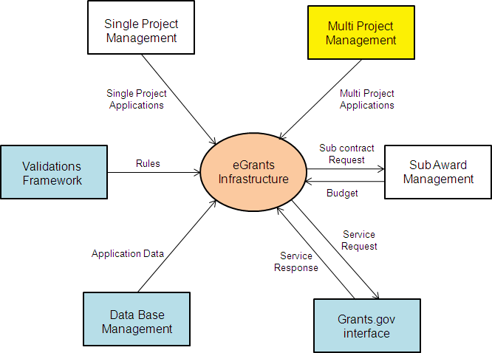

Functionality of the System(s)

<Describe in detail, the functionality of the system(s). The functionality may be given as bullet points, to start with and then the points may be elaborated to provide the details of the all the systems of the subject project. This may make references to the System Diagram, to make things easy for future reference or for the stakeholders. Note that there is a possibility that some of these functional points may be disconnected with each other, as a project may have some disconnected items, as its scope. Also note that there is no need to map the functionality to the systems, at this level. Give the importance, at this level, to list the functionality that the system(s) offer.>

Architecture

<Make here the references to the architecture document. If there is no change in the architecture from the already established usage for the product, mention that there is no change in architecture. This means any kind of architectural changes cannot be accepted for the new system, without proper high-level and low-level design.>

Technology Stack

<Provide the technology stack for the solution being designed. If there is no change in the technology stack from the already established usage for the product, mention that there is no change in the technology stack and no new technologies are being used or can be used for the solution.>

Assumptions and Dependencies

<Describe any assumptions or dependencies regarding the software and its use. These may concern such issues as:
Related software or hardware
Operating systems
End-user characteristics
Restrictions to processing in each mode
Possible and/or probable changes in functionality>

System Design
This gives the details and the design of the systems that this project generates. Each of those components/systems shall be described hereunder with the defined detailing. There is a possibility the not all the systems are connected to each other.

Systems
<Present here the Systems that this Project generates in a tabular format, with the details like the name of the system, functionality of the system and any comments about it.>

<This has to give the functionality, as identified in the section titled ‘functionality of the system’ in this document.>
System Name | Functionality | Comments

System 1

<Present here the references to those functional requirements that this system will meet. This has to reflect the functional requirements from the section titled ‘functional requirements’ section in this document. Also provide some additional understanding about this system, besides the functionality this system offers, as documented in the section titled ‘systems’ of this document.>

Use Case Diagram

<A use case diagram at its simplest is a representation of a user's interaction with the system and depicting the specifications of a use case. A use case diagram can portray the different types of users of a system and the various ways that they interact with the system. This type of diagram is typically used in conjunction with the textual use case and will often be accompanied by other types of diagrams as well. The textual use cases may be as available from the requirements specification.>

An Example Use Case Diagram, taken from a GMS project:
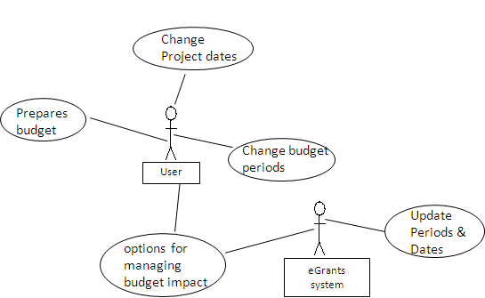

Activity Diagram
<Activity diagrams are graphical representations of workflows of stepwise activities and actions^{[1]} with support for choice, iteration and concurrency. Activity diagrams show the overall flow of control.
Activity diagrams are constructed from a limited number of shapes, connected with arrows. The most important shape types:
- rounded rectangles represent actions;
- diamonds represent decisions;
- bars represent the start (split) or end (join) of concurrent activities;
- a black circle represents the start (initial state) of the workflow;
- an encircled black circle represents the end (final state).
Arrows run from the start towards the end and represent the order in which activities happen.
Hence they can be regarded as a form of flowchart. Typical flowchart techniques lack constructs for expressing concurrency. However, the join and split symbols in activity diagrams resolve this to some extent.>

An Example Activity Diagram, taken from a GMS project:

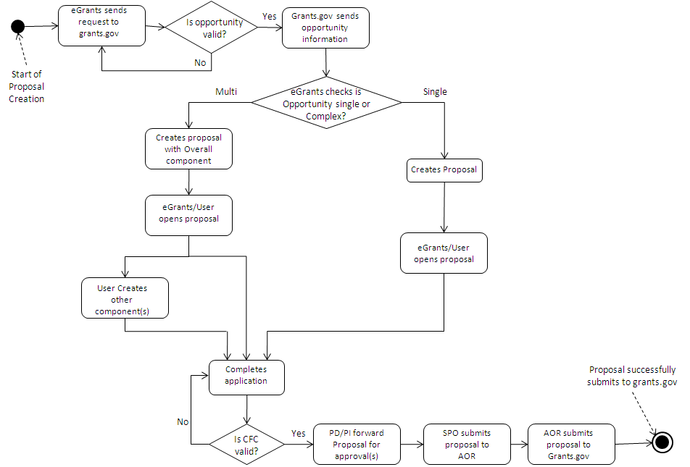

State Chart Diagram

<A state chart diagram describes a state machine. Now to clarify it, state machine can be defined as a machine which defines different states of an object and these states are controlled by external or internal events.

State chart diagram describes the flow of control from one state to another state. States are defined as a condition in which an object exists and it changes when some event is triggered. So the most important purpose of state chart diagram is to model life time of an object from creation to termination.>

An example state chart diagram, taken from a GMS project:

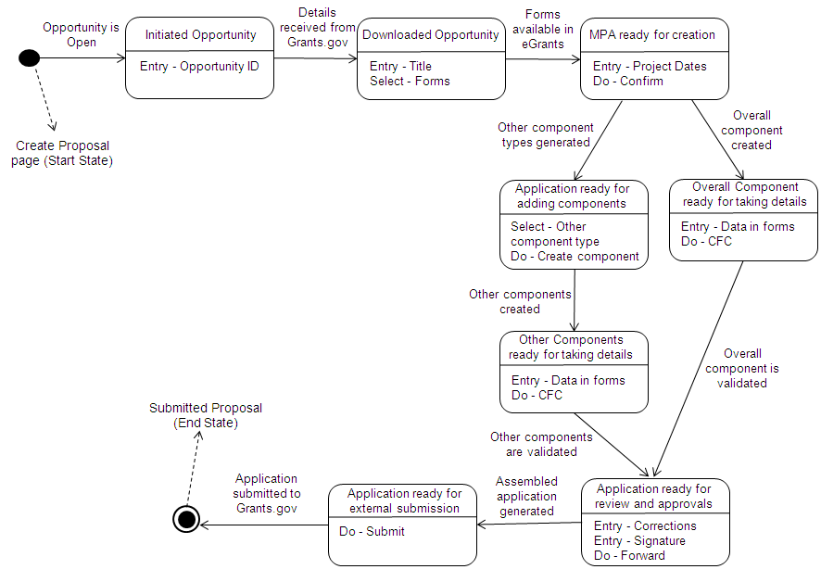

Sequence Diagram
<A Sequence diagram is an interaction diagram that shows how processes operate with one another and in what order. It is a construct of a Message Sequence Chart. A sequence diagram shows object interactions arranged in time sequence. It depicts the objects and classes involved in the scenario and the sequence of messages exchanged between the objects needed to carry out the functionality of the scenario. Sequence diagrams are typically associated with use case realizations in the Logical View of the system under development.>
An Example Sequence Diagram, taken from a GMS project:

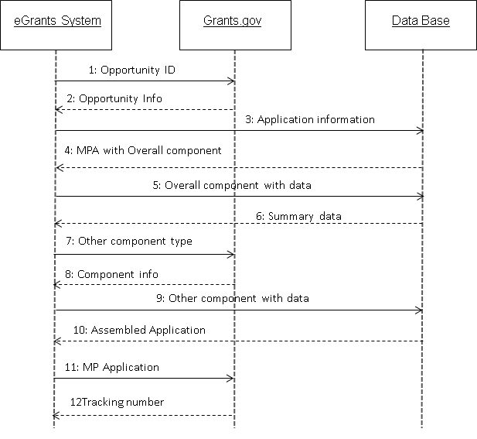

User Interfaces

<Present here the design of the user interfaces, in a logical order of the usage for the users of the real time. Identify each of the user interface screens for easy references for different purposes. Mention the functionality that is going to be achieved from each of those screens. This also has to explain the navigational features of the solution. This has to go beyond the wireframe model and has to be as close as possible to the actual user interfaces that are going to be offered>.

Physical Data Model

<Physical data model represents how the model will be built in the database. A physical database model shows all table structures, including column name, column data type, column constraints, primary key, foreign key, and relationships between tables. Features of a physical data model include:
- Specification all tables and columns.
- Foreign keys are used to identify relationships between tables.
- DE normalization may occur based on user requirements.
- Physical considerations may cause the physical data model to be quite different from the logical data model.
- Physical data model will be different for different RDBMS. For example, data type for a column may be different between MySQL and SQL Server.
The steps for physical data model design are as follows:
- Convert entities into tables.
- Convert relationships into foreign keys.
- Convert attributes into columns.
- Modify the physical data model based on physical constraints / requirements.
The figure below is an example of a physical data model.
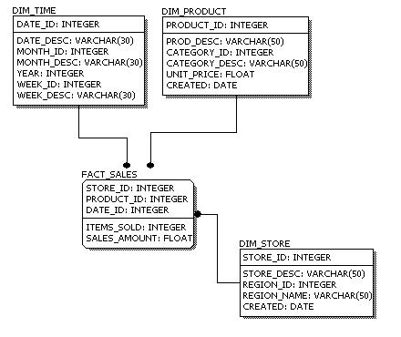
Comparing the physical data model shown above with the logical data model diagram, we see the main differences between the two:
- Entity names are now table names.
- Attributes are now column names.
- Data type for each column is specified. Data types can be different depending on the actual database being used.>

DB Additions/Modifications

<Present here all those database tables added and modified (with reference to the existing DB), to achieve the requirements of the system. These particulars shall be presented in a tabular format, with a table as the reference.>

System to Functional Requirements Mapping

This will provide the mapping between the systems of the project and targeted functional requirements of the project. This is presented in a tabular format and this information also helps like a checklist for the design completeness, against the target goals.

System Name | Functional Requirements | Comments

Design for Non-Functional Requirements

User Interface Related

Requirement

<Carry the requirement from the requirement specification document>

Design Resolution

<Present here how this requirement is addressed in the design. Highlight the point in red color, if no attempts are made in the design to meet the requirement.>

Usability

Requirement

<Carry the requirement from the requirement specification document>

Design Resolution

<Present here how this requirement is addressed in the design. Highlight the point in red color, if no attempts are made in the design to meet the requirement.>

Performance

Requirement

<Carry the requirement(s) from the requirement specification document>

Design Resolution

<Present here how this requirement is addressed in the design. Highlight the point in red color, if no attempts are made in the design to meet the requirement.>

Manageability/Maintainability

Requirement

<Carry the requirement from the requirement specification document>

Design Resolution

<Present here how this requirement is addressed in the design. Highlight the point in red color, if no attempts are made in the design to meet the requirement.>

Security/Access Control

Requirement

<Carry the requirement from the requirement specification document>

Design Resolution

<Present here how this requirement is addressed in the design. Highlight the point in red color, if no attempts are made in the design to meet the requirement.>

Reusable Components

<Present here the reusable components across the systems of this project and also considering the components from the existing product(s). This exercise has to avoid duplication of effort for the things that are already available with us. This will obviously increase the productivity of the teams and many teams the quality, as well. The project manager has to make a clear statement about the reusable components, with the help of his staff, other project managers and the other senior staff.>

Requirement to Design Mapping

Present here all functional requirements and mapping them to the designs.

User Acceptance Criterion | Requirement Reference | Design Reference | Comments

Future Improvements/Areas of Likely Change

<If the system presently lacks useful/desirable features, note details here. You could also comment on non-functional improvements to the package, such as usability. >

Design and Architecture Checklist
Courtesy of some external reference, we have a good checklist, of course with some modifications. These questions are NOT for answering, they are only to assist you to think on your design…
- Is the overall program organization clear, including a good architectural overview and justification?
- Are modules well defined including their functionality and interfaces to other modules?
- Are all the functions that are listed in the requirements covered sensibly, neither by too many nor too few modules?
- Are all major objects described and justified?
- Is the user interface modularized so that changes in it won't affect the rest of the program?
- Is a strategy for handling user input described?
- Are key aspects of the user interface defined?
- Are memory use estimates and a strategy for memory management described and justified?
- Is a strategy for handling I/O described and justified?
- Is a coherent error-handling strategy included?
- Are error messages managed as a set to present a clean user interface?
- Is a level of robustness specified?
- Are necessary buy vs. build decisions included?
- Is the architecture designed to accommodate likely changes?
- Is any part over- or under-architected?
- Are the major system goals clearly stated?
- Does the complete architecture hang together conceptually?
- Is the top-level design independent of the machine and language that will be used to implement it?
- Are motivations given for all major decisions?
- Is the design intellectually manageable?
- Does the design have low complexity?
- Will the program be easy to maintain?
- Will the design be easy to port to another environment?
- Is the design lean? Are all of its parts strictly necessary?
- Is the design stratified into layers?

Comments exchange for review/sign-off:
<Here all the review comments by the Reviewers from the Indus team or US team will be captured. The Reviewer has to write his/her comments with reference to the specific section and the specific context. Whenever a document is saved with new set of comments at the review stage, the version number of the document has to be increased. Sign-off has to be written in the Comments column, when the RSD is approved. >

Team / Person | Date | Comments

Exit Criteria

Sign Off for HLD from UST

Sign-Off Particulars:
Sign-Off Milestone | Approved by and Date | Communication Reference for the Approval
IDC Approval
KSI Approval 1
KSI Approval 2

