BITBUCKET

1. Download Bitbucket from the following atlassian link as it’s an Atlassian tool –

<https://www.atlassian.com/software/bitbucket/download>

select Windows 64 bit from the dropdown list and click on ‘Download’

option.

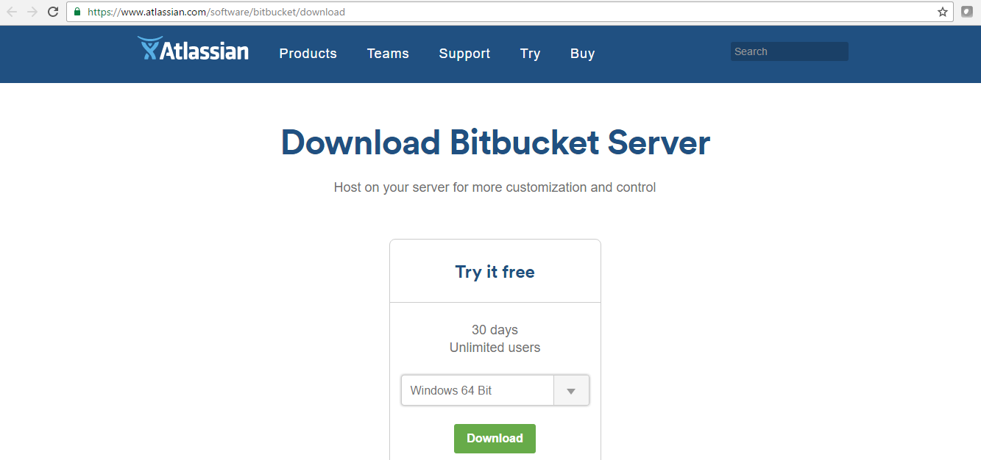

2.One .exe file will get downloaded 🡪 open that file and start installation

🡪 It may ask you for 64-bit jre and jdk both then set 64-bit of both in your JAVA_HOME under your system variables.

3.Then choose your Installation directory i.e, any empty folder anywhere in local disk ‘D’ or else it will create a folder for you by-default in your ‘C’.

4.

NOTE :

Sometimes, bitbucket willn’t run as a ‘service’ then in that case everytime when you want to access then go to 🡪 bin folder inside its installation directory for ex- D:\AtlassianBitbucket\bin 🡪 run the ‘start-bitbucket’ windows batch file.

Then try accessing the url, it will open the bitbucket.

1. git init
2. git status
3. git add –all
4. git status
5. git commit -m "initial commit"
6. git status
7. git remote add origin
8. git push http://admin@172.19.81.217:7990/scm/hel/hellorepo.git master:bugfix/jaya

- command to push to one branch i.e,jaya not to master.

<http://nvie.com/posts/a-successful-git-branching-model/> - link for branching concept in bitbucket

<https://www.atlassian.com/git/tutorials/comparing-workflows> - link for branching concept in bitbucket