JIRA

Install Xampp:

* **In your web browser, go to**[**https://www.apachefriends.org/index.html**](https://www.apachefriends.org/index.html)

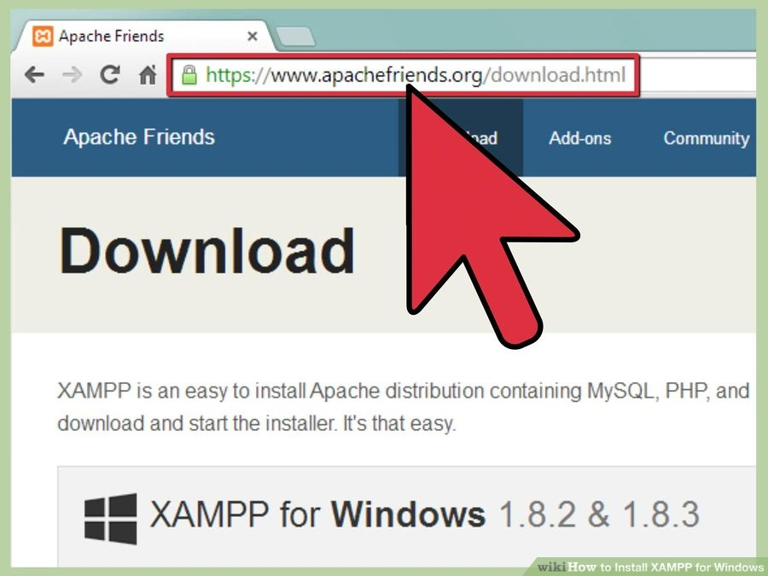

* **Click on the download link for XAMPP.**

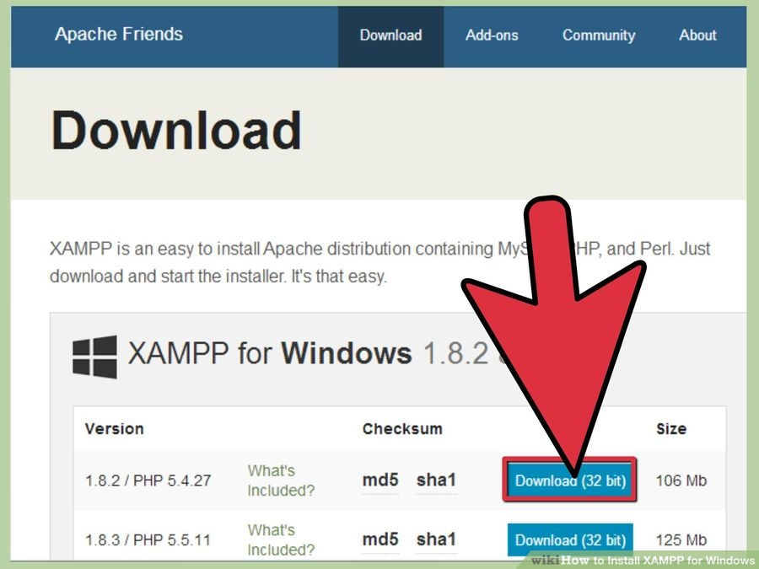

* **When prompted for the download, click "Save" and wait for your download to finish.**

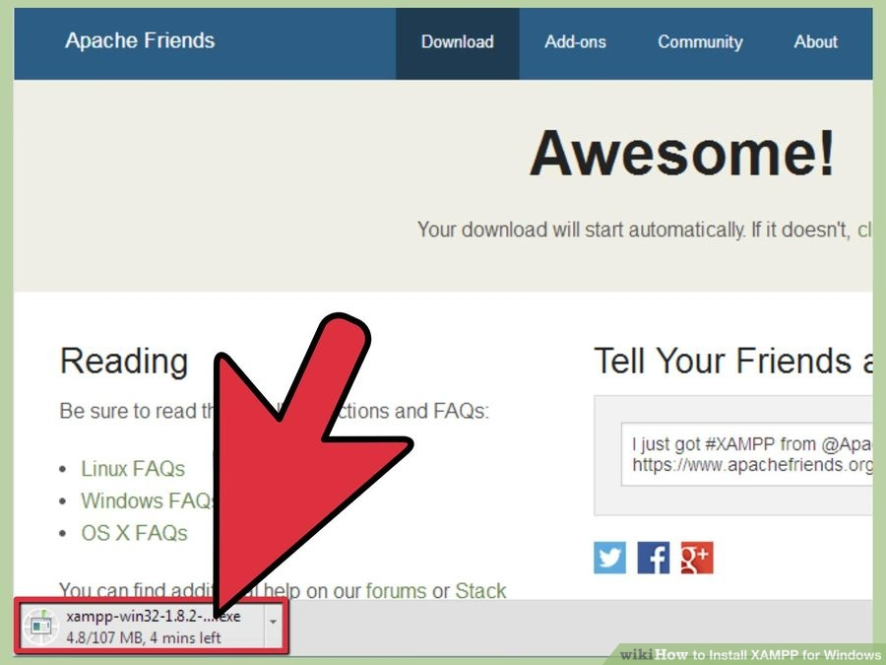

* **Open CD or DVD drive from My Computer.** Install the program, and click on "Run."

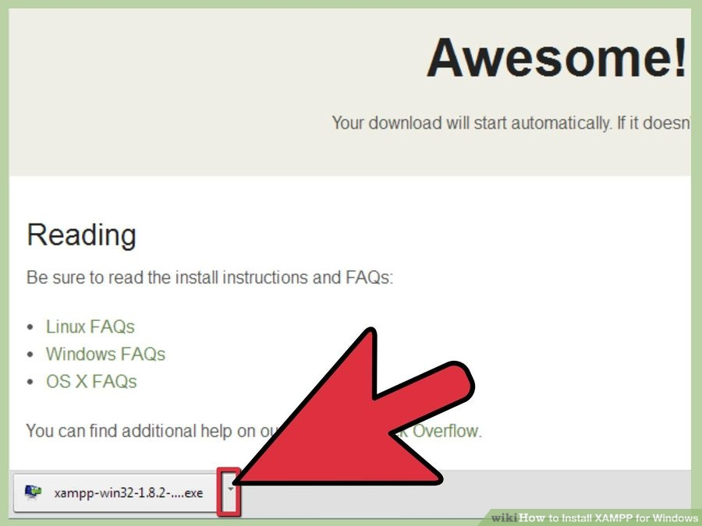

* **Accept the default settings.** A command will open and offer an initial installation prompt. Just hit the Enter key, and accept the default settings. To simplify installation, just hit ENTER when prompted on the command line. You can always change settings, by editing the configuration files later.

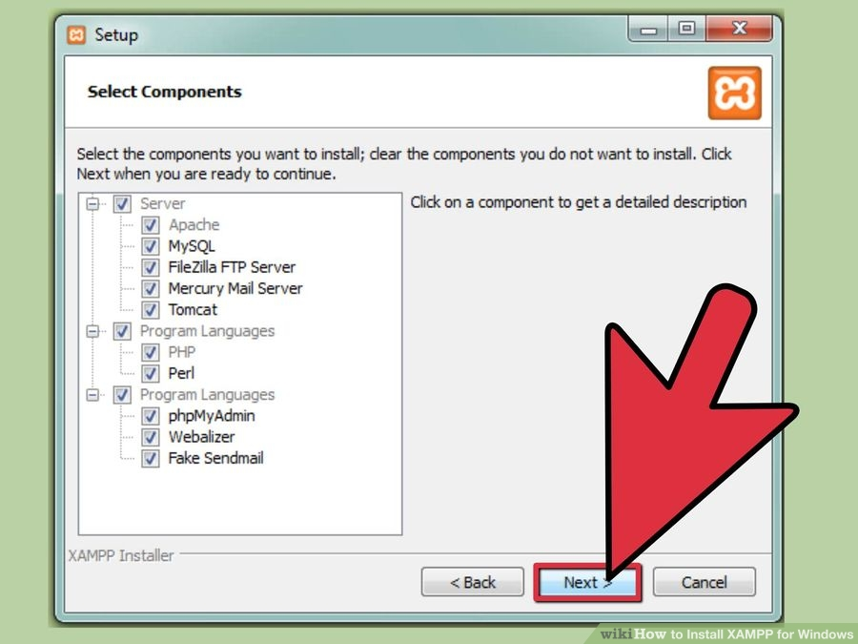

* **When your installation is complete, exit the command window by typing x on the command line.**

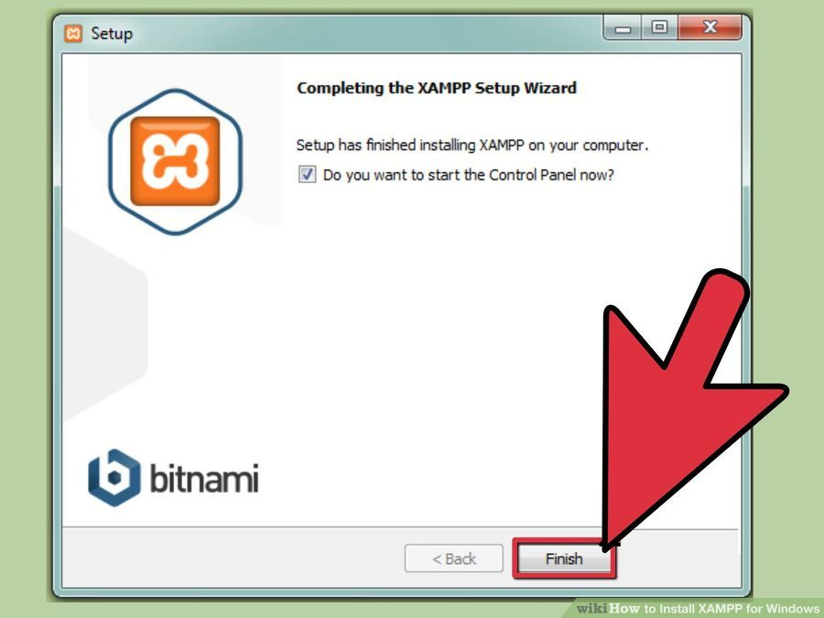

* **Start the XAMPP Control Panel.**

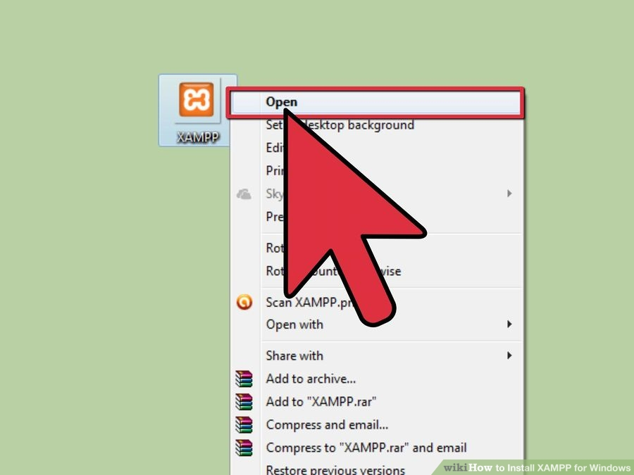

* **Start the Apache and MySQL components.** You can also start the other components, if you plan to use them.

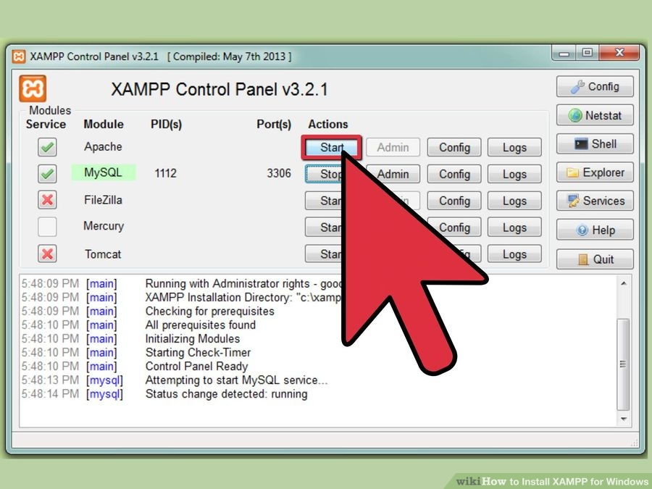

* **Verify the Apache install, by clicking on the Apache administrative link in the Control Panel.**

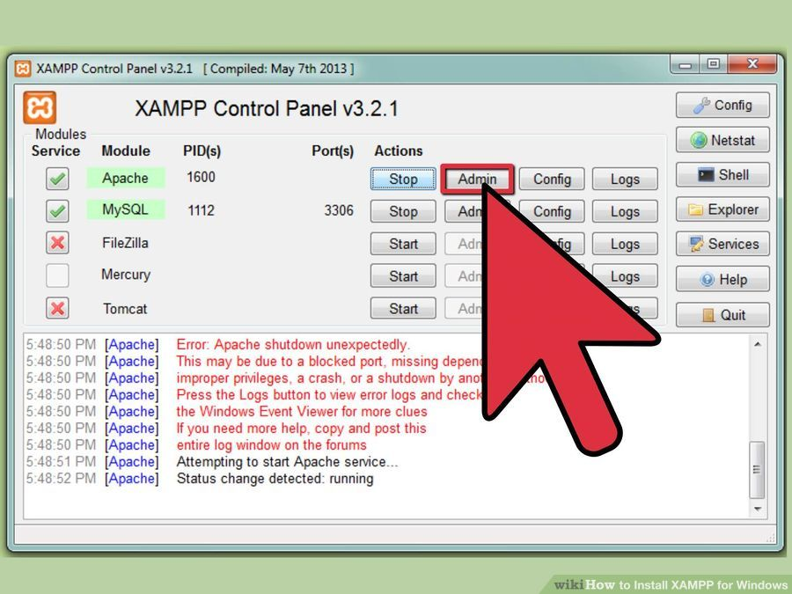

**Verify the MySQL installation, by clicking on the MySQL administrative link in the XAMPP Control Panel.**

* If the verification steps are successful, XAMPP should be successfully installed on your PC. Open a browser and enter "localhost" on your address bar. You will be redirected to a page telling you that you've successfully installed xampp on your system

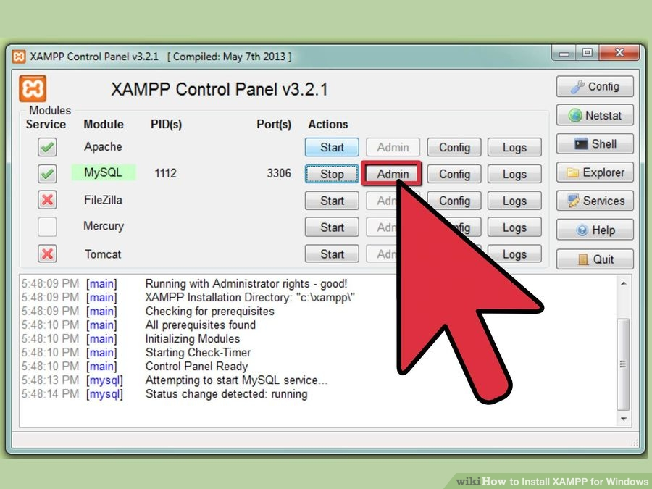

* Start services of Apache and MySql from the Xampp terminal and proceed with below installation steps of JIRA.

Installation of JIRA:

1. Download the JIRA application's**'Windows installer'** (.exe) file from the [JIRA download](https://www.atlassian.com/software/jira/download) page.
2. Run the '.exe' file to start the installation wizard.  
   (info) If a Windows 7 (or Vista) 'User Account Control' dialog box asks if you want to allow the installation wizard to make changes to your computer, specify '**Yes**'. If you do not, the installation wizard will have restricted access to your operating system and any subsequent installation options will be limited.
3. At the 'Upgrading JIRA?' step, choose between the '**Express Install**' or '**Custom Install**' options:
   * **Express Install** — If you choose this option, JIRA will be installed with default settings, which are shown in the next step of the installation wizard. If you want to customize any of these options, click the '**Back**' button, and choose the '**Custom Install**' option instead.
   * **Custom Install** — If you choose this option, JIRA will prompt you to specify the following options, which are presented during subsequent steps of the installation wizard and pre-populated with default values:
     + The 'Destination Directory' in which to [install JIRA](https://confluence.atlassian.com/adminjiraserver071/jira-application-installation-directory-802593035.html).
     + The [JIRA home directory](https://confluence.atlassian.com/adminjiraserver071/jira-application-home-directory-802593036.html), which must be unique for each JIRA installation.
     + The Windows 'Start' menu folder options.
     + The *TCP ports* (i.e. an HTTP and a Control port) that JIRA will run through.
     + If you are running the installer using an administrator account, you will be prompted to 'Install JIRA as a service' (recommended). You can also do this manually later, as described in [Running JIRA as a Windows service](https://confluence.atlassian.com/adminjiraserver071/running-jira-applications-as-a-windows-service-802593173.html).  
       (tick) If you installed JIRA as a service, you must start JIRA through the Windows 'Start' menu, since JIRA will not start if you run start-jira.bat at the Windows Command Prompt.
4. The installation wizard will install JIRA onto your operating system and will start JIRA automatically when the wizard finishes. JIRA will also be launched automatically in your browser window if you chose this option.

Start and Stop JIRA

Enter the bin subdirectory of your JIRA installation directory and run the appropriate file:

* start-jira.bat (to start JIRA)
* stop-jira.bat (to stop JIRA)