Getting started with Jira

Getting started with Jira as Administrator:

Setting up your workspace

1. **Setting up your workspace**
2. **Customizing your project**
3. **Creating your backlog**
4. **Grooming your backlog**
5. **Planning your sprint**
6. **Tracking your progress**
7. **Wrapping up your work**
8. **Doing more with your agile projects**

When setting up your JIRA Software workspace, you'll need to do the following:

1. Sign up for a JIRA Software site.
2. Create your project.
3. View your Scrum board.

Sign up for a JIRA Software site

You will need your own JIRA Software site for this tutorial. Let's set you up with a JIRA Software Cloud site. **Cloud** is our hosted offering and will allow you to set up your own site without installing a thing! If you already have a site, you can skip this step.

Signing up for JIRA Software will provide you with a fully functional JIRA Software site for one month.

1. Open  link in a new tab to view the Atlassian Cloud signup page.
2. Follow the signup form steps to enter your site URL and administrator username.
3. It takes about 10 minutes to create your JIRA Software Cloud site. You'll receive an email when your Cloud site is ready.

Create your project

A JIRA Software project is a collection of issues and tools that allows your team to coordinate the development of a piece of software. Every project contains configurable boards and workflows that you can create and customize to fit your team's workflows.

1. Log in to your Cloud site using the link and credentials you set when you signed up. You'll see the System Dashboard, as shown below.   
   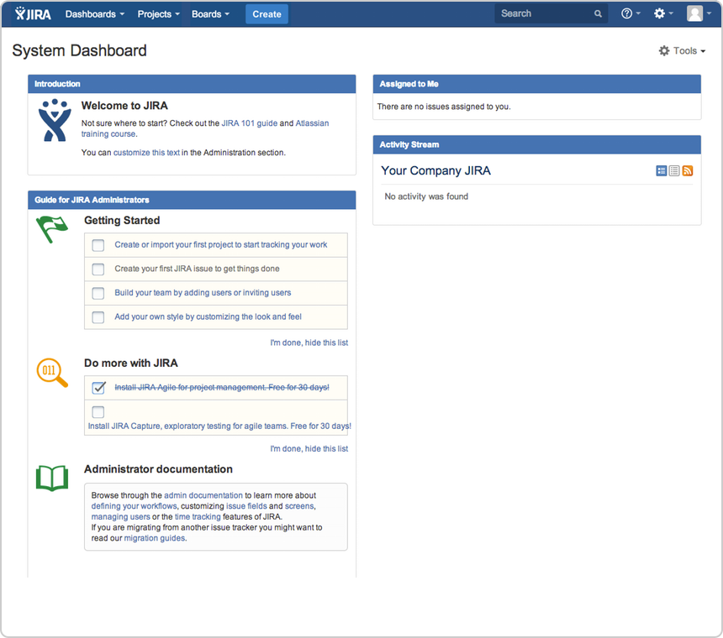
2. Choose **Projects** > **Create project**, and then select your project type. Typically, you would choose 'Scrum software development' for iteration planning, or 'Kanban software development' for constraint-based task management.   
   For this tutorial, let's do Scrum since most software developers use scrum in agile projects.
3. Choose **Scrum software development**> **Next**.   
   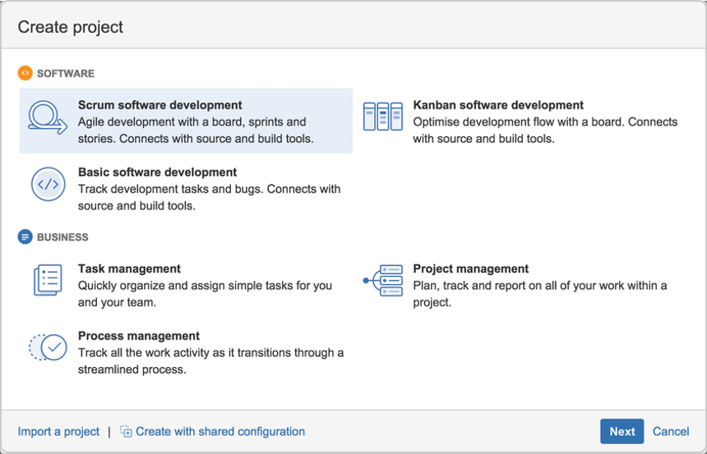
4. In the Name field, enter **Teams in Space**.
5. Choose **Submit**to create your new project.

View your Scrum board  

A Scrum board is automatically created with your new project. Use your Scrum board to view and work on issues, such as new features or bugs. You can rank, view, edit, and track issues on your scrum board via the **Backlog**, **Active sprints**, and **Reports**.

This is what your Scrum board will look like:

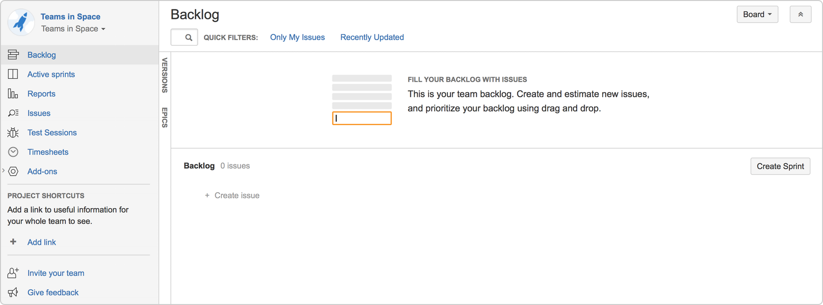

Add users

A software team without any members just won't cut it! Let's go ahead and configure Teams in Space's development team. The team consists of you (the manager) and two developers (Jennifer and Kevin).

1. Choose**https://confluence.atlassian.com/jirasoftwarecloud/files/800707660/800707661/1/1454495569737/bluecog-icon.png**>**User management**.
2. Select **Users.**
3. In the Create new users page, enter the following details for each user:

|  |  |
| --- | --- |
| **Full name** | **Email address** |
| Jennifer Evans | [**jevans@veryrealemail.com**](mailto:Ellie@email.com) |
| Kevin Campbell | [**kcampbell@veryrealemail.com**](mailto:Ellie@email.com) |

1. Click **Create users**.

Configure estimation and tracking

One of the first things you need to do for a new Scrum project is to configure estimation and tracking. This is essential for understanding how much work your team has and how much it can do, as you build a backlog, run sprints, and review reports.

Scrum teams use different methods to calculate the amount of work involved in completing an issue, and in turn, a sprint. Many teams separate ***estimation*** (used for measuring the amount of work in the backlog and calculating velocity) from ***tracking***(used for measuring burndown of hours used during the sprint), using different units for each. For example, some teams *estimate* tasks in *story points*, then *track* tasks using *hours*.

In this tutorial, Teams in Space uses story points for both estimation and tracking, as per the instructions below.

1. Navigate to the desired board, then click  **Board** >  **Configure**.

1. Click the **Estimation**tab.
2. In the **Estimation Statistic** field, select **Story Points**. Leave the **Time Tracking** field set to None.  
   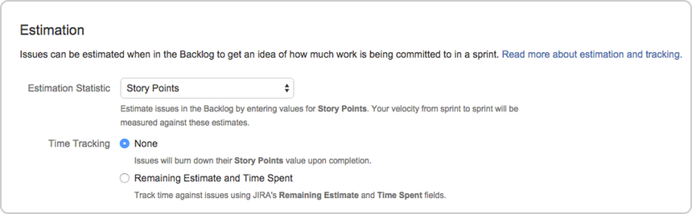

## Backlog

The Backlog gives you a place to organize your sprints. You can create new issues or sub-tasks, organize your backlog, create versions, organize via epics, and start sprints.

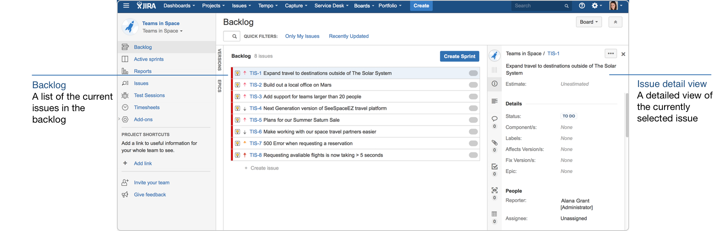

## Create issues

By default, any team member can create issues. In this tutorial, however, you will create all of the backlog issues.

1. On the Teams in Space board, choose **Create** at the top of the screen.

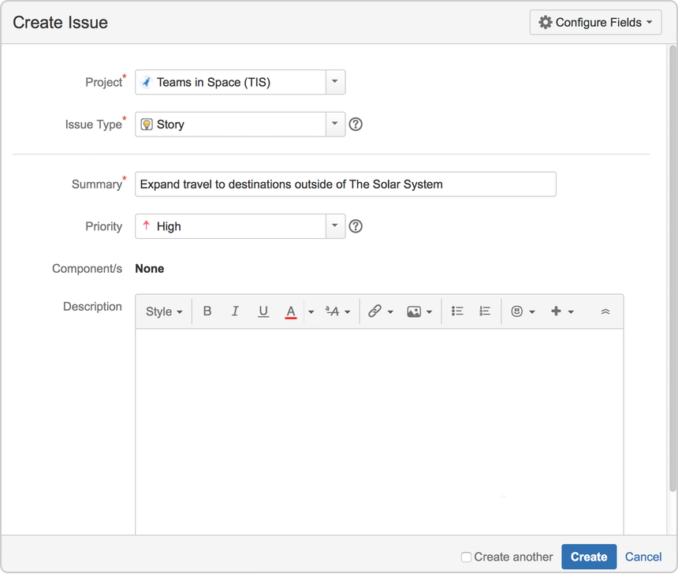

Fill in the fields using the data shown below. Only the fields with * are mandatory.

* + **Project:** Teams in Space
  + **Issue Type:** Story
  + **Summary:** Expand travel to destinations outside of The Solar System
  + **Priority:** High
  + Leave all other fields blank or at their default values.

1. Choose **Create** to make a new issue. An issue key (**TIS-1)**is created for this issue, which comes in handy when searching for issues later.

**Tip!** If you select the **Create another**checkbox, JIRA Software will create your issue and automatically pre-populate a new 'Create Issue' dialog box with your previous issue details.

### Add more issues

One issue isn't enough to get your team working! Let's add more issues so you can create and run a complete sprint. Create the following issues using the same steps as above.

|  |  |  |
| --- | --- | --- |
| **Type** | **Summary** | **Priority** |
| Story | Build out a local office on Mars | High |
| Story | Add support for teams larger than 20 people | High |
| Story | Next Generation version of SeeSpaceEZ travel platform | Low |
| Story | Plans for our Summer Saturn Sale | High |
| Story | Make working with our space travel partners easier | Low |
| Story | 500 Error when requesting a reservation | Medium |
| Story | Requesting available flights is now taking > 5 seconds | Highest |

Adjust your backlog

Before starting your sprint, you need to prepare your backlog. You can easily adjust your backlog by:

* Right-clicking on issues to view, estimate, or add details
* Ranking your issues by dragging and dropping
* Creating new issues
* Editing an issue using the issue detail view

Estimate issues

Now, let's add some estimates to the issues in our backlog. This way, you can easily determine what you can accomplish, and your team can also have a way of measuring the success of the sprint.

1. On the Teams in Space board, select **Backlog**.
2. Select each issue on the left-hand side of the screen to display the issue details on the right-hand side of the screen.
3. Click the **Estimate** field on the right-hand side of the screen for each of the issues, and enter the following information for each issue:

|  |  |
| --- | --- |
| **Issue** | **Estimate** |
| Expand travel to destinations outside of The Solar System | **6** |
| Build out a local office on Mars | **2** |
| Add support for teams larger than 20 people | **4** |
| Next Generation version of SeeSpaceEZ travel platform | **3** |
| Plans for our Summer Saturn Sale | **8** |
| Make working with our space travel partners easier | **16** |
| 500 Error when requesting a reservation | **6** |
| Requesting available flights is now taking > 5 seconds | **4** |

Rank the backlog

By default, the issues in your backlog are ranked in the order in which you added them. You can change the rank of your issues according to their relative priority. This helps you organize the issues in your backlog more effectively.

Rankings let you determine whether an issue is more important or urgent than another issue. For example, you may have two separate issues that are both of 'High' priority. Using JIRA Software ranking, you can assign one of the issues a higher ranking than the other.

1. Find issue **TIS-8**in your backlog. This issue has the 'Highest' priority, and therefore should be at the top of your backlog.
2. Select **TIS-8** and drag it to the top.
3. Move issues **TIS-2** and **TIS-5** to positions two and three in the backlog. These issues have 'High' priority, but they're not as high a priority as TIS-8.

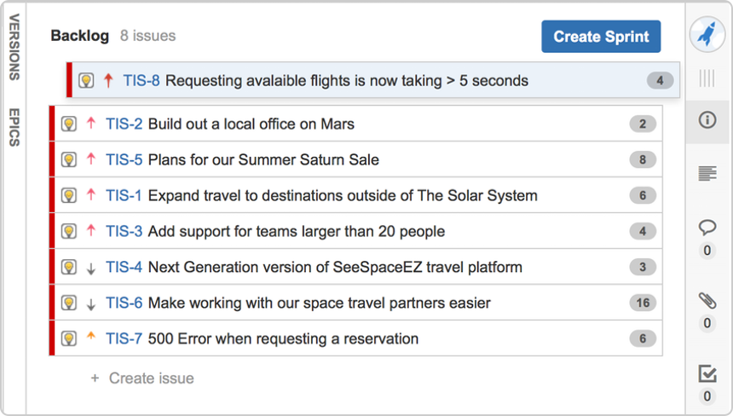

Sprint planning

Before creating and starting a sprint, your Scrum team would typically hold a sprint planning meeting. In this meeting, your team should:

* Review the estimates for selected issues
* Break down the selected issues into an initial list of sprint tasks
* Consider upcoming employee time-off, holidays, and other issues that may impact the completion of these sprint tasks
* Gauge the team's capacity team to complete these sprint tasks

By the end of the meeting, your team should be confident enough to commit to completing the work in the sprint.

In this tutorial, we will assume that the Teams in Space team can handle 20 story points of work in a sprint, and that everyone is available for the full sprint. Typically, you would know how much work your team can complete in a sprint by reviewing information from past sprints, usually through velocity and sprint reports.

**Need help scheduling?**

By using JIRA Software in tandem with Confluence, you can embed your sprints using Team Calendars for Confluence. This helps you see the duration of your sprint and how your team's availability or other team events could impact the sprint.

Create a sprint

1. On the Teams in Space board, click **Backlog**.
2. Click **Create Sprint** at the top of the Backlog.
3. Your new upcoming sprint will be added to your board, below any other future sprints. Select the **Sprint 1** text and edit the name of the sprint to 'Spring Cleanup'.
4. The top 4 issues in the Backlog are equal to 20 story points. This is what the team estimated that they could accomplish in the upcoming sprint. Drag and drop the top four issues from the Backlog into your new sprint.  
   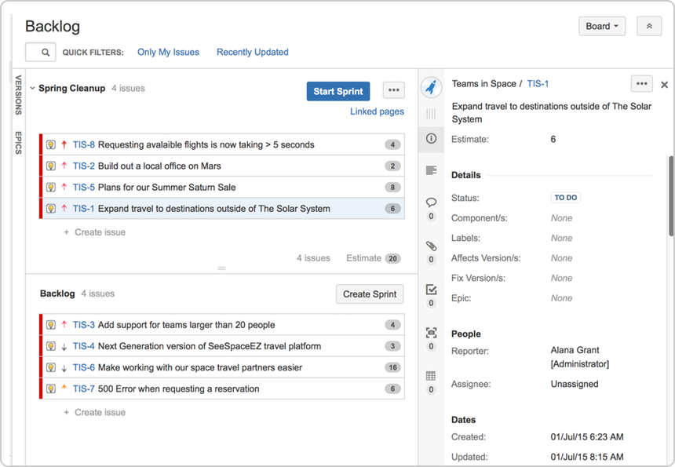

**Streamline your work**

By connecting your JIRA Software instance to a[Confluence](http://www.atlassian.com/software/confluence/)instance, you can link Confluence pages to your sprints via JIRA Software to build stronger user stories and to better plan for sprints or releases. For example, you may want to write up the sprint meeting notes in Confluence and link them to the sprint.

Start your sprint

Now that you have created a sprint, you can go ahead and start it.

1. Click **Start Sprint**.
2. Today's date and current time become the start date and time for the sprint. For the purpose of this tutorial, enter an end date of 5 minutes from the start date and time.
3. Select **Start** to start the sprint and move the issues into Active sprints.

Active sprints

The **Active sprints** page is where you monitor the progress of your team's work during a sprint. Here, your team can transition issues through a series of columns (statuses), allowing everyone to quickly visualize the progress being made in the sprint. You can also edit issues by adding information, such as descriptions, attachments, and comments.

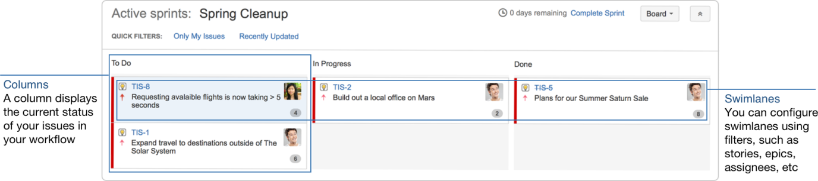

**More about Active sprints**

Issues that you ranked higher in your backlog appear at the top of the column, to make it easier for users to select the most important issue to work on.

Transition issues

During the sprint, let's say your team was only able to finish three issues, TIS-1, TIS-2, and TIS-5. Issue TIS-8 remains in the 'To Do' column since no team member was able to work on the issue. Let's show on the board what happened during the sprint by transitioning issues from one column to another.

1. On the Teams in Space board, click **Active sprints**.
2. Select **TIS-5** and move the issue to the 'In Progress' column.  
   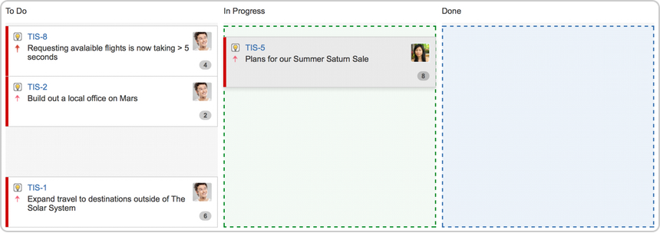
3. Select **TIS** **-5**,**TIS-2**,and **TIS-1**, and then move the issues to the 'Done' column.

**Tip!**

Use <Ctrl> or <Shift> to select multiple issues, and then drag and drop the issues to a column.

View the Burndown Chart

You've just seen how your team is progressing, from the Active sprints of your board. The Burndown Chart is another useful tracking tool, which can help you visualize your team's progress, as well as determine whether your team is on target to achieve the sprint goal.

1. On the Teams in Space board, click **Reports**.
2. Select **Burndown Chart**.  
   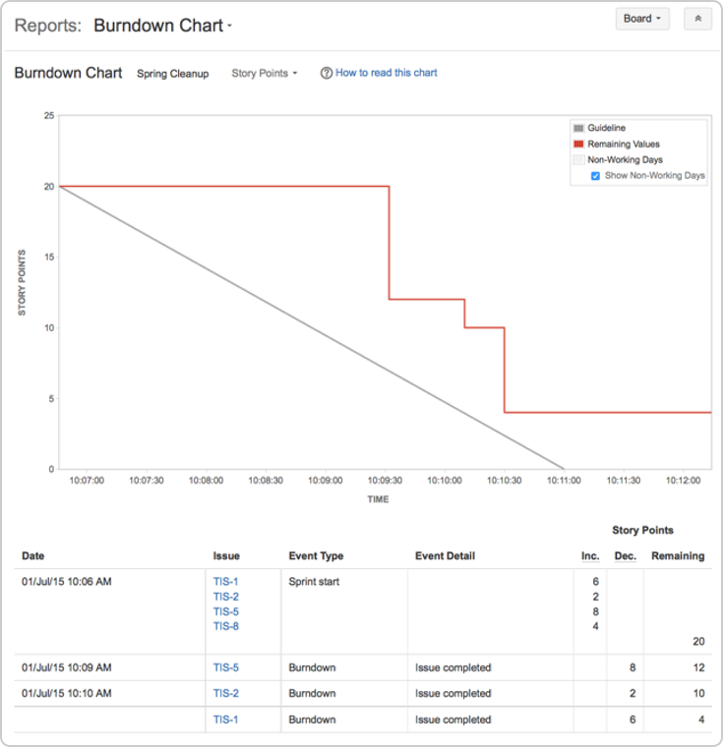

The grey line in your Burndown Chart is a guide showing the rate of work required to complete the sprint. The red line, on the other hand, shows the actual work completed by your team.

If your Burndown Chart shows the red line above the grey line, your team may not achieve the sprint goal. You may want to consider removing some issues from the sprint. Any changes to scope (e.g. issues added to sprint, issues removed from sprint) are shown in the table below the graph.

## End the sprint

Once your team reaches the end date of the sprint, you need to end the sprint — regardless if this means some issues in the sprint are not yet completed.

1. On the Teams in Space board, click **Active sprints**.
2. Select **Spring Cleanup** from the Active sprints drop-down.
3. Click **Complete Sprint**. The Complete Sprint dialog box will be displayed, showing the number of issues that are completed in the sprint, and the number of issues that were not completed.   
   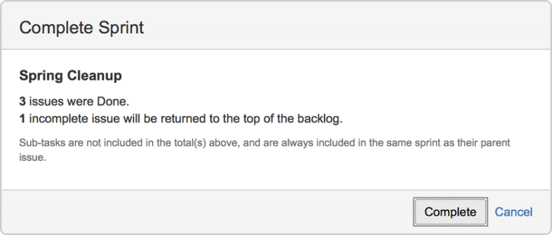

In this case, the incomplete issues are moved to the backlog. However, if you had more sprints planned, then they would be moved to the next planned sprint. Note, you can always add issues that are returned to the backlog to another sprint, if you wish.

## View the Sprint Report

After a sprint, your team can hold a sprint retrospective meeting, to determine your wins for the sprint, as well as point out the potential areas of improvement that your team can tackle in future sprints. You can use the Sprint Report during sprint retrospective meetings to do this.

The Sprint Report shows a status list of issues in each sprint. It also provides a breakdown of the progress, status, and estimation information for each issue. You can also use the Sprint Report to perform progress checks in the middle of a sprint.

**Looking for more reports?**

There are many other reports available for your team to use in the Reports page. You can also create your own reports, or use reports in the Atlassian Marketplace.

1. On the Teams in Space board, click **Reports**.
2. Select **Sprint Report** from the Reports drop-down.
3. Select **Sprint 1** from the Sprint Report drop-down.  
   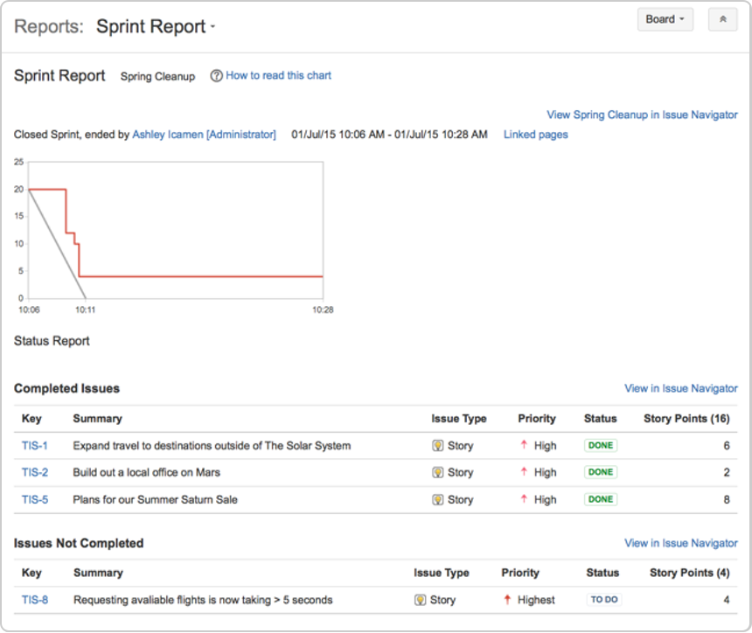

## Other tools you can use

Other useful tools can give your team a better visual of the improvement areas – and more importantly, these tools can help your team figure out action plans for these areas. For this tutorial, some of the tools you may want to use are:

* Velocity Chart
* Release Hub

### Velocity Chart

You can use the Velocity Chart to track the amount of work your team completes from sprint to sprint. Using the Velocity Chart lets you predict a more realistic amount of work that your team can commit in future sprints.

1. On the Teams in Space board, click **Reports**.
2. Select **Velocity Chart**from the Reports drop-down.  
   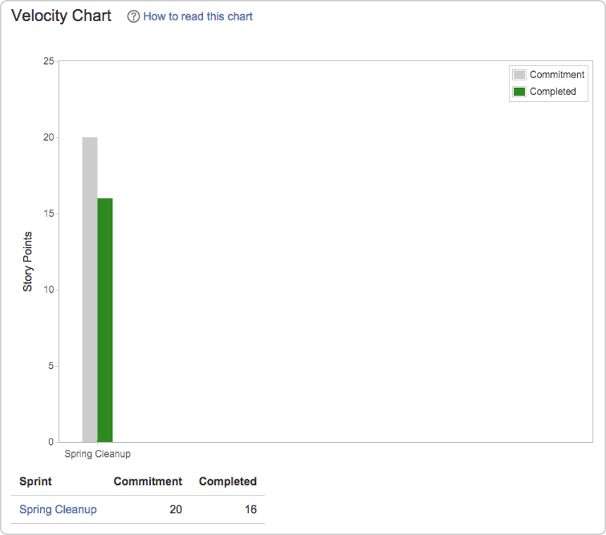

### Release Hub

Aside from using reports (like the Sprint Report and Velocity Chart), you can also monitor the progress of a version after you complete a sprint. Monitoring a version's progress helps you see problems early, as well as determine the likelihood of releasing a version on time.

### Workflows

A workflow is a set of statuses and transitions that an issue goes through during its lifecycle. JIRA Software makes it easy to create and edit workflows that fit your team's needs. Click [here](https://confluence.atlassian.com/jirasoftwarecloud/workflows-764478422.html) for more information on creating and editing workflows.

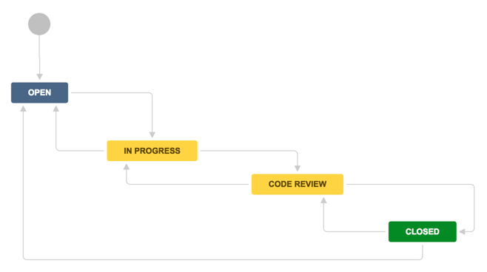

### Development panel

JIRA Software can be connected to a range of development tools, such as repository managers, code review applications, and build and deployment managers. These tools can help you keep your project tracking in sync with your development work. Click [here](https://confluence.atlassian.com/jirasoftwarecloud/configuring-development-tools-764478056.html) for more information on integrating development tools.

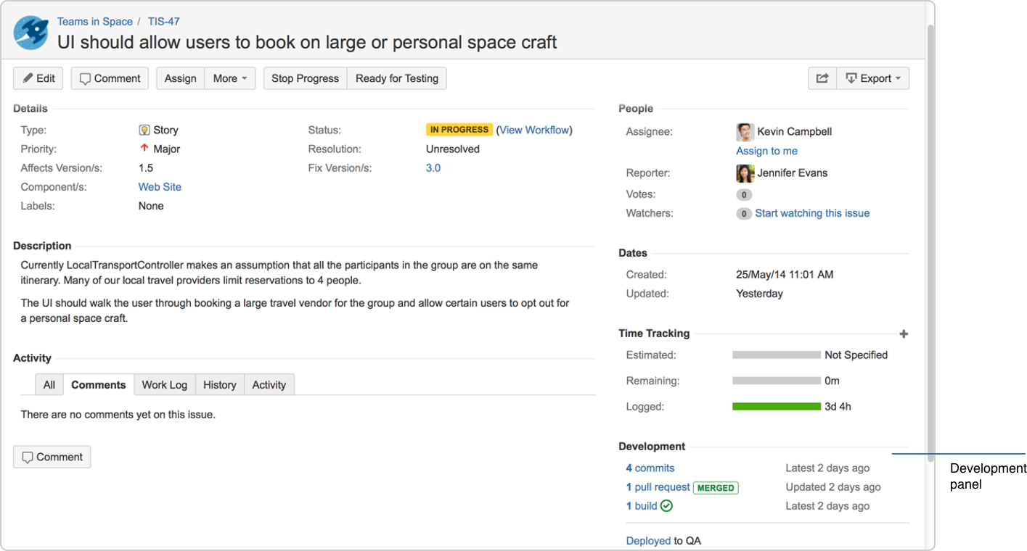

### Notifications

Email other JIRA users a link to an issue either by sharing the issue with them, or by mentioning them in an issue's **Description** or **Comment** field. See [Editing and collaborating on issues](https://confluence.atlassian.com/jirasoftwarecloud/editing-and-collaborating-on-issues-764478442.html) for more information on notifications in JIRA Software.

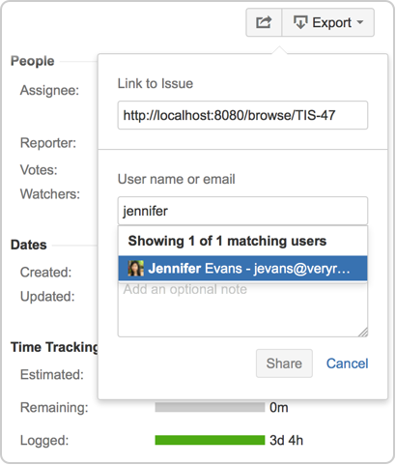

### Custom cards

Customize issue cards for your boards to bring the right information to your team's attention at a glance.You can change the card colors to help people quickly identify cards on your board as being of a particular issue type, priority, assignee, or any JQL that you want. Click [here](https://confluence.atlassian.com/jirasoftwarecloud/customizing-cards-764478020.html) for more information on custom cards.

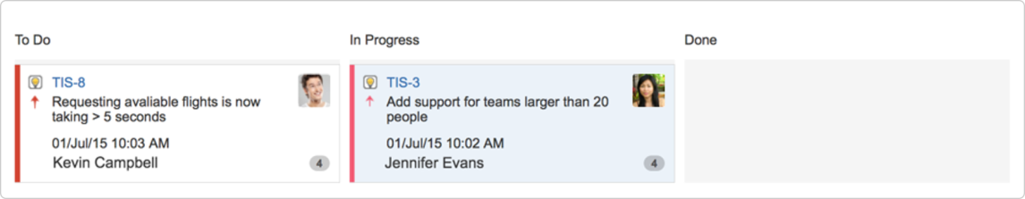

### Confluence integration

You can link your JIRA Software instance to a Confluence instance to create and link Confluence pages to your [sprints](https://confluence.atlassian.com/jirasoftwarecloud/linking-a-confluence-page-to-a-sprint-764478134.html) and[epics](https://confluence.atlassian.com/jirasoftwarecloud/linking-a-confluence-page-to-an-epic-764478100.html). For example, you can link your sprint meeting notes in Confluence directly to the relevant sprint. This makes it easy for your team to quickly share information about the sprint. Click on [sprints](https://confluence.atlassian.com/jirasoftwarecloud/linking-a-confluence-page-to-a-sprint-764478134.html) or [epics](https://confluence.atlassian.com/jirasoftwarecloud/linking-a-confluence-page-to-an-epic-764478100.html) for more information on linking your project to Confluence.

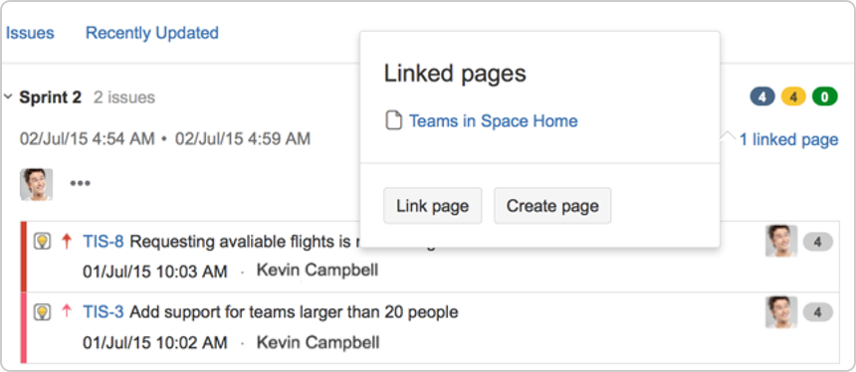

### Wallboards

A wallboard runs on a wall display and is used to monitor vital data about a project's progress. You can use wallboards to share information with your team during stand-ups. You can also add gadgets to a wallboard – make sure to add gadgets that are useful to your team, such as a gadget that displays the status of a sprint, including issue status, time remaining, and build status. Click [here](https://confluence.atlassian.com/jirasoftwarecloud/gadgets-for-jira-applications-764478208.html) for more information on creating wallboards and setting up other gadgets for JIRA Software.

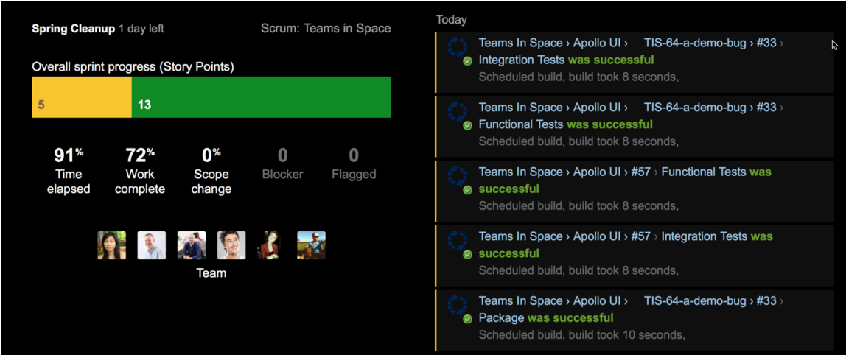

Getting started with Jira as a User:

Find your issue

There are a number of ways to navigate around your project, but the easiest way to view information is by using boards. A board displays issues from one or more projects – it gives you a flexible way of viewing, managing, and reviewing your work. In this step, we describe how you would typically find an issue to work on, in the active sprint of the board of a Scrum project.

1. Select **Boards** from the top menu, and then select a board from the drop-down list.
2. Select **Active sprints** to see the issues in the sprint of the selected board.
3. Issues are represented by issue cards in the Active sprints of your board. The cards show quick reference information, like issue keys, assignees, and descriptions. Locate the top card in the **To Do** column and drag it to the **In Progress** column. By doing this, you are actually moving to assign the issue to yourself, and start working on it.  
   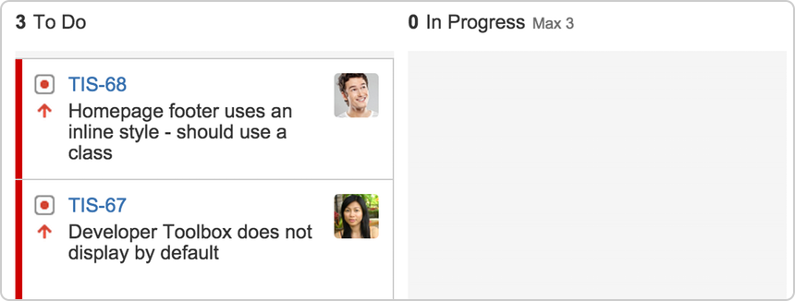 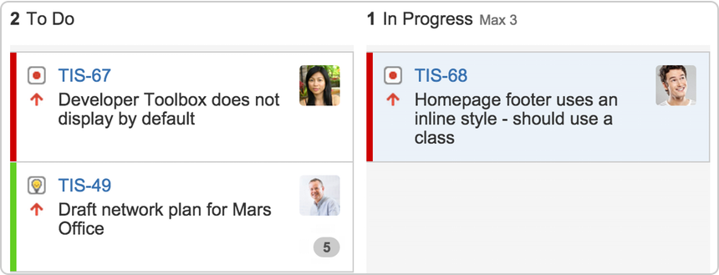

Work on an issue

By moving an issue to In Progress, you are indicating that work has started on it. At this stage, you will need to assign it to yourself, so that everyone knows who is working on it. You may also want to add some technical details about the issue – it's helpful for your teammates to know as much information as possible about the issues you're working on.

1. In the **Active sprints** of your board, select the issue in the **In Progress** column. The issue is displayed in the Issue Detail view.
2. In the Issue Detail view, select **Edit** from the 'cog' drop-down. The 'Edit Issue' dialog will be displayed.
3. If the issue is not assigned to you yet, type your name in the **Assignee** field.
4. Add some technical details about the issue as necessary.  
   Note, you may want to specify a component or a version (if components and versions have been configured for your project), or add attachments as needed, etc.
5. When you're done adding technical details, click the **Update** button.

Collaborate with your team

While you're working on an issue, you will probably need to share some information, clarify some requirements, or discuss some details about the issue with your team. This is easy to do with issue comments.

1. Select the issue to add a comment.
2. In the Issue Detail view,locate and click the **Comment** button.
3. In the **Comment** text box, type your comment.
4. To email other users about your comment,simply mention these users in the **Comment** text box (by typing @User's Name). An email will be sent to the users' email addresses that are registered with their JIRA accounts.
5. Click the **Add** button to save the comment.

Create a branch

After assigning an issue to yourself and entering technical details about the issue, you're ready to do some coding. It is recommended that you create a branch when you start working on an issue. This way, you'll have your own stream of work that won't interfere with the rest of the team's work. It also ensures that your changes get reviewed before being merged back into the master branch.

JIRA Software can be linked to a code hosting or repository management source, like [Bitbucket Cloud](https://confluence.atlassian.com/bitbucket/bitbucket-cloud-documentation-home-221448814.html) or [Bitbucket Server](https://confluence.atlassian.com/bitbucketserver/bitbucket-server-documentation-home-776639749.html). This lets you open, collaborate, and manage source code directly from within JIRA. Integrating an application lets you and your team create a branch directly from an issue, giving you a faster workflow from selecting an issue to coding.

Before creating a branch, you should already know how to use branches in the source repository that your team is using ([Bitbucket Cloud instructions](https://confluence.atlassian.com/bitbucket/branch-or-fork-your-repository-221450630.html), [Bitbucket Server instructions](https://confluence.atlassian.com/bitbucketserver/using-branches-in-bitbucket-server-776639968.html)).

1. Select the issue for which you want to create a branch.
2. In the Issue Detail view, locate the **Development** panel, and click **Create branch**. The Create branch dialog will be displayed.
3. Include the issue key in the branch name. If you have workflow triggers configured, the status of the issue may automatically transition to 'In Progress'. See [Configuring workflow triggers](https://confluence.atlassian.com/adminjiracloud/configuring-workflow-triggers-776636696.html) for more information.
4. Enter other details for the branch as necessary.
5. Click the **Create branch** button. Your branch will be created in your source repository.

Start coding

Now that you have created a new branch, you can start coding without worrying about your changes affecting the master branch. Ensure that you add the issue key that references the issue that you're working on. When you [reference your issue key(s) in your development work](https://confluence.atlassian.com/jirasoftwarecloud/referencing-issues-in-your-development-work-777002789.html), your connected development tools will also have links back to the relevant issues.

1. Go to your source repository where you new branch is created, and access your new branch.
2. In your new branch, implement your code or fixes as necessary.

Send your work for review

Use pull requests to tell your teammates about changes you've pushed to the repository. Once a pull request is sent, your team can review, discuss changes, or push follow-up commits.

1. Click **branches** in the Development panel to open a dialog in JIRA Software that shows linked branches in the Software Configuration Manager(SCM). If JIRA Software has been linked to more than one SCM, a tab will show for each SCM application (e.g. Bitbucket Server). The branches will be grouped under each SCM in these tabs.  
   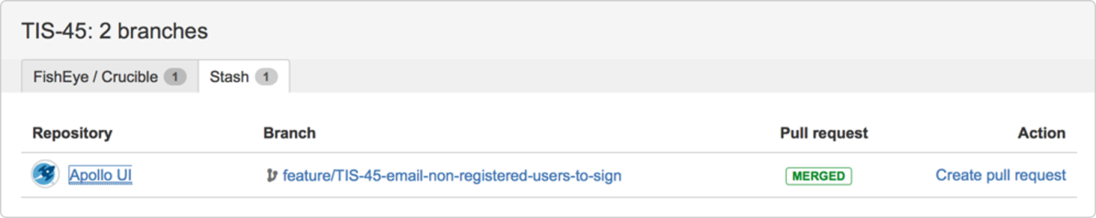
2. Click a repository or branch to open the linked SCM at the relevant repository or branch.
3. Hover over a **Pull request** status (e.g. **MERGED**) to show a popup displaying a link to the pull request.
4. Click **Create pull request** to create a pull request for the branch (to merge it back to master).
5. Include the issue key in the title of the pull request. If you have workflow triggers configured, the status of the issue may automatically transition to 'In Review'. See [Configuring workflow triggers](https://confluence.atlassian.com/adminjiracloud/configuring-workflow-triggers-776636696.html) for more information.

Finish your work

After you work has been reviewed and merged with the master branch, the last step is to close or resolve the issue.

1. Locate your card in the **Active sprints** of your board.
2. Drag and drop the card to the **Done** column. If you have workflow triggers configured, the status of the issue may automatically transition to 'Closed'. You can skip the next steps. See [Configuring workflow triggers](https://confluence.atlassian.com/adminjiracloud/configuring-workflow-triggers-776636696.html) for more information.
3. Select the **Resolution** for the issue from the drop-down menu.  
   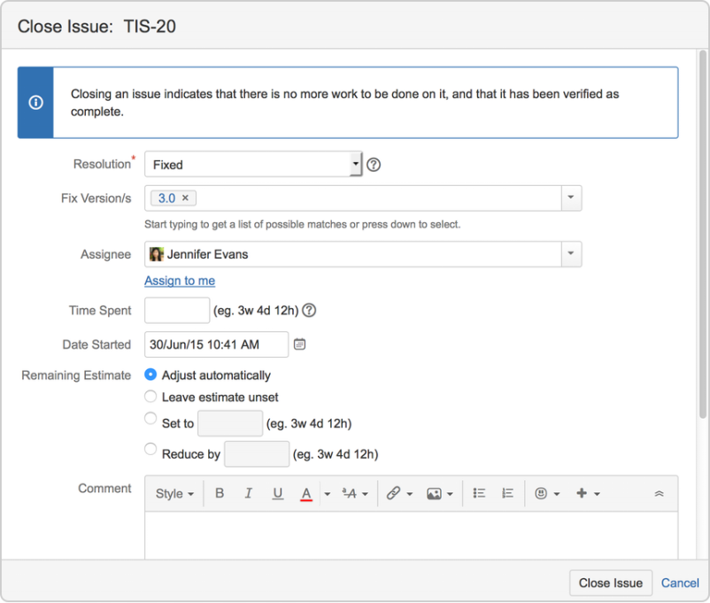
4. Provide details as necessary.
5. Select **Close Issue**.