**Introduction**

[Rational Quality Manager](http://www-01.ibm.com/software/rational/products/rqm/) (RQM) is a quality and test management tool created by IBM.

In RQM a test plan is a dynamic quality contract that evolves with the project tracking key criteria such as business objectives, exit and entry criteria, priorities, and requirement scope.

A test plan has test cases and test suites. This plugin is able to pull the test cases from a test plan and suite in RQM.

The plugin expands the logic of a test case by the convention that through the use of input fields for automatic test scripts. The plugin will contribute any input fields added to your automatic test script as an environment variable, which you can use to script your test execution.

**Setup**

The plugin appears as an "RQM Test Script Iterator" build phase option in the build phase.

The plugin requires that you enter the following values:

* **Project Name** - RQM Project you wish to use.
* **Test plan name** - Name of the RQM test plan to use, it must be within the project you chose above.
* **Execution records -** The execution records you wish to use as base.

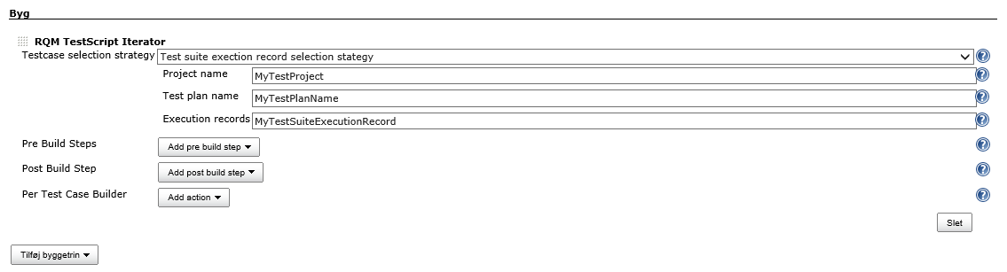

You'll also need to configure the global options for the plugin:

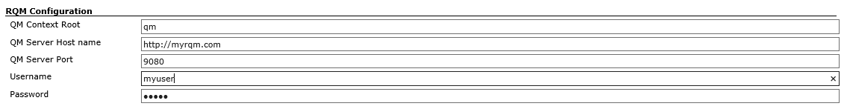

**How it works**

In order for the plugin to function the following assumptions are made:

1. Your RQM installation has a test plan with a test suite and a test suite execution record.
2. The plugin expects that your RQM test scripts have a number of input fields assigned.
3. The plugin will add the value of these fields as environment variables as key-value pairs. For example if your automatic test script has an input field named Script, an environment variable is added to each build step added in the "Per Test Case builder" and can be printed and used like so: %SCRIPT%
4. Then you can add buildsteps to use the extracted values

This is an example. In this case i will for each testcase and selected testscript i echo the value of the "Script" input parameter in a build step. This can be used to script your test execution.  
