**RQM-Jenkins Integration**

How to install Command Line Adapter

**Pre-requisites**

Before running this adapter, please make sure that

- java.exe is accessible in the path. The version of JAVA required is 1.5 or later

- the input information is available to start the adapter, namely

o the Jazz repository URL, typically http://<qmserver>:<port>/qm

o a user ID to login to RQM that has appropriate licenses to login as an adapter

o the password or this user

o the project area to which the adapter is being logged in

**Procedure**

1. Obtain the *install-location*\server\conf\qm\adapters\RQMCommmandLineAdapter.zip file from the installation machine.

Note: A server administrator who has read access to the server might need to get the compressed file for you.

1. Extract the RQMCommmandLineAdapter.zip file to a folder on the target test machine.
2. Start the command-line adapter.
3. To start the command-line adapter for the first time:

Run the batch file with the command line arguments as shown:

C:\ start.bat -repository https://qmserver:port/qm -user userid -password password [-adapter adapter]

[-projectArea project area] [-sleepTime sleeptime] [-configFile configuration file]

Here the command is as follows:

E:\RQMCommandLineAdapter>start.bat -repository https://bsd-pc1528497:9443/qm -user clmadmin -password clmadmin -adapter Adapter87 -projectArea POC-RQM-CQ [-sleepTime 10] [-configFile config.ini]

where:

-***qmserver***: is the hostname or IP address of the quality management server.

-***port***: is the port where the quality management server is running

-***userid***: is a registered user ID for quality management that has the license to run an adapter.

*-****password***: is the password of the submitted user ID.

*-****adapter***: is an adapter name that the user has assigned.

*-****project******area***: is the name of the project being logged in to.

*-****sleep******time***: is the polling interval between polling for tasks. The default setting is 5 seconds.

*-****log******file***: is the file that logs output messages. The default file name is CommandLineAdapter.log.

***configuration******file***: is the file to store and read the settings for this adapter. The default file name isconfig.ini.

The adapter generates a configuration file (the config.ini file or the file that is specified in the -configFile option) to contain the registration information. This information is reused when the adapter is restarted.

You will see the following output when the adapter is created:

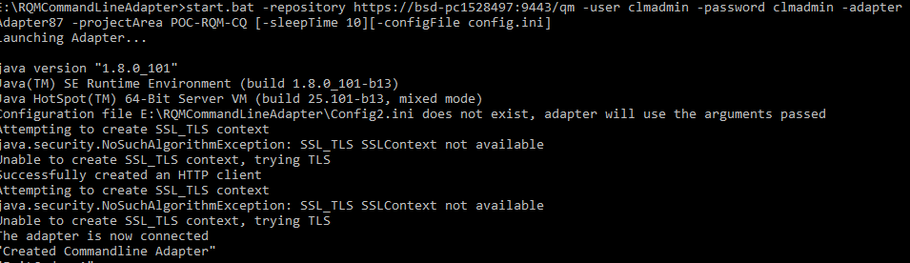

***To restart the command-line adapter from a config.ini file***:

Run the batch file(start.bat) without any arguments:

Note: The configuration file is expected to be in the directory that the adapter is started from.

**Results**

The system generates a message that is similar to this message:

Launching Command Line Adapter…

Configuration file adapterConfig.ini does not exist, adapter will use the arguments passed

Successfully created an HTTP client

The adapter is now connected

**What to do next**

You can verify the adapter state on the quality management application on the tester machine by clicking Execution > Adapter Console. Make sure the status is GREEN before you attempt to run a test against a running command-line adapter.

**Once you install the Command Line Adaptor then you configure in the Jenkins as per below**

**To Trigger Jenkins build from command line some perquisite are there**

1. Jenkins service is running.
2. Enable security option under “Configure Global Security”

Go to jenkins dashboard in Home page ( e.g http://localhost:8080/ ) -> Manage Jenkins  
-> Configure Global Security -> Click on “**Enable security**” checkbox

You can also configure “**Access Control**” and “**Authorization**” option in Global Security page.  
Jenkins allow us to trigger Jenkins build with any specific user, For that we have to pass username and password in command line.

[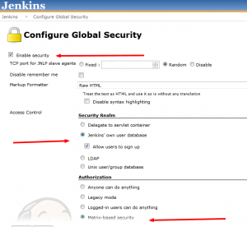](http://techieroop.com/wp-content/uploads/2014/07/Configure-Global-Security-Jenkins-2014-07-07-18-44-04.png)

Below command used to trigger Jenkins job from command line

java -jar jenkins-cli.jar -s http://localhost:8080/ build 'my-project-build' --username admin --password admin

Here the command used is:

java -jar jenkins-cli.jar -s http://localhost:7777/ build Test1 --username admin --password admin

**Triggering Jenkins Job from command line adapter in RQM:**

Before running a script to trigger Jenkins through command line adapter, make sure that you place **Jenkins-cli.jar** and the **script file to trigger Jenkins from command line** in the installation folder of Command Line Adapter.

**Note**: Script(batch file to trigger Jenkins) and jenkin-cli.jar should be in the same folder.

Create a test script and change the type to Command Line, as shown in figure.

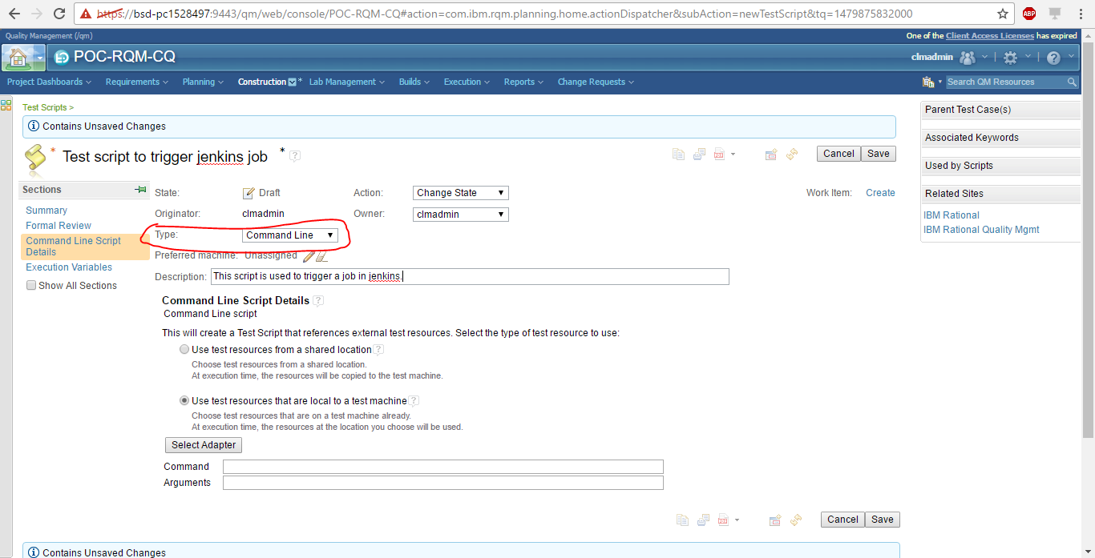

Click on Select Adapter to select the adapter you have installed.

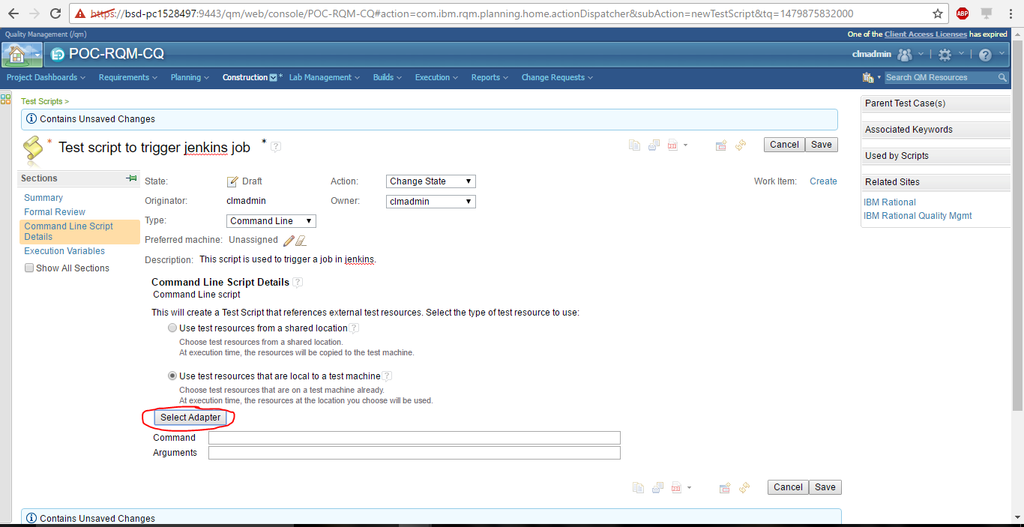

You can see the list of adapters available. Select the Adapter you wish to use and click on Next.

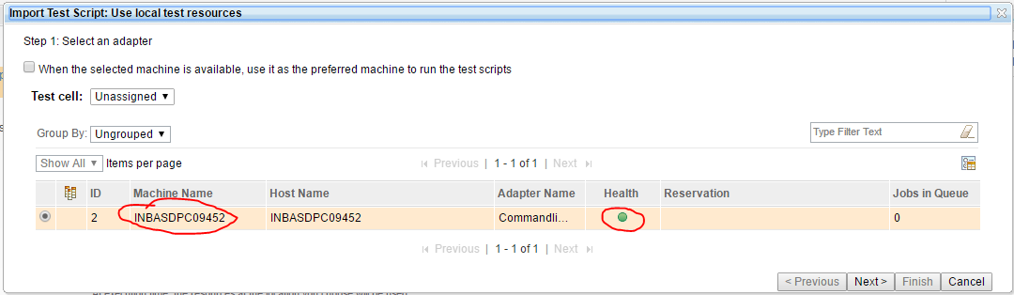

In Project Path field, give the path where the script and Jenkins-cli.jar are present.

Click on Go.(Here the path is Adapter installation folder)

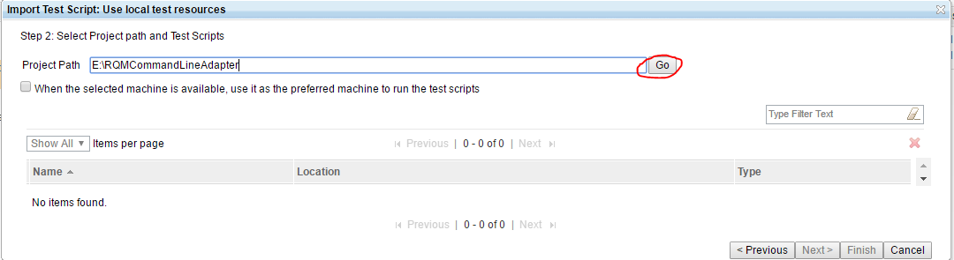

The next screen will display all the files present in the path you have provided.

Select the script which triggers the job in Jenkins.

Click on Finish.

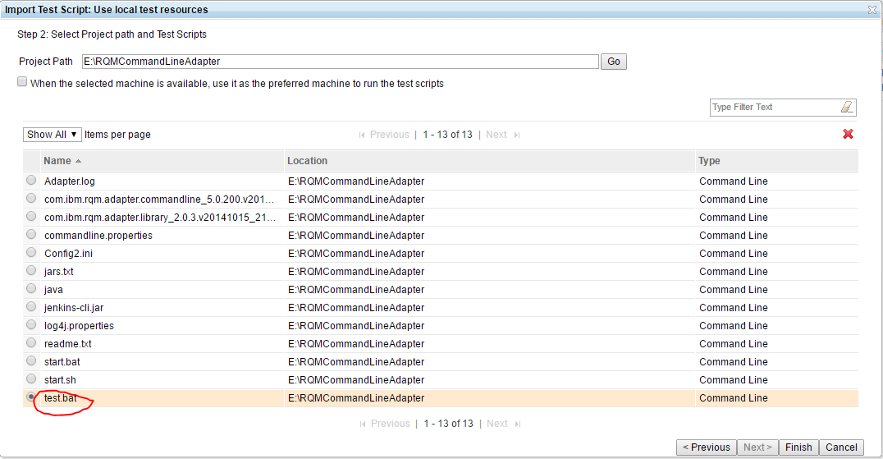

Create a test case and assign the test script which you have just created and run the test case.

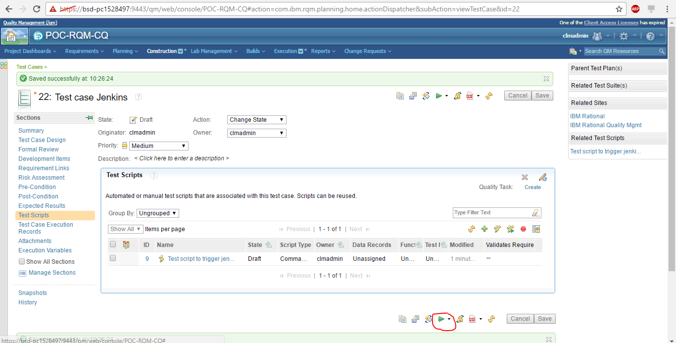

Provide the details in the Define Record Details window and Click Finish.

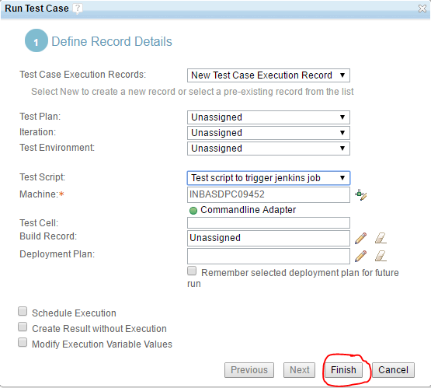

You can see that the test script is running.

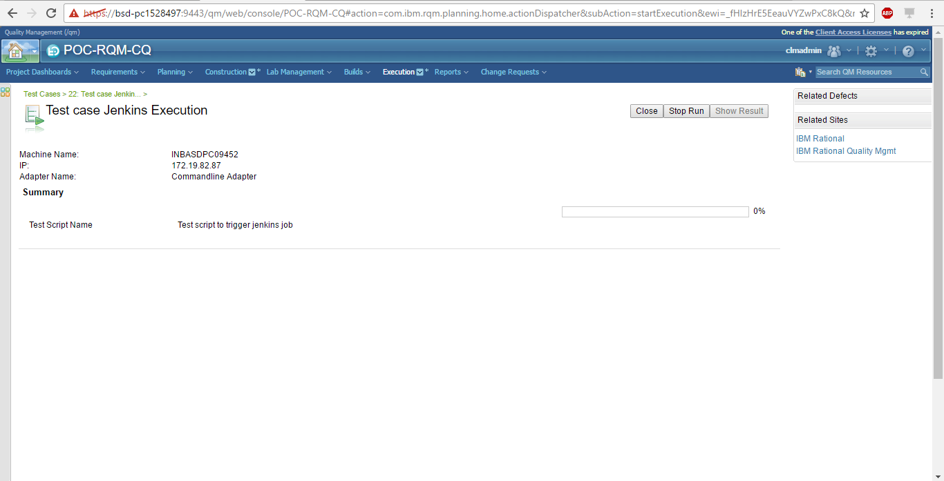

When the test script is executed, you can see the status as Done.

Click on Show Result to view the results of test script execution.

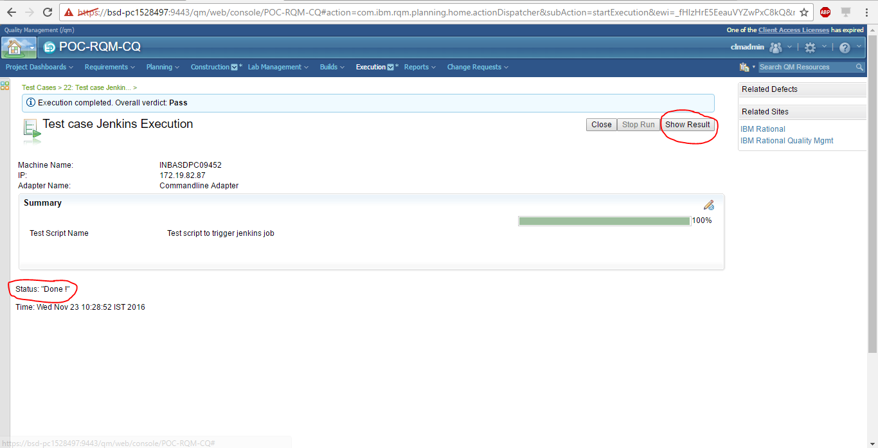

You can also view the output file in attachments.

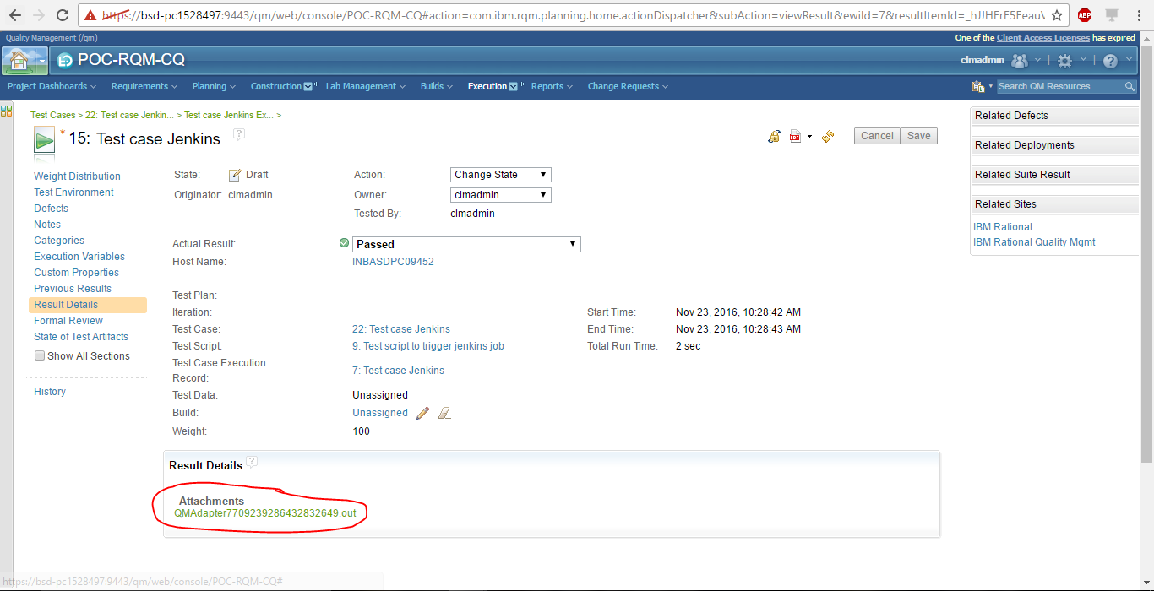

Output file:

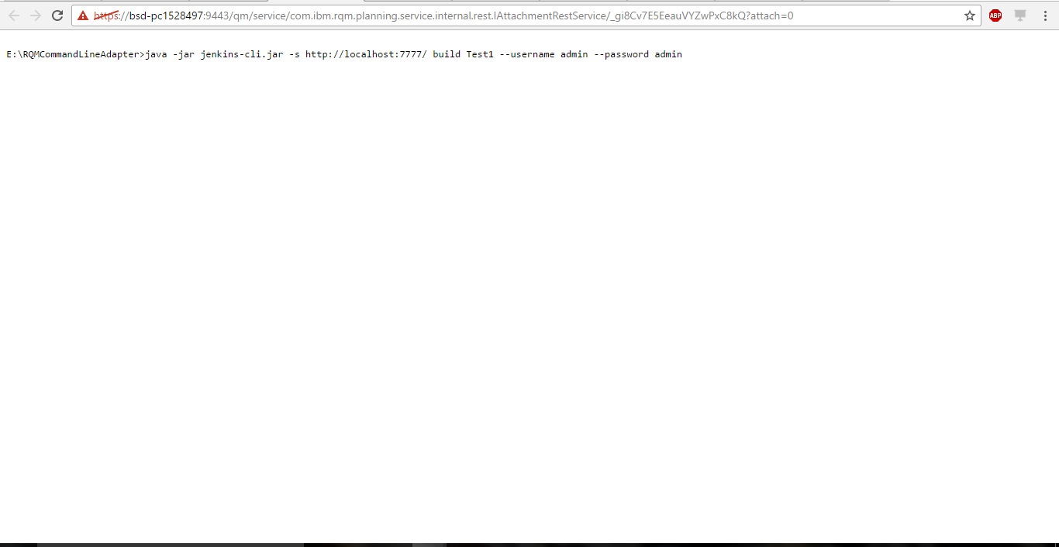

You can see that job is triggered in Jenkins.

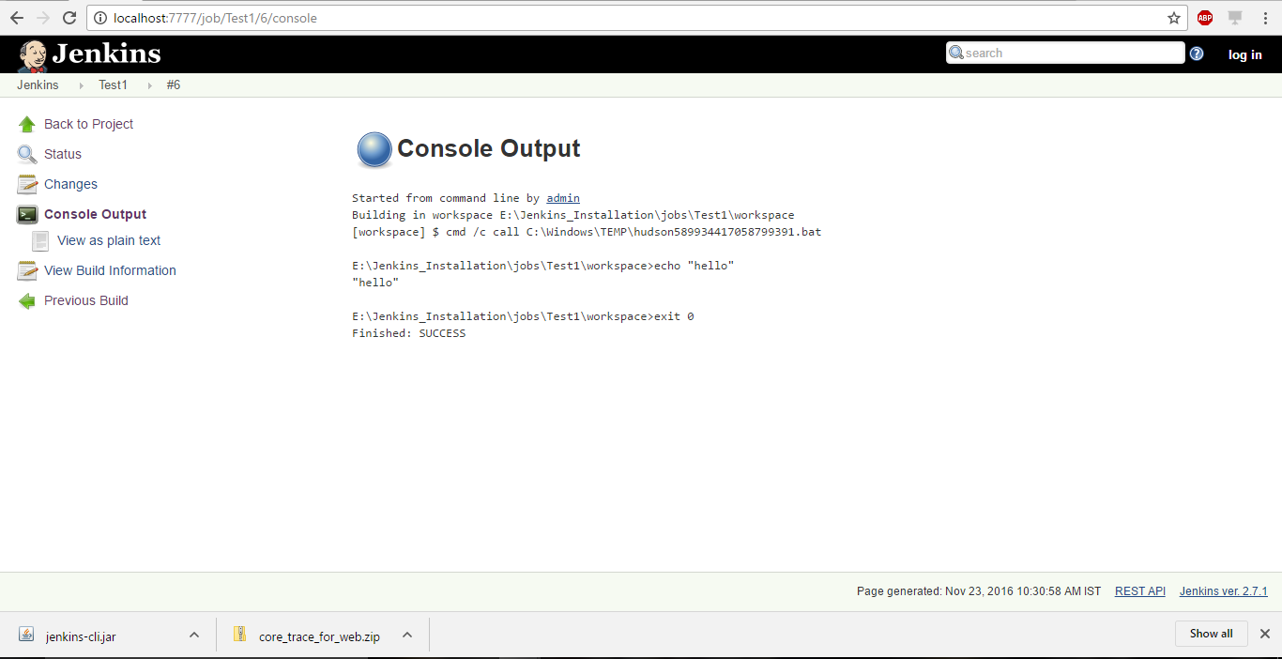

Server is not running

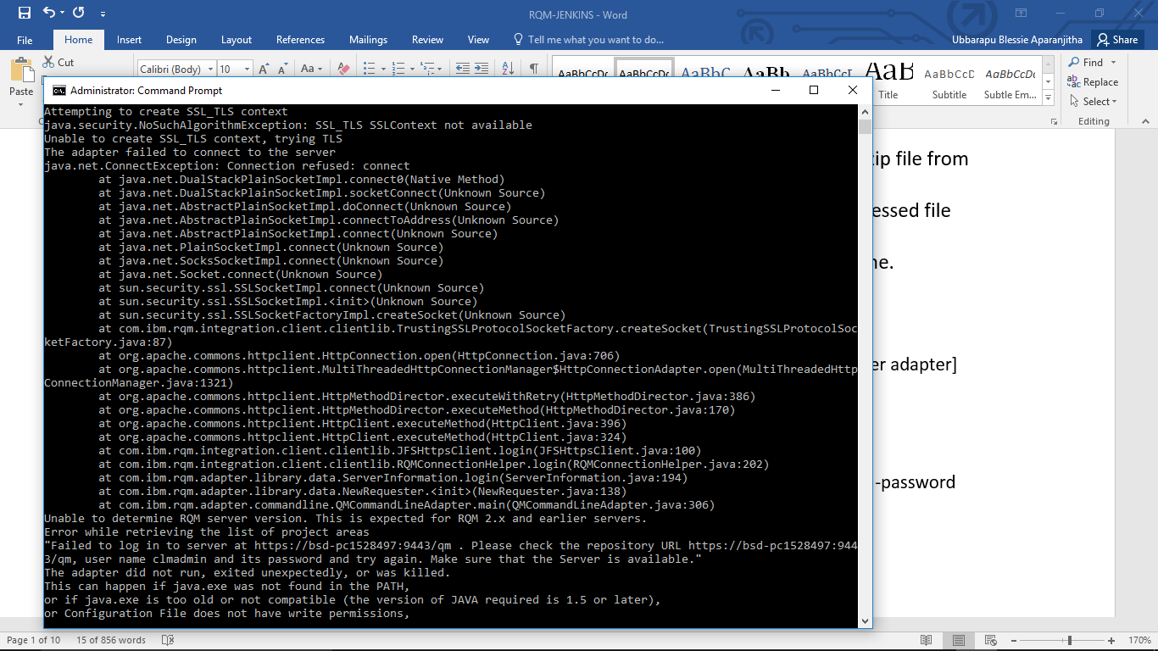

Wrong password

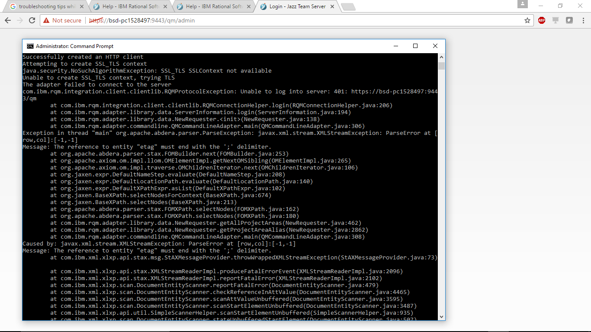

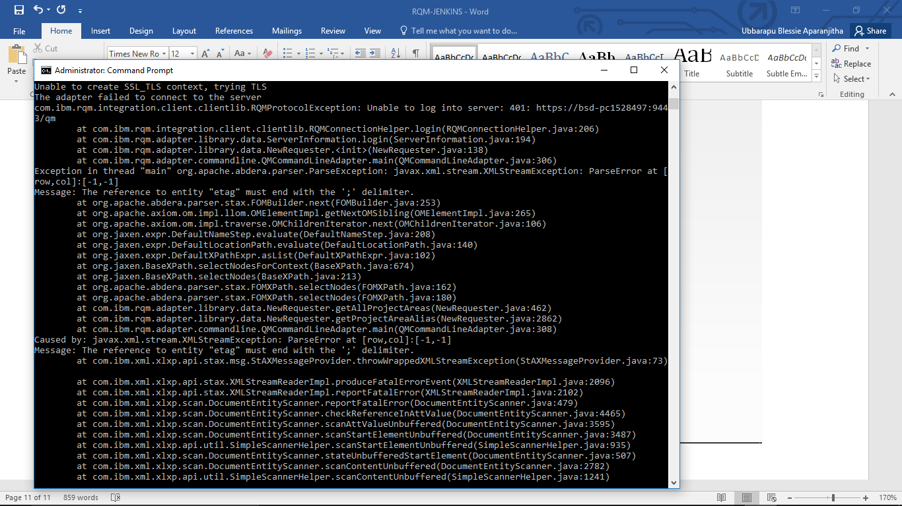

Wrong user name

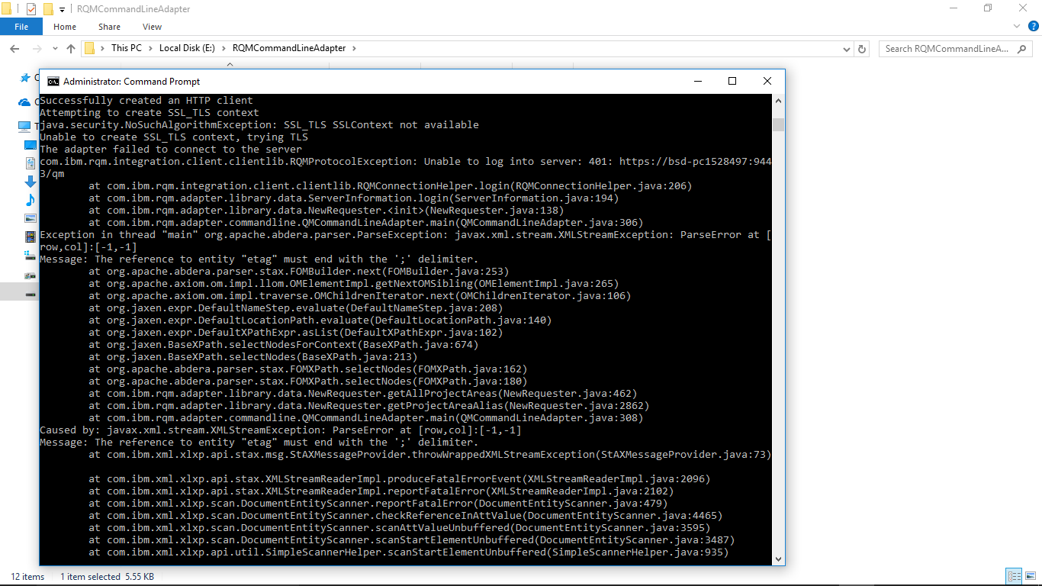

Wrong project name

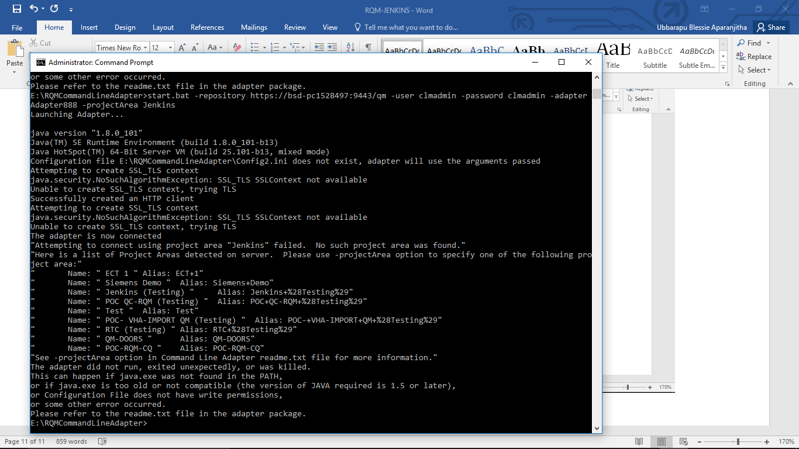

Correct command

