Following setup is done in **https://cvm-673.techmahindra.com/ccm**

Project Area: **RTC_IMP**

**RTC 6.0** installed in **Eclipse Juno**

Create the work item types which are present in the CSV file and also the states, actions and workflows.(Here Bug, Story, Support and Task are used.)

1. Create(or modify the attributes accordingly in RTC) attributes that are present in the CSV file for all the work item types that you have created above.(R_Id, Tracker, Project, Parent task, Status, Priority, Subject, Author, Assignee, Updated, Category, Target version, Start date, Due date, Estimated time, Spent time, % Done, Created , Closed, Related issues, Iteration, Actual Time, Accepted By, Bug Source, Optional, Initial, Estimated Time, Branch, Reported for Build, Test Run, Change Request, Description)
2. Create Editor presentations in to reflect all the fields present in CSV.
3. Modify the CSV file as below(This is to make sure that there’s no issue while importing the links from CSV to RTC)

Select the first two columns of CSV file

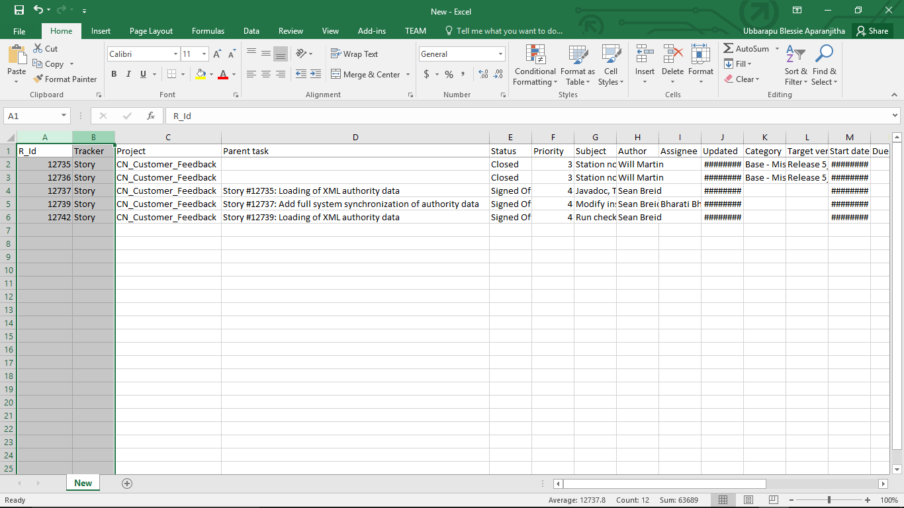

Select **Sort and Filter>Custom Sort** to sort the two columns of the CSV file as follows(This arranges the Stories at the top and all the stories will be arranged in ascending order as per the ID.

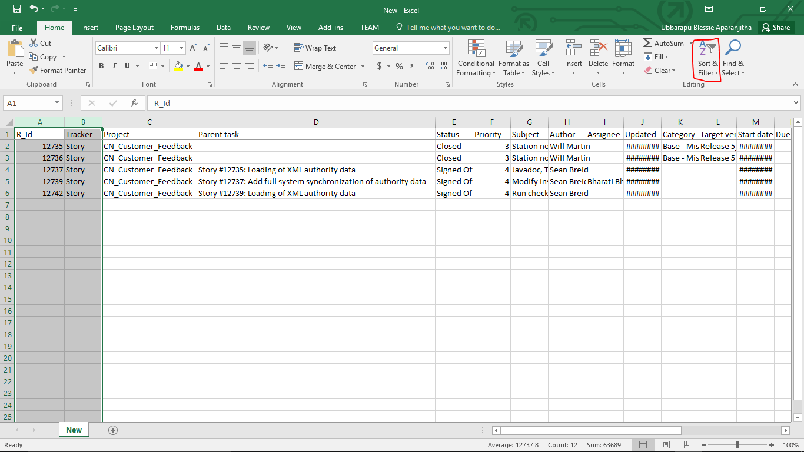

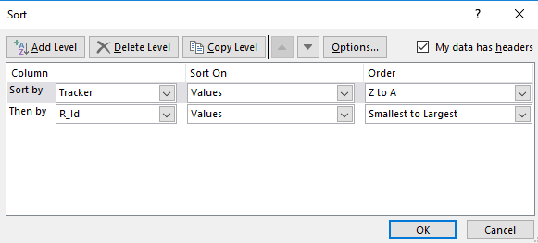

Modify the date format for the fields which contain date.

Select the columns which you want to modify and right click. Select **Format Cells**

Use the below format(as used in RTC)

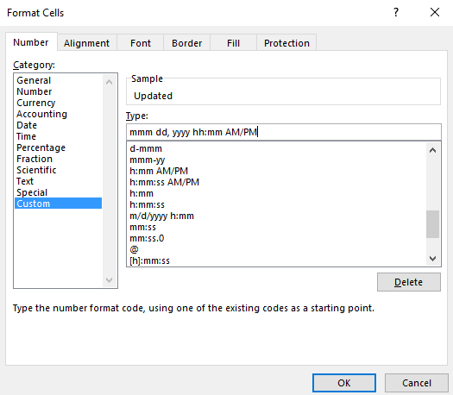

Save the excel sheet.

Open RTC Client and create a repository connection and connect to the project area to which you are going to import the data.

Goto **File>Import>Team>Work Items from CSV** and click next. Browse to the CSV file which contains the workitems to be imported.

Select Create new work item.

Click on **Save Default As.**  This will give you a default mapping file. Save this to some location.

Modify the xml file according to the CSV file and fields present in RTC.

Source Id is the column name in CSV file and Target Id is the Attribute Id in RTC.

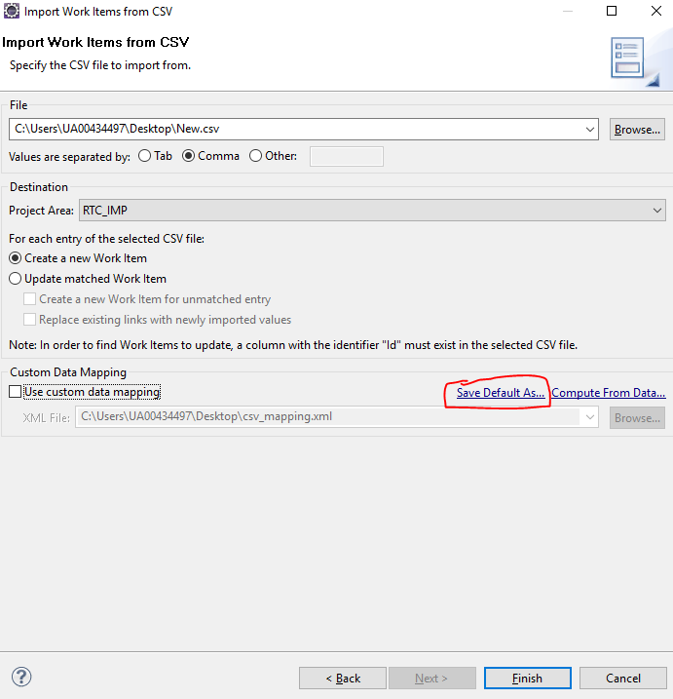

Open the XML file that you have saved and check if all the Source Ids and Target Ids are mapped properly.

**Here is the sample XML file.**

<?xml version="1.0" encoding="UTF-8"?>

<mapping version="1">

<!--

Usage:

- Specify the mapping between source attributes/values to Jazz attributes/values

- Removal of an <attribute> element will disable the import of the corresponding attribute

- If no explicit mapping for a value exists the mapping for source id "*" will be used if it exists

- Using source id "*" with an empty target id can be used to ignore unknown values

Limitations:

- Import of some attributes is still hard-coded

- Some attributes are not supported for import

-->

<attribute sourceId="Accepted By" targetId="com.ibm.team.workitem.attribute.resolver"/>

<attribute sourceId="R_Id" targetId="com.ibm.team.workitem.attribute.id"/>

<attribute sourceId="Actual time" targetId="com.ibm.team.workitem.attribute.correctedestimate"/>

<attribute sourceId="Archived" targetId="archived"/>

<attribute sourceId="Tracker" targetId="Tracker"/>

<attribute sourceId="Assignee" targetId="com.ibm.team.workitem.attribute.owner"/>

<attribute sourceId="Author" targetId="com.ibm.team.workitem.attribute.creator"/>

<attribute sourceId="Category" targetId="com.ibm.team.workitem.attribute.category"/>

<attribute sourceId="Closed" targetId="com.ibm.team.workitem.attribute.resolutiondate"/>

<attribute sourceId="Created" targetId="com.ibm.team.workitem.attribute.creationdate"/>

<attribute sourceId="Description" targetId="com.ibm.team.workitem.attribute.description"/>

<attribute sourceId="Due date" targetId="com.ibm.team.workitem.attribute.duedate"/>

<attribute sourceId="Estimated time" targetId="com.ibm.team.workitem.attribute.duration"/>

<attribute sourceId="Iteration" targetId="com.ibm.team.workitem.attribute.version"/>

<attribute sourceId="Modified By" targetId="com.ibm.team.workitem.attribute.modifiedby"/>

<attribute sourceId="Priority" targetId="com.ibm.team.workitem.attribute.priority">

<value sourceId="-1" targetId="priority.literal.l1"/>

<value sourceId="*" targetId="priority.literal.l1"/>

<value sourceId="1" targetId="priority.literal.l2"/>

<value sourceId="2" targetId="priority.literal.l3"/>

<value sourceId="3" targetId="priority.literal.l4"/>

<value sourceId="4" targetId="priority.literal.l5"/>

<value sourceId="5" targetId="priority.literal.l6"/>

</attribute>

<attribute sourceId="Project" targetId="Project"/>

<attribute sourceId="Spent time" targetId="com.ibm.team.workitem.attribute.timespent"/>

<attribute sourceId="Start date" targetId="startDate"/>

<attribute sourceId="Status" targetId="com.ibm.team.workitem.attribute.state"/>

<attribute sourceId="Subject" targetId="com.ibm.team.workitem.attribute.summary"/>

<attribute sourceId="Target version" targetId="com.ibm.team.workitem.attribute.target"/>

<attribute sourceId="Updated" targetId="com.ibm.team.workitem.attribute.modified"/>

<attribute sourceId="% Done" targetId="done"/>

<attribute sourceId="Branch" targetId="Branch"/>

<attribute sourceId="Bug Source" targetId="Bug"/>

<attribute sourceId="Change Request" targetId="Change"/>

<attribute sourceId="Initial Estimated Time" targetId="initialestimatedtime"/>

<attribute sourceId="Optional" targetId="Optional">

<value sourceId="Yes" targetId="optional.literal.l1"/>

<value sourceId="*" targetId="optional.literal.l2"/>

<value sourceId="No" targetId="optional.literal.l2"/>

</attribute>

<attribute sourceId="Reported for Build" targetId="Reportedforbuild"/>

<attribute sourceId="Start date" targetId="Startdate"/>

<attribute sourceId="Test Run" targetId="testrun"/>

<attribute sourceId="Related" targetId="com.ibm.team.workitem.linktype.relatedworkitem.related"/>

<attribute sourceId="Work Items" targetId="com.ibm.team.workitem.linktype.attachment.workItem"/>

<attribute sourceId="Attachments" targetId="com.ibm.team.workitem.linktype.attachment.attachment"/>

<attribute sourceId="Children" targetId="com.ibm.team.workitem.linktype.parentworkitem.children"/>

<attribute sourceId="Parent task" targetId="com.ibm.team.workitem.linktype.parentworkitem.parent"/>

<attribute sourceId="Related Change Request" targetId="com.ibm.team.workitem.linktype.relatedChangeManagement.relatedChangeManagement"/>

<attribute sourceId="Resolved By" targetId="com.ibm.team.workitem.linktype.resolvesworkitem.resolvedBy"/>

<attribute sourceId="Resolves" targetId="com.ibm.team.workitem.linktype.resolvesworkitem.resolves"/>

<attribute sourceId="Related issues" targetId="com.ibm.team.workitem.linktype.relatedartifact.relatedArtifact"/>

<attribute sourceId="Change Request" targetId="com.ibm.team.filesystem.oslc_cm.change_request.change_set.changerequest"/>

<attribute sourceId="*"/>

</mapping>

Now browse to the modified XML file and Click Finish.

This will import all the work items present In the CSV file.

Verify this by creating a query in RTC to get all the recently modified workitems.