<http://www.ibm.com/support/knowledgecenter/SSB2MU_8.1.3/com.ibm.rhp.doors.tutorial.doc/topics/lesson7_apply.html>

**Exporting Rational Rhapsody model elements**

Changes made to a Rhapsody model element in Rhapsody are uploaded back to DOORS. With the model elements in DOORS, the links from requirements to model elements are traceable.

Traceability information from Rhapsody Gateway can be uploaded back to DOORS.

## **Procedure**

1. Start Rational Rhapsody and load the same elevator project you have been using in the previous lesson by opening elevator.rpy file.
2. Select the elevator project, right click elevator and select **Rhapsody Gateway**. The Gateway Management window opens.
3. In the **Coverage Analysis** view, select **UML Model Rhapsody** in the center **Selection** column.

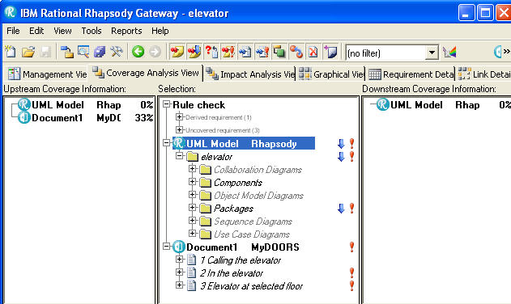

1. In the Rhapsody Gateway option, select **Tools** > **Export Elements to DOORS** to open **Export elements to DOORS** window.

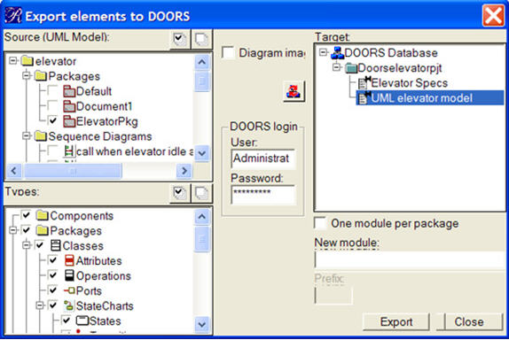

The left hand part of the dialog allows the selection of what to export:

* + The **Source UML Model** list allows you to select objects individually
  + The **Types** list allows you to filter the UML element types that are uploaded into DOORS

The right part of the dialog provides a tree view of the DOORS database. The tree is viewable when you click on the update button converter.

If the diagram images box is checked, images will also be uploaded to DOORS.

1. In the **Source UML Model** box on the top left, check only the **ElevatorPkg** box, clear the diagram images box,.and login to DOORS.
2. In the **New module** box on the bottom right enter the name **UML elevator model**.
3. Click the **Update** button to view the DOORS database tree, and select the **DOORSelevatorpjt** file in the tree. Click **Export**

When you click on **Export**, the synchronization between Gateway and DOORS starts to perform the export.

1. Check to see what is being exported, and confirm the export by clicking the **Export** button. A different **Export elements to DOORS** dialog opens that says that DOORS export operation is completed.
2. Click the **OK** button and click **Close** in the original **Export elements to DOORS** dialog.

## Results

All model elements are successfully exported to DOORS. If you want to change an element before exporting it to DOORS follow the steps listed in lesson 9.

**Note:**

* If the **New Module** field is empty and a project is selected, the module is created in the DOORS database with the name of the uploaded document assigned in Gateway.
* If a module is selected then the upload is appended to the selected module.

The Rhapsody elevator model elements are exported to DOORS in lesson 9.