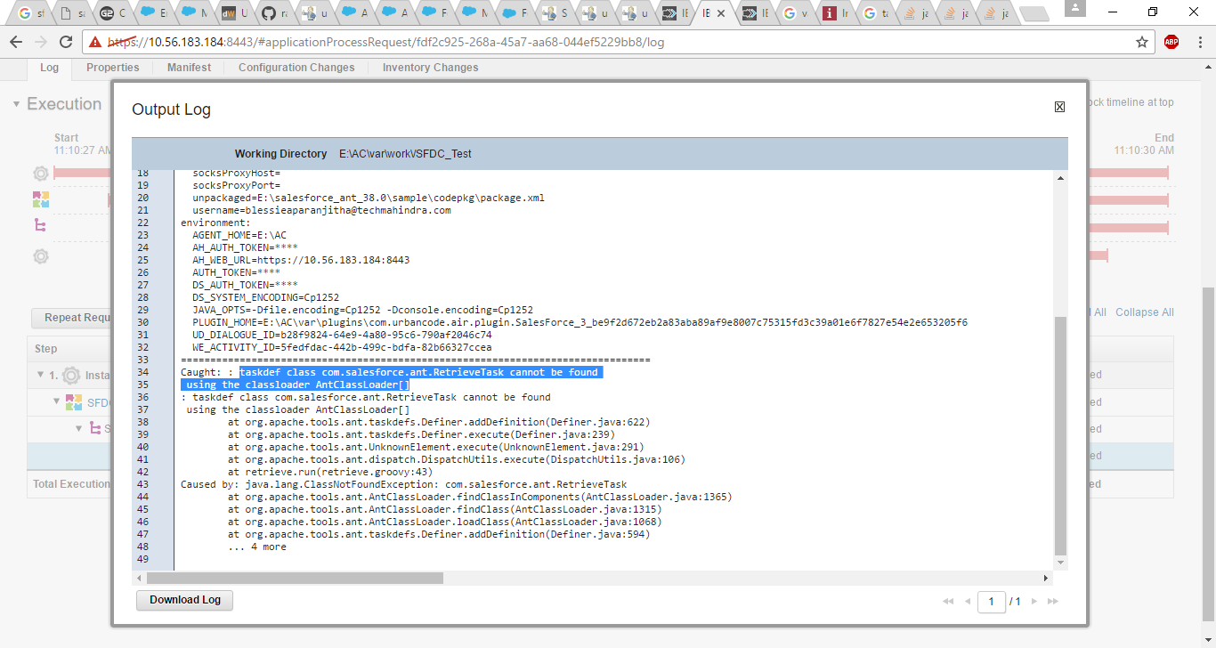

Provide the jar path

Append security token to the password after resetting the security in salesforce developer account.

**Replacing your Salesforce password with a password and security token**

To access Salesforce via AtomSphere, replace your current password with a combination of your password and a security token.

1. Log into Salesforce via the browser to request your security token.
2. Do one of the following:
   * If you have a regular Salesforce account, go to **Setup** > **My Personal Information** > **Reset Security Token**.
   * If you have a Salesforce developer account, from the home page, go to **Manage Users** > **Users** > **click your name** > **Change password** > **Reset Security Token**.

This triggers an email which contains your security token.

1. Select and copy the token from the email.
2. In AtomSphere, replace your Salesforce password with combination of the password and the security token. For example, if your password is "MyPassword" and your security token is "XXXXXX", you would enter "MyPasswordXXXXXX" in the Password field.

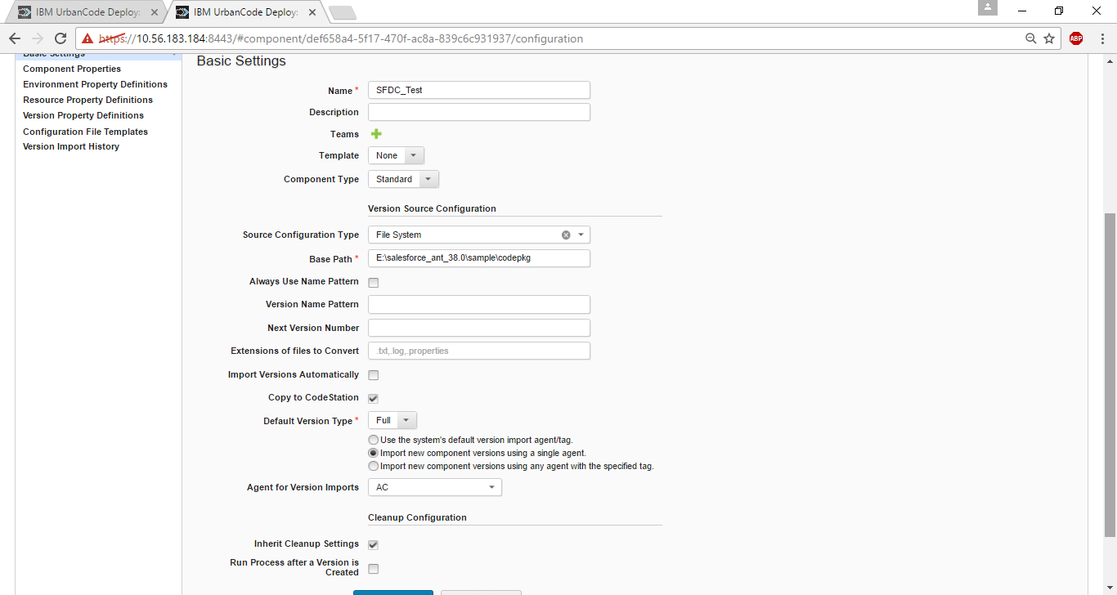

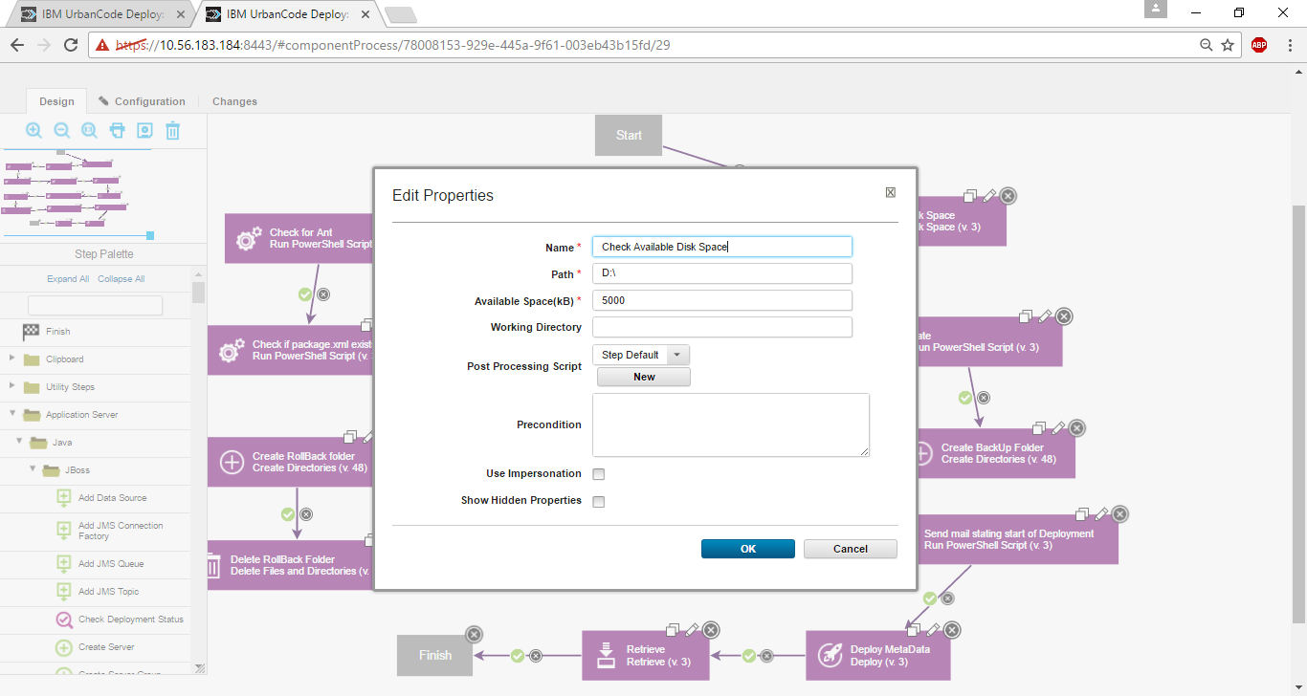

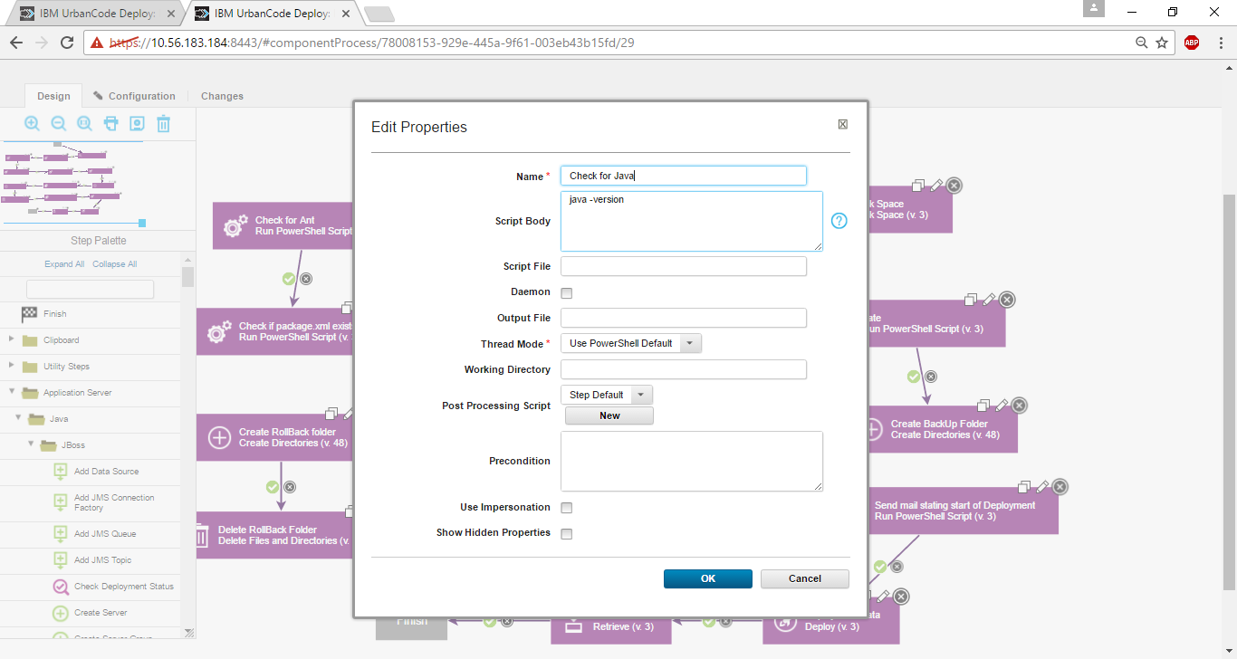

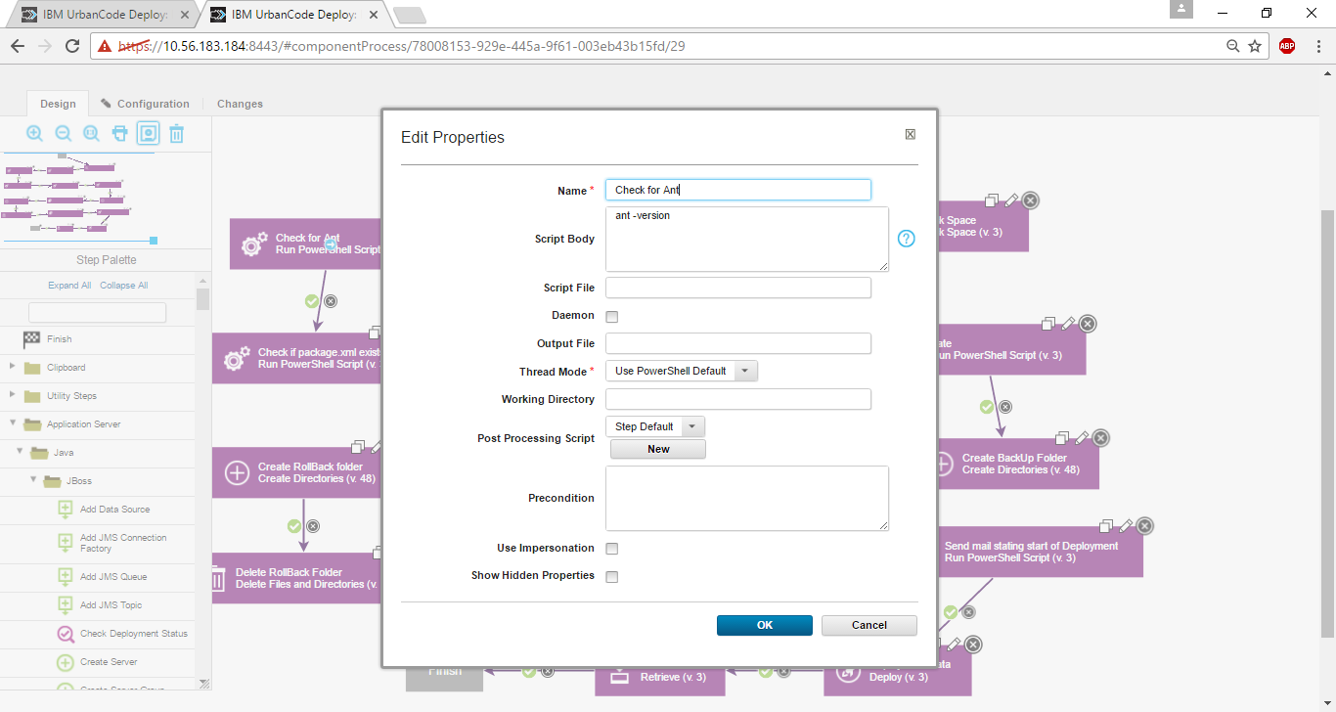

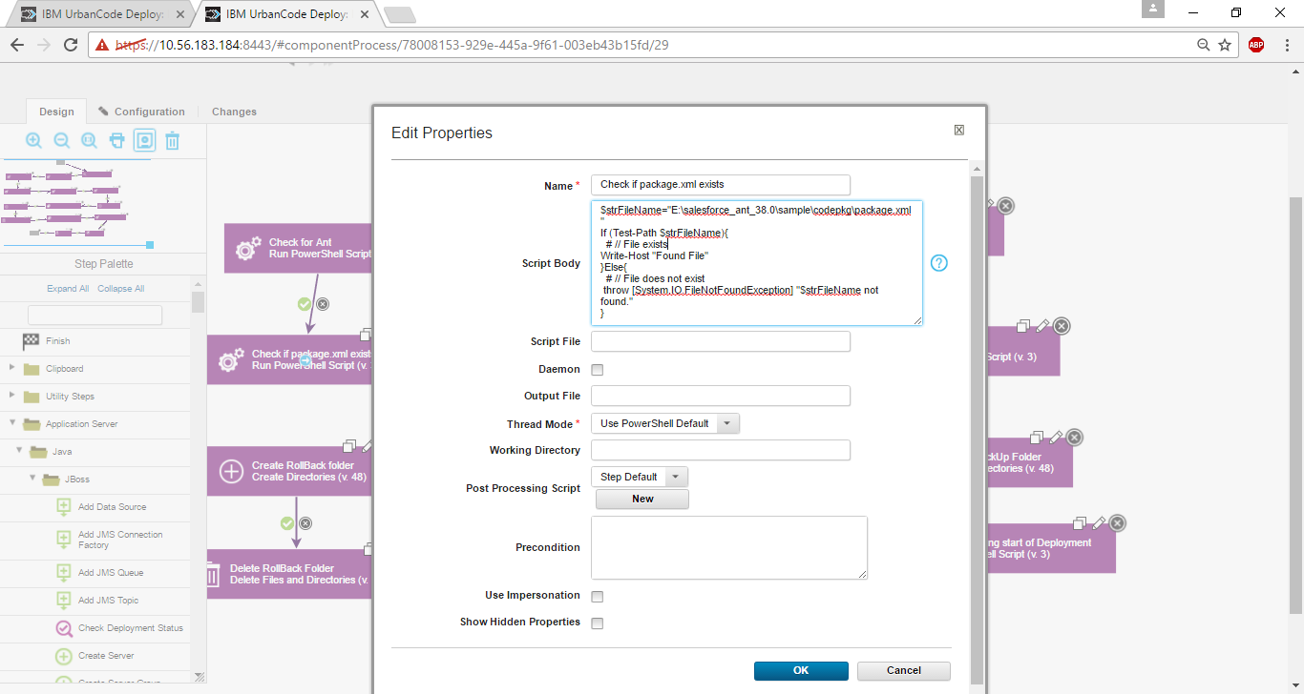

Powershell script to check if a file exists

$strFileName="E:\salesforce_ant_38.0\sample\codepkg\package.xml"

If (Test-Path $strFileName){

# // File exists

Write-Host "Found File"

}Else{

# // File does not exist

throw [System.IO.FileNotFoundException] "$strFileName not found."

}

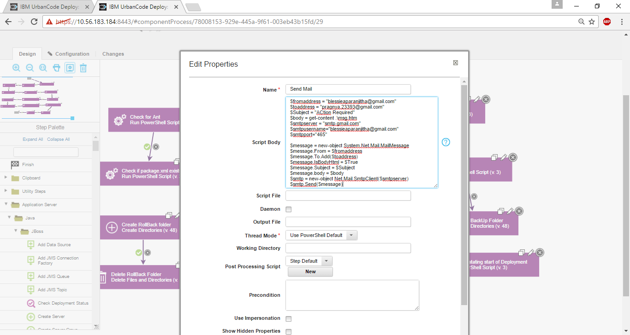

Powershell script to send a mail:

$fromaddress = "blessieaparanjitha@gmail.com"

$toaddress = "pragnya.23393@gmail.com"

$Subject = "ACtion Required"

$body = get-content .\msg.htm

$smtpserver = "smtp.gmail.com"

$smtpusername="blessieaparanjitha@gmail.com"

$smtpport="465"

$message = new-object System.Net.Mail.MailMessage

$message.From = $fromaddress

$message.To.Add($toaddress)

$message.IsBodyHtml = $True

$message.Subject = $Subject

$message.body = $body

$smtp = new-object Net.Mail.SmtpClient($smtpserver)

$smtp.Send($message)

## Passing a value from one step to another

Passing a value from one step to another involves a few general steps:

1. In the first step, store the value in a place where the post-processing script can access it. You can store the value by writing it to the log file for the step. For example, if you are using a Shell step, you can write the value and a unique key to the log with an echo command:

echo "myvalue=1234"

As a result, the log for the step shows the key and value:

myvalue=12345

1. In the post-processing script for the step, use the **scanner** object to scan the log for the key. Then, assign the value to an output parameter. The following example script searches the output log for the key myvalue= and then stores the value in the output property myOutputValue:
2. var exit = properties.get('exitCode');
3. scanner.register("myvalue=", function(lineNumber, line) {
4. var value=line.replace("myvalue=","");
5. properties.put("myOutputValue",value);
6. });
7. if (exit == 0) {
8. properties.put('Status', 'Success');
9. }
10. else {
11. properties.put('Status', 'Failure');
12. }

scanner.scan();

1. In future steps, refer to the output parameter of the first step. For example, if the first step is named SetMyValue, future steps can refer to the property with the following code:

${p:SetMyValue/myOutputValue}

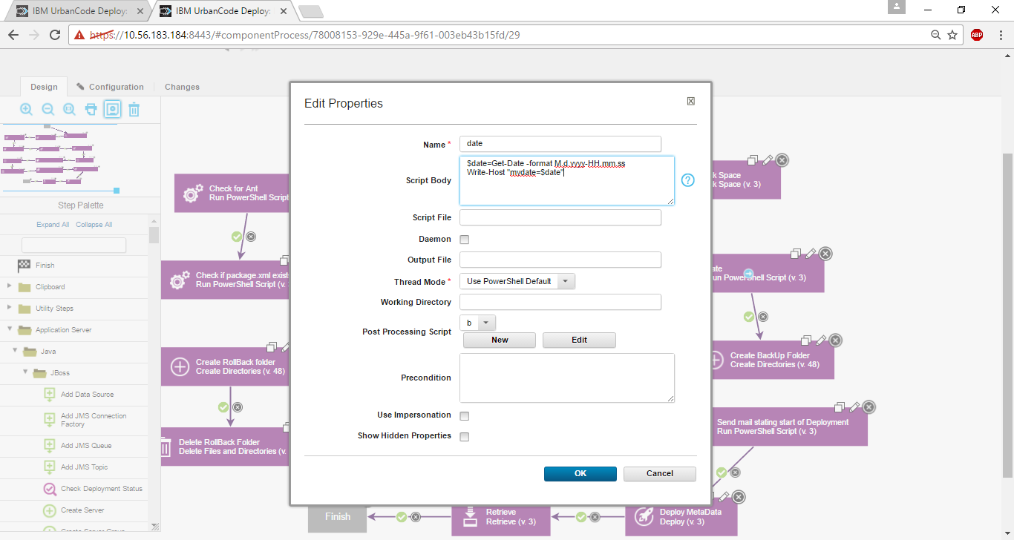

Powershell script for getting system date in required format

$date=Get-Date -format M.d.yyyy-HH.mm.ss

Write-Host "mydate=$date"

Post processing script

var exit = properties.get('exitCode');

scanner.register("mydate=", function(lineNumber, line) {

var value=line.replace("mydate=","");

properties.put("myOutputValue",value);

});

if (exit == 0) {

properties.put('Status', 'Success');

}

else {

properties.put('Status', 'Failure');

}

scanner.scan();

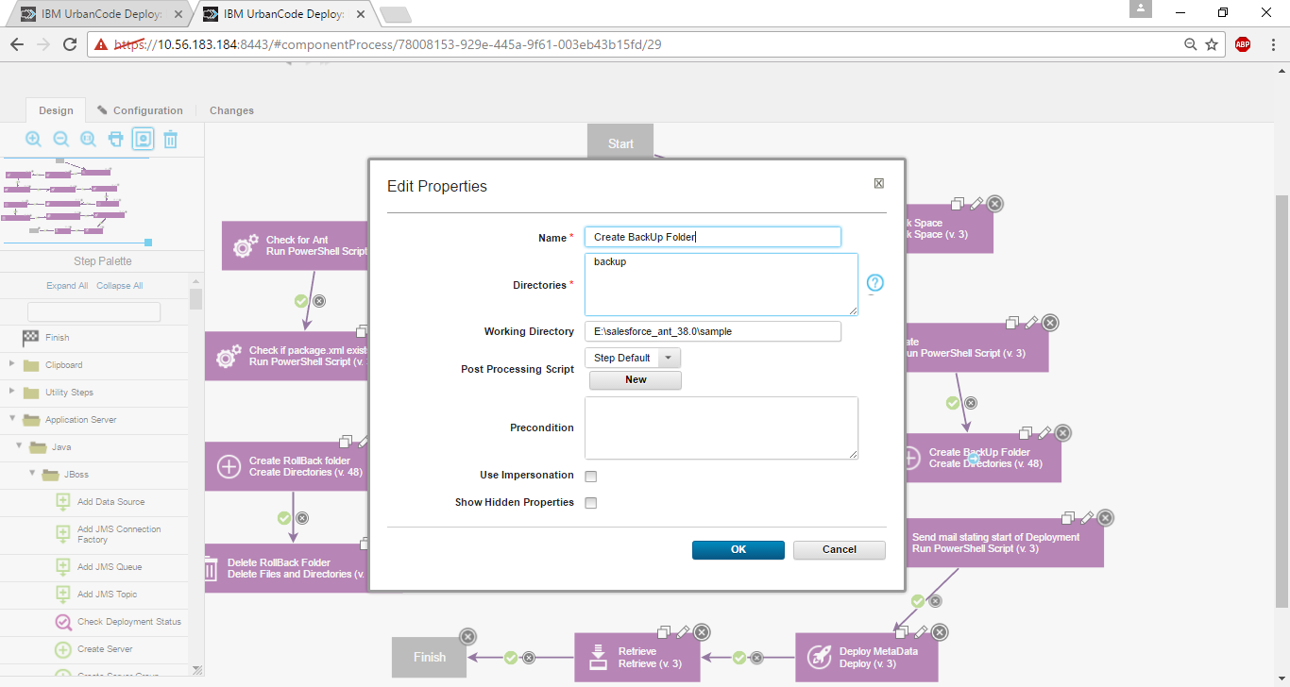

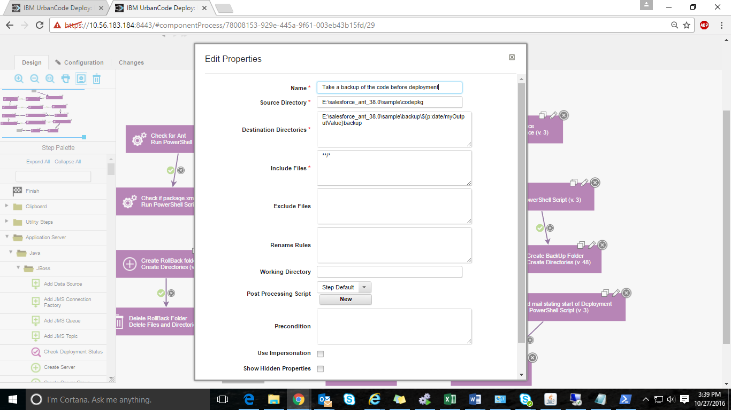

Passing property to the next step

${p:date/myOutputValue}backup

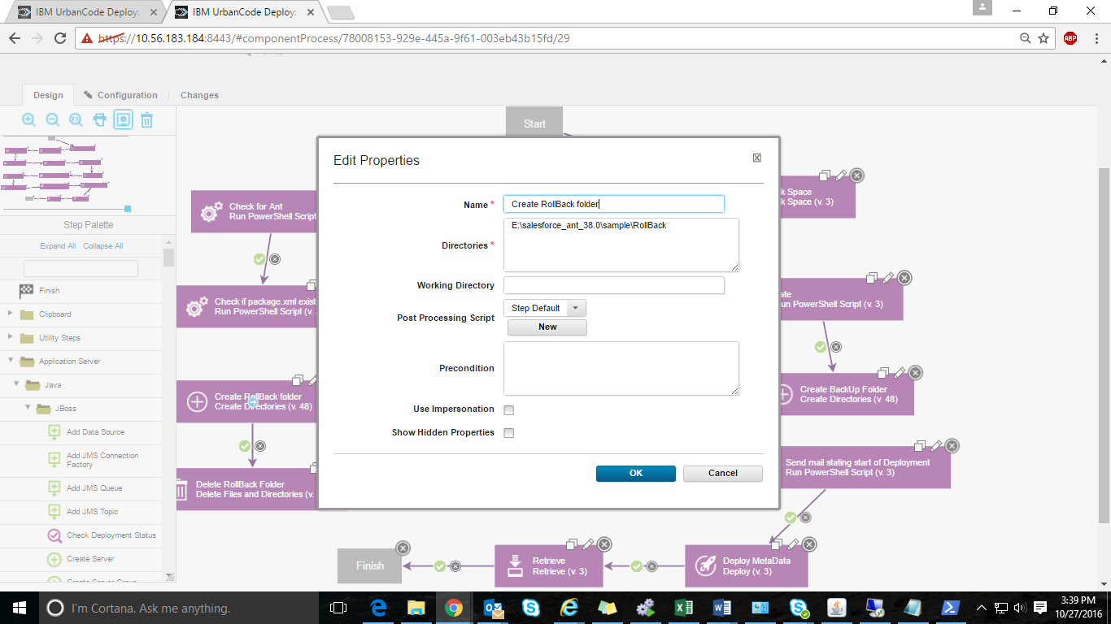

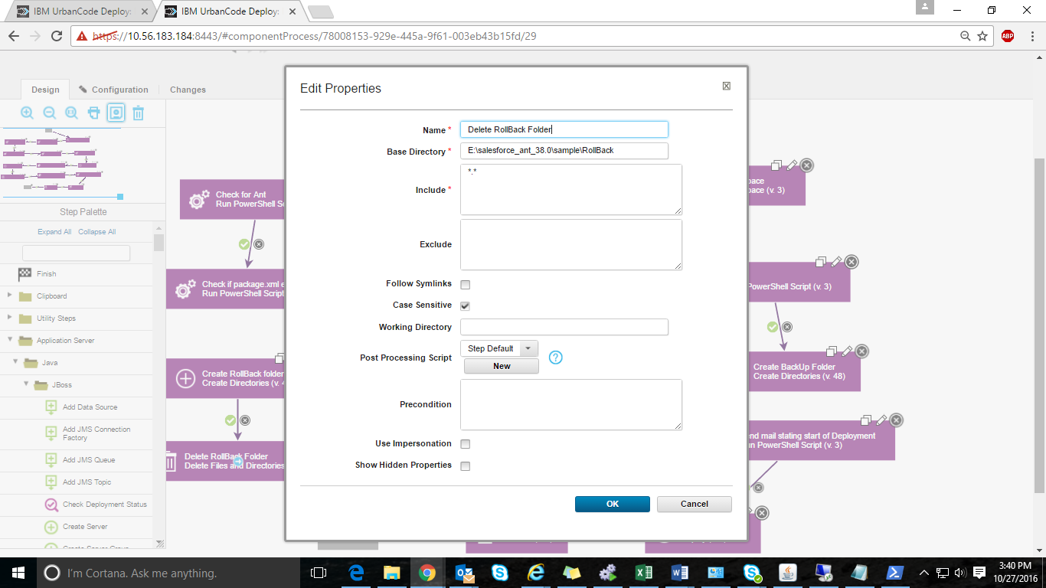

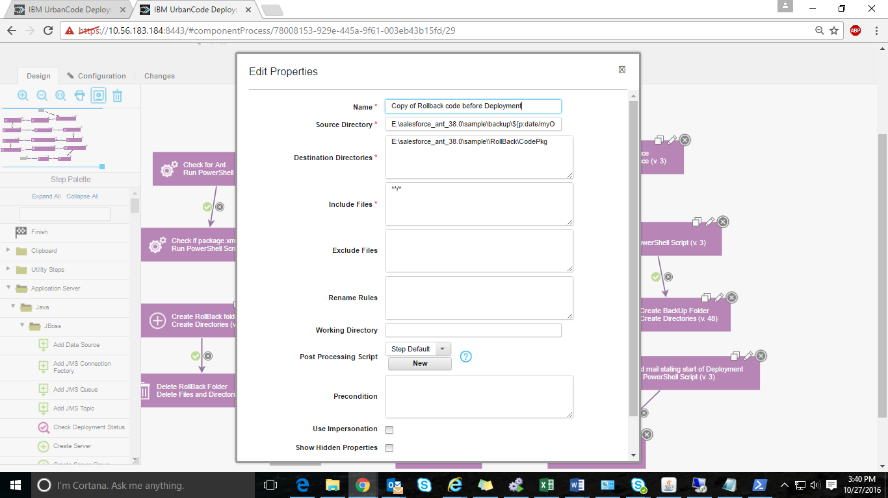

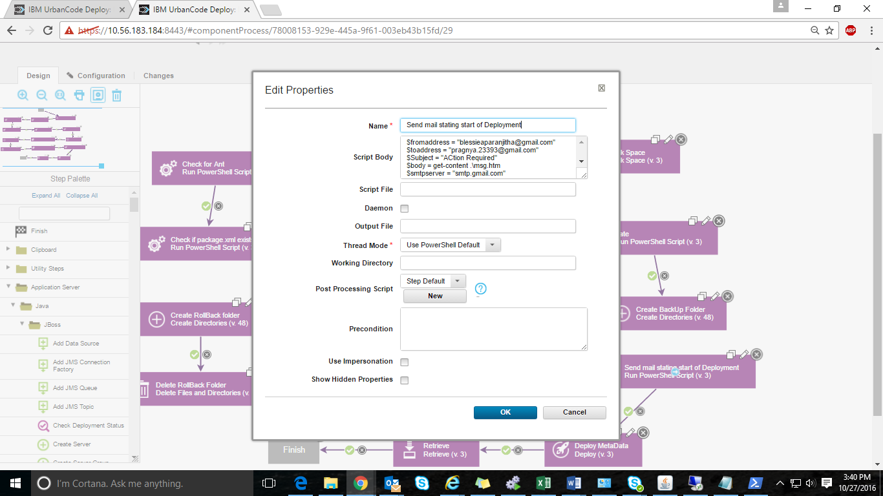

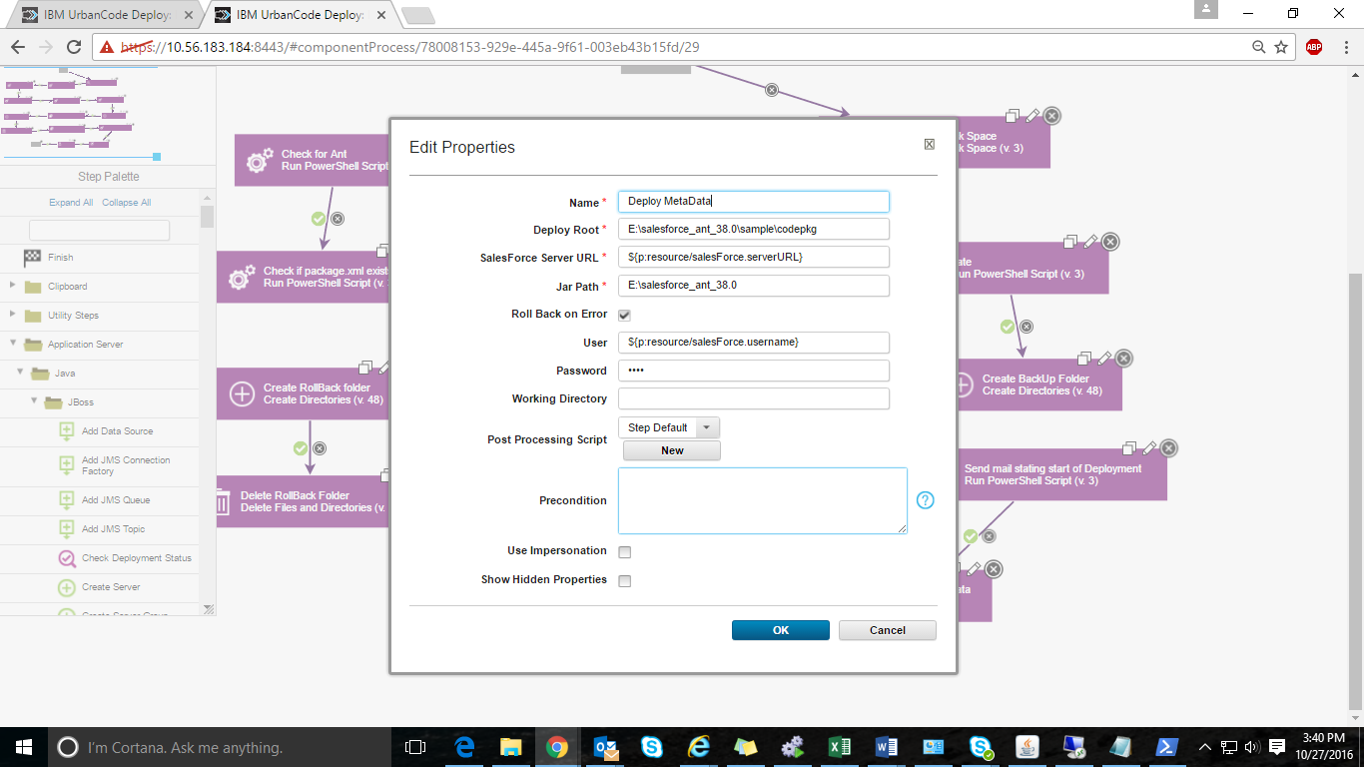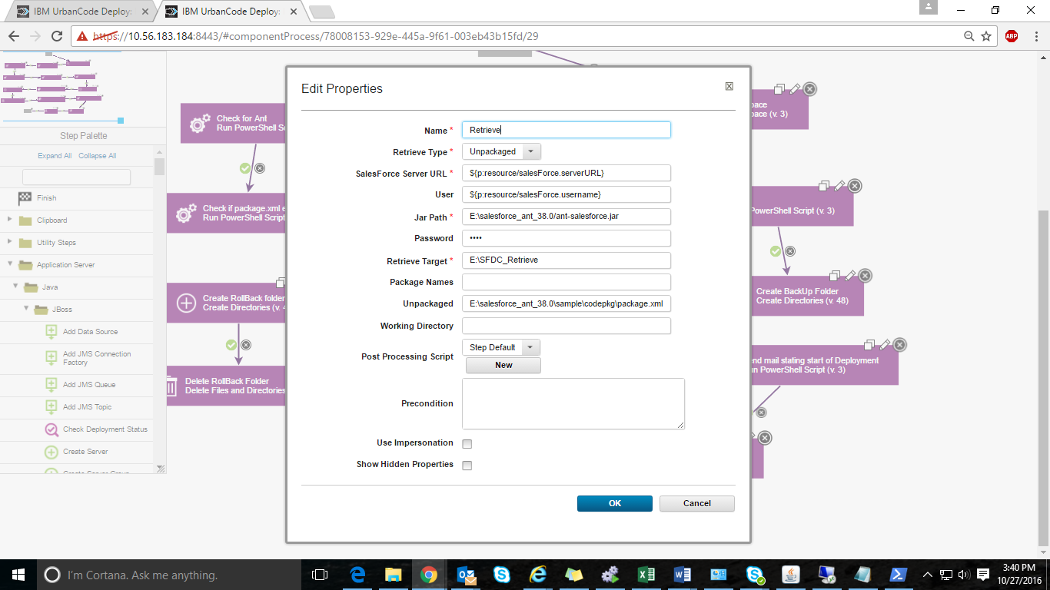

|  |  |  |  |
| --- | --- | --- | --- |
| salesForce.password |  |  | EditDelete |
| salesForce.proxyHost |  |  | EditDelete |
| salesForce.proxyPassword | ******** |  | EditDelete |
| salesForce.proxyPort | 8080 |  | EditDelete |
| salesForce.proxyUser | TechMahindra\UA00434497 |  | EditDelete |
| salesForce.serverURL | https://login.salesforce.com |  | EditDelete |
| salesForce.token |  |  | EditDelete |
| salesForce.username | blessieaparanjitha@techmahindra.com |  | EditDelete |

Errors faced while using ant plugin:

BUILD FAILED

E:\salesforce_ant_38.0\sample\build.xml:60: Can't assign value '${sf.maxPoll}' to attribute maxpoll, reason: class java.lang.NumberFormatException with message 'For input string: "${sf.maxPoll}"'

Give the value of maxpoll directly

Any JVM can have its proxy options explicitly configured by passing the appropriate -D system property options to the runtime. Ant can be configured through all its shell scripts via the ANT_OPTS environment variable, which is a list of options to supply to Ant's JVM:

For bash:

export ANT_OPTS="-Dhttp.proxyHost=proxy -Dhttp.proxyPort=8080"

<http://ant.apache.org/manual/proxy.html>

INCLUDE THE CODE

<target name="probe-proxy">

<condition property="proxy.enabled">

<and>

<isset property="proxy.host"/>

<isreachable host="******"/>

</and>

</condition>

</target>

<target name="proxy" depends="probe-proxy" if="proxy.enabled">

<property name="proxy.port" value="8080"/>

<property name="proxy.user" value="YOURUSERNAME"/>

<property name="proxy.pass" value="PROXYPASSWORD"/>

<setproxy proxyhost="PROXYHOST" proxyport="${proxy.port}"

proxyuser="${proxy.user}" proxypassword="${proxy.pass}"/>

</target>

Building project

command: E:\AC\opt\apache-ant-1.8.4\bin\ant.bat -f E:\salesforce_ant_38.0\sample\build.xml proxy, deployCode

Buildfile: E:\salesforce_ant_38.0\sample\build.xml

probe-proxy:

proxy:

deployCode:

[sf:deploy] Note: use ant -verbose to get more information on the failure

BUILD FAILED

E:\salesforce_ant_38.0\sample\build.xml:78: Failed to login: Failed to send request to https://login.salesforce.com/services/Soap/u/38.0

Total time: 22 seconds

Caught: com.urbancode.air.ExitCodeException: Command failed with exit code: 1

com.urbancode.air.ExitCodeException: Command failed with exit code: 1

at com.urbancode.air.CommandHelper.runCommand(CommandHelper.groovy:195)

at com.urbancode.air.CommandHelper$runCommand$0.callCurrent(Unknown Source)

at com.urbancode.air.CommandHelper.runCommand(CommandHelper.groovy:121)

at com.urbancode.air.CommandHelper$runCommand.call(Unknown Source)

at ant.run(ant.groovy:118)

Error:

Building project

command: E:\AC\opt\apache-ant-1.8.4\bin\ant.bat -f E:\salesforce_ant_38.0\sample\build.xml proxy, deployCode

Buildfile: E:\salesforce_ant_38.0\sample\build.xml

probe-proxy:

proxy:

deployCode:

[sf:deploy] Request for a deploy submitted successfully.

[sf:deploy] Request ID for the current deploy task: 0Af2800000UUt2UCAT

[sf:deploy] Waiting for server to finish processing the request...

[sf:deploy] Request Status: InProgress (0/3) -- Processing Type: ApexClass

BUILD FAILED

E:\salesforce_ant_38.0\sample\build.xml:78: Failed to obtain result from server within specified time of 10sec.

Execute following command to obtain the results later: ant deployCode -Dsf.asyncRequestId=0Af2800000UUt2UCAT

Total time: 14 seconds

Caught: com.urbancode.air.ExitCodeException: Command failed with exit code: 1

com.urbancode.air.ExitCodeException: Command failed with exit code: 1

at com.urbancode.air.CommandHelper.runCommand(CommandHelper.groovy:195)

at com.urbancode.air.CommandHelper$runCommand$0.callCurrent(Unknown Source)

at com.urbancode.air.CommandHelper.runCommand(CommandHelper.groovy:121)

at com.urbancode.air.CommandHelper$runCommand.call(Unknown Source)

at ant.run(ant.groovy:118)

--🡪 maxPoll=10

uilding project

command: E:\AC\opt\apache-ant-1.8.4\bin\ant.bat -f E:\salesforce_ant_38.0\sample\build.xml proxy, deployCode

Buildfile: E:\salesforce_ant_38.0\sample\build.xml

probe-proxy:

proxy:

deployCode:

BUILD FAILED

E:\salesforce_ant_38.0\sample\build.xml:78: Failed to submit request to https://ap2.salesforce.com/services/Soap/m/38.0/00D28000000aLP2 for user blessieaparanjitha@techmahindra.com.

Error: Failed to send request to https://ap2.salesforce.com/services/Soap/m/38.0/00D28000000aLP2

Total time: 23 seconds

Caught: com.urbancode.air.ExitCodeException: Command failed with exit code: 1

com.urbancode.air.ExitCodeException: Command failed with exit code: 1

at com.urbancode.air.CommandHelper.runCommand(CommandHelper.groovy:195)

at com.urbancode.air.CommandHelper$runCommand$0.callCurrent(Unknown Source)

at com.urbancode.air.CommandHelper.runCommand(CommandHelper.groovy:121)

at com.urbancode.air.CommandHelper$runCommand.call(Unknown Source)

at ant.run(ant.groovy:118)

DEPLOY step:

Caught: groovy.lang.MissingPropertyException: No such property: canonicalPath for class: java.lang.String

groovy.lang.MissingPropertyException: No such property: canonicalPath for class: java.lang.String

at deploy.run(deploy.groovy:28)

Building project

command: E:\AC\opt\apache-ant-1.8.4\bin\ant.bat -f E:\salesforce_ant_38.0\sample\build.xml proxy, deployCode

Buildfile: E:\salesforce_ant_38.0\sample\build.xml

probe-proxy:

proxy:

deployCode:

BUILD FAILED

E:\salesforce_ant_38.0\sample\build.xml:78: Failed to submit request to https://ap2.salesforce.com/services/Soap/m/38.0/00D28000000aLP2 for user blessieaparanjitha@techmahindra.com.

Error: Failed to send request to https://ap2.salesforce.com/services/Soap/m/38.0/00D28000000aLP2

Total time: 23 seconds

Caught: com.urbancode.air.ExitCodeException: Command failed with exit code: 1

com.urbancode.air.ExitCodeException: Command failed with exit code: 1

at com.urbancode.air.CommandHelper.runCommand(CommandHelper.groovy:195)

at com.urbancode.air.CommandHelper$runCommand$0.callCurrent(Unknown Source)

at com.urbancode.air.CommandHelper.runCommand(CommandHelper.groovy:121)

at com.urbancode.air.CommandHelper$runCommand.call(Unknown Source)

at ant.run(ant.groovy:118)

**Download Log**

Building project

command: E:\AC\opt\apache-ant-1.8.4\bin\ant.bat -f E:\salesforce_ant_38.0\sample\build.xml proxy, deployCode

Buildfile: E:\salesforce_ant_38.0\sample\build.xml

probe-proxy:

proxy:

deployCode:

[sf:deploy] Note: use ant -verbose to get more information on the failure

BUILD FAILED

E:\salesforce_ant_38.0\sample\build.xml:78: Failed to login: Failed to send request to https://login.salesforce.com/services/Soap/u/38.0

Total time: 22 seconds

Caught: com.urbancode.air.ExitCodeException: Command failed with exit code: 1

com.urbancode.air.ExitCodeException: Command failed with exit code: 1

at com.urbancode.air.CommandHelper.runCommand(CommandHelper.groovy:195)

at com.urbancode.air.CommandHelper$runCommand$0.callCurrent(Unknown Source)

at com.urbancode.air.CommandHelper.runCommand(CommandHelper.groovy:121)

at com.urbancode.air.CommandHelper$runCommand.call(Unknown Source)

at ant.run(ant.groovy:118)

http://www-01.ibm.com/support/docview.wss?uid=swg21673000