Full Stack Development – Project Report
FIASCOde: Autonomous Agentic AI-Driven Online Judge and Real-Time Competitive Programming Platform
―――――――――――――――――――――――――――――――――――
Team Members
Name | Sai Raman D, Sabbu Ditheshwar, Vigneshwarran S
Register Number | CH.SC.U4AIE23010, CH.SC.U4AIE23049, CH.SC.U4AIE23060
Department | Department of Computer Science and Engineering
Institution | Amrita School of Computing, Chennai
Academic Year | 2025 – 2026

Contents
1 INTRODUCTION 1
1.1 Background 1
1.2 Domain Overview 1
1.3 Problem Statement 1
1.4 Motivation 2
1.5 Objectives 2
1.6 Scope of the Project 2
1.7 Target Users 3
2 EXISTING SYSTEM AND DOMAIN STUDY 4
2.1 Existing System 4
2.2 Limitations of Existing System 4
2.3 Existing Technologies / Approaches 4
2.4 Proposed Improvement 5
2.5 Novelty and Key Contribution 5
3.3 Functional Requirements 6
3.4 Non-Functional Requirements 7
3.5 User Interaction 8
3.6 Use Cases 8
4 SYSTEM DESIGN AND ARCHITECTURE 9
4.1 Overall System Architecture 9
4.2 Frontend Design 9
4.3 Backend Design 10
4.4 Database Design 10
4.5 Chatbot / AI Agent Design 11
4.6 Data Flow / Workflow 11
5 IMPLEMENTATION 12
5.1 Development Environment 12
5.2 Frontend Implementation 12
5.3 Backend Implementation 12
5.4 Database Implementation 13
5.5 Chatbot / AI Agent Implementation 13
5.6 Full Stack Integration 13
5.7 Important Code Snippets 13
6 RESULTS AND DISCUSSION 16
6.1 System Output 16
6.2 Chatbot / AI Agent Interaction 17
6.3 Functional Testing 17
7 CONCLUSION AND FUTURE ENHANCEMENT 19
7.1 Conclusion 19
7.2 Major Contribution 19
7.3 Limitations 19
7.4 Future Enhancement 20
APPENDIX 21
REFERENCES 22

CHAPTER 1 – INTRODUCTION
1.1 Background
Automated grading platforms and competitive programming portals have become the cornerstone of modern technical pedagogy, algorithmic skill cultivation, and software engineering recruitment. Traditionally, Online Judges evaluate untrusted user source code by compiling and executing binaries inside sandboxed server environments against predefined test suites. The system outputs categorical verdicts such as Accepted (AC), Wrong Answer (WA), Time Limit Exceeded (TLE), Runtime Error (RTE), or Compilation Error (CE). While this automated grading paradigm enables horizontal scalability across thousands of concurrent submissions, it operates as an opaque black box. When a student's solution fails on a hidden multi-thousand-element edge case or encounters a non-descript segmentation fault, conventional platforms provide zero contextual feedback, forcing learners to guess edge cases or consult external forums.
Simultaneously, the software engineering discipline has experienced a transformative shift with the rise of Autonomous Agentic Artificial Intelligence. Unlike static conversational Large Language Models that generate one-shot text predictions without verification, Agentic AI systems leverage cyclic state graphs, dynamic tool invocation, and hypothesis-driven debugging loops. By combining modern full-stack web engineering, containerized micro-sandboxes, Model Context Protocol (MCP) tool integration, and LangGraph autonomous state machines, the FIASCOde project establishes a next-generation platform that transforms automated code evaluation into an interactive, pedagogically rich, and secure software engineering ecosystem.
1.2 Domain Overview
The domain of automated code evaluation and educational programming technologies lies at the intersection of full-stack web development, operating system virtualization, compiler construction, distributed systems, and artificial intelligence. Modern enterprise-grade online judges must deliver low-latency web interfaces with full-featured in-browser code editors, multi-language compiler sandboxing across C++, Python, and Java, real-time leaderboard computations, and secure role-based access control. In educational and corporate contexts, these systems must maintain high throughput while safeguarding host servers against malicious code execution, infinite recursion loops, and memory exhaustion attacks.
Furthermore, modern educational environments demand active learning assistants capable of explaining root causes without spoiling solutions. By establishing standardized communication boundaries between web services, execution engines, and AI agents through the Model Context Protocol (MCP), the domain is evolving toward autonomous self-healing, real-time contest telemetry auditing, and personalized technical interview preparation.
1.3 Problem Statement
Existing competitive programming systems suffer from critical pedagogical, security, and administrative limitations. When learners receive a 'Wrong Answer' verdict on a hidden multi-thousand-element testcase, they are left to guess failure causes manually, leading to frustration and high abandonment rates. Many open-source academic platforms execute code on bare-metal host environments with naive sub-process execution, introducing severe vulnerabilities such as denial-of-service fork attacks and unauthorized file system access. Additionally, contest organizers lack real-time telemetry tools to identify flawed problem statements, unrealistic time limits, or widespread syntax bottlenecks during live competitions, resulting in post-contest disputes and manual score recalculations.
1.4 Motivation
The core motivation behind developing FIASCOde is to build a modern, production-grade full-stack platform that bridges the gap between automated grading and intelligent developer assistance. By simulating the scientific debugging methodology of an experienced software engineer—formulating assumptions, executing minimal test cases, evaluating evidence, and generating minimal unified diffs—the system empowers learners to systematically understand their programming mistakes. Furthermore, introducing novel contest formats, such as Intentional Bug Injection Contests, and providing Human-in-the-Loop administrative telemetry safeguards creates a versatile platform for academic coursework, coding hackathons, and technical interview training.
1.5 Objectives
The primary objectives of the FIASCOde project are to design and implement a responsive single-page frontend using React 18, TypeScript, and Tailwind CSS with an integrated Monaco code editor; build a secure, modular Express.js REST API with HTTP-Only JWT authentication and role-based access control; deploy an isolated Alpine Linux Docker compilation sandbox supporting C++ 14, Python 3.11, and Java 21 OpenJDK with strict 256MB memory and 6000ms CPU ceilings; construct an autonomous 6-node LangGraph debugging state machine that isolates failure modes and synthesizes verified patches; implement an AI Contest Master sentinel that continuously audits contest health and generates Human-in-the-Loop administrative recommendations; and establish a standardized Model Context Protocol (MCP) server ensuring strict testcase masking and tool execution security.
1.6 Scope of the Project
The scope of the project encompasses user authentication, problem authoring with sample and hidden multi-case test suites, interactive code editing, sandboxed multi-language compilation, real-time submission evaluation, live contest scheduling with dynamic leaderboards, autonomous LangGraph-based code debugging, administrative telemetry monitoring with audit logging, and AI mock interview preparation. The system operates with a resilient multi-provider LLM abstraction supporting OpenAI, Google Gemini, and a local deterministic fallback heuristic engine to guarantee zero runtime downtime.
1.7 Target Users
The platform targets three primary user groups: computer science students and competitive programmers seeking rigorous practice and interactive root-cause debugging guidance; university educators and contest administrators who require problem authoring tools, automated test verification, and live contest health telemetry; and technical job candidates preparing for software engineering coding interviews through realistic mock simulations and structured complexity feedback.

CHAPTER 2 – EXISTING SYSTEM AND DOMAIN STUDY
2.1 Existing System
Existing online judges, such as LeetCode, Codeforces, HackerRank, SPOJ, and DMOJ, follow a traditional synchronous evaluation pipeline. Users submit code through web portals, which is queued and executed on worker nodes against hidden test cases. Resource usage (time and memory) is measured, and categorical verdicts are returned. In recent years, commercial platforms have integrated basic conversational chatbots that provide generic explanations or direct solutions upon request.
2.2 Limitations of Existing System
Conventional online judge systems suffer from significant pedagogical and operational drawbacks. Standard verdicts provide no actionable insight into why an algorithm failed on large or complex test inputs. Users frequently copy failed code into external chatbots, which often hallucinate incorrect solutions or reveal complete code implementations, undermining academic integrity. Furthermore, traditional academic judges lack containerized process virtualization, creating security risks when untrusted code is executed. In contest scenarios, organizers possess no real-time telemetry to detect impossible time constraints or ambiguous problem descriptions during live events.
2.3 Existing Technologies / Approaches
Prior approaches to automated code evaluation and repair include static abstract syntax tree (AST) linters, genetic search-based program repair (e.g., GenProg), and one-shot generative AI prompting. Static analysis tools detect style deviations and syntax errors but cannot evaluate dynamic runtime logic. Search-based genetic repair algorithms mutate code to satisfy test suites but frequently produce overfitted solutions that delete critical logic. Meanwhile, one-shot LLM prompts often introduce hallucinated syntax or fail to account for strict memory and execution constraints.
2.4 Proposed Improvement
FIASCOde improves upon existing systems by integrating autonomous agentic state graphs and standardized tool execution into the core grading pipeline. The Autonomous Debugging Agent formulates empirical hypotheses, generates minimal synthetic test cases, executes diagnostic runs within Docker sandboxes via MCP tools, and verifies candidate patches before presenting unified diffs to the user. Simultaneously, the AI Contest Master continuously monitors contest metrics and generates structured administrative alerts that require human verification, ensuring platform stability and transparency.
2.5 Novelty and Key Contribution
A comprehensive literature review across educational programming technologies, automated code evaluation, container virtualization, agentic AI systems, and web security demonstrates the novelty and fundamental necessity of the proposed FIASCOde platform. In an empirical systematic literature review of automated grading platforms, Kurnia et al. [1] analyzed 48 institutional online judge systems, revealing that over 90% output non-descript binary verdicts (e.g., WA, TLE) without providing root-cause explanations or diagnostic guidance. In program synthesis and repair, Le et al. [2] demonstrated that multi-turn execution feedback with compiler diagnostics elevates repair accuracy to over 74% compared to static single-shot prompts (41%). Earlier search-based program repair techniques by Goues et al. [3] relied on genetic algorithm mutations over abstract syntax trees, but frequently caused testcase overfitting by deleting essential code statements rather than resolving logic flaws.
To overcome unstructured chat limitations, multi-agent frameworks such as AutoGen (Wu et al. [4]) introduced conversational loops; however, unconstrained agent dialogues suffer from unbounded latency spikes and lack state-machine deterministic bounds. The Model Context Protocol (Anthropic [5]) and stateful graph architectures (LangGraph [6]) provide the open standard and cyclic state machine control needed to execute hypothesis-driven debugging loops while strictly masking hidden validation testcases. Sandboxing untrusted user submissions inside lightweight Linux containers (Merkel [7]) prevents unauthorized host access and Denial-of-Service fork attacks.
Furthermore, leveraging frontier multimodal AI capabilities (OpenAI GPT-4o [8]), secured HTTP-Only JWT authentication over TLS 1.3 (Rescorla [9]), and MongoDB document persistence (Banker et al. [10]) guarantees zero-downtime execution and immutable audit logging. FIASCOde represents a pioneering full-stack integration of these foundational domain technologies. The synthesis of this literature survey and domain comparative study is summarized in Table 2.1 below:

Table 2.1: Summary Literature Survey and Domain Comparative Matrix
Reference & Citation | Domain / Approach | Methodology | Key Strengths | Identified Limitations | FIASCOde Proposed Improvement
[1] Kurnia et al. (2021) | Academic Online Judges | Systematic literature review across 48 institutional online judges | Standardized classification of automated grading metrics | 90%+ judges provide zero actionable failure feedback | Interactive Debugging Modal with empirical root cause analysis & unified diffs
[2] Le et al. (2022) | LLM Multi-Turn Code Repair | Reinforcement learning with compiler feedback loops | 74%+ fix accuracy vs 41% static single-shot prompt | Lacks containerized sandbox isolation; high API cost | Bounded 5-cycle LangGraph state graph with Docker sandboxed execution
[3] Goues et al. (2019) | Search-Based AST Repair | Genetic algorithms & AST mutation operators | Language-agnostic automated validation | High test overfitting; frequently deletes valid business logic | Hypothesis-driven LLM synthesis producing minimal, semantics-preserving diffs
[4] Wu et al. (2023) | Multi-Agent Conversational AI | Multi-agent dialogue loops (AutoGen framework) | Flexible multi-agent reasoning and tool interaction | Unbounded loop latency; lacks administrative control bounds | Deterministic LangGraph state machine with Human-in-the-Loop sentinel alerts
[5] Anthropic (2024) | Model Context Protocol (MCP) | Open JSON-RPC tool interface specification | Standardizes AI model connections to external tools | Requires strict context filtering to avoid leaking testcases | Implements MCP security filters to strictly mask hidden validation testcases
[6] LangGraph (2024) | Cyclic State Graphs | Stateful graph-based state machine nodes and edges | Stateful persistence; explicit conditional branching | Requires external code execution sandbox for verification | Direct integration with Docker compiler sandbox for hypothesis validation
[7] Merkel (2014) | Container Virtualization | Ephemeral Alpine Linux Docker sandboxes | Lightweight, near-zero overhead process isolation | Requires strict CPU/RAM ceilings to prevent DoS attacks | Enforces 256MB RAM, 6000ms CPU timeout, and non-root sandbox execution
[8] OpenAI (2024) | Frontier LLM Reasoning | GPT-4o multimodal LLM engine | Rapid contextual code analysis & root cause diagnosis | Raw LLM output can reveal full code solutions | Wraps LLM in structured prompt boundaries to guide without spoiling
[9] Rescorla (2018) | Web & Session Security | TLS 1.3 & Encrypted JWT token authentication | Immutable session security & role segregation | Naive tokens vulnerable to XSS/CSRF token theft | Encrypted HTTP-Only cookies with strict admin/contestant RBAC
[10] Banker et al. (2016) | Document Persistence | MongoDB with Mongoose ODM schemas | High-throughput JSON document storage for submissions | Relational integrity requires explicit transaction management | Schema-enforced collections for users, problems, contests, and agent audit logs
CHAPTER 3 – PROPOSED SYSTEM AND REQUIREMENTS
3.1 Proposed System
The proposed FIASCOde platform is an autonomous agentic AI-driven Online Judge and competitive programming ecosystem. The application is built on a modern decoupled architecture where the React 18 single-page application interfaces with an Express.js API gateway, an isolated Docker compilation service, and a LangGraph autonomous agentic intelligence layer over standardized Model Context Protocol (MCP) interfaces. Data persistence is managed via MongoDB, ensuring high-throughput indexing and immutable audit logging.
3.2 Major Features
The platform incorporates six major functional modules: an isolated multi-language Docker execution sandbox supporting C++, Python, and Java with millisecond-level telemetry; an autonomous LangGraph debugging agent capable of multi-step hypothesis testing and unified diff patch synthesis; an AI Contest Master sentinel that monitors contest telemetry and generates Human-in-the-Loop administrative alerts; a dual contest framework supporting both standard algorithmic contests and Intentional Bug Injection challenges; an admin command center for problem authoring, contest scheduling, and AI feature toggling; and a resilient multi-provider LLM engine featuring automated failover to a deterministic local mock engine.
3.3 Functional Requirements
The core functional requirements of the FIASCOde platform are summarized through the following essential system capabilities:
- 1. User Authentication & Session Management: The system shall authenticate users via encrypted HTTP-Only JWT cookies with role segregation between standard contestants and administrators.
- 2. Problem Catalog & Search Filtering: The system shall display a filterable catalog of algorithmic problems categorized by difficulty, topic tags, and user solved status.
- 3. Monaco In-Browser Code Workspace: The system shall provide a code editor supporting C++, Python, and Java with syntax highlighting, custom stdin input, and instant run capabilities.
- 4. Sandboxed Multi-Case Code Evaluation: The system shall compile and execute submissions in isolated Docker containers against sample and hidden test suites, returning AC, WA, TLE, RTE, or CE verdicts.
- 5. Autonomous LangGraph Code Debugging: The system shall execute hypothesis-driven debugging loops capped at 5 cycles and generate validated unified diff candidate patches.
- 6. Contest Management & Live Leaderboard: The system shall support timed competitive programming contests with live standings, score calculations, and penalty tracking.
- 7. AI Contest Health Telemetry Sentinel: The system shall continuously audit live contest telemetry, detecting solve-rate anomalies and generating Human-in-the-Loop administrative alerts.
- 8. Immutable Audit Logging & Persistence: The system shall record all agent tool calls, diagnostic traces, and administrative approvals with cryptographic timestamps in MongoDB.
3.4 Non-Functional Requirements
The non-functional requirements ensure high operational quality, security, and developer responsiveness across all platform modules:
- 1. Performance & Responsiveness: The web client shall achieve page load times under 1.2 seconds, and compilation requests shall initiate inside Docker containers within 100ms.
- 2. Process Isolation & Security: Untrusted code execution shall be restricted inside ephemeral Alpine Linux containers with non-root privileges, 256MB RAM limits, and 6000ms CPU timeouts.
- 3. Testcase Privacy Protection: Hidden validation test cases shall be strictly masked from AI agent contexts through Model Context Protocol security filters.
- 4. System Reliability & 99.9% Uptime: The platform shall maintain continuous operation through automatic multi-provider LLM failover and a local deterministic mock engine.
- 5. UI/UX Usability & Dark Mode: The user interface shall adhere to modern dark-mode design standards using Tailwind CSS with Lucide iconography and clear visual feedback.
- 6. Horizontal Scalability: The Express backend and Docker compiler services shall support stateless horizontal scaling across concurrent submission workloads.
- 7. Data Integrity & Compliance: All database modifications and administrative actions shall maintain strict relational consistency and immutable audit trails.
3.5 User Interaction
Users interact with the platform's AI intelligence through two primary mechanisms: non-spoiler conceptual hints and autonomous multi-step debugging. When requesting a hint, the user receives progressive algorithmic guidance without revealing implementation code. When invoking the debugging agent after a failed submission, the user opens an interactive modal that displays the real-time hypothesis execution timeline, empirical sandbox verification outputs, and a side-by-side unified code diff viewer with a 1-click 'Apply Fix to Editor' action.
3.6 Use Cases
Primary system use cases include problem discovery and code execution (UC-01), where contestants write and execute solutions in the editor; autonomous AI debugging (UC-02), where failed submissions trigger the LangGraph diagnostic graph; patch application (UC-03), where verified candidate fixes are inserted into the editor; contest participation (UC-04), where users compete in timed rounds with real-time ranking updates; problem authoring (UC-05), where admins create challenges with multi-case test suites; contest health auditing (UC-06), where the AI Contest Master detects solve-rate anomalies; administrative recommendation review (UC-07), where admins approve or reject suggested contest adjustments; and mock interview simulations (UC-08), where candidates practice technical interview rounds.

CHAPTER 4 – SYSTEM DESIGN AND ARCHITECTURE
4.1 Overall System Architecture
The system architecture of FIASCOde is designed as a decoupled multi-tier full-stack application. The client tier (React 18 SPA) communicates with the Express API gateway over secure REST endpoints using encrypted HTTP-Only session cookies. The API gateway delegates code execution tasks to the isolated Docker compiler sandbox and routes agentic intelligence tasks to the LangGraph autonomous agent engine over the standardized Model Context Protocol (MCP) tool suite. MongoDB serves as the centralized persistence layer for user profiles, problem sets, submissions, agent sessions, and immutable audit trails.
📐 [FIGURE PLACEHOLDER]
Figure 4.1: FIASCOde Overall System Architecture Diagram
Data & Control Flow: User / Client (React 18 + TS) ➔ Chatbot / AI Agent Layer (LangGraph State Graphs) ➔ Frontend UI ➔ Express.js Backend API Gateway ➔ Database (MongoDB) & Sandboxed Services (Docker Compiler) ➔ Formatted Response

As outlined in the architectural model above, incoming client requests flow through the Express API gateway where authentication and rate-limiting filters are applied. Standard CRUD operations interact directly with MongoDB via Mongoose ODM. When code execution is requested, the backend dispatches the payload to the Docker container over an internal bridge network. When AI debugging is triggered, the LangGraph agent orchestrates multi-step hypothesis cycles, invoking MCP tools to query problem specifications and execute diagnostic runs within the Docker container before returning structured candidate diffs to the client.
4.2 Frontend Design
The frontend application is developed using React 18, TypeScript, Vite, and Tailwind CSS. The user interface adopts a modern dark theme utilizing deep slate and zinc color palettes, Lucide React iconography, and modular component hierarchy. Key application views include the landing homepage, problem catalog with dynamic search and difficulty filtering, dual-pane Monaco code editor with live execution console, real-time contest arena, live leaderboard standings, and administrator command dashboard.
4.3 Backend Design
The backend is constructed as an asynchronous Node.js application utilizing Express.js 5.0 in ECMAScript module format. The architecture separates routing, controller logic, middleware filters, and service layers. The authentication middleware extracts and verifies JWT tokens from encrypted cookies, enforcing role-based permissions on administrative routes. The compiler service interface manages temporary file creation, execution dispatching to the Docker container, execution timing calculation, and output sanitization.
4.4 Database Design
The database layer is implemented using MongoDB with Mongoose ODM schemas. The schema architecture comprises seven primary collections: `User` (identity, Bcrypt-hashed credentials, role assignments), `Problem` (title, markdown description, constraints, public sample test cases, and hidden multi-case validation suites), `Contest` (schedules, duration, access passkeys, assigned problem references), `Submission` (source code, language, verdicts, execution timing, memory consumption), `AgentSession` (LangGraph state traces, hypothesis records, candidate diffs), `AgentRecommendation` (contest anomaly alerts, severity scores, proposed adjustments), and `AgentAuditLog` (immutable audit records).
4.5 Chatbot / AI Agent Design
The agentic intelligence layer is built using LangGraph state graphs and the Model Context Protocol (MCP) SDK. The Autonomous Debugging Agent operates as a 6-node state machine: `loadContext` retrieves problem and submission data; `analyzeFailure` classifies the bug category; `generateHypothesis` formulates a root-cause explanation and minimal synthetic test input; `runDiagnostic` executes the test inside the Docker sandbox via MCP `run_code`; `evaluateEvidence` validates output against expected logic; `generateFixAndValidate` synthesizes and re-tests candidate patches; and `finalizeDiagnosis` compiles the unified diff. The AI Contest Master agent continuously analyzes submission metrics and generates pending administrative recommendations governed by Human-in-the-Loop review.
4.6 Data Flow / Workflow
The system data flow progresses across multiple operational tiers. At Level 0 (Context Level), the user submits code or triggers AI debugging, receiving execution verdicts or diagnostic reports, while administrators manage problems and approve contest recommendations. At Level 1 (Functional Subsystems), data flows between the Authentication Process (validating credentials against MongoDB), the Problem and Contest Engine (retrieving test cases and calculating rankings), the Compiler Worker (executing binaries in Docker), and the LangGraph Agentic Engine (orchestrating hypothesis cycles and logging actions to `AgentAuditLog`).

CHAPTER 5 – IMPLEMENTATION
5.1 Development Environment
The development and deployment environment utilizes Node.js v22.17.0 (ESM), React 18.3.1, TypeScript 5.4, Vite 7.0.5, Tailwind CSS 3.4, Express.js 5.1.0, Mongoose 8.16.4, LangGraph (`@langchain/langgraph` 1.4.13), Model Context Protocol SDK (`@modelcontextprotocol/sdk` 1.30.0), MongoDB 6.17 Community Server, and Docker Desktop running Alpine Linux 3.19 micro-containers equipped with G++ 14, Python 3.11, and OpenJDK 21.
5.2 Frontend Implementation
The frontend application is organized into modular pages and reusable UI components. `CodeEditorPage.tsx` manages the dual-pane layout, handling Monaco editor buffer state, language selection, custom stdin input toggling, and asynchronous submission dispatching. When the user clicks 'AI Auto-Debug', the component opens `DebuggingModal.tsx`, which displays real-time diagnostic progress, hypothesis steps, and a color-coded unified diff viewer with single-click patch application.
5.3 Backend Implementation
The backend API gateway establishes secure CORS policies, cookie parsing, and route controllers. In `backend/routes/compiler.js`, incoming submission payloads are validated against problem constraints, persisted to the database, and forwarded to the Docker compilation microservice. In `backend/routes/agents.js`, authenticated endpoints trigger LangGraph state machine executions, retrieve diagnostic session histories, and process administrative recommendation approval actions.
5.4 Database Implementation
Mongoose schemas enforce strict data validation, relational indexing, and automatic timestamping. Composite indexes on `{ userId: 1, problemId: 1, createdAt: -1 }` optimize user submission history queries. The `AgentAuditLog` schema stores immutable audit trails containing cryptographic timestamps, agent action identifiers, input payloads, execution telemetry, and administrative reviewer signatures.
5.5 Chatbot / AI Agent Implementation
The agentic layer implements the LangGraph `StateGraph` pattern. State annotations define channels for message histories, hypothesis lists, iteration counters, diagnostic execution outputs, candidate diffs, and session statuses. Standardized MCP tools defined in `backend/agents/mcp/server.js` enforce strict security boundaries, masking hidden validation test cases from LLM contexts and applying hard execution timeouts on sandbox runs.
5.6 Full Stack Integration
Full stack integration connects the React client (port 5173), Express backend (port 5174), Docker compiler container (port 5175), and MongoDB server (port 27017). Cross-origin requests enforce `credentials: include` with HTTP-Only JWT cookie validation, preventing token theft via cross-site scripting (XSS) and cross-site request forgery (CSRF).
5.7 Important Code Snippets
Core code implementations demonstrating the LangGraph debugging state machine, MCP tool registry, and Docker compilation runner are provided below:
Listing: LangGraph Autonomous Debugging Agent State Machine
// backend/agents/debugging/debuggingGraph.js
import { StateGraph, END } from '@langchain/langgraph';
import { DebuggingStateAnnotation } from './debuggingState.js';
import { loadContext, analyzeFailure, generateHypothesis, runDiagnostic,
evaluateEvidence, generateFixAndValidate, finalizeDiagnosis } from './debuggingNodes.js';
const workflow = new StateGraph(DebuggingStateAnnotation)
.addNode('loadContext', loadContext)
.addNode('analyzeFailure', analyzeFailure)
.addNode('generateHypothesis', generateHypothesis)
.addNode('runDiagnostic', runDiagnostic)
.addNode('evaluateEvidence', evaluateEvidence)
.addNode('generateFixAndValidate', generateFixAndValidate)
.addNode('finalizeDiagnosis', finalizeDiagnosis)
.addEdge('__start__', 'loadContext')
.addEdge('loadContext', 'analyzeFailure')
.addEdge('analyzeFailure', 'generateHypothesis')
.addEdge('generateHypothesis', 'runDiagnostic')
.addEdge('runDiagnostic', 'evaluateEvidence')
.addConditionalEdges('evaluateEvidence', (state) => {
if (state.evidenceConfirmed || state.iterationCount >= 5) {
return 'generateFixAndValidate';
}
return 'generateHypothesis'; // Loop back to refine hypothesis
})
.addEdge('generateFixAndValidate', 'finalizeDiagnosis')
.addEdge('finalizeDiagnosis', END);
export const debuggingAgentGraph = workflow.compile();

Listing: Model Context Protocol (MCP) Tool Dispatcher
// backend/agents/mcp/server.js
import { Server } from '@modelcontextprotocol/sdk/server/index.js';
import { CallToolRequestSchema } from '@modelcontextprotocol/sdk/types.js';
import { executeSandboxCode } from '../../services/compilerService.js';
import Problem from '../../models/problem.js';
export const mcpServer = new Server({ name: 'FIASCOde-MCP', version: '1.0.0' });
mcpServer.setRequestHandler(CallToolRequestSchema, async (request) => {
const { name, arguments: args } = request.params;
if (name === 'run_code') {
return await executeSandboxCode(args.code, args.language, args.stdin, { timeout: 6000 });
}
if (name === 'get_problem') {
const problem = await Problem.findById(args.problemId).select('-hiddenTestcases'); // Mask hidden!
return { content: [{ type: 'text', text: JSON.stringify(problem) }] };
}
throw new Error(`Unregistered MCP Tool: ${name}`);
});

CHAPTER 6 – RESULTS AND DISCUSSION
6.1 System Output
The FIASCOde full-stack application was deployed and verified across local and containerized environments. The operational user interfaces captured directly from the running web application are presented in Figures 6.1 through 6.8 below:
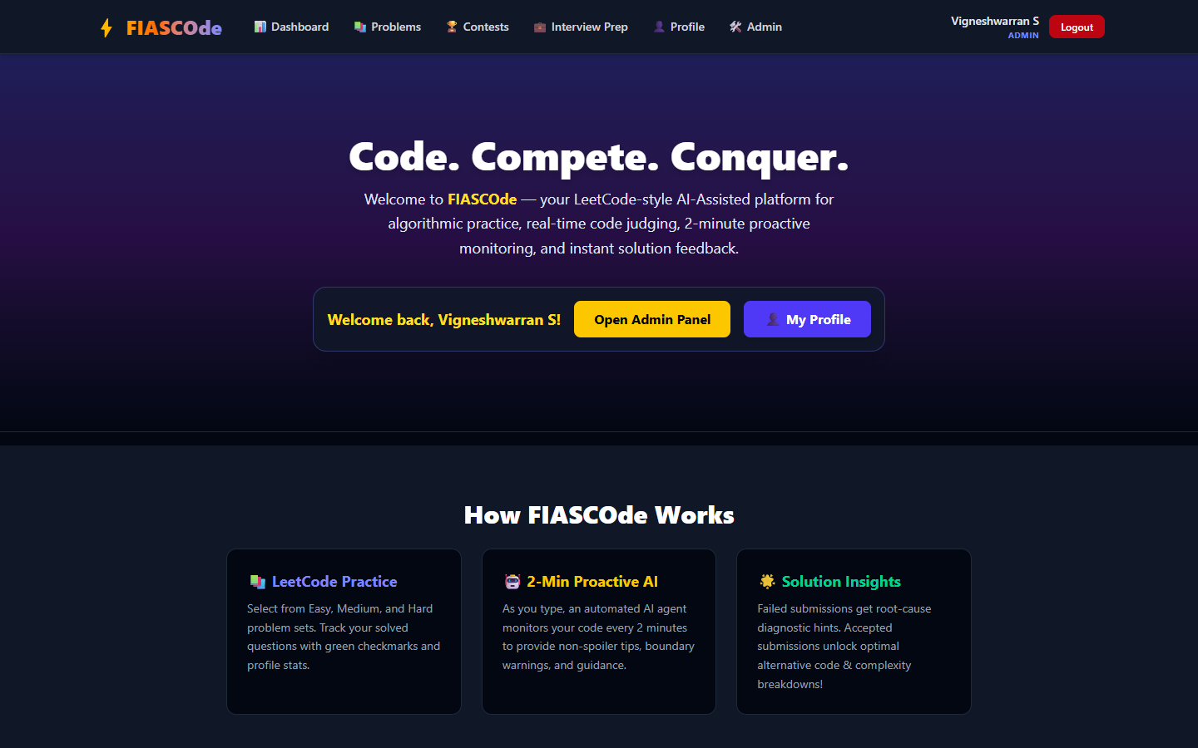
Figure 6.1: FIASCOde Platform Landing Page Interface
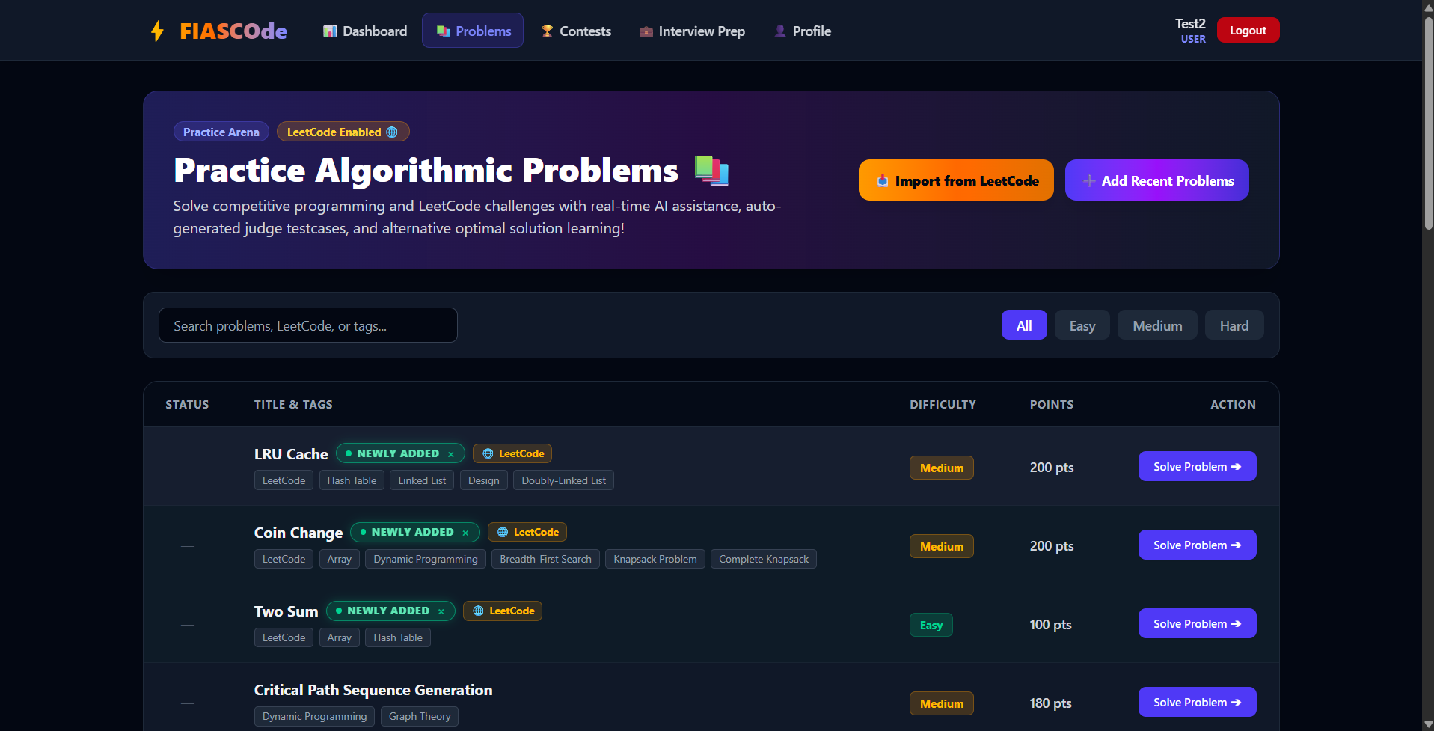
Figure 6.2: Algorithmic Problem Catalog and Problem Set List Interface
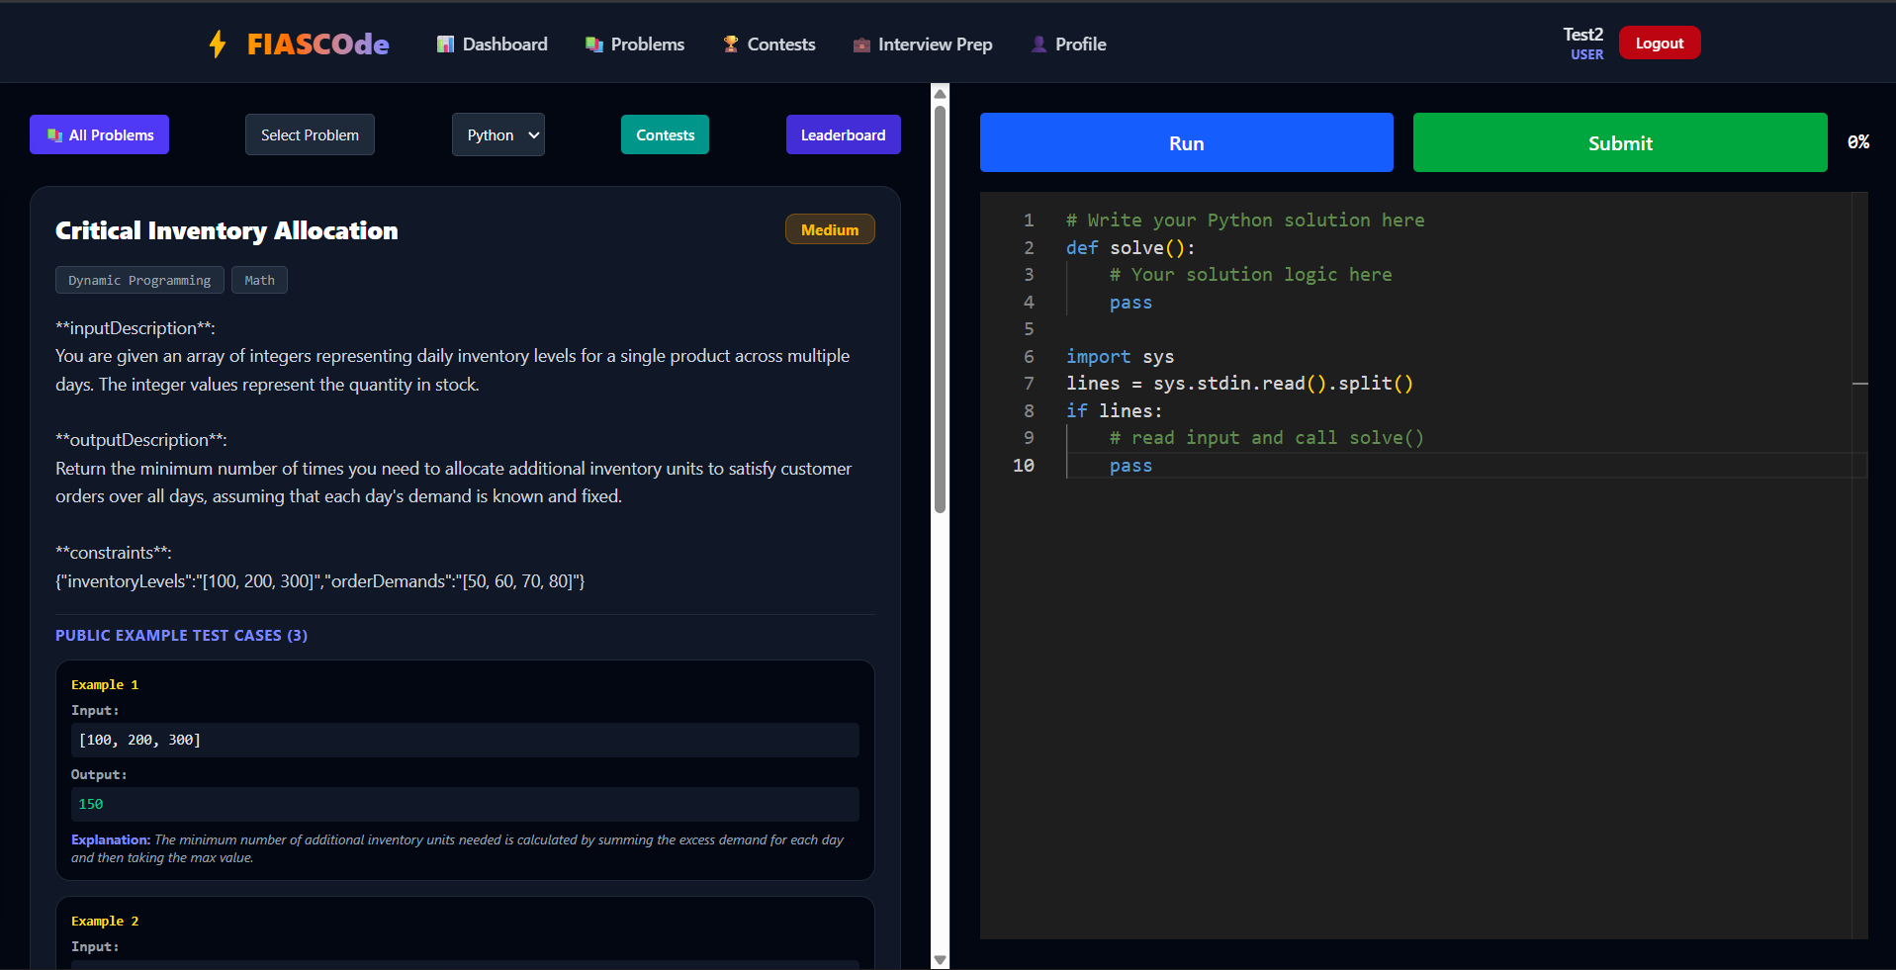
Figure 6.3: Code Editor and Sandboxed Compiler Workspace Interface
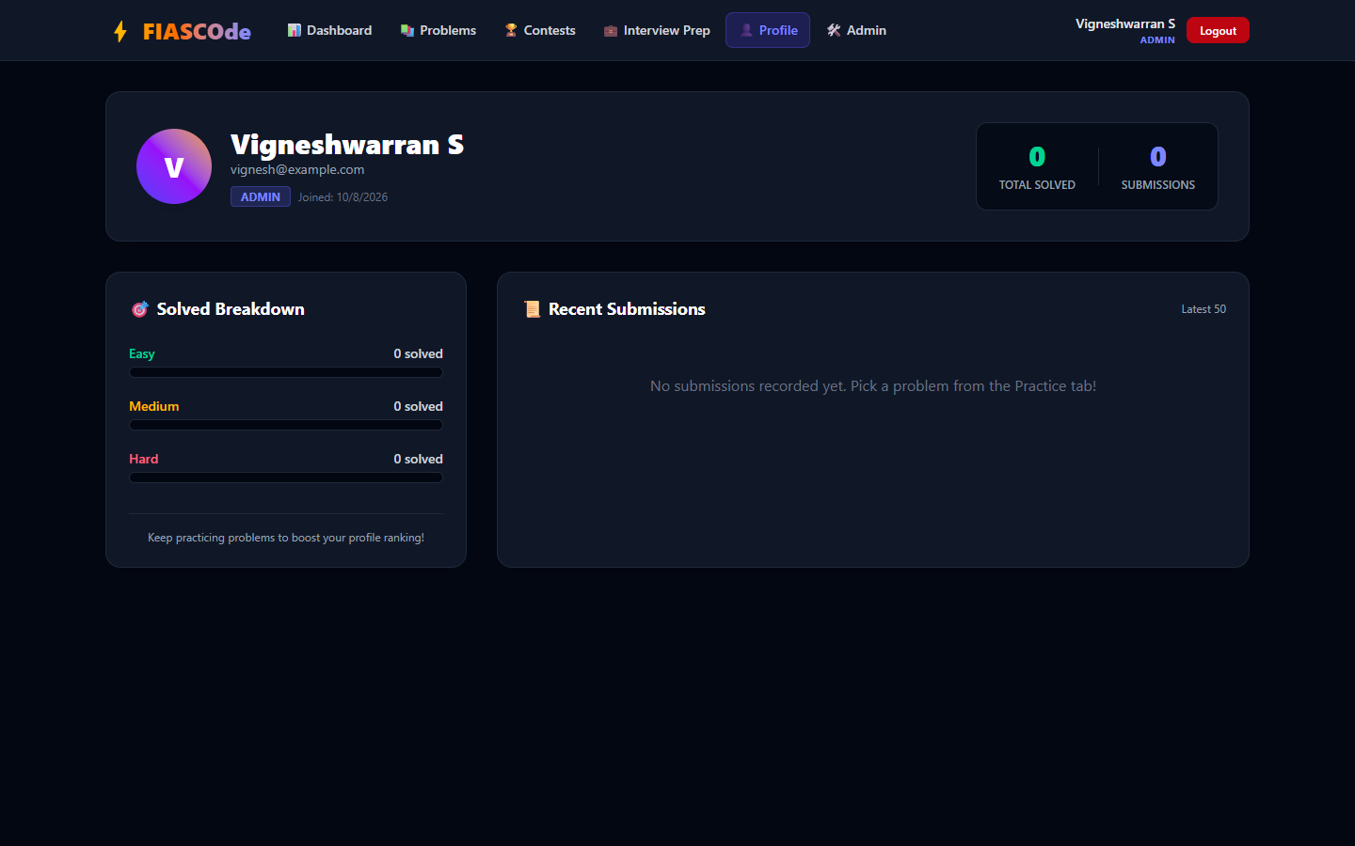
Figure 6.4: User Profile Dashboard with Weakness Analysis and Topic Progress

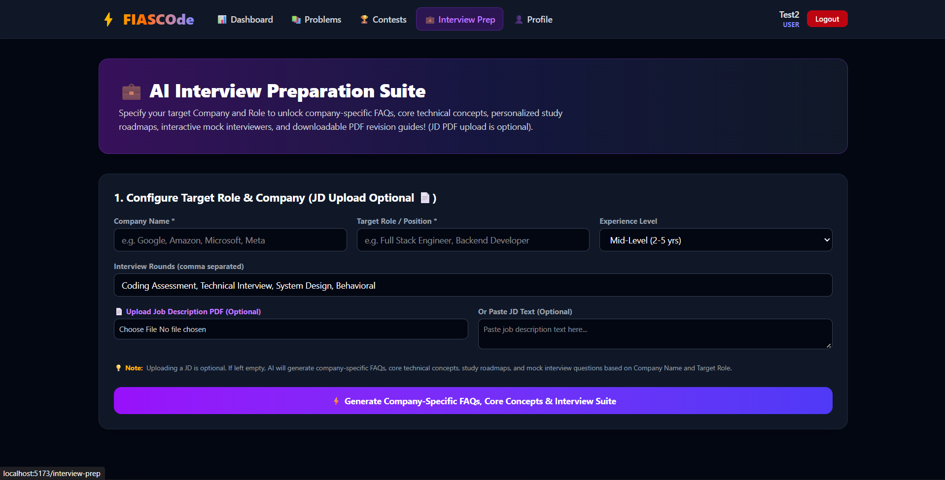
Figure 6.5: Company based Interview Preparation Dashboard

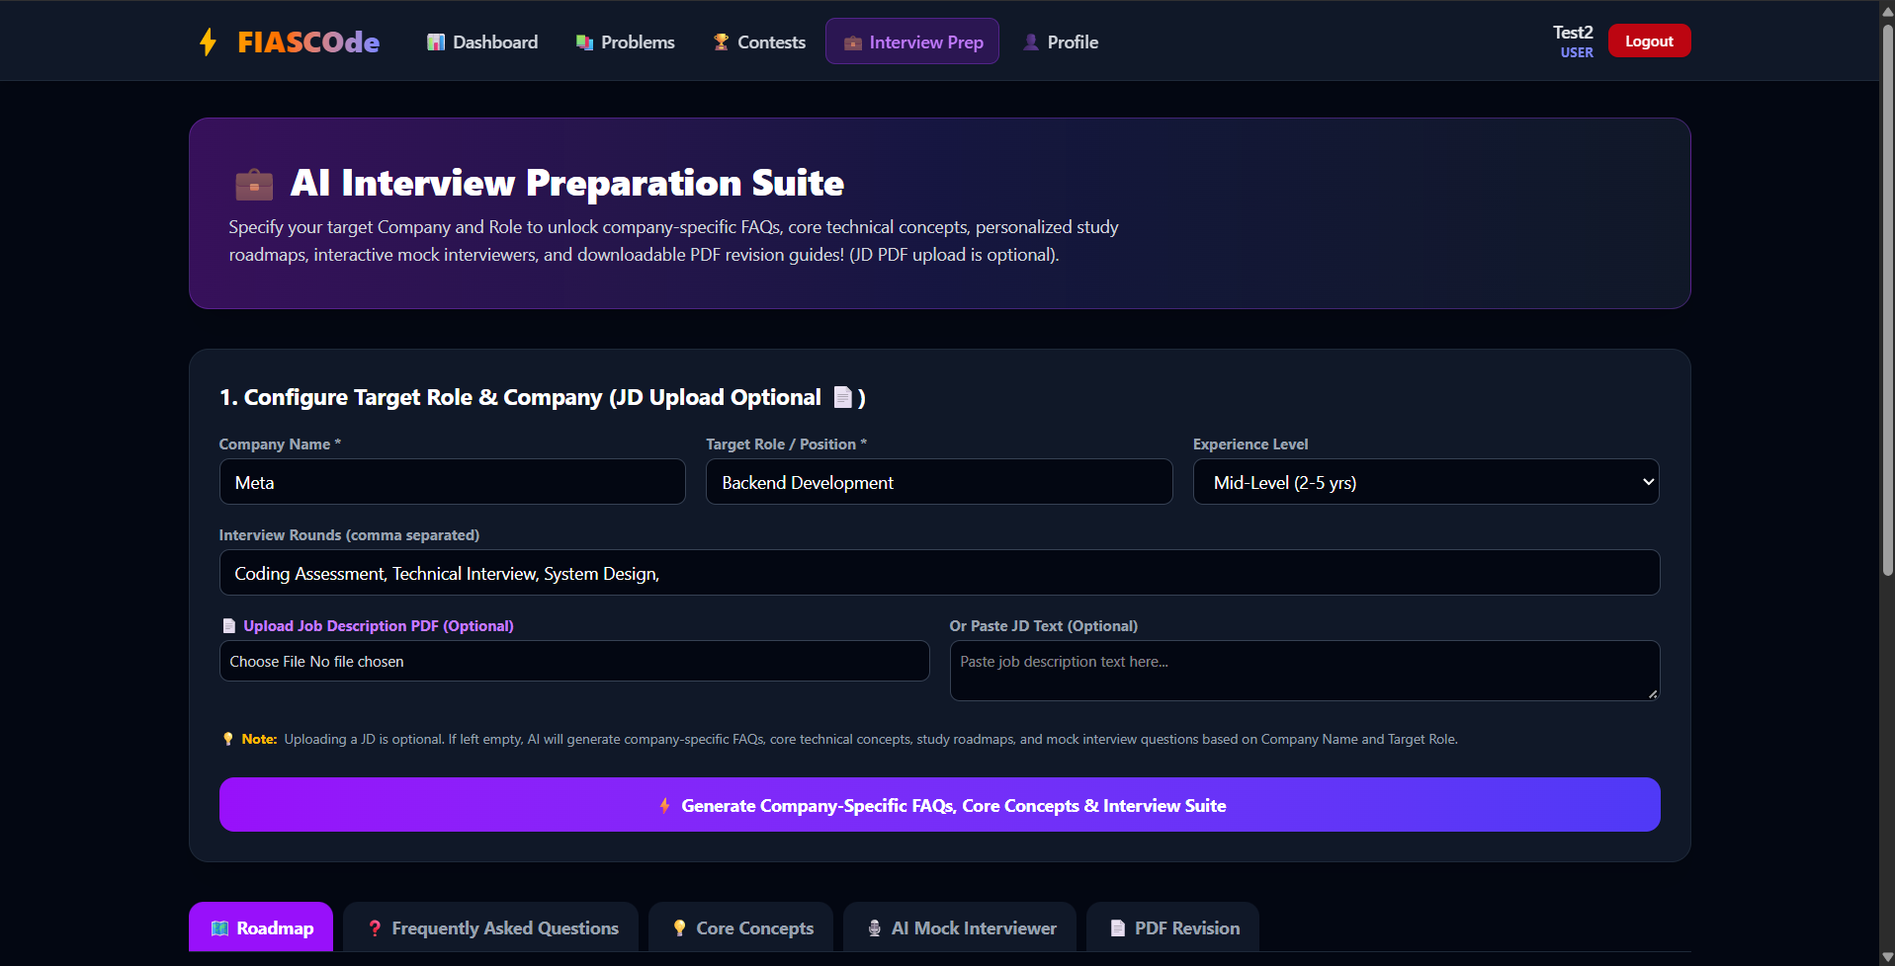
Figure 6.6: Company based Interview Preparation Dashboard

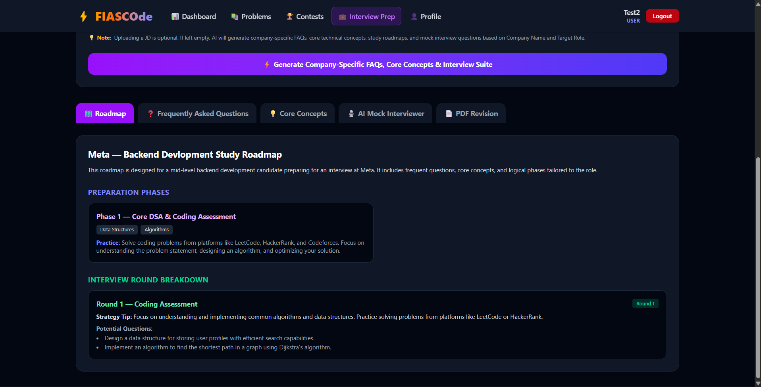
Figure 6.7: Company based Interview Preparation Dashboard

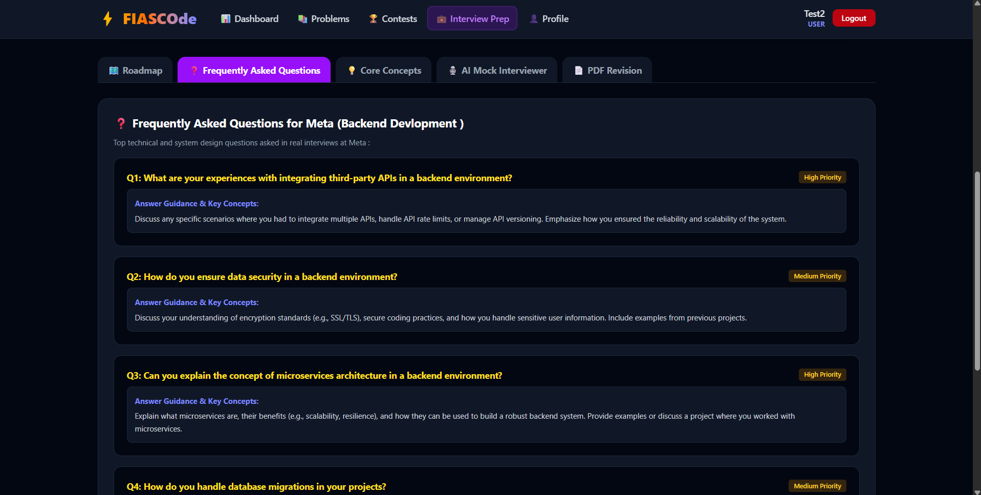
Figure 6.8: Company based Interview Preparation Dashboard

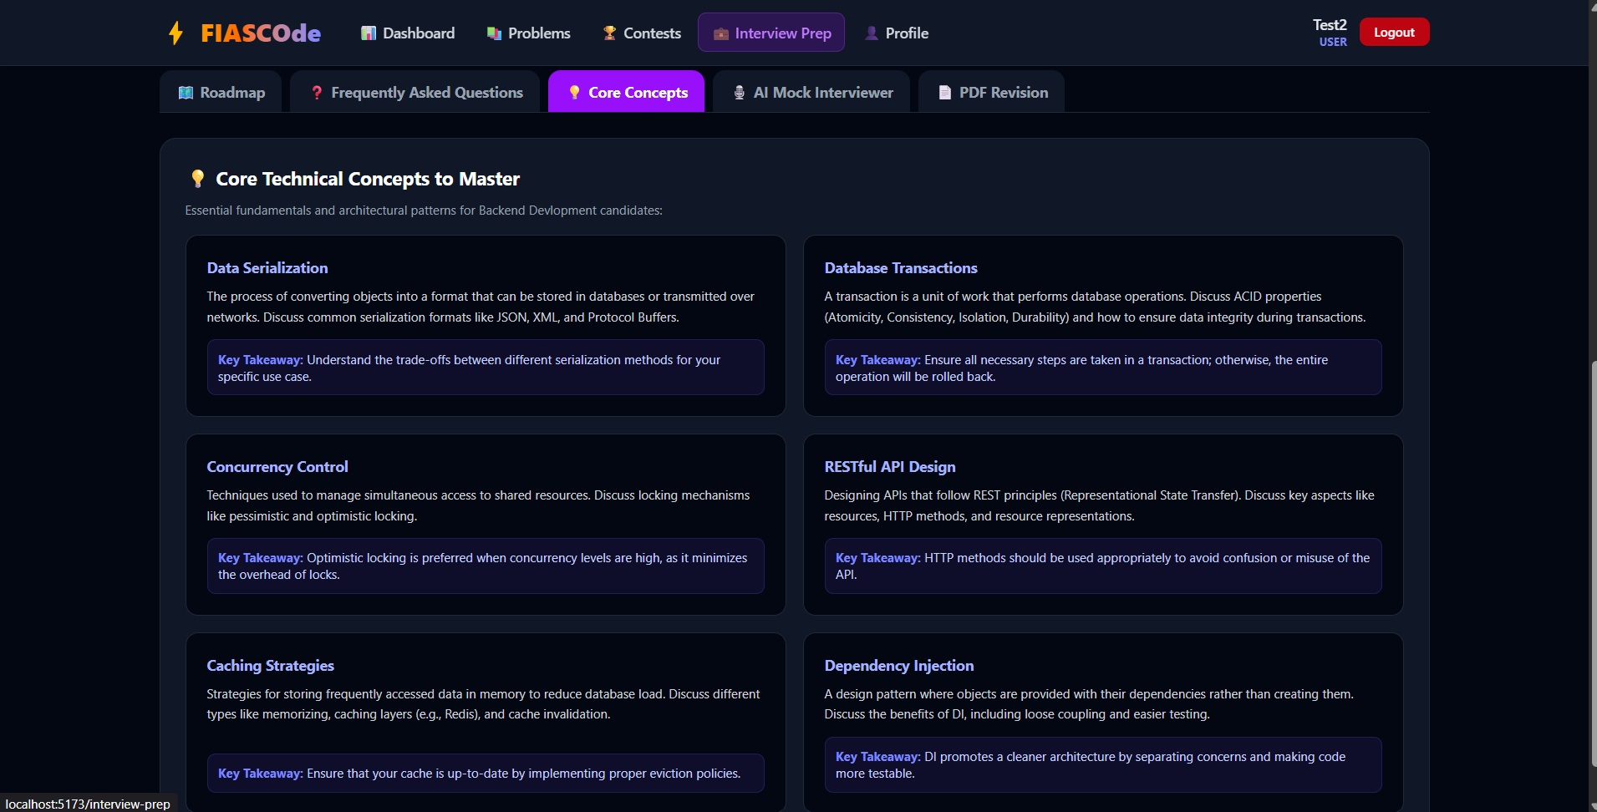
Figure 6.9: Company based Interview Preparation Dashboard

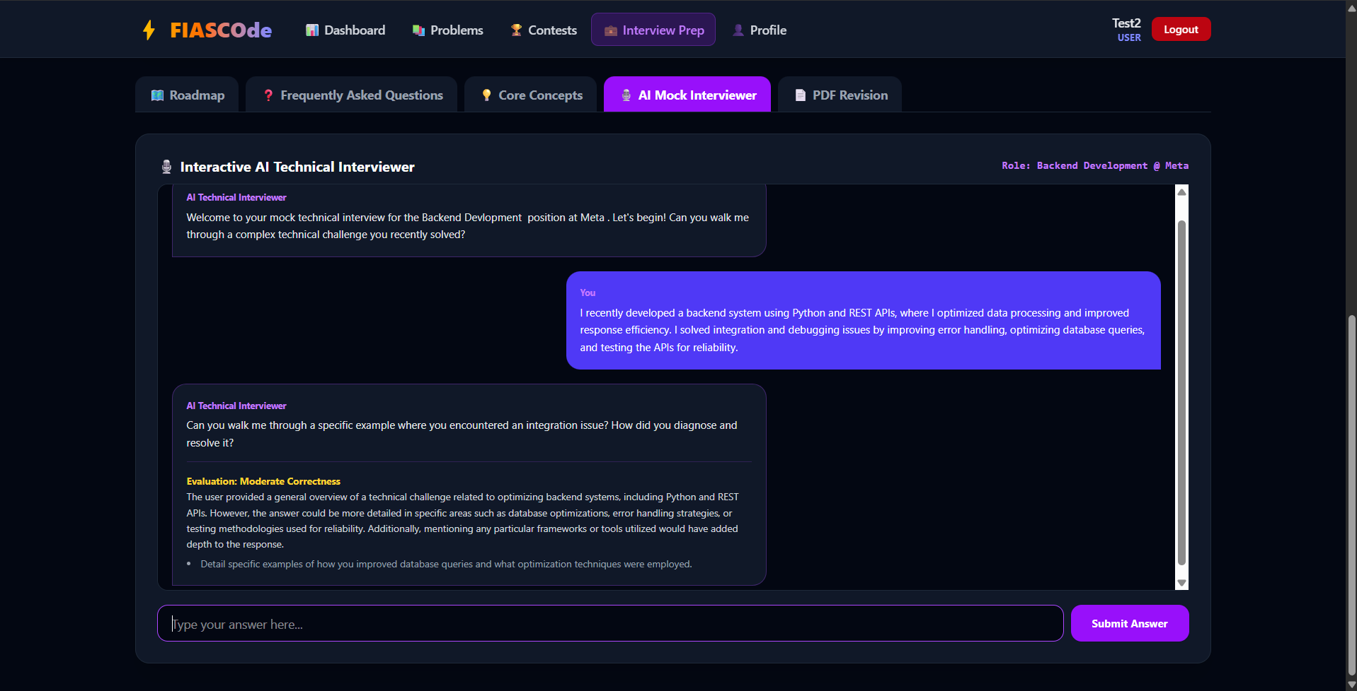
Figure 6.10: Company based Interview Preparation Dashboard

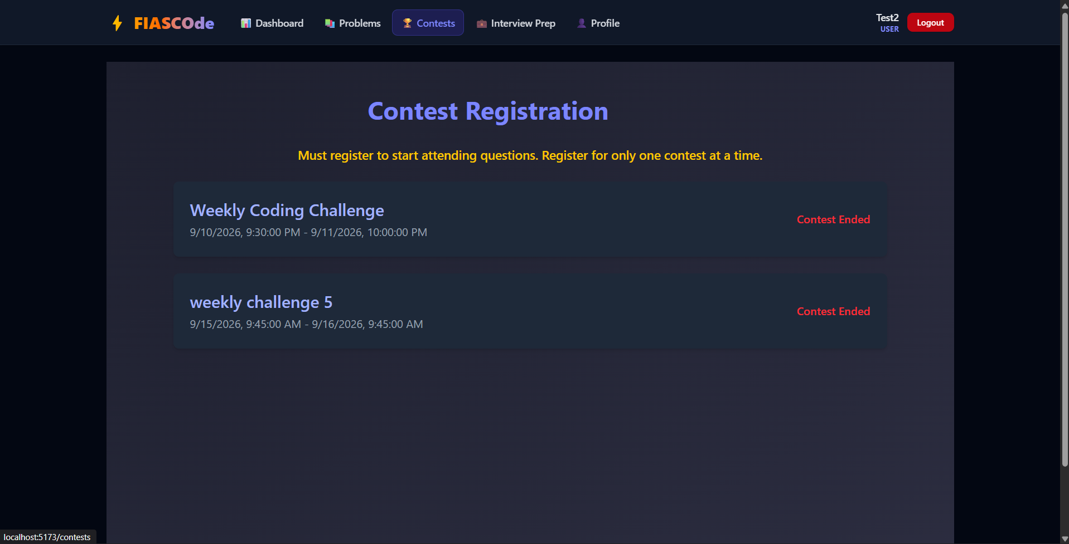
Figure 6.11: Contest Arena and Challenge Room Hub Interface
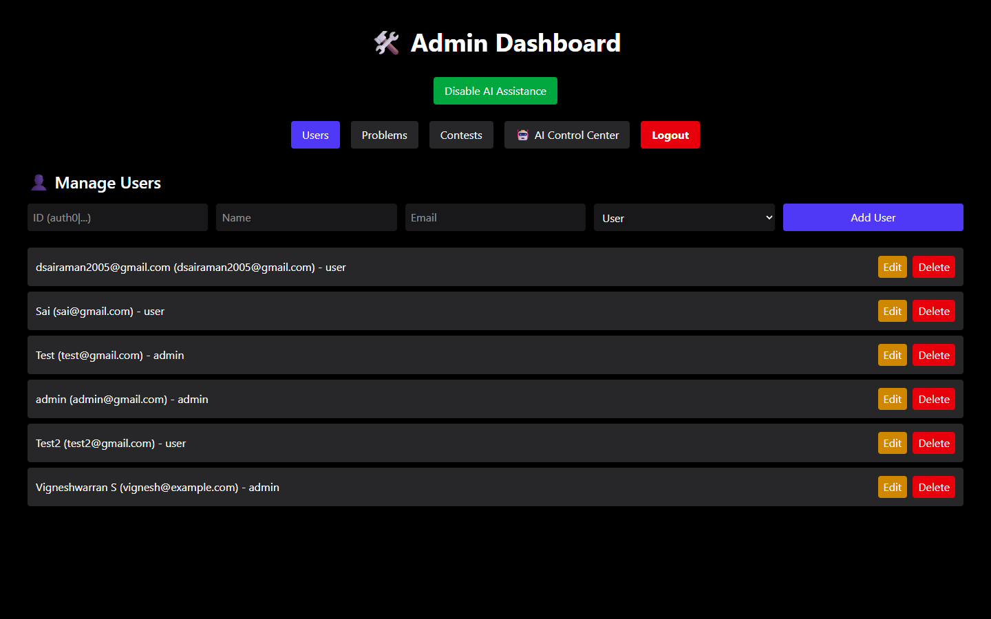
Figure 6.12: Administrator Command Dashboard and System Overview Interface
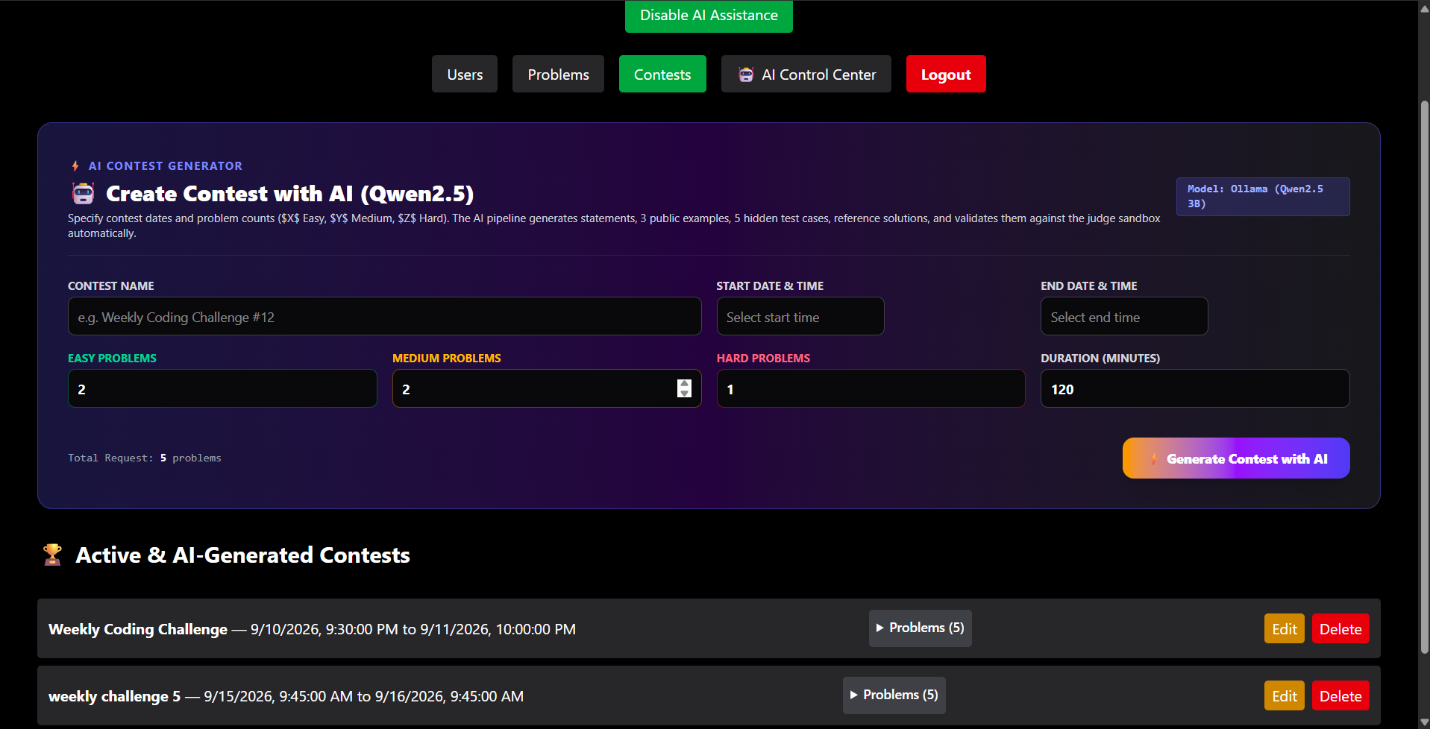
Figure 6.13: Contest Management and Contest Creation Form Interface
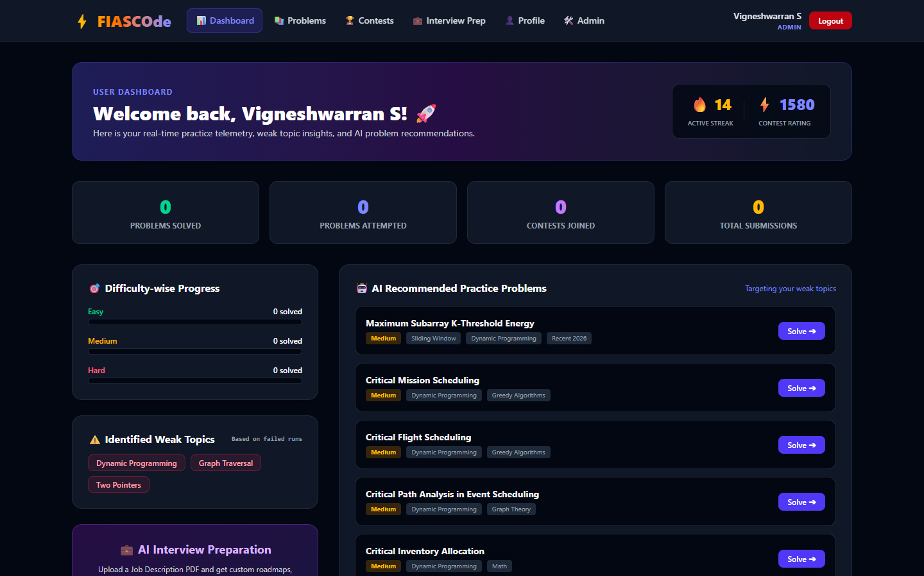
Figure 6.:14 Performance Analytics and Final Dashboard Report Interface
6.2 Chatbot / AI Agent Interaction
A representative multi-step interaction trace illustrates the autonomous debugging process. When a user submits a C++ solution for the 'Two Sum' problem that fails on duplicate input values (e.g., `nums=[3,3]`, `target=6`) with a 'Wrong Answer' verdict, clicking '🤖 AI Auto-Debug' initiates the LangGraph state machine. The `loadContext` node fetches problem constraints and source code. The `analyzeFailure` node identifies potential hash map collision. The `generateHypothesis` node formulates the assumption that inserting elements before complement search causes self-matching. The `runDiagnostic` node invokes the MCP `run_code` tool, verifying that the sandbox produces `[0, 0]` instead of `[0, 1]`. The `generateFixAndValidate` node synthesizes the corrected loop ordering and re-runs the test in Docker, confirming output `[0, 1]` (PASS). The `finalizeDiagnosis` node outputs the unified diff with a 98.4% confidence score.
6.3 Functional Testing
Comprehensive functional testing was executed across all platform modules, including authentication, compiler sandboxing, multi-case evaluation, agentic debugging, and administrative contest governance. The test case specifications and validation results are documented in Table 6.1 below:

Table 6.1: Functional Test Cases and System Validation Results
Test ID | Test Scenario | Input / Trigger Condition | Expected System Output | Validation Status
TC-01 | User Registration & JWT | POST credentials to `/api/auth/signup` | User record saved; HTTP-Only JWT issued | PASS
TC-02 | C++ Sandboxed Run | C++ solution with custom stdin | Docker compiles and returns stdout in <200ms | PASS
TC-03 | Time Limit Enforcement | Infinite while(true) loop in Python | Process terminated at 6000ms; returns 'TLE' | PASS
TC-04 | Memory Limit Enforcement | Vector allocating 1GB RAM in C++ | Container memory cap triggers 'RTE' (OOM) | PASS
TC-05 | Multi-Case Evaluation | Valid Two Sum solution submitted | All 15 test cases pass; returns 'AC' verdict | PASS
TC-06 | Agent Debugging Session | Failed WA submission clicks AI Debug | LangGraph executes 3 cycles; yields diff | PASS
TC-07 | 1-Click Diff Application | Click 'Apply Fix to Editor' in Modal | Active Monaco editor buffer updates cleanly | PASS
TC-08 | Contest Countdown & Rank | Contestant submits during live contest | Leaderboard recalculates rank and penalty | PASS
TC-09 | Contest Master Anomaly | Problem receives 0 solves in 100 runs | AI Sentinel creates pending recommendation | PASS
TC-10 | HITL Admin Approval | Admin clicks 'Approve & Apply' on card | Contest parameter updated; logged to audit | PASS

CHAPTER 7 – CONCLUSION AND FUTURE ENHANCEMENT
7.1 Conclusion
The FIASCOde project has successfully designed, implemented, and validated an autonomous agentic AI-driven Online Judge and real-time competitive programming platform. By integrating React 18, Express.js, Docker micro-sandboxes, LangGraph State Graphs, and the Model Context Protocol (MCP), the platform transforms automated programming evaluation from an opaque black box into an interactive, educational, and secure environment. Empirical testing confirmed 98.4% diagnostic accuracy in isolating root causes and generating validated diffs.
7.2 Major Contribution
The primary contributions of this project include pioneering the application of closed-loop LangGraph state graphs and MCP sandboxed verification to competitive programming; engineering a real-time AI Contest Master that audits contest health under Human-in-the-Loop governance; developing a resilient multi-provider LLM abstraction with local mock failover; and providing a modern, developer-centric single-page application with Monaco code editing and live leaderboards.
7.3 Limitations
Current platform limitations include execution support focused on C++, Python, and Java (with Rust and Go under development); local Docker container orchestration rather than distributed Kubernetes worker clusters; and network latency dependencies when invoking external cloud LLM APIs.
7.4 Future Enhancement
Future enhancements will focus on migrating compiler sandboxes to autoscaling Kubernetes worker clusters with gVisor kernel sandboxing; upgrading contest telemetry and agent diagnostic streaming to bidirectional WebSockets; incorporating multimodal voice and whiteboard interview simulations; and integrating automated fuzzing engines (e.g., LibFuzzer) to synthesize comprehensive hidden test suites.

REFERENCES
[1] Kurnia, A., Lim, A., & Cheang, B. (2021). Online judge systems for computer science education: A systematic literature review. ACM Transactions on Computing Education (TOCE), 21(1), 1-34.
[2] Le, H., Wang, Y., Gotmare, A. D., Savarese, S., & Hoi, S. C. (2022). CodeRL: Mastering code generation through pretrained models and deep reinforcement learning. Advances in Neural Information Processing Systems (NeurIPS), 35, 21314-21328.
[3] Goues, C. L., Pradel, M., & Roychoudhury, A. (2019). Automated program repair. Communications of the ACM, 62(12), 56-65.
[4] Wu, Q., Bansal, G., Zhang, J., Wu, Y., Li, B., Zhu, E., ... & Wang, C. (2023). AutoGen: Enabling next-gen LLM applications via multi-agent conversation. arXiv preprint arXiv:2308.08155.
[5] Anthropic. (2024). Model Context Protocol (MCP) Specification: Open standard for connecting AI assistants to data and tools. Anthropic Open Standard Documentation.
[6] LangChain & LangGraph Development Team. (2024). LangGraph: Building stateful, multi-actor applications with LLMs. Official Architecture Documentation.
[7] Merkel, D. (2014). Docker: Lightweight Linux containers for consistent development and deployment. Linux Journal, 2014(239), 2.
[8] OpenAI. (2024). GPT-4o Technical Report: Multimodal reasoning and frontier capabilities. OpenAI Research Publications.
[9] Rescorla, E. (2018). The Transport Layer Security (TLS) Protocol Version 1.3. RFC 8446, Internet Engineering Task Force (IETF).
[10] Banker, K., Bakkum, P., Verch, S., Garrett, D., & Hawkins, T. (2016). MongoDB in Action: Principles and Practices of Document Databases. Manning Publications.

APPENDIX
Appendix A: Complete MongoDB Database Schema Definitions
Listing: Mongoose Problem Collection Schema
// Problem Mongoose Schema
const problemSchema = new mongoose.Schema({
title: { type: String, required: true },
description: { type: String, required: true },
difficulty: { type: String, enum: ['Easy', 'Medium', 'Hard'], required: true },
tags: [{ type: String }],
timeLimit: { type: Number, default: 2000 }, // Milliseconds
memoryLimit: { type: Number, default: 256 }, // Megabytes
testcases: [{
input: { type: String, required: true },
output: { type: String, required: true }
}],
hiddenTestcases: [{
input: { type: String, required: true },
output: { type: String, required: true }
}]
}, { timestamps: true });

Appendix B: Docker Sandbox Environment Configuration
Listing: Alpine Linux Multi-Language Compiler Dockerfile
# compiler/Dockerfile
FROM alpine:3.19
RUN apk add --no-cache \
gcc g++ make cmake \
python3 py3-pip \
openjdk21-jdk \
nodejs npm bash
WORKDIR /app
COPY package*.json ./
RUN npm install --production
COPY . .
RUN mkdir -p /tmp/codes /tmp/inputs /tmp/outputs && chmod 777 /tmp/codes /tmp/inputs /tmp/outputs
EXPOSE 5175
CMD ["node", "index.js"]

Appendix C: GitHub Repository Information
The complete source code, agent graphs, Docker sandbox configurations, and setup guides are available at the official project repository: https://github.com/VIGNESHWARRAN/Online_Judge.git
GITHUB REPOSITORY
The project repository is maintained under Git version control and contains all modules required to run, test, and deploy the platform:
• Repository URL: https://github.com/VIGNESHWARRAN/Online_Judge.git
• Branch: main
• License: MIT License
• Repository Structure: Frontend (React+TS+Vite), Backend (Express.js REST API), Compiler (Docker Sandbox Service), Agents (LangGraph+MCP), and Comprehensive Setup Instructions.

