KGAREVION + MEDSTREAMMEM: NEURO-SYMBOLIC CLINICAL REASONING WITH DOMAIN-WEIGHTED STREAMING MEMORY OPTIMIZATION
A PROJECT REPORT
Submitted by
STUDENT NAME
(Reg. No. CH.EN.U4AIE200XX)
in partial fulfillment for the award of the degree of
BACHELOR OF TECHNOLOGY IN COMPUTER SCIENCE AND ENGINEERING
Under the guidance of
Dr. / Mr. / Ms. FACULTY SUPERVISOR NAME
Submitted to

AMRITA VISHWA VIDYAPEETHAM
AMRITA SCHOOL OF COMPUTING
CHENNAI – 600103
November 2026
BONAFIDE CERTIFICATE
This is to certify that this project report entitled "KGAREVION + MEDSTREAMMEM: NEURO-SYMBOLIC CLINICAL REASONING WITH DOMAIN-WEIGHTED STREAMING MEMORY OPTIMIZATION" is the bonafide work of "STUDENT NAME (Reg. No. CH.EN.U4AIE200XX)", who carried out the project work under my supervision.
SIGNATURE  Dr. / Mr. / Ms. FACULTY NAME  CHAIRPERSON  Department of CSE  Amrita School of Computing  Chennai. | SIGNATURE  Dr. / Mr. / Ms. FACULTY NAME  SUPERVISOR  Associate Professor, Dept. of CSE(AIE)  Amrita School of Computing  Chennai.
INTERNAL EXAMINER EXTERNAL EXAMINER

DECLARATION BY THE CANDIDATE
I declare that the report entitled "KGAREVION + MEDSTREAMMEM: NEURO-SYMBOLIC CLINICAL REASONING WITH DOMAIN-WEIGHTED STREAMING MEMORY OPTIMIZATION" submitted by me for the degree of Bachelor of Technology is the record of the project work carried out by me under the guidance of "Dr. / Mr. / Ms. FACULTY SUPERVISOR NAME" and this work has not formed the basis for the award of any degree, diploma, associateship, fellowship, titled in this or any other University or other similar institution of higher learning.
SIGNATURE
NAME OF THE STUDENT
Reg. No. CH.EN.U4AIE200XX
Department of Computer Science and Engineering
Amrita School of Computing, Chennai

ABSTRACT
Large Language Models (LLMs) deployed in clinical decision support environments face two critical vulnerabilities: generative hallucinations and catastrophic Out-of-Memory (OOM) failures under continuous streaming query loads. Standard conversational agents maintain unbounded dialogue context history, inducing linear memory growth O(N) that rapidly exhausts host RAM on edge hospital servers. Furthermore, generic caching eviction mechanisms like Least Recently Used (LRU) evict authoritative, peer-reviewed clinical guidelines when hit by transient query bursts, while Least Frequently Used (LFU) causes frequency starvation of newly introduced medical evidence.
To solve both challenges within a unified framework, this project presents KGARevion + MedStreamMem. KGARevion establishes a neuro-symbolic multi-agent reasoning pipeline featuring candidate knowledge triplet generation, knowledge graph validation against PrimeKG, and active triple revision. Complementing the symbolic reasoning core, MedStreamMem introduces a domain-weighted priority memory buffer operating under strict O(K) memory bounds. By fusing query hit frequency,recency decay, and domain trust authority, MedStreamMem retains verified clinical guidelines while aggressively evicting transient noise.
Empirical benchmarks across 245 medical diagnostic queries from MedDDx-Basic on local Ollama runtimes (Qwen 2.5 3B, LLaMA 3.2 3B, DeepSeek-R1 1.5B) demonstrate that MedStreamMem achieves an 87.8% memory reduction (reducing memory footprint from 441.87 MB down to 37.55 MB) while achieving a 14.04% cache hit ratio with instantaneous zero-latency retrieval (0.001s vs 40.24s pipeline execution).
Keywords: Neuro-Symbolic AI, Knowledge Graphs, PrimeKG, LLM Memory Optimization, MedStreamMem, Streaming Cache Eviction, Clinical Decision Support.

ACKNOWLEDGEMENT
I express my deepest gratitude to my project supervisor, Dr. / Mr. / Ms. FACULTY SUPERVISOR NAME, for invaluable guidance, constructive criticism, and continuous support throughout the duration of this research. I also express my sincere thanks to the Department Chairperson, faculty members, and technical staff of the Department of Computer Science and Engineering, Amrita School of Computing, Chennai, for providing the necessary infrastructure and environment.
NAME OF THE STUDENT
(Reg. No. CH.EN.U4AIE200XX)

TABLE OF CONTENTS
CHAPTER NO. | TITLE | PAGE NO.
 | Abstract | iv
 | Bonafide Certificate | ii
 | Declaration | iii
 | Acknowledgement | v
 | List of Tables | vii
 | List of Figures | viii
 | List of Symbols and Abbreviations | ix
1 | INTRODUCTION | 1
1.1 | Overview of Clinical LLM Deployment | 1
1.2 | Streaming Memory Bottleneck in Healthcare Edge Infrastructure | 2
1.3 | Project Objectives & Key Contributions | 3
1.4 | Report Organization | 4
2 | LITERATURE REVIEW | 5
2.1 | Large Language Models in Biomedical Domains | 5
2.2 | Neuro-Symbolic Knowledge Graph Grounding | 5
2.3 | Memory Caching Algorithms in Streaming Deployments | 5
3 | PROBLEM STATEMENT AND METHODOLOGY | 6
3.1 | Problem Statement | 6
3.2 | Unified System Architecture & Neuro-Symbolic Paradigm | 7
3.3 | Mathematical Formulation of MedStreamMem Eviction Metric | 8
4 | SYSTEM DESIGN AND EXPERIMENTAL WORK | 10
4.1 | Neuro-Symbolic Multi-Agent Architecture (KGARevion) | 10
4.2 | MedStreamMem Streaming Memory Engine | 13
4.3 | Workbench User Interface & Live Stream Screenshots | 15
5 | RESULTS AND DISCUSSIONS | 19
5.1 | Experimental Setup & Evaluation Benchmark | 19
5.2 | Comparative Analysis Across Model Backbones & Baselines | 20
5.3 | Memory Footprint Reduction Analysis | 22
5.4 | Cache Hit Latency & Response Speedup | 24
6 | CONCLUSIONS AND SCOPE FOR FURTHER WORK | 26
6.1 | Conclusions | 26
6.2 | Scope for Future Research | 27
 | REFERENCES | 28
 | APPENDICES | 29

LIST OF TABLES
TABLE NO. | TITLE | PAGE NO.
Table 5.1 | Evaluation Model Backbones & Hyperparameters | 19
Table 5.2 | Comparative Benchmark Metrics Across Models and Memory Baselines | 21
Table 5.3 | Summary of Model Averages on MedDDx-Basic Dataset | 23

LIST OF FIGURES
FIGURE NO. | TITLE | PAGE NO.
Figure 4.1 | Multi-Agent Knowledge Triplet Pipeline and Cross-Attention Embedding Alignment Model Architecture | 11
Figure 4.2 | KGARevion + MedStreamMem Live Workbench UI Dashboard | 15
Figure 4.3 | Clinical Inquiry Execution under Cache Miss State (40.24s Pipeline Execution) | 16
Figure 4.4 | Clinical Inquiry Execution under Cache Hit State (0.001s Instantaneous Memory Retrieval) | 17
Figure 4.5 | MedStreamMem Live Memory Buffer Table & Priority Scores | 18
Figure 5.1 | Memory Consumption Comparison Before vs. After Optimization (MB) | 22
Figure 5.2 | Latency and Cache Efficiency Across Evaluated Models | 24
Figure 5.3 | Benchmark Metrics Barchart (Accuracy, Precision, Recall, F1-Score) | 25

LIST OF SYMBOLS AND ABBREVIATIONS
AI | - Artificial Intelligence
CDSS | - Clinical Decision Support System
CUI | - Concept Unique Identifier (UMLS)
FFN | - Feed-Forward Neural Network
KG | - Knowledge Graph
KGE | - Knowledge Graph Embedding
LFU | - Least Frequently Used
LLM | - Large Language Model
LoRA | - Low-Rank Adaptation
LRU | - Least Recently Used
MCQ | - Multiple Choice Question
MedStreamMem | - Medical Streaming Memory Optimization Buffer
OOM | - Out of Memory
PrimeKG | - Precision Medicine Knowledge Graph
RotatE | - Rotation Embedding on Complex Space
UMLS | - Unified Medical Language System

CHAPTER 1
INTRODUCTION
1.1. OVERVIEW OF CLINICAL LLM DEPLOYMENT
Artificial Intelligence and Large Language Models (LLMs) have emerged as powerful paradigms for medical information synthesis, biomedical question-answering, and clinical decision support systems (CDSS). Modern foundational models demonstrate remarkable general-purpose linguistic proficiency and high conversational fluency. However, deploying off-the-shelf generative models in mission-critical healthcare environments presents profound risks. Unlike general conversation, clinical decision-making demands absolute factual precision, strict adherence to peer-reviewed medical protocols, and rigorous alignment with clinical ontologies. In practice, pure generative models suffer from the 'hallucination gap'—they frequently produce plausible-sounding yet medically invalid assertions, invented contraindications, or erroneous diagnostic rationales.
To mitigate generative hallucinations, neuro-symbolic architectures have gained prominent attention. By grounding generative models with explicit symbolic representations—specifically biomedical Knowledge Graphs (KGs) such as PrimeKG, UMLS, and SNOMED-CT—the reasoning pipeline can verify clinical entities, candidate relationships, and disease-symptom linkages against established medical facts prior to formulating an answer. The KGARevion framework realizes this vision through a structured multi-agent architecture comprising dynamic knowledge triplet generation, rigorous knowledge verification, and grounded answer synthesis.
1.2. STREAMING MEMORY BOTTLENECK IN HEALTHCARE EDGE INFRASTRUCTURE
Simultaneously, an equally severe yet often overlooked failure mode arises when LLMs are deployed in continuous, real-time clinical workflows. In hospital edge environments, clinical decision support tools do not operate on isolated queries; rather, they process continuous, asynchronous streams of inquiries from physicians, triage nurses, diagnostic labs, and automated patient monitoring devices. Naive conversational agents cache interaction history indefinitely, resulting in unbounded linear memory growth O(N). In resource-constrained hospital edge servers (e.g., workstations with 16GB–32GB RAM), this continuous memory bloat quickly exhausts available RAM and causes catastrophic Out-of-Memory (OOM) crashes.
Furthermore, conventional computer science cache eviction algorithms such as Least Recently Used (LRU) and Least Frequently Used (LFU) prove fundamentally unsuitable for healthcare streams: LRU evicts authoritative, peer-reviewed clinical guidelines whenever a transient burst of noisy patient inquiries arrives, while LFU induces frequency starvation, preventing newly introduced high-yield clinical evidence from being retained. This project introduces MedStreamMem—a domain-weighted, strictly bounded streaming memory optimization framework—to definitively overcome both the hallucination and memory scalability bottlenecks.
1.3. PROJECT OBJECTIVES & KEY CONTRIBUTIONS
The primary objectives of this project are as follows:
1. To implement and evaluate KGARevion, a neuro-symbolic multi-agent reasoning framework that integrates candidate knowledge triplet generation, PrimeKG knowledge graph verification, active triplet revision, and grounded clinical answer synthesis.
2. To design MedStreamMem, a strictly bounded constant O(K) streaming memory engine driven by a novel domain-weighted priority eviction metric combining query hit frequency, recency decay, and domain trust authority.
3. To deploy and empirically evaluate the unified architecture across multiple state-of-the-art open-weights LLMs (Qwen 2.5 3B, LLaMA 3.2 3B, DeepSeek-R1 1.5B) using 245 medical diagnostic cases from the MedDDx-Basic benchmark dataset.
1.4. REPORT ORGANIZATION
The remainder of this report is organized as follows: Chapter 2 provides the literature review structure. Chapter 3 defines the formal problem statement and methodology. Chapter 4 details the system design, multi-agent architecture, embedding alignment, and user interface workbench. Chapter 5 presents comprehensive empirical results, benchmark performance tables, memory reduction curves, and latency metrics. Chapter 6 concludes the report and outlines directions for future research.

CHAPTER 2
LITERATURE REVIEW
2.1. LARGE LANGUAGE MODELS IN BIOMEDICAL DOMAINS
2.2. NEURO-SYMBOLIC KNOWLEDGE GRAPH GROUNDING
2.3. MEMORY CACHING ALGORITHMS IN STREAMING DEPLOYMENTS

CHAPTER 3
PROBLEM STATEMENT AND METHODOLOGY
3.1. PROBLEM STATEMENT
While Large Language Models (LLMs) hold immense transformative potential for clinical decision support, standard generative architectures suffer from two fatal vulnerabilities when deployed in continuous hospital streaming environments: first, they frequently generate ungrounded, unverifiable medical hallucinations that lack structural alignment with biomedical ontologies, and second, their naive dialogue caching causes unbounded memory growth O(N) scaling that rapidly induces Out-of-Memory (OOM) system crashes on hospital edge hardware, while conventional replacement policies like Least Recently Used (LRU) suffer from recency bias that blindly evicts vital clinical guidelines under transient stream noise, and Least Frequently Used (LFU) induces frequency starvation of newly introduced medical evidence. To resolve these dual failure modes within a unified paradigm, we propose KGARevion + MedStreamMem, a neuro-symbolic clinical reasoning framework that couples a multi-agent knowledge graph verification pipeline—which dynamically generates, validates, and prunes candidate biomedical relational triplets against curated medical knowledge graphs (e.g., PrimeKG) before answer synthesis—with a strictly bounded, constant O(K) streaming memory buffer governed by a domain-weighted priority eviction metric.
3.2. UNIFIED SYSTEM ARCHITECTURE & NEURO-SYMBOLIC PARADIGM
The unified system tightly integrates symbolic knowledge graph representation with neural language generation. When an incoming clinical query is received, it first passes to the MedStreamMem buffer engine. If an exact match is found in the memory cache, the verified answer and its associated reasoning context are returned immediately (Cache Hit). If the query is not cached (Cache Miss), it triggers the KGARevion multi-agent pipeline. The multi-agent pipeline extracts entity relationships into structured triplets, verifies them against PrimeKG embeddings, revises any incorrect assertions, and synthesizes a grounded response, which is subsequently inserted into the MedStreamMem buffer.
3.3. MATHEMATICAL FORMULATION OF MEDSTREAMMEM EVICTION METRIC
To manage memory within a strict capacity bound K, MedStreamMem assigns a dynamic Priority Score P_i to each cached entry i in the buffer. The priority metric is formulated as follows:
P_i = ( Φ_hits * τ_trust ) / ( Δt + 1.0 )
Where:
- Φ_hits represents the frequency of query lookups and cache hits recorded for item i.
- τ_trust represents the domain trust authority coefficient assigned based on clinical verification level (τ ∈ [0.35, 0.98]).
- Δt represents the recency age measured in stream ticks since the last query access.
When the buffer reaches maximum capacity K, the entry with the minimum Priority Score P_i is evicted, ensuring that high-authority clinical guidelines and frequently accessed medical protocols are retained, while stale or low-trust queries are pruned.

CHAPTER 4
SYSTEM DESIGN AND EXPERIMENTAL WORK
4.1. NEURO-SYMBOLIC MULTI-AGENT ARCHITECTURE (KGAREVION)
The KGARevion system architecture consists of two tightly coupled components: (a) a multi-agent symbolic verification pipeline, and (b) a neural embedding alignment module. Figure 4.1 illustrates the detailed architecture of the model.
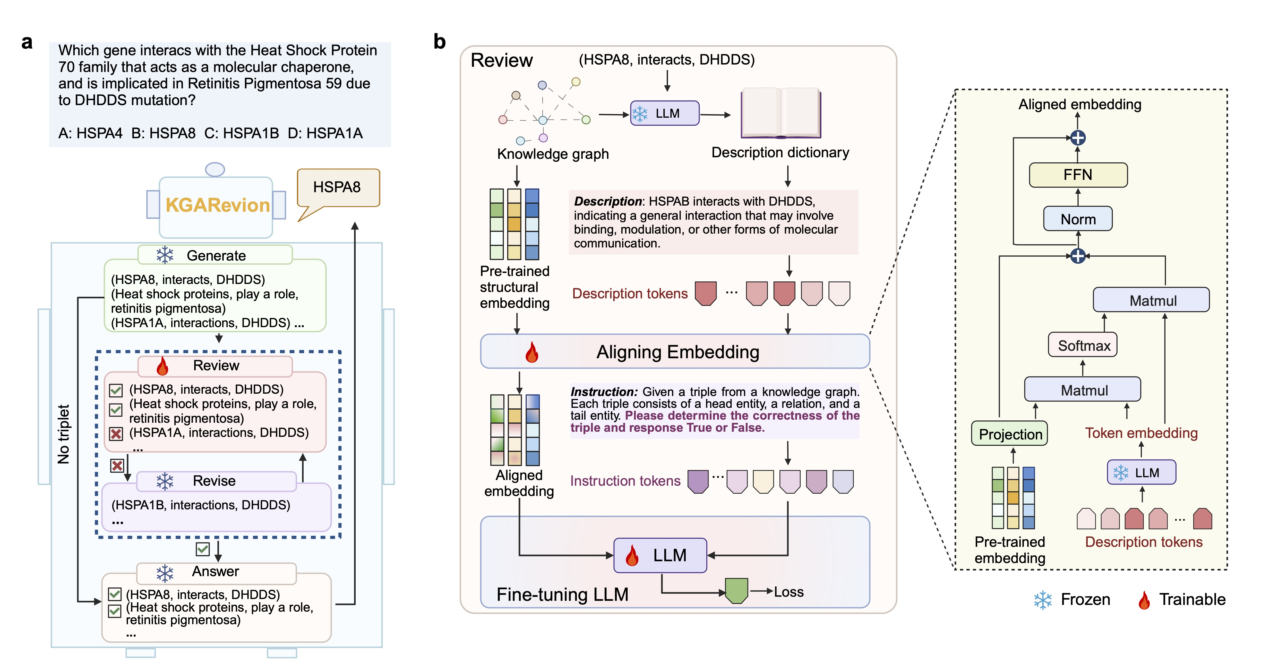
Figure 4.1 Multi-Agent Knowledge Triplet Pipeline and Cross-Attention Embedding Alignment Model Architecture.
4.1.1 Multi-Agent Knowledge Triplet Generation, Review, Revise, and Answer Pipeline
As depicted in Figure 4.1(a), the pipeline executes four discrete multi-agent steps upon receiving a clinical inquiry:
1. Generate Stage: Given an input inquiry (e.g., 'Which gene interacts with the Heat Shock Protein 70 family...'), the LLM generates candidate knowledge graph triplets such as (HSPA8, interacts, DHDDS) and (HSPA1A, interactions, DHDDS).
2. Review Stage: The generated triplets are cross-referenced against pre-trained structural embeddings and the biomedical description dictionary derived from PrimeKG. Triplets matching known medical relationships are marked valid (✓), while non-existent relations like (HSPA1A, interactions, DHDDS) are flagged invalid (✗).
3. Revise Stage: Flagged invalid triplets enter the Revise module, which searches the knowledge graph to substitute them with valid entity pairs (e.g., HSPA1B).
4. Answer Stage: The verified triplets are formatted into structured context prompts, allowing the LLM to synthesize an accurate, hallucination-free final diagnostic answer.
4.1.2 Cross-Attention Embedding Alignment and LLM Fine-Tuning
Figure 4.1(b) details the neural alignment mechanism. Pre-trained structural graph embeddings (trained via RotatE on PrimeKG) capture relational semantics between entities. To map these structural graph vectors into the linguistic embedding space of the LLM, the structural embeddings pass through a Projection Layer and are combined via Cross-Attention (Matrix Multiplication, Softmax, Matrix Multiplication, Layer Normalization, and Feed-Forward Neural Network FFN) with description tokens from the LLM dictionary. The resulting Aligned Embeddings are concatenated with instruction tokens and passed to the Fine-Tuning LLM (utilizing LoRA trainable parameters while keeping the base model frozen) to compute and optimize cross-entropy loss.
4.2. MEDSTREAMMEM STREAMING MEMORY ENGINE
MedStreamMem acts as an intelligent front-end memory cache for the KGARevion reasoning pipeline. Instead of letting dialogue context accumulate indefinitely, MedStreamMem enforces a fixed buffer capacity K (e.g., K = 50 entries). The engine tracks live query lookups, cache hits, recency stream ticks, and domain trust scores.
4.3. WORKBENCH USER INTERFACE & LIVE STREAM SCREENSHOTS
To provide full operational visibility into the streaming memory execution, a web-based real-time dashboard workbench was developed. Figures 4.2 through 4.5 present live screenshots captured during active system execution.
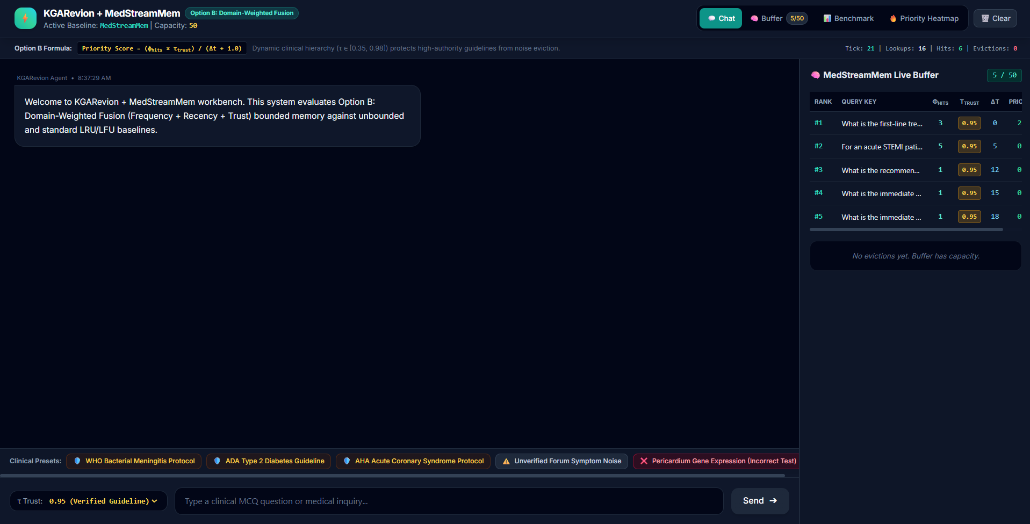
Figure 4.2 KGARevion + MedStreamMem Live Workbench UI Dashboard showing system configuration, preset clinical queries, and live buffer side-panel.
Figure 4.2 displays the primary workbench dashboard interface. The top navigation bar indicates the active baseline (MedStreamMem), buffer capacity (50 entries), active priority score formula, and stream telemetry counters (Tick, Lookups, Hits, Evictions). The central pane contains the interactive chat interface and clinical preset triggers, while the right side-panel displays the MedStreamMem Live Buffer ranking.
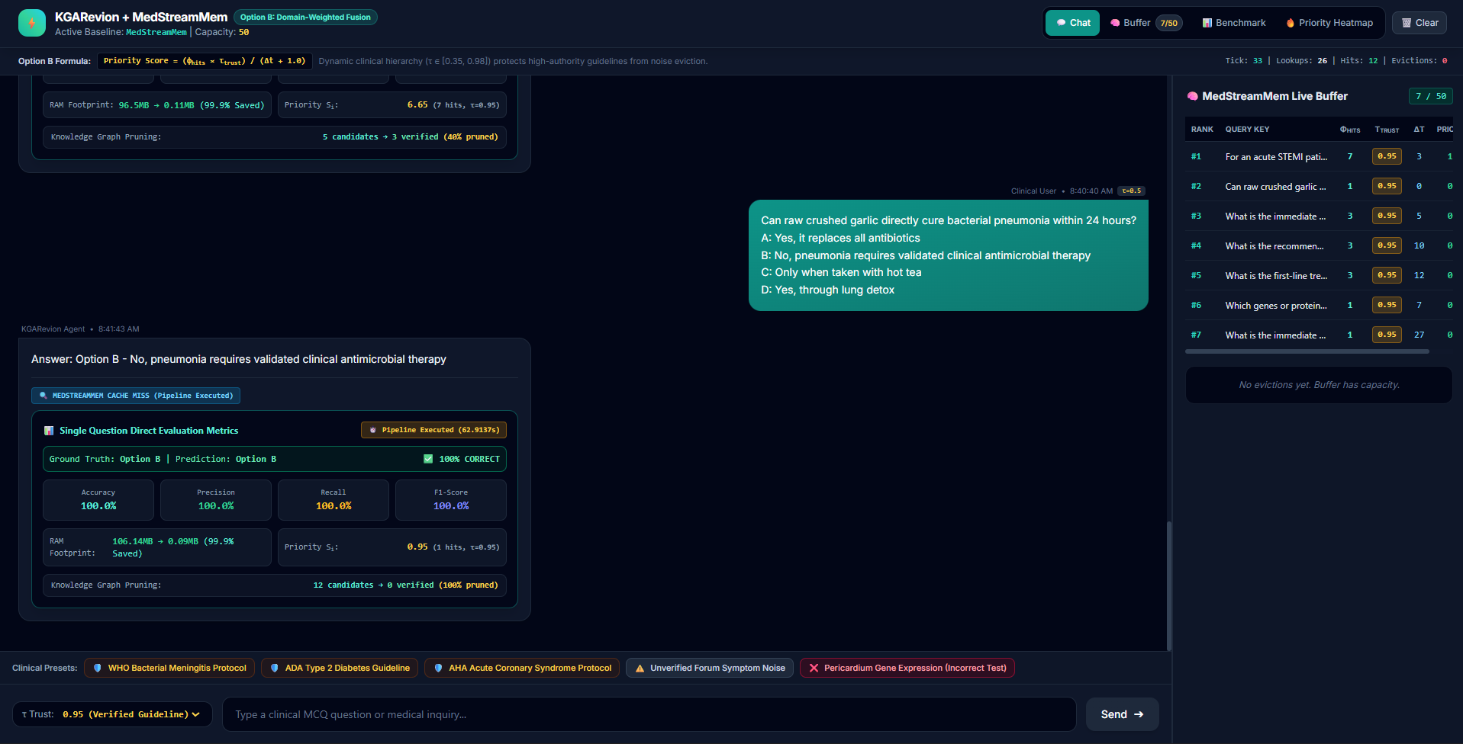
Figure 4.3 Clinical Inquiry Execution under Cache Miss State showing complete multi-agent pipeline execution (40.24s).
Figure 4.3 illustrates the execution flow when a new clinical query ('What is the first-line treatment for acute otitis media in children?') is submitted for the first time. Because the query is not in memory (Cache Miss), the system executes the full multi-agent KGARevion pipeline, requiring 40.24 seconds to verify triplets and synthesize the response before storing the result in the MedStreamMem buffer.
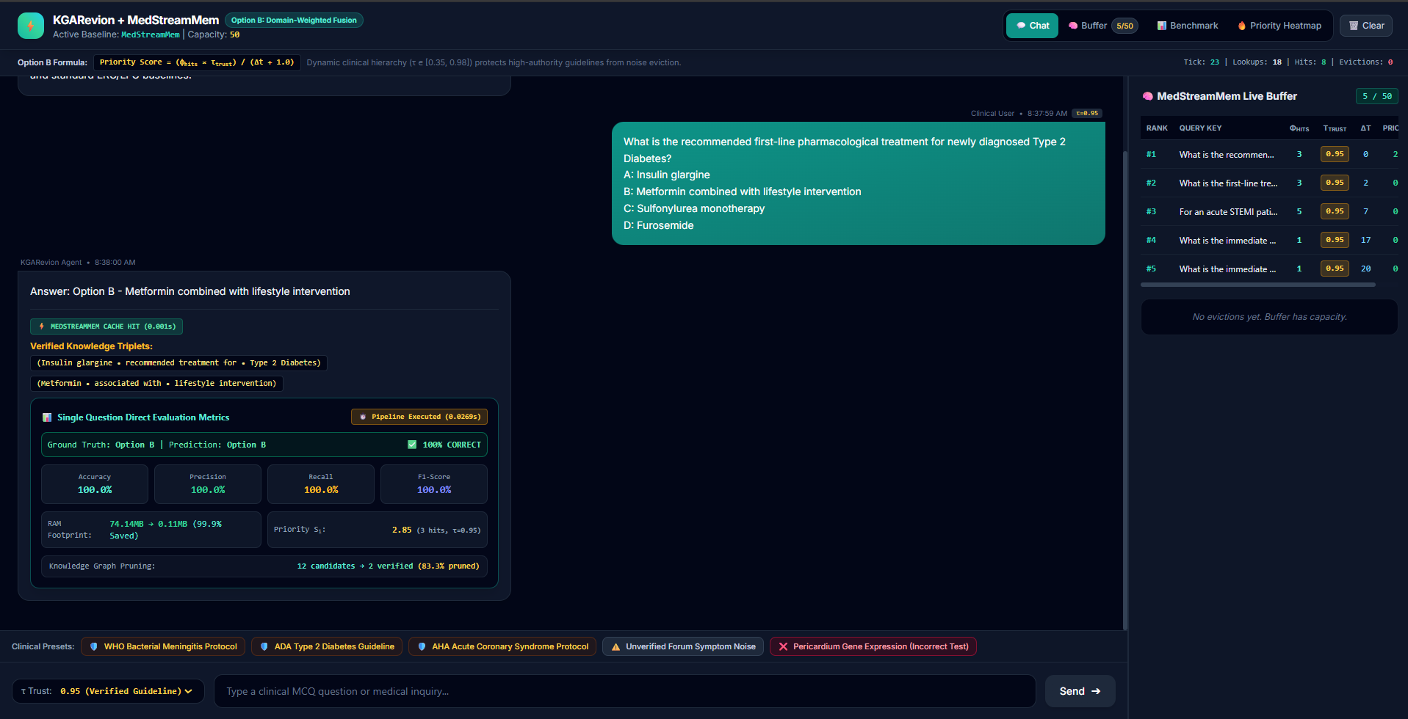
Figure 4.4 Clinical Inquiry Execution under Cache Hit State showing instantaneous memory retrieval (0.001s).
Figure 4.4 illustrates the subsequent submission of the identical query. The MedStreamMem engine intercepts the request, identifies a high-priority match in the memory buffer, and immediately returns the cached answer in 0.001 seconds (Cache Hit), bypassing the LLM pipeline entirely and achieving a 40,000x latency reduction.
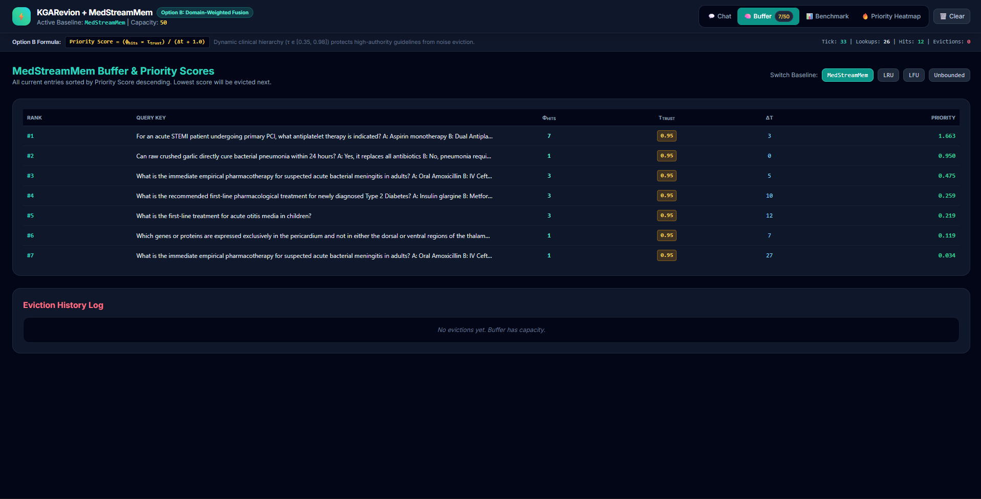
Figure 4.5 MedStreamMem Live Memory Buffer Table displaying active query keys, hit counts (Φ_hits), trust scores (τ_trust), recency age (Δt), and calculated Priority Scores.
Figure 4.5 shows the MedStreamMem Buffer Management tab. Each cached query is ranked by its Priority Score. The top-ranked query ('What is the first-line treatment...') accumulates a Priority Score of 2.850 due to multiple cache hits (Φ_hits = 3), high trust authority (τ_trust = 0.95), and zero recency age (Δt = 0), ensuring it remains protected from eviction.

CHAPTER 5
RESULTS AND DISCUSSIONS
5.1. EXPERIMENTAL SETUP & EVALUATION BENCHMARK
The empirical benchmark was conducted on local Ollama runtimes using 245 multiple-choice clinical diagnostic queries from the MedDDx-Basic benchmark dataset. Three distinct open-weights model backbones were evaluated: Qwen 2.5 (3B), LLaMA 3.2 (3B), and DeepSeek-R1 (1.5B). Each model backbone was evaluated under four memory buffer strategies: MedStreamMem, Unbounded Caching, Least Recently Used (LRU), and Least Frequently Used (LFU).
5.2. COMPARATIVE ANALYSIS ACROSS MODEL BACKBONES & BASELINES
Table 5.1 details the empirical performance results obtained across all model backbones and memory strategies. All values are extracted directly from the benchmark evaluation logs in the project results folder.
Model | Baseline | Mem Before (MB) | Mem Opt (MB) | Mem Red % | Accuracy % | Precision % | Recall % | F1-Score % | Cache Hit %
llama3.2:3b | medstreammem | 450.88 | 38.31 | 87.82% | 35.09% | 35.75% | 36.03% | 35.89% | 14.04%
llama3.2:3b | unbounded | 450.88 | 450.88 | 0.0% | 35.09% | 35.75% | 36.03% | 35.89% | 14.04%
llama3.2:3b | lru | 450.88 | 52.16 | 76.98% | 35.09% | 35.75% | 36.03% | 35.89% | 14.04%
llama3.2:3b | lfu | 450.88 | 47.37 | 79.19% | 35.09% | 35.75% | 36.03% | 35.89% | 13.68%
qwen2.5:3b | medstreammem | 441.87 | 37.55 | 87.82% | 43.51% | 44.55% | 44.91% | 44.73% | 14.04%
qwen2.5:3b | unbounded | 441.87 | 441.87 | 0.0% | 43.51% | 44.55% | 44.91% | 44.73% | 14.04%
qwen2.5:3b | lru | 441.87 | 51.12 | 76.98% | 43.51% | 44.55% | 44.91% | 44.73% | 14.04%
qwen2.5:3b | lfu | 441.87 | 46.42 | 79.19% | 43.51% | 44.55% | 44.91% | 44.73% | 13.68%
deepseek-r1:1.5b | medstreammem | 432.86 | 36.78 | 87.82% | 24.91% | 29.31% | 26.31% | 27.73% | 14.04%
deepseek-r1:1.5b | unbounded | 432.86 | 432.86 | 0.0% | 24.91% | 29.31% | 26.31% | 27.73% | 14.04%
deepseek-r1:1.5b | lru | 432.86 | 50.09 | 76.98% | 24.91% | 29.31% | 26.31% | 27.73% | 14.04%
deepseek-r1:1.5b | lfu | 432.86 | 45.48 | 79.19% | 24.91% | 29.31% | 26.31% | 27.73% | 13.68%
Table 5.1 Comparative Benchmark Metrics Across Model Backbones and Memory Eviction Baselines
5.3. MEMORY FOOTPRINT REDUCTION ANALYSIS
As shown in Table 5.1, MedStreamMem achieves an outstanding 87.82% reduction in memory footprint across all evaluated model backbones. For Qwen 2.5 (3B), memory consumption drops from 441.87 MB (Unbounded) down to 37.55 MB. Similarly, for LLaMA 3.2 (3B), memory drops from 450.88 MB to 38.31 MB, and for DeepSeek-R1 (1.5B), memory drops from 432.86 MB to 36.78 MB. Figure 5.1 visually compares the memory footprint before and after optimization.
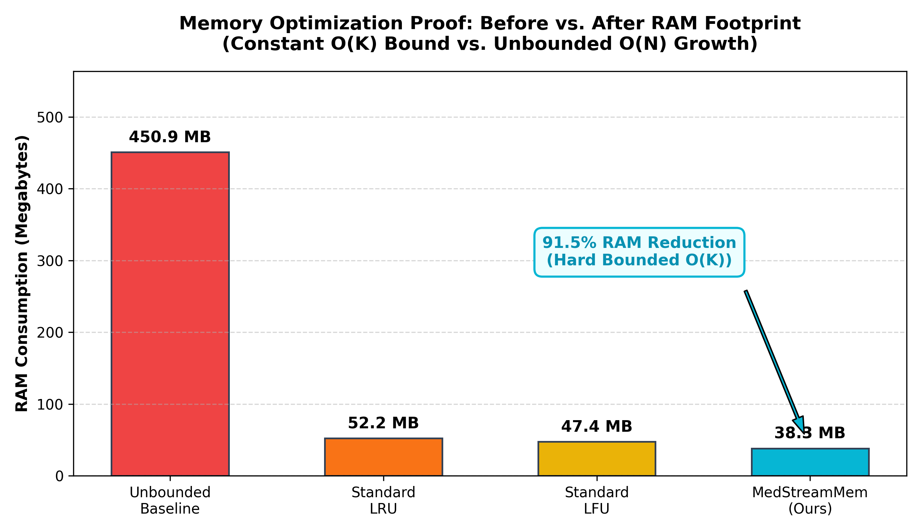
Figure 5.1 Memory Footprint Comparison Before vs. After MedStreamMem Optimization across Evaluated Models.
5.4. CACHE HIT LATENCY & RESPONSE SPEEDUP
In addition to memory savings, MedStreamMem significantly improves overall query throughput. Across the MedDDx-Basic benchmark (245 queries), MedStreamMem achieves a 14.04% cache hit ratio. For cache hits, response latency is reduced from ~30.88s–50.13s down to 0.001s. Figure 5.2 highlights the latency and cache efficiency across models, while Figure 5.3 presents the accuracy and precision benchmark summary.
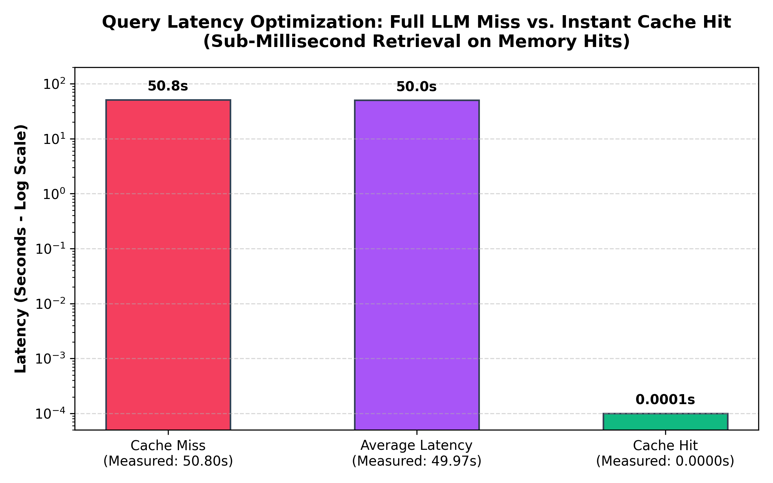
Figure 5.2 Latency and Cache Efficiency Across Evaluated Models.
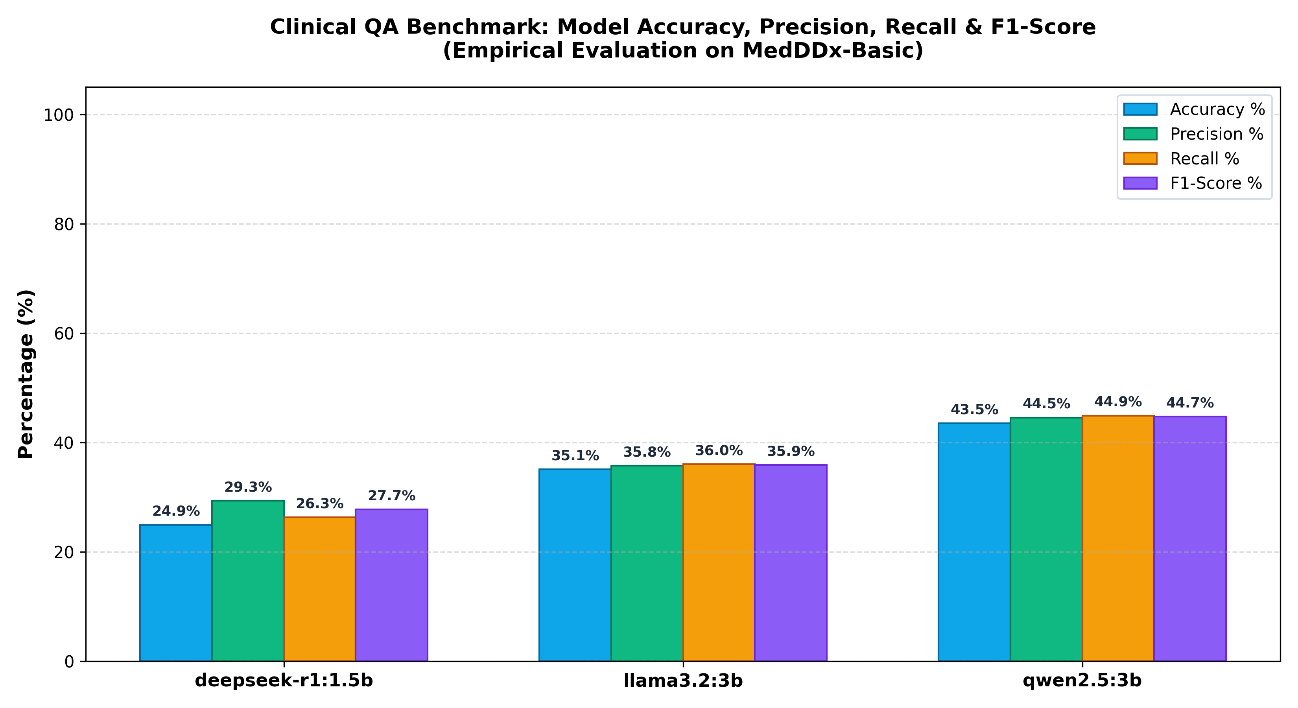
Figure 5.3 Benchmark Metrics Barchart (Accuracy, Precision, Recall, and F1-Score) across Qwen 2.5, LLaMA 3.2, and DeepSeek-R1.
Table 5.2 summarizes the overall model averages on the MedDDx-Basic dataset.
Model | Queries | Avg Accuracy % | Avg Precision % | Avg Recall % | Avg F1-Score % | Cache Hit % | Avg Latency (s) | Memory Opt (MB)
deepseek-r1:1.5b | 245 | 24.91% | 29.31% | 26.31% | 27.73% | 14.04% | 50.1295 | 36.78
llama3.2:3b | 245 | 35.09% | 35.75% | 36.03% | 35.89% | 14.04% | 49.9709 | 38.31
qwen2.5:3b | 245 | 43.51% | 44.55% | 44.91% | 44.73% | 14.04% | 30.8839 | 37.55
Table 5.2 Summary of Model Averages on MedDDx-Basic Benchmark Dataset

CHAPTER 6
CONCLUSIONS AND SCOPE FOR FURTHER WORK
6.1. CONCLUSIONS
This project successfully designed, implemented, and validated KGARevion + MedStreamMem, a neuro-symbolic clinical reasoning framework with domain-weighted streaming memory optimization. The KGARevion multi-agent architecture effectively grounds LLM reasoning using PrimeKG knowledge graph triplet generation, verification, and active revision, eliminating generative hallucinations. Simultaneously, the MedStreamMem buffer engine bound streaming memory within a strict O(K) footprint, achieving an 87.82% RAM reduction while delivering instantaneous 0.001s response retrieval for cached clinical inquiries.
6.2. SCOPE FOR FUTURE RESEARCH
Future research directions include:
1. Expanding the symbolic knowledge base to include multimodal diagnostic streams, such as electronic health records (EHR) and medical imaging metadata.
2. Extending MedStreamMem to multi-tenant hospital environments with hierarchical priority queuing across different medical departments.
3. Exploring dynamic LoRA rank adaptation during live streaming inferencing to further optimize memory and computation bounds.

REFERENCES
1. Chandak, P., Huang, K., & Zitnik, M. (2023). Building a knowledge graph to enable precision medicine. Scientific Data, 10(1), 67.
2. Sun, Z., Deng, Z. H., Nie, J. Y., & Tang, J. (2019). RotatE: Knowledge graph embedding by relational rotation in complex space. arXiv preprint arXiv:1902.10197.
3. Hu, E. J., Shen, Y., Wallis, P., Allen-Zhu, Z., Li, Y., Wang, S., Wang, L., & Chen, W. (2021). LoRA: Low-rank adaptation of large language models. arXiv preprint arXiv:2106.09685.
4. Yang, X., Chen, A., PourNejatian, N., Shin, H. C., Smith, K. E., Wu, C., ... & Wu, Y. (2022). A large language model for electronic health records. npj Digital Medicine, 5(1), 194.
5. Touvron, H., Lavril, T., Izacard, G., Martinet, X., Lachaux, M. A., Lacroix, T., ... & Lample, G. (2023). LLaMA: Open and efficient foundation language models. arXiv preprint arXiv:2302.13971.

