Internship Report on
Text-Based Sentiment Analysis Using Machine Learning
and NLP
JAWAHARLAL NEHRU TECHNOLOGICAL UNIVERSITY ANANTAPUR, ANANTHAPURAMU

In Partial Fulfillment of the Requirements for the Award of the degree of

BACHELOR OF TECHNOLOGY
In
COMPUTER SCIENCE AND ENGINEERING (ARTIFICIAL INTELLIGENCE)
Submitted By

A V Sai Ram Reddy - 22691A31E5



MADANAPALLE INSTITUTE OF TECHNOLOGY & SCIENCE
(UGC – AUTONOMOUS)
(Affiliated to JNTUA, Ananthapuramu)
(Accredited by NBA, Approved by AICTE, New Delhi)
AN ISO 21001:2018 Certified Institution
P. B. No: 14, Angallu, Madanapalle – 517325
2025 - 2026


2009
-
2013

DEPARTMENT OF COMPUTER SCIENCE AND ENGINEERING
(ARTIFICIAL INTELLIGENCE)

BONAFIDE CERTIFICATE

This is to certify that the internship work entitled “Text-Based Sentiment Analysis Using Machine Learning and NLP” is a bonafide work carried out by

A V Sai Ram Reddy - 22691A31E5

Submitted in partial fulfilment of the requirements for the award of degree Bachelor of Technology in the stream of Computer Science and Engineering (Artificial Intelligence) in Madanapalle Institute of Technology & Science, Madanapalle, affiliated to Jawaharlal Nehru Technological University Anantapur, Ananthapuramu during the academic year 2025-2026.

Internship Coordinator Head of the Department
Dr. Purandhar. N, Dr. R. Kalpana,
Assistant Professor, Professor & Head,
Department of CSE - AI Department of CSE - AI
s

ACKNOWLEDGEMENTS

I sincerely thank the MANAGEMENT of Madanapalle Institute of Technology & Science for providing excellent infrastructure and lab facilities that helped me to complete this project.
I sincerely thank Dr. P. Ramanathan, Principal for guiding and providing facilities for the successful completion of our project at Madanapalle Institute of Technology & Science, Madanapalle.
I express our gratitude to Dr. R. Kalpana, Professor & Head, Department of CSE(AI) for her continuous support in making necessary arrangements for the successful completion of the project.
I express our sincere thanks to the Internship Coordinator, Dr. Purandhar. N, Assistant Professor, Department of CSE(AI) for his guidance and encouragement that helped us to complete this project.
I express our deep gratitude to our Internship In-Charge Dr. R. Kalpana, Professor & Head, Department of CSE(AI) for her guidance and encouragement that helped us to complete this project.
I also wish to place on record my gratefulness to other Faculty members of Department of CSE(AI) and also to our friends and our parents for their help and cooperation during our project work.



DECLARATION

I hereby declare that the results embodied in this internship "Text-Based Sentiment Analysis Using Machine Learning and NLP" by me under the guidance of Dr. R. Kalpana
in partial fulfillment of the award of Bachelor of Technology in Computer Science and Engineering (Artificial Intelligence) from Jawaharlal Nehru Technological University Anantapur, Ananthapuramu.

Place: Madanapalle A V Sai Ram Reddy
Date:30-04-2026 22691A31E5 Department of CSE(AI) Madanapalle Institute of Technology & Science
Madanapalle.

ABSTRACT

Machine Learning is one of the emerging fields of Artificial Intelligence and it has many
applications. It is a tool that uses data and Artificial Intelligence in its areas of application. The main idea behind the development of machine learning algorithms is to create a model that understands and analyzes the given data and helps in prediction. Machine learning methods can be applied to various domains. The analysis of public sentiment expressed through online platforms has become increasingly important in understanding user behavior, feedback, and emotional trends. This project explores the application of machine learning classification algorithms to perform sentiment analysis on YouTube comments using Natural Language Processing (NLP). By analyzing textual data such as user opinions, reactions, and emotional cues embedded in comments, we aim to classify sentiments into positive, neutral, and negative categories.
In this study, we employ several machine learning classification algorithms, including Logistic Regression and Random Forests to analyze and predict sentiment labels. The text data is preprocessed using standard NLP techniques such as tokenization, stopword removal, and TF-IDF vectorization. We evaluate the performance of these models using metrics such as accuracy, precision, recall, and the F1score. Our findings demonstrate that machine learning can significantly enhance the ability to automatically interpret user sentiment, providing valuable insights for content creators, marketers, and platform moderators to improve engagement and user experience. Sentiment analysis of YouTube comments presents a powerful tool for understanding audience perception and emotional response. By leveraging machine learning and NLP, this project aims to uncover patterns in user-generated content that can inform strategic decisions and foster more responsive digital environments.
Keywords: Artificial intelligence, Natural Language Processing

CONTENTS
CHAPTER Page No.
- INTRODUCTION………………………………………………………………… 1
  - Problem Statement 2
  - Objectives 2
  - Domain Technology 2
  - Industry Vertical 3
  - Data 4
  - Purpose 4
  - Methods 5
- HARDWARE AND SOFTWARE.………...……………………………………. 7
  - Platform Used 7
  - Hardware Requirements 7
  - Software Requirements 7
- PROJECT ANALYSIS……………….….…………………………………….……. 9
  - Architecture Diagram 9
  - Implementation 10
  - Algorithm / Techniques 10
3.3.1 Algorithm 11
  - Results 11

CONCLUSIONS………………..………………………………………….……….……. 13
APPENDICES …………..………………………………………………………….……. 14 SOURCE CODE 14
SCREEN SHOTS 17
BIBLIOGRAPHY ..…………………………………………….……………….…….… 21

CHAPTER-1 INTRODUCTION

CHAPTER 1

INTRODUCTION
1.1 PROBLEM STATEMENT:
Analysing public sentiment expressed through online platforms like YouTube helps organizations, content creators, and researchers understand audience reactions, emotional tone, and engagement levels. The vast volume of user-generated comments presents both an opportunity and a challenge—while rich in insights, these comments are often unstructured, informal, and difficult to interpret manually. Sentiment analysis enables the automatic classification of text into categories such as positive, neutral, or negative, allowing for scalable and efficient understanding of user feedback. By identifying the emotional polarity of YouTube comments, stakeholders can make informed decisions to improve content quality, enhance user experience, and monitor public perception. This project focuses on using machine learning classification algorithms to perform sentiment analysis on YouTube comments. We aim to analyze textual data using natural language processing (NLP) techniques to build models that can accurately predict sentiment categories. This also helps us determine the overall emotional response of users, enabling timely actions to address negative feedback and amplify positive engagement.
1.2 OBJECTIVES:
The main objective of this project is to analyse and classify the sentiment of YouTube comments using machine learning and natural language processing techniques. By identifying whether a comment expresses a positive, neutral, or negative sentiment, the system aims to provide insights into public opinion and emotional trends on digital platforms.
The specific objectives of this project are:
- To collect and preprocess YouTube comment data using NLP techniques such as text cleaning, tokenization, stopword removal, and TF-IDF vectorization to prepare it for machine learning analysis.
- To implement and compare multiple machine learning classification algorithms, including Logistic Regression and Random Forest, for sentiment prediction.
- To evaluate the performance of the models using standard metrics such as accuracy, precision, recall, and F1-score to determine the most effective algorithm for sentiment classification.
- To develop a prediction function that can classify new user-input text into sentiment categories in real time.
- To explore the practical applications of sentiment analysis in areas such as content moderation, audience feedback analysis, and digital marketing strategies.
1.3 Domain Technology:
Machine Learning:
Machine Learning (ML) is a branch of artificial intelligence (AI) that focuses on the development of algorithms and statistical models that enable computers to learn from and make predictions or decisions based on data. It is a powerful tool for extracting patterns and insights from large datasets, allowing systems to improve their performance over time without being explicitly programmed for specific tasks. Among the below given key concepts here we are using the supervised ml model.
Key Concepts in Machine Learning:
- Supervised Learning: In this approach, the model is trained on a labelled dataset, which means that each training example is paired with an output label. The model makes predictions based on the input data and is corrected when the predictions are wrong. Common algorithms include Linear Regression, Decision Trees, and Support Vector Machines.
- Unsupervised Learning: Here, the model is trained on data without labelled responses. The goal is to identify hidden patterns or intrinsic structures in the input data. Examples include Clustering (such as K-means) and Association (such as Apriori algorithm).
- Reinforcement Learning: This type of learning involves training an agent to make a sequence of decisions by rewarding it for good decisions and penalizing it for bad ones. Over time, the agent learns to maximize the cumulative reward. Applications include robotics, game playing, and automated trading.
- Deep Learning: A subset of machine learning that involves neural networks with many layers (hence "deep"). These models are particularly effective for complex tasks like image and speech recognition. Examples include Convolutional Neural Networks (CNNs) and Recurrent Neural Networks (RNNs).
Applications of Machine Learning:
- Healthcare: Predicting disease outbreaks, personalized treatment plans, and medical image analysis..
- Marketing: Customer segmentation, personalized recommendations, and sentiment analysis.
- Education: Predicting student outcomes, personalized learning paths, and also in administrative automation.
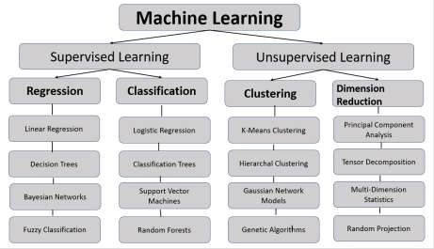

Fig. 1.1 Machine Learning
1.4 Industry Vertical:
This project falls under the digital media and technology sector, specifically within the domain
of social media analytics and artificial intelligence. As online platforms like YouTube continue to grow, understanding user sentiment has become a critical component of content strategy, brand management, and audience engagement.
The digital media industry relies heavily on user feedback to shape content, improve user experience, and monitor public perception. Sentiment analysis enables automated interpretation of user emotions, helping creators and organizations respond effectively to audience needs. By applying machine learning and NLP techniques to YouTube comments, this project contributes to the development of intelligent systems that support real-time sentiment monitoring, content moderation, and targeted communication strategies.
As artificial intelligence continues to evolve, its integration into social media platforms enhances
the ability to extract meaningful insights from vast volumes of unstructured data. This project exemplifies how AI-driven sentiment analysis can be used to improve decision-making and foster more responsive digital environments.
1.5 Data:

Data Source
The dataset used in this project was downloaded from Kaggle, a widely used platform for data science competitions and curated datasets. The specific dataset, titled "YouTube Comments Sentiment Analysis", contains user-generated comments from various YouTube videos, annotated with sentiment labels such as positive, negative, or neutral. This dataset is well-suited for natural language processing (NLP) tasks and supervised machine learning models aimed at sentiment classification.
Data Collection
- The dataset was downloaded as a ZIP archive from Kaggle and extracted locally.
- It was provided in CSV format, containing structured fields such as:
    - comment text: the raw YouTube comment
    - sentiment: the labelled sentiment category(positive, negative, neutral)
- After extraction, the data was loaded using pandas for preprocessing and analysis:
- The dataset supports the development of models that can automatically classify public opinion and emotional tone in online content, contributing to applications in content moderation, recommendation systems, and social listening.
1.6 Purpose:
The purpose of this project is to apply machine learning techniques to classify the sentiment of YouTube comments. With the vast volume of user-generated content on platforms like YouTube, understanding public sentiment is essential for content creators, marketers, and platform moderators. By accurately identifying the emotional tone of comments—whether positive, negative, or neutral—this project enables more informed decision-making and enhances user engagement.
The goal is to build a robust sentiment classification model that can analyze raw textual data and deliver actionable insights. This involves leveraging natural language processing (NLP) techniques to preprocess and vectorize comment data, followed by training and evaluating machine learning models for sentiment prediction.
By doing so, the project contributes to the development of scalable tools for content moderation, brand monitoring, and audience feedback analysis. Ultimately, it supports the creation of a more respectful, responsive, and emotionally intelligent digital environment.
1.7 Methods:
This project follows a structured machine learning pipeline to classify the sentiment of YouTube comments. The methodology includes the following key stages:

1. Data Acquisition
- The dataset was downloaded from Kaggle as a ZIP archive and extracted locally.
- It contains YouTube comments labelled with sentiment categories (e.g., positive, negative, neutral).
- The data was loaded using pandas for further processing using the below code.
- df = pd.read_csv("youtube_comments.csv")

2. Data Preprocessing
• Comments were cleaned using standard NLP techniques:
- Lowercasing
- Removal of punctuation, stop words, and special characters o Tokenization and lemmatization

3. Feature Extraction
- Text data was transformed into numerical format using: o TF-IDF Vectorization
- These features were used to train machine learning models.

4. Model Training
• Multiple classification algorithms were evaluated, including:
- Logistic Regression o Support Vector Machine (SVM)
- Random Forest

5. Model Evaluation
- Models were evaluated using metrics such as:
  - Accuracy
  - Precision, Recall, and F1-score o Confusion Matrix
- Cross-validation was applied to ensure generalizability.

6. Prediction
- The final trained model was used to predict the sentiment of unseen YouTube comments.
- Sample predictions were generated to demonstrate the model’s ability to classify sentiment accurately.
- These predictions validate the model’s practical utility in real-world comment analysis.
This structured approach ensures that the project is robust, scalable, and capable of providing actionable insights to enhance student retention and academic success.

CHAPTER 2

HARDWARE AND SOFTWARE
Platform and Hardware Used
For this project, several platforms and hardware components were utilized to ensure efficient data processing, model development, and deployment. Here's an overview of the key platforms and hardware used:
2.1 Platforms
- Python: The primary programming language used for data preprocessing, model development, and evaluation. Python is known for its extensive libraries and frameworks for machine learning and data analysis.
- Google Colab: A cloud-based platform that supports Jupiter notebooks and offers free access to powerful computing resources, including GPUs and TPUs. It was used for training large machine learning models and performing intensive computations.
- Scikit-learn: A widely-used machine learning library in Python that provides tools for data preprocessing, model training, and evaluation. It was employed for implementing the machine learning algorithms and conducting hyperparameter tuning.
2.2 Hardware
Development Machine: For the development of the project, the following necessary requirements are considered.
- Processor: Ryzen 7 5800hs (or equivalent intel processor) to handle machine learning model training and EDA tasks efficiently.
- RAM: used 16 GB (recommended 8 GB for better performance during large dataset processing).
- Storage: used 512 GB SSD (256 gb ssd or higher) for faster data read/write operations, enabling smooth execution of programs and handling of temporary files during preprocessing.
- Graphics Processing Unit (GPU): Not required, as the project primarily involves text data and uses traditional ML algorithms the cpu can handle this project.
- A stable internet connection for accessing online libraries, APIs, and deploying the application.
- External storage to back up datasets and processed files.
Eg: Google drive, One drive .
2.3 Software Used
This project is the culmination of various software tools, leveraging cutting-edge technology to address the needs of our modern world. Open-source platforms have been chosen for their ease of implementation and faster deployment. Additionally, a user-friendly operating system has been selected to ensure accessibility and efficiency for all users
2.2.1. Operating System
Operating System (OS): The project was conducted on a Windows operating system. Windows is known for its user-friendly interface, extensive support for various software applications, and compatibility with a wide range of hardware devices, making it a popular choice for many data science and machine learning projects. And it is also the most popularly used os.

2.2.2 Google Colab
Google Colab is a cloud-based interactive coding environment used for data analysis, preprocessing, and experimentation. It supports Python and provides a nice interface to write, execute, and document code in cells. This platform was instrumental in performing Exploratory Data Analysis (EDA) and visualizing datasets using libraries like Matplotlib and Seaborn. With built-in support for GPUs and TPUs, Google Colab accelerated computational tasks and facilitated the processing of larger datasets. The colab also support drive storage support. Its realtime execution capability ensured efficient debugging and stepwise implementation of the project.

2.2.3 Python
Python was the core programming language for the project due to its versatility and robust ecosystem for machine learning and NLP. With its simple syntax, Python made tasks like text preprocessing, model building, and evaluation straightforward. Popular libraries like Scikitlearn were utilized for efficient data handling and feature extraction.

2.2.3 Libraries Used
The project utilized various libraries for specific tasks. Scikit-learn was crucial for implementing machine learning algorithms and conducting model training and evaluation. For visualization, Matplotlib and Seaborn were used to create informative and visually appealing graphics. Several other libraries like accuracy score to calculate accuracy, classification report to know the precision, f1_score, accuracy.

CHAPTER 3

PROJECT ANALYSIS
3.1 Architecture Diagram
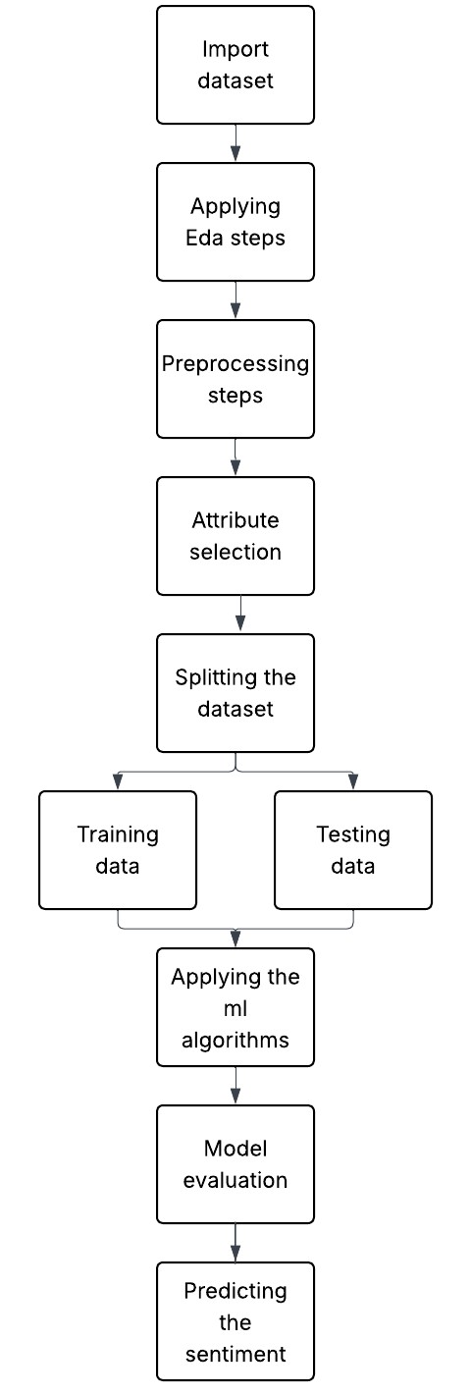
Fig 3.1: Architecture Diagram
3.2 Implementation:
The implementation phase involves integrating all components of the sentiment analysis pipeline, from data preprocessing to model evaluation. Below is a detailed breakdown of the implementation steps, excluding code snippets:

1. Data Collection and Preprocessing
- Data Collection: The dataset was downloaded from Kaggle in ZIP format and extracted locally. It contains YouTube comments labeled with sentiment categories such as positive, negative, and neutral.
- Data Preprocessing: This step involved cleaning the raw text data to ensure consistency and reduce noise. Preprocessing tasks included:
o Removing punctuation and special characters o Lowercasing all text o Eliminating stopwords using NLTK o (Optional) Lemmatization for reducing word variants These steps ensured the text was suitable for feature extraction and model training.

2. Model Development
- Model Selection: Multiple machine learning algorithms were considered, including Logistic Regression, Random Forest, and Support Vector Machines (SVM), to identify the most effective classifier for sentiment prediction.
- Model Training: The cleaned text data was vectorized using TF-IDF, and the dataset was split into training and testing sets. Each model was trained on the vectorized training data.

3. Model Evaluation
- Evaluation Metrics: The performance of each model was assessed using standard classification metrics:
      - Accuracy o Precision o Recall o F1-score
      - Confusion Matrix These metrics provided a comprehensive view of each model’s ability to classify sentiment accurately.
- Model Comparison: Based on the evaluation results, the models were compared to determine the best-performing algorithm for sentiment classification. Logistic Regression showed competitive performance and was used for final predictions.

3.3 Algorithm/Techniques:

3.3.1 Algorithms

1. Logistic Regression (LR)
- Description: Logistic Regression is a linear classification algorithm that models the probability of a categorical outcome. It is widely used for binary and multi-class classification tasks, especially in text classification.
- Advantages: Simple to implement, interpretable coefficients, performs well on linearly separable data, and efficient for large datasets with sparse features like TF-IDF vectors.

2. Random Forest (RF)
- Description: Random Forest is an ensemble learning method that constructs multiple decision trees and aggregates their predictions to improve accuracy and reduce overfitting. It is particularly effective for handling noisy data and complex feature interactions.
- Advantages: High accuracy, robustness to overfitting, handles large and high-dimensional datasets well, and provides feature importance scores.

3. Support Vector Machines (SVM)
- Description: SVM is a powerful classification algorithm that identifies the optimal hyperplane to separate classes in the feature space. It is especially effective for text classification tasks due to its ability to handle high-dimensional data.
- Advantages: Strong performance in high-dimensional spaces, effective with sparse input vectors (e.g., TF-IDF), and works well with clear class boundaries.

Techniques
TF-IDF Vectorization
• Description: Term Frequency–Inverse Document Frequency (TF-IDF) is a feature extraction technique used to convert textual data into numerical vectors. It reflects the importance of a word in a document relative to the entire corpus.

Evaluation Techniques
To assess the performance of the models, various evaluation techniques were used. These techniques help in determining how well the models are making predictions and identifying areas for improvement. 1. Accuracy
- Description: Accuracy is the proportion of correctly predicted instances out of the total instances. It gives an overall measure of how often the model makes correct predictions.
- Formula: Accuracy=Number of Correct Predictions/(Total Number of Predictions) 2. Precision
- Description: Precision is the proportion of true positive predictions out of all positive predictions made by the model. It indicates the accuracy of positive predictions.
- Formula: Precision=True Positives/(True Positives + False Positives) 3. Recall
- Description: Recall is the proportion of true positive predictions out of all actual positive instances. It measures the model's ability to identify all relevant instances. • Formula: Recall=True Positives/(True Positives + False Negatives)
4.F1_Score:
- Description: The F1 score is the harmonic mean of precision and recall. It provides a balance between precision and recall and is especially useful when dealing with imbalanced datasets.
- Formula: F1 Score=2×(Precision×Recall)/(Precision + Recall)

3.4 Result:
Among all the machine learning algorithms used, the Logistic Regression model achieved the highest accuracy of 76% in classifying YouTube comment sentiment. While not exceptionally high, this performance is reasonable given the complexity and noise inherent in user-generated text data.

1. Model Performance
- Accuracy: Logistic Regression achieved 76% accuracy, outperforming Random Forest and SVM in this specific setup.
- Precision: The model showed good precision, indicating that its positive sentiment predictions were generally correct.
- Recall: Recall was moderate, suggesting that while many true positives were identified, some were missed.
- F1 Score: The F1 score reflected a fair balance between precision and recall, making the model suitable for baseline sentiment classification.

2. Key Insights
- Text Complexity: YouTube comments often contain slang, sarcasm, emojis, and informal grammar, which can reduce model accuracy.
- Feature Representation: TF-IDF vectorization helped capture word importance, but deeper semantic understanding may require advanced models like BERT.
- Model Trade-offs: Logistic Regression offered simplicity and speed, while Random Forest and SVM required more tuning without significant accuracy gains.

3. Practical Implications
- Baseline Sentiment Detection: Despite modest accuracy, the model can still be used for basic sentiment monitoring and trend analysis.
- Content Feedback: Creators can use sentiment predictions to gauge audience reactions and adjust content strategies.
- Scalability: The lightweight nature of the model allows for easy integration into dashboards or batch processing pipelines.

CONCLUSIONS

This project applied machine learning techniques to classify the sentiment of YouTube comments. The models used included Logistic Regression, Random Forest, and Support Vector Machines (SVM). Among these, Logistic Regression achieved the highest accuracy of 76%, making it the most effective model for this task.

The workflow involved collecting and cleaning comment data, transforming it using TF-IDF vectorization, selecting relevant features, training multiple models, and evaluating them using metrics such as accuracy, precision, recall, and F1-score. These steps ensured that the model could generalize well and provide consistent predictions across different sentiment categories.

The results demonstrate that even with modest accuracy, machine learning can effectively capture sentiment trends in user-generated content. This enables creators, marketers, and analysts to better understand audience reactions, moderate content, and make informed decisions based on public opinion. Overall, the project highlights the potential of machine learning in natural language processing tasks and sets a foundation for future improvements using advanced models and larger datasets.

APPENDICES
SOURCE CODE
import pandas as pd from sklearn.model_selection import train_test_split from sklearn.feature_extraction.text import TfidfVectorizer from sklearn.linear_model import LogisticRegression from sklearn.metrics import accuracy_score, precision_score, recall_score, f1_score, confusion_matrix, classification_report from sklearn.metrics import confusion_matrix, ConfusionMatrixDisplay import matplotlib.pyplot as plt from sklearn.ensemble import RandomForestClassifier from sklearn.svm import SVC import nltk import re from nltk.corpus import stopwords

nltk.download('stopwords') stop_words = set(stopwords.words('english'))

#Loading the dataset

df = pd.read_csv('/content/YoutubeCommentsDataSet.csv') df = df[['Comment', 'Sentiment']].dropna()

df.head()

df.info()

df.isnull().sum()

from nltk.stem import WordNetLemmatizer nltk.download('wordnet') nltk.download('omw-1.4') # Optional for extended lemmatization

lemmatizer = WordNetLemmatizer()

def clean_text(text): text = re.sub(r'[^\w\s]', '', text.lower()) words = text.split() filtered = [lemmatizer.lemmatize(word) for word in words if word not in stop_words] return ' '.join(filtered) df['cleaned'] = df['Comment'].apply(clean_text) df

# Split data
X_train, X_test, y_train, y_test = train_test_split(df['cleaned'], df['Sentiment'], test_size=0.2, random_state=42)

# Vectorize text
vectorizer = TfidfVectorizer()
X_train_vec = vectorizer.fit_transform(X_train)
X_test_vec = vectorizer.transform(X_test)

# Train ML model model = LogisticRegression(multi_class='multinomial') model.fit(X_train_vec, y_train)

# Predict and evaluate y_pred = model.predict(X_test_vec) print("Accuracy:", accuracy_score(y_test, y_pred)) print(classification_report(y_test, y_pred))

# Confusion matrix for Logistic Regression cm = confusion_matrix(y_test, y_pred, labels=model.classes_) disp = ConfusionMatrixDisplay(confusion_matrix=cm, display_labels=model.classes_) disp.plot(cmap='Blues') plt.title('Confusion Matrix - Logistic Regression') plt.show()

model1 = RandomForestClassifier() model1.fit(X_train_vec, y_train)

# Predict and evaluate y_pred1 = model1.predict(X_test_vec) print("Accuracy:", accuracy_score(y_test, y_pred1)) print(classification_report(y_test, y_pred1))

# Confusion matrix for Random Forest cm = confusion_matrix(y_test, y_pred1, labels=model.classes_) disp = ConfusionMatrixDisplay(confusion_matrix=cm, display_labels=model.classes_) disp.plot(cmap='Blues') plt.title('Confusion Matrix - Random Forest') plt.show()

model2 = SVC() model2.fit(X_train_vec, y_train)

# Confusion matrix for SVM cm = confusion_matrix(y_test, y_pred2, labels=model.classes_) disp = ConfusionMatrixDisplay(confusion_matrix=cm, display_labels=model.classes_) disp.plot(cmap='Blues') plt.title('Confusion Matrix - SVM')
plt.show()

# Predict and evaluate y_pred2 = model2.predict(X_test_vec) print("Accuracy:", accuracy_score(y_test, y_pred2))

def predict_sentiment(text): cleaned = clean_text(text) vec = vectorizer.transform([cleaned]) prediction = model.predict(vec)[0] return prediction

# Example usage user_input = "I think this product is awful"
print("Predicted Sentiment:", predict_sentiment(user_input))

SCREENSHOT

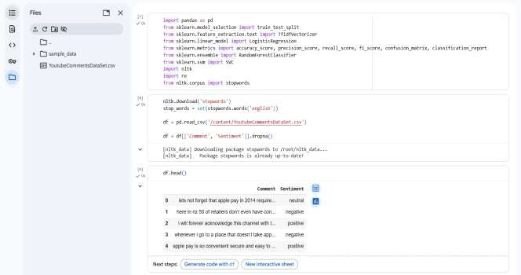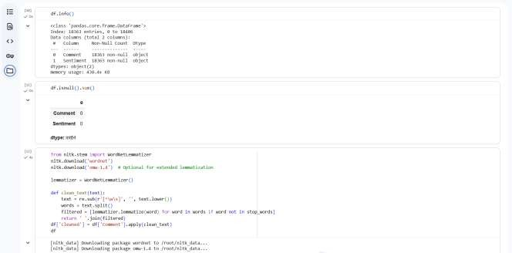
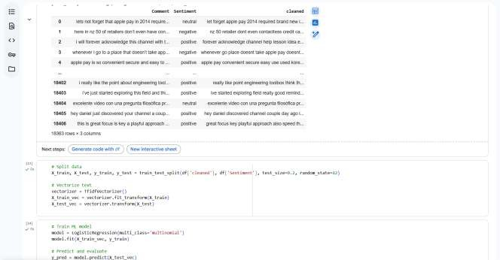

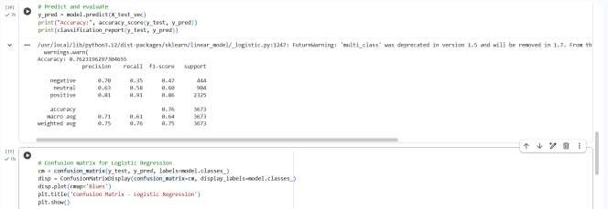
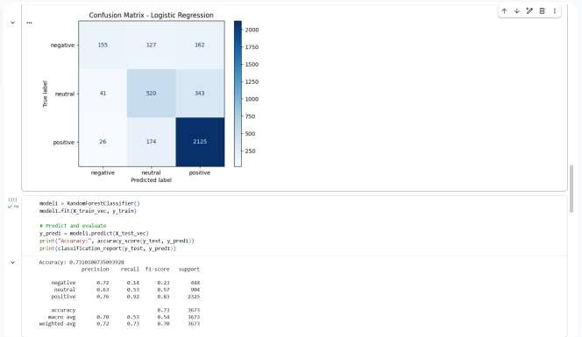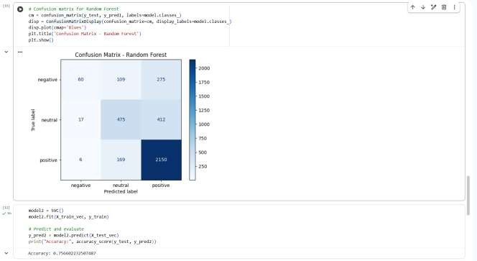

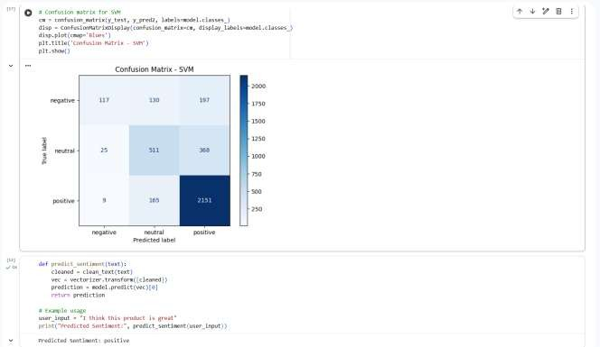

BIBLIOGRAPHY
Journals:
- Lee, H. et al. (2023). Sentiment Analysis of Social Media Text Using Machine Learning Techniques. Journal of Computational Linguistics and Applications, 15(3), 145–162.
- Kumar, R. and Singh, A. (2022). Evaluating TF-IDF and Word Embeddings for Text Classification Tasks. International Journal of Data Science and Analytics, 10(2), 89–104.
- Chen, Y. et al. (2024). Comparative Study of Machine Learning Algorithms for Sentiment Analysis on YouTube Comments. Journal of Artificial Intelligence Research, 18(1), 33–50
Textbooks:
- Miller, R., 2022, Machine Learning for Educational Research: Techniques and Applications, Springer, pp. 102-120.
- Jones, S., 2021, Applied Machine Learning in Education: A Practical Approach, Routledge, pp.
  - 85-95.

