DATA CLASSIFICATION
- Qualitative
Qualitative properties are properties that are observed and can generally not be measured with a numerical result.
- Nominal
Data with no inherent order or ranking such as gender
- Ordinal
Data with an order series or such as sentiment options in supermarkets
- Quantitative
- Discrete
Categorical data finite number of possible values of students in a class
- continuous
Data can hold infinite number of possible values (weight of a person)

PROBABILITY
- Probability Measure Of How Likely An Event Will Occur
- Statistics is a branch of mathematics that concerns the collection, organization, displaying, analysis, interpretation and presentation of data
Random experiment:- a random experiment is a process by which we observe something uncertain
Sample space:- Sample space of an experiment or random trial is the set of all possible outcomes or results of that experiment.
Event:- an event is a one or set of outcomes of an experiment
- Dis-joint Event:-doesn't have any common outcomes
- Non Dis-joint Event:-have some common outcomes

SKEWNESS & KURTOSIS
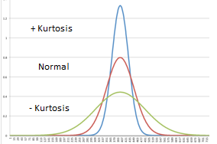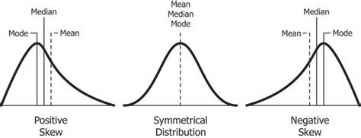

PROBABILITY DISTRIBUTION

Probability Density Function:-(RAINFALL FOR THE NEXT DAY WILL BE A RANGE 1CM-2CM)
The PDF is used to specify the probability of the random variable falling within a particular range of values, as opposed to taking on any one value(single value).
Normal distribution:-
Normal distribution is a probability distribution that associates the normal random variable(it has mean at 0 and the variance equal to 1) x with a cumulative probability

CENTRAL LIMIT THEOREM:-
In the study of probability theory, the central limit theorem (CLT) states that the distribution of sample approximates a normal distribution (also known as a “bell curve”) as the sample size becomes larger, assuming that all samples are identical in size, and regardless of the population distribution shape.
“MEAN IS EQUAL TO THE SAMPLES TO THE REAL DISTRIBUTION FOR LARGE DATASET”

TYPE OF PROBABILITY
Marginal Probability:- probability of that an single event occur
Join Probability:-A joint probability, in probability theory, refers to the probability that two events will both occur at the same time. In other words, joint probability is the likelihood of two events occurring together
Conditional Probability:-In probability theory, conditional probability is a measure of the probability of an event occurring, given that another event (by assumption, presumption, assertion or evidence) has already occurred.

NAIVE BAYES THEOREM:-shows the relation between one conditional probability and its inverse
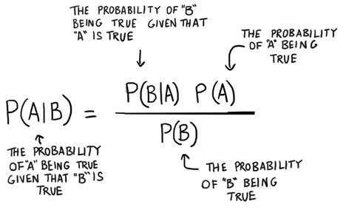

STATISTICS
statistics is the discipline that concerns the collection, organization, analysis, interpretation, and presentation of data. In applying statistics to a scientific, industrial, or social problem, it is conventional to begin with a statistical population or a statistical model to be studied.

POPULATION:-
A statistical population is any group of individuals who are the subject of a study, meaning that almost anything can make up a population so long as the individuals can be grouped together by a common feature, or sometimes two common features
SAMPLE:-
A sample is a smaller group of members of a population selected to represent the population. In order to use statistics to learn things about the population, the sample must be random
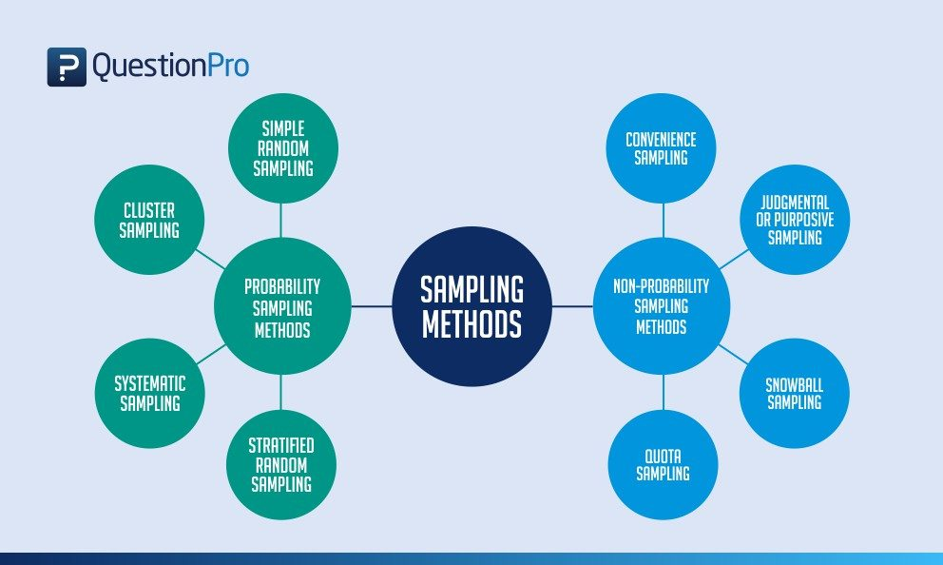
PROBABILITY SAMPLING:-
Probability sampling is defined as a sampling technique in which the researcher chooses samples from a larger population using a method based on the theory of probability.
- RANDOM SAMPLING
as the name suggests, is an entirely random method of selecting the sample.
- SYSTEMATIC SAMPLING:- NTH RECORD
is when you choose every “nth” individual to be a part of the sample. For example, you can select every 5th person to be in the sample.
- STRATIFIED SAMPLING:-
involves a method where the researcher divides a more extensive population into smaller groups stratum that usually don’t overlap but represent the entire population. While sampling, organize these groups and then draw a sample from each group separately.
- RANDOM CLUSTER SAMPLING is a way to select participants randomly that are spread out geographically.

TYPES OF STATISTICS
- DESCRIPTIVE STATISTICS
A descriptive statistic is a summary statistic that quantitatively describes or summarizes features from a collection of information, while descriptive statistics is the process of using and analysing those statistics aims to describe a chunk of raw data using summary statistics, graphs, and tables.
EX:- MIN,MAX,AVG t-shirt size
- INFERENTIAL STATISTICS
Inferential statistics uses a small sample of data to draw inferences about the larger population that the sample came from.
Ex:- large,medium,large

DESCRIPTIVE STATISTICS

- Measure of central tendency

MEAN,MEDIAN,MODE
The mean is the most common measure of central tendency used by researchers and people in all kinds of professions. It is the measure of central tendency that is also referred to as the average.
The median is the value at the middle of a distribution of data when those data are organized from the lowest to the highest value.
The mode is the measure of central tendency that identifies the category or score that occurs the most frequently within the distribution of data. 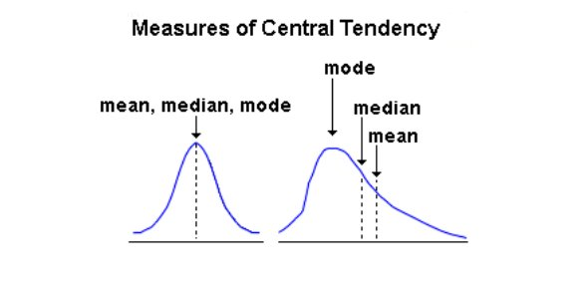
- Measure of variability(spread):-
It describe the variability in a population
- The range of a dataset is the difference between the largest and smallest values in that dataset.
- The interquartile range includes the 50% of data points that fall between Q1 and Q3.
- Variance is the average squared difference of the values from the mean.
- Deviation
- Sample Variance
- Population Variance
- The standard deviation is the standard or typical difference between each data point and the mean.

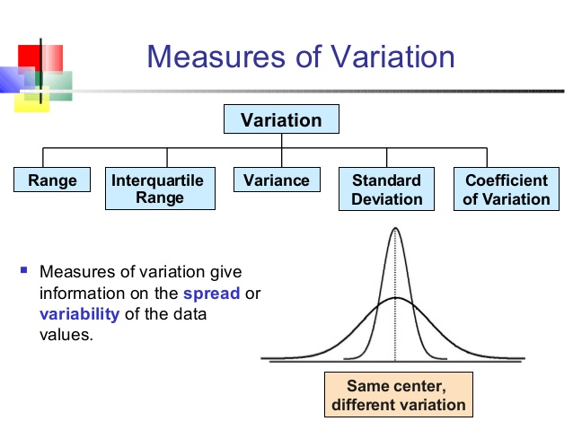

INFORMATION GAIN AND ENTROPY
How can we select the root node for the decision tree???
ENTROPY :-
It measures the impurity or uncertainty present in the whole data ,this quantity is required fo the information gain formula,lesser the entropy better the perimeter
INFORMATION GAIN:-
It give the information of a particular future give us about the final outcome .High information gain is better the selection of root node

CONFUSION MATRIX
Well, it is a performance measurement for machine learning classification problems where output can be two or more classes. It is a table with 4 different combinations of predicted and actual values.
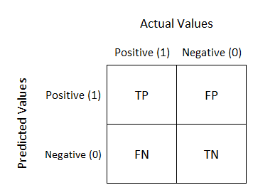
INFERENTIAL STATISTICS

- POINT ESTIMATION:-In statistics, point estimation involves the use of sample data to calculate a single value which is to serve as a "best guess" or "best estimate" of an unknown population parameter. More formally, it is the application of a point estimator to the data to obtain a point estimate

Estimator:- function that calculator the single value of the sample data
Estimate:- value of the estimator is estimate

- INTERNAL ESTIMATE:-
In statistics, interval estimation is the use of sample data to calculate an interval of possible values of an unknown population parameter; this is in contrast to point estimation, which gives a single value.
- CONFIDENCE INTERVAL:-
Measure of your confidence that the interval estimate the population mean
- CONFIDENCE LEVEL:- how confidence that the value lies in the confidence interval you are at the prediction
- MARGINAL INTERVAL:-
Difference between point estimate and the actual population parameter(real) value is called sampling error
MARGIN OF ERROR:-
The margin of error is a statistic expressing the amount of random sampling error in the results of a survey. The larger the margin of error, the less confidence one should have that a poll result would reflect the result of a survey of the entire population.

HYPOTHESIS TESTING
Hypothesis testing to formally check whether the hypothesis(taken in the previous step) is accepted or rejected
Steps for hypothesis testing
- State the hypothesis
- Formulate and analysis plan
- Analyse sample data
- Interpret results
- CRITICAL VALUE or THRESHOLD VALUE:- set a value of probability for the hypothesis
- T-TEST:-A t-test can only be used when comparing the means of two groups (a.k.a. pairwise comparison). If you want to compare more than two groups, or if you want to do multiple pairwise comparisons, use an ANOVA test or a post-hoc test.
- Z-TEST:- In a z-test, the sample is assumed to be normally distributed. A z-score is calculated with population parameters such as “population mean” and “population standard deviation” and is used to validate a hypothesis that the sample drawn belongs to the same population
- NULL HYPOTHESIS:-Taken hypothesis is true
- ALTERNATE HYPOTHESIS:-Taken hypothesis is contradicting the take hypothesis
Z-SCORE:- number of standard deviations the data point is far from mean
critical value gives the vale of z in the sheet for us to know where the data is located compared to standard deviations
BASICS
BALANCED DATASET:-
Number of data points of each class is same or approximately same it is called balanced data set
IMBALANCED DATASET:-
Number of data points of each class is not same or approximately same it is called balanced data set
Cumulative density function(differentiation):- give the probability to a particular point percentage of data till the set value
Probability density function(integration):- gives the shape of the distribution it tells the number of data at a particular point

Basic statistics:-
- Mean :Mean is also known as average of all the numbers in the data set which is calculated by below equation.
- Median :Median is mid value in this ordered data set.
- Mode :Mode is the number which occurs most often in the data set.Here 150 is occurring twice so this is our mode.

These below helps us to understand the distribution of the observations about mean
- Variance :Variance is the numerical values that describe the variability of the observations from its arithmetic mean and denoted by sigma-squared(σ2 )
- Standard Deviation :(near to normal values)It is a measure of dispersion of observation within the dataset relative to their mean.It is square root of the variance and denoted by Sigma (σ) .
- Median absolute deviation:- (MAD) of a data set is the average distance between each data value and the mean. Mean absolute deviation is a way to describe variation in a data set. Outlier are not that affected since we are taking modulus
Outlier:-the data point significantly differ from others
Percentile:- It measles indicating the value below which a given percentage of observations in the given observations
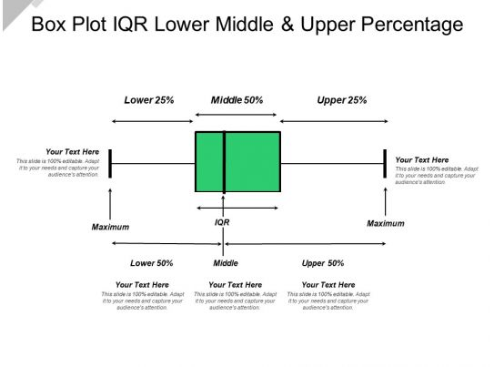
Univariate analysis:-Analysing every variable one by one
Ex:-PDF,CDF,box-Plot,violin Pot
Bivariate analysis:-Analysing two variables at time
Ex:-scatterplot, pair plot
Multivariate analysis:-more than 2 variable are analyzed
Ex:-Machine learning

MATHEMATICS IN MACHINE LEARNING

LINEAR ALGEBRA

- Linear equation:- order 1
- Vectors
- matrix
Line ,plane, hyperplane
Definition and how to find the distance from a point
Square,rectangle, circle ,ellipse
Cuboid,ellipsoid,sphere
Hyper cuboid,hyper ellipse
CALCULUS
Multivariate calculus
Differentiation
Gradient desent

- Power Pivot
- Power Query
- Power View

