Use Case Documentation
Deploying a Web Application to Azure Web App Service (Container) using Azure DevOps CI/CD Pipelines

End-to-end walkthrough: Azure resources → DevOps repo → Pipeline → Live app
Prepared by: Sai Ram Dasara
Project: angular project / angular-webapp
Application: Real Estate Management System

Table of Contents
1. Overview & Objective
2. Architecture at a Glance
3. Prerequisites
4. Step 1 — Set Up Azure DevOps Project
5. Step 2 — Create Azure Resources
5.1 Resource Group
5.2 App Service Plan
5.3 Azure Container Registry (ACR)
5.4 Azure Web App (Container)
5.5 Cosmos DB (MongoDB API)
6. Step 3 — Configure Service Connections
7. Step 4 — Set Up the Repository
8. Step 5 — Build the CI/CD Pipeline (YAML)
9. Step 6 — Configure Environment Variables
10. Step 7 — Run the Pipeline & Verify Deployment
11. Errors Faced & Resolutions
12. Final Outcome
13. Quick Reference Cheat Sheet

1. Overview & Objective
This document captures the end-to-end use case of deploying an Angular-based Real Estate Management web application to an Azure Web App Service (running as a container) using a CI/CD pipeline built in Azure DevOps. The goal is to make this a reference Sai can return to whenever a similar deployment is repeated.
What we built
- An Angular front end + Node.js (Fastify) backend, packaged together inside a single Docker container.
- A CI/CD pipeline that builds the Docker image, pushes it to Azure Container Registry (ACR), and deploys it to an Azure Web App.
- MongoDB data layer hosted on Azure Cosmos DB (with MongoDB compatibility).
High-level steps
- Create an Azure DevOps project and repository.
- Provision Azure resources: Resource Group, App Service Plan, ACR, Web App (Container), and Cosmos DB.
- Create service connections in Azure DevOps for ARM and ACR.
- Add the application code, Dockerfile, and supporting configs to the repo.
- Author an azure-pipelines.yml that builds, pushes, and deploys.
- Configure environment variables on the Web App.
- Run, verify, troubleshoot, and confirm a healthy deployment.
2. Architecture at a Glance
The flow can be summarised as: developer commits code → Azure DevOps pipeline triggers → image is built and pushed to ACR → Web App pulls the new image and restarts → users hit the live URL.
Developer → Azure Repos (Git) → Azure Pipelines (build + test + push) → Azure Container Registry → Azure Web App (Linux Container) → End User
End-to-end deployment flow
Side services:
- Azure Cosmos DB (MongoDB API) — application database.
- App Service Plan (Linux, P0v3) — compute behind the Web App.
- Service Connections — the secure bridge from DevOps to Azure resources.
3. Prerequisites
- Active Azure subscription (this project used “Azure for Students”).
- Azure DevOps organization and access to create projects.
- Application source code with a working Dockerfile.
- Owner / Contributor rights on the target Azure subscription (to create resources and service principals).
- Basic familiarity with YAML pipelines and Docker.
4. Step 1 — Set Up Azure DevOps Project
Sign in to https://dev.azure.com using the Azure account, create an organization (here: sairamdasara12), and create a new project named angular_project with default Basic process and Private visibility.
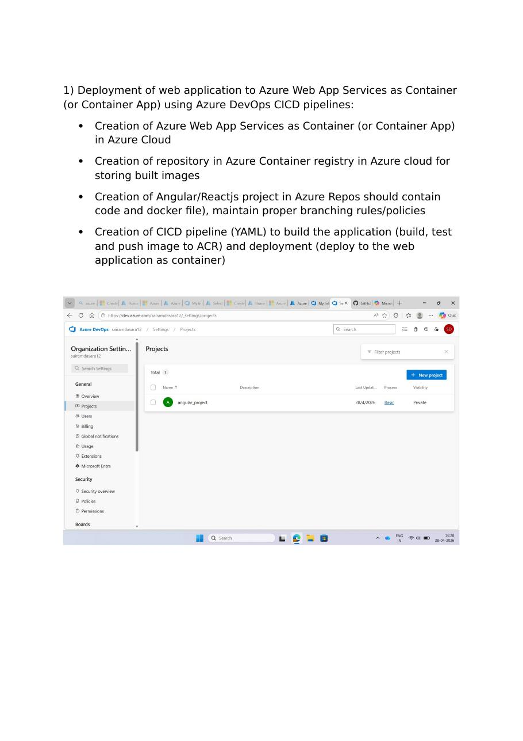
Azure DevOps → Organization Settings → Projects (angular_project created)
Once the project is open, the landing page shows the project tile under the organization.
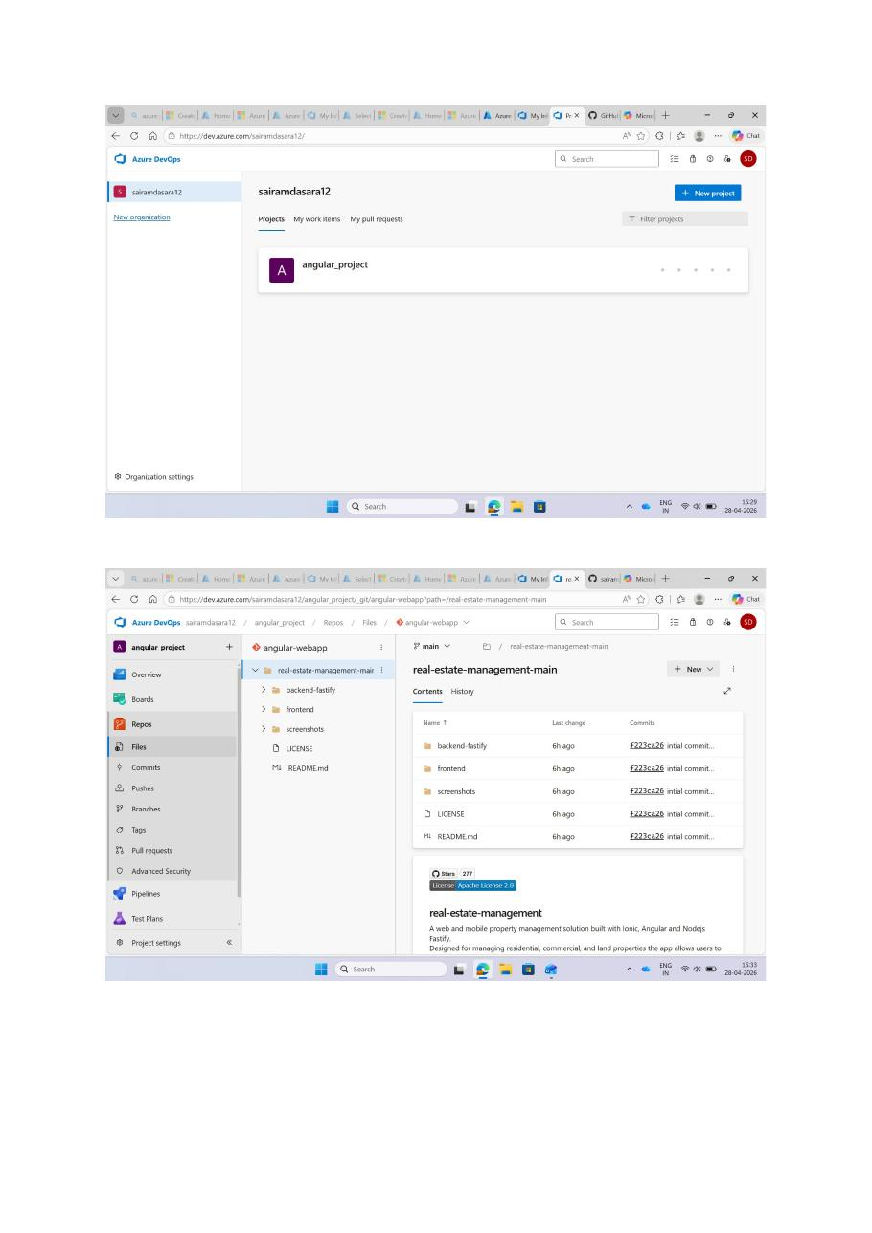
Project home and the angular-webapp repository structure (frontend + backend-fastify)
5. Step 2 — Create Azure Resources
All resources for this use case live inside a single resource group so they are easy to manage and clean up.
5.1 Resource Group
Created myresourcegroup2473994 in the Central India region. This becomes the container for every other resource below.
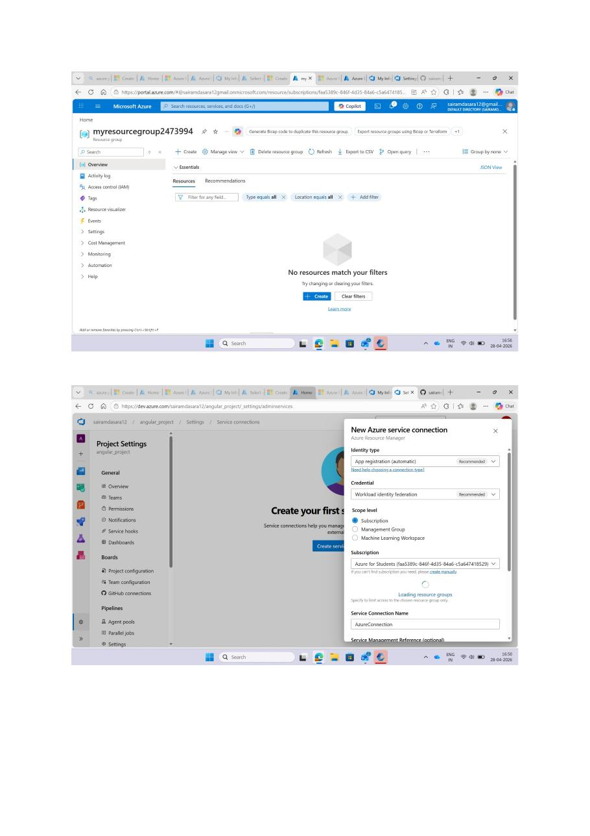
Resource group created (initially empty) and Service Connection dialog shown for context
5.2 App Service Plan
Created an App Service Plan named myPlan on Linux, pricing tier P0v3, region Central India. This provides the compute that runs the Web App container.
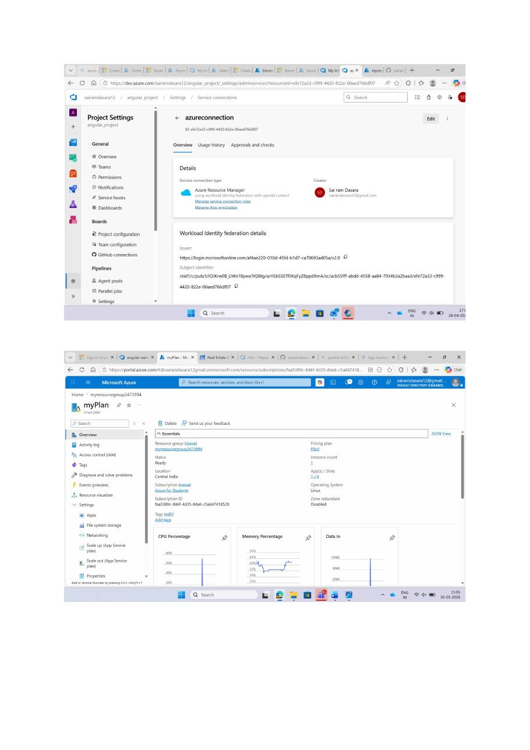
App Service Plan: myPlan (Linux, P0v3, Central India)
5.3 Azure Container Registry (ACR)
Created azrecontainerregistry4799 (Standard tier). The login server is azrecontainerregistry4799.azurecr.io — this is the address the pipeline will push images to and the Web App will pull from.
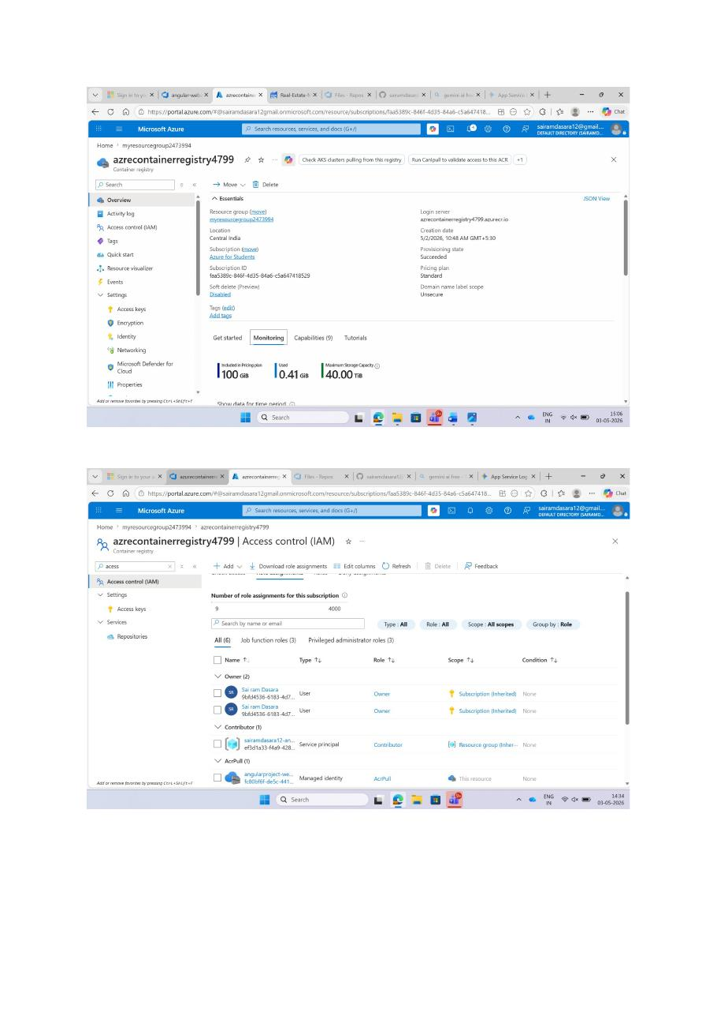
ACR overview and IAM role assignments (Owner, Contributor, AcrPull managed identity)
Enable the admin user under Settings → Access keys so the Web App can authenticate to pull images. Note the username and password — these are used when wiring up the Web App to the registry.
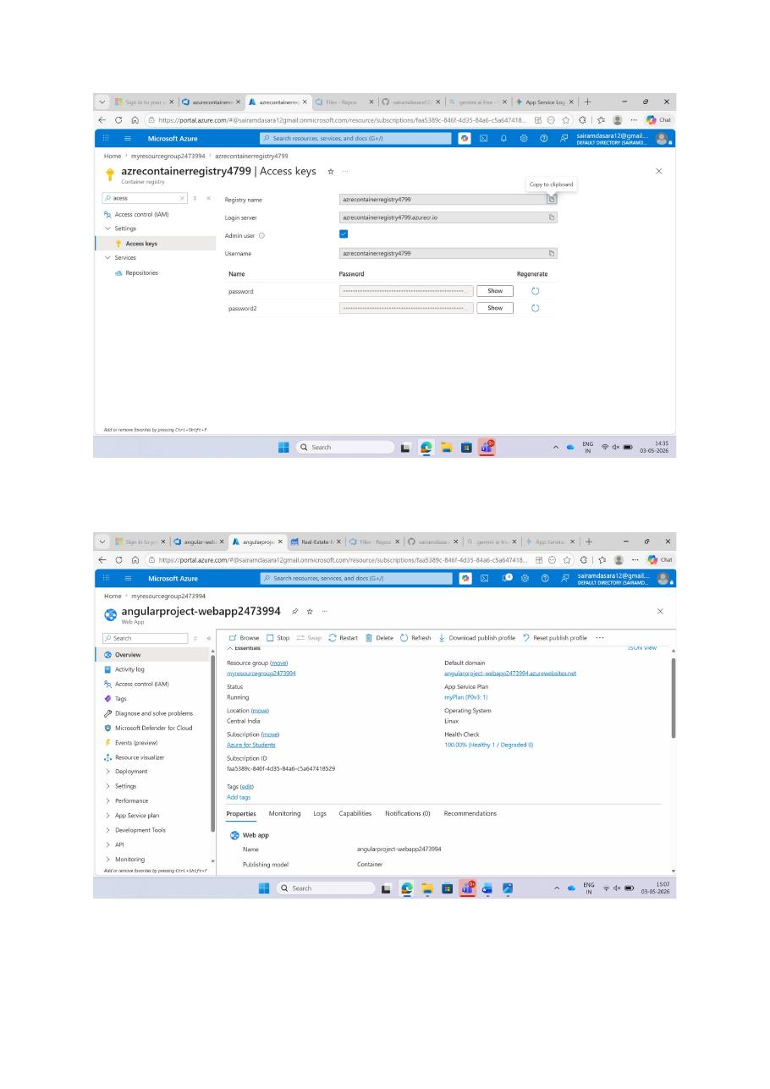
ACR Access Keys page (Admin user enabled)
5.4 Azure Web App (Container)
Created angularproject-webapp2473994 as a Linux Web App configured for container deployment. The Default domain becomes the public URL of the application:
https://angularproject-webapp2473994.azurewebsites.net

Web App overview — Status: Running, OS: Linux, Publishing model: Container
5.5 Cosmos DB (MongoDB API)
Created cluster2473994 — Azure Cosmos DB with MongoDB compatibility (version 8.0), Free tier. The connection string from this cluster will be passed to the Web App via the DB_CONNECT environment variable.
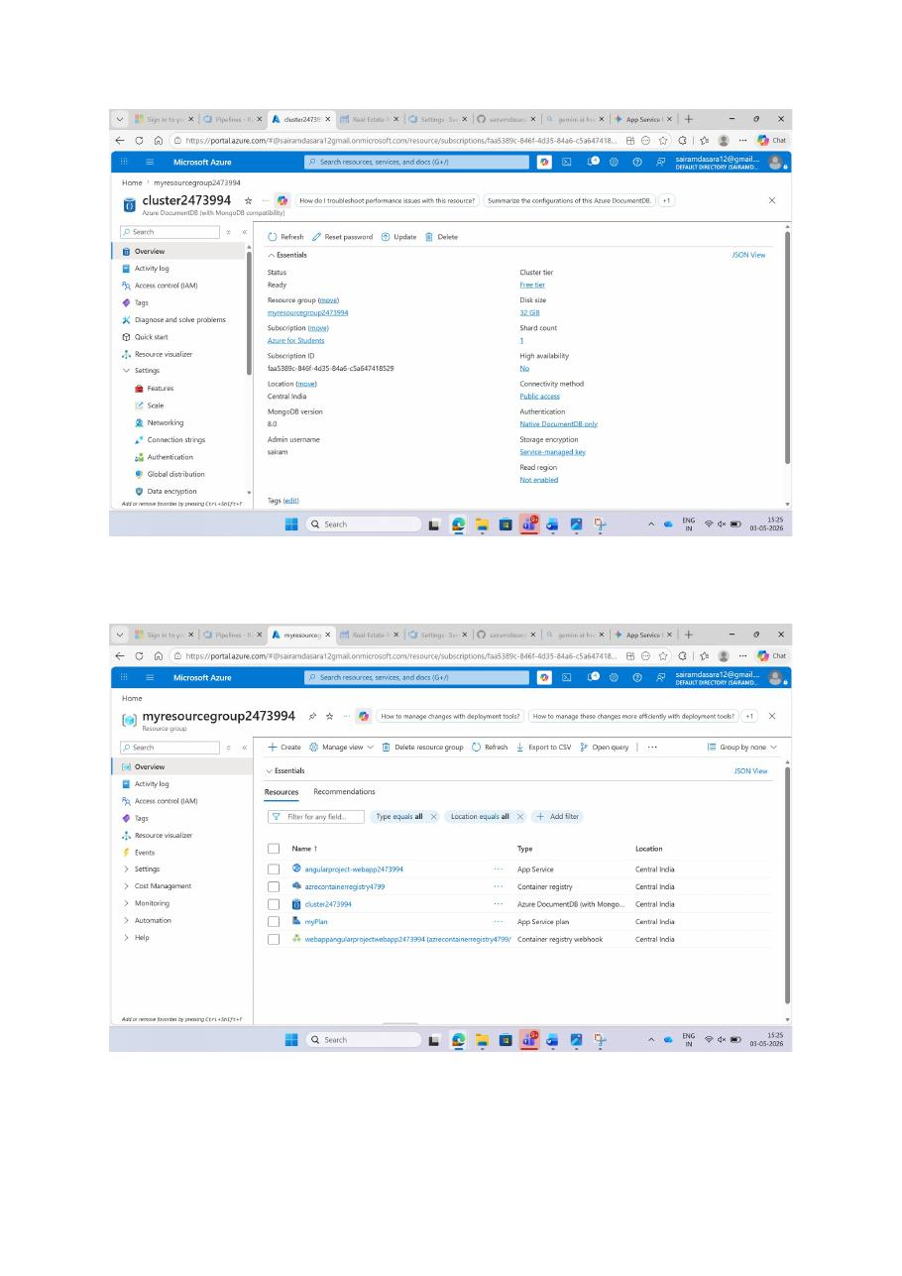
Cosmos DB cluster (top) and final resource group view with all 5 resources (bottom)
6. Step 3 — Configure Service Connections
Service Connections let the Azure DevOps pipeline talk to Azure. Two are needed for this use case:
- azureconnection — Azure Resource Manager connection (for deploying to the Web App).
- azurecontainerregistry / azurecontainerregistry1 — Docker Registry connection pointing to ACR (for pushing images).
Create them under Project Settings → Pipelines → Service connections → New service connection.

New Azure service connection — ARM, App registration (automatic), Workload identity federation
After creation, verify the ARM connection details (Issuer, Subject identifier, etc.):

azureconnection — Azure Resource Manager connection details
Then create the Docker Registry connection pointing to the ACR you provisioned earlier:
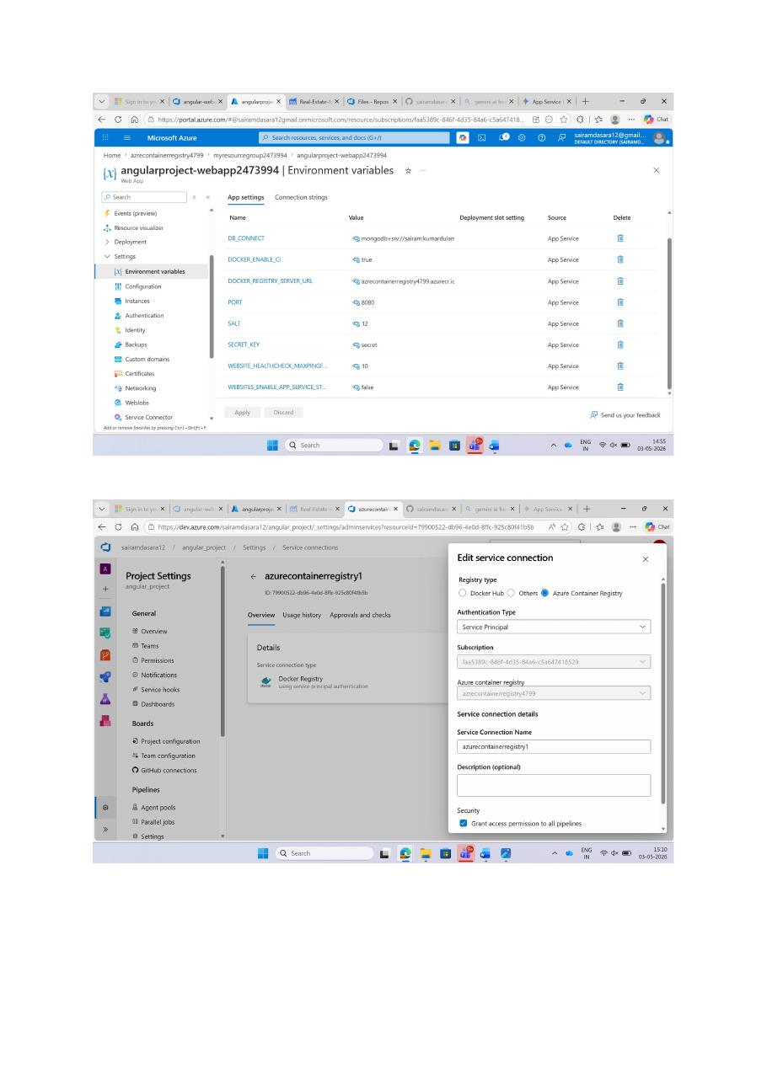
Edit service connection → Azure Container Registry, Service Principal authentication
All three service connections should now be visible:
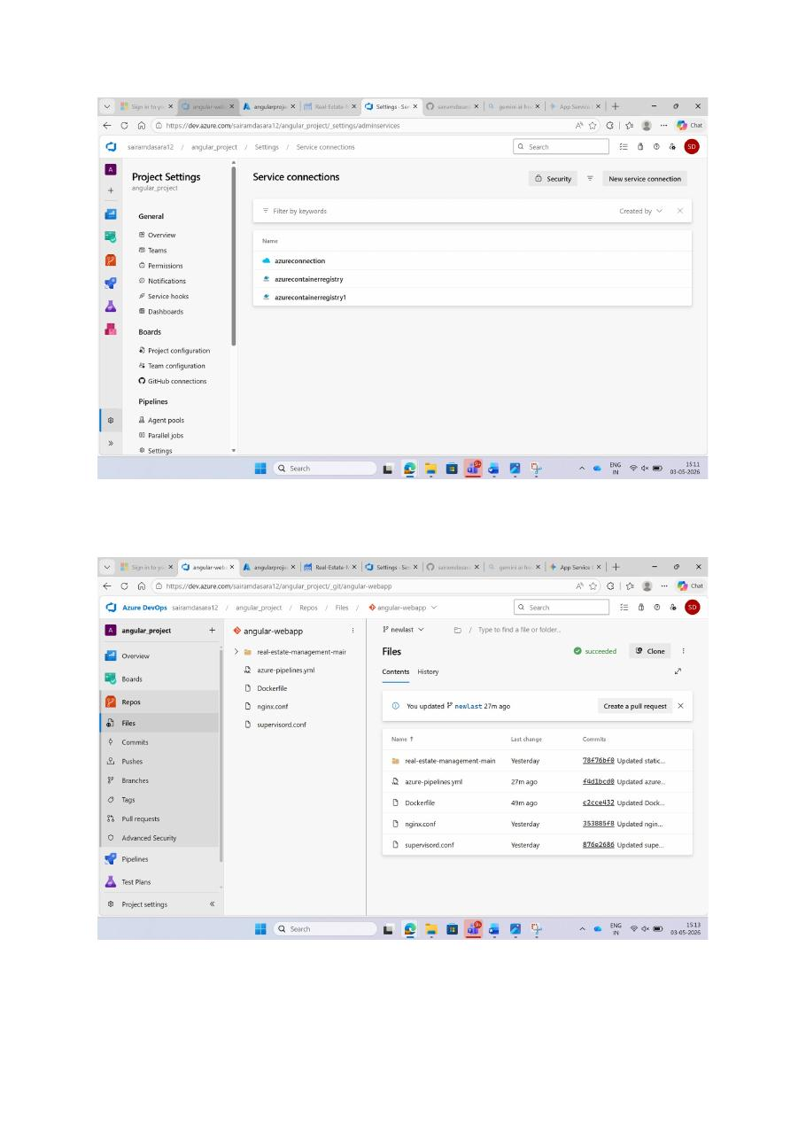
Service Connections list: azureconnection + 2 ACR connections
7. Step 4 — Set Up the Repository
Inside the angular_project, create (or import) a Git repository named angular-webapp. The repo should contain:
- Application source code (frontend + backend-fastify in this use case).
- Dockerfile — build instructions for the container image.
- nginx.conf — reverse proxy config (serves the Angular build and proxies API calls).
- supervisord.conf — runs nginx and Node.js inside the same container.
- azure-pipelines.yml — the CI/CD definition.

angular-webapp repo — newlast branch with all required files in place
Set up sensible branch policies on main (require PR, build validation, etc.) before any production deployments.
8. Step 5 — Build the CI/CD Pipeline (YAML)
In Pipelines → New pipeline, choose the Azure Repos source and pick a starter template (e.g. Node.js with Angular).
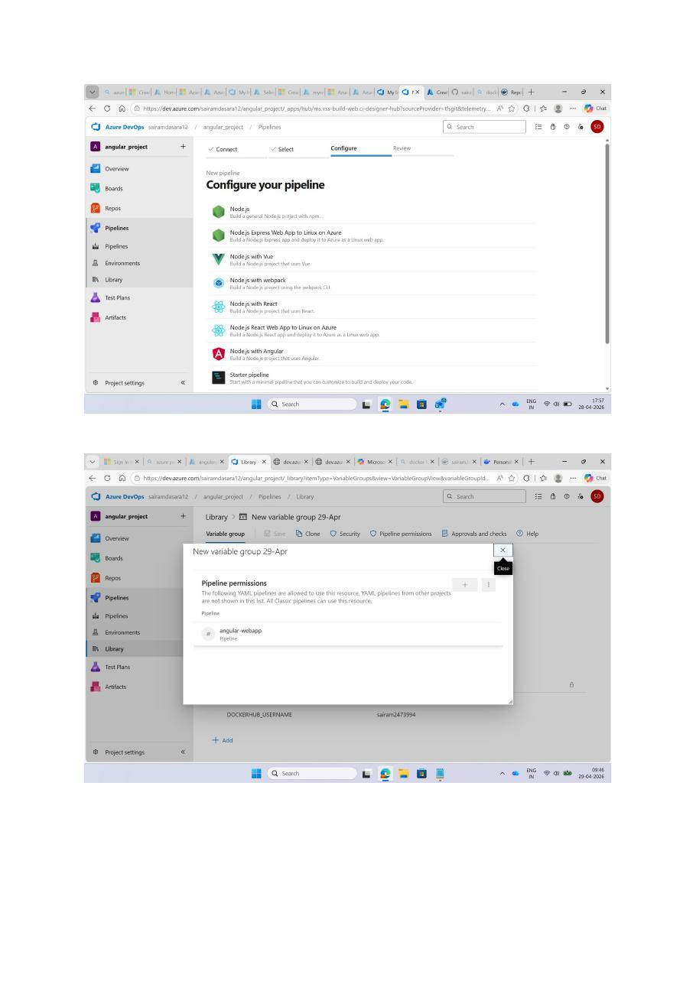
New pipeline — Configure your pipeline (Node.js with Angular template) + Variable Group permissions
The pipeline runs in two stages:
- Build and Push — npm install, build, run tests, build the Docker image, push it to ACR with a unique tag (e.g. the build ID).
- Deploy to Azure Web App — use the AzureWebAppContainer task to point the Web App at the new image tag.
Reference the service connections by name in the YAML, and reference secrets through a Variable Group (so things like DB_CONNECT, DOCKERHUB_USERNAME, SECRET_KEY etc. are not committed to source). Grant the pipeline permission to use the Variable Group when prompted.
9. Step 6 — Configure Environment Variables
In the Web App, open Settings → Environment variables and add the runtime configuration the application expects:
- DB_CONNECT — the Cosmos DB MongoDB connection string.
- DOCKER_ENABLE_CI — true (so the Web App auto-pulls new images).
- DOCKER_REGISTRY_SERVER_URL — https://azrecontainerregistry4799.azurecr.io
- PORT — 8080 (the port nginx listens on inside the container).
- SECRET_KEY — used by the backend for token signing.
- SALT — 12 (bcrypt salt rounds).
- WEBSITE_HEALTHCHECK_MAXPINGFAILURES — 10.
- WEBSITES_ENABLE_APP_SERVICE_STORAGE — false.

Environment variables panel on the Web App
⚠ Important: every name=value pair must use a real “=” between the name and value, and there must be no stray spaces. A malformed env var here is what caused the supervisord error described in section 11.
10. Step 7 — Run the Pipeline & Verify Deployment
Trigger the pipeline by pushing to the watched branch (or queueing it manually). A successful run shows green ticks for all stages: Initialize job → Checkout → Install Node.js → Build and Push → Deploy.
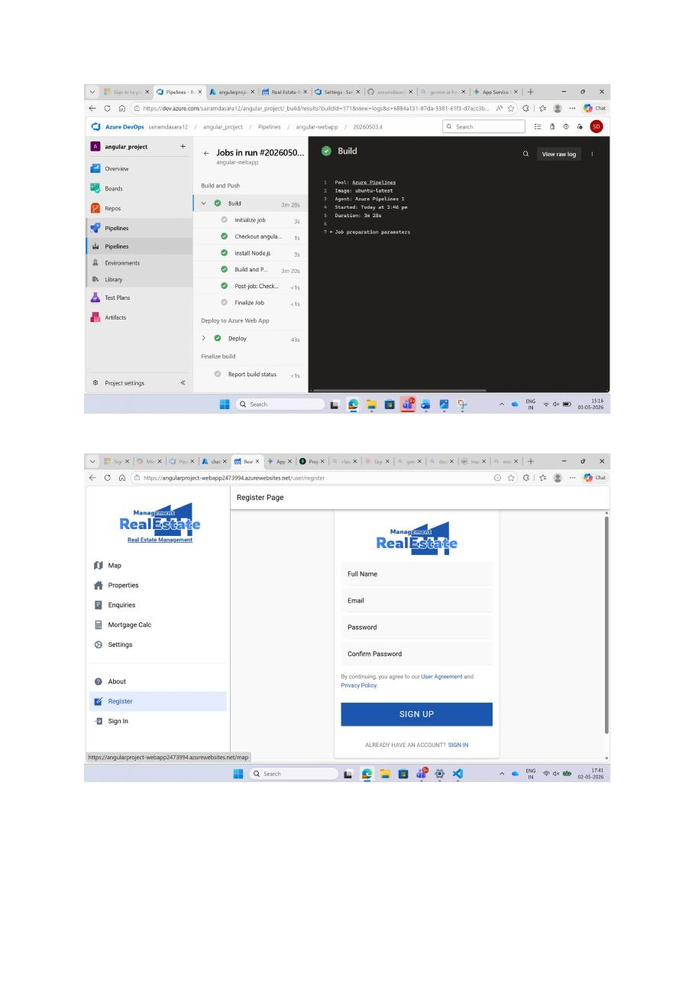
Pipeline run #20260503.4 — Build (3m 28s) + Deploy (43s) succeeded; live app showing the Register page
Once the pipeline reports succeeded, browse to the Web App’s default domain. The Real Estate Management UI should load.
Verifying the running app
Each major page should render without console errors:
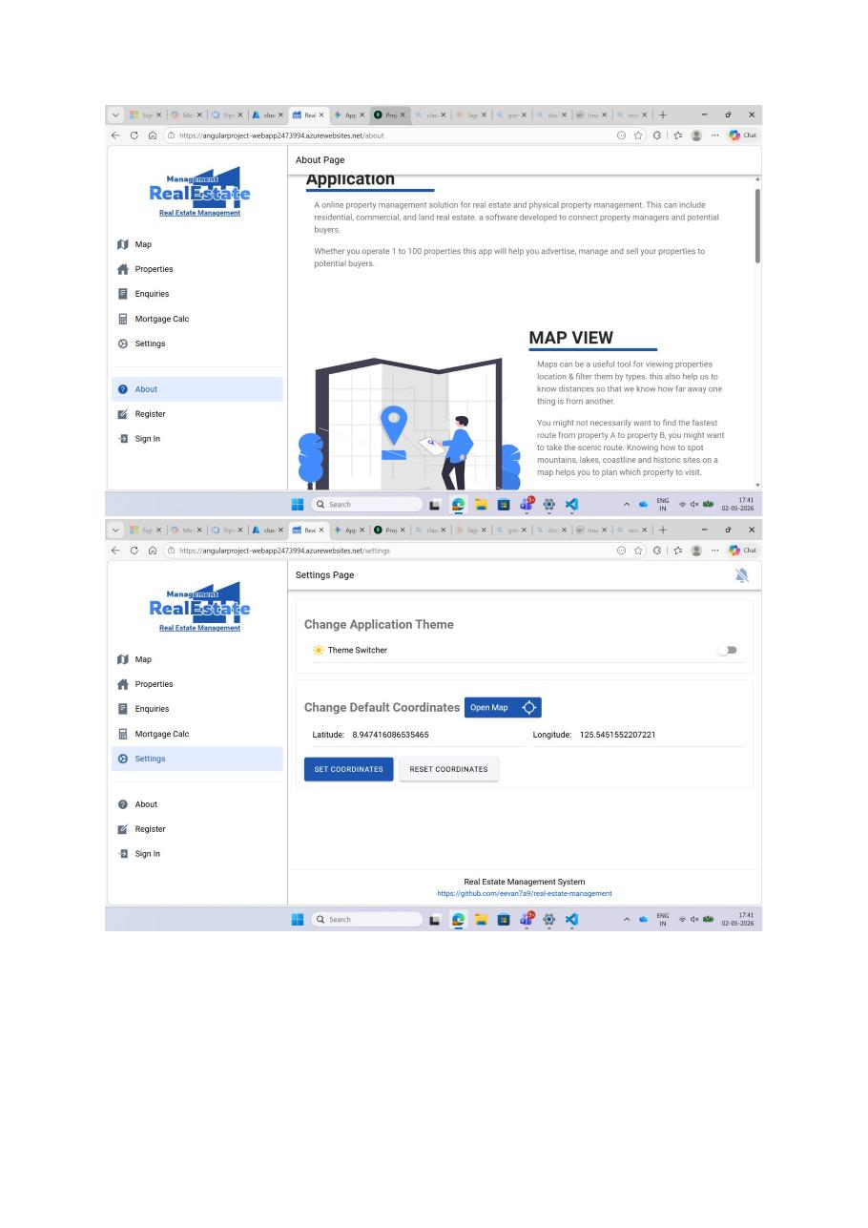
About page (top) and Settings page with theme toggle and default coordinates (bottom)
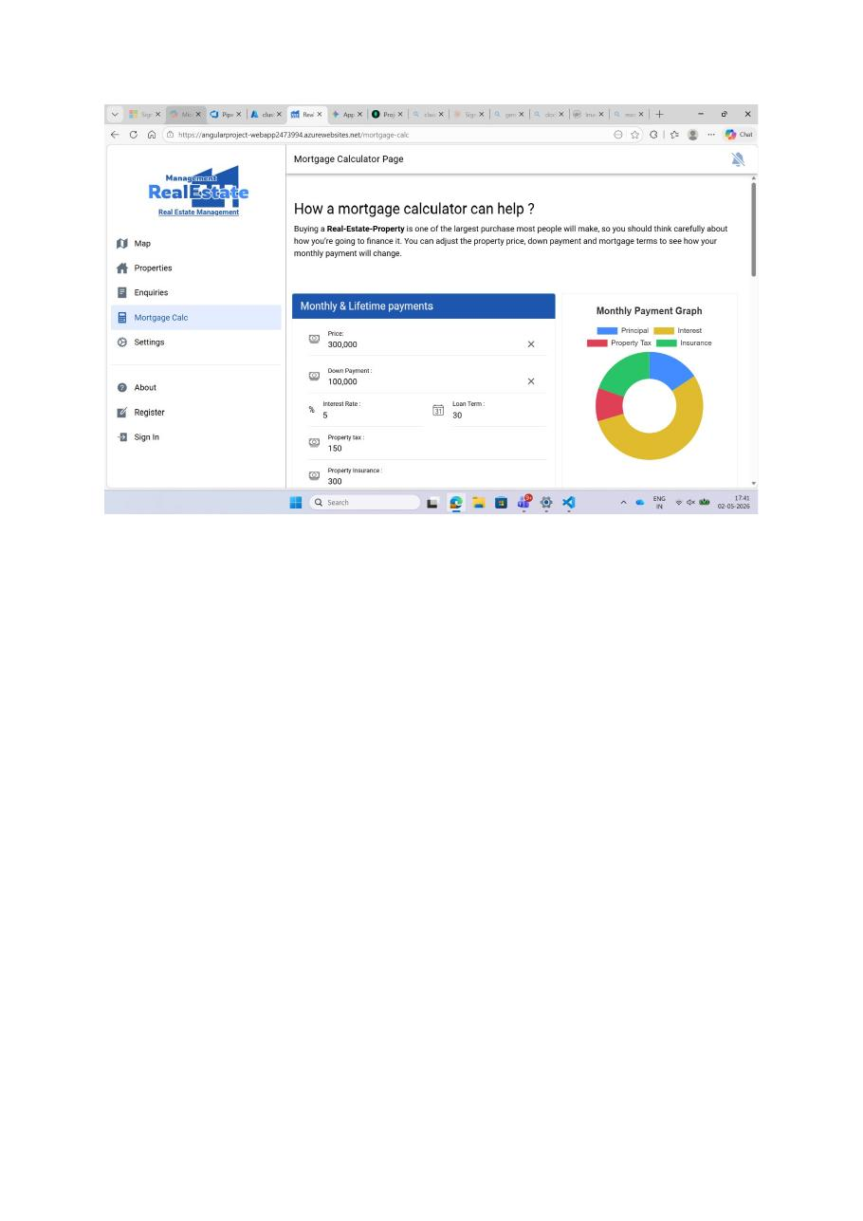
Mortgage Calculator page — working form + chart
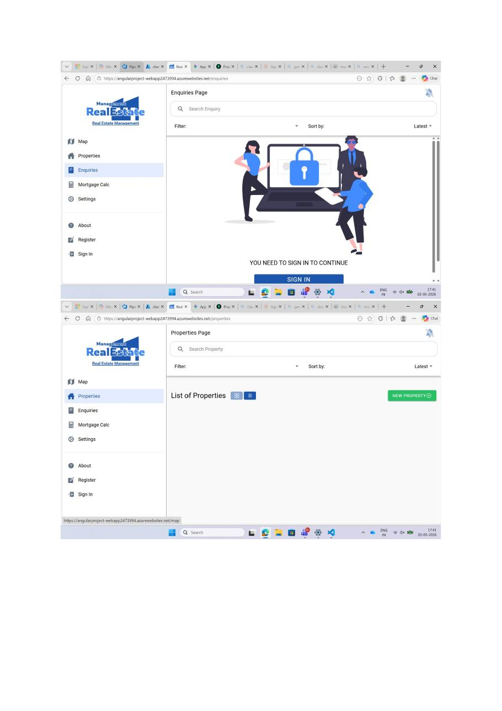
Enquiries page (auth-gated) and Properties page
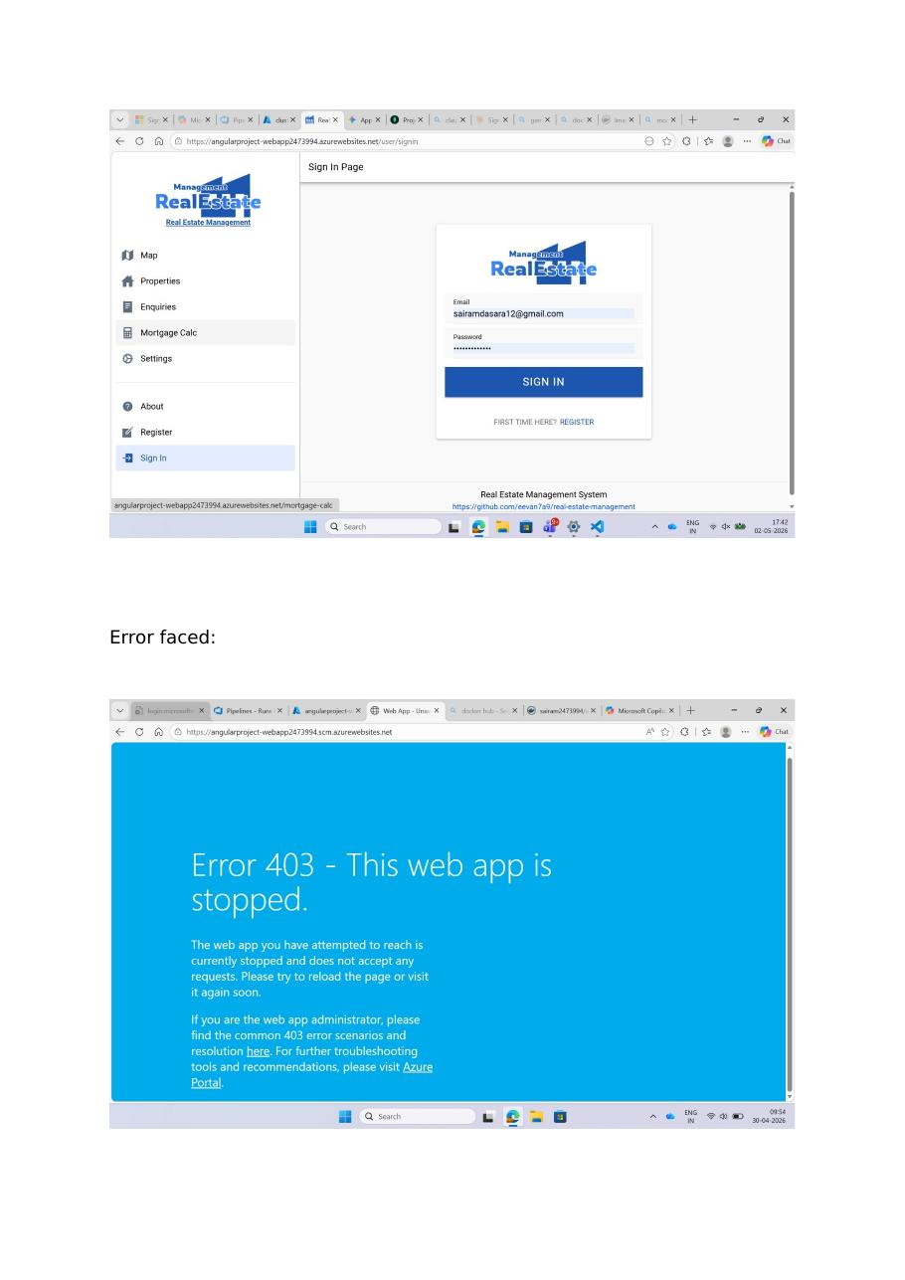
Sign In page (top). The bottom screenshot shows an early failure that we will dissect in section 11.
11. Errors Faced & Resolutions
Several issues came up before the deployment was finally healthy. Capturing them here makes future repeats much faster.
11.1 “Error 403 — This web app is stopped”
Symptom: hitting the Web App URL returned a blue “Error 403 — This web app is stopped” page.
Cause: the Web App was in a Stopped state (manual stop, or it had been stopped after repeated container start failures).
Fix: in the Azure portal → Web App → Overview, click Start. If the container fails immediately after starting, follow section 11.3.
11.2 “:( Application Error” / blank “true” page
Symptom: the URL renders only :( Application Error or, intermittently, just the word true on a blank page (this comes from the Node API’s health endpoint being served at the root before the SPA assets are routed correctly).
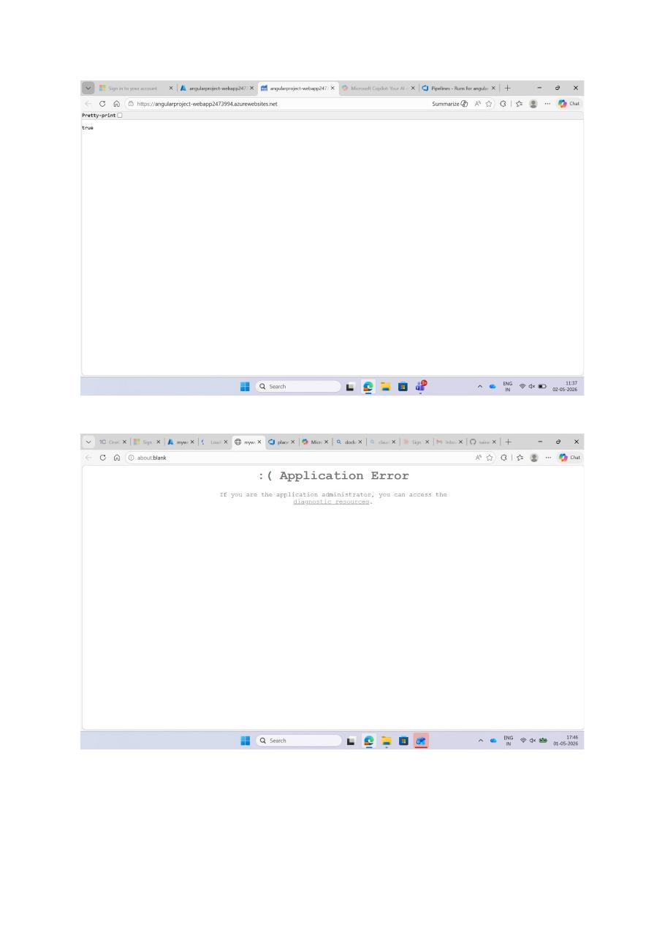
“true” response (top) and Application Error page (bottom)
Causes:
- nginx.conf was routing / to the API instead of falling through to index.html.
- Container started but a worker process crashed shortly after.
Fix: make sure nginx.conf has try_files $uri $uri/ /index.html; for the SPA location and only proxies /api/ to the Node backend. Restart the Web App after pushing the corrected image.
11.3 ContainerTimeOut — “Container did not start within expected time limit of 230s”
Symptom: every instance shows Blocked / Unhealthy with the error ContainerTimeOut.
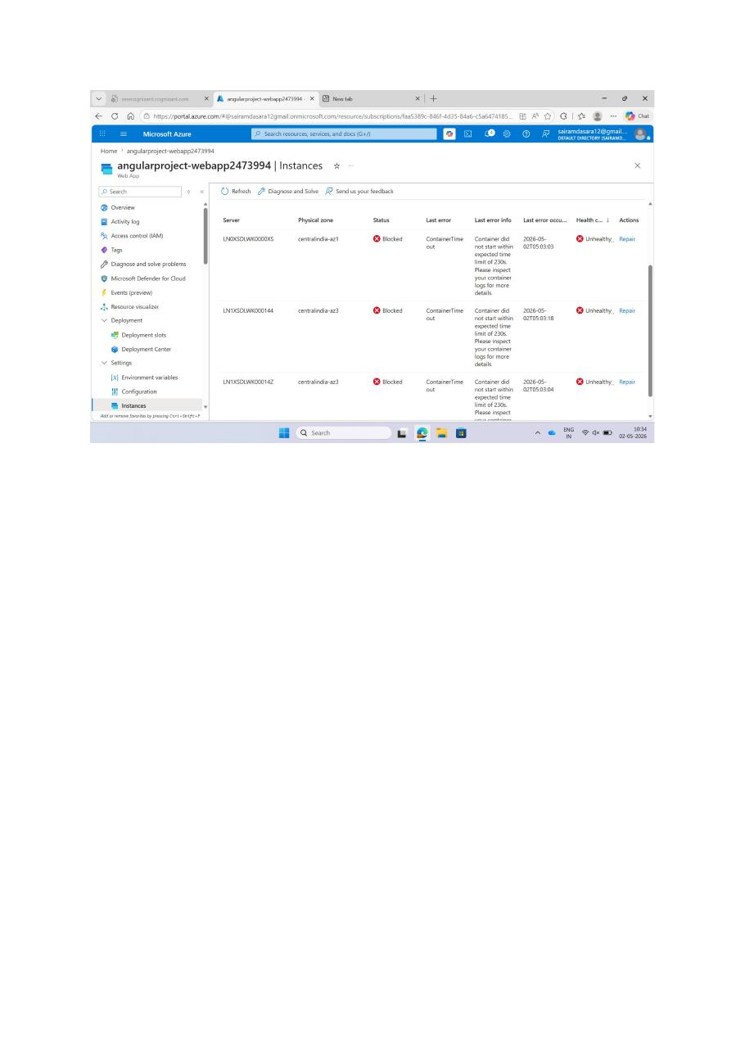
Web App → Instances: three blocked instances, all reporting ContainerTimeOut
Cause: the application inside the container was not listening on the port Azure expected. By default, Azure App Service probes the port given by the WEBSITES_PORT (or PORT) environment variable. If the container listens on 80 internally but PORT is 8080 (or vice versa), the probe fails for 230 seconds and Azure marks the instance unhealthy.
Fix:
- Decide on one port (we used 8080) and make it consistent everywhere: nginx.conf listens on 8080, EXPOSE 8080 in the Dockerfile, and PORT=8080 in Web App environment variables.
- Restart the Web App after correcting the env var.
11.4 Supervisord parse error in container logs
Symptom: under Diagnose and solve problems → App Container Failed to Start, the additional info shows:
Error: Unexpected end of key/value pairs in value 'PORT=800 SECRET_KE=secret SALT=12' in section 'program:' (file: /etc/sup...
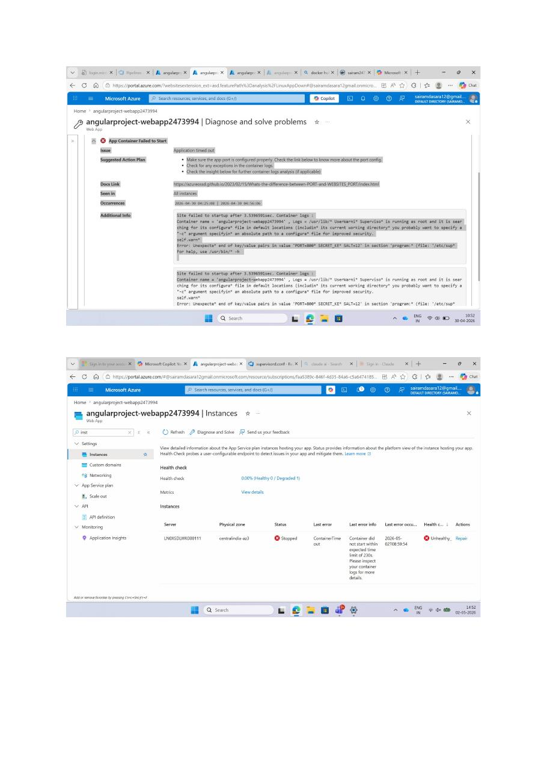
Diagnose and solve problems → detailed container failure with the supervisord parse error
Cause: in supervisord.conf, the environment= line was written without quotes around individual values, and one key was misspelled (SECRET_KE instead of SECRET_KEY). supervisord then tried to parse the whole string as a single value and failed.
Fix: rewrite the line so every value is quoted and every key is correct, for example:
environment=PORT="8080",SECRET_KEY="%(ENV_SECRET_KEY)s",SALT="12"
- Pull the actual values from Web App env vars using %(ENV_NAME)s rather than hard-coding them.
- Commit the fix, let the pipeline rebuild the image, and restart the Web App.
11.5 Diagnose & Solve — the fastest debugging surface
Whenever the app misbehaves, the first stop should be Web App → Diagnose and solve problems. It auto-detects the most common categories: Application Logs, Web App Troubleshooter, HTTP Server Errors (5xx). The Web App Down view also gives a clear timeline of when availability dropped.
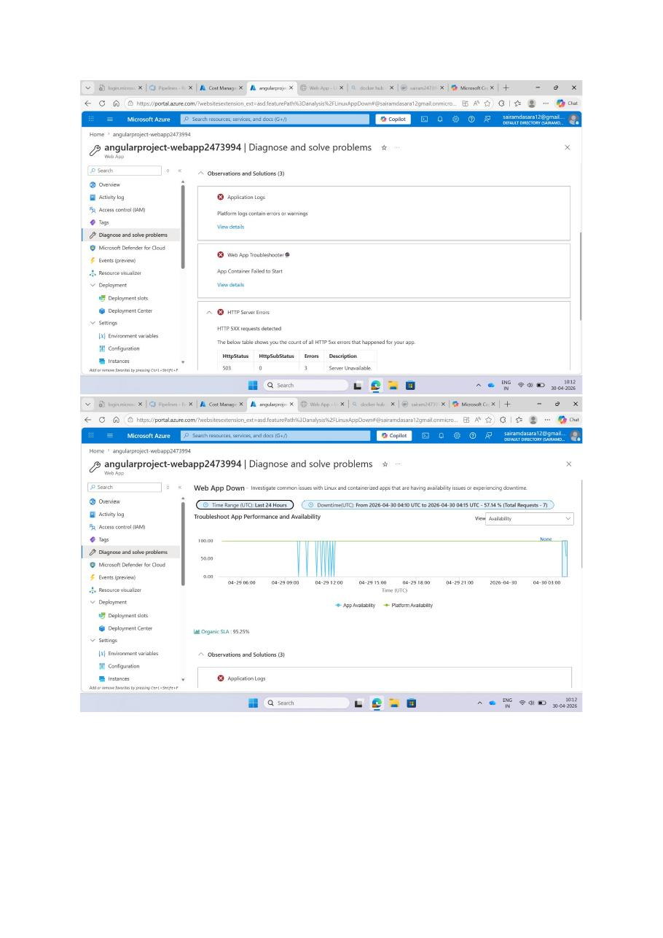
Diagnose and solve problems — Observations and Solutions + Web App Down chart
12. Final Outcome
After fixing the port, env vars, and supervisord config, the Web App reaches a healthy state.

Health check 0% (Stopped) right before the fix
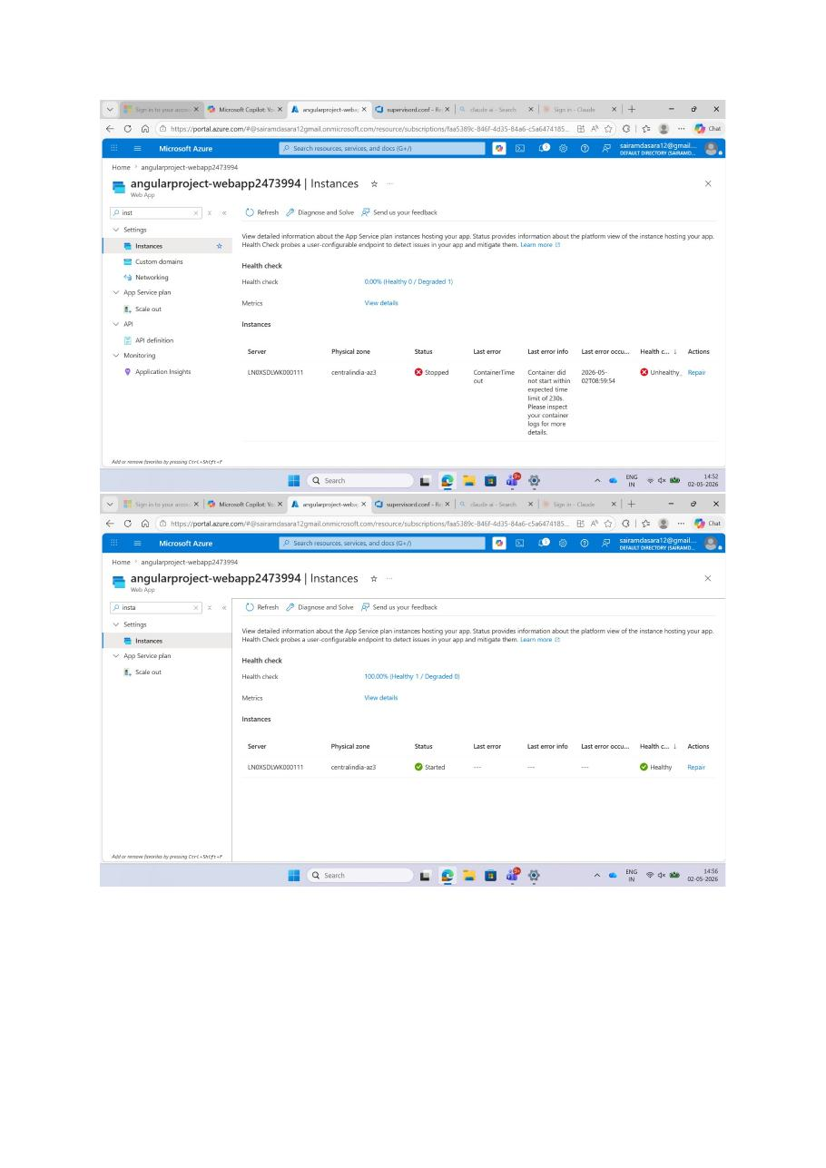
Health check 100% (Started, Healthy) after the fix — deployment confirmed working
Verification checklist:
- Pipeline shows green for both Build and Deploy stages.
- Instances panel shows the instance as Started / Healthy.
- Default domain serves the Real Estate Management UI without errors.
- Sign in / Register / Mortgage Calc / Properties / Settings all work end-to-end.
13. Quick Reference Cheat Sheet
Resource names used
- Resource group: myresourcegroup2473994
- App Service Plan: myPlan (Linux, P0v3, Central India)
- ACR: azrecontainerregistry4799 (Standard)
- Web App: angularproject-webapp2473994
- Cosmos DB: cluster2473994 (MongoDB API, v8.0, Free tier)
- Default domain: https://angularproject-webapp2473994.azurewebsites.net
Service connections
- azureconnection — ARM (Workload identity federation)
- azurecontainerregistry — Docker Registry, Service Principal auth
Required environment variables on the Web App
- DB_CONNECT, DOCKER_ENABLE_CI, DOCKER_REGISTRY_SERVER_URL, PORT, SALT, SECRET_KEY, WEBSITE_HEALTHCHECK_MAXPINGFAILURES, WEBSITES_ENABLE_APP_SERVICE_STORAGE
If the deployment goes red, check (in order)
- Pipeline logs — did Build and Push and Deploy both succeed?
- Web App → Instances — is anything Blocked / ContainerTimeOut?
- Web App → Diagnose and solve problems → App Container Failed to Start — read Additional Info.
- Environment variables — every key spelled correctly, every value present, PORT matches what the container actually listens on.
- supervisord.conf — every value quoted, no typos in keys.
- ACR Access keys — admin user enabled and credentials still valid.

— End of document —

