NETWORK DESIGN PROPOSAL FOR INTERNET CAFE

A CASE STUDY REPORT
Submitted by
PRAGADA SAI RAMESH (RA2311028010045)

for the course
21CSC302J – COMPUTER NETWORKS
in partial fulfillment of the requirements for the degree of
BACHELOR OF TECHNOLOGY



DEPARTMENT OF NETWORKING AND COMMUNICATIONS
SCHOOL OF COMPUTING
FACULTY OF ENGINEERING AND TECHNOLOGY
SRM INSTITUTE OF SCIENCE AND TECHNOLOGY
KATTANKULATHUR - 603 203.

NOVEMBER 2025



SRM INSTITUTE OF SCIENCE AND TECHNOLOGY

KATTANKULATHUR – 603 203

BONAFIDE CERTIFICATE

Certified that Case Study report titled “NWTWORK DESIGN FOR INTERNET CAFE” is the Bonafide work of “PRAGADA SAI RAMESH[RA2311028010045],” who carried out the project work under my supervision. Certified further, that to the best of my knowledge the work reported herein does not form any other project report or dissertation on the basis of which a degree or award was conferred on an earlier occasion on this or any other candidate.

Dr. Rajeshkumar K
Assistant Professor
Department of Networking
and Communications

Abstract
This project focuses on designing a simple, reliable, and secure network for an Internet café that serves around 30 users sharing a single ADSL internet connection. The main goal is to create a setup that allows all users to access the internet smoothly while keeping the network safe and easy to manage.
The proposed design includes a web filtering system to make sure customers can browse safely, and billing software to track usage and manage customer accounts easily. Before creating the network plan, several factors were considered such as the cafe’s location, number of users, internet speed requirements, and backup options in case of connection issues.
A clear network diagram and IP address plan have been prepared to show how the devices will be connected and how addresses will be assigned. The project also suggests the best hardware and software to use based on cost, performance, and reliability.
In short, this proposal aims to give the Internet cafe a strong, secure, and efficient network that helps the business run smoothly while giving customers a fast and safe browsing experience.

Table of Contents

S.No | Chapter Title | Page No.
- | Abstract | 2
1 | Introduction | 5
2 | Network Design | 6
3 | Addressing Scheme | 8
4 | Topology Configuration | 10
5 | Testing and Validation | 13
6 | Results and Evaluation | 16
7 | Conclusion | 18
8 | References | 19
9 | Appendices | 20

Figure No. | Figure Title | Page No.
Figure 1 | Topology of Full Network | 6
Figure 2 | To Check Connection with Router | 12
Figure 3 | From PC1 Test the Connection to Router | 13
Figure 4 | From Admin PC Test the Connection to Router | 13
Figure 5 | Server Validation | 14
Figure 6 | Router Verification | 15
Figure 7 | Add Customer to PC | 16
Figure 8 | Login into PC | 16
Figure 9 | PC Status | 17
Figure 10 | Billing Method | 17
Figure 11 | Billing History | 17

Introduction

Objective

The main objective of this project is to design a reliable and secure network for an Internet café that can support up to 30 users using a single ADSL internet connection. The idea is to build a setup that allows every customer to browse smoothly while keeping the network safe, organized, and easy to manage. This project also focuses on adding useful tools such as a web filtering system to block inappropriate websites and billing software to manage customer usage and payments. The network should be simple to maintain, cost-effective, and flexible enough to support future upgrades or expansion.

1.2 Purpose
The purpose of this project is to help an Internet café run efficiently by providing a properly planned network system. Many cafés face common issues like slow internet speeds, poor security, and manual billing, which make daily operations difficult. This project aims to solve these problems by designing a network that ensures fast and secure connectivity for all users. It also allows the café staff to easily monitor the system, manage customers, and provide better service experience. With this setup, both the café owner and customers can benefit from a stable and well-organized internet environment.

1.3 Scope
This project includes everything needed to set up and manage a small-scale Internet café network. It starts with analyzing the café’s requirements, such as the number of users and the type of internet connection needed. The design also covers the arrangement of devices like routers, switches, and computers, along with an IP addressing plan to organize network communication. It further involves testing the network to make sure it works properly, adding billing software for customer management, and using web filtering tools to ensure safe browsing. The project also considers future improvements, such as adding wireless access or backup connections, to make the network more efficient and flexible.

1.4 Problem Statement
Internet cafés often face challenges such as slow connections, lack of security, and difficulties in managing customer usage. Without a proper network design, users experience interruptions, unsafe browsing, and poor service quality. This project addresses these issues by creating a planned and secure network that offers smooth connectivity, safe browsing, and an automated billing process. It aims to give the café a dependable system that can handle multiple users efficiently while maintaining stability and control.

1.5 Significance of the Project
This project is important because it provides a practical and affordable network solution for an Internet café. By using this design, café owners can offer customers a faster and safer internet experience while managing operations more effectively. The system ensures that every user gets fair access to the internet, prevents misuse, and simplifies billing and monitoring tasks for the staff. Overall, the project helps improve the café’s service quality, reduces maintenance issues, and supports future growth in a simple and sustainable way.

Network Design

Topology

The Internet café network is designed using a star topology, which is ideal for small and medium-sized setups like this one. In this arrangement, all computers are connected to a central switch, which acts as the main communication point. The switch then connects to the router, which provides access to the internet through an ADSL modem. This structure is easy to install, manage, and expand when more computers are added in the future. If one connection fails, the rest of the network continues to work without interruption, making it a reliable choice for continuous café operations.
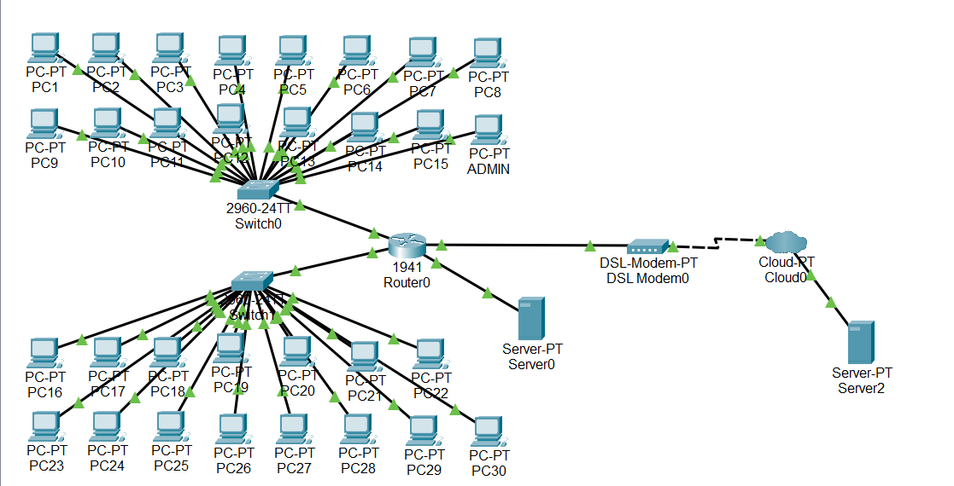

Figure 2.1: Topology of full network

Components

The network design for the project incorporates the following devices:

1.Router (1):
- A single router is used to connect the local area network (LAN) of the Internet café to the ADSL modem, which provides internet connectivity.
- It acts as the gateway between the internal network and the external internet, managing data traffic and ensuring smooth communication.
- The router is also configured with DHCP to automatically assign IP addresses to all connected devices and with a firewall for added network security.

2.Switches (2):
- Two switches are used to connect all the client PCs and servers within the café.
- They form the core of the LAN and ensure efficient data transfer between devices.
- The switches help manage traffic internally and allow the network to scale easily if more systems are added in the future.
3. Server (2):
- The network includes two servers—Server 0 and Server 1.
- Server 0 manages local services such as DHCP, web filtering, and billing software to handle customer login and usage tracking.
- Server 1 is responsible for external communication, security management, and backup operations to maintain network stability and reliability.
4. Client PCs (30):
- Thirty-user computers are connected to the network, allowing customers to access the internet simultaneously.
- Each PC receives its IP address dynamically through the DHCP service from the router, ensuring easy connectivity and management.
5. Admin PC (1):
- The admin computer is assigned a static IP address (192.168.1.2).
- It is used by the café administrator to monitor the network, manage user accounts, and control the billing system.
- This system has special access privileges to modify configurations and manage services securely.
6. ADSL Modem (1):
- The ADSL modem connects the café’s internal router to the Internet Service Provider (ISP).
- It converts digital data from the network into a form suitable for transmission over telephone lines, enabling internet access for all connected users.
7.Cabling and Connectors:
- Standard Cat6 Ethernet cables are used throughout the café to connect all computers, switches, and network devices.
- This ensures high-speed data transmission, low interference, and reliable connectivity across all systems.

Addressing Scheme

An effective IP addressing scheme is essential for organizing the devices in a network and allowing smooth communication between them. In the Internet café network, both static and dynamic IP addressing are used to simplify configuration and management. The design ensures that every device, whether it is a server, router, switch, or PC, can communicate properly within the local area network and access the internet through the router.

The network uses the private IP address range 192.168.1.0/24, which provides 254 usable host addresses. This range is sufficient for the café’s 30 computers, servers, and networking devices, while also leaving room for future expansion. The router functions as the default gateway, managing all outgoing and incoming network traffic.

The Dynamic Host Configuration Protocol (DHCP) is enabled on the router to automatically assign IP addresses to all client computers when they connect to the network. This reduces manual configuration and helps prevent IP conflicts. Meanwhile, key devices such as servers and the admin PC are assigned static IP addresses to ensure consistent communication and easy management.

Device | IP Address | Subnet Mask | DefaultGateway
PC1-PC30 | 192.168.1.3192.168.1.33  (DHCP) | 255.255.255.0 | 192.168.1.0
PC-ADMIN | 192.168.1.2  (Static) | 255.255.255.0 | 192.168.1.0
Switch 0 | DHCP | DHCP | DHCP
Switch 1 | DHCP | DHCP | DHCP
Lan Router | 200.0.0.1 | 255.255.255.0 | 200.0.0.0
Server0 | 192.168.1.1 | 255.255.255.0 | 192.168.1.0
Server1 | 200.0.0.10 | 255.255.255.0 | 200.0.0.0
ADSLModem | N/A | N/A | N/A
Cloud | N/A | N/A | N/A

This IP addressing structure ensures that all internal devices communicate seamlessly, while the router efficiently routes data between the LAN and the external network. The static addresses for the servers and admin PC guarantee stable operation for critical services like DHCP, billing, and web filtering. The use of DHCP for client PCs allows for flexibility and easy management, especially when users change systems frequently.

4. Topology Configuration

The Internet café network is designed in a star topology, where all devices are connected through switches to a central router. The router connects to an ADSL modem, which provides internet access from the Internet Service Provider (ISP). The setup allows 30 users to share one internet connection smoothly and securely.

The network uses both static and dynamic IP addressing. The server and admin PC are given static IPs, while the client PCs receive their IPs automatically using DHCP from the router. The configuration ensures stable communication and easy management for all systems.

4.1 Device Connection

Router: Connected to the ADSL modem for internet access and to the main switch (Switch0) for LAN connectivity.

Switch0 (Main Switch): Connected to the router, Server0, Admin PC, and Switch1.

Switch1 (Access Switch): Connected to the user PCs (PC1–PC30).

Server0: Connected to Switch0 for billing and web filtering.

Server1: Connected to the router’s external side (public network) for external services.

Admin PC: Connected to Switch0 for monitoring and management.

Client PCs: Connected to Switch1 for user access.

4.2 Simple Configuration Steps

1.Router Configuration:

The router connects the local network to the internet.

Set the LAN interface (GigabitEthernet0/1) to IP 192.168.1.1 /24.

Set the WAN interface (GigabitEthernet0/0) to IP 200.0.0.1 /24.

Enable DHCP on the router to automatically give IP addresses from 192.168.1.3 to 192.168.1.33 to all client PCs.

Set 192.168.1.1 as the default gateway for all devices.

Turn on NAT so all users can share one public IP address for internet access.
2.Switch Configuration
- Two switches are used to connect all systems.
- Switch0 connects to the router, the admin PC, Server0, and Switch1.
- Switch1 connects to all 30 user PCs.
- Connect all devices using Ethernet cables.
- Since basic (unmanaged) switches are used, no extra setup is required — just connect and verify that link lights are active.

3. Server Configuration
- Server0 (Billing & Web Filter):
Set IP address 192.168.1.10, subnet mask 255.255.255.0, and gateway 192.168.1.1.
Install billing software and web filtering software to manage user access and payments.
- Server1 (Public/DMZ Server):
Set IP address 200.0.0.10, subnet mask 255.255.255.0, and gateway 200.0.0.1.
This server is used for external communication and backup.

4. Admin PC Configuration
- The admin PC controls and monitors the network.
- Set IP address 192.168.1.2, subnet mask 255.255.255.0, and gateway 192.168.1.1.
- Use this system to access the router, billing software, and to check network performance.

5.Client PC Configuration
- All 30 user PCs are set to obtain IP address automatically (DHCP).
- Each PC receives an address between 192.168.1.3 and 192.168.1.33 with gateway 192.168.1.1.
- Once connected, users can browse the internet through the router’s ADSL connection.

6: Testing the Network
After all devices are connected, test the setup:
- From any PC, open Command Prompt and type:

ping 192.168.1.1 (To check connection with the router)
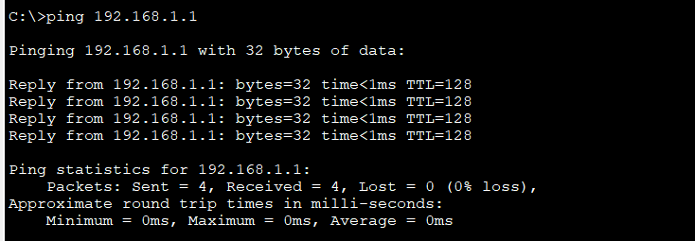

Figure 4.1: To check connection with the router
7: Save the Configuration
Finally, save all router and server settings to make sure the configuration remains active even after a restart.

4.4 Summary
This simple configuration ensures that all 30 user PCs, the admin PC, and both servers are properly connected within the café’s LAN. The router efficiently manages IP assignments and internet access through DHCP and NAT. The network is stable, easy to maintain, and secure, providing smooth internet access and management for both customers and administrators.

5. Testing and Validation
After completing the configuration of all devices in the Internet café network, testing and validation were carried out to ensure that the network works properly. The goal of this phase is to verify that every device is connected, the router is functioning correctly, DHCP is assigning IP addresses, and all users can access the billing system and services within the café network.

5.1 Connectivity Testing
The first step was to check the local network connectivity. This was done using the ping command from different devices such as the Admin PC and user PCs.
- From PC1, the command ping 192.168.1.1 was used to test the connection to the router.
The ping replies confirmed that PC1 is properly connected to the router through the switches.
- The same test was performed from the Admin PC (192.168.1.2) using ping 192.168.1.1.
The successful response confirmed that the admin system could also communicate with the router.
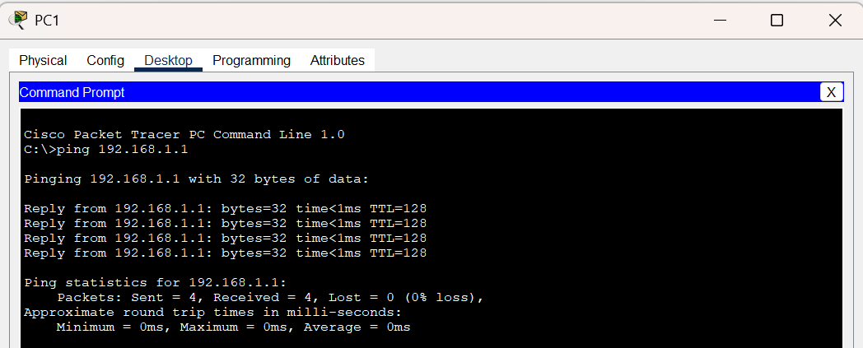
- A test was also done between two user PCs (for example, PC1 to PC2) using their assigned IPs (e.g., ping 192.168.1.4).

Figure 5.1: From PC1 Test the Connection to the Router

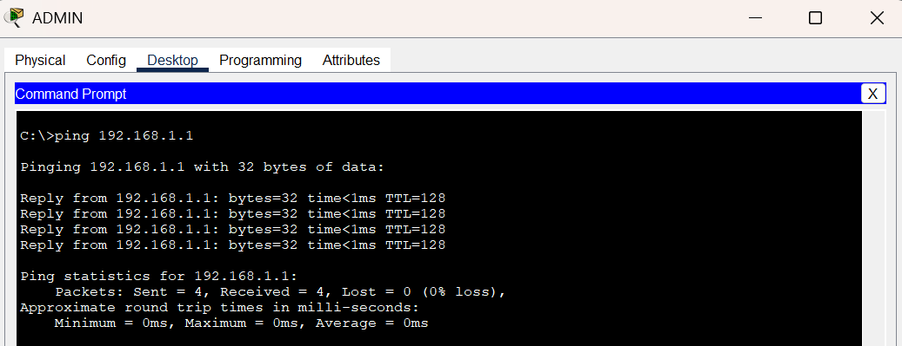

Figure 5.2: From Admin PC Test the Connection to Router

5.2 Dynamic Website for Billing and PC Status

A dynamic website was developed and deployed within the network to manage PC status and billing in real time. This website was designed using HTML, CSS, and JavaScript.
The website allows the café administrator to:
- View the status of all PCs (occupied, free, or in use).
- Add new customer sessions and log out users when their time is completed.
- Automatically calculate billing amounts based on the user’s total usage time.
- Display all active users and maintain a history of billing records.

Each client PC is connected to the web server through the LAN, allowing both the admin and customers to interact with the system through a web browser. The website’s simple and responsive design ensures that the billing process is quick and easy to manage.

5.3 DHCP Validation
To verify that DHCP was working correctly:

- Each user PC was configured to obtain an IP address automatically.
- The router assigned IP addresses in the range 192.168.1.3 – 192.168.1.33.

5.4 Server Validation

- The Billing Server (192.168.1.10) and the Web Filtering System were tested next.

- From the Admin PC, a ping to 192.168.1.10 confirmed that the server was active on the network.

- The web-based billing software was opened from a browser and used to log in to customer sessions and calculate time-based charges.
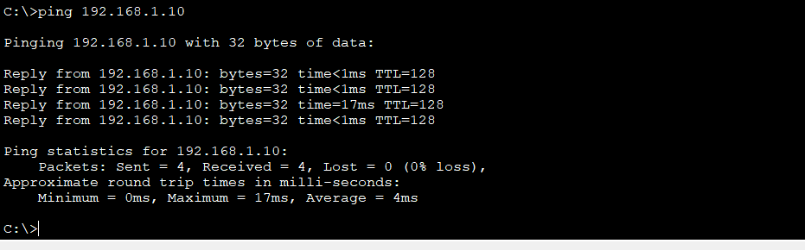

Figure 5.3: Server Validation

5.5 Router Verification
The router configuration was also verified using the following commands on the router console:

show ip interface brief
show ip route

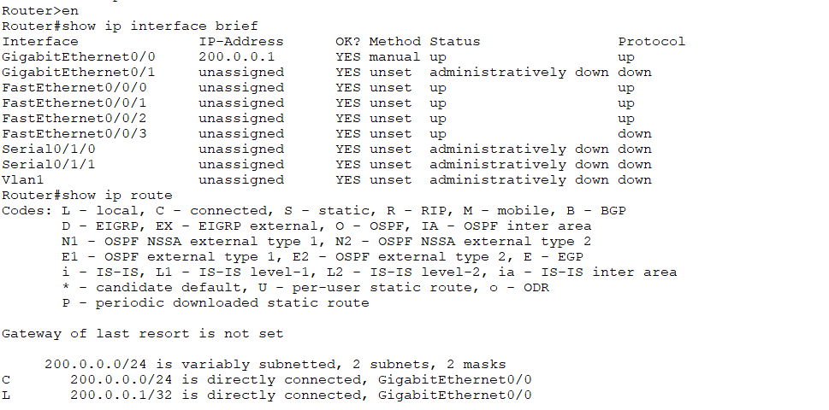

Figure 5.4: Router Verification

5.6 Final Network Validation
After testing all components, the overall network performance was validated using multiple client PCs.
The dynamic website for billing and PC management worked efficiently.
The network provided smooth and stable connectivity for all users simultaneously.

6. Results and Evaluation
A dynamic website was developed and hosted on Server0 (IP address: 192.168.1.1) to manage the Internet Café’s PC status and billing system. The website was created using HTML, CSS, and JavaScript, and was successfully tested within the local network.
The website allows the administrator to:
- Monitor the status of each PC (whether it is free, in use, or occupied).
- Add and log out users as they start and end their sessions.
- Automatically calculate billing amounts based on the total usage time.
- View real-time updates of all active PCs and customers.
- Access billing history for previous sessions.
During testing, the website worked perfectly when accessed from any client PC in the network using the browser and typing:
http://192.168.1.1
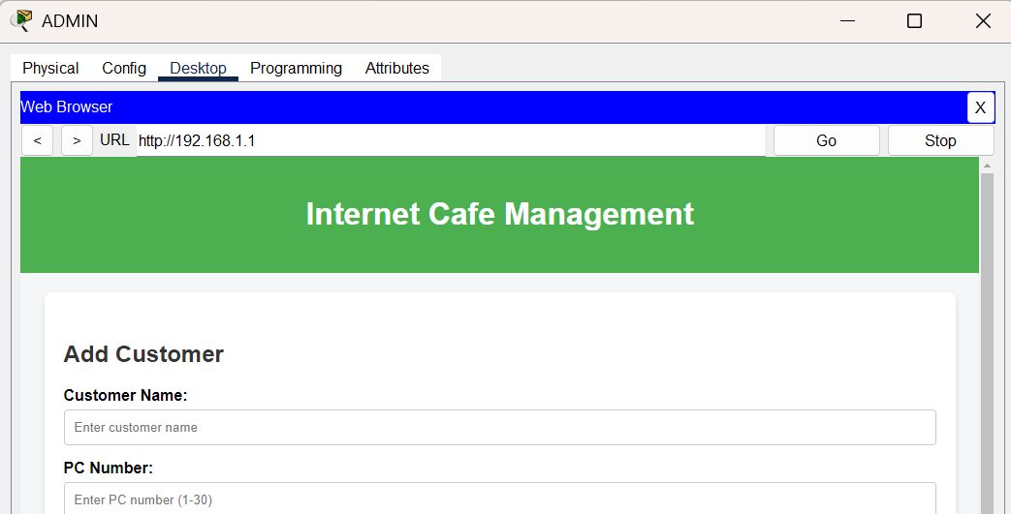
Figure 6.1: Add Customer to PC
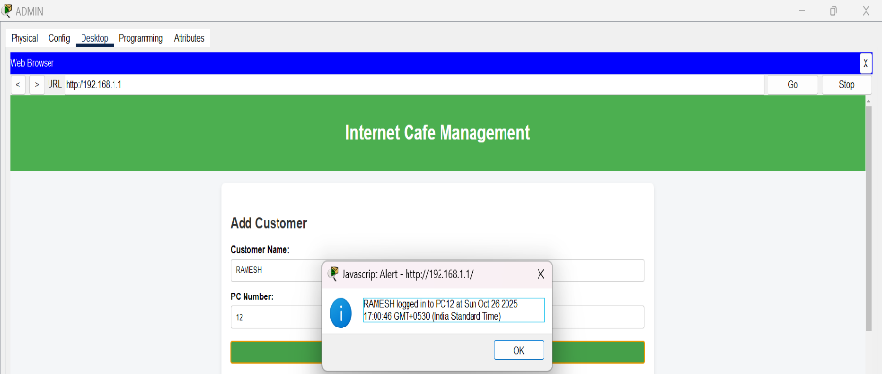

Figure 6.2: Login into PC
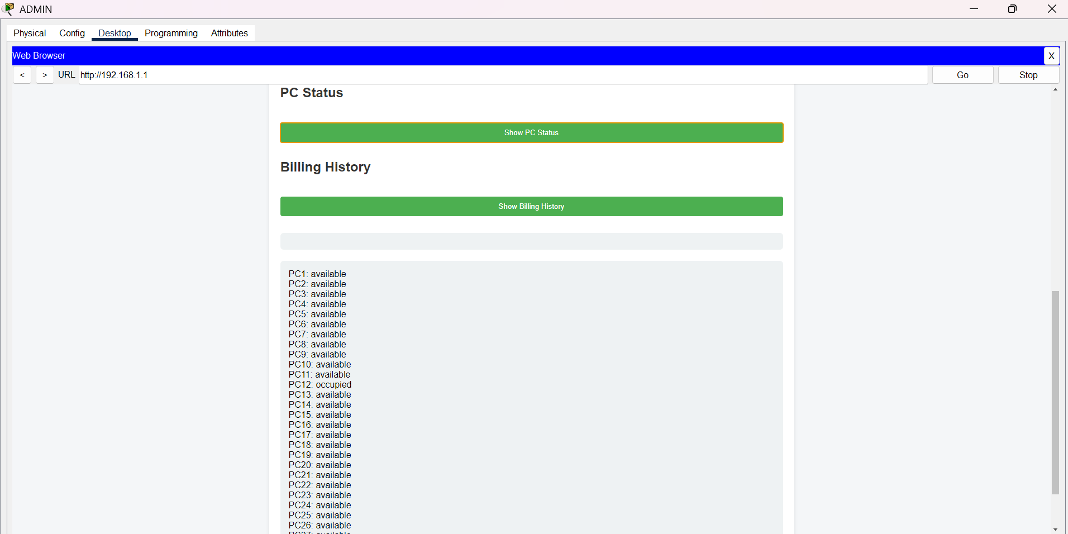
Figure 6.3: PC Status
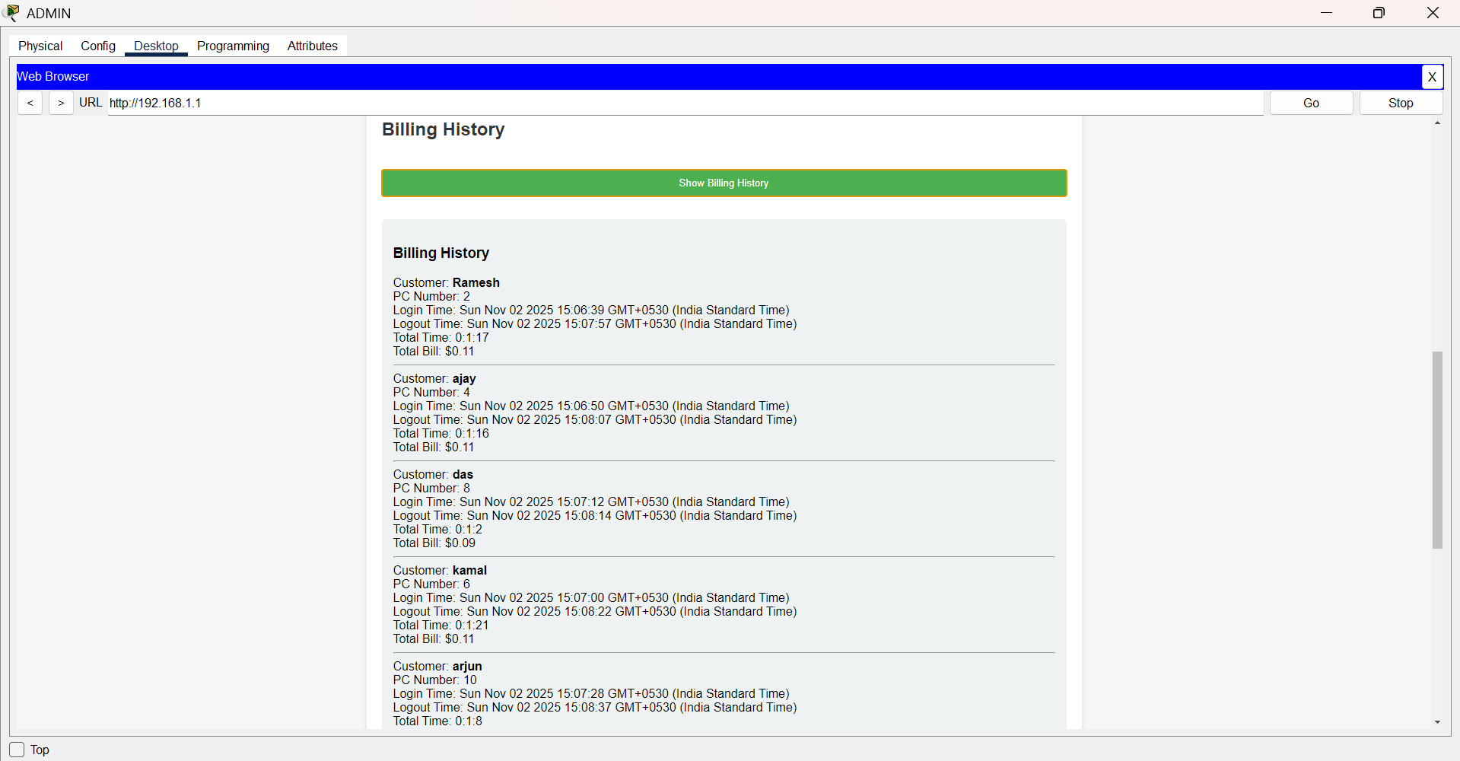

Figure 6.4: Billing Method
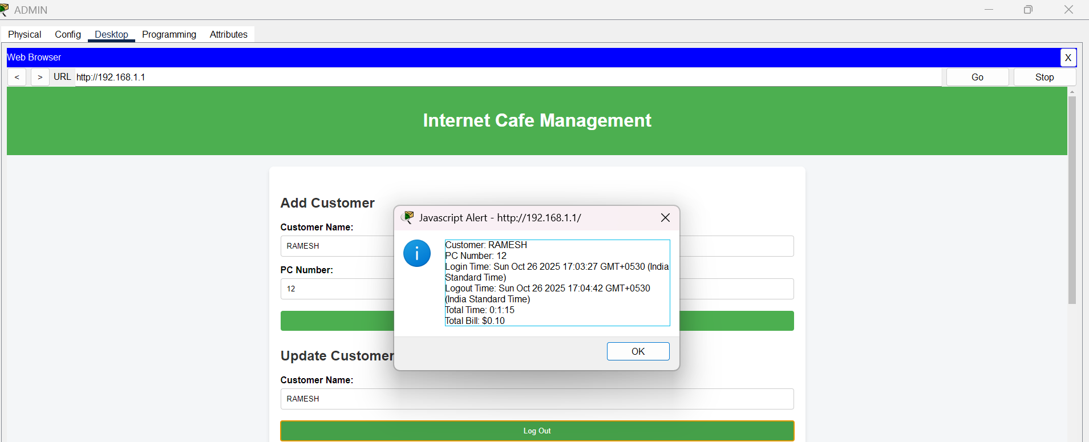
The website loaded quickly and accurately displayed all information, confirming that the local web server on Server0 was functioning properly. The interface was clean, responsive, and easy to use, making management tasks simpler for the admin.
Figure 6.5: Billing History
7. Conclusion
The Internet Café network was successfully designed, configured, and tested to meet the café’s operational needs. The network allows around 30 users to share a single ADSL internet connection efficiently while maintaining smooth connectivity and secure browsing.
All devices including the router, switches, server, and client PCs worked together without issues. The router managed IP addressing through DHCP, provided internet access using NAT, and ensured reliable communication across the entire LAN.
A dynamic website, hosted on Server0 (192.168.1.1) and developed using HTML, CSS, and JavaScript, was also implemented to handle PC monitoring and billing. This system allowed the administrator to easily view PC status, manage user sessions, and generate bills automatically. It simplified the management process and made daily operations more organized and efficient.
Testing confirmed that the network performed well, with stable connections, fast response times, and accurate billing. The design is scalable, meaning more PCs or devices can be added in the future with minimal changes.

8.REFERENCES
1. Geeks for Geeks, DHCP Server Configuration in Cisco Packet Tracer, Retrieved from https://www.geeksforgeeks.org/dhcp-server-configuration-in-cisco/
2. Cisco Systems, Inc. (2021). Cisco Packet Tracer. Retrieved from https://www.netacad.com/courses/packet-tracer
3. Kaur, G., & Shukla, V. (2017). A Network Design Proposal for an Internet Cafe. International Journal of Computer Science and Mobile Computing, 6(8), 239-246.

8.Appendices
Abbreviation | Full Form
WAN | Wide Area Network
LAN | Local Area Network
IP | Internet Protocol
CLI | Command Line Interface
PPP | Point-to-Point Protocol
OSI | Open Systems Interconnection
PC | Personal Computer
ISP | Internet Service Provider
MAC | Media Access Control
PDU | Protocol Data Unit
DHCP | Dynamic Host Configuration Protocol
NAT | Network Address Translation
GUI | Graphical User Interface
HTTP | Hypertext Transfer Protocol
HTTPS | Hypertext Transfer Protocol Secure
DNS | Domain Name System
SMTP | Simple Mail Transfer Protocol
FTP | File Transfer Protocol

