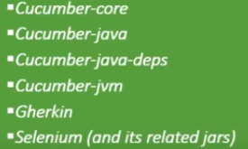

testng

selenium-java

cucumber-java

cucumber-jvm-deps

junit

cucumber-testng

Cucumber-jvm

Install plug-in in intellij IDE (Ctrl + Alt +S )



Every feature file has code behind file

Add cucumber-java dependency to pom.xml file. It will auto import all the feature files

Write sample login.feature file

Ctrl + Shift + A 🡪 to increase font size

Alt + Enter 🡪 to auto implement the step definition file



Run debug config

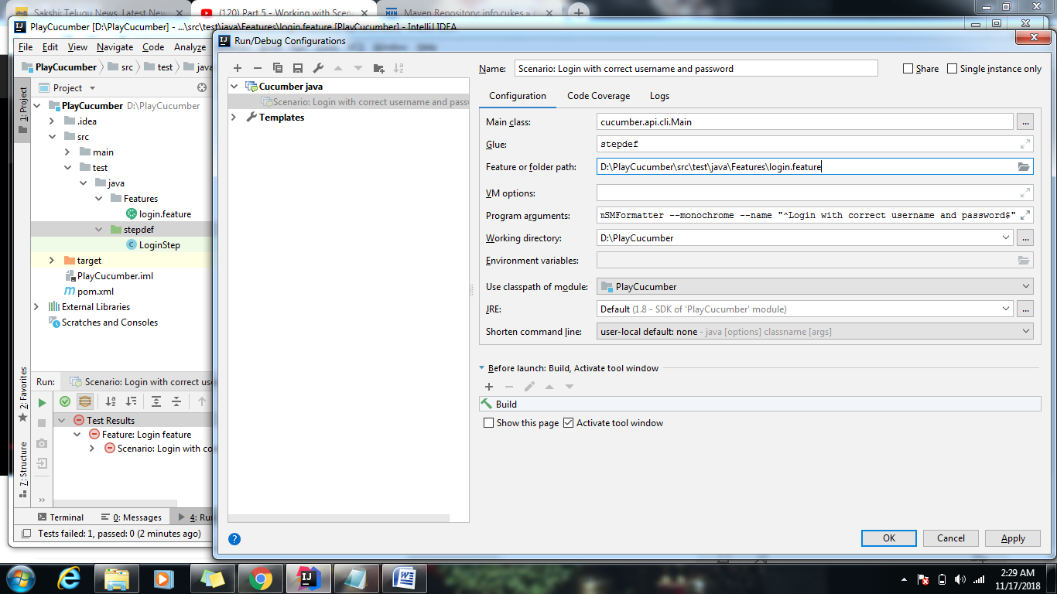

Feature file with Parameter

**Feature:** Login feature  
 deals to with login functionality  
  
 **Scenario:** Login with correct username and password  
 **Given** i navigate to login page  
 **And** i enter username as “admin” and password as “admin”  
 **And** i click on login  
 **Then** i should see the userform page

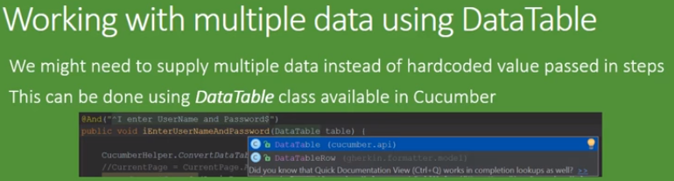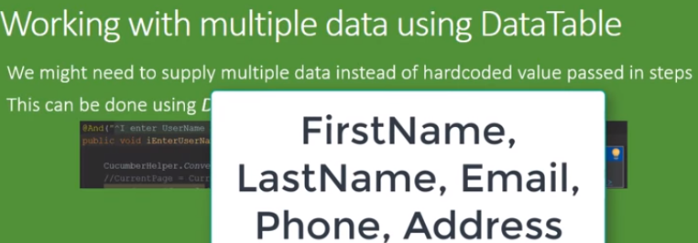

Data-Tables

