Scenario: Login to site

Given I navigate to Google sign page

And I enter username and Password

|Username| Password|

|admin | password|

And I click Login Button

Then I should see the userdetails page

Ctrl + Alt + L - index correction

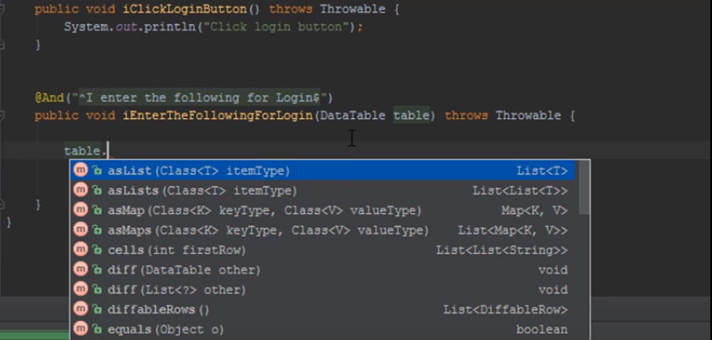

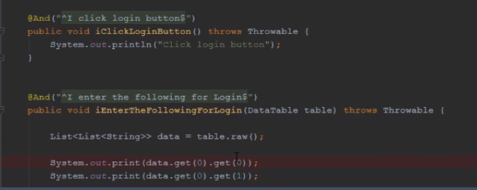

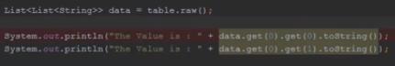



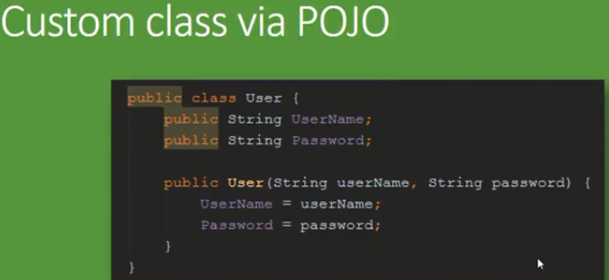

Alt + insert 🡪 To create setters and getters

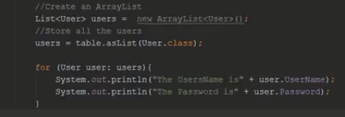



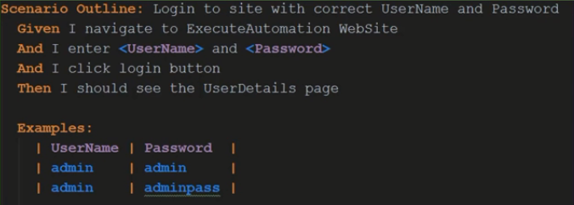

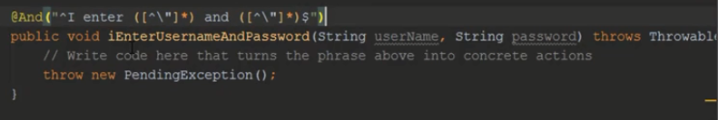

In order to execute scenario’s multiple times we can use scenario outline

**Cucumber hooks**

@Before

@After

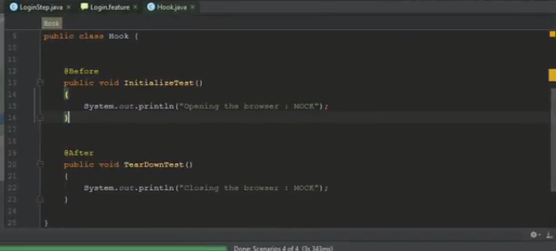

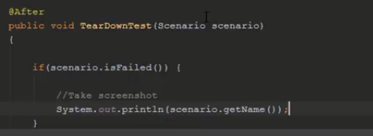

Dependency injection



