Typescript is the typed superset of JavaScript that compiles to javascript

Why typescript rather than JavaScript

1) Typescript as its name adds types enforcement which JS wont

2) Typescript has much neat easy to maintain

3) Typescript has cross-plat form support

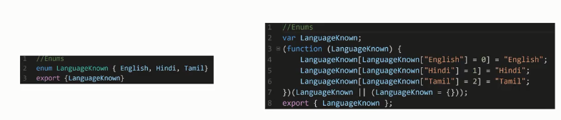

where we can use Typescript

AngularJS, Protractor, jasmine, webdriverIO

download and install node.js , visual studio code

Visual studio code configration

launch.json , task.json , tsconfig.json

install

npm install -g typescript

compile

tsc helloworld.ts

install vscode-icons in visual studio code extensions

create Helloworld.ts file then press F5 key it will create launch.json file

launch.json file

{

// Use IntelliSense to learn about possible attributes.

// Hover to view descriptions of existing attributes.

// For more information, visit: https://go.microsoft.com/fwlink/?linkid=830387

"version": "0.2.0",

"configurations": [

{

"type": "node",

"request": "launch",

"name": "Launch Program",

"program": "${workspaceFolder}/Helloworld.ts",

"outFiles": [

"${workspaceFolder}/\*\*/\*.js"

]

}

]

}

Types

Number , String , Boolean , Any , void , Null

Enum allow us to define a set of named numeric constants . An enum can be defined using enum keyword

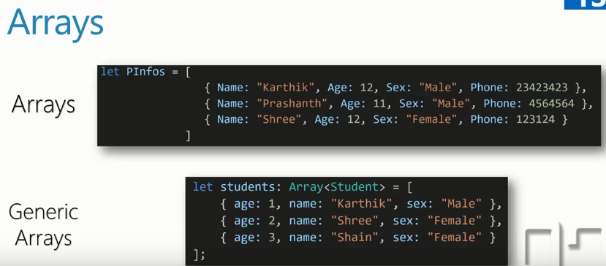

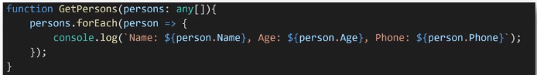

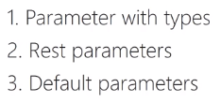

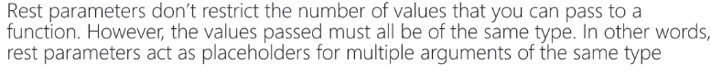

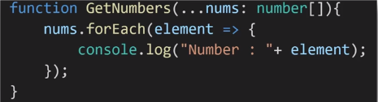

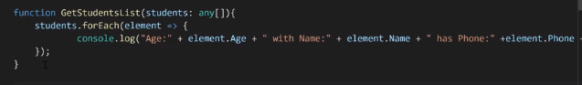

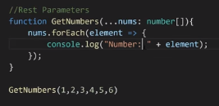

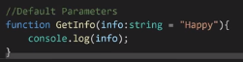



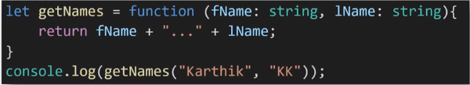

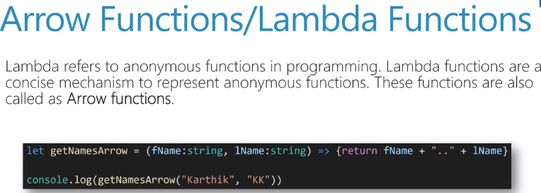

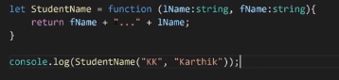

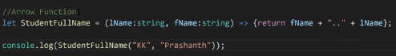

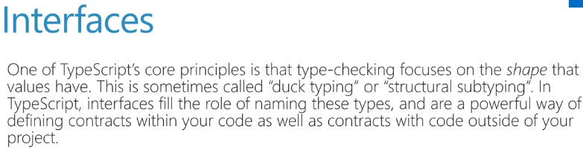

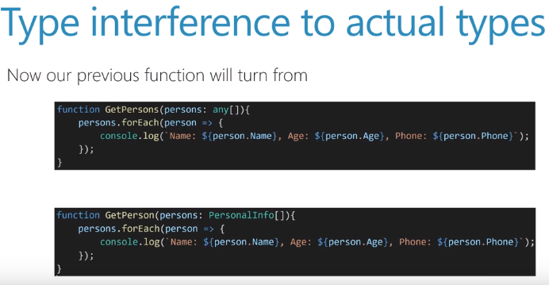

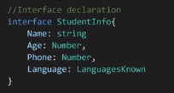

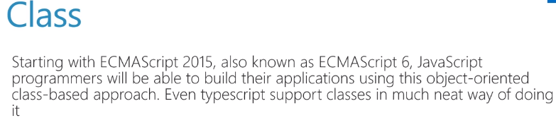

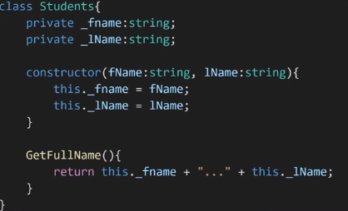

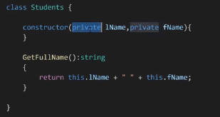



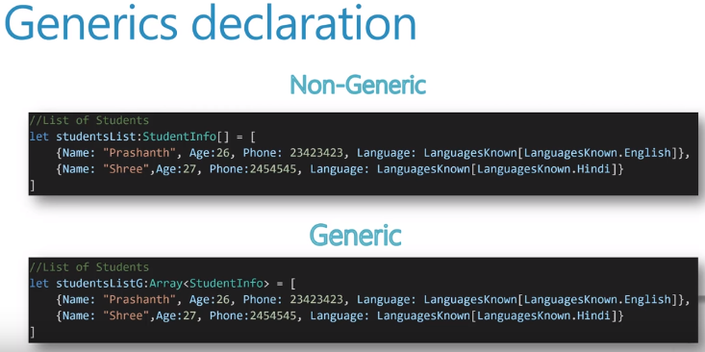

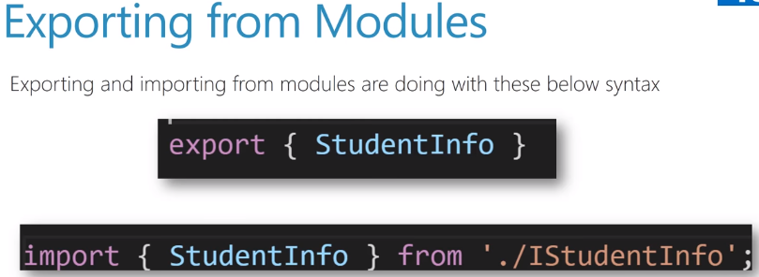

Tsc –target es6 helloworld.ts

Node helloworld.js







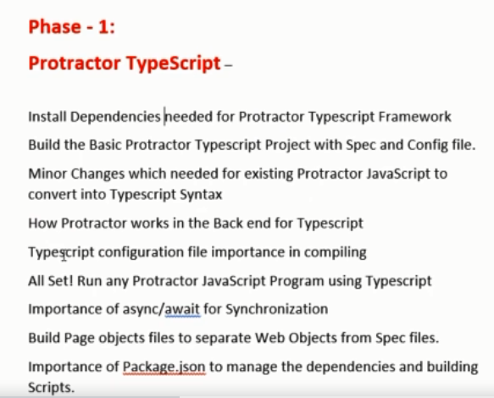

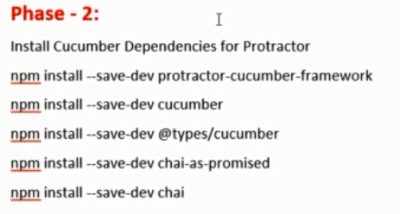

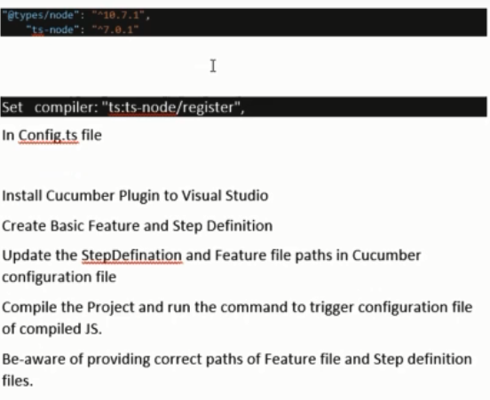

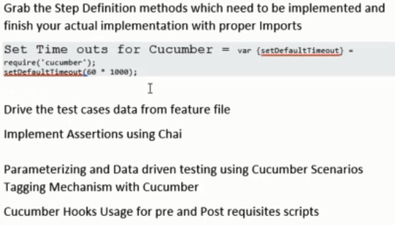

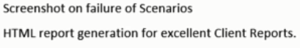

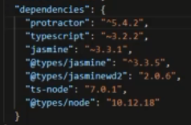

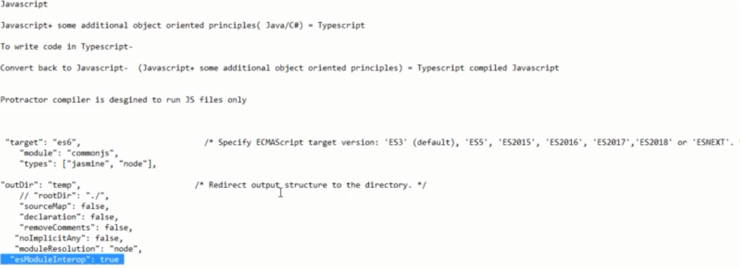

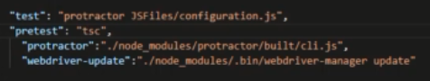

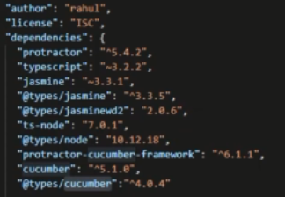

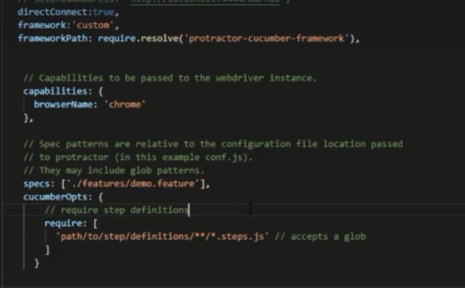

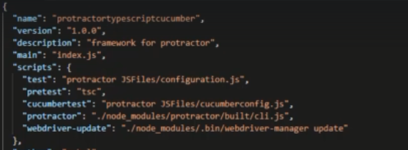

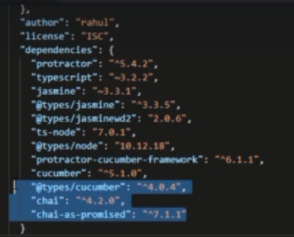

https://www.chaijs.com/

<https://github.com/cucumber/cucumber-js/blob/master/docs/support_files/hooks.md>

cucumber-html-report

