RETAIL CALCULUS
Enterprise Cloud Software Suite for Furniture, Appliance, & Big-Ticket Retailers
Complete Website and Product Documentation

Version 1.0 | Compiled from Local Source Assets
Co-Founded by Edward L Rennemann & Jaikishen Koranchath
https://retailcalculus.com

Table of Contents
Select a page from the list below to navigate directly to its section:
Homepage — Web Content (index.html)
Platform Specifications — Web Content (platform.html)
Customer Stories — Web Content (customer-stories.html)
Book a Demo — Web Content (book-demo.html)
Contact Us — Web Content (contact.html)

Homepage

Figure: Website Image Asset
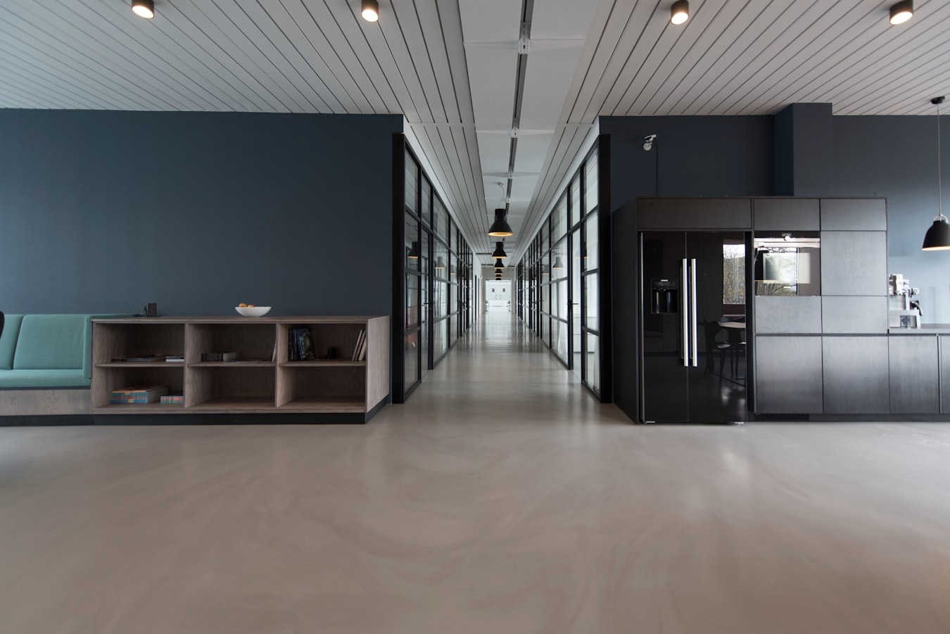
Figure: Modern Office
Retail Calculus helps multi-location retailers turn fragmented data into clear insights—so teams can optimize inventory, improve sales performance, and act faster.
Trusted by high-ticket retail leaders

Figure: American Sale Logo

Empowering Retailers for the Digital Age
We bolt onto your existing legacy systems to reduce risk, or replace them entirely. The choice is yours.

The Mission
Revitalize traditional furniture and big-ticket retailers by modernizing the shopping experience for customers and sales associates alike.

The Approach
Cloud-hosted, subscription-based microservices. We reduce implementation effort, risk, and cost by integrating with your current stack.

Value Prop
Retail Calculus provides the structure and tools to enable digital transformation, allowing you to compete with today's digital giants.

Orientation
Calibrated for professional, personalized selling. Perfect for furniture, appliances, and complex configurable products.

Technology
Built from scratch using open-source technologies on AWS. Secure, scalable, and designed for the modern web.

Proven Success in High-Ticket Retail
See how top-tier multi-location brands solve inventory bottlenecking and sales order complexity with our cloud microservices.

Figure: American Sale

Unified Inventory & Sales: How American Sale Modernized Pool & Patio Operations
By integrating Retail Calculus **Product Explorer** and **Prime PIM**, high-ticket recreation retailer American Sale unlocked absolute real-time citable inventory visibility across multiple showrooms, directly accelerating in-store operations and transaction accuracy.
"Before Retail Calculus, configuring special-order patio sets across showrooms and checking purchase orders was a major bottleneck. Now, our associates complete error-free orders in under three minutes."

Leading the new era of retail
Decades of combined experience in retail technology and digital transformation.

Figure: Edward L Rennemann

Edward L Rennemann
Former Chief Transformation Officer at Crate and Barrel

Figure: Jaikishen Koranchath

Jaikishen Koranchath
CEO of ndVOR Solutions, an INC 5000 Company

Figure: Website Image Asset
Incorporated in 2016. Enterprise-grade microservices for the modern furniture retailer.

Company

Products
© 2016-2026 Retail Calculus LLC. All rights reserved.

Our Approach
Flexible Integration: Our solutions are architected to seamlessly integrate with your current technology stack.
Subscription-Based Model: Predictable monthly costs with no large upfront capital expenditures.
Reduced Risk: By bolting onto existing systems rather than replacing them, you minimize disruption.

Product Orientation
Big-Ticket Retail Expertise: Our solutions are purpose-built for furniture, appliances, mattresses, outdoor living, and other high-consideration purchases where customers benefit from expert guidance.
Professional Selling Tools: Empower your sales associates with tools that make them product experts and selling consultants, not just order takers.
Complex Product Management: Handle special orders, custom configurations, fabric and finish options, room packages, and protection plans with ease.
Delivery & Installation: Manage the complete customer journey including in-home delivery scheduling, white-glove service, and installation coordination.
Universal Application: While optimized for big-ticket retail, our flexible architecture adapts to any retail vertical that values comprehensive product information and customer service.

Technology
Microservices Architecture: Each component is independently deployable and scalable, ensuring maximum flexibility and reliability. Services communicate through secure RESTful APIs.
Open Source Foundation: Built on proven open-source technologies, avoiding vendor lock-in and ensuring long-term sustainability and community support.
AWS Cloud Infrastructure: Hosted on Amazon Web Services with enterprise-grade security, 99.9% uptime SLA, automatic backups, and disaster recovery capabilities.
Optimized User Experience: User interfaces are optimized for Google Chrome and Apple iPads, delivering a fast, responsive experience for in-store sales associates and back-office users.
API-First Design: Every function is accessible via secure APIs, enabling seamless integration with your existing systems, third-party applications, and future innovations.
Real-Time Data: All product information, inventory, and customer data is accessed in real-time, ensuring accuracy and consistency across all touchpoints.
Security & Compliance: Enterprise-grade security with role-based access control, data encryption at rest and in transit, and compliance with industry standards.
Scalable & Future-Proof: Architecture designed to scale with your business and adapt to emerging technologies including AI, machine learning, and advanced analytics.

Prime
- Prime manages all Product Information: Structured Data, Unstructured Data (Romantic Copy, Images and Documents), and Retails.
- Division → Department → Class → Subclass (Actually, nine hierarchy levels are allowed, only two levels are required)
- Collection → Item → SKU (Collection is optional)
- Inventory Sets and Selling Sets with set pricing and child sku price proration.
- Not Stocked and Not Sellable SKUs to support fees, fixtures, supplies...
- Lean fixed Structured Data. Unlimited User Defined Data (UDD) configured at any level in the product hierarchy. Fifteen UDD data types.
- Data Cloning throughout the Prime.
- Rules based distribution of Product Information to legacy and third-party systems. All Retail Calculus applications access Product Information in real-time using secure APIs.

Product Explorer
In-Store Web Site - Has every capability that best-in-class eCommerce sites have but delivers all the SKUs and Product Information that you want Sales Associates to see including detailed and drillable product and purchase order availability. Detailed product status.
- Uses familiar eCommerce site conventions. Easy to learn and understand.
- Fine tuned for Sales Associates to allow them to focus on the customer and selling.
- Rich information which can include videos helps to make the Sales Associate "The Product Expert."
Made to Order - Guided customer special order creation from Stock Plus to full Custom. Generates purchase order ready SKUs. Configured in Prime and executed in Product Explorer with APIs available for third-party applications.
Sales Order Advisor - Guided Sale Orders Creation. Point and click. Product recommendations and add-ons. Tiered package pricings. Discounts prorated across all products. Configured in Prime and executed in Product Explorer with APIs available for third-party applications.
Cloud Cart - More than a cart. Has all the functionality needed to support Big Ticket Order Entry:
- Customer bill-to and ship-to. Both spouse's/partner's names and contact information.
- Quotes and leads management.
- Supports all delivery methods including Take With, Shipped, Drop Shipped and In-Home Delivery.
- In-Home Delivery booking.
- Support for multiple financing options. Automatic calculation of payments.
- If configured, automatic pricing adjustment for cash payments on select products.
- Automatic calculation of Sale Tax. Support for all US States.
- Special Allowance including Make the Total Equal function.
- Automatic calculation of minimum deposit based on product type and delivery method.
- Automatic calculation of customer savings.
Emailed, visually modern invoice with product pictures.

Platform Specifications
A modular suite of microservices. Use one, or use them all to modernize your entire stack without the technical debt.

Prime PIM
The single source of truth. Handles structured and unstructured data, images, documents, and complex hierarchy logic specifically engineered for furniture retail.
- Manage Division → Department → Class → Subclass hierarchies
- Inventory Sets and Selling Sets with pricing logic
- Unlimited User Defined Data (UDD)
- Real-time API distribution to legacy systems
[Video Demonstration Placeholder]
Embed URL: https://www.youtube.com/embed/LXb3EKWsInQ?si=Rel=0
Title: Prime PIM Demo

Product Explorer
An in-store website designed for sales associates. Turn your team into product experts with guided selling tools that close deals faster.
- Guided special order creation (Stock Plus to Custom)
- Sales Order Advisor with tiered package pricing
- Cloud Cart: Rapid big-ticket order entry
- Automatic calculation of taxes, financing, and delivery fees
[Video Demonstration Placeholder]
Embed URL: https://www.youtube.com/embed/5qap5aO4i9A?si=Rel=0
Title: Product Explorer Demo

Optimus
True omnichannel inventory availability. Stop selling what you don't have and start fulfilling from the best locations.
- Supports Hunt Path availability logic
- Rules-Based reservations system
- Real-time sync across web and store channels
[Video Demonstration Placeholder]
Embed URL: https://www.youtube.com/embed/tFq6Q_muwG0?si=Rel=0
Title: Optimus Demo

Flexible Deployment & Security
Enterprise-grade architecture designed for scale, security, and developer freedom.

Deploy in Retail Cloud
Retail Calculus Cloud is a SaaS product operated and maintained by us. Customers receive continuous code updates and it can be deployed in AWS and multi-region.

Deploy Self-hosted
Self-hosted uses the same codebase as our Cloud and is ideal for retailers needing enhanced security, governance, or control for data residency.

Integration
Open APIs and Declarative SDKs — connect to existing ERPs, POS systems, and 3rd-party logistics seamlessly.

Security and Trust
Trusted Platform — SOC 2 Type II compliant, inherited permissions, and role-based access control.

Accessibility
Inclusive Design — WCAG 2.1 compliant interfaces ensuring your entire workforce can operate the platform effectively.

Complete Retail Ecosystem
How our microservices connect your stores, warehouse, and digital channels.

Enterprise Retail Architecture – Retail Calculus
High-scale microservices architecture for large-format retail, supporting in-store associates, iPads, and desktop terminals.

ARK – Associate Entry Gateway
Centralized SSO for all in-store users and roles.
Angular responsive web app.
- Product Explorer (Selling Suite)
- Cart & Sale Order Advisor (USP)
- POS Submission
- HubSpot Integration
Enterprise Product Information Management.
- Structured & Unstructured Data
- Product & Its Hierarchy Management
- Pricing & Promotions
Delivery scheduling & fleet orchestration.
- Capacity & Routing
- Real-time Slot Reservation
Identity & Role-Based Access Control.
Single secure entry point for UI and devices.
Item, Cart, Pricing, and Order orchestration.
In-memory caching for low-latency sessions.
High-performance inventory availability & Delivery Scheduling logic.
Async processing and POS synchronization.

Technical Stack
A modern, modular stack built for reliability and speed.

Frontend
Angulars

Backend
Node.js & Golang

Storage
MySQL, Redis, S3

Async
RabbitMQ & Python

Security
CIAM & RBAC

Cloud
AWS Infrastructure
Incorporated in 2016. Enterprise-grade microservices for the modern furniture retailer.

Company

Products
© 2016-2026 Retail Calculus LLC. All rights reserved.

Customer Stories

Figure: RC Logo
From pools and patios to complex furniture configurations, discover how we help retailers modernize their stack with real-time data.

Figure: RC Logo

Unified Inventory & Sales: How American Sale Modernized Their Pool & Patio Operations.
By implementing Retail Calculus Product Explorer and Optimus, American Sale gained real-time visibility into complex inventory sets across multiple locations, streamlining their high-ticket sales process.

Eliminating Overselling: A High-End Furniture Retailer's Journey to 100% Inventory Accuracy.

From 30 Minutes to 3 Minutes: Accelerating Appliance Orders with Cloud Cart.

Connecting 50+ Showrooms: Real-time Data Sync for Seamless Omnichannel Retail.

Ready to modernize like American Sale?
See how Retail Calculus can optimize your operations with embedded AI and real-time data.
Incorporated in 2016. Enterprise-grade microservices for the modern furniture retailer.

Company

Products
© 2016-2026 Retail Calculus LLC. All rights reserved.

Book a Demo
Experience first-hand how our modular suites optimize inventory and multiply checkout speed.

When to take the demo?

June 2026

Meeting Location
Google Meet (Meeting link will be sent automatically)

Meeting Duration
30 mins session

What time works best?
Select a date to view available time slots.

Your information

Demo Scheduled Successfully!
We've sent a calendar invitation complete with the Google Meet link and dial-in details to your email address.
Jane Doe
Wednesday, June 3, 2026 at 10:00 AM
Google Meet video session
Incorporated in 2016. Enterprise-grade microservices for the modern furniture retailer.

Company

Products
© 2016-2026 Retail Calculus LLC. All rights reserved.

Contact Us
Ready to transform your retail operations? Fill out the form or reach us directly.

Let's Transform Your Retail Experience
Ready to modernize your retail operations? Contact us to learn how our solutions can help your business thrive.
Incorporated in 2016. Enterprise-grade microservices for the modern furniture retailer.

Company

Products
© 2016-2026 Retail Calculus LLC. All rights reserved.

