SKILL
2520090081
To Install Linux VM, Configure GCC, Setup Git Repository, Create Project Structure, Understand Shell Architecture, Build Initial Makefile To Analyze process abstraction, execute fork(), understand exec() family, analyze parent-child relationships, inspect process tree, practice system call tracing 1) Install Linux VM/WSL and Configure GCC a) Ubuntu installation, b) Terminal, c) Linux filesystem, d) GCC installation, e) Compiling and executing a C program
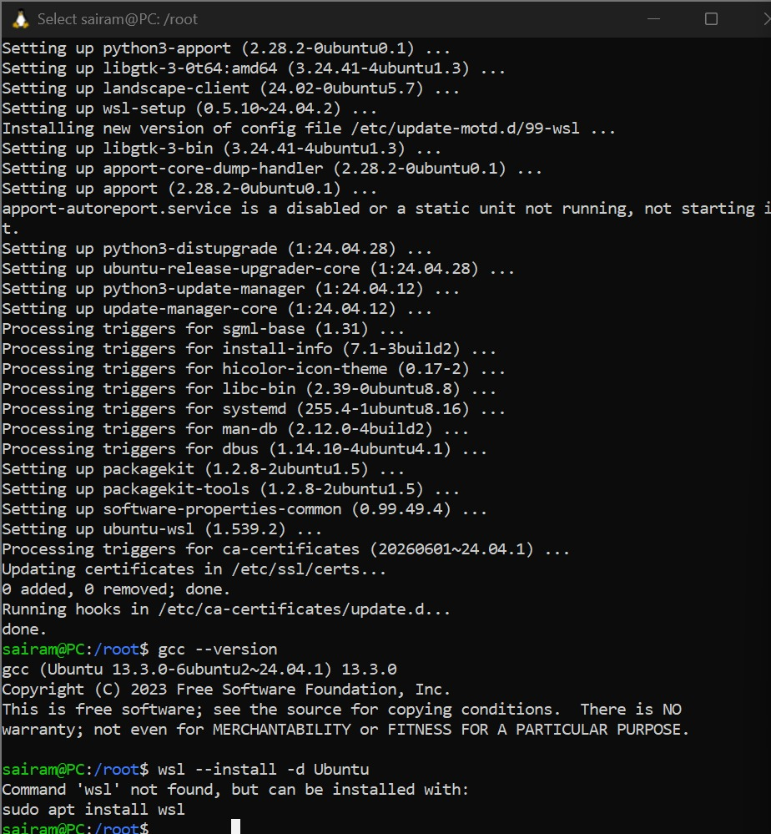
2. Linux Shell and Basic Commandsa) pwd, b) ls, c) cd, d) mkdir, e) rmdir, f) cp, g) mv, h) rm, i) cat, j) echo, k) find, l) history, m) shell usage
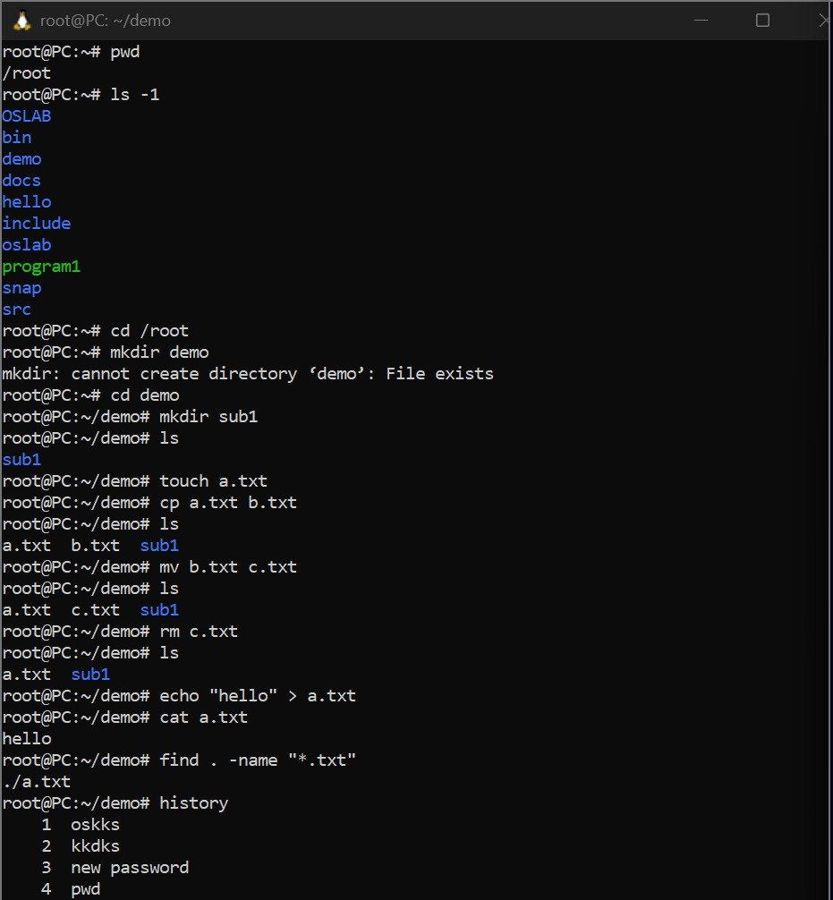
3. Git Repository and Project Structure - Git installation, git init, git add, git commit, git status, project directory organization (src, include, bin, docs)
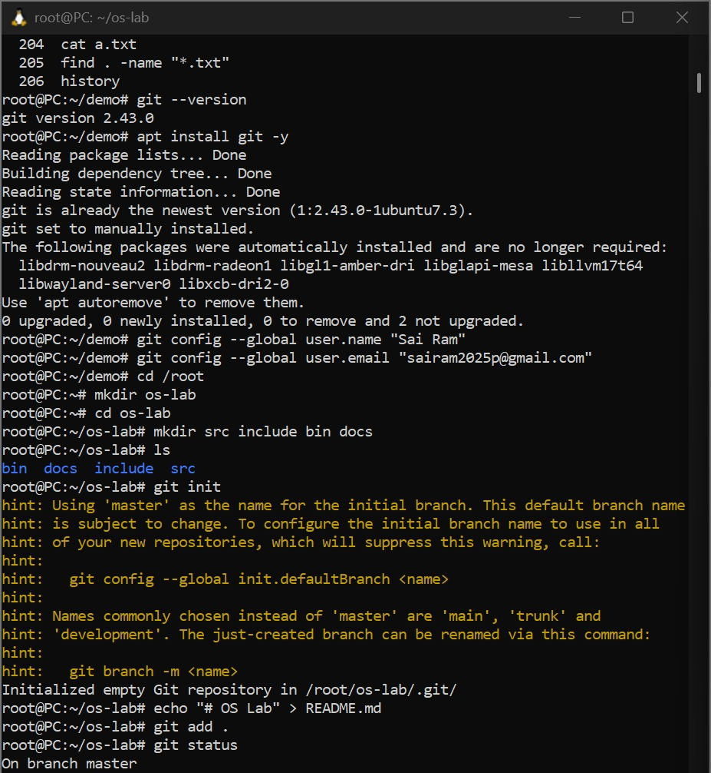

4. Shell Architecture and Makefile - User → Shell → Kernel → Hardware, Bash, process execution, writing a simple Makefile, using make

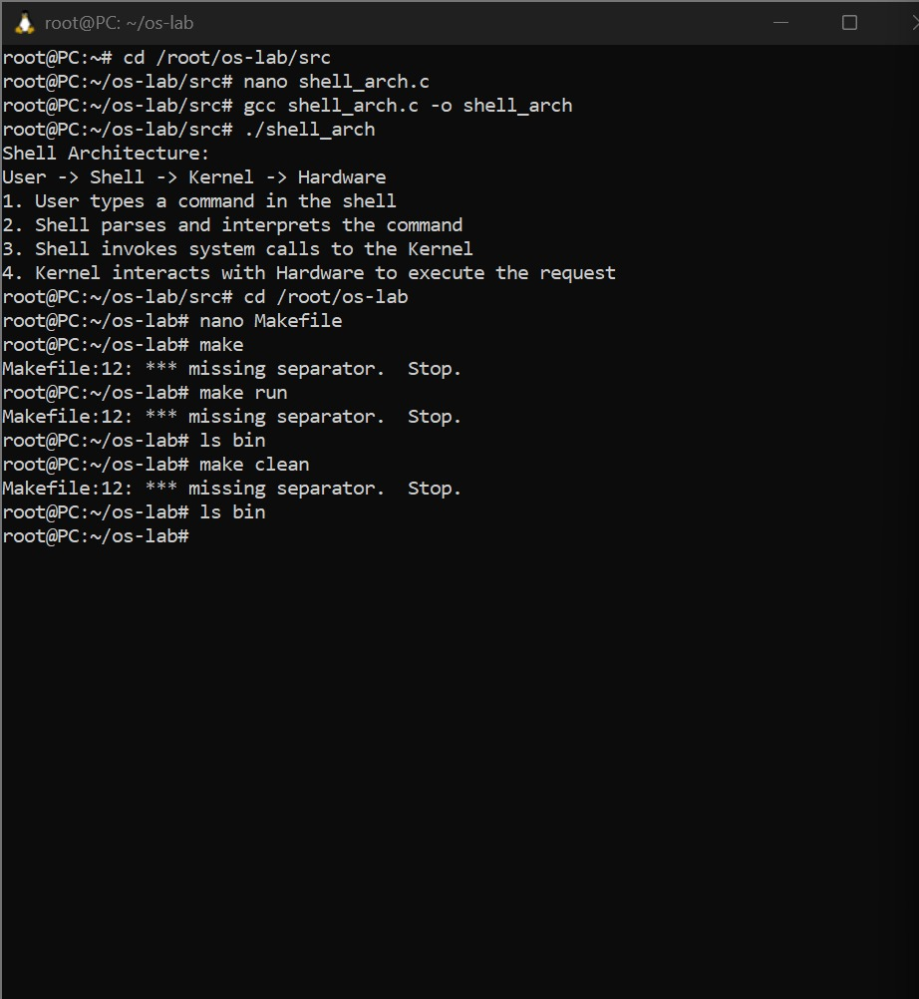
5. Process Creation using fork() - Process abstraction, fork(), parent and child processes, getpid(), getppid(), multiple fork() examples
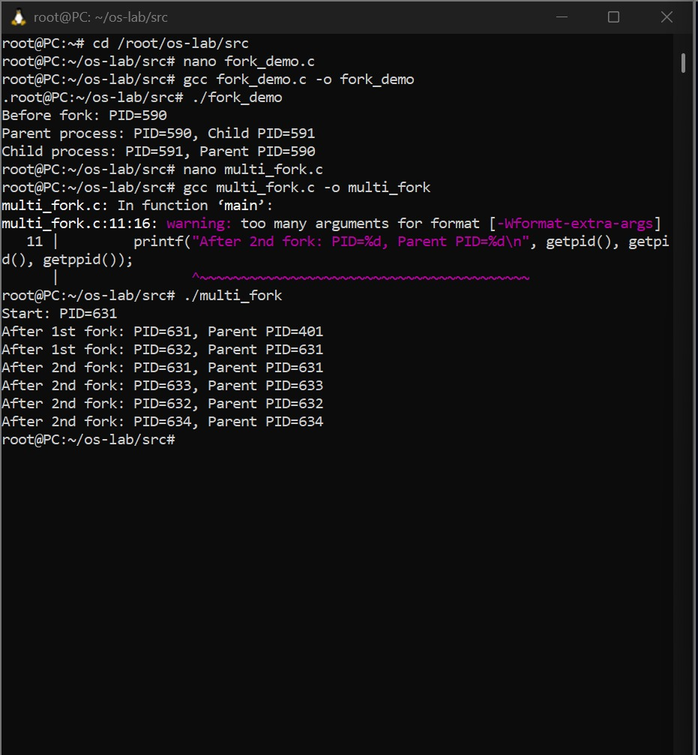

6. Process Replacement using the exec() Family- execl(), execv(), execvp(), replacing the current process, executing Linux commands from C
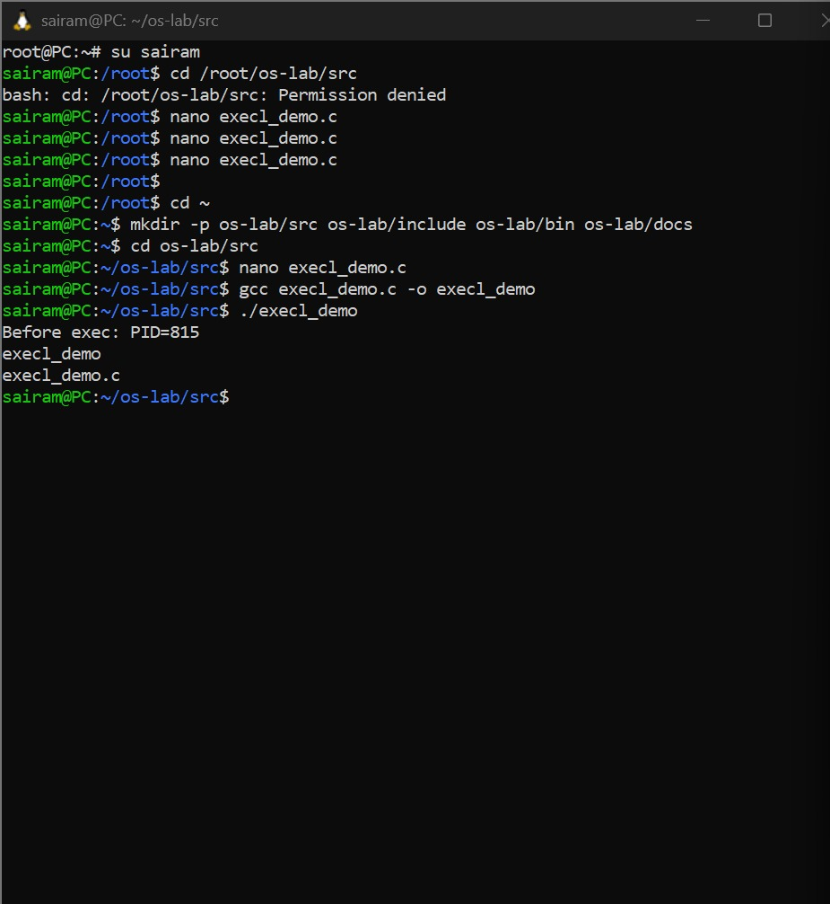

7. Parent–Child Synchronization using wait(), waitpid(), synchronization, process termination order
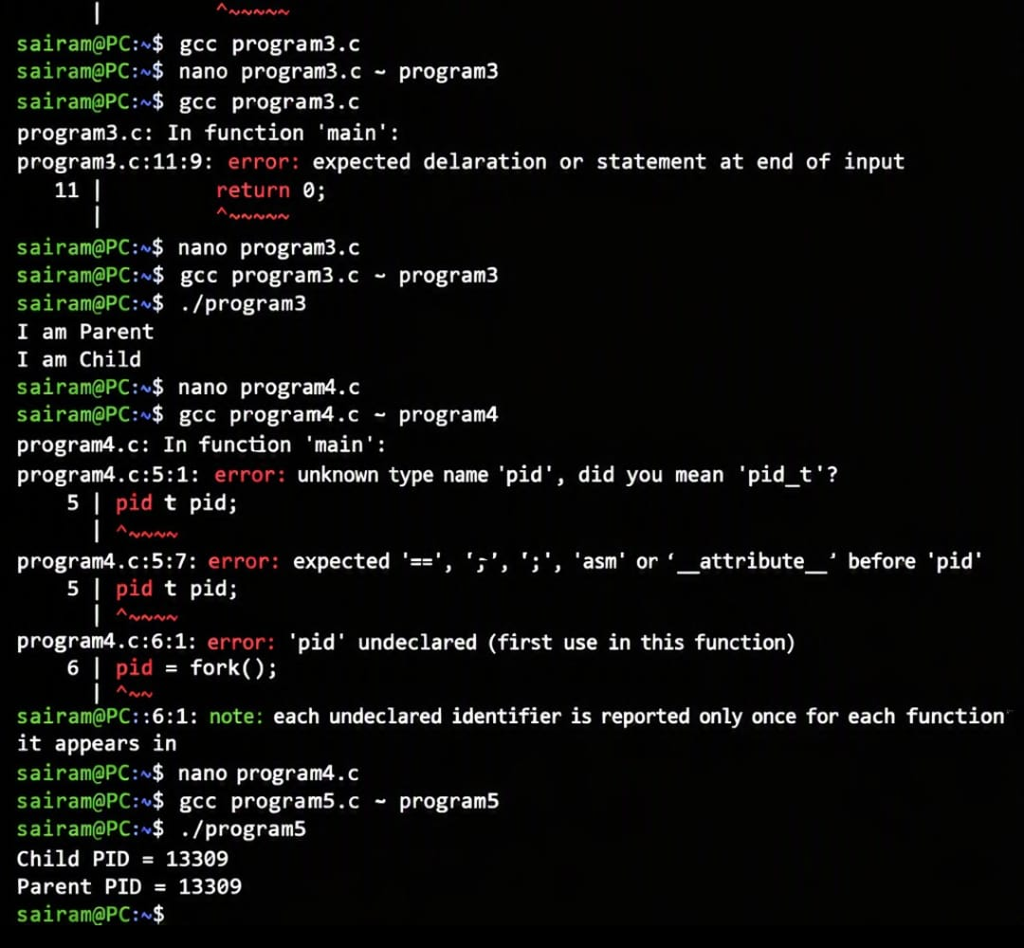

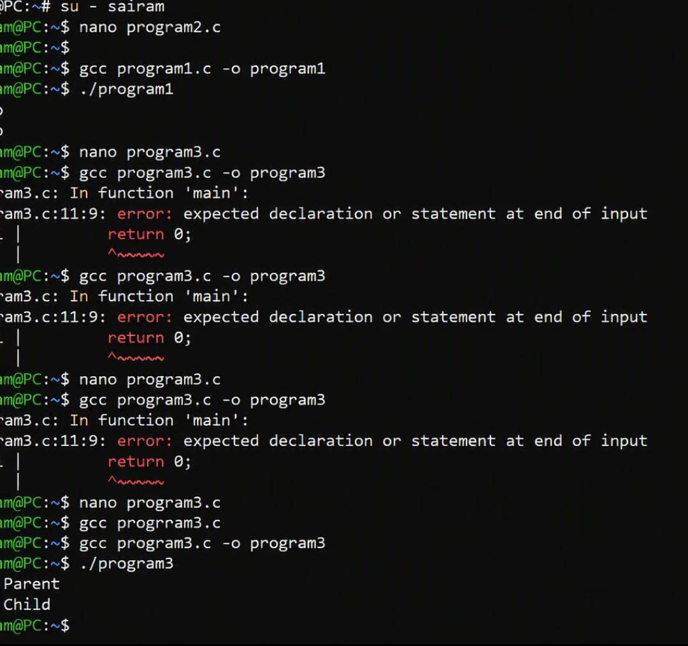

8. Process Tree Analysis- Multiple fork() calls, process hierarchy, pstree, ps, process IDs
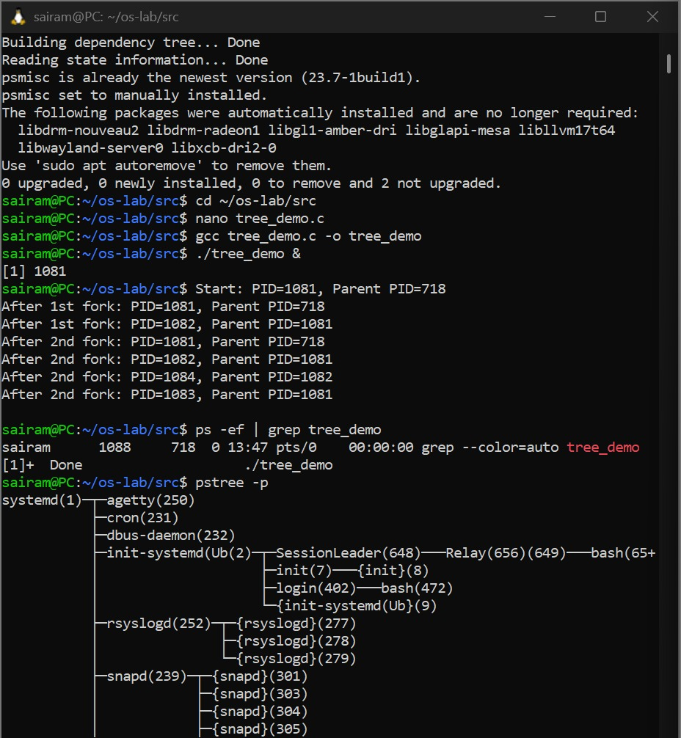

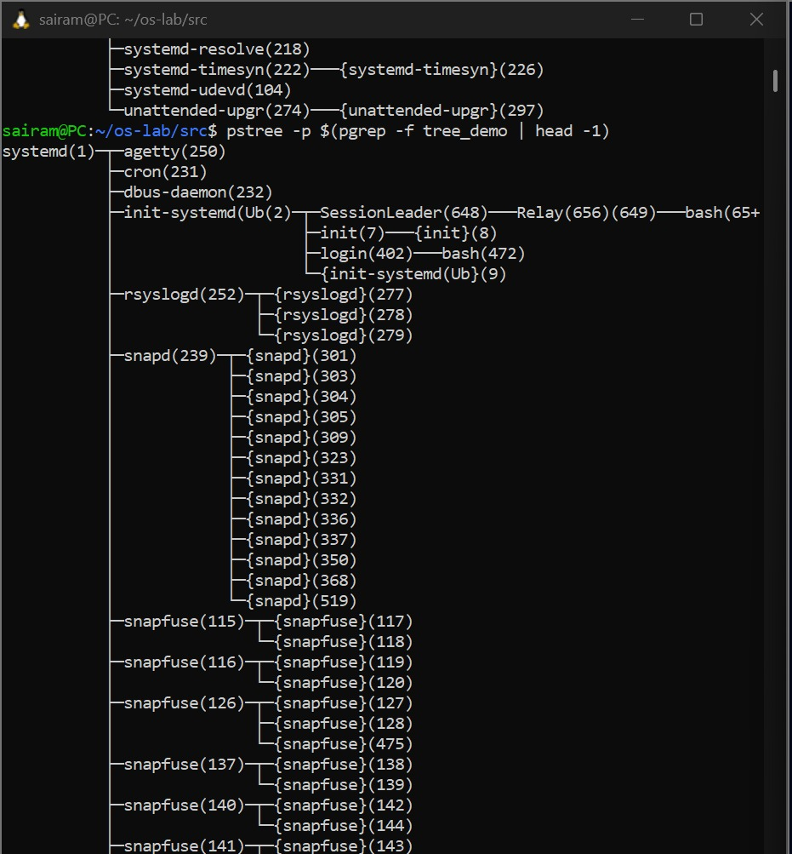

9. System Call Tracing - strace, tracing ls, pwd, date, observing execve(), open(), read(), write(), close()

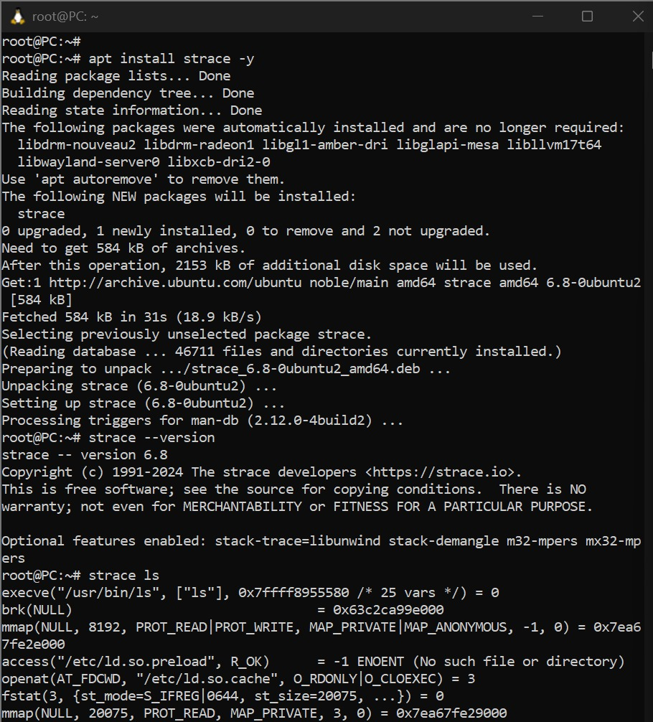

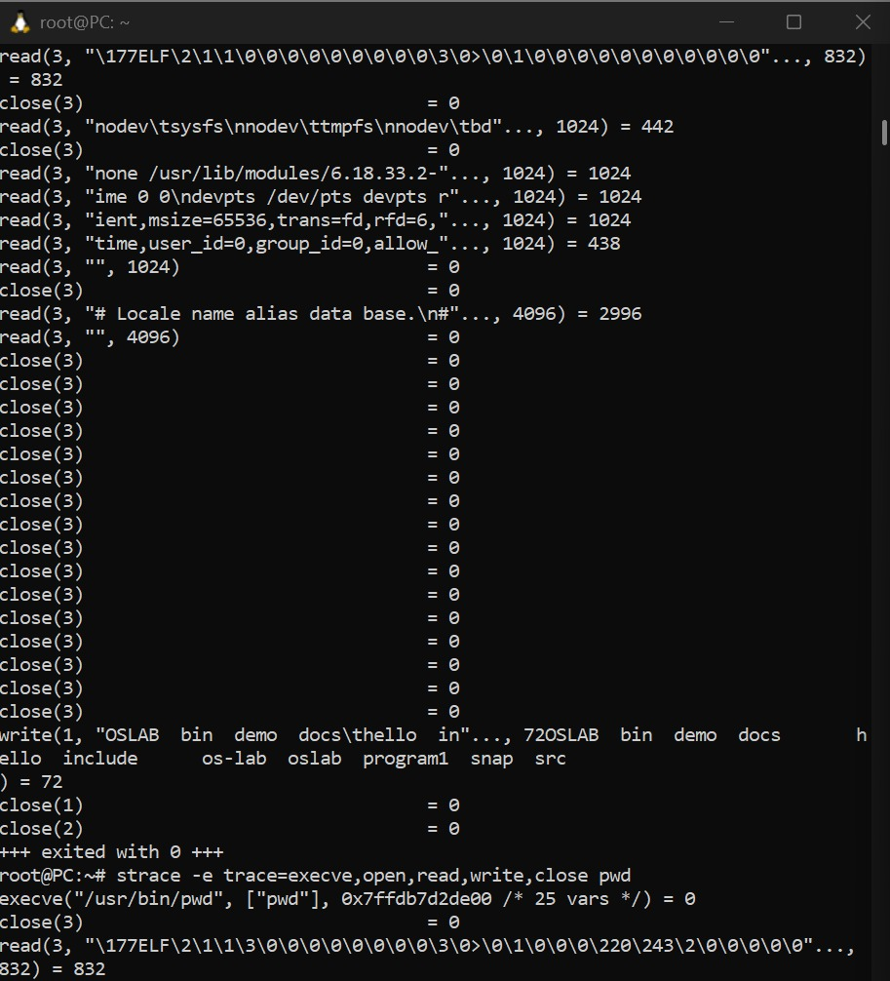
10.Mini Shell Program - Accept a command from the user, use fork(), exec(), and wait() to execute it, displaying parent and child PIDs
