Technologies : Spring Boot ,Junit(added junits)

Run Junit testcases (BillsServiceTest.java)

Insert bill details

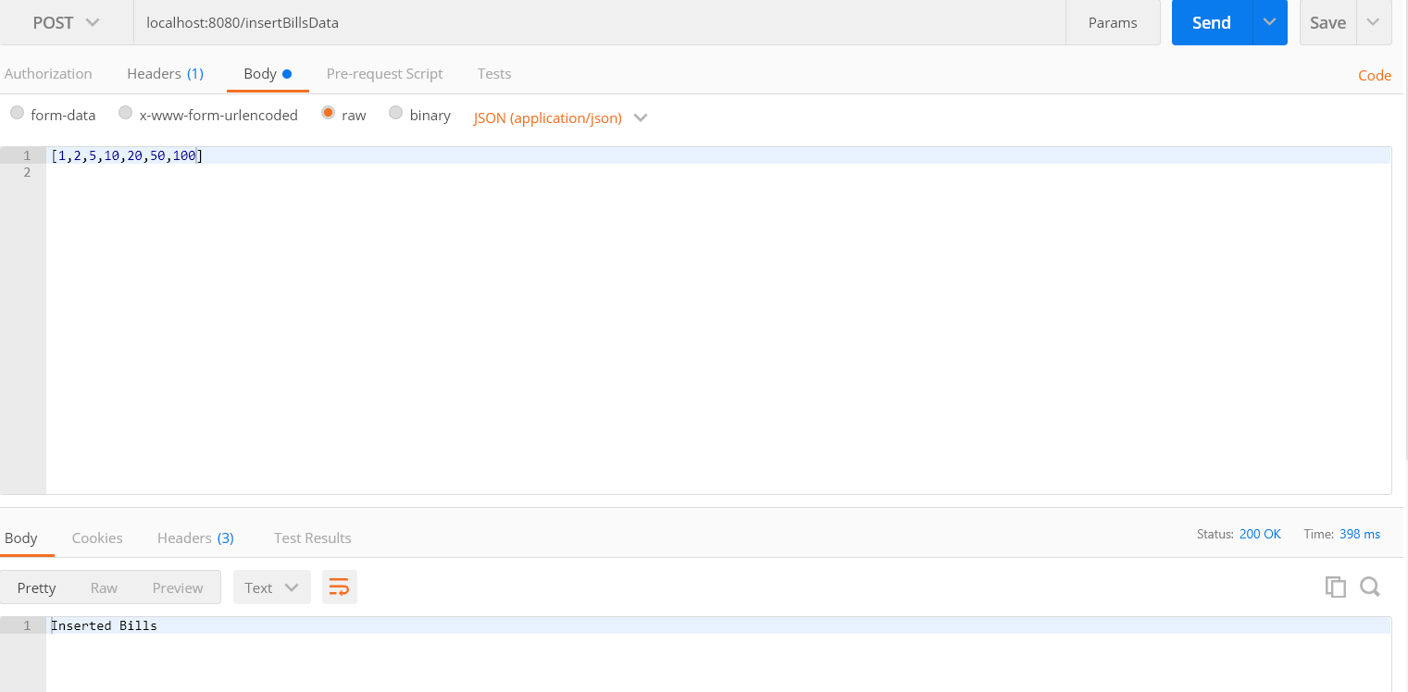

Insert coins and number of coins

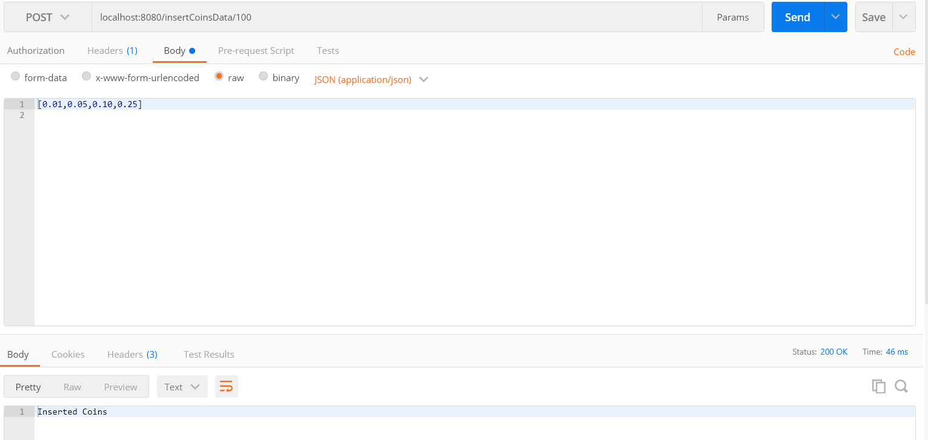

Invalid Bill Amount

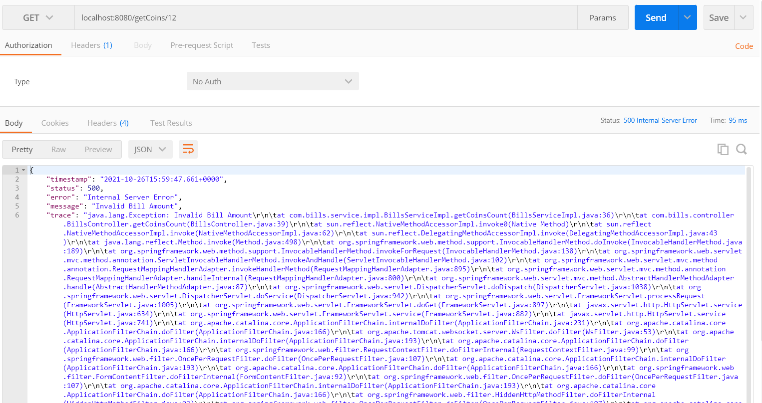

Valid Bill Amount

