Project_4
Sai Ram Vodnala, Bibek Adhikari
2025-05-04
#Installing required packages and loading libraries
# Install packages, if not already installed
packages <- c("tidyverse", "randomForest", "cluster", "mclust", "ggplot2", "factoextra", "caret")
installed <- rownames(installed.packages())
to_install <- setdiff(packages, installed)
if(length(to_install)) install.packages(to_install)
# Load required libraries
library(tidyverse)
## ── Attaching core tidyverse packages ──────────────────────── tidyverse 2.0.0 ──
## ✔ dplyr 1.1.4 ✔ readr 2.1.5
## ✔ forcats 1.0.0 ✔ stringr 1.5.1
## ✔ ggplot2 3.5.1 ✔ tibble 3.2.1
## ✔ lubridate 1.9.4 ✔ tidyr 1.3.1
## ✔ purrr 1.0.4
## ── Conflicts ────────────────────────────────────────── tidyverse_conflicts() ──
## ✖ dplyr::filter() masks stats::filter()
## ✖ dplyr::lag() masks stats::lag()
## ℹ Use the conflicted package (<http://conflicted.r-lib.org/>) to force all conflicts to become errors
library(randomForest)
## Warning: package 'randomForest' was built under R version 4.4.3
## randomForest 4.7-1.2
## Type rfNews() to see new features/changes/bug fixes.
##
## Attaching package: 'randomForest'
##
## The following object is masked from 'package:dplyr':
##
## combine
##
## The following object is masked from 'package:ggplot2':
##
## margin
library(cluster)
library(mclust)
## Warning: package 'mclust' was built under R version 4.4.3
## Package 'mclust' version 6.1.1
## Type 'citation("mclust")' for citing this R package in publications.
##
## Attaching package: 'mclust'
##
## The following object is masked from 'package:purrr':
##
## map
library(ggplot2)
library(factoextra)
## Warning: package 'factoextra' was built under R version 4.4.3
## Welcome! Want to learn more? See two factoextra-related books at https://goo.gl/ve3WBa
library(caret)
## Loading required package: lattice
##
## Attaching package: 'caret'
##
## The following object is masked from 'package:purrr':
##
## lift
library(readr)
#Loading the datasets
# Loading unexploded, background and query data sets required for Project
setwd("D:/Spring-2025/Stat602/Project04")
uw <- read_csv("unexploded_watchlist.csv")
## Rows: 9649 Columns: 13
## ── Column specification ────────────────────────────────────────────────────────
## Delimiter: ","
## chr (5): Particle, Sample, Distributor, Brand, Shape
## dbl (8): Area, Perim., Major, Minor, Circ., AR, Round, Solidity
##
## ℹ Use `spec()` to retrieve the full column specification for this data.
## ℹ Specify the column types or set `show_col_types = FALSE` to quiet this message.
bg <- read.csv("background_data.csv")
q1 <- read.csv("query_1.csv")
q2 <- read.csv("query_2.csv")
q6 <- read.csv("query_6.csv")

Previewing each of the loaded datasets
#unexploded
head(uw)
## # A tibble: 6 × 13
## Particle Sample Distributor Brand Shape Area Perim. Major Minor Circ. AR
## <chr> <chr> <chr> <chr> <chr> <dbl> <dbl> <dbl> <dbl> <dbl> <dbl>
## 1 SP-069.E… SP-06… Alliant Bull… flake 5.07e5 2686. 817. 790. 0.883 1.03
## 2 SP-032.C… SP-03… Hodgdon BL-C… flat… 3.14e5 2095. 637. 627. 0.898 1.02
## 3 SP-007.E… SP-00… Hodgdon H335 flat… 2.81e5 1995. 639. 561. 0.888 1.14
## 4 SP-032.E… SP-03… Hodgdon BL-C… flat… 3.27e5 2138. 653. 638. 0.9 1.02
## 5 SP-007.C… SP-00… Hodgdon H335 flat… 3.42e5 2201. 674. 646. 0.887 1.04
## 6 SP-069_2… SP-069 Alliant Bull… flake 4.87e5 2672. 812. 763. 0.857 1.06
## # ℹ 2 more variables: Round <dbl>, Solidity <dbl>
#background
head(bg)
## Particle Sample Distributor Brand Shape Area
## 1 SP-025_64 SP-025 Alliant AR-Comp cylindrical 923741.37
## 2 SP-095_210 SP-095 Western Accurate1680 flattened_spherical 157943.83
## 3 SP-083_C_13 SP-083 Alliant Reloader19 cylindrical 1432391.88
## 4 SP-107_40 SP-107 VihtaVuori N160 cylindrical 1335394.02
## 5 SP-065_690 SP-065 Western RamshotEnforcer spherical 40382.14
## 6 SP-060_181 SP-060 Western Accurate2200 flattened_spherical 270609.56
## Perim. Major Minor Circ. AR Round Solidity
## 1 3988.0465 1293.0909 909.5602 0.7299 1.4217 0.7034 0.9668
## 2 1482.3601 450.8563 446.0408 0.9032 1.0108 0.9893 0.9751
## 3 4880.5370 1631.2570 1118.0200 0.7560 1.4590 0.6850 0.9720
## 4 4986.7477 1557.1806 1091.8942 0.6748 1.4261 0.7012 0.9705
## 5 740.8047 229.4538 224.0805 0.9247 1.0240 0.9766 0.9619
## 6 1948.4259 617.9233 557.5948 0.8957 1.1082 0.9024 0.9802
#query1
head(q1)
## Area Perim. Major Minor
## 1 292790.6 2024.738 625.964 595.550
## 2 316066.0 2095.411 638.893 629.883
## 3 282901.0 1991.618 607.930 592.503
## 4 199689.0 1663.507 504.687 503.782
## 5 395681.8 2360.124 727.691 692.324
## 6 337892.9 2161.234 662.872 649.023
#query2
head(q2)
## Area Perim. Major Minor
## 1 387690.3 2343.564 745.219 662.386
## 2 250635.1 1880.672 610.084 523.073
## 3 332049.1 2154.669 666.369 634.451
## 4 322609.1 2127.110 670.311 612.788
## 5 328402.9 2134.680 665.281 628.509
## 6 348182.0 2201.213 675.927 655.869
#query6
head(q6)
## Area Perim. Major Minor
## 1 595636.5 3316.123 947.3547 800.5322
## 2 636634.2 3116.166 998.4772 811.8241
## 3 722815.6 3440.870 999.9856 920.3307
## 4 628385.4 3291.519 1030.3844 776.4920
## 5 844044.1 4504.337 1093.1176 983.1242
## 6 860008.2 3846.513 1093.8597 1001.0392
#Exploratory Data Analysis (EDA)
#Structure and summary of the loaded data sets
str(uw) #unexploded
## spc_tbl_ [9,649 × 13] (S3: spec_tbl_df/tbl_df/tbl/data.frame)
## $ Particle : chr [1:9649] "SP-069.E_188" "SP-032.C_175" "SP-007.E_304" "SP-032.E_A_296" ...
## $ Sample : chr [1:9649] "SP-069.E" "SP-032.C" "SP-007.E" "SP-032.E" ...
## $ Distributor: chr [1:9649] "Alliant" "Hodgdon" "Hodgdon" "Hodgdon" ...
## $ Brand : chr [1:9649] "Bullseye" "BL-C(2)" "H335" "BL-C(2)" ...
## $ Shape : chr [1:9649] "flake" "flattened_spherical" "flattened_spherical" "flattened_spherical" ...
## $ Area : num [1:9649] 506515 313918 281203 327455 341839 ...
## $ Perim. : num [1:9649] 2686 2095 1995 2138 2201 ...
## $ Major : num [1:9649] 817 637 639 653 674 ...
## $ Minor : num [1:9649] 790 627 561 638 646 ...
## $ Circ. : num [1:9649] 0.883 0.898 0.888 0.9 0.887 ...
## $ AR : num [1:9649] 1.03 1.02 1.14 1.02 1.04 ...
## $ Round : num [1:9649] 0.967 0.984 0.878 0.977 0.959 ...
## $ Solidity : num [1:9649] 0.978 0.981 0.98 0.983 0.98 ...
## - attr(*, "spec")=
## .. cols(
## .. Particle = col_character(),
## .. Sample = col_character(),
## .. Distributor = col_character(),
## .. Brand = col_character(),
## .. Shape = col_character(),
## .. Area = col_double(),
## .. Perim. = col_double(),
## .. Major = col_double(),
## .. Minor = col_double(),
## .. Circ. = col_double(),
## .. AR = col_double(),
## .. Round = col_double(),
## .. Solidity = col_double()
## .. )
## - attr(*, "problems")=<externalptr>
summary(uw)
## Particle Sample Distributor Brand
## Length:9649 Length:9649 Length:9649 Length:9649
## Class :character Class :character Class :character Class :character
## Mode :character Mode :character Mode :character Mode :character
##
##
##
## Shape Area Perim. Major
## Length:9649 Min. : 10228 Min. : 646.5 Min. : 261.3
## Class :character 1st Qu.: 280304 1st Qu.: 1986.5 1st Qu.: 615.9
## Mode :character Median : 362217 Median : 2272.6 Median : 706.7
## Mean : 623297 Mean : 2859.3 Mean : 897.3
## 3rd Qu.: 530713 3rd Qu.: 2831.1 3rd Qu.: 855.8
## Max. :4521547 Max. :10656.6 Max. :4704.8
## Minor Circ. AR Round
## Min. : 46.21 Min. :0.2640 Min. :1.001 Min. :0.1510
## 1st Qu.: 576.32 1st Qu.:0.8440 1st Qu.:1.034 1st Qu.:0.8807
## Median : 655.21 Median :0.8830 Median :1.066 Median :0.9380
## Mean : 757.77 Mean :0.8483 Mean :1.149 Mean :0.8937
## 3rd Qu.: 797.63 3rd Qu.:0.8996 3rd Qu.:1.136 3rd Qu.:0.9670
## Max. :1690.44 Max. :0.9240 Max. :6.643 Max. :0.9994
## Solidity
## Min. :0.7320
## 1st Qu.:0.9720
## Median :0.9790
## Mean :0.9724
## 3rd Qu.:0.9810
## Max. :0.9896
str(bg) #background
## 'data.frame': 60925 obs. of 13 variables:
## $ Particle : chr "SP-025_64" "SP-095_210" "SP-083_C_13" "SP-107_40" ...
## $ Sample : chr "SP-025" "SP-095" "SP-083" "SP-107" ...
## $ Distributor: chr "Alliant" "Western" "Alliant" "VihtaVuori" ...
## $ Brand : chr "AR-Comp" "Accurate1680" "Reloader19" "N160" ...
## $ Shape : chr "cylindrical" "flattened_spherical" "cylindrical" "cylindrical" ...
## $ Area : num 923741 157944 1432392 1335394 40382 ...
## $ Perim. : num 3988 1482 4881 4987 741 ...
## $ Major : num 1293 451 1631 1557 229 ...
## $ Minor : num 910 446 1118 1092 224 ...
## $ Circ. : num 0.73 0.903 0.756 0.675 0.925 ...
## $ AR : num 1.42 1.01 1.46 1.43 1.02 ...
## $ Round : num 0.703 0.989 0.685 0.701 0.977 ...
## $ Solidity : num 0.967 0.975 0.972 0.971 0.962 ...
summary(bg)
## Particle Sample Distributor Brand
## Length:60925 Length:60925 Length:60925 Length:60925
## Class :character Class :character Class :character Class :character
## Mode :character Mode :character Mode :character Mode :character
##
##
##
## Shape Area Perim. Major
## Length:60925 Min. : 10104 Min. : 399.5 Min. : 128.9
## Class :character 1st Qu.: 273975 1st Qu.: 1987.9 1st Qu.: 620.7
## Mode :character Median : 717316 Median : 3465.2 Median :1091.0
## Mean : 904096 Mean : 3543.2 Mean :1147.7
## 3rd Qu.:1409640 3rd Qu.: 4947.0 3rd Qu.:1606.4
## Max. :6145767 Max. :14358.7 Max. :6045.9
## Minor Circ. AR Round
## Min. : 44.28 Min. :0.2503 Min. :1.000 Min. :0.1460
## 1st Qu.: 557.53 1st Qu.:0.7040 1st Qu.:1.049 1st Qu.:0.6701
## Median : 814.86 Median :0.8180 Median :1.165 Median :0.8580
## Mean : 847.17 Mean :0.7902 Mean :1.325 Mean :0.8017
## 3rd Qu.:1104.41 3rd Qu.:0.8891 3rd Qu.:1.492 3rd Qu.:0.9537
## Max. :2226.85 Max. :0.9680 Max. :6.872 Max. :1.0000
## Solidity
## Min. :0.5715
## 1st Qu.:0.9560
## Median :0.9708
## Mean :0.9640
## 3rd Qu.:0.9790
## Max. :0.9928
#queries
str(q1)
## 'data.frame': 847 obs. of 4 variables:
## $ Area : num 292791 316066 282901 199689 395682 ...
## $ Perim.: num 2025 2095 1992 1664 2360 ...
## $ Major : num 626 639 608 505 728 ...
## $ Minor : num 596 630 593 504 692 ...
str(q2)
## 'data.frame': 867 obs. of 4 variables:
## $ Area : num 387690 250635 332049 322609 328403 ...
## $ Perim.: num 2344 1881 2155 2127 2135 ...
## $ Major : num 745 610 666 670 665 ...
## $ Minor : num 662 523 634 613 629 ...
str(q6)
## 'data.frame': 472 obs. of 4 variables:
## $ Area : num 595637 636634 722816 628385 844044 ...
## $ Perim.: num 3316 3116 3441 3292 4504 ...
## $ Major : num 947 998 1000 1030 1093 ...
## $ Minor : num 801 812 920 776 983 ...
#unique Brands in unexploded watchlist
unique(uw$Brand)
## [1] "Bullseye" "BL-C(2)" "H335" "Reloader23" "RedDot"
table(uw$Brand)
##
## BL-C(2) Bullseye H335 RedDot Reloader23
## 3041 1544 3186 760 1118
#View Sample Distribution in unexploded watchlist
table(uw$Sample)
##
## SP-007 SP-007.B SP-007.C SP-007.D SP-007.E SP-032 SP-032.B SP-032.C
## 623 550 510 772 731 552 510 514
## SP-032.D SP-032.E SP-069 SP-069.B SP-069.C SP-069.D SP-069.E SP-073
## 729 736 481 300 240 273 250 379
## SP-073.B SP-073.C SP-073.D SP-073.E SP-130 SP-130.B SP-130.C SP-130.D
## 100 100 81 100 318 498 97 91
## SP-130.E
## 114
#xtabs(~Sample + Brand, uw)
#Adding featuring engineered columns into the query data sets
# Add derived shape features
add_shape_features <- function(df) {
df$Circ <- 4 * pi * df$Area / (df$Perim. ^ 2) #Circularity (Circ.)
df$AR <- df$Major / df$Minor #Aspect Ratio
df$Round <- 1 / df$AR #Roundness
return(df)
}
q1 <- add_shape_features(q1) #adding to q1
q2 <- add_shape_features(q2) #adding to q2
q6 <- add_shape_features(q6) #adding to q6
#Selecting relevant(7) features and scaling
#Scaling features before clustering as it essential for Mclust
q1_scaled <- scale(q1[, c("Area", "Perim.", "Major", "Minor", "Circ", "AR", "Round")])
q2_scaled <- scale(q2[, c("Area", "Perim.", "Major", "Minor", "Circ", "AR", "Round")])
q6_scaled <- scale(q6[, c("Area", "Perim.", "Major", "Minor", "Circ", "AR", "Round")])
#Clusturing using Mclust
# Fitting Mclust model
mc_q1 <- Mclust(q1_scaled)
mc_q2 <- Mclust(q2_scaled)
mc_q6 <- Mclust(q6_scaled)
#Summary of models
summary(mc_q1)
## ----------------------------------------------------
## Gaussian finite mixture model fitted by EM algorithm
## ----------------------------------------------------
##
## Mclust VVV (ellipsoidal, varying volume, shape, and orientation) model with 9
## components:
##
## log-likelihood n df BIC ICL
## 9523.694 847 323 16869.82 16844.34
##
## Clustering table:
## 1 2 3 4 5 6 7 8 9
## 120 99 108 121 60 55 102 66 116
summary(mc_q2)
## ----------------------------------------------------
## Gaussian finite mixture model fitted by EM algorithm
## ----------------------------------------------------
##
## Mclust VVV (ellipsoidal, varying volume, shape, and orientation) model with 9
## components:
##
## log-likelihood n df BIC ICL
## 10731.13 867 323 19277.16 19267.11
##
## Clustering table:
## 1 2 3 4 5 6 7 8 9
## 132 84 102 101 92 117 110 90 39
summary(mc_q6)
## ----------------------------------------------------
## Gaussian finite mixture model fitted by EM algorithm
## ----------------------------------------------------
##
## Mclust VVV (ellipsoidal, varying volume, shape, and orientation) model with 9
## components:
##
## log-likelihood n df BIC ICL
## 5803.221 472 323 9617.737 9610.013
##
## Clustering table:
## 1 2 3 4 5 6 7 8 9
## 37 23 81 59 44 119 22 66 21
#Principal Component Analysis #Clusturing charts
#PCA1 for q1
pca_q1 <- prcomp(q1_scaled)
fviz_pca_ind(pca_q1,
geom.ind = "point",
col.ind = as.factor(mc_q1$classification),
palette = "jco",
addEllipses = TRUE,
ellipse.level = 0.95,
title = "PCA: Query 1 Particles by Mclust Cluster")
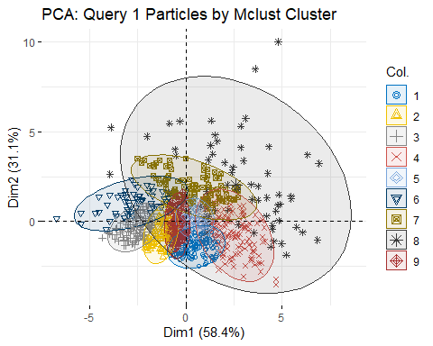
#PCA1 for q2
pca_q2 <- prcomp(q2_scaled)
fviz_pca_ind(pca_q2,
geom.ind = "point",
col.ind = as.factor(mc_q2$classification),
palette = "jco",
addEllipses = TRUE,
ellipse.level = 0.95,
title = "PCA: Query 2 Particles by Mclust Cluster")
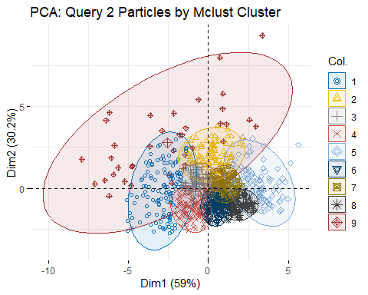
#PCA1 for q6
pca_q6 <- prcomp(q6_scaled)
fviz_pca_ind(pca_q6,
geom.ind = "point",
col.ind = as.factor(mc_q6$classification),
palette = "jco",
addEllipses = TRUE,
ellipse.level = 0.95,
title = "PCA: Query 6 Particles by Mclust Cluster")
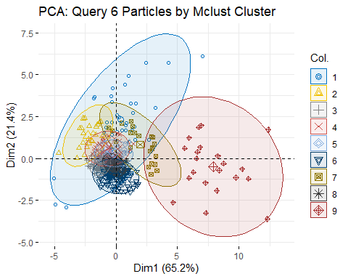
q1$cluster <- mc_q1$classification
q2$cluster <- mc_q2$classification
q6$cluster <- mc_q6$classification
# Clean up column names
colnames(uw)[colnames(uw) == "Circ."] <- "Circ"
colnames(bg)[colnames(bg) == "Circ."] <- "Circ"
#Add a Class Label Column
uw$class <- uw$Brand # Keep brand name as class
bg$class <- "Background" # Assign one label to all background particles
#Select only the seven required features
features <- c("Area", "Perim.", "Major", "Minor", "Circ", "AR", "Round", "class")
uw_clean <- uw[, features]
bg_clean <- bg[, features]
#Combine into one training data set
train_data <- rbind(uw_clean, bg_clean)
# Convert class column to factor
train_data$class <- as.factor(train_data$class)
# Check class distribution
table(train_data$class)
##
## Background BL-C(2) Bullseye H335 RedDot Reloader23
## 60925 3041 1544 3186 760 1118
# Check for missing values
colSums(is.na(train_data))
## Area Perim. Major Minor Circ AR Round class
## 0 0 0 0 0 0 0 0
#Training
# Set predictors and outcome
X <- train_data[, c("Area", "Perim.", "Major", "Minor", "Circ", "AR", "Round")]
y <- train_data$class
#splitting the Data for Training and Validation
set.seed(123)
train_index <- createDataPartition(y, p = 0.8, list = FALSE)
X_train <- X[train_index, ]
X_test <- X[-train_index, ]
y_train <- y[train_index]
y_test <- y[-train_index]
#Training Random Forest Model
# Get the number of samples per class (balanced down to the smallest class)
table(y_train)
## y_train
## Background BL-C(2) Bullseye H335 RedDot Reloader23
## 48740 2433 1236 2549 608 895
min_class_size <- min(table(y_train))
# Training Random Forest with balanced sampling
set.seed(123)
rf_model <- randomForest(
x = X_train,
y = y_train,
ntree = 500,
importance = TRUE,
strata = y_train,
sampsize = rep(min_class_size, length(levels(y_train)))
)
print(rf_model)
##
## Call:
## randomForest(x = X_train, y = y_train, ntree = 500, strata = y_train, sampsize = rep(min_class_size, length(levels(y_train))), importance = TRUE)
## Type of random forest: classification
## Number of trees: 500
## No. of variables tried at each split: 2
##
## OOB estimate of error rate: 39.69%
## Confusion matrix:
## Background BL-C(2) Bullseye H335 RedDot Reloader23 class.error
## Background 28936 4060 4000 4482 3648 3614 0.40631924
## BL-C(2) 82 1281 54 1016 0 0 0.47348952
## Bullseye 70 6 1144 15 1 0 0.07443366
## H335 96 1044 85 1323 1 0 0.48097293
## RedDot 53 0 2 0 539 14 0.11348684
## Reloader23 58 0 0 0 11 826 0.07709497
#Prediction
# Predict on test data
rf_preds <- predict(rf_model, newdata = X_test)
# Confusion Matrix
confusionMatrix(rf_preds, y_test)
## Confusion Matrix and Statistics
##
## Reference
## Prediction Background BL-C(2) Bullseye H335 RedDot Reloader23
## Background 7210 16 13 26 12 13
## BL-C(2) 979 309 3 255 0 0
## Bullseye 1022 11 285 21 0 0
## H335 1126 272 7 335 0 0
## RedDot 905 0 0 0 136 6
## Reloader23 943 0 0 0 4 204
##
## Overall Statistics
##
## Accuracy : 0.6008
## 95% CI : (0.5927, 0.6089)
## No Information Rate : 0.8634
## P-Value [Acc > NIR] : 1
##
## Kappa : 0.2602
##
## Mcnemar's Test P-Value : NA
##
## Statistics by Class:
##
## Class: Background Class: BL-C(2) Class: Bullseye
## Sensitivity 0.5917 0.50822 0.92532
## Specificity 0.9585 0.90840 0.92365
## Pos Pred Value 0.9890 0.19987 0.21285
## Neg Pred Value 0.2708 0.97621 0.99820
## Prevalence 0.8634 0.04308 0.02182
## Detection Rate 0.5109 0.02189 0.02019
## Detection Prevalence 0.5165 0.10954 0.09488
## Balanced Accuracy 0.7751 0.70831 0.92449
## Class: H335 Class: RedDot Class: Reloader23
## Sensitivity 0.52590 0.894737 0.91480
## Specificity 0.89574 0.934747 0.93182
## Pos Pred Value 0.19253 0.129895 0.17724
## Neg Pred Value 0.97559 0.998775 0.99853
## Prevalence 0.04514 0.010770 0.01580
## Detection Rate 0.02374 0.009637 0.01445
## Detection Prevalence 0.12329 0.074187 0.08156
## Balanced Accuracy 0.71082 0.914742 0.92331
# Variable Importance Plot
varImpPlot(rf_model)
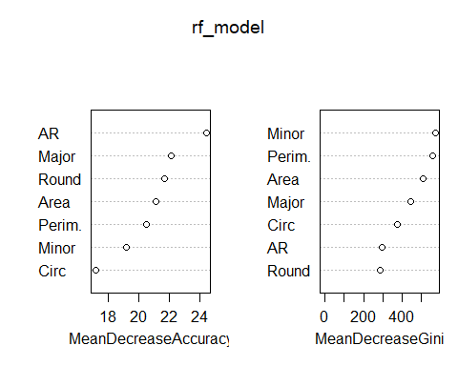
query_features <- c("Area", "Perim.", "Major", "Minor", "Circ", "AR", "Round")
# Confirm features exist
stopifnot(all(query_features %in% colnames(q1)))
#Prediction for q1,q2,q3
# Predict class
q1$predicted_class <- predict(rf_model, q1[, query_features])
q2$predicted_class <- predict(rf_model, q2[, query_features])
q6$predicted_class <- predict(rf_model, q6[, query_features])
# Predict class probabilities (optional confidence)
q1$prediction_confidence <- apply(predict(rf_model, q1[, query_features], type = "prob"), 1, max)
q2$prediction_confidence <- apply(predict(rf_model, q2[, query_features], type = "prob"), 1, max)
q6$prediction_confidence <- apply(predict(rf_model, q6[, query_features], type = "prob"), 1, max)
head(q1[, c("Area", "Perim.", "Major", "Minor", "predicted_class", "prediction_confidence")])
## Area Perim. Major Minor predicted_class prediction_confidence
## 1 292790.6 2024.738 625.964 595.550 H335 0.540
## 2 316066.0 2095.411 638.893 629.883 BL-C(2) 0.782
## 3 282901.0 1991.618 607.930 592.503 BL-C(2) 0.668
## 4 199689.0 1663.507 504.687 503.782 BL-C(2) 0.386
## 5 395681.8 2360.124 727.691 692.324 BL-C(2) 0.476
## 6 337892.9 2161.234 662.872 649.023 BL-C(2) 0.590
#writing the predictions as csv file
write.csv(q1, "q1_with_predictions.csv", row.names = FALSE)
write.csv(q2, "q2_with_predictions.csv", row.names = FALSE)
write.csv(q6, "q6_with_predictions.csv", row.names = FALSE)
#Prediction results:
# Function to generate a bar plot
plot_bar_distribution <- function(df, query_name) {
ggplot(df, aes(x = predicted_class)) +
geom_bar(fill = "#2C3E50") +
labs(title = paste("Predicted Class Distribution -", query_name),
x = "Predicted Class", y = "Number of Particles") +
theme_minimal() +
theme(axis.text.x = element_text(angle = 45, hjust = 1))
}
# Running plots for each query
plot_bar_distribution(q1, "Query 1")
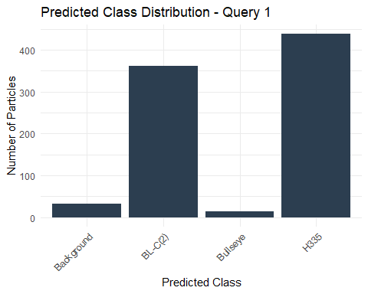
plot_bar_distribution(q2, "Query 2")
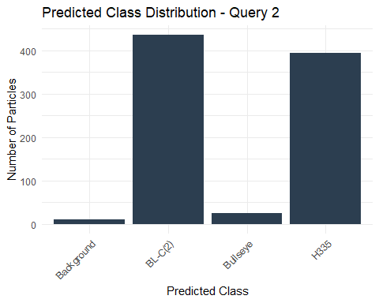
plot_bar_distribution(q6, "Query 6")
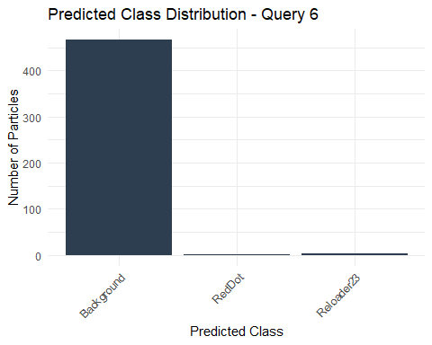
#Piecharts
# Function to generate a pie chart
plot_pie_distribution <- function(df, query_name) {
df_summary <- as.data.frame(table(df$predicted_class))
colnames(df_summary) <- c("Class", "Count")
df_summary$Percent <- round(df_summary$Count / sum(df_summary$Count) * 100, 1)
df_summary$Label <- paste0(df_summary$Class, " (", df_summary$Percent, "%)")
ggplot(df_summary, aes(x = "", y = Count, fill = Label)) +
geom_bar(stat = "identity", width = 1) +
coord_polar("y", start = 0) +
labs(title = paste("Predicted Class Proportion -", query_name), fill = "Class") +
theme_void()
}
# Run for each query
plot_pie_distribution(q1, "Query 1")
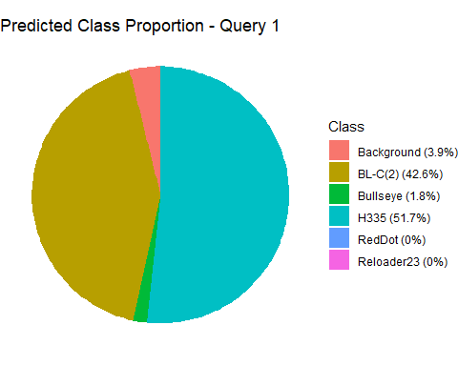
plot_pie_distribution(q2, "Query 2")
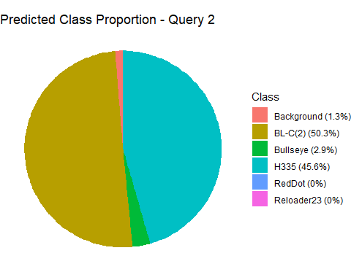
plot_pie_distribution(q6, "Query 6")
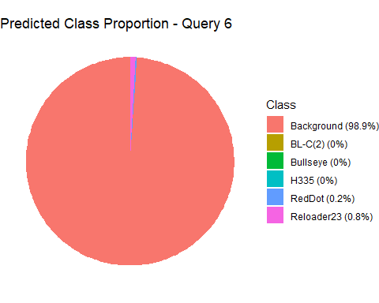
#Per Clustering Aggregation #clusterwise prediction
# Function to get class distribution per cluster
aggregate_by_cluster <- function(df, query_name) {
summary <- df %>%
group_by(cluster, predicted_class) %>%
summarise(count = n()) %>%
arrange(cluster, desc(count))
print(paste("=== Summary for", query_name, "==="))
print(summary)
return(summary)
}
#summaries
summary_q1 <- aggregate_by_cluster(q1, "Query 1")
## `summarise()` has grouped output by 'cluster'. You can override using the
## `.groups` argument.
## [1] "=== Summary for Query 1 ==="
## # A tibble: 25 × 3
## # Groups: cluster [9]
## cluster predicted_class count
## <dbl> <fct> <int>
## 1 1 BL-C(2) 68
## 2 1 H335 52
## 3 2 BL-C(2) 75
## 4 2 H335 24
## 5 3 BL-C(2) 77
## 6 3 H335 30
## 7 3 Background 1
## 8 4 H335 82
## 9 4 BL-C(2) 31
## 10 4 Bullseye 5
## # ℹ 15 more rows
summary_q2 <- aggregate_by_cluster(q2, "Query 2")
## `summarise()` has grouped output by 'cluster'. You can override using the
## `.groups` argument.
## [1] "=== Summary for Query 2 ==="
## # A tibble: 22 × 3
## # Groups: cluster [9]
## cluster predicted_class count
## <dbl> <fct> <int>
## 1 1 H335 79
## 2 1 BL-C(2) 40
## 3 1 Bullseye 12
## 4 1 Background 1
## 5 2 H335 71
## 6 2 BL-C(2) 13
## 7 3 H335 79
## 8 3 BL-C(2) 23
## 9 4 BL-C(2) 61
## 10 4 H335 40
## # ℹ 12 more rows
summary_q6 <- aggregate_by_cluster(q6, "Query 6")
## `summarise()` has grouped output by 'cluster'. You can override using the
## `.groups` argument.
## [1] "=== Summary for Query 6 ==="
## # A tibble: 12 × 3
## # Groups: cluster [9]
## cluster predicted_class count
## <dbl> <fct> <int>
## 1 1 Background 35
## 2 1 RedDot 1
## 3 1 Reloader23 1
## 4 2 Background 23
## 5 3 Background 81
## 6 4 Background 59
## 7 5 Background 44
## 8 6 Background 119
## 9 7 Background 22
## 10 8 Background 66
## 11 9 Background 18
## 12 9 Reloader23 3
# Function to plot class distribution per cluster
plot_cluster_composition <- function(summary_df, query_name) {
ggplot(summary_df, aes(x = factor(cluster), y = count, fill = predicted_class)) +
geom_bar(stat = "identity", position = "stack") +
labs(title = paste("Cluster-wise Brand Prediction -", query_name),
x = "Cluster", y = "Particle Count", fill = "Predicted Class") +
theme_minimal()
}
plot_cluster_composition(summary_q1, "Query 1")
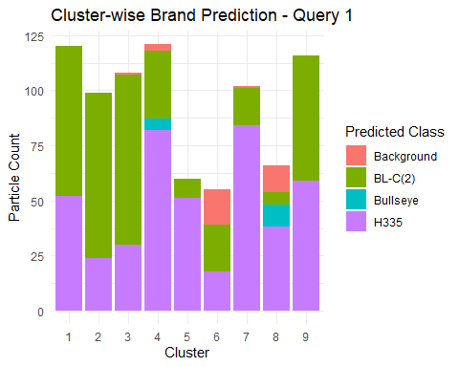
plot_cluster_composition(summary_q2, "Query 2")
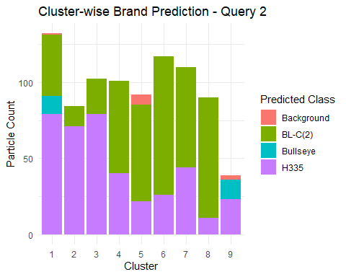
plot_cluster_composition(summary_q6, "Query 6")
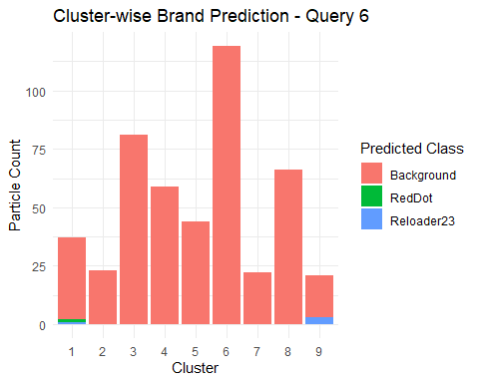
#Not required
# Combine class + one feature for each plot
#ggplot(train_data, aes(x = Area, fill = class)) +
# geom_histogram(position = "identity", bins = 50, alpha = 0.4) +
# labs(title = "Area Distribution by Class")
#ggplot(train_data, aes(x = Circ, fill = class)) +
# geom_histogram(position = "identity", bins = 50, alpha = 0.4) +
# labs(title = "Circularity Distribution by Class")
#ggplot(train_data, aes(x = AR, fill = class)) +
# geom_histogram(position = "identity", bins = 50, alpha = 0.4) +
# labs(title = "Aspect Ratio Distribution by Class")
#library(MASS)
# Fit LDA
#lda_model <- lda(class ~ Area + Perim. + Major + Minor + Circ + AR + Round, data = train_data)
# View summary
#lda_model

