Project 4: Classification of Smokeless Arms Propellants (SAP) Particles from Recovered Improvised Explosive Devices (IEDs) Using Cluster-Based Ensemble Model

This forensic project focuses on identifying the origin of smokeless arms propellants (SAP) particles recovered from unexploded improvised explosive devices (IEDs). The analysis is based on size and shape descriptors extracted using ImageJ software from automated particle images and the Jarvis et al. article published in 2023.
Goal: The aim is to determine whether particles in each query object (IEDs) match any of the five known watchlist SAP brands or fall under a universal background class (non-watchlist).

Data Summary:

Training Data:
unexploded_watchlist.csv`: Contains 5 lots (brands) with multiple particle samples.
background_data.csv`: Contains particles from various non-watchlist brands.
Query Data:
query_1.csv`, `query_2.csv`, `query_6.csv`: Contain unknown particles to be classified.

The training data sets, unexploded_watchlist.csv is a data set of five different lots of SAPs (each from a different brand as well), with five samples of SAP particles per brand for unexploded_watchlist.csv. While, the background_data.csv data set has one sample per lot from a number of lots that are not of interest to the examiners (typically, lot and brand are equivalent in this data set). For these data sets, each row of these data sets corresponds to 1 SAP particle. The 13 columns of correspond to the features recorded for each particle and are as follows:
- Particle: The individual SAP particle.
- Sample: The scoop of particles from one of the SAP containers. The lot that a scoop is from is the first 6 characters. The characters after the first 6 are the container that the scoop was from, ie. SP-007.B is the scoop from the \(B^{th}\) container of the lot SP-007. If there is not a trailing text string then the scoop is either the first scoop or the only scoop from a lot.
- Distributor: The distributor of the brand of SAP.
- Brand: The brand of the SAP, this is the main class variable of interest.
- Shape: The examiner explained that they think this is the claimed shape of the particles- this is determined by the brand label, and not determined by the measurement process.
- Area: Area of selection in square pixels or in calibrated square units.
- Perim.: The length of the outside boundary of the selection. Uses the heading Perim. with Version IJ 1.44f and later, the perimeter of a composite selection is calculated by decomposing it into individual sections. Note that the composite perimeter and the sum of the individual perimeters may be different due to use of different calculation methods.
- Fit Ellipse Feature Set- The Ellipse Fits command fits an ellipse to the selection.
- Major: Major is the primary axis of the best fitting ellipse.
- Minor: Minor is the secondary axis of the best fitting ellipse.
- Shape Descriptors: divided into following 4 columns
- Circularity (Circ.): \(4\pi \frac{Area}{Perimeter^2}\) with a value of one indicating a perfect circle. As the value approaches 0, it indicates an increasingly elongated shape. Values may not be valid for very small particles.
- Aspect ratio (AR): The aspect ratio of the particle’s fitted ellipse, i.e., \(\frac{Major\ Axis}{Minor\ Axis}\).
- Roundness (Round): The inverse of the Aspect Ratio.
- Solidity: \(\frac{Area}{Convex\ Area}\)

The first and second data sets only contain the features from the ImageJ software, namely:
“Area”
“Perim.”
“Major”
“Minor”
“Circ.”
“AR”
“Round”
“Solidity”

The query csv data files contain particles from the recovered IED’s. These data sets only have the following variables, with one particle per row.
“Area”
“Perim.”
“Major”
“Minor”

Feature Engineering:
Adding three derived features to the query data sets.
"Circ", "AR", "Round”
Selecting relevant(7) features and scaling as we need to do scale features before clustering as it essential for Mclust
("Area", "Perim.", "Major", "Minor", "Circ", "AR", "Round")
[Note: As the Convex is unavailable, Solidity has not been considered as a featured engineering parameter.]

Step 1: Clustering Query Particles
To explore the internal composition of each IED query, Mclust clustering was used to group particles by their morphometric similarity. This unsupervised step identified 9 natural clusters for each query object. The number of clusters is not assumed to equal the number of brands but provides useful segmentation to assess brand involvement.
We are not interpreting each cluster as a distinct brand but using it as a tool to group particles with similar shape/size features for downstream aggregation.
Mclust() uses Bayesian Information Criterion (BIC) to select the number of clusters automatically. It tries to balance model fit with complexity. It doesn’t know you're working with 5 brands. it just sees multimodal, continuous distributions in 7D feature space and identifies where natural groups exist.

Clustering charts:
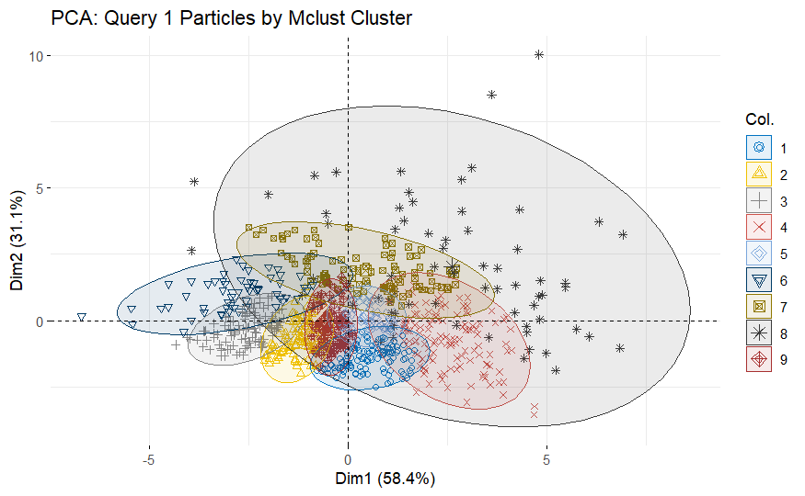
Principal Component Analysis (PCA) for Clustering was done for all three queries.
Figure 1. PCA for Query 1.

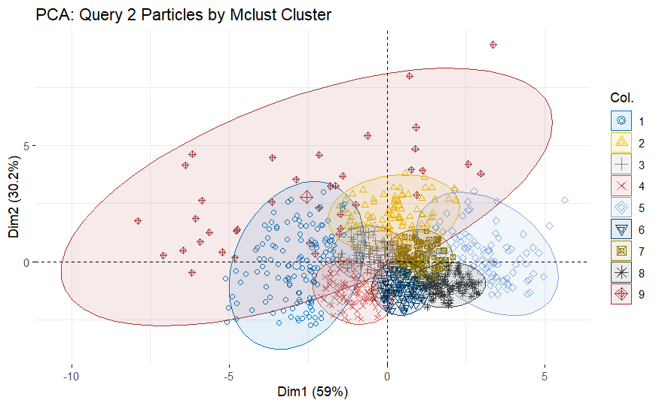
Figure 2. PCA for Query 2.

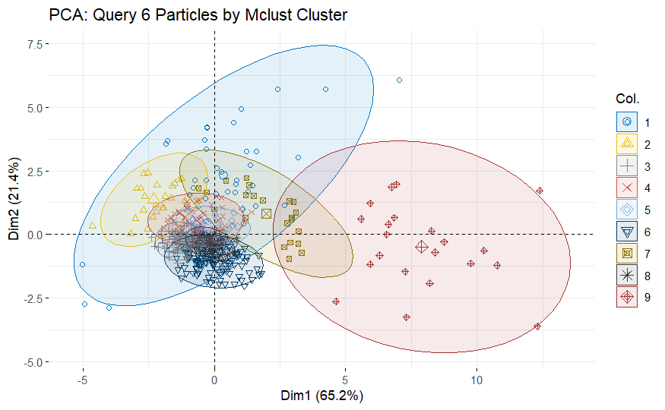Figure 3. PCA for Query 6.
Cluster Results Summary
Query 1
- 9 clusters identified
- Clustering table: balanced-ish cluster sizes (ranging ~55 to 121 particles)
- PCA shows distinct groupings, especially clusters 1, 4, and 9, implying multiple distinct powders
Query 2
- Again, 9 clusters
- Cluster sizes vary but no severe imbalance
- PCA shows more overlap than Query 1, but clusters 1, 4, 6 appear visually distinct
Query 6
- 9 clusters
- Cluster 6 has a larger group (119), while some clusters are small (e.g., cluster 2 = 23)
- PCA shows clear separation: clusters 1, 4, and 6 dominate visually
Insights:
- All three queries show a clear internal structure, which validates the hypothesis that each IED may contain a mixture of particles from different brands/lots.
- Mclust’s 9-cluster solution is not necessarily 9 brands — some may be noise, minor variation, or overlapping shapes.
- Mclust() uses the Bayesian Information Criterion (BIC) to select the number of clusters automatically.
- It tries to balance model fit with complexity.
- It doesn’t know you're working with 5 brands — it just sees multimodal, continuous distributions in 7D feature space and identifies where natural groups exist.

Assigned one label to all background particles
Step 2: Training the Classifier
Features used: `Area`, `Perim.`, `Major`, `Minor`, `Circ`, `AR`, and `Round`
Combined watchlist and background data to form a 6-class classification problem.
Classifier: **Random Forest** (500 trees) with balanced sampling across all classes.
Performance (Test Set):
unexploded_watchlist and background_data are combined into One Training Dataset.

Train Random Forest with balanced sampling
Overall Accuracy: 60.1%
- Accuracy = 0.6008 (not bad, especially given the heavy imbalance)
- No Information Rate (NIR) = 0.8634
→ This means if you guessed only "Background" all the time, you’d still be right 86% of the time. So accuracy alone isn't the best measure here.
- Kappa = 0.26
→ Moderate agreement beyond chance. We can aim to improve this.
Per-Class Breakdown
Table 1. Summary statistics for the random forest sampling.
Class | Sensitivity (Recall) | Precision (PPV) | Balanced Accuracy
Background | 0.59 | 0.99 | 0.775
BL-C(2) | 0.51 | 0.20 | 0.71
Bullseye | 0.93 | 0.21 | 0.92
H335 | 0.53 | 0.19 | 0.71
RedDot | 0.89 | 0.13 | 0.91
Reloader23 | 0.91 | 0.18 | 0.92

Prediction for Q1, Q2, Q3:
Predictions are saved into q1_with_predictions.csv, q2_with_predictions.csv, q6_with_predictions.csv files.

Prediction results:
Predict Each Particle in the Query:
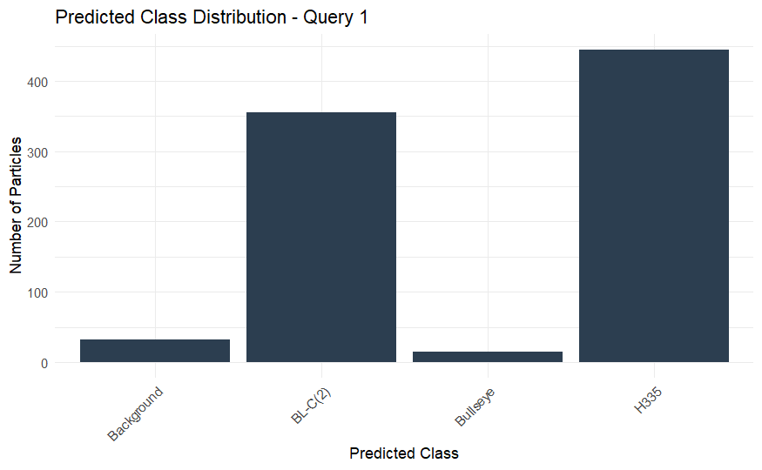
Figure 4. Bar graph showing the distribution of the particles in predicted class for Query 1.
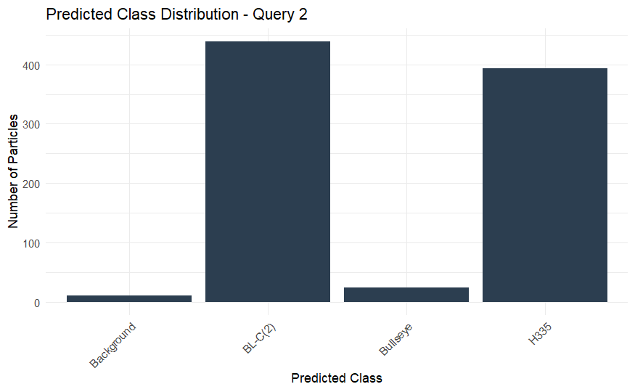
Figure 5. Bar graph showing the distribution of the particles in predicted class for Query 2.

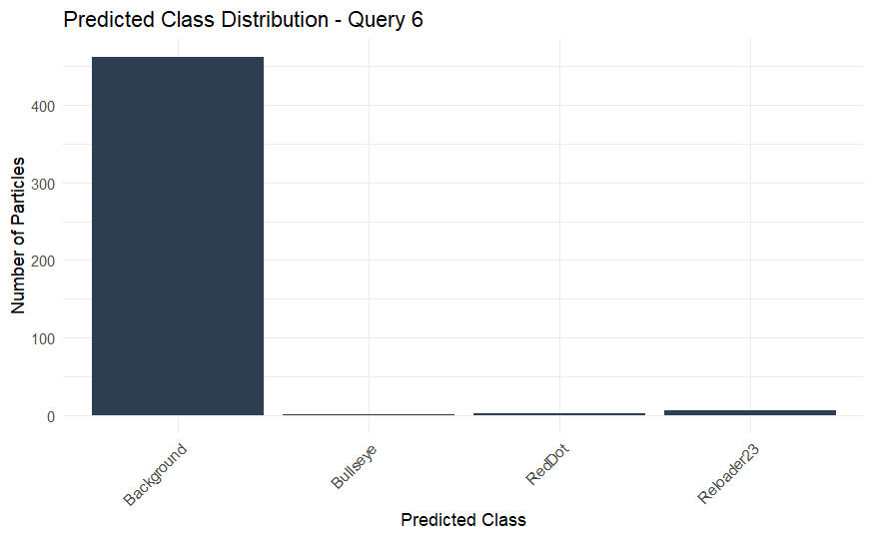
Figure 6. Bar graph showing the distribution of the particles in predicted class for Query 6.

Table 2. Query 1 Summary.
Predicted Class | Particle Count
H335 | 445
BL-C(2) | 355
Background | 32
Bullseye | 15
Interpretation for Query 1:
- This query is strongly associated with two known brands:
  - H335 and BL-C(2) make up 94% of the particles
- Very few particles are predicted as “Background” (only 32), indicating that the recovered particles are very likely from known brands
- Conclusion:
Query 1 IED likely contains both H335 and BL-C(2) powders (possibly a mixture).

Table 3. Query 2 Summary.
Predicted Class | Particle Count
BL-C(2) | 439
H335 | 393
Bullseye | 24
Background | 11
Interpretation for Query 1:
- Similar to Query 1, this is clearly dominated by BL-C(2) and H335
- Very few “Background” particles (11 total) — most are confidently predicted as known watchlist brands
- Conclusion:
Query 2 IED also likely contains a mix of H335 and BL-C(2) (perhaps more evenly distributed than Query 1)

Table 4. Query 6 Summary.
Predicted Class | Particle Count
Background | 462
Reloader23 | 6
RedDot | 3
Bullseye | 1
Interpretation for Query 6:
- This query is almost entirely classified as Background
- Only 10 particles (2%) are predicted to belong to known brands
- Conclusion:
Query 6 IED is most likely not composed of any of the 5 watchlist brands. These particles may be from unlisted powders or background lots

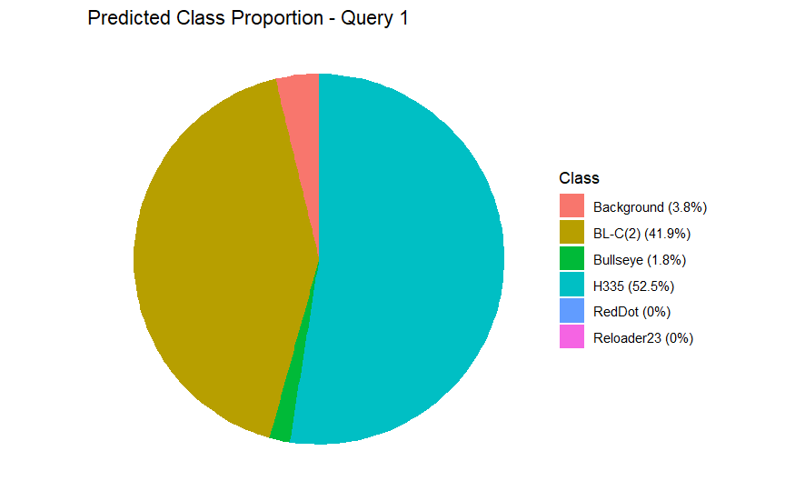
Figure 7. Pie chart showing the distribution of the particles in predicted class for Query 1.
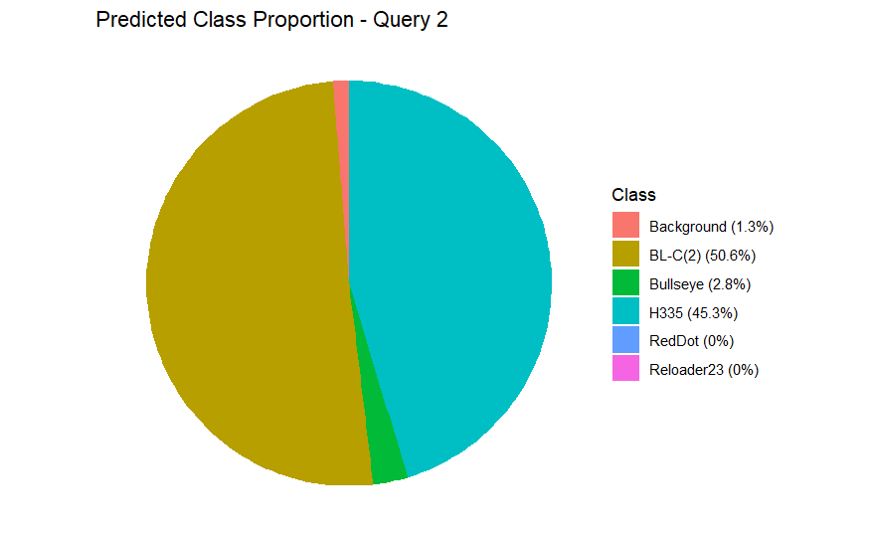
Figure 8. Pie chart showing the distribution of the particles in predicted class for Query 2.
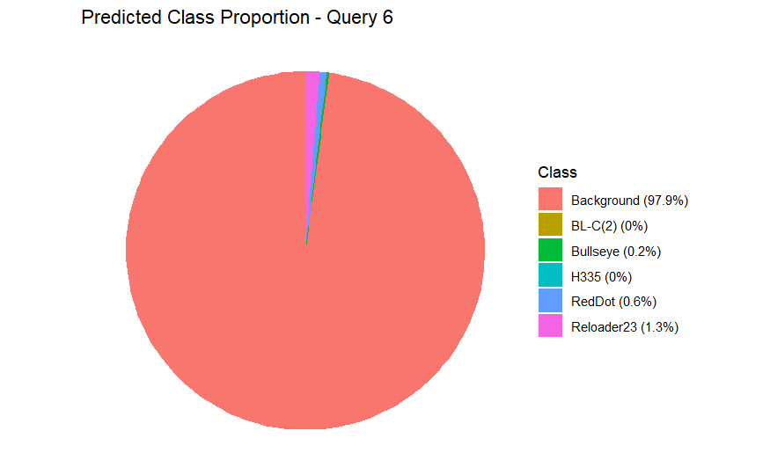
Figure 9. Pie chart showing the distribution of the particles in predicted class for Query 6.

Query 1: Predicted Class Proportion
Table 5. Query 1.
Class | Proportion
H335 | 52.5%
BL-C(2) | 41.9%
Background | 3.8%
Bullseye | 1.8%
Others | 0%
Insight:
- Over 94% of particles are confidently classified as either H335 or BL-C(2).
- Very low background noise, indicating clear match with known brands.
- Conclusion: Query 1 is a high-confidence dual-brand IED (H335 + BL-C(2)).

Query 2: Predicted Class Proportion
Table 6. Query 2.
Class | Proportion
BL-C(2) | 50.6%
H335 | 45.3%
Bullseye | 2.8%
Background | 1.3%
Others | 0%
Insight:
- Almost the exact same pattern as Query 1, but with more balance between H335 and BL-C(2).
- Slight increase in Bullseye presence (likely a minor contaminant or genuine blend).
- Background is negligible.
- Conclusion: Query 2 also likely contains both BL-C(2) and H335, with possible Bullseye trace — still a clear multi-brand match.

Query 6: Predicted Class Proportion
Table 7. Query 6.
Class | Proportion
Background | 97.9%
Reloader23 | 1.3%
Bullseye | 0.2%
RedDot | 0.6%
Others | 0%
Insight:
- Almost total background dominance, suggesting particles are not from any of the five known watchlist brands.
- The few non-background predictions are very sparse and not clustered, suggesting noise rather than true brand signals.
- Conclusion: Query 6 was likely constructed using unknown or non-watchlist propellants — supports brand exclusion in forensic terms.
Summary Comparison
Table 8. Summary Comparison.
Query | Primary Brands Detected | Background Proportion | Conclusion
Q1 | H335, BL-C(2) | 3.8% | High-confidence dual-brand match
Q2 | BL-C(2), H335 (+ Bullseye) | 1.3% | Dual-brand IED with minor third brand
Q6 | (None) | 97.9% | Likely non-watchlist origin

Clusterwise Brand Prediction:
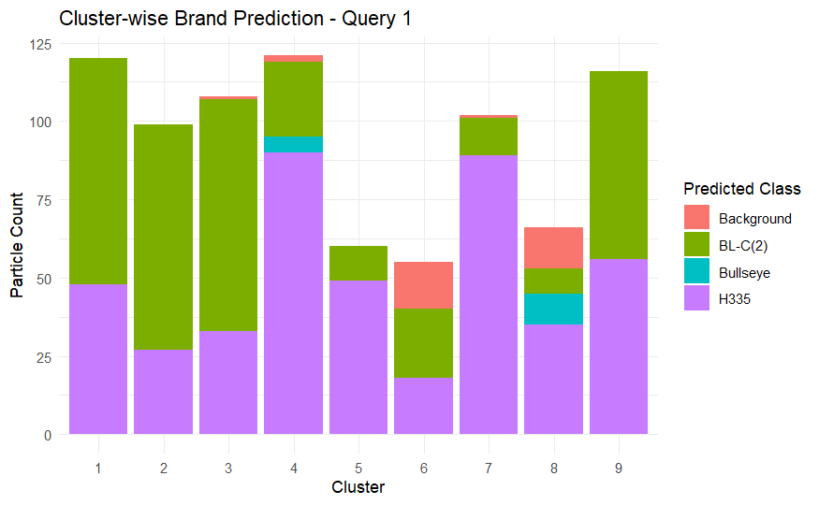
Figure 10. Bar chart showing the distribution of the particles in predicted class for Query 1 in each cluster.

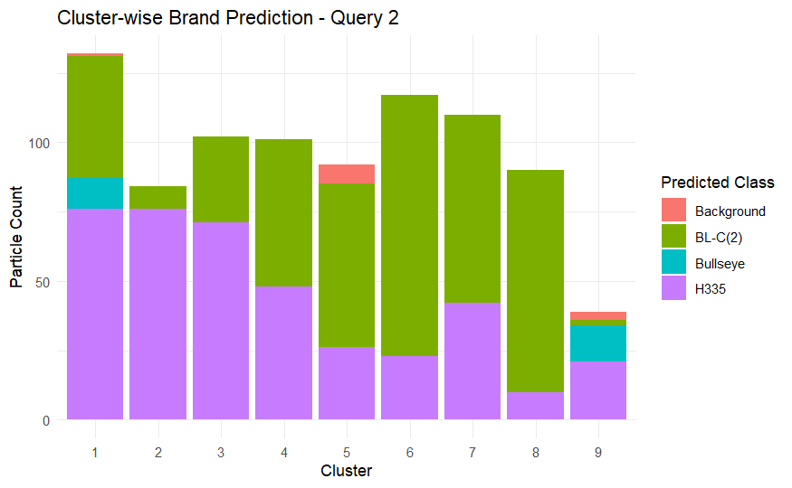
Figure 11. Bar chart showing the distribution of the particles in predicted class for Query 2 in each cluster.

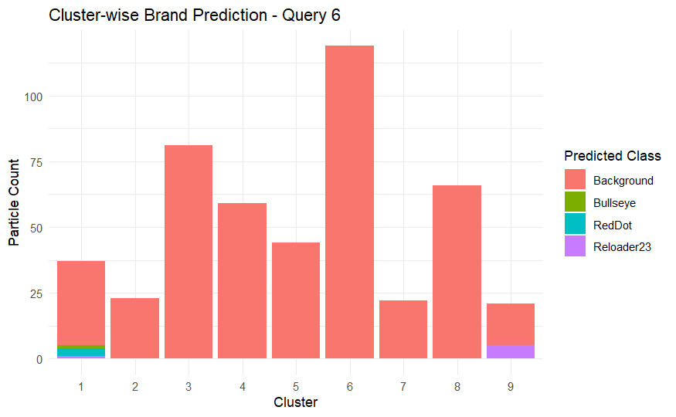
Figure 12. Bar chart showing the distribution of the particles in predicted class for Query 6 in each cluster.
Query 1: Cluster-Wise Brand Prediction
Key Observations:
- Clusters 1, 2, 3, 4, 7, 9: Dominated by H335 and BL-C(2).
These likely came from a mixture of known brands.
- Clusters 5, 6, 8:
  - More mixed, but H335 and BL-C(2) still show up prominently.
  - Cluster 6 has notable Background presence, indicating possible contamination or unrelated powder.
Conclusion:
Query 1 contains mostly H335 and BL-C(2).
Likely a dual-brand IED with minor background noise.

Query 2: Cluster-Wise Brand Prediction
Key Observations:
- Clusters 1, 3, 4, 5, 6, 7: Strong representation of both BL-C(2) and H335.
- Cluster 9: More Bullseye presence than other clusters (still mixed with H335).
- Cluster 8: Predominantly BL-C(2).
- Minimal Background across all clusters, predictions are confident.
Conclusion:
Query 2 also likely involves BL-C(2) and H335, with a small trace of Bullseye.
Brand usage appears more balanced across clusters than in Query 1.

Query 6: Cluster-Wise Brand Prediction
Key Observations:
- Overwhelming dominance of “Background” in all clusters
- Tiny traces of Reloader23, Bullseye, and RedDot, all in Cluster 1 and 9
- Clusters 3, 4, 6, 8: Purely Background
Conclusion:
Query 6 does not appear to match any of the five watchlist brands.
Any non-background predictions are very sparse, possibly noise.
This IED most likely used off-watchlist powder brands.

Summary Table
Table 9. Finalized summary table.
Query | Clusters with Known Brand Matches | Main Brands | Verdict
Query 1 | Clusters 1–4, 7, 9 (mostly H335, BL-C(2)) | H335, BL-C(2) | Dual-brand IED (strong match)
Query 2 | Clusters 1, 3–7, 9 (H335, BL-C(2), Bullseye) | H335, BL-C(2), Bullseye | Multi-brand IED (mainly H335 + BL-C(2))
Query 6 | Mostly Background (tiny traces in cluster 1 & 9) | None dominant | Likely not from any watchlist brand

Overall Conclusion:
- Based on cluster-level classification and shape analysis, Query 1 and Query 2 clearly contain particles most similar to known watchlist brands, primarily H335 and BL-C(2). Query 2 also shows minor involvement of Bullseye.
- Query 6, however, shows nearly full classification into the “Background” category, indicating no match to any of the five brands. This suggests the possible use of non-watch-listed powders in its construction.

References
- Saunders C.P., STAT 600, 601, and 602 Lecture Notes.
- Jarvis, C. M., Kress, D., Hanka, J., Moorehead, W., & Hietpas, J. (2023). Assessing the strengths and limitations of quantitative micromorphometry for the forensic examination of small arms propellant towards brand identification. Forensic Science International, 353, 111880.
- Schindelin, J., Arganda-Carreras, I., Frise, E., Kaynig, V., Longair, M., Pietzsch, T., ... & Cardona, A. (2012). Fiji: an open-source platform for biological-image analysis. Nature methods, 9(7), 676-682.
- Hothorn, T., & Everitt, B. S. (2009). A handbook of statistical analyses using R. Chapman and Hall/CRC.
- Kassambara, A. (2017). Practical guide to cluster analysis in R: Unsupervised machine learning (Vol. 1). Sthda.
- ChatGPT. (02/2025). Used for debugging and code cleaning. Retrieved from OpenAI

