SOUTH DAKOTA STATE UNIVERSITY



Project 2

Submitted by
Sai Ram Vodnala, Soniya Shahi, Kevin Osei-Onomah, Carlos Quevedo Garza

Professor: Dr. Christopher Saunders Assistant: Clarisa Giefer

November 12, 2024

- Introduction and Background:

In this study, we have undertaken the task of developing a Generalized Linear Model (GLM) with a binomial family response, akin to a logistic regression model. Our dataset comprises 89 classified voles, with 43 belonging to the multiplex species and 46 to the subterraneous species. To ensure the accuracy of our model, we adhered to a systematic approach. The initial phase of our analysis involved an in-depth exploration of the dataset. This exploration not only familiarized us with the structure of the data but also highlighted potential challenges such as missing values and outliers.

Addressing data quality concerns, we removed rows with missing values and implemented outlier handling techniques. By addressing these issues early in the analysis, we aimed to create a more reliable and representative dataset for model training.

With the refined dataset in hand, our next steps involved the selection and exploration of relevant dependent variables. In this context, we considered Length Condylo_incisive length (0.01mm), Height (Skull height above bullae in 0.01mm), and Rostrum (Skull width across rostrum in 0.01mm) as potential predictors for our GLM. The choice of these variables is rooted in their biological significance and relevance to Microtus classification.

The subsequent sections will explore the specifics of our modeling process, including the formulation of different models with various combinations of de- pendent variables. We will elaborate on the rationale behind these choices and discuss the implications of our findings in the context of Microtus classification.

- Data Collection:

The dataset consists of 288 skull measurements from two species, with 89 specimens classified through chromosomal analysis. The remaining 199 specimens are unclassified, presenting a unique challenge for statistical modeling. The measurements include:

- Condylo incisive length (0.01mm)
- Skull height above bullae (0.01mm)
- Skull width across rostrum (0.01mm)

These variables are considered crucial for the accurate classification of the species involved.

- Methodology:
The methodology section starts with an exploratory data analysis, removing missing values and identifying outliers. Key predictors selected based on biological relevance included skull length, height, and width. The dataset comprised 89 classified voles from two species, leading to the creation of several models to identify the most effective predictor combination.

The dataset included measurements such as skull length, height, and width from two vole species, totalling 89 samples. Preliminary data cleaning involved removing entries with missing data and identifying and handling outliers.

3.2 Exploratory Data Analysis (EDA):

EDA was conducted to understand data distribution and identify any inherent biases or anomalies in the dataset. Techniques such as summary statistics and boxplots were utilized to assess the data quality and distribution characteristics of the variables.

3.3 Missing Values Removal:

In our initial examination of the labeled dataset used to train our models, which are constructed from the subterraneous and multiplex worksheets, we identified one empty row in each sheet, and those were subsequently removed. Addition- ally, we were pleased to discover the absence of any missing values, providing a strong foundation for our analysis.
The unknown dataset, however, had one empty set that was eliminated.
Exhibit 1: Summary, Boxplots and distribution of the Multiplex data:

multiplex - Before Outliers
Statistic | Skull Length  (mm) | Skull Height  (mm) | Skull Width  (mm)
Min. | 234 | 84 | 416
1st Qu. | 2330 | 787.5 | 455
Median | 2370 | 805 | 465
Mean | 2337 | 791.9 | 466.4
3rd Qu. | 2454 | 829 | 475
Max. | 2600 | 910 | 524

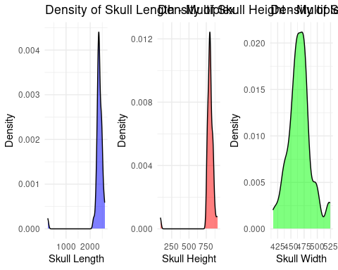
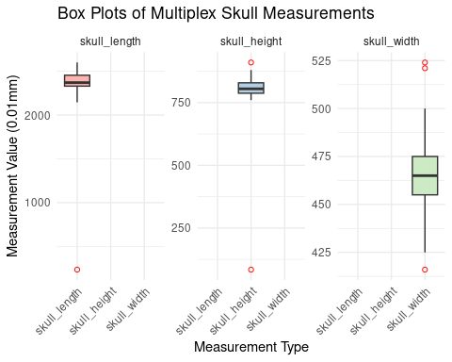

Exhibit 2: From the above charts of Multiplex, we can observe that skull length, skull height data is skewed towards right because of outliers, but skull width slightly symmetrical.

Exhibit 3: Summary, Boxplots and distribution of the Subterraneous data:

subterraneous- Before Outliers
Statistic | Skull Length  (mm) | Skull Height  (mm) | Skull Width  (mm)
Min. | 1965 | 715 | 42
1st Qu. | 2176 | 741.2 | 415
Median | 2255 | 750 | 425
Mean | 2655 | 909.2 | 419
3rd Qu. | 2290 | 775.8 | 434.2
Max. | 21899 | 7722 | 488

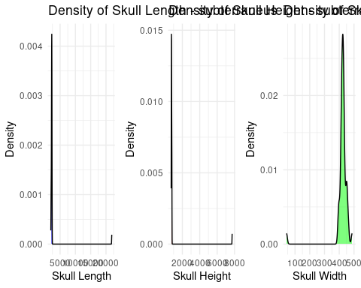
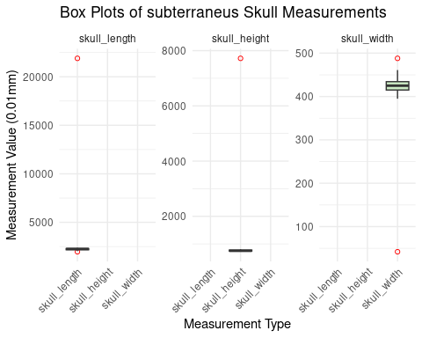

Exhibit 4: From above charts of subterraneous we can observe that skull length, skull height data is skewed towards extreme left and skull width is right skewed because of outliers.
3.4 Outlier Handling:

A percentile-based method was used for outlier management, where data points below the 2.5th percentile and above the 97.5th percentile were adjusted to these threshold values, ensuring that the model was not unduly influenced by extreme values.

Our outlier handling strategy involved a meticulous examination of the dataset through box plots to identify values that deviated significantly from the clustered data. For both types of Microtus - multiplex and Subterraneous – box plots were created for the features: Length, Width, and Height.

To mitigate the impact of outliers, we implemented a percentile-based approach. Values exceeding the 97.5th percentile were deemed as high outliers, while those falling below the 2.5th percentile were classified as low outliers. Subsequently, we replaced high outliers with the 97.5th percentile value and low outliers with the 2.5th percentile value. This process was executed independently for each feature (Length, Width, and Height) and for both types of Microtus. By systematically addressing outliers, we aimed to enhance the robustness of our dataset and ensure that extreme values did not unduly.

Exhibit 5: Summary, Boxplots and distribution of the Multiplex and Subterraneous data after Handling Outliers:

Multiplex:

multiplex clean - After Handling Outliers
Statistic | Skull Length | Skull Height | Skull Width
Minimum | 2150 | 760 | 425.5
1st Quartile | 2330 | 787.5 | 455
Median | 2370 | 805 | 465
Mean | 2381 | 806.8 | 466.5
3rd Quartile | 2454 | 829 | 475
Maximum | 2587 | 879 | 520

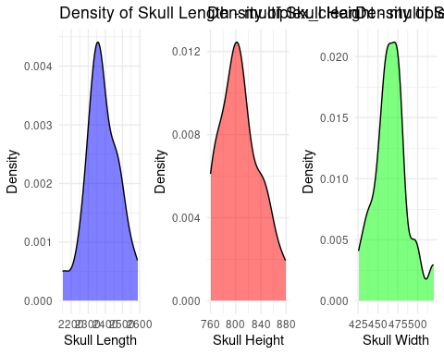
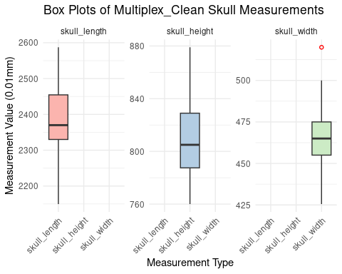

Subterraneous:

subterraneous clean - After Handling Outliers
Statistic | Skull Length | Skull Height | Skull Width
Minimum | 2044 | 720.6 | 395
1st Quartile | 2176 | 741.2 | 415
Median | 2255 | 750 | 425
Mean | 2232 | 758.9 | 426.1
3rd Quartile | 2290 | 775.8 | 434.2
Maximum | 2364 | 803.8 | 460.9

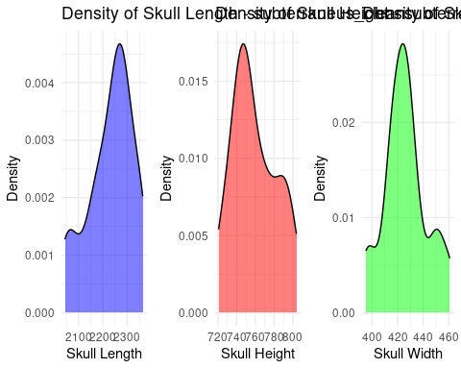
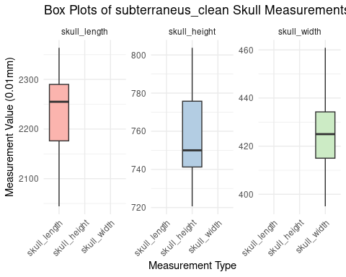

After replacing the outliers, we can proceed with Model Development and Evaluation.

- Model Development:

4.2 Training and Validation:

Having consolidated the labeled datasets for subterraneus and multiplex voles, we created a unified training dataset. To assess the model's performance, we employed Ten-fold cross-validation. This technique involves dividing the dataset into Ten subsets, using nine for training and one for validation in each iteration.

We calculated both training and validation accuracies for each of the ten iterations, allowing us to derive a more robust assessment of the model's effectiveness. The final training and validation accuracies were obtained by taking the mean of the accuracies across the Ten iterations.

Developing seven models, each representing a distinct combination of the three features (Length, Width, and Height), we explored the various permutations to identify the most effective feature set for classification. The results from these models provided insights into the significance of each feature combination in the context of microtus classification.

Exhibit 6:

# Define feature combinations
feature_combinations <- list(
c("skull_length", "skull_height", "skull_width"), # Model with three features
c("skull_length", "skull_height"), # Model with Length and Height
c("skull_length", "skull_width"), # Model with Length and Rostrum
c("skull_height", "skull_width"), # Model with Height and Rostrum
c("skull_length"), # Model with Length only
c("skull_height"), # Model with Height only
c("skull_width") # Model with Rostrum only
)

Exhibit 7: Training Results:

Model | Predictors | Accuracy | Kappa | Significant Coefficients (p¡0.05) | AIC
1 | 3 (All) | 0.8742 | 0.7502 | Intercept, Skull Height, Skull Width | 55.238
2 | Skull Length, Height | 0.7953 | 0.5923 | Intercept, Skull Length, Skull Height | 67.556
3 | Skull Length, Width | 0.8472 | 0.6919 | Intercept, Skull Width | 62.684
4 | Skull Height, Width | 0.8783 | 0.7593 | Intercept, Skull Height, Skull Width | 53.244
5 | Skull Length | 0.7964 | 0.5909 | Intercept, Skull Length | 82.105
6 | Skull Height | 0.7781 | 0.5573 | Intercept, Skull Height | 77.377
7 | Skull Width | 0.8400 | 0.6757 | Intercept, Skull Width | 61.750

4.3 Predictions:

Due to missing values in the unknown dataset, we addressed this challenge by utilizing previously developed models, as mentioned earlier. Model featuring Width and Height took precedence in our analysis, given its effectiveness. Specifically, if all features were present or only Length was missing, we utilized this model for predictions. In cases where Width was missing, we employed the model with Length and Height as features. Similarly, if Height was missing, we utilized the model with Length and Width. For scenarios where two features were missing, we turned to the model with the remaining features as predictors. This systematic approach ensured adaptive predictions based on the availability of features in the dataset.

Exhibit 8: Prediction Result Count Summary:

Model | Multiplex | Subterraneous
1 | 67 | 50
2 | 11 | 7
3 | 10 | 10
4 | 10 | 8
5 | 2 | 2
6 | 6 | 3
7 | 9 | 4

- Conclusions and Recommendations:

Model | Predictors | Multiplex | Subterraneous
1 | 3 (All) | 67 | 50
2 | Skull Length, Height | 11 | 7
3 | Skull Length, Width | 10 | 10
4 | Skull Height, Width | 10 | 8
5 | Skull Length | 2 | 2
6 | Skull Height | 6 | 3
7 | Skull Width | 9 | 4
 |  | 115 | 84

Exhibit 9: The models were compared based on their classification accuracy, kappa values, and AIC. The comprehensive analysis revealed that the model Incorporating all three features (skull length, height, and width) and (Skull Height, Width) performed best, offering the highest classification accuracy and the lowest AIC, indicating a strong balance between model complexity and goodness of fit.

- References:

- Airoldi, J.P., Flury, B.D., & Salvioni, M. (1995). Discrimination Between Two Species of Microtus.
- Castro, H.M., & Ferreira, J.C. (2023). Linear and Logistic Regression Models.
- DataCamp. (2022, December). Linear Regression in R Tutorial.
- Johnson, D. (2023, September 30). GLM in R: Generalized Linear Model with Example
- https://github.com/mominulislam2329/Logistic-Regression-STAT-601/blob/main/README.md
- ChatGPT. (10/2024). Used for debugging and code cleaning. Retrieved from OpenAI

