Project_2
SAI RAM VODNALA
2024-11-09

Data Preparation
EXCEL
Removed the empty rows (35,14,22) and duplicate(29 multiplex) in data for multiplex, subterraneus and unknown sheets in excel. And changed column names then converted to CSV format.

Exploratory Data Analysis
R
#Importing the data sets
multiplex <- read.csv("Multiplex1.csv")
subterraneus <- read.csv("Subterraneus1.csv")
unknown <- read.csv("Unknown1.csv")
#checking the top rows
head(multiplex)
## vole_skull_index chromosomal_analysis_ID skull_length skull_height
## 1 1 multiplex 2355 805
## 2 2 multiplex 2305 760
## 3 3 multiplex 2388 775
## 4 4 multiplex 2370 766
## 5 5 multiplex 2470 815
## 6 6 multiplex 2535 838
## skull_width
## 1 475
## 2 450
## 3 460
## 4 460
## 5 475
## 6 521
head(subterraneus)
## vole_skull_index chromosomal_analysis_ID skull_length skull_height
## 1 1 subterraneus 2350 735
## 2 2 subterraneus 2285 750
## 3 3 subterraneus 2170 738
## 4 4 subterraneus 2060 720
## 5 5 subterraneus 2275 785
## 6 6 subterraneus 2330 790
## skull_width
## 1 450
## 2 42
## 3 415
## 4 415
## 5 417
## 6 450
head(unknown)
## vole_skull_index chromosomal_analysis_ID skull_length skull_height
## 1 1 unknown 2232 821
## 2 2 unknown NA 755
## 3 3 unknown 2295 NA
## 4 4 unknown 2355 842
## 5 5 unknown 2335 814
## 6 6 unknown 2355 NA
## skull_width
## 1 430
## 2 405
## 3 NA
## 4 490
## 5 481
## 6 460
# Checking missing values
sum(is.na(multiplex))
## [1] 0
sum(is.na(subterraneus))
## [1] 0
#checking the structure and data types
str(multiplex)
## 'data.frame': 43 obs. of 5 variables:
## $ vole_skull_index : int 1 2 3 4 5 6 7 8 9 10 ...
## $ chromosomal_analysis_ID: chr "multiplex" "multiplex" "multiplex" "multiplex" ...
## $ skull_length : int 2355 2305 2388 2370 2470 2535 2385 2445 2435 2330 ...
## $ skull_height : int 805 760 775 766 815 838 815 84 835 830 ...
## $ skull_width : int 475 450 460 460 475 521 480 480 440 475 ...
str(subterraneus)
## 'data.frame': 46 obs. of 5 variables:
## $ vole_skull_index : int 1 2 3 4 5 6 7 8 9 10 ...
## $ chromosomal_analysis_ID: chr "subterraneus" "subterraneus" "subterraneus" "subterraneus" ...
## $ skull_length : int 2350 2285 2170 2060 2275 2330 2260 2290 2340 2270 ...
## $ skull_height : int 735 750 738 720 785 790 760 750 795 771 ...
## $ skull_width : int 450 42 415 415 417 450 426 432 450 420 ...
str(unknown)
## 'data.frame': 199 obs. of 5 variables:
## $ vole_skull_index : int 1 2 3 4 5 6 7 8 9 10 ...
## $ chromosomal_analysis_ID: chr "unknown" "unknown" "unknown" "unknown" ...
## $ skull_length : int 2232 NA 2295 2355 2335 2355 2416 2423 2504 2100 ...
## $ skull_height : int 821 755 NA 842 814 NA 850 760 835 720 ...
## $ skull_width : int 430 405 NA 490 481 460 5000 NA 487 40 ...
summary(multiplex)
## vole_skull_index chromosomal_analysis_ID skull_length skull_height
## Min. : 1.0 Length:43 Min. : 234 Min. : 84.0
## 1st Qu.:11.5 Class :character 1st Qu.:2330 1st Qu.:787.5
## Median :22.0 Mode :character Median :2370 Median :805.0
## Mean :22.0 Mean :2337 Mean :791.9
## 3rd Qu.:32.5 3rd Qu.:2454 3rd Qu.:829.0
## Max. :43.0 Max. :2600 Max. :910.0
## skull_width
## Min. :416.0
## 1st Qu.:455.0
## Median :465.0
## Mean :466.4
## 3rd Qu.:475.0
## Max. :524.0
summary(subterraneus)
## vole_skull_index chromosomal_analysis_ID skull_length skull_height
## Min. : 1.00 Length:46 Min. : 1965 Min. : 715.0
## 1st Qu.:12.25 Class :character 1st Qu.: 2176 1st Qu.: 741.2
## Median :23.50 Mode :character Median : 2255 Median : 750.0
## Mean :23.50 Mean : 2655 Mean : 909.2
## 3rd Qu.:34.75 3rd Qu.: 2290 3rd Qu.: 775.8
## Max. :46.00 Max. :21899 Max. :7722.0
## skull_width
## Min. : 42.0
## 1st Qu.:415.0
## Median :425.0
## Mean :419.0
## 3rd Qu.:434.2
## Max. :488.0
#creating boxplots to find ouliers for Multiplex
library(ggplot2)
# Prepare data by melting it into long format for easy faceting
multiplex_long <- reshape2::melt(multiplex, id.vars = "vole_skull_index", measure.vars = c("skull_length", "skull_height", "skull_width"))
# Create box plots for all features
ggplot(multiplex_long, aes(x = variable, y = value, fill = variable)) +
geom_boxplot(outlier.colour = "red", outlier.shape = 1) + # Red color for outliers
scale_fill_brewer(palette = "Pastel1") + # Colorful boxes using a pastel palette
facet_wrap(~ variable, scales = "free_y") + # Separate plots for each feature
labs(title = "Box Plots of Multiplex Skull Measurements", x = "Measurement Type", y = "Measurement Value (0.01mm)") +
theme_minimal() +
theme(legend.position = "none", # Hide legend since color distinguishes the features
axis.text.x = element_text(angle = 45, hjust = 1)) # Rotate x labels for clarity
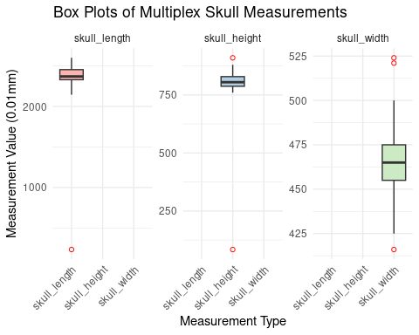
#Creating Density charts to know distribution of a column values for Multiplex
library(ggplot2)
# Density plot for 'skull_length' in the multiplex dataset
p1_multiplex <- ggplot(multiplex, aes(x = skull_length)) +
geom_density(fill = "blue", alpha = 0.5) +
labs(title = "Density of Skull Length - Multiplex", x = "Skull Length", y = "Density") +
theme_minimal()
# Density plot for 'skull_height' in the multiplex dataset
p2_multiplex <- ggplot(multiplex, aes(x = skull_height)) +
geom_density(fill = "red", alpha = 0.5) +
labs(title = "Density of Skull Height - Multiplex", x = "Skull Height", y = "Density") +
theme_minimal()
# Density plot for 'skull_width' in the multiplex dataset
p3_multiplex <- ggplot(multiplex, aes(x = skull_width)) +
geom_density(fill = "green", alpha = 0.5) +
labs(title = "Density of Skull Width - Multiplex", x = "Skull Width", y = "Density") +
theme_minimal()
# Display the plots
gridExtra::grid.arrange(p1_multiplex, p2_multiplex, p3_multiplex, ncol = 3)
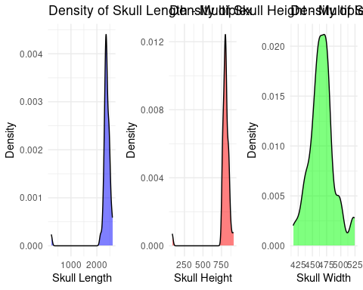 The box plot and density plot show how the skull measurements—length, height, and width—vary for a species known as “Multiplex.” Both skull length and height have a moderate spread with some rare, extreme values. In particular, skull width shows more variability, with values that frequently stray far from the average, both lower and higher. The density plots support this, showing that most skulls have lengths and heights close to a common middle value, but skull width varies more widely across different skulls. This broader variation in width is reflected in a spread-out pattern in its density plot, suggesting that skull width is a more diverse trait within this species.
library(ggplot2)
#creating boxplots to find ouliers for subterraneus
# Prepare data by melting it into long format for easy faceting
subterraneus_long <- reshape2::melt(subterraneus, id.vars = "vole_skull_index", measure.vars = c("skull_length", "skull_height", "skull_width"))
# Create box plots for all features
ggplot(subterraneus_long, aes(x = variable, y = value, fill = variable)) +
geom_boxplot(outlier.colour = "red", outlier.shape = 1) + # Red color for outliers
scale_fill_brewer(palette = "Pastel1") + # Colorful boxes using a pastel palette
facet_wrap(~ variable, scales = "free_y") + # Separate plots for each feature
labs(title = "Box Plots of subterraneus Skull Measurements", x = "Measurement Type", y = "Measurement Value (0.01mm)") +
theme_minimal() +
theme(legend.position = "none", # Hide legend since color distinguishes the features
axis.text.x = element_text(angle = 45, hjust = 1)) # Rotate x labels for clarity
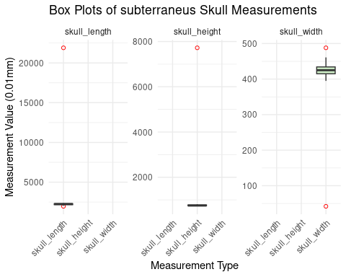
#Creating Density charts to know distribution of a column values for subterraneus
library(ggplot2)
# Density plot for 'skull_length' in the subterraneus dataset
p1_subterraneus <- ggplot(subterraneus, aes(x = skull_length)) +
geom_density(fill = "blue", alpha = 0.5) +
labs(title = "Density of Skull Length - subterraneus", x = "Skull Length", y = "Density") +
theme_minimal()
# Density plot for 'skull_height' in the subterraneus dataset
p2_subterraneus <- ggplot(subterraneus, aes(x = skull_height)) +
geom_density(fill = "red", alpha = 0.5) +
labs(title = "Density of Skull Height - subterraneus", x = "Skull Height", y = "Density") +
theme_minimal()
# Density plot for 'skull_width' in the subterraneus dataset
p3_subterraneus <- ggplot(subterraneus, aes(x = skull_width)) +
geom_density(fill = "green", alpha = 0.5) +
labs(title = "Density of Skull Width - subterraneus", x = "Skull Width", y = "Density") +
theme_minimal()
# Display the plots
gridExtra::grid.arrange(p1_subterraneus, p2_subterraneus, p3_subterraneus, ncol = 3)
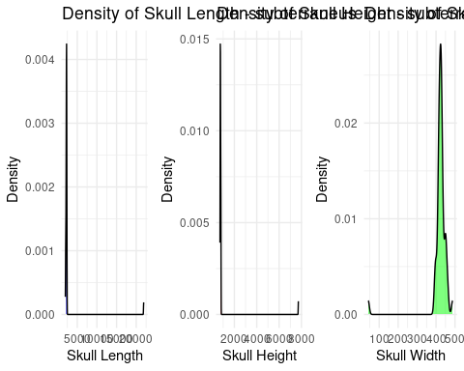 box plots and density plots for Subterraneus skull measurements reveal significant outliers and extreme variability, particularly in skull length and height. The box plots show that while the median values for skull height and width are within a more typical range, the lengths and heights have extreme outliers far beyond the norm, with skull length outliers over 20,000 and skull height exceeding 8,000. The density plots confirm this distribution, displaying sharp peaks at lower values for height and width, indicating a concentration of most data at these levels, but with skull length showing a drastic spread, indicative of possible measurement errors or extraordinary specimens.
so we need to handle the outliers –> setting them to the 97.5th percentile value. Upper bound set to 97.5th percentile Lower bound set to 2.5th percentile
# Calculate lower and upper bounds for x, y, and z
lower_bound_x <- quantile(multiplex[[3]], 0.025)
upper_bound_x <- quantile(multiplex[[3]], 0.975)
lower_bound_y <- quantile(multiplex[[4]], 0.025)
upper_bound_y <- quantile(multiplex[[4]], 0.975)
lower_bound_z <- quantile(multiplex[[5]], 0.025)
upper_bound_z <- quantile(multiplex[[5]], 0.975)
# Replace values outside the bounds for x, y, and z
multiplex[[3]][multiplex[[3]] < lower_bound_x] <- lower_bound_x
multiplex[[3]][multiplex[[3]] > upper_bound_x] <- upper_bound_x
multiplex[[4]][multiplex[[4]] < lower_bound_y] <- lower_bound_y
multiplex[[4]][multiplex[[4]] > upper_bound_y] <- upper_bound_y
multiplex[[5]][multiplex[[5]] < lower_bound_z] <- lower_bound_z
multiplex[[5]][multiplex[[5]] > upper_bound_z] <- upper_bound_z
# Calculate lower and upper bounds for x, y, and z
lower_bound_x <- quantile(subterraneus[[3]], 0.025)
upper_bound_x <- quantile(subterraneus[[3]], 0.975)
lower_bound_y <- quantile(subterraneus[[4]], 0.025)
upper_bound_y <- quantile(subterraneus[[4]], 0.975)
lower_bound_z <- quantile(subterraneus[[5]], 0.025)
upper_bound_z <- quantile(subterraneus[[5]], 0.975)
# Replace values outside the bounds for x, y, and z
subterraneus[[3]][subterraneus[[3]] < lower_bound_x] <- lower_bound_x
subterraneus[[3]][subterraneus[[3]] > upper_bound_x] <- upper_bound_x
subterraneus[[4]][subterraneus[[4]] < lower_bound_y] <- lower_bound_y
subterraneus[[4]][subterraneus[[4]] > upper_bound_y] <- upper_bound_y
subterraneus[[5]][subterraneus[[5]] < lower_bound_z] <- lower_bound_z
subterraneus[[5]][subterraneus[[5]] > upper_bound_z] <- upper_bound_z
# Check the structure and summary of the cleaned data
multiplex_clean <- multiplex
subterraneus_clean <- subterraneus
summary(multiplex_clean)
## vole_skull_index chromosomal_analysis_ID skull_length skull_height
## Min. : 1.0 Length:43 Min. :2150 Min. :760.0
## 1st Qu.:11.5 Class :character 1st Qu.:2330 1st Qu.:787.5
## Median :22.0 Mode :character Median :2370 Median :805.0
## Mean :22.0 Mean :2381 Mean :806.8
## 3rd Qu.:32.5 3rd Qu.:2454 3rd Qu.:829.0
## Max. :43.0 Max. :2587 Max. :879.0
## skull_width
## Min. :425.5
## 1st Qu.:455.0
## Median :465.0
## Mean :466.5
## 3rd Qu.:475.0
## Max. :520.0
summary(subterraneus_clean)
## vole_skull_index chromosomal_analysis_ID skull_length skull_height
## Min. : 1.00 Length:46 Min. :2044 Min. :720.6
## 1st Qu.:12.25 Class :character 1st Qu.:2176 1st Qu.:741.2
## Median :23.50 Mode :character Median :2255 Median :750.0
## Mean :23.50 Mean :2232 Mean :758.9
## 3rd Qu.:34.75 3rd Qu.:2290 3rd Qu.:775.8
## Max. :46.00 Max. :2364 Max. :803.8
## skull_width
## Min. :395.0
## 1st Qu.:415.0
## Median :425.0
## Mean :426.1
## 3rd Qu.:434.2
## Max. :460.9
# Check the structure and summary of the cleaned data
summary(multiplex_clean)
## vole_skull_index chromosomal_analysis_ID skull_length skull_height
## Min. : 1.0 Length:43 Min. :2150 Min. :760.0
## 1st Qu.:11.5 Class :character 1st Qu.:2330 1st Qu.:787.5
## Median :22.0 Mode :character Median :2370 Median :805.0
## Mean :22.0 Mean :2381 Mean :806.8
## 3rd Qu.:32.5 3rd Qu.:2454 3rd Qu.:829.0
## Max. :43.0 Max. :2587 Max. :879.0
## skull_width
## Min. :425.5
## 1st Qu.:455.0
## Median :465.0
## Mean :466.5
## 3rd Qu.:475.0
## Max. :520.0
summary(subterraneus_clean)
## vole_skull_index chromosomal_analysis_ID skull_length skull_height
## Min. : 1.00 Length:46 Min. :2044 Min. :720.6
## 1st Qu.:12.25 Class :character 1st Qu.:2176 1st Qu.:741.2
## Median :23.50 Mode :character Median :2255 Median :750.0
## Mean :23.50 Mean :2232 Mean :758.9
## 3rd Qu.:34.75 3rd Qu.:2290 3rd Qu.:775.8
## Max. :46.00 Max. :2364 Max. :803.8
## skull_width
## Min. :395.0
## 1st Qu.:415.0
## Median :425.0
## Mean :426.1
## 3rd Qu.:434.2
## Max. :460.9
library(ggplot2)
# Prepare data by melting it into long format for easy faceting
multiplex_clean_long <- reshape2::melt(multiplex_clean, id.vars = "vole_skull_index", measure.vars = c("skull_length", "skull_height", "skull_width"))
# Create box plots for all features
ggplot(multiplex_clean_long, aes(x = variable, y = value, fill = variable)) +
geom_boxplot(outlier.colour = "red", outlier.shape = 1) + # Red color for outliers
scale_fill_brewer(palette = "Pastel1") + # Colorful boxes using a pastel palette
facet_wrap(~ variable, scales = "free_y") + # Separate plots for each feature
labs(title = "Box Plots of Multiplex_Clean Skull Measurements", x = "Measurement Type", y = "Measurement Value (0.01mm)") +
theme_minimal() +
theme(legend.position = "none", # Hide legend since color distinguishes the features
axis.text.x = element_text(angle = 45, hjust = 1)) # Rotate x labels for clarity
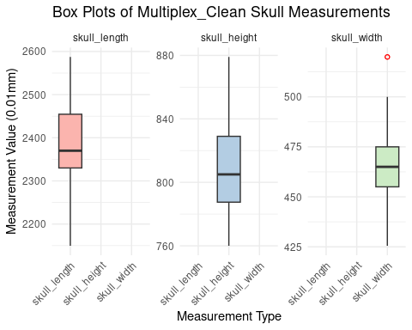
library(ggplot2)
# Density plot for 'skull_length' in the multiplex_clean dataset
p1_multiplex_clean <- ggplot(multiplex_clean, aes(x = skull_length)) +
geom_density(fill = "blue", alpha = 0.5) +
labs(title = "Density of Skull Length - multiplex_clean", x = "Skull Length", y = "Density") +
theme_minimal()
# Density plot for 'skull_height' in the multiplex_clean dataset
p2_multiplex_clean <- ggplot(multiplex_clean, aes(x = skull_height)) +
geom_density(fill = "red", alpha = 0.5) +
labs(title = "Density of Skull Height - multiplex_clean", x = "Skull Height", y = "Density") +
theme_minimal()
# Density plot for 'skull_width' in the multiplex_clean dataset
p3_multiplex_clean <- ggplot(multiplex_clean, aes(x = skull_width)) +
geom_density(fill = "green", alpha = 0.5) +
labs(title = "Density of Skull Width - multiplex_clean", x = "Skull Width", y = "Density") +
theme_minimal()
# Display the plots
gridExtra::grid.arrange(p1_multiplex_clean, p2_multiplex_clean, p3_multiplex_clean, ncol = 3)
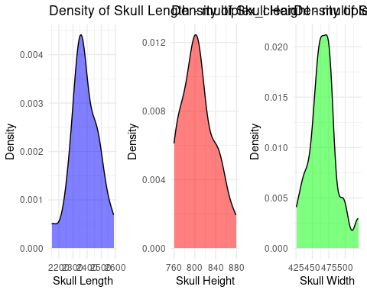
library(ggplot2)
# Prepare data by melting it into long format for easy faceting
subterraneus_clean_long <- reshape2::melt(subterraneus_clean, id.vars = "vole_skull_index", measure.vars = c("skull_length", "skull_height", "skull_width"))
# Create box plots for all features
ggplot(subterraneus_clean_long, aes(x = variable, y = value, fill = variable)) +
geom_boxplot(outlier.colour = "red", outlier.shape = 1) + # Red color for outliers
scale_fill_brewer(palette = "Pastel1") + # Colorful boxes using a pastel palette
facet_wrap(~ variable, scales = "free_y") + # Separate plots for each feature
labs(title = "Box Plots of subterraneus_clean Skull Measurements", x = "Measurement Type", y = "Measurement Value (0.01mm)") +
theme_minimal() +
theme(legend.position = "none", # Hide legend since color distinguishes the features
axis.text.x = element_text(angle = 45, hjust = 1)) # Rotate x labels for clarity
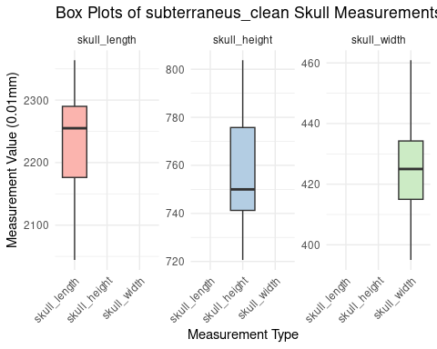
library(ggplot2)
# Density plot for 'skull_length' in the subterraneus_clean dataset
p1_subterraneus_clean <- ggplot(subterraneus_clean, aes(x = skull_length)) +
geom_density(fill = "blue", alpha = 0.5) +
labs(title = "Density of Skull Length - subterraneus_clean", x = "Skull Length", y = "Density") +
theme_minimal()
# Density plot for 'skull_height' in the subterraneus_clean dataset
p2_subterraneus_clean <- ggplot(subterraneus_clean, aes(x = skull_height)) +
geom_density(fill = "red", alpha = 0.5) +
labs(title = "Density of Skull Height - subterraneus_clean", x = "Skull Height", y = "Density") +
theme_minimal()
# Density plot for 'skull_width' in the subterraneus_clean dataset
p3_subterraneus_clean <- ggplot(subterraneus_clean, aes(x = skull_width)) +
geom_density(fill = "green", alpha = 0.5) +
labs(title = "Density of Skull Width - subterraneus_clean", x = "Skull Width", y = "Density") +
theme_minimal()
# Display the plots
gridExtra::grid.arrange(p1_subterraneus_clean, p2_subterraneus_clean, p3_subterraneus_clean, ncol = 3)
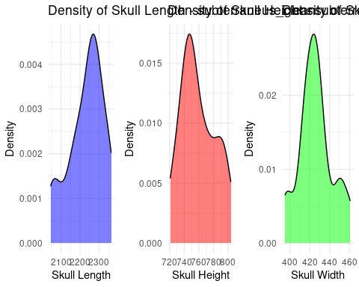
# Specify the file path and save the multiplex_clean dataset as a CSV file
write.csv(multiplex_clean, "multiplex_clean.csv", row.names = FALSE)
# Specify the file path and save the subterraneus_clean dataset as a CSV file
write.csv(subterraneus_clean, "subterraneus_clean.csv", row.names = FALSE)
library(dplyr)
##
## Attaching package: 'dplyr'
## The following objects are masked from 'package:stats':
##
## filter, lag
## The following objects are masked from 'package:base':
##
## intersect, setdiff, setequal, union
# Merge the datasets
combined_data <- bind_rows(multiplex_clean, subterraneus_clean)
combined_data <- combined_data[, -1]
combined_data <- combined_data[, c("skull_length", "skull_height", "skull_width", "chromosomal_analysis_ID")]
# Save the combined dataset to a CSV file
write.csv(combined_data, "combined_data.csv", row.names = FALSE)
library(dplyr) # For data manipulation
library(ggplot2) # For creating visualizations
library(gridExtra) # For arranging multiple plots
##
## Attaching package: 'gridExtra'
## The following object is masked from 'package:dplyr':
##
## combine
summary(combined_data)
## skull_length skull_height skull_width chromosomal_analysis_ID
## Min. :2044 Min. :720.6 Min. :395.0 Length:89
## 1st Qu.:2237 1st Qu.:750.0 1st Qu.:425.0 Class :character
## Median :2300 Median :776.0 Median :446.0 Mode :character
## Mean :2304 Mean :782.0 Mean :445.6
## 3rd Qu.:2370 3rd Qu.:804.0 3rd Qu.:465.0
## Max. :2587 Max. :879.0 Max. :520.0

Training the data using CV
Now we use cross validation with 10 fold as a function to train and test the model.
#creating seven feature combinations to develop glm models
library(caret)
## Loading required package: lattice
combined_data$chromosomal_analysis_ID <- as.factor(combined_data$chromosomal_analysis_ID)
# Define feature combinations
feature_combinations <- list(
c("skull_length", "skull_height", "skull_width"), # Model with three features
c("skull_length", "skull_height"), # Model with Length and Height
c("skull_length", "skull_width"), # Model with Length and Rostrum
c("skull_height", "skull_width"), # Model with Height and Rostrum
c("skull_length"), # Model with Length only
c("skull_height"), # Model with Height only
c("skull_width") # Model with Rostrum only
)
#Training seven models
cv_results <- list()
for (i in seq_along(feature_combinations)) {
# Define the formula based on feature combinations
formula <- as.formula(paste("chromosomal_analysis_ID ~", paste(feature_combinations[[i]], collapse = "+")))
# Set up cross-validation
train_control <- trainControl(method = "cv", number = 10, classProbs = TRUE, savePredictions = "final")
# Train the model using cross-validation
cv_model <- train(formula, data = combined_data, method = "glm", family = binomial(), trControl = train_control)
# Store results
cv_results[[i]] <- cv_model
}
# Print results from seven models
for (i in seq_along(cv_results)) {
cat("\nResults for Model", i, "using Cross-Validation:\n")
print(cv_results[[i]])
print(summary(cv_results[[i]]))
}
##
## Results for Model 1 using Cross-Validation:
## Generalized Linear Model
##
## 89 samples
## 3 predictor
## 2 classes: 'multiplex', 'subterraneus'
##
## No pre-processing
## Resampling: Cross-Validated (10 fold)
## Summary of sample sizes: 80, 81, 80, 79, 80, 80, ...
## Resampling results:
##
## Accuracy Kappa
## 0.8833333 0.7660694
##
##
## Call:
## NULL
##
## Coefficients:
## Estimate Std. Error z value Pr(>|z|)
## (Intercept) 77.1270157 17.1040589 4.509 6.5e-06 ***
## skull_length 0.0004584 0.0059136 0.078 0.93822
## skull_height -0.0437707 0.0161474 -2.711 0.00671 **
## skull_width -0.0986386 0.0296264 -3.329 0.00087 ***
## ---
## Signif. codes: 0 '***' 0.001 '**' 0.01 '*' 0.05 '.' 0.1 ' ' 1
##
## (Dispersion parameter for binomial family taken to be 1)
##
## Null deviance: 123.279 on 88 degrees of freedom
## Residual deviance: 47.238 on 85 degrees of freedom
## AIC: 55.238
##
## Number of Fisher Scoring iterations: 6
##
##
## Results for Model 2 using Cross-Validation:
## Generalized Linear Model
##
## 89 samples
## 2 predictor
## 2 classes: 'multiplex', 'subterraneus'
##
## No pre-processing
## Resampling: Cross-Validated (10 fold)
## Summary of sample sizes: 80, 80, 79, 80, 80, 80, ...
## Resampling results:
##
## Accuracy Kappa
## 0.7955556 0.5794938
##
##
## Call:
## NULL
##
## Coefficients:
## Estimate Std. Error z value Pr(>|z|)
## (Intercept) 73.544020 16.279553 4.518 6.26e-06 ***
## skull_length -0.014295 0.004888 -2.925 0.003448 **
## skull_height -0.051898 0.015227 -3.408 0.000654 ***
## ---
## Signif. codes: 0 '***' 0.001 '**' 0.01 '*' 0.05 '.' 0.1 ' ' 1
##
## (Dispersion parameter for binomial family taken to be 1)
##
## Null deviance: 123.279 on 88 degrees of freedom
## Residual deviance: 61.556 on 86 degrees of freedom
## AIC: 67.556
##
## Number of Fisher Scoring iterations: 6
##
##
## Results for Model 3 using Cross-Validation:
## Generalized Linear Model
##
## 89 samples
## 2 predictor
## 2 classes: 'multiplex', 'subterraneus'
##
## No pre-processing
## Resampling: Cross-Validated (10 fold)
## Summary of sample sizes: 80, 81, 80, 80, 80, 80, ...
## Resampling results:
##
## Accuracy Kappa
## 0.8313889 0.6642576
##
##
## Call:
## NULL
##
## Coefficients:
## Estimate Std. Error z value Pr(>|z|)
## (Intercept) 54.106207 11.367525 4.760 1.94e-06 ***
## skull_length -0.004496 0.004363 -1.030 0.303
## skull_width -0.098101 0.024114 -4.068 4.74e-05 ***
## ---
## Signif. codes: 0 '***' 0.001 '**' 0.01 '*' 0.05 '.' 0.1 ' ' 1
##
## (Dispersion parameter for binomial family taken to be 1)
##
## Null deviance: 123.279 on 88 degrees of freedom
## Residual deviance: 56.684 on 86 degrees of freedom
## AIC: 62.684
##
## Number of Fisher Scoring iterations: 6
##
##
## Results for Model 4 using Cross-Validation:
## Generalized Linear Model
##
## 89 samples
## 2 predictor
## 2 classes: 'multiplex', 'subterraneus'
##
## No pre-processing
## Resampling: Cross-Validated (10 fold)
## Summary of sample sizes: 80, 80, 80, 80, 79, 80, ...
## Resampling results:
##
## Accuracy Kappa
## 0.8747222 0.7480488
##
##
## Call:
## NULL
##
## Coefficients:
## Estimate Std. Error z value Pr(>|z|)
## (Intercept) 77.42510 16.76203 4.619 3.85e-06 ***
## skull_height -0.04353 0.01589 -2.739 0.00616 **
## skull_width -0.09736 0.02455 -3.966 7.31e-05 ***
## ---
## Signif. codes: 0 '***' 0.001 '**' 0.01 '*' 0.05 '.' 0.1 ' ' 1
##
## (Dispersion parameter for binomial family taken to be 1)
##
## Null deviance: 123.279 on 88 degrees of freedom
## Residual deviance: 47.244 on 86 degrees of freedom
## AIC: 53.244
##
## Number of Fisher Scoring iterations: 6
##
##
## Results for Model 5 using Cross-Validation:
## Generalized Linear Model
##
## 89 samples
## 1 predictor
## 2 classes: 'multiplex', 'subterraneus'
##
## No pre-processing
## Resampling: Cross-Validated (10 fold)
## Summary of sample sizes: 80, 81, 81, 79, 80, 80, ...
## Resampling results:
##
## Accuracy Kappa
## 0.8027778 0.5993814
##
##
## Call:
## NULL
##
## Coefficients:
## Estimate Std. Error z value Pr(>|z|)
## (Intercept) 44.714799 10.002869 4.47 7.81e-06 ***
## skull_length -0.019342 0.004327 -4.47 7.82e-06 ***
## ---
## Signif. codes: 0 '***' 0.001 '**' 0.01 '*' 0.05 '.' 0.1 ' ' 1
##
## (Dispersion parameter for binomial family taken to be 1)
##
## Null deviance: 123.279 on 88 degrees of freedom
## Residual deviance: 78.105 on 87 degrees of freedom
## AIC: 82.105
##
## Number of Fisher Scoring iterations: 5
##
##
## Results for Model 6 using Cross-Validation:
## Generalized Linear Model
##
## 89 samples
## 1 predictor
## 2 classes: 'multiplex', 'subterraneus'
##
## No pre-processing
## Resampling: Cross-Validated (10 fold)
## Summary of sample sizes: 80, 80, 80, 80, 80, 79, ...
## Resampling results:
##
## Accuracy Kappa
## 0.7736111 0.5451072
##
##
## Call:
## NULL
##
## Coefficients:
## Estimate Std. Error z value Pr(>|z|)
## (Intercept) 50.63175 10.38734 4.874 1.09e-06 ***
## skull_height -0.06480 0.01332 -4.865 1.14e-06 ***
## ---
## Signif. codes: 0 '***' 0.001 '**' 0.01 '*' 0.05 '.' 0.1 ' ' 1
##
## (Dispersion parameter for binomial family taken to be 1)
##
## Null deviance: 123.279 on 88 degrees of freedom
## Residual deviance: 73.377 on 87 degrees of freedom
## AIC: 77.377
##
## Number of Fisher Scoring iterations: 5
##
##
## Results for Model 7 using Cross-Validation:
## Generalized Linear Model
##
## 89 samples
## 1 predictor
## 2 classes: 'multiplex', 'subterraneus'
##
## No pre-processing
## Resampling: Cross-Validated (10 fold)
## Summary of sample sizes: 81, 80, 80, 80, 79, 80, ...
## Resampling results:
##
## Accuracy Kappa
## 0.8277778 0.6539208
##
##
## Call:
## NULL
##
## Coefficients:
## Estimate Std. Error z value Pr(>|z|)
## (Intercept) 48.85488 9.50539 5.140 2.75e-07 ***
## skull_width -0.10963 0.02135 -5.135 2.82e-07 ***
## ---
## Signif. codes: 0 '***' 0.001 '**' 0.01 '*' 0.05 '.' 0.1 ' ' 1
##
## (Dispersion parameter for binomial family taken to be 1)
##
## Null deviance: 123.28 on 88 degrees of freedom
## Residual deviance: 57.75 on 87 degrees of freedom
## AIC: 61.75
##
## Number of Fisher Scoring iterations: 6
##Predicting the unknown data Making unknown data into seven subsets files based on features to test with their respective model.
# Define all possible columns in the dataset for reference
all_columns <- c("skull_length", "skull_height", "skull_width")
# Define the feature combinations
feature_combinations <- list(
c("skull_length", "skull_height", "skull_width"), # Model with three features
c("skull_length", "skull_height"), # Model with Length and Height
c("skull_length", "skull_width"), # Model with Length and Rostrum
c("skull_height", "skull_width"), # Model with Height and Rostrum
c("skull_length"), # Model with Length only
c("skull_height"), # Model with Height only
c("skull_width") # Model with Rostrum only
)
# Process each feature combination
for (i in seq_along(feature_combinations)) {
# Select only the relevant columns for this model
data_subset <- unknown[, feature_combinations[[i]], drop = FALSE]
# Identify non-relevant columns for this combination
non_relevant_columns <- setdiff(all_columns, feature_combinations[[i]])
# Filter out rows where any of the non-relevant columns are not NA
if (length(non_relevant_columns) > 0) {
# Ensure that the subset operation does not drop dimensions, even if it's a single column
temp_non_rel_data <- unknown[, non_relevant_columns, drop = FALSE]
data_subset <- data_subset[rowSums(!is.na(temp_non_rel_data)) == 0, , drop = FALSE]
}
# Remove rows with any NAs in the relevant columns, ensuring data_subset stays as a dataframe
if(ncol(data_subset) > 0) {
data_subset <- data_subset[complete.cases(data_subset), , drop = FALSE]
}
# Check if the dataframe is empty or has been reduced incorrectly
if (ncol(data_subset) > 0 && nrow(data_subset) > 0) {
# Save to CSV only if data subset is not empty
filename <- paste0("unknown_subset_", i, ".csv")
write.csv(data_subset, filename, row.names = FALSE)
} else {
cat(sprintf("No data available to save for model %d due to filtering or NA removal.\n", i))
}
}
predicting seven unknown data subsets with respective feature combination models.
library(caret) # If not already loaded
unknown_results <- list()
for (i in seq_along(cv_results)) {
# Load the data for this model
filename <- paste0("unknown_subset_", i, ".csv")
model_data <- read.csv(filename)
# Predict using the ith model
predictions <- predict(cv_results[[i]], model_data, type = "raw")
probabilities <- predict(cv_results[[i]], model_data, type = "prob")
# Store results
unknown_results[[i]] <- list(predictions = predictions, probabilities = probabilities)
}
Printing the predicted results
# Summarize predictions
for (i in seq_along(unknown_results)) {
cat("\nModel", i, "Summary:\n")
print(table(unknown_results[[i]]$predictions)) # Show frequency of each predicted class
if ("probabilities" %in% names(unknown_results[[i]])) {
cat("\nModel", i, "Probability Summary:\n")
summary_stats <- summary(unknown_results[[i]]$probabilities) # Summarize probabilities if available
print(summary_stats)
}
}
##
## Model 1 Summary:
##
## multiplex subterraneus
## 67 50
##
## Model 1 Probability Summary:
## multiplex subterraneus
## Min. :0.00000 Min. :0.000000
## 1st Qu.:0.06275 1st Qu.:0.008317
## Median :0.73160 Median :0.268398
## Mean :0.57201 Mean :0.427993
## 3rd Qu.:0.99168 3rd Qu.:0.937249
## Max. :1.00000 Max. :1.000000
##
## Model 2 Summary:
##
## multiplex subterraneus
## 11 7
##
## Model 2 Probability Summary:
## multiplex subterraneus
## Min. :0.01144 Min. :0.0005565
## 1st Qu.:0.20612 1st Qu.:0.0699212
## Median :0.63475 Median :0.3652528
## Mean :0.55974 Mean :0.4402641
## 3rd Qu.:0.93008 3rd Qu.:0.7938825
## Max. :0.99944 Max. :0.9885602
##
## Model 3 Summary:
##
## multiplex subterraneus
## 10 10
##
## Model 3 Probability Summary:
## multiplex subterraneus
## Min. :0.01808 Min. :0.0001548
## 1st Qu.:0.05912 1st Qu.:0.1380468
## Median :0.63060 Median :0.3693994
## Mean :0.50746 Mean :0.4925372
## 3rd Qu.:0.86195 3rd Qu.:0.9408819
## Max. :0.99985 Max. :0.9819172
##
## Model 4 Summary:
##
## multiplex subterraneus
## 10 8
##
## Model 4 Probability Summary:
## multiplex subterraneus
## Min. :0.003615 Min. :0.0000143
## 1st Qu.:0.115976 1st Qu.:0.0134807
## Median :0.670986 Median :0.3290140
## Mean :0.570812 Mean :0.4291877
## 3rd Qu.:0.986519 3rd Qu.:0.8840238
## Max. :0.999986 Max. :0.9963851
##
## Model 5 Summary:
##
## multiplex subterraneus
## 2 2
##
## Model 5 Probability Summary:
## multiplex subterraneus
## Min. :0.02629 Min. :0.2448
## 1st Qu.:0.32137 1st Qu.:0.3034
## Median :0.54836 Median :0.4516
## Mean :0.46956 Mean :0.5304
## 3rd Qu.:0.69655 3rd Qu.:0.6786
## Max. :0.75525 Max. :0.9737
##
## Model 6 Summary:
##
## multiplex subterraneus
## 6 3
##
## Model 6 Probability Summary:
## multiplex subterraneus
## Min. :0.06406 Min. :0.0006346
## 1st Qu.:0.32349 1st Qu.:0.0149670
## Median :0.86461 Median :0.1353895
## Mean :0.67732 Mean :0.3226813
## 3rd Qu.:0.98503 3rd Qu.:0.6765084
## Max. :0.99937 Max. :0.9359377
##
## Model 7 Summary:
##
## multiplex subterraneus
## 9 4
##
## Model 7 Probability Summary:
## multiplex subterraneus
## Min. :0.02446 Min. :0.003196
## 1st Qu.:0.35065 1st Qu.:0.042641
## Median :0.79531 Median :0.204692
## Mean :0.66593 Mean :0.334074
## 3rd Qu.:0.95736 3rd Qu.:0.649349
## Max. :0.99680 Max. :0.975539

