Modern Applied Statistics (STAT 601)
Fall 2023

Project 3

Generalized Linear Model for Classification of two classes of Microtus.

Submitted By
Sai Ram Vodnala
Soniya Shahi
Kevin Osei-Onomah
Carlos Quevedo Garza

November 28, 2024
Introduction
In this study, we have undertaken the task of developing a Generalized Linear Model (GLM) with a binomial family response, akin to a logistic regression model. Our dataset comprises 89 classified voles, with 43 belonging to the multiplex species and 46 to the subterraneous species.
To ensure the accuracy of our model, we have adhered to a systematic approach. The initial phase of our analysis involved an in-depth exploration of the dataset. This exploration not only familiarized us with the structure of the data but also highlighted potential challenges such as missing values and outliers.
Addressing data quality concerns, we removed rows with missing values and implemented outlier handling techniques. By addressing these issues early in the analysis, we aimed to create a more reliable and representative dataset for model training.
With the refined dataset in hand, our next steps involved the selection and exploration of relevant dependent variables. In this context, we considered Length Condylo incisive length (0.01mm), Height (Skull height above bullae in 0.01mm), and Rostrum (Skull width across rostrum in 0.01mm) as potential predictors for our GLM. The choice of these variables is rooted in their biological significance and significance to microtus classification.
The subsequent sections will explore into the specifics of our modeling process, including the formulation of different models with various combinations of dependent variables. We will elaborate on the rationale behind these choices and discuss the implications of our findings in the context of microtus classification. Through this systematic approach, we aim to contribute to the development of a robust logistic regression model that can effectively discriminate between multiplex and subterraneus voles based on selected skull measurements. The line indicates how much the dependent variable changes for a unit change in the independent variable(s).
Logistic Regression
Logistic regression is a statistical analysis method to predict a binary outcome, such as yes or no, based on prior observations of a data set. A logistic regression model predicts a dependent data variable by analyzing the relationship between one or more existing independent variables. For example, a logistic regression could be used to predict whether a political candidate will win or lose an election. These binary outcomes allow straightforward decisions between two alternatives.
$$P (Y|X) = \frac{1}{1 + e^{-Xβ}}$$
The X represents our predictors. The β represents weights or coefficients for our predictors. If we had two predictors, X₁ and X₂, then
Xβ = X₁β₁ + X₂β₂
No matter what we plug into the model, it always returns a value between 0 and 1, or a probability.\
Exploratory Data Analysis
Missing Values Removal:
In our initial examination of the labeled dataset used to train our models, which are constructed from the subterraneous and multiplex worksheets, we identified one empty row in each sheet, and those were subsequently removed. Additionally, we were pleased to discover the absence of any missing values, providing a strong foundation for our analysis.
The unknown dataset, however, had one empty set that was eliminated.
Outlier Handling:
Our outlier handling strategy involved a meticulous examination of the dataset through scatter plots to identify values that deviated significantly from the clustered data. For both types of Microtus - multiplex and Subterraneus - scatter plots were created for the features: Length, Width, and Height.
To handle outliers, we employed an IQR-based approach combined with the median to mitigate their impact. First, we calculated the Interquartile Range (IQR) for each feature (Length, Width, and Height) to determine the spread of the middle 50% of the data. The IQR is the difference between the 75th percentile (Q3) and the 25th percentile (Q1).
We then defined outliers as any data points that fell outside of the following range:
- Lower Bound = Q1 - 1.5 * IQR
- Upper Bound = Q3 + 1.5 * IQR
Rather than simply removing these outliers, we replaced them with the median value of the respective feature. The median was chosen because it is less sensitive to extreme values than the mean, making it a more robust measure for replacing outliers. This process was applied to each feature (Length, Width, and Height) for both types of Microtus species independently. By using this IQR-based method and replacing outliers with the median, we aimed to reduce the influence of extreme values while retaining the integrity of the data, leading to a more reliable and stable dataset for subsequent modeling.
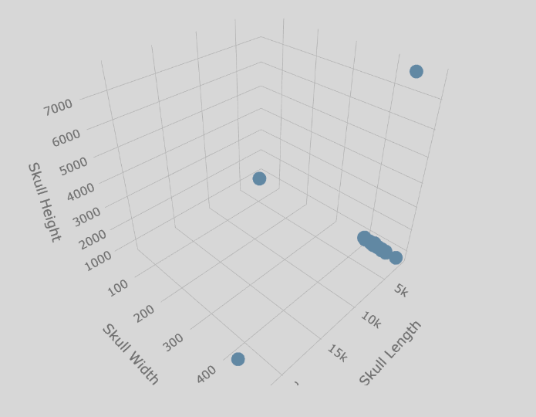  Figure 1: Subterraneus Data before outlier handling | 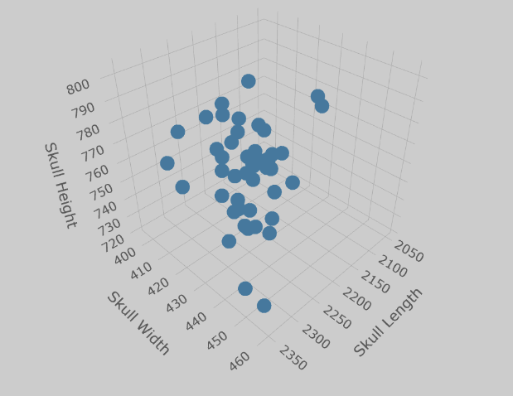  Figure 2: Subterraneus Data after outlier handling
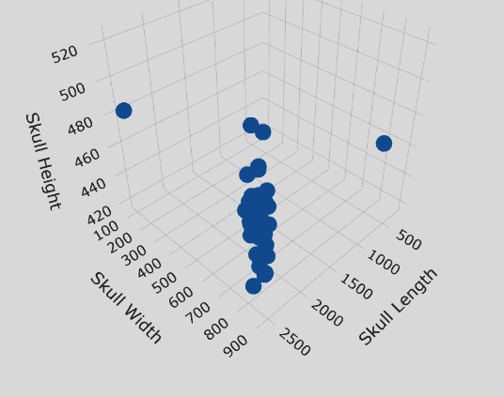  Figure 3: Multiplex Data before Outlier Handling | 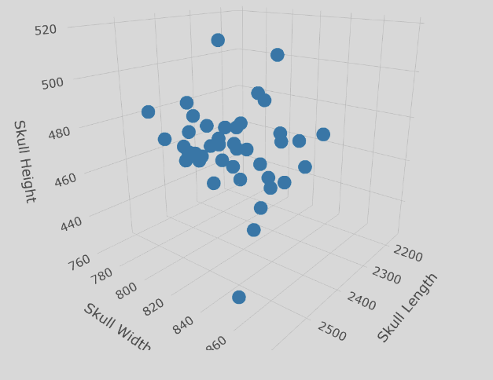  Figure 4: Multiplex Data after outlier handling
Pair plots Visualization:
As a complementary step in our exploratory data analysis, we generated pair plots to visualize relationships between the selected dependent variables (Length, Width, and Height) for both multiplex and subterraneous voles. Pair plots provide a comprehensive view of the pairwise interactions between variables, aiding in identifying potential patterns or trends.
The visual exploration facilitated an intuitive understanding of the data distribution and allowed us to discern any apparent distinctions between the two Microtus species based on the chosen skull measurements. This visualization served as a precursor to the subsequent stages of model development, guiding our variable selection process and influencing the formulation of our logistic regression model.
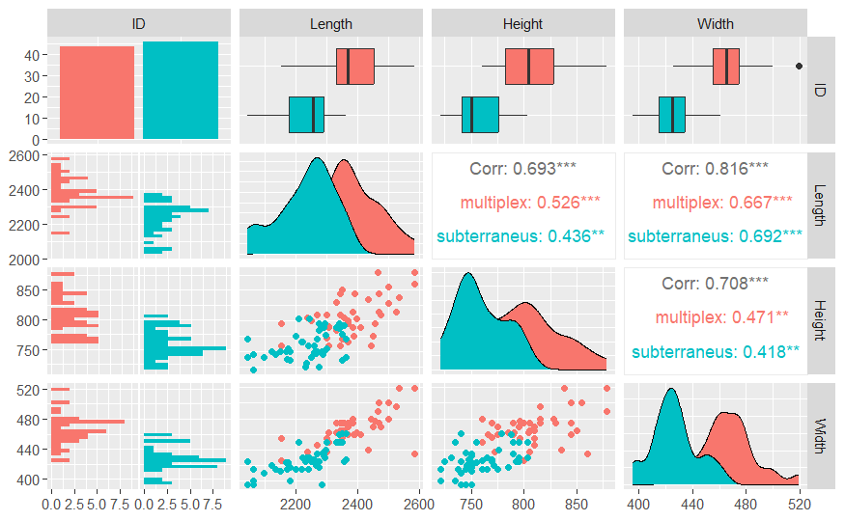
Figure 5: Pair plot among the features of the dataset
The pair plots from our Exploratory Data Analysis (EDA) reveal significant overlap in the datasets of multiplex and subterraneous voles. Although width seems somewhat more distinctive, there is still overlap. Notably, the pair plot for width and height suggests better separability in this plane compared to other feature pairs. This observation guides our choice for feature selection.
From EDA, it appears that the combination of width and height might offer better discriminatory power for classification. To validate this, we will employ five-fold cross-validation in our model development, systematically testing different feature combinations. This strategic approach ensures a robust assessment of the model's performance.
Stepwise Regression Model
To validate insights from our Exploratory Data Analysis (EDA), we employed a stepwise regression model. The model confirmed that the combination of Width and Height holds significance in classifying microtus species. The formula included Length, Width, and Height, along with their interaction terms.
Table 2: Final Stepwise Regression Model summary
Coefficients | Estimate | Std. Error | z-value | p-value
Intercept | 77.72138 | 16.82958 | 4.618 | 3.87e-06
Height | -0.04253 | 0.01574 | -2.702 | 0.00689
Width | -0.09988 | 0.02478 | -4.030 | 5.57e-05

The stepwise regression results shown above highlighted that Width and Height are the most significant features, with p-values less than 0.05. This emphasizes the accuracy of using Height and Width as key contributors to the microtus classification model. Further refinement and validation steps will follow to ensure the model's generalizability and effectiveness.
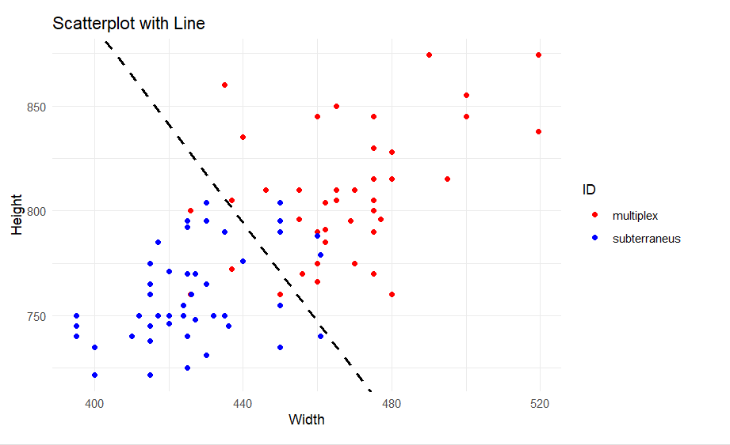
Figure 6: Training dataset with decision boundary
Model Development
Training and Validation
Having consolidated the labeled datasets for subterraneus and multiplex voles, we created a unified training dataset. To assess the model's performance and prevent overfitting, we employed five-fold cross-validation. This technique involves dividing the dataset into five subsets, using four for training and one for validation in each iteration.
We calculated both training and validation accuracies for each of the five iterations, allowing us to derive a more robust assessment of the model's effectiveness. The final training and validation accuracies were obtained by taking the mean of the accuracies across the five iterations.
Developing seven models, each representing a distinct combination of the three features (Length, Width, and Height), we explored the various permutations to identify the most effective feature set for classification. The results from these models provided insights into the significance of each feature combination in the context of microtus classification.
Table 3: Accuracy of models using different combination of features
Formula | Mean Training Accuracy | Mean Validation Accuracy
ID ~ Length + Width + Height | 0.881 | 0.844
ID ~ Length + Width | 0.861 | 0.789
ID ~ Length + Height | 0.827 | 0.711
ID ~ Width + Height | 0.883 | 0.844
ID ~ Length | 0.819 | 0.733
ID ~ Width | 0.850 | 0.822
ID ~ Height | 0.777 | 0.722

The results highlight that width and height emerge as the optimal features for discriminating between the two microtus species, reinforcing findings from our visual Exploratory Data Analysis (EDA) and the stepwise regression process. While the model with all three features demonstrates comparable accuracy, the model employing only width and height stands out for its simplicity and interpretability.
Choosing a simpler model with two features (width and height) proves advantageous not only for its higher accuracy compared to using just length or just height but also for its ease of interpretation. It's worth noting, however, that this simplicity comes at the cost of slightly higher bias, as evidenced by a decrease in accuracy for both training and validation sets when compared to the model with all three features.
In summary, the trade-off between model complexity and accuracy is evident. The model with width and height strikes a balance, offering practical interpretability without sacrificing significant predictive power. Further consideration of this trade-off can guide the selection of the most suitable model for the specific goals and constraints of the microtus classification task.
Predictions
Due to missing values in the unknown dataset, we addressed this challenge by utilizing previously developed models, as mentioned earlier. Each model took precedence based on available features or missing values, considering their accuracy. The model featuring Width and Height took precedence in our analysis, given its effectiveness. Specifically, if all features were present or only Length was missing, we utilized this model for predictions. In cases where Width was missing, we employed the model with Length and Height as features. Similarly, if Height was missing, we utilized the model with Length and Width. For scenarios where two features were missing, we turned to the model with the remaining features as predictors. This systematic approach ensured adaptive predictions based on the availability of features in the dataset.
Model Used | No of Datapoints | Subterraneus | Multiplex
ID ~ Width + Height | 135 | 56 | 79
ID ~ Length + Height | 18 | 8 | 10
ID ~ Length + Width | 20 | 10 | 10
ID ~ Width | 13 | 4 | 9
ID ~ Length | 4 | 2 | 2
ID ~ Height | 9 | 3 | 6
Total | 199 | 83 | 116

Recommendations
- Feature Selection: Given the findings from both Exploratory Data Analysis (EDA) and model development, it is recommended to prioritize the use of width and height as key features for microtus classification. This combination not only provides accurate results but also yields a more interpretable and straightforward model compared to using all three features.
- Model Choice: The model employing width and height features strikes a practical balance between simplicity and accuracy. This model is suggested for applications where interpretability is crucial, understanding that a marginal increase in bias is acceptable.
- Validation and Generalization: While the chosen model demonstrates effectiveness on the training and validation datasets, it is crucial to assess its generalizability to new data. Continued validation and testing on independent datasets will enhance the reliability of the model in real-world applications.
- Further Exploration: Future efforts could involve exploring additional features or incorporating domain-specific knowledge to improve classification accuracy. Continuous refinement of the model based on evolving data and insights can contribute to its ongoing effectiveness.
- Utilize Stepwise Regression for Feature Selection: Incorporating stepwise regression in the feature selection process can streamline the identification of the most relevant variables for the model. This automated approach efficiently narrows down the feature set, reducing the need for exhaustive manual efforts. The use of stepwise regression can enhance efficiency in model development and contribute to the overall effectiveness of the microtus classification model.
References
Airoldi, J. P., Flury, B. D., & Salvioni, M. (1995). Discrimination Between Two Species of Microtus using both Classified and Unclassified Observations. Journal of Theoretical Biology, 177(3), 247-262.
Castro, H. M., & Ferreira, J. C. (2023). Linear and logistic regression models: when to use and how to interpret them?
Das, S. (2022). Discrimination Between Two Species of Microtus. ScienceOpen Preprints.
DataCamp. (2022, December). Linear Regression in R Tutorial. Retrieved from https://www.datacamp.com/tutorial/linear-regression-R
GeeksforGeeks. (n.d.). Linear Regression in Machine Learning. Retrieved from https://www.geeksforgeeks.org/ml-linear-regression/
Johnson, D. (2023, September 30). GLM in R: Generalized Linear Model with Example. Retrieved from https://www.guru99.com/r-generalized-linear-model.html
https://github.com/mominulislam2329/Logistic-Regression-STAT-601/blob/main/README.md
ChatGPT. (10/2024). Used for debugging and code cleaning. Retrieved from OpenAI

