Project 1: Passcode Project One
Introduction
The project is focused on enhancing password-based security systems by incorporating typing dynamics as a biometric feature. The goal is to analyze users’ typing dynamics (keystroke timing) to identify a threshold for when a system can start recognizing "learned" typing behaviors. This threshold will allow us to distinguish between genuine users and potential intruders more effectively. Essentially, you are aiming to determine the optimal amount of typing data needed to create a robust biometric profile for a user.
Data Description:
We began the project by loading and summarizing the dataset while performing checks for missing values. The dataset contains 20,400 observations and 34 variables, providing a robust foundation for analysis.
Dataset Variables were concluded as:
H.period: The amount of time that the "." is held down.
DD.period.t: The time between pressing down the "." key to the time to press down the "t" key.
UD.period.t: The time between the "." key coming up to the time to press down the "t" key.
H.t: The amount of time that the "t" is held down.
DD.t.i: The time between pressing down the "t" key to the time to press down the "i" key.
UD.t.i: The time between the "t" key coming up to the time to press down the "i" key.
H.i: The amount of time that the "i" is held down.
DD.i.e: The time between pressing down the "i" key to the time to press down the "e" key.
UD.i.e: The time between the "i" key coming up to the time to press down the "e" key.
H.e: The amount of time that the "e" is held down.
DD.e.five: The time between pressing down the "e" key to the time to press down the "5" key.
UD.e.five: The time between the "e" key coming up to the time to press down the "5" key.
H.five: The amount of time that the "5" is held down.
DD.five.Shift.r: The time between pressing down the "5" key to the time to press down the "shift+r" key combination.
UD.five.Shift.r: The time between the "5" key coming up to the time to press down the "shift+r" key combination.
H.Shift.r: The amount of time that the "shift+r" key combination is held down.
DD.Shift.r.o: The time between pressing down the "shift+r" key combination to the time to press down the "o" key.
UD.Shift.r.o: The time between the "shift+r" key combination coming up to the time to press down the "o" key.
H.o: The amount of time that the "o" is held down.
DD.o.a: The time between pressing down the "o" key to the time to press down the "a" key.
UD.o.a: The time between the "o" key coming up to the time to press down the "a" key.
H.a: The amount of time that the "a" is held down.
DD.a.n: The time between pressing down the "a" key to the time to press down the "n" key.
UD.a.n: The time between the "a" key coming up to the time to press down the "n" key.
H.n: The amount of time that the "n" is held down.
DD.n.l: The time between pressing down the "n" key to the time to press down the "l" key.
UD.n.l: The time between the "n" key coming up to the time to press down the "l" key.
H.l: The amount of time that the "l" is held down.
DD.l.Return: The time between pressing down the "l" key to the time to press down the "return" key.
UD.l.Return: The time between the "l" key coming up to the time to press down the "return" key.
H.Return: The amount of time that the "return" is held down key.
The data collection group included:
• 51 subject participants
• 8 data collection sessions
• 50 passcode entries per session
• Sessions were one day apart
• Passcode: .tie5Roanl

Covariate Analysis
Variables of Interest
The keypad records numerous timing variables for each key press, including:
• Hold times (H) as total_h_time which is created by adding up the all holding time needed to type the password.
• Down-Down times (DD) as total_dd_time which is created by adding up the all down time needed to type the password.
• Up-Down times (UD) as total_ud_time which is created by adding up the all up time needed to type the password.
We also created a typing count for each subject as variable typing_count.
So, main purpose of Typing Count is
Modeling: It serves as an independent variable to study how typing dynamics (e.g., Hold time, Down-Down time) change with practice.
- Threshold Identification: It helps determine the minimum number of repetitions required to achieve stable or learned typing behavior.
- Regression Analysis: In linear models, typing_count is used to predict changes in metrics like total_H, total_DD, and total_UD.
Filtering to the last 20 (keep only 31 to 50 ) for each subject within each session. is beneficial if we want to focus on consistent and stabilized typing behavior, minimizing the impact of early attempts that may not accurately represent typical typing performance.
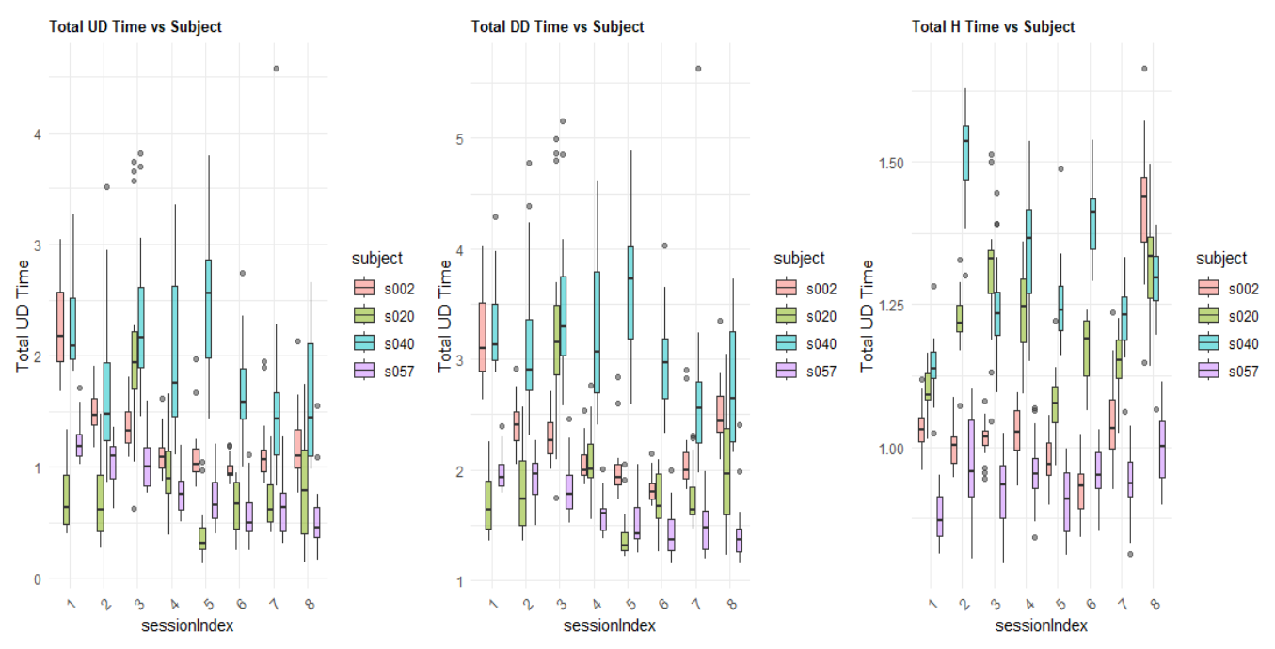
Figure 1. Exploratory Data Analysis (EDA) showing the boxplot of the distribution of total UD, DD, and H time for later 20 typings of selected subjects (s002, s020, s040, and s057).
1. Total UD Time (Up-Down key transitions):
- After filtering (only the top 20 attempts), variability reduces notably, suggesting that subjects become more consistent towards the end of each session.
- There is a clearer downward trend over sessions, indicating subjects significantly improve their key transition speed with repeated practice.
- The presence of fewer extreme outliers compared to the unfiltered data supports the idea that the initial attempts may have been noisier.
2. Total DD Time (Down-Down key intervals):
- Similar to UD times, DD times also exhibit reduced variability and fewer outliers.
3. Total H Time (Hold time):
- Hold times continue to show relatively stable patterns. Variability across sessions and subjects remains minimal compared to UD/DD times, indicating this metric is less sensitive to repeated practice.
- The filtering did not significantly alter the pattern seen previously, reinforcing that hold times are inherently consistent for individuals.
Key Takeaways After Filtering:
- Filtering (top 20 attempts) effectively reduces noise, highlighting more stable, representative typing performance.
- Clear improvement is visible over the sessions, especially in UD and DD timings, reinforcing the learning and practice effect.
- Subjects become more consistent and efficient typists across sessions, primarily improving inter-key transitions (UD/DD) rather than the time keys are physically held down (H).

Regression Analysis
Building the Regression Models:
Dependent Variables: total_UD, total_DD, and total_H.
Independent Variable: typing_count.
Linear models are used
1. Up-Down Time Model
total_ud_time=β0​+β1​⋅typing_count+β2​⋅sessionIndex
2. Down-Down Time Model
total_dd_time=β0​+β1​⋅typing_count+β2​⋅sessionIndex
3. Hold Time Model
total_h_time=β0​+β1​⋅typing_count+β2​⋅sessionIndex
Results:
Table 1. Regression model summary statistics.
Model | Typing Count Coefficient | Session Index Coefficient | Significance of Session Index | R² (Model Fit)
Up-Down Time (UD) | 0.00187 (p = 0.347) | -0.2052 (p = 0.0393) | Significant (faster over sessions) | 0.057
Down-Down Time (DD) | 0.00234 (p = 0.224) | -0.2198 (p = 0.0226) | Significant (faster over sessions) | 0.052
Hold Time (H) | 0.00055 (p = 0.227) | -0.0181 (p = 0.424) | Not Significant | 0.0082

Key Interpretation:
- Session Index is a significant factor for UD and DD times, indicating users type faster with more practice.
- Typing Count does not significantly affect keystroke times across all models.
- Hold Time remains mostly unchanged over multiple typing sessions.
Insight | Observation | Impact
Typing Speed Improves Over Sessions | UD and DD times decrease as session index increases. | Users develop muscle memory and type faster.
Hold Time Remains Constant | No significant decrease in hold time across sessions. | Users consistently hold keys for the same duration, even as they improve overall typing speed.
Low R² Values (Weak Model Fit) | R² values are low, especially for hold time (0.0082). | Other factors (fatigue, cognition, hand placement) might influence typing behavior.

False Discovery Rate (FDR)
The residuals of a regression model should ideally follow a normal distribution, as this assumption underlies many statistical tests and inferences. To evaluate whether this assumption holds for each of the models (Up-Down, Down-Down, Hold), we use False Discovery Rates (FDRs).
The FDR is a statistical method used to adjust for multiple comparisons, particularly when testing the normality of residuals across many observations or models. It provides a more robust control of Type I errors (false positives) when making numerous comparisons.
So firstly, we do Graphical test for Normality assumption:
#QQ plot for UD model
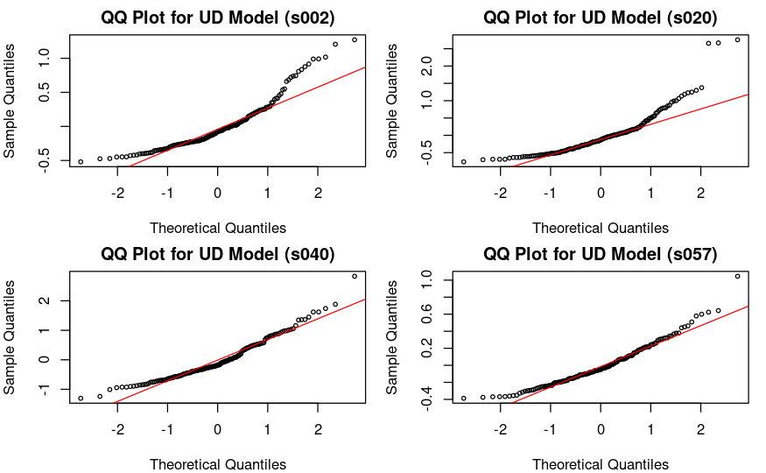
Figure 2. QQ plots for the UD model.
Subject | Normality Check | Possible Issues | Suggested Action
s002 | Not Normal | Moderate deviation at both tails | Consider log transformation to normalize distribution
s020 | Not Normal | Strong deviation at upper end, possible outliers | Investigate and remove extreme values if necessary
s040 | Not Normal | Curvature in QQ plot, indicating systematic bias | Explore nonlinear regression or mixed-effects models
s057 | Approximately Normal | Minimal deviation, residuals follow normality line | No immediate action needed, but verify with more data

#QQ plot for DD model
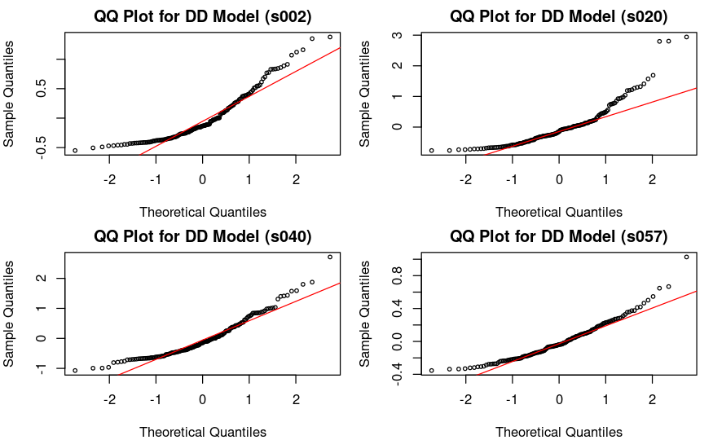
Figure 3. QQ plots for the DD model.

Subject | Normality Check | Possible Issues | Suggested Action
s002 | Not Normal | Moderate deviation at both tails | Consider log transformation to normalize residuals
s020 | Not Normal | Strong deviation in upper tail, potential outliers | Investigate and remove extreme values if necessary
s040 | Not Normal | Curvature in QQ plot, suggesting model bias | Explore nonlinear regression or mixed-effects models
s057 | Approximately Normal | Minimal deviation, residuals closely follow normality | No immediate action needed, verify with additional checks

##QQ plot for H model

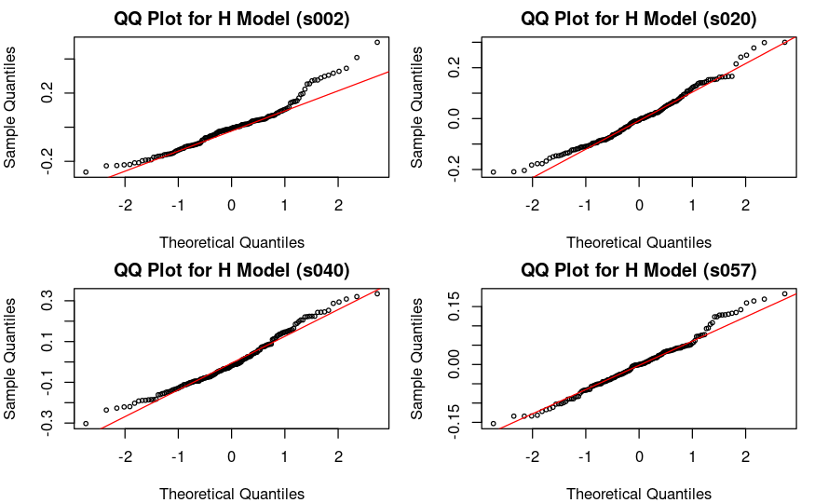
Figure 4. QQ plots for the H model.

Subject | Normality Check | Possible Issues | Suggested Action
s002 | Approximately Normal | Slight deviation at upper tail | No immediate action needed
s020 | Approximately Normal | Small deviations but overall good fit | Continue using the linear model
s040 | Normal | Residuals closely follow normality | No action required
s057 | Normal | Minimal deviation, best fit among all | No action required

#Residuals vs Fitted plot for UD
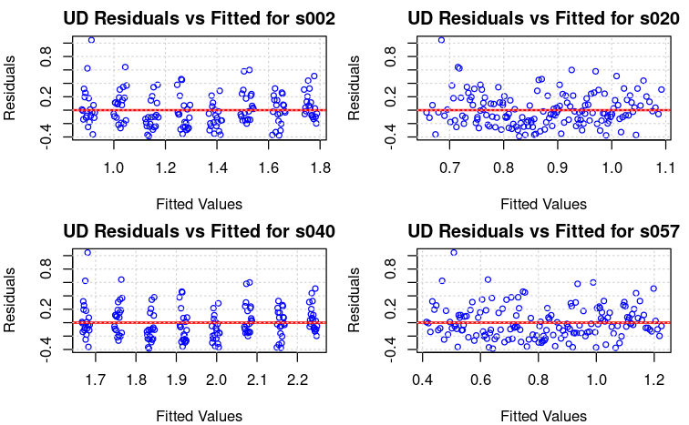
Figure 5. Residuals vs Fitted plots for the UD model.
Subject | Homoscedasticity Check | Pattern in Residuals | Possible Issues
s002 | Mostly constant variance | Minor clustering | Slight heteroscedasticity
s020 | Variance slightly increases with fitted values | Some spread in residuals | Mild heteroscedasticity
s040 | Somewhat uneven spread | Possible outliers | Minor non-constant variance
s057 | Best model fit (no major issues) | Randomly scattered | No major issues

#Residuals vs Fitted plot for DD

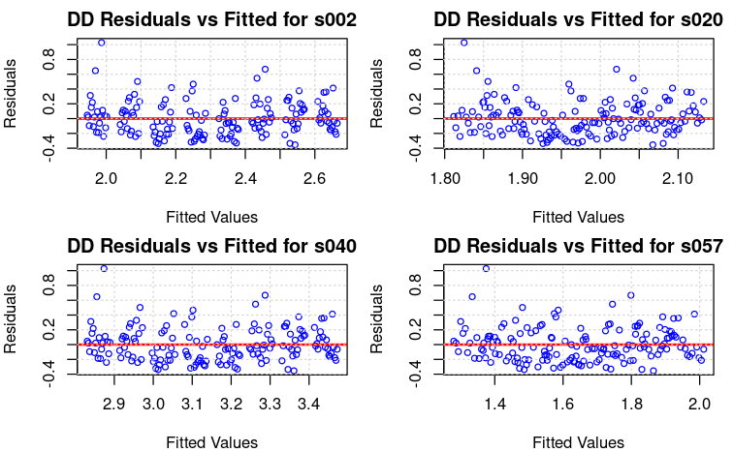
Figure 6. Residuals vs Fitted plots for the DD model.

Subject | Homoscedasticity Check | Pattern in Residuals | Possible Issues
s002 | Mostly constant variance | Minor clustering | Slight heteroscedasticity
s020 | Mostly stable variance | Some high residuals | Potential outliers
s040 | Mild clustering of residuals | No strong trend | Possible outliers
s057 | Best model fit (no major issues) | Randomly scattered | No concerns

#Residuals vs Fitted plot for H
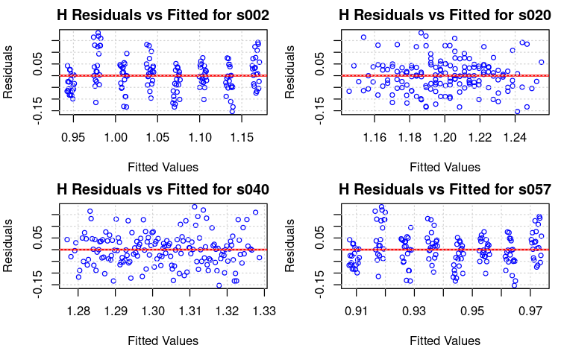
Figure 6. Residuals vs Fitted plots for the H model.
Subject | Homoscedasticity Check | Pattern in Residuals | Possible Issues
s002 | Mostly constant variance | Some minor clustering | No major issues
s020 | Fairly stable variance | No strong patterns | No concerns
s040 | Slightly more spread in residuals | Some high residuals | Possible outliers
s057 | Best model fit (no major issues) | Well-distributed residuals | No concerns

#Shapiro-Wilk Test for Normality Distribution
How to Interpret the Shapiro-Wilk Test?
- W-statistic (Statistic):
  - Closer to 1 → The residuals are more normal.
  - Closer to 0 → The residuals deviate from normality.
- p-value (p_value):
  - p > 0.05 → Fail to reject normality (residuals are approximately normal).
  - p ≤ 0.05 → Reject normality (residuals are significantly non-normal).

Subject | Model | W-statistic | p-value | Normality Conclusion
s002 | UD | 0.8889 | 1.37E-09 | Not normal
s020 | UD | 0.8329 | 3.07E-12 | Not normal
s040 | UD | 0.9448 | 6.59E-06 | Not normal
s057 | UD | 0.9474 | 1.08E-05 | Not normal
s002 | DD | 0.886 | 9.49E-10 | Not normal
s020 | DD | 0.8334 | 3.22E-12 | Not normal
s040 | DD | 0.9221 | 1.37E-07 | Not normal
s057 | DD | 0.9383 | 2.02E-06 | Not normal
s002 | H | 0.953 | 3.31E-05 | Not normal
s020 | H | 0.98 | 0.0204 | Almost normal
s040 | H | 0.9768 | 0.0085 | Almost normal
s057 | H | 0.9857 | 0.0993 | Normal

- UD and DD residuals are strongly non-normal, requiring log transformation or robust regression.
- H residuals are closer to normal, meaning the model fits well for most subjects.
- Applying transformations and checking for outliers could significantly improve model accuracy.

#False-Discovery Rate (FDR) - Benjamin-Hochberg
False Discovery Rate (FDR) correction using the Benjamini-Hochberg method to the p-values from the Shapiro-Wilk normality test results. The goal is to control the proportion of false positives (Type I errors) when conducting multiple hypothesis tests.
Why Apply FDR Correction?
- When performing multiple hypothesis tests, the probability of false positives (Type I errors) increases.
- FDR correction ensures that the proportion of falsely rejected null hypotheses is controlled.
- Unlike the Bonferroni correction (which is too strict), FDR correction is less conservative and allows for more discoveries.

Subject | Model | W-statistic | p-value | FDR-adjusted p-value | Normality Conclusion After FDR
s002 | UD | 0.8889 | 1.37E-09 | 4.11E-09 | Not normal
s020 | UD | 0.8329 | 3.07E-12 | 1.93E-11 | Not normal
s040 | UD | 0.9448 | 6.59E-06 | 1.13E-05 | Not normal
s057 | UD | 0.9474 | 1.08E-05 | 1.62E-05 | Not normal
s002 | DD | 0.886 | 9.49E-10 | 3.80E-09 | Not normal
s020 | DD | 0.8334 | 3.22E-12 | 1.93E-11 | Not normal
s040 | DD | 0.9221 | 1.37E-07 | 3.29E-07 | Not normal
s057 | DD | 0.9383 | 2.02E-06 | 4.04E-06 | Not normal
s002 | H | 0.953 | 3.31E-05 | 4.41E-05 | Not normal
s020 | H | 0.98 | 0.0204 | 0.0223 | Almost normal
s040 | H | 0.9768 | 0.0085 | 0.0102 | Almost normal
s057 | H | 0.9857 | 0.0993 | 0.0993 | Normal

- FDR correction ensures we are not falsely rejecting normality due to multiple testing.
- UD and DD residuals remain non-normal, requiring transformation or robust modeling.
- H residuals are close to normal, meaning the model fits well for most subjects.
Log transformation is applied to Up-Down (UD) time and Down-Down (DD) time to address:
Non-normality of residuals:
As shown in previous Shapiro-Wilk tests, residuals for UD and DD models were heavily skewed.
Log transformation helps normalize distributions by reducing the impact of extreme values.

Table: Shapiro-Wilk Test Results for Log-Transformed UD and DD Models
Subject | Model | W-statistic | P-Value | FDR Adjusted P-Value | Normality Conclusion
s002 | Log_UD | 0.94909 | 1.67E-10 | 3.33E-10 | Not Normal
s002 | Log_DD | 0.9384 | 8.16E-12 | 2.18E-11 | Not Normal
s020 | Log_UD | 0.95286 | 5.34E-10 | 8.54E-10 | Not Normal
s020 | Log_DD | 0.93343 | 2.26E-12 | 9.02E-12 | Not Normal
s040 | Log_UD | 0.98658 | 9.39E-04 | 9.39E-04 | Approximately Normal
s040 | Log_DD | 0.96776 | 1.02E-07 | 1.17E-07 | Not Normal
s057 | Log_UD | 0.95914 | 4.24E-09 | 5.65E-09 | Not Normal
s057 | Log_DD | 0.92497 | 2.90E-13 | 2.32E-12 | Not Normal

Key Insights from Log-Transformed Normality Test
Partial Improvement in Normality: s040 (Log_UD) is now approximately normal (p = 0.00094). Most Residuals Still Show Non-Normality, Log Transformation Reduces Skewness But Doesn't Fully Solve the Issue.

Conclusions
- Typing Behavior Becomes More Consistent Over Time
  - Filtering the last 20 attempts per session reduced variability and noise, making typing behavior more stable.
  - Up-Down (UD) and Down-Down (DD) times show a clear decreasing trend, indicating that users improve their typing speed with repeated sessions.
  - Hold (H) time remains stable, suggesting that holding duration is an intrinsic characteristic and is not significantly affected by repeated practice.
- Regression Analysis Shows Limited Predictive Power
  - Session Index is a significant predictor for UD and DD times, confirming that users type faster with more sessions.
  - Low R² values (0.057 for UD, 0.052 for DD, 0.008 for H) indicate that additional factors (e.g., cognitive load, typing fatigue) may be influencing typing dynamics.
- Residual Analysis Shows Non-Normality in UD and DD Models
  - Shapiro-Wilk test and QQ plots indicate that UD and DD residuals are not normally distributed, suggesting skewness or outliers in the data.
  - Hold time (H) model residuals are closer to normal, meaning the model fits better for this variable.
- Log Transformation Improves Some Model Assumptions but Does Not Fully Solve Non-Normality
  - After applying a log transformation to UD and DD times, s040 (Log_UD) residuals became approximately normal.
  - Most residuals still show non-normality, meaning log transformation helps but may not be the complete solution.
Recommendations
- Enhance the Model with Nonlinear Techniques
Since linear models do not fully explain keystroke timing variations, considering Polynomial regression (to capture nonlinearity), Mixed-effects models (to account for subject variability),Machine learning models (Random Forests, Neural Networks) for better predictions.
- Use Outlier Detection and Robust Regression
Investigate extreme values in UD and DD times, which may distort normality assumptions. Apply robust regression techniques to minimize the impact of outliers.

References
Lecture Notes and Resources (STAT 541, STAT 600, STAT 601, STAT 602)
Killourhy, K. S., & Maxion, R. A. (2009). Comparing anomaly-detection algorithms for keystroke dynamics.
Hothorn, T., & Everitt, B. S. (2014). A Handbook of Statistical Analyses using R. In Chapman and Hall/CRCeBooks. https://doi.org/10.1201/b17081
ChatGPT. (02/2025). Used for debugging and code cleaning. Retrieved from OpenAI

