Modern Applied Statistics (STAT 601)
Fall 2024

Project 4

EXPLORATION OF THE CONJECTURE OF A PERSON'S TYPING DYNAMICS

Submitted By
Soniya Shahi
Kevin Osei-Onomah
Carlos Quevedo Garza
Sai Ram Vodnala

Introduction
In a study for incorporating typing dynamics into the password-based security system, 51 individuals participated in the input of a passcode for a specific system. The participants underwent a total of 8 data collection sessions, with each session involving the typing of the passcode provided 50 times. This accumulates to a comprehensive dataset of 400 instances of password typing across the entire group.
The primary focus of this project is to explore prediction intervals for the range of typing times for the passcode from all individuals. With the 400 typing intervals recorded for each participant, our objective is to develop and compare various models. These models aim to predict the time interval everyone will take to type the password for the 401st occurrence.

Quantile Regression:
Quantile Regression is a statistical technique that considers the relationship between independent variables and some specific quantiles (percentiles) of dependent variables apart from traditional mean-based linear regression. It provides a wider perspective on how the whole distribution of the response variable changes with varying levels of the predictor variables rather than assessing an average response.
The major key features include:
Focused on specific quantiles: Unlike standard linear regression, which focuses on the conditional mean, quantile regression can estimate any quantile of the response variable like the median, 90th percentile, or others. When using quantile regression, it means that more focused and refined relations can be modeled.
Robustness to outliers: Mean-based methods are far more sensitive to the presence of a few outliers in data than shallow quantiles if the number of observations is high. This makes quantile regression suitable for heavy-tailed or skewed distributions of many economic and financial series.
That makes the story complete as well: Quantile regression, by using several quantiles, provides a more complete picture of how the variables are related to each other as it may reveal evidence of heteroscedasticity and nonlinearities in functions.

Linear Mix Effect Random Models:
Linear mixed effects random (LMER) models are an extension of simple linear models that accommodate both fixed and random effects. LMER models are employed when dealing with non-independence in the data, arising from a hierarchical structure. These models are favored over conventional analysis of variance regression models due to their flexibility in handling missing values and coping with uneven spacing of repeated measurements.

Key Components of LMER models:
- Fixed Effects: These represent the effects of variables that are assumed to be constant across all levels of the data. They represent the average impact or influence of independent variables across the entire population, and their values are assumed to be the same for every individual or group within the dataset.
- Random Effect: refer to parameters that introduce variability and account for individual variations within groups or levels of a categorical variable. They account for the non-independence and account for the variation between groups within the data.
- Hierarchical data: also known as nested data, refers to a structure in which observations are organized into groups or levels, and each level contains subgroups or individual observations. This organization creates a hierarchy with multiple levels of grouping.
In matrix notation a linear mixed model can be represented as:
Y = Xβ + Zμ + ε
Where,
Y is a known vector of observations, with mean E(y) = Xβ,
β is an unknown vector of fixed effects,
μ is an unknown vector of random effects,
ε is an unknown vector of random errors,
X is the known design matrix for the fixed effects relating the observation y and β respectively,
Z is the known design matrix for the random effects relating to the observations y and μ respectively.

Task 1: Exploratory Data Analysis

Response Variable:
Due to time constraints, we have chosen total time, total hold time, total key UD time, and total key DD time as our response variables for the analysis. These response variables have been used to build the model later. There were 4 response variables in total, that were taken into consideration.
- Total Time
All the data were summed up to make this variable except for “subject”, “sessionIndex” and “rep”. Total time is the summation of all the time taken for a subject to type the password. It considers, hold time, gap time, and key press time in all directions.

sessionIndex | count | mean | std | min | q25 | median | q75 | max
1 | 2550 | 6.43 | 3.53 | 2.47 | 4.45 | 5.52 | 7.14 | 71.91
2 | 2550 | 5.54 | 2.22 | 2.65 | 4.00 | 4.90 | 6.30 | 20.11
3 | 2550 | 5.29 | 2.24 | 2.60 | 3.80 | 4.69 | 6.00 | 34.37
4 | 2550 | 4.96 | 2.09 | 2.48 | 3.60 | 4.37 | 5.59 | 21.60
5 | 2550 | 4.78 | 1.85 | 2.37 | 3.50 | 4.34 | 5.37 | 17.51
6 | 2550 | 4.61 | 1.67 | 2.28 | 3.41 | 4.19 | 5.33 | 14.46
7 | 2550 | 4.49 | 1.59 | 2.22 | 3.38 | 4.07 | 5.18 | 19.31
8 | 2550 | 4.48 | 1.78 | 2.11 | 3.29 | 4.07 | 5.17 | 19.40

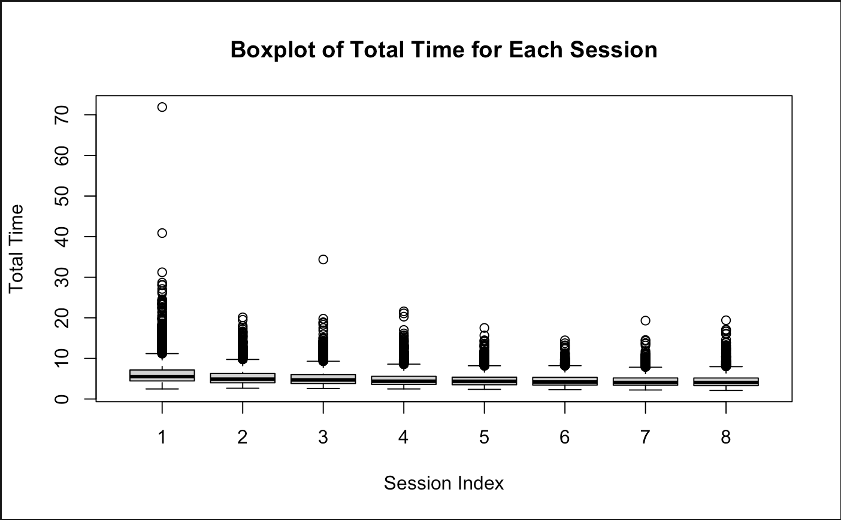
The above table shows that the median total time spent per session is trending to decrease, which suggests that password typing has gotten faster over time. Outliers continue even as the interquartile range is smaller as sessions go on, indicating a tighter data distribution. This shows that there has been development generally, but it also emphasizes the need for additional optimization to enable uniform, quick password entering among all users.

- Total Hold Time
Total hold time is the summation of the time for all the keys held and nothing else. It includes the hold time for each key press.
sessionIndex | count | mean | std | min | q25 | median | q75 | max
1 | 2550 | 0.95 | 0.22 | 0.35 | 0.82 | 0.93 | 1.08 | 2.07
2 | 2550 | 0.98 | 0.22 | 0.47 | 0.85 | 0.98 | 1.11 | 2.03
3 | 2550 | 0.98 | 0.24 | 0.43 | 0.84 | 0.97 | 1.09 | 3.27
4 | 2550 | 0.98 | 0.22 | 0.44 | 0.85 | 0.97 | 1.09 | 1.91
5 | 2550 | 0.98 | 0.21 | 0.48 | 0.85 | 0.98 | 1.09 | 1.86
6 | 2550 | 1.01 | 0.23 | 0.44 | 0.86 | 1.00 | 1.14 | 2.01
7 | 2550 | 1.01 | 0.24 | 0.44 | 0.87 | 0.99 | 1.14 | 2.04
8 | 2550 | 1.02 | 0.26 | 0.50 | 0.87 | 0.99 | 1.14 | 1.89

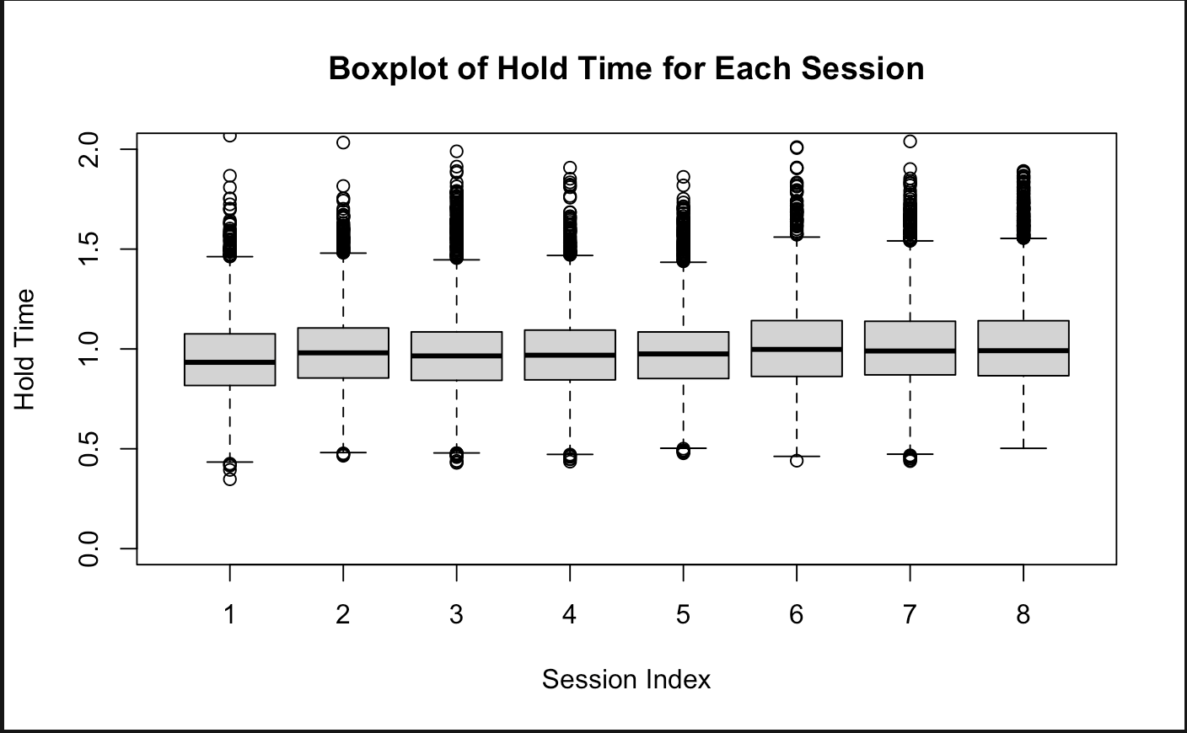A troubling pattern of longer hold times between sessions can be seen by analyzing the boxplot of total hold time. In session 8, the interquartile range widens as well, suggesting that more individuals are holding onto keys for longer, as the median time increases from 0.95 minutes in session 1 to 1.02 minutes in session 8. This raises the possibility of problems such as increasing comfort causing one to type more slowly, increased error correction necessitating longer key holds, or the task itself becoming intrinsically harder. To determine the precise origin of this tendency and create countermeasures, such as feedback mechanisms or specialized typing training sessions, more research is essential. These measures will help eliminate needless key holding and increase typing efficiency.
- Total UD (Up-Down) Time
The total up-down time is the summation of all the time when the preceding key is release and the succeeding key is pressed.
sessionIndex | count | mean |  | std |  | min |  | q25 |  | median |  | q75 |  | max
1 | 2550 |  | 2.30 |  | 1.79 |  | 0.32 |  | 1.32 |  | 1.83 |  | 2.65 |  | 34.94
2 | 2550 |  | 1.83 |  | 1.14 |  | 0.27 |  | 1.06 |  | 1.52 |  | 2.19 |  | 8.97
3 | 2550 |  | 1.71 |  | 1.15 |  | 0.21 |  | 0.95 |  | 1.42 |  | 2.05 |  | 16.52
4 | 2550 |  | 1.54 |  | 1.07 |  | 0.17 |  | 0.86 |  | 1.25 |  | 1.83 |  | 10.17
5 | 2550 |  | 1.45 |  | 0.96 |  | 0.13 |  | 0.79 |  | 1.23 |  | 1.76 |  | 7.83
6 | 2550 |  | 1.34 |  | 0.87 |  | -0.03 |  | 0.74 |  | 1.13 |  | 1.69 |  | 6.21
7 | 2550 |  | 1.27 |  | 0.84 |  | -0.22 |  | 0.70 |  | 1.06 |  | 1.64 |  | 8.59
8 | 2550 |  | 1.26 |  | 0.94 |  | -0.17 |  | 0.68 |  | 1.07 |  | 1.61 |  | 9.16

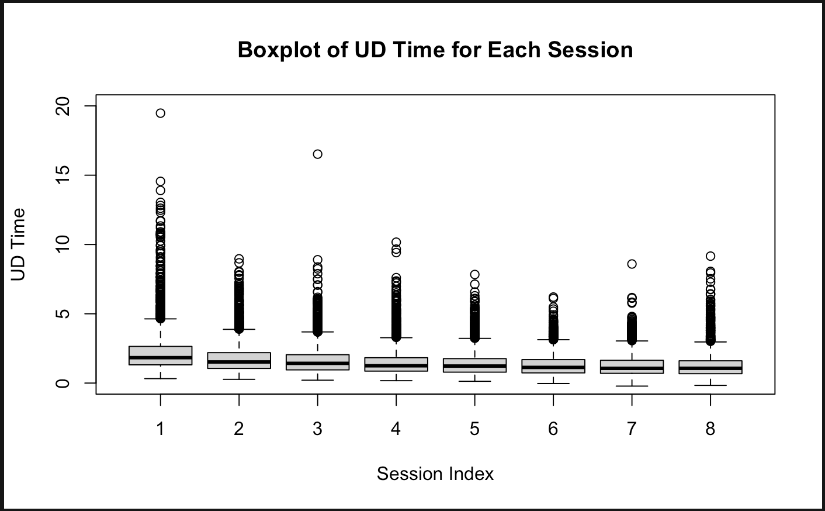
The total up-down (UD) time in the table above shows a strong learning effect, with the median UD time decreasing throughout the sessions, indicating that participants wrote the password more quickly. Greater consistency in typing speed is demonstrated by the corresponding drop in the interquartile range, which further emphasizes a convergence in performance. These results highlight the value of practice in enhancing motor skills and point to the possibility of enhancing typing efficiency and speed in password entry systems using feedback mechanisms and specialized training modules.
- Total DD (Down Down) Time
The total down-down time is the summation of the time between pressing down the preceding key to the time to press down the succeeding key.
sessionIndex | count | mean |  | std |  | min |  | q25 |  | median |  | q75 |  | max
1 | 2550 |  | 3.17 |  | 1.77 |  | 1.18 |  | 2.18 |  | 2.71 |  | 3.53 |  | 35.92
2 | 2550 |  | 2.72 |  | 1.11 |  | 1.27 |  | 1.95 |  | 2.40 |  | 3.11 |  | 10.02
3 | 2550 |  | 2.60 |  | 1.12 |  | 1.24 |  | 1.86 |  | 2.30 |  | 2.96 |  | 17.15
4 | 2550 |  | 2.44 |  | 1.05 |  | 1.20 |  | 1.76 |  | 2.15 |  | 2.74 |  | 10.76
5 | 2550 |  | 2.35 |  | 0.93 |  | 1.14 |  | 1.71 |  | 2.12 |  | 2.64 |  | 8.72
6 | 2550 |  | 2.26 |  | 0.84 |  | 1.07 |  | 1.66 |  | 2.05 |  | 2.62 |  | 7.17
7 | 2550 |  | 2.20 |  | 0.80 |  | 1.04 |  | 1.65 |  | 1.99 |  | 2.55 |  | 9.61
8 | 2550 |  | 2.20 |  | 0.89 |  | 1.02 |  | 1.60 |  | 1.99 |  | 2.54 |  | 9.68

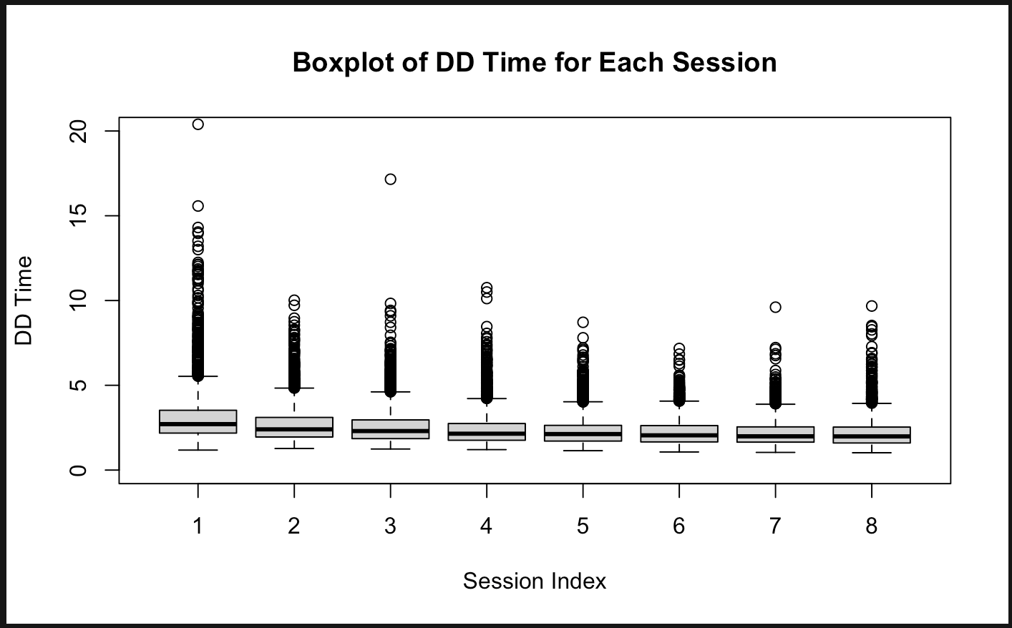
The table above of total down-down time exhibits a clear improvement trend, with median time steadily decreasing across sessions. While the initial median sits at 3.17 minutes, it consistently drops to 2.20 minutes by session 8, implying participants' rapid acquisition of the password typing skill. A significant reduction in interquartile range further highlights this convergence, showing a tighter cluster of performance times. These findings provide valuable insights into the efficacy of practice in enhancing motor skills, suggesting the potential of integrating feedback mechanisms and dedicated training modules within password entry systems to optimize user experience and improve typing speed and accuracy.

Subject 002
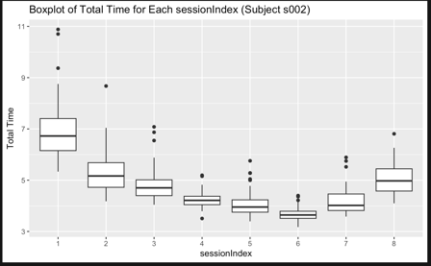 | 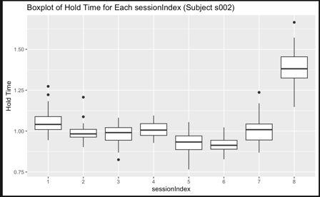
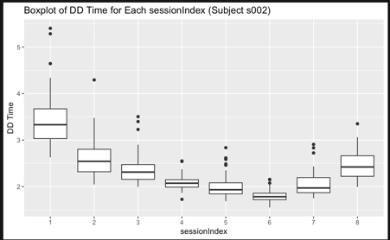 | 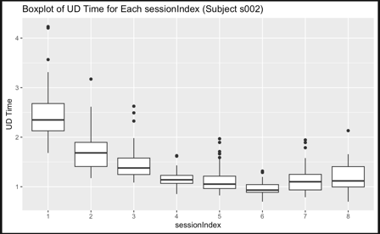
The explanation provided above holds for subject 002 when checked individually.

Subject 010
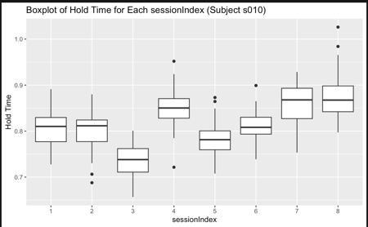 | 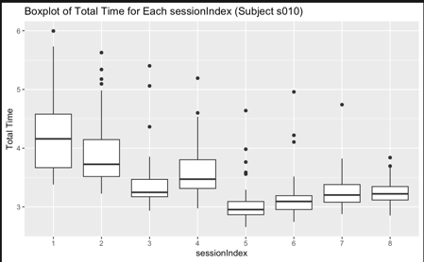
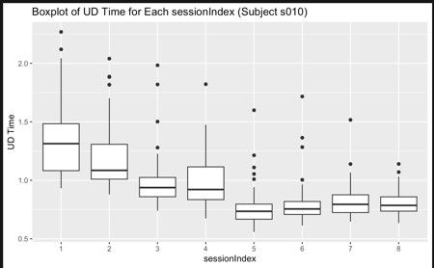 | 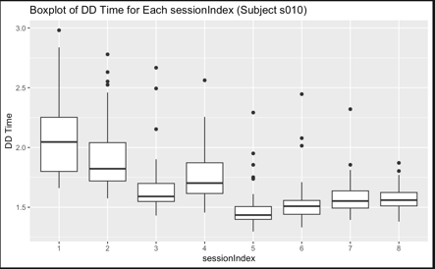
Upon examining box plots for all subjects collectively, limited insights into the data were gleaned. However, a more nuanced exploration, plotting these box plots for individual subjects, unraveled substantial variations. Notably, distinct differences emerged in metrics such as total time, hold time, key up and down time, and key down time across various sessions. This nuanced analysis underscores the importance of scrutinizing subject-specific patterns, revealing significant variations in temporal aspects of key interactions within each session.

Task 2: Model Development

Model 1: Random Intercept Model
Because of its hierarchical nature, a multilevel model called a random intercept model worked incredibly well in our data analysis. This model allowed for better generalizability and more accurate estimations by differentiating between within-group and between-group variances. Our findings can be understood more nuancedly since the model took into consideration the random intercepts for each group, which allowed it to capture the varied average responses across groups. This method provides a strong tool for deciphering intricate data structures and drawing insightful conclusions from nested datasets.
Y_{ij} = β₀ + β₁ * X_{ij} + U_{i} + ε_{ij}
where:
Y_{ij}: the response variable for observation i in group j
β₀: the overall intercept (fixed)
β₁: the coefficient for the explanatory variable X (fixed)
X_{ij}: the value of the explanatory variable for observation i in group j
U_{i}: the random intercept for group j, which represents the deviation of the group's average response from the overall intercept.
ε_{ij} : the error term for observation i in group j, which represents the random variability not explained by the model

Assumptions:
- The random intercepts (U_{i}) follow a normal distribution (U_{i} ~ N(0, τ²)) with constant variance.
- The residuals ε_{ij} follows a normal distribution (εij ~ N(0, σ²)).
- ε_{ij} is assumed to be independent across observations.
- The variance of the errors (ε_{ij}) is constant across all levels of X_{ij}.
Total Time:
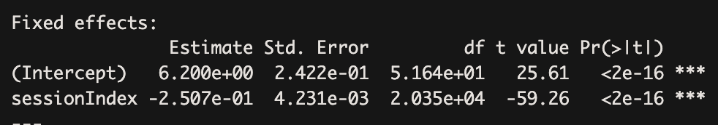
Total Hold Time:
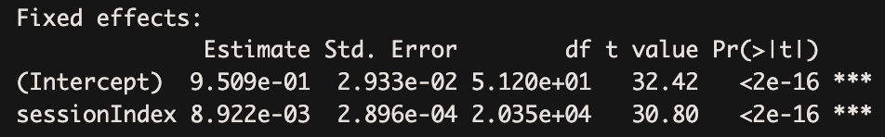
Total Up-Down Time:
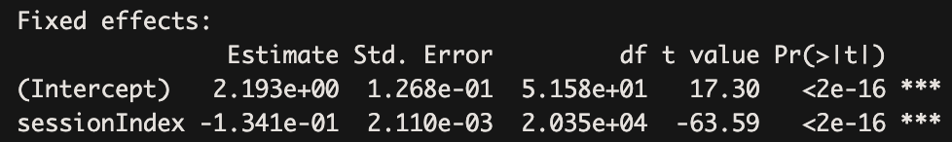
Total Down-Down Time:
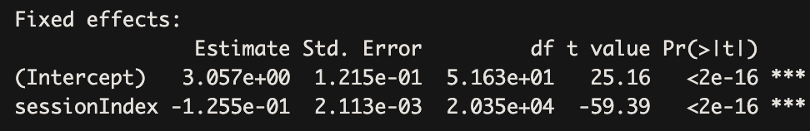
All the above random intercept models reveal statistical significance (p < 0.05) for both the baseline total time (β₀) and the impact of the session index (β₁), supporting our hypothesis that typing dynamics undergo meaningful changes over time. This suggests not only a significant baseline total time/ hold time / key up down time / key down down time when the session index is zero but also a substantial alteration in these times as the session index increases.

Model 2: Random Slope and Intercept Model
Basic models only display average trends; Random Slope and Intercept Models indicate differences in the effects of an explanatory variable on each group as well as variability in the average response across groups. This makes it an effective tool for evaluating complicated data structures since it enables us to comprehend both the big picture and the various subtleties inside various groups.
Y_{ij} = β₀ + β₁ * X_{ij} + U_{i} + β₂ * X_{ij} * U_{ij} + ε_{ij}
where:
Y_{ij}: the response variable for observation i in group j
β₀: the overall intercept (fixed)
β₁: the coefficient for the explanatory variable X (fixed)
X_{ij}: the value of the explanatory variable for observation i in group j
U_{i}: the random intercept for group j (random effect)
β₂: the coefficient for the random slope (fixed effect)
U_{ij}: the interaction term between the random intercept and the explanatory variable for observation i in group j (random effect)
ε_{ij}: the error term for observation i in group j (random effect)
Assumptions:
- The random intercepts U_{i} follow a normal distribution (U0i ∼N(0,τ₀²)) with constant variance.
- The random slope U_{ij} follows a normal distribution (U0i ∼N(0,τ₁²)) with constant variance.
- The residuals εij follow a normal distribution (εij ~ N(0, σ²)).
- Εij is assumed to be independent across observations.
- The variance of the residuals εij is constant across all levels of Xij.
Total Time:
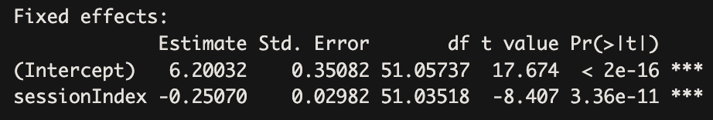
Total Hold Time:
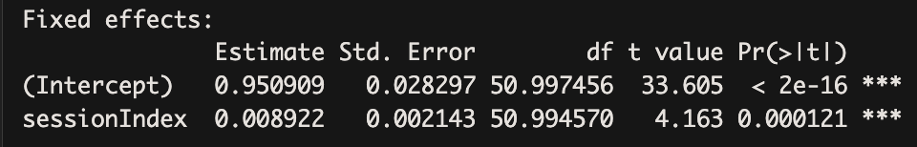
Total Up-Down Time:
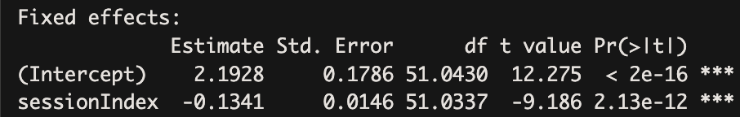
Total Down-Down Time:
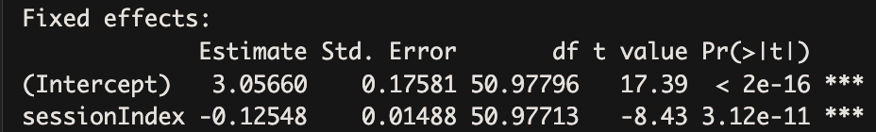
The results from the random slope and intercept model, demonstrate statistical significance (p < 0.05) for both the baseline total time (β₀) and the impact of the session index (β₁). supports our hypothesis that typing dynamics undergo meaningful changes over time. The findings suggest that there is a significant baseline total time when the session index is zero, and as the session index increases, there is a substantial alteration in total time. This signifies the dynamic nature of typing behaviors, where both fixed and varying effects contribute significantly to the observed temporal patterns.

ANOVA Test:
The ANOVA test results reveal that the random slope and intercept model provides a better fit to the data compared to the random intercept model. This conclusion is supported by p-values less than 0.05, signifying statistical significance, and lower AIC and BIC values for the former model. These findings suggest that the inclusion of random slopes improves the model's ability to capture the nuanced changes in typing dynamics over time, making it a more suitable choice for explaining the observed variability in the data.
Total Time:
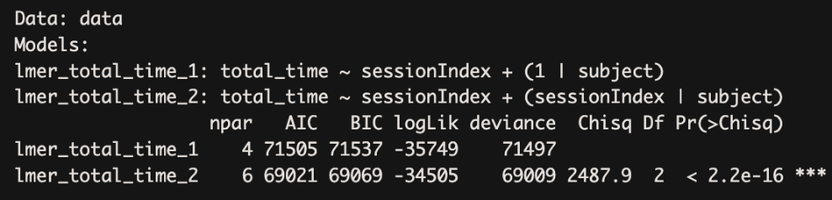
Total Hold Time:
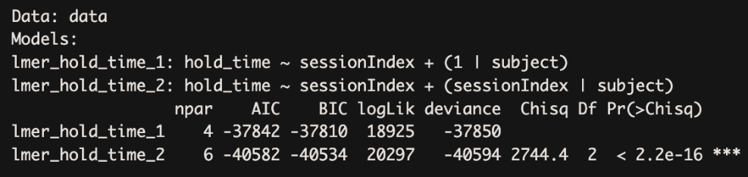
Total Up-Down Time:
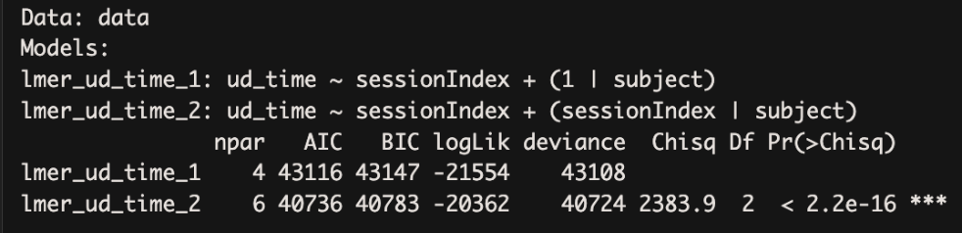
Total Down-Down Time:
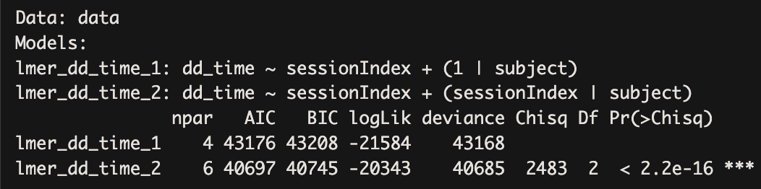

Task 3: Post Hoc Analysis
The post hoc analysis involved testing the assumptions of the Random Slope and Intercept model, specifically focusing on the normality of residuals and random effects. This evaluation was carried out using qq plots and the Shapiro-Wilk test for all four response variables (total time, total hold time, total key up down time and total key down down time) representing typing dynamics.

Normality test of residuals and random effects:
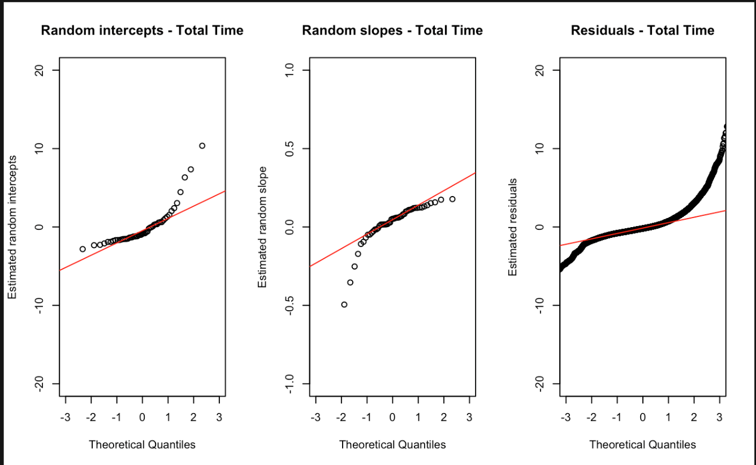
Random Intercepts: | Random Slopes: | Residuals:
W = 0.75528, p-value = 7.616e-08  The random intercepts are not normally distributed (p-value < 0.05) | W = 0.59092, p-value = 1.1e-10  The random slopes are not normally distributed (p-value < 0.05) | W = 0.74384, p-value < 2.2e-16  The residuals are not normally distributed (p-value < 0.05)

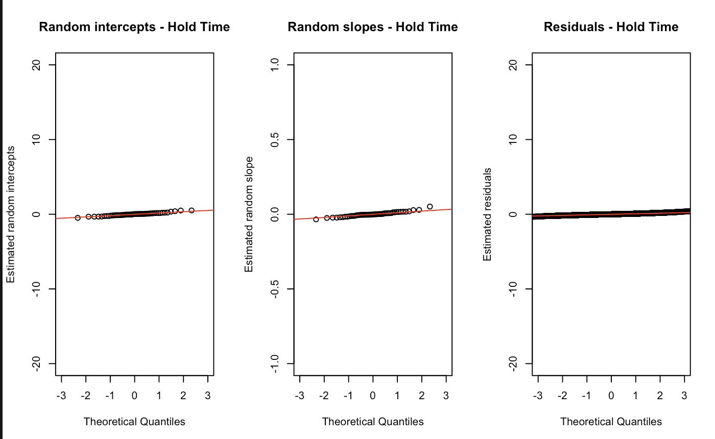
Random Intercepts: | Random Slopes: | Residuals:
W = 0.97661, p-value = 0.4063  The random intercepts are normally distributed (p-value >= 0.05) | W = 0.96422, p-value = 0.1262  The random slopes are normally distributed (p-value >= 0.05) | W = 0.98638, p-value < 2.2e-16  The residuals are not normally distributed (p-value < 0.05)

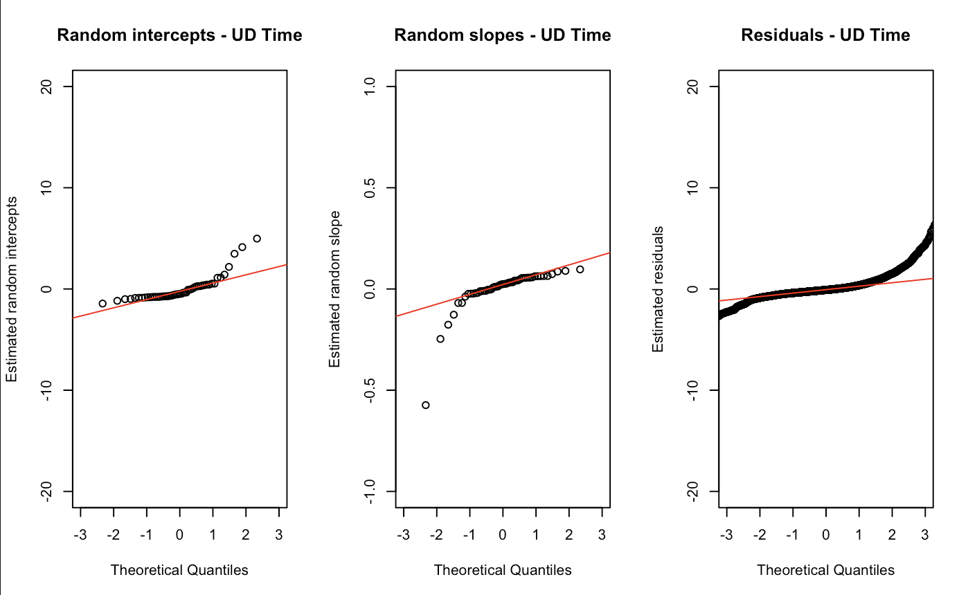
Random Intercepts: | Random Slopes: | Residuals:
W = 0.73207, p-value = 2.616e-08  The random intercepts are not normally distributed (p-value < 0.05) | W = 0.61024, p-value = 2.141e-10  The random slopes are not normally distributed (p-value < 0.05) | W = 0.7767, p-value < 2.2e-16  The residuals are not normally distributed (p-value < 0.05)

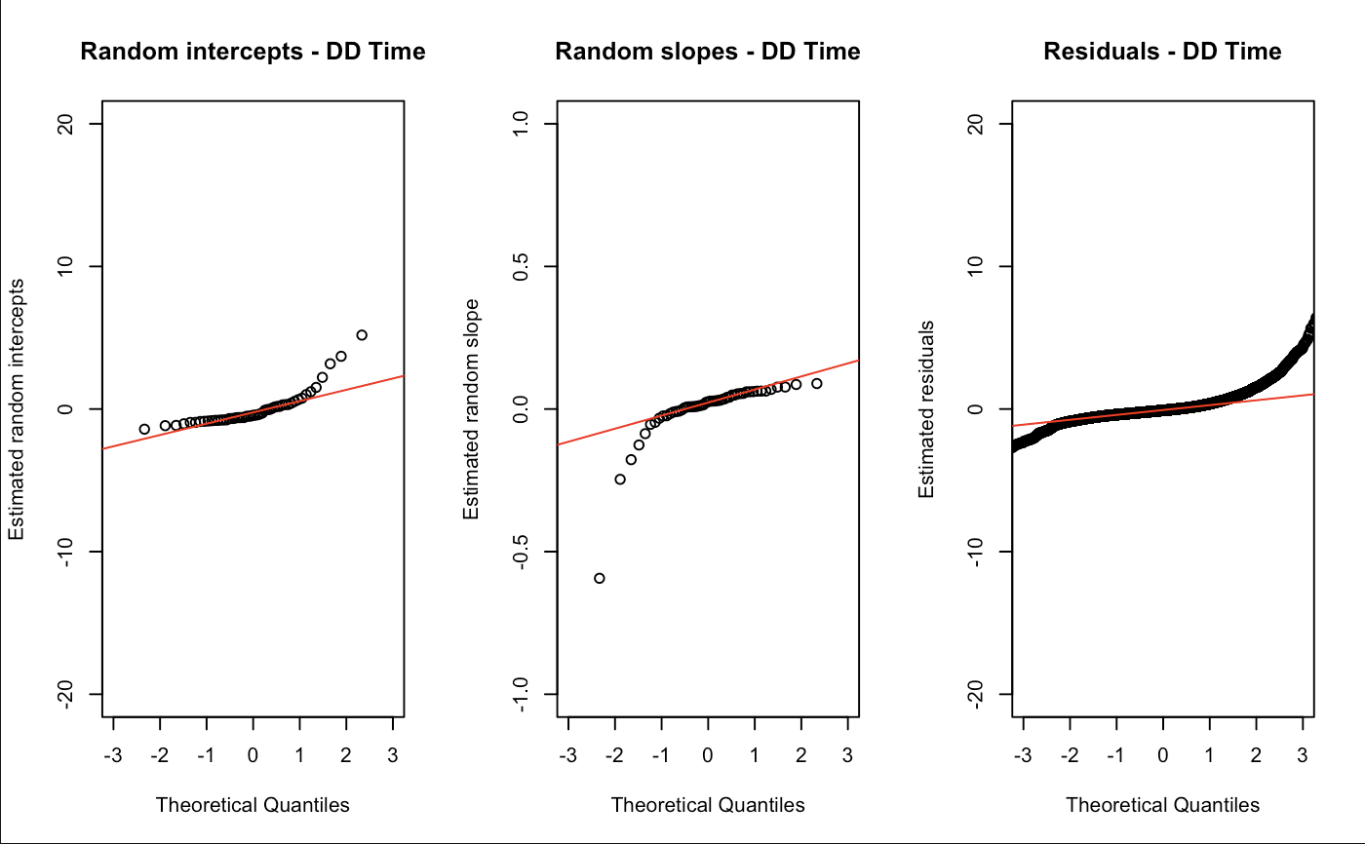
Random Intercepts: | Random Slopes: | Residuals:
W = 0.75405, p-value = 7.187e-08  The random intercepts are not normally distributed (p-value < 0.05) | W = 0.58844, p-value = 1.011e-10  The random slopes are not normally distributed (p-value < 0.05) | W = 0.5928, p-value < 2.2e-16  The residuals are not normally distributed (p-value < 0.05)

Notably, the results indicated that the residuals and random effects were found to be normally distributed for the model with total hold time as the response variable. This conformity to normality assumptions enhances the robustness and reliability of the model's predictions for total hold time, suggesting that the model is a suitable representation of the underlying data dynamics for this specific typing metric.

Pairwise comparison:
In addition to assessing normality, pairwise comparisons were conducted to compare marginal means for total typing time, total key hold time, total key up down time, and total key down down time across different session indices. The analysis revealed differences in almost all of the metrics, indicating variations in typing dynamics for each session index. While some marginal means for certain indices did not exhibit significant differences, particularly in the case of total hold time, the majority demonstrated statistically significant distinctions following pairwise comparisons. The detailed results of these pairwise comparisons are presented below, providing further insights into the nuanced differences in typing behavior across different session indices.
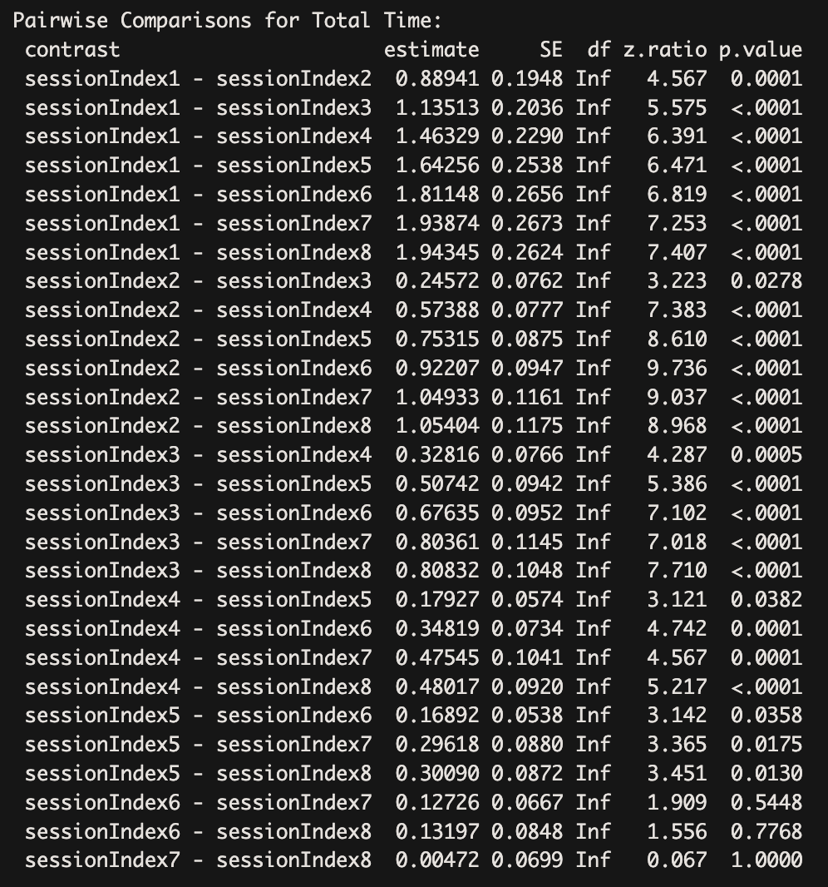

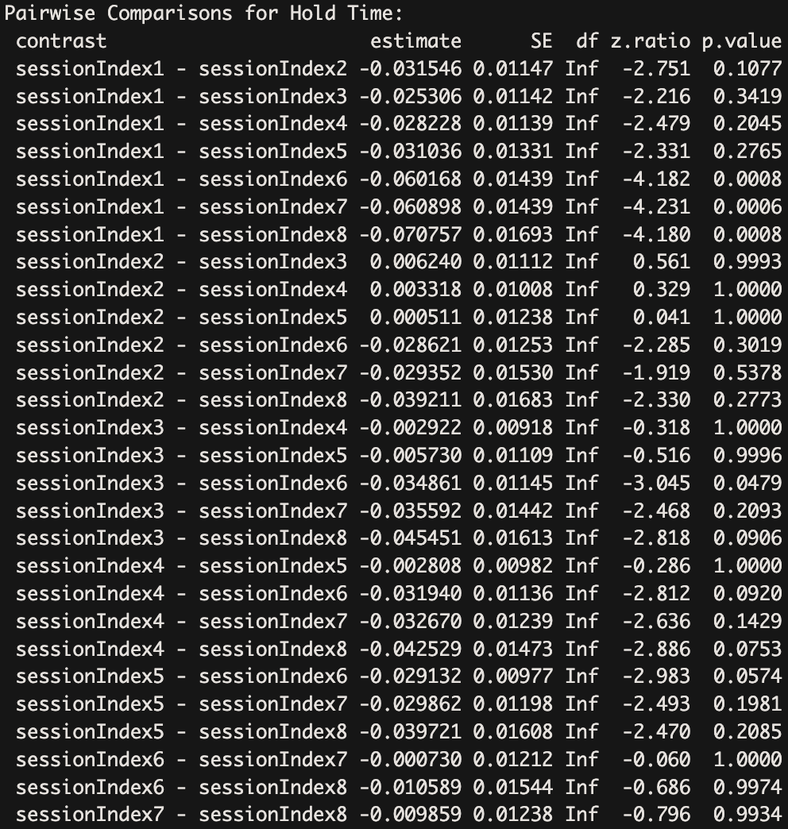
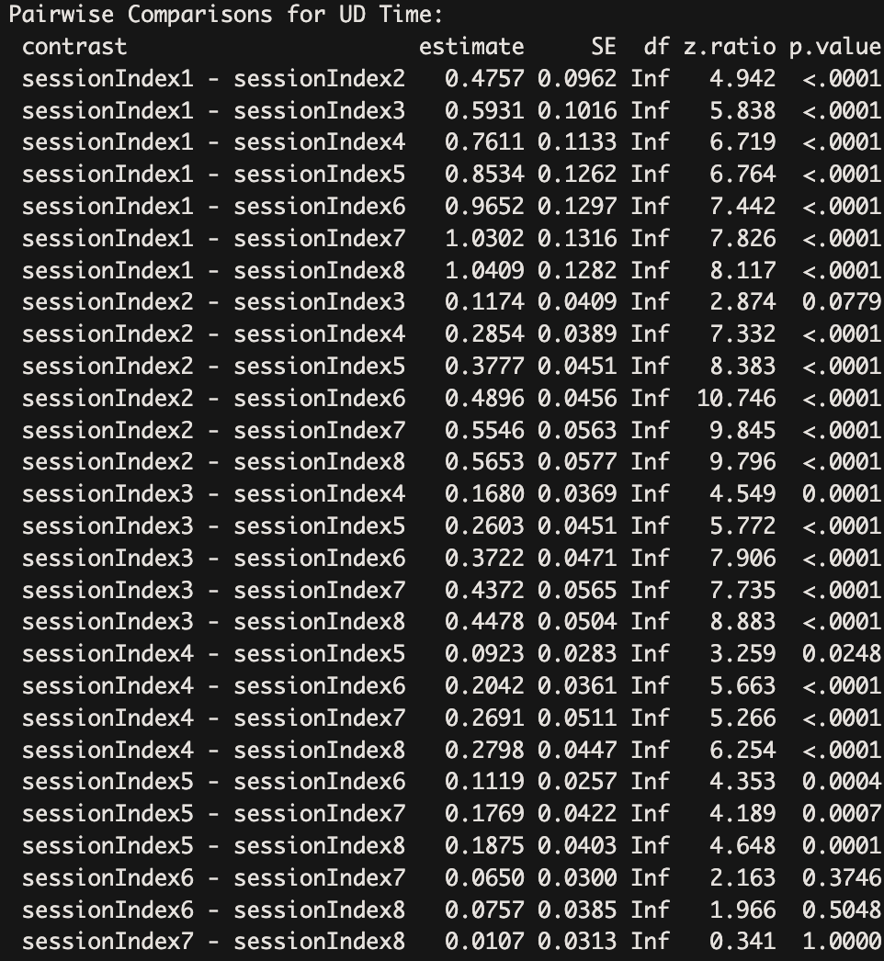
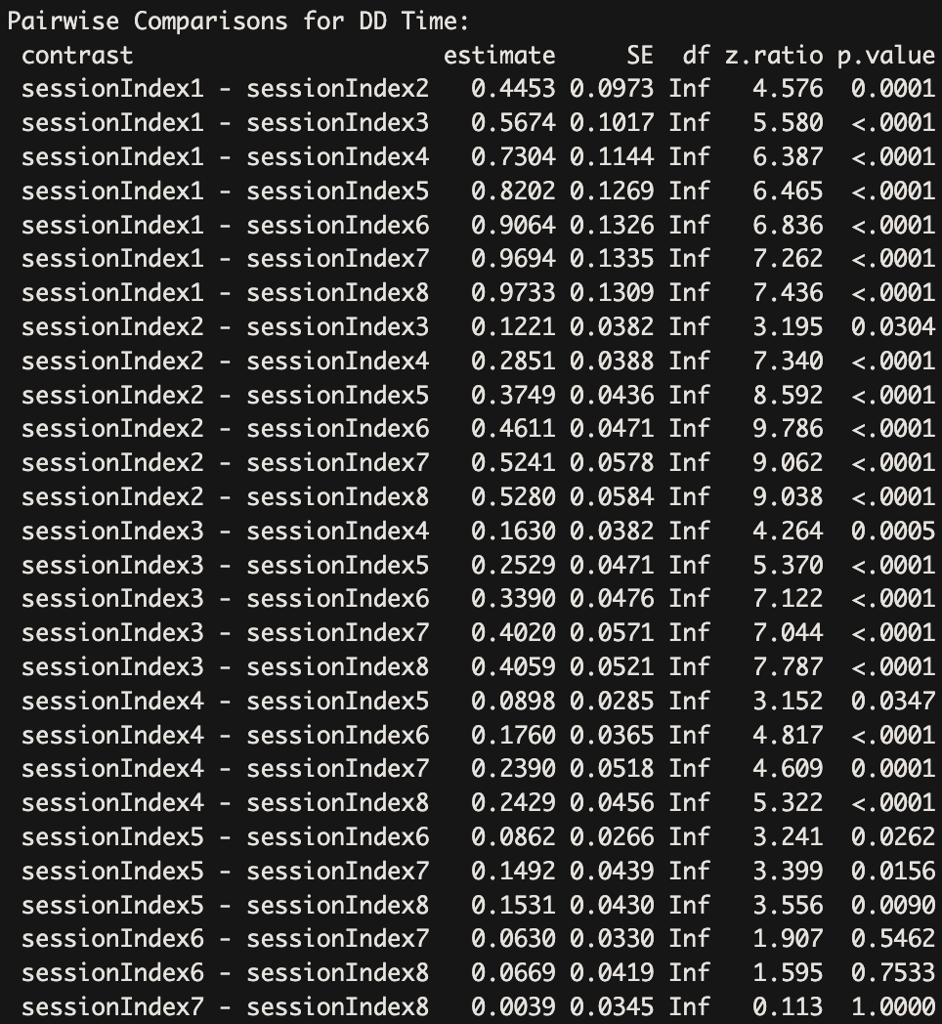

Task 4: Quantile Regression

Quantile Regression Model:
Quantile regression provides a more thorough understanding of the relationship between variables by focusing on predicting multiple percentiles (quantiles) of the response variable rather than just the average response, as classical regression does. It is an effective technique for studying complicated datasets because it can provide important insights into how variables affect not just the average result but also the extremes and fluctuations within the data.
For Task 4, we implemented quantile regression by first creating a repetitions column using the formula (sessionIndex-1)*50 + rep(sessionIndex-1)*50 + rep, representing the number of times a subject typed the password. We then applied a non-linear quantile regression model to predict total time, with repetitions as the predictor. Specifically, the model was defined using the formula total_time ˜ns(repetitions, df = 3)total_time ˜ns(repetitions, df = 3), and the non-linear quantile regression model was fitted using the \text{rqss} function with the specified quantile levels of 0.025, 0.25, 0.5, 0.75, and 0.975. This process was repeated for each subject. To visually inspect the results, quantiles were plotted in scatter plots for randomly selected subjects. Additionally, the trained model was utilized to make predictions for the chosen quantiles, providing insights into the expected total typing time for the randomly selected subjects.
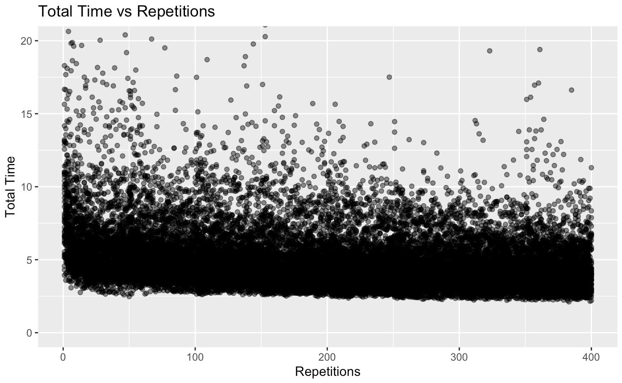
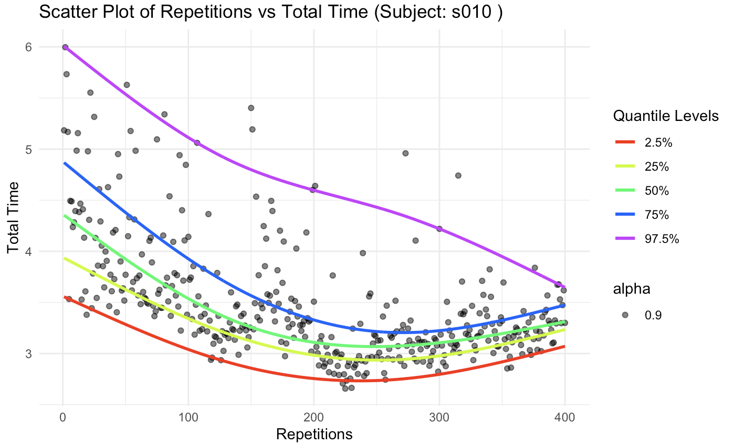
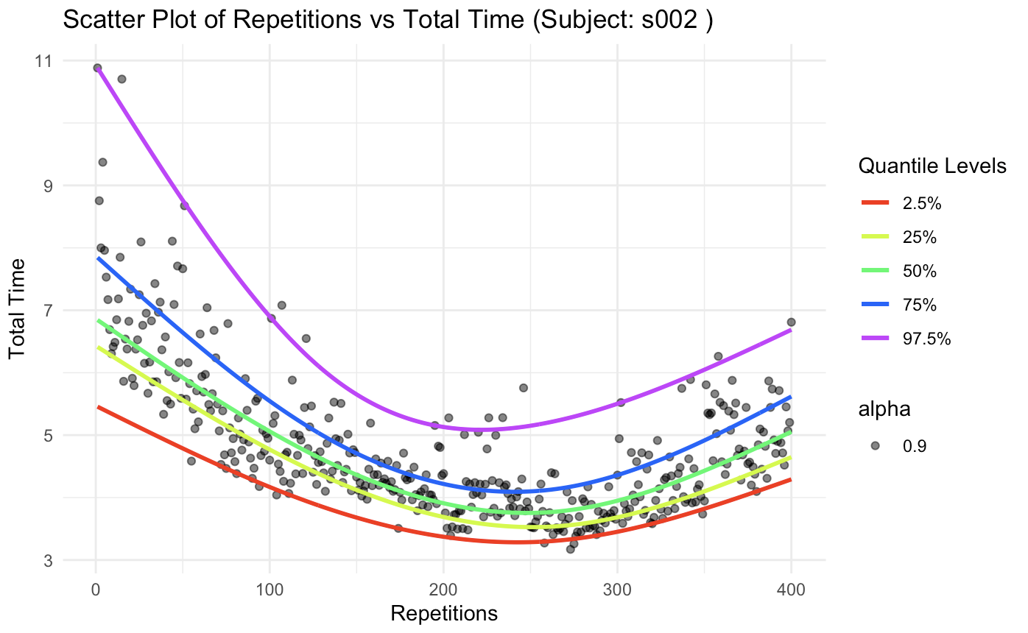
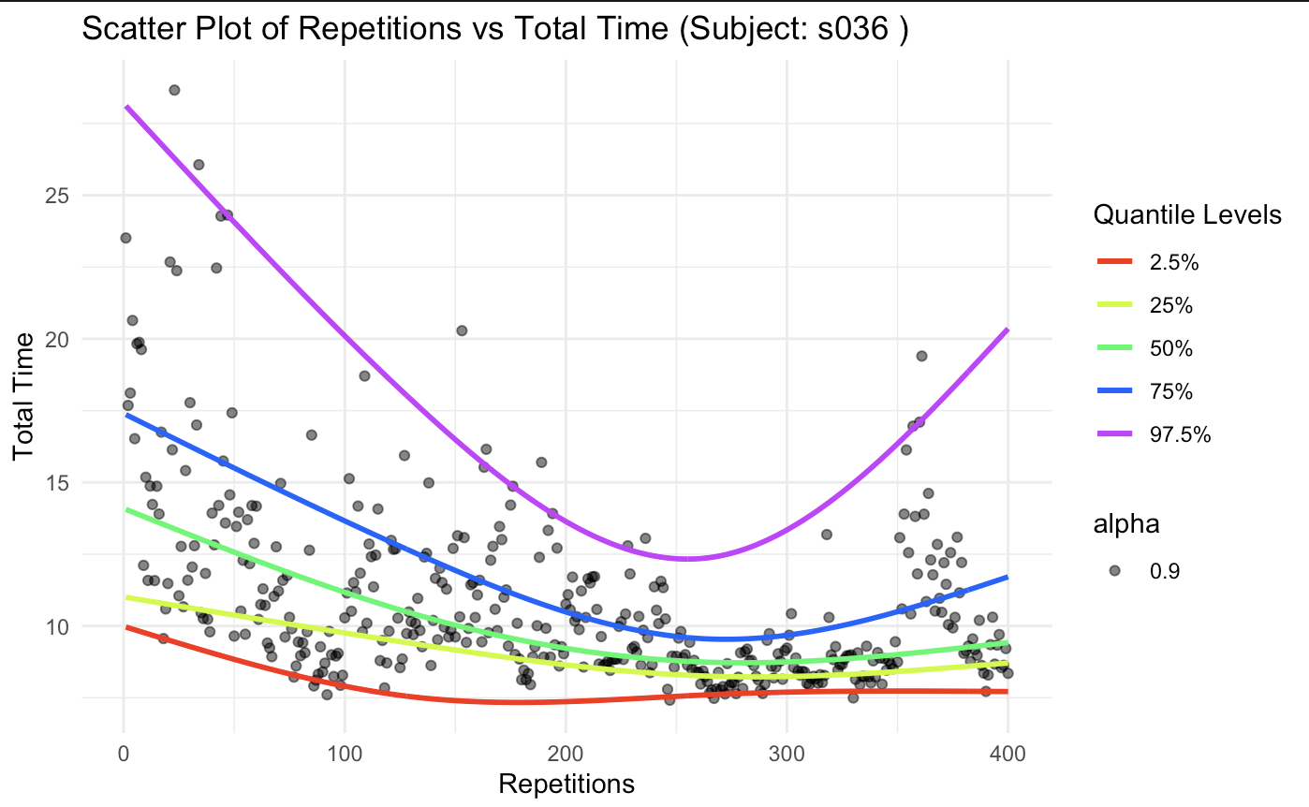
Prediction for Subject s010
Quantile_level | 2.5 | 25 | 50 | 75 | 97.5
Prediction | 2.7424 | 2.964035 | 3.0658 | 3.2819 | 4.4701

Prediction for Subject s002
Quantile_level | 2.5 | 25 | 50 | 75 | 97.5
Prediction | 3.3584 | 3.662085 | 3.8851 | 4.1665 | 4.9266

Prediction for Subject s036
Quantile_level | 2.5 | 25 | 50 | 75 | 97.5
Prediction | 7.1906 | 8.605796 | 9.0736 | 10.431 | 13.769

Conclusion
In this comprehensive exploration of password entry dynamics, our study aimed to unravel the intricate patterns and nuances embedded within the keystrokes of individuals and we came to following conclusions:
- Typing dynamics, encompassing key holding and interaction times, were identified as crucial metrics for understanding password entry behavior.
- Through extensive analysis, we observed distinct patterns in the temporal evolution of typing dynamics. Interaction time consistently decreased, while holding time exhibited varied trends across different individuals.
- To comprehensively capture the nuances of typing behavior, we opted for total typing time as the primary measure. This allowed us to account for the complex interplay between holding time, key up-down time, and key down-down time.
- While Linear Mixed Effects Random models indicated temporal changes, we recognized that model assumptions aligned more effectively with hold time as the response variable. This insight is vital for accurate model selection.
- Further validation through pairwise comparisons emphasized significant differences in typing dynamics across various session times, reinforcing the notion that password typing behavior undergoes substantial variations.
In conclusion, our findings underscore the dynamic nature of typing behavior and emphasize the necessity of thoughtful variable and model selection to ensure a nuanced understanding of temporal patterns in password entry dynamics.

References
Kevin S. Killourhy, Roy A. Maxion (2009) Comparing Anomaly-Detection Algorithms for Keystroke Dynamics (cmu.edu)
Marvin. (2020, June 30). Probabilitic_flood_forecast#linear-quantile-regression. Retrieved from https://github.com/marvinmin/Probabilitic_flood_forecast#linear-quantile-regression
Roger Koenker and Kevin F. Hallock (2001). Quantile Regression (uiuc.edu)

Liping Huang, Wenying Zhu, Christopher P Saunders, James N MacLeod, Mai Zhou, Arnold J Stromberg & Arne C Bathke, (2008). A novel application of quantile regression for identification of biomarkers exemplified by equine cartilage microarray data | BMC Bioinformatics (springer.com)
Nikolay Oskolkov (2020). How Linear Mixed Model Works. And how to understand LMM through… | by Nikolay Oskolkov | Towards Data Science
Rebecca Pillinger, Random intercept models | Centre for Multilevel Modelling | University of Bristol
Brunton-Smith. Multilevel Models: Random Intercept Models | Ian Brunton-Smith - YouTube
Corey S. Sparks, PhD. (2018). RPubs - DEM 7473 - Week 3: Basic Hierarchical Models - Random Intercepts and Slopes
Analytics Vidhya - Gurchetan Singh. (2023). ANOVA: Complete guide to Statistical Analysis & Applications (analyticsvidhya.com)
Sachin Date. Introduction To The Quantile Regression Model – Time Series Analysis, Regression, and Forecasting (timeseriesreasoning.com)

