6 Control Structures Homework
Sai Ram Vodnala
07/03/2024

Instructions
There are four exercises below. Three exercises are worth 10 points each, and are labelled (Either R, Python or Julia). For these exercises, you can implement a solution in the language of your choice. I’ve included code chunk templates for all three languages, but you only need to fill in the chunks for one language.
One exercise is labelled (R, Python and Julia). This exercise is worth 20 points, and you must provide a solution using all three languages. This exercise also includes code chunk templates for all three languages.
Some of the exercises have questions relating to the results. Write your answers in the narrative part of the text, formatted as italicized text, bold text or
quoted text.
Submit both Rmd and typeset results using file name formats as in previous exercises.
Do not use libraries in R that are not part of the base R installation (with one exception as stated below); this includes popular libraries for data tables like data.table or tidyverse libraries like dplyr and tidyr. You may use any Python or Julia libraries introduced in lecture, except for graphs. You are free to use any Python or Julia graphics library, as long as I can install it on my machine if necessary.

Reuse
We will be using your NormPDF function for two of these exercises. Define that function here.

Python
import math
def NormPdf(x, mu=0, sigma=1):
a = 1 / (sigma * math.sqrt(2 * math.pi))
b = -((x - mu)**2) / (2 * sigma**2)
pdf = a * math.exp(b)
return pdf

Exercise 1 (Either R, Python or Julia)

Part a.
Write a function MyMoments to compute mean, standard deviation, skewness and kurtosis from a single vector of numeric values. You can use library mean functions, but should use one (and only one) for loop to compute the rest. Note that computationally efficient implementations of moments take advantage of ${\left(Y_{i}−\overset{‾}{Y}\right)}^{4}=\left(Y_{i}−\overset{‾}{Y}\right)×{\left(Y_{i}−\overset{‾}{Y}\right)}^{3}$, etc.
See https://www.itl.nist.gov/div898/handbook/eda/section3/eda35b.htm for formula for skewness and kurtosis. This reference gives several definitions for both skewness and kurtosis, you only need to implement one formula for each. Note that for computing skewness and kurtosis, standard deviation is computed using $N$ as a divisor, not $N−1$.
Your function should return a list or a tuple with Mean, SD, Skewness and Kurtosis.
Your function should check for missing values, and accumulate sums only if values are non-missing. You might need to pass arguments to specify how to handle missing values if you use library functions to compute a mean (na.rm in R, nanmean in numpy or skipmissing in Julia)

R
MyMoments <- function(x, na.rm = FALSE) {
diff2 <-0
diff3 <-0
diff4 <-0
L <- length(x)
mean_val <- mean(x, na.rm = na.rm)
for (i in 1:L) {
if (!is.na(x[i])) {
delta <- (x[i] - mean_val)
diff2<- diff2 + (delta)^2
diff3 <- diff3 + (delta)^3
diff4 <- diff4 + (delta)^4
}
}
N = sum(!is.na(x))
Strandard_Deviation <- sqrt(diff2 / N)
Skewness <- (diff3 / (N*Strandard_Deviation^3))
Kurtosis <- (diff4 / (N*Strandard_Deviation^4))
return(list(mean = mean_val, Standard_Deviation = Strandard_Deviation, Skewness = Skewness, Kurtosis = Kurtosis))
}

Python

Julia

Part b.
Test your function by computing moments for MPG from the file mpg.csv. This file will be available on D2L under Week 5 Lecture Materials. Note that there are missing values in this column, so will be testing your functions ability to process a vector with missing values.

R
data <- read.csv("C:/Users/sairam/Desktop/Stat600/0.files/HOMEWORKS/HW5/mpg.csv")
mpg_values <- data$MPG
moments <- MyMoments(mpg_values, na.rm = TRUE)
print(moments)
## $mean
## [1] 33.977
##
## $Standard_Deviation
## [1] 2.780822
##
## $Skewness
## [1] 0.3861054
##
## $Kurtosis
## [1] 2.474183

Python

Julia
If you wish, compare your function results with the skewness and kurtosis in the R moments package (you may need to use na.rm=TRUE), or the skew and kurtosis functions from scipy.stats (you may need to call .to_list() and use nan_policy='omit'), or the StatsBase functions skewness and kurtosis in Julia (You may need to use collect(skipmissing(...)). Note that some functions may return excess kurtosis (Pearson’s kurtosis minus 3).

R
library(moments)
skewness(mpg_values, na.rm = TRUE)
## [1] 0.3861054
kurtosis(mpg_values, na.rm = TRUE)
## [1] 2.474183

Python

Julia

Exercise 2 (Either R, Python or Julia)
Consider Newton’s method to find a minimum or maximum value attained by a function over an interval. Given a function $f$, we wish to find
$$\max_{x∈\left[a,b\right]}f\left(x\right)$$
Start with an initial guess, $x_{0}$, then generate a sequence of guesses using the formula
$$x_{k+1}=x_{k}−\frac{f′\left(x_{k}\right)}{f″\left(x_{k}\right)}$$
where $f′$ and $f″$ are first and second derivatives. We won’t be finding derivatives analytically, instead, we will be using numerical approximations (central finite differences), given by
$$\begin{matrix}f′ & ≈\frac{f\left(x+\frac{h}{2}\right)−f\left(x−\frac{h}{2}\right)}{h} \\ f″ & ≈\frac{f\left(x+h\right)−2f\left(x\right)+f\left(x−h\right)}{h^{2}}\end{matrix}$$
where $h$ is some arbitrary small value.
We will work with the normal pdf, $f\left(x;μ,σ^{2}\right)=\frac{1}{σ{\sqrt{2π}}^{​}}e^{−\frac{{\left(x−μ\right)}^{2}}{2σ^{2}}}$. Let $μ=m_{1936}$ be the mean Calories per Serving from 1936, and let $σ=s_{1936}$ be the corresponding standard deviation. We will wish to find the $x_{*}$ that maximizes
$$maxpdf\left(x;m_{1936},s_{1936}^{2}\right)$$
Let the initial guess be $x_{0}=180$ and let $h=0.1$. Calculate 10 successive $x_{k}$, saving each value in a vector. Print the final $x_{k}$. Why does this value maximize the likelihood function? The final value of Xk, which is very close to 268.1, aligns with the mean of the normal distribution you’re analyzing. This is significant because the highest point of the normal distribution’s probability density function (pdf) occurs at its mean. When using Newton’s method to maximize this pdf, the process hones in on the mean since that’s where the rate of change flattens out (the first derivative is zero) and the curve indicates a peak (the second derivative is negative). This convergence toward the mean maximizes the likelihood function of the normal distribution, suggesting it’s the most probable or expected value for observations under this distribution, providing a clear statistical interpretation of where data points are most likely to fall.

R
f <- function(x,mean,serving) {
(normal.pdf((x+(h/2)),mean1936,serving1936) -normal.pdf((x-(h/2)),mean1936,serving1936))/h
}
fderivateive <- function(x,mean,serving) {
(normal.pdf((x+h),mean1936,serving1936) -2*normal.pdf(x,mean1936,serving1936)+ normal.pdf((x-h),mean1936,serving1936))/h^2
}
normal.pdf <- function(x,mu, sigma){
1/(sigma*sqrt(pi*2))*exp(-((x-mu)^2)/(2*sigma^2))
}
mean1936 <- 268.1
serving1936 <-124.8
x_0 <- 180
h <- 0.1
maxpdf <- 0
for (i in 1:10)
{
x_k <- x_0 - (f(x_0, mean1936,serving1936*serving1936)/fderivateive(x_0,mean1936, serving1936))
x_0 = x_k
maxpdf[i] <- x_k
}
print(maxpdf)
## [1] 355.6157 183.4261 340.3258 231.7267 271.4765 268.0975 268.1000 268.1000
## [9] 268.1000 268.1000

Python

Julia

Part b.
Plot the sequence of $x$ versus iteration number ($k$) as the independent variable. Add a horizontal line corresponding to $m_{1936}=268.1$. How many iterations are required until $\left|x_{k+1}−x_{k}\right|<{10}^{−6}$? we see that the change between iterations 6 and 7 in the values (from 268.0975 to 268.1000) is approximately 0.0025, which is above the threshold of 10 power −6. However, from the seventh iteration onward, there’s no change in the values, consistently remaining at 268.1000, which means the difference becomes zero—certainly less than 10 power−6. Therefore, the condition of the difference being less than 10 power −6 is first met between the seventh and eighth iterations. This indicates that it takes seven iterations for the change between successive x values to drop below 10 power −6, marking a point where the values have effectively stabilized and are no longer changing significantly.

R
mean1936 <- 268.1
iter_no <- c(10,20,30,40,50,60,70,80,90,100)
print(iter_no)
## [1] 10 20 30 40 50 60 70 80 90 100
plot(x = iter_no, y = maxpdf)
abline(h=mean1936)
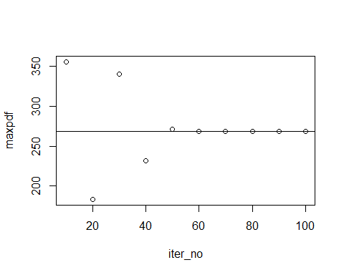
count <- 0
for (i in 2:10)
{
if ((maxpdf[i]- maxpdf[i-1]) < 10^(-6))
{
count = count +1
}
}
print(count)
## [1] 6

Exercise 3 (Either R, Python or Julia)
Consider the Trapezoidal Rule for integration. From “Analysis by Its History” (https://books.google.com/books/about/Analysis_by_Its_History.html?id=E2IhMXPZMNIC)
On the interval $\left[x_{i},x_{i+1}\right]$ the function $f\left(x\right)$ is replaced by a straight line passing through $\left(x_{i},f\left(x_{i}\right)\right)$ and $\left(x_{i+1},f\left(x_{i+1}\right)\right)$. The integral between $x_{i}$ and $x_{i+1}$ is then approximated by the trapezoidal area $h⋅\left(f\left(x_{i}\right)+f\left(x_{i+1}\right)\right)/2$ and we obtain
$$\int_{a}^{b}{f}\left(x\right)dx=F\left(x\right)≈\sum_{i=1}^{N−1}{\frac{h}{2}}\left(f\left(x_{i}\right)+f\left(x_{i+1}\right)\right)$$
We will calculate the integral for the normal pdf
$$\int_{−3}^{3}{f}\left(x;μ,σ^{2}\right)dx=\int_{−3}^{3}{\frac{1}{σ{\sqrt{2π}}^{​}}}e^{−\frac{{\left(x−μ\right)}^{2}}{2σ^{2}}}dx$$
with $μ=0$ and $sigma=1$, using your NormPdf function. We will do this by creating a sequence of approximations, each more precise than the preceding approximation.

Part a.
Calculate a first approximation of step size $h_{0}=1$, using the sequence of $x_{i}=\left\{−3.0,−2.0,−1.0,0.0,1.0,2.0,3.0\right\}$. Let this approximation be $F_{0}$. Print the first approximation.

Python
h0 = 1
xval = [-3.0, -2.0, -1.0, 0.0, 1.0, 2.0, 3.0]
def tra(xval, h):
approx = 0
for i in range(len(xval) - 1):
pos = xval[i]
pos1 = xval[i + 1]
approx += (h / 2) * (NormPdf(pos) + NormPdf(pos1))
return approx
F0 = tra(xval, h0)
print(xval, F0)
## [-3.0, -2.0, -1.0, 0.0, 1.0, 2.0, 3.0] 0.9952975108780335

Part b.
Continue to calculate a series of approximations $F_{0},F_{1},F_{2},…$ such that $F_{k+1}$ improves on $F_{k}$ by increasing $N$. Do this by decreasing the step size by 2, $h_{k+1}=h_{k}/2$. Thus, the sequence used to calculate $F_{1}$ will be of the form $x_{i}=\left\{−3.0,−2.5,−2.0,−1.5,−1.0,…,1.5,2.0,2.5,3.0\right\}$. If you use Python, you may need to use numpy.arange to produce a range of float values.
Calculate the first 10 approximations in the series and print the final approximation.

Python
import numpy as np
start = -3.0
end = 3.0
num_of_approx = 10
h = 1
approx1 = []
for k in range(num_of_approx):
x_values = np.arange(start, end + h, h)
approx2 = tra(x_values, h)
approx1.append(approx2)
h /= 2
print("Final:", approx1[-1])
## Final: 0.9973001954836621

Part c.
Plot the successive approximations $F_{i}$ against iteration number (you will need to define an array to store each approximation). Add a horizontal line for the expected value (pnorm(3, lower.tail = TRUE)-pnorm(-3, lower.tail = TRUE)). Set y-axis limits for this plot to be $\left[0.92,1\right]$ to best view the progression of approximations.
It is common practice to terminate a sequence of approximations when the difference between successive approximations is less than some small value. What is the difference between your final two approximations (It should be less than ${10}^{−6}$)?

Python
import matplotlib.pyplot as plt
plt.figure(2)
plt.plot(range(num_of_approx), approx1, marker='o')
plt.axhline(y=0.9973002039367398, color='r', linestyle='--')
plt.xlabel('Iteration')
plt.ylabel('Approximation (Fi)')
plt.ylim(0.92, 1)
## (0.92, 1.0)
plt.show()
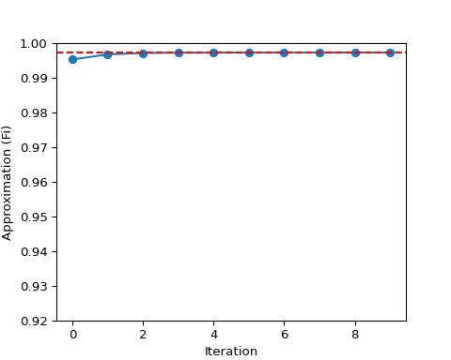
print("Difference between final 2 approximations:", abs(approx1[-1] - approx1[-2]))
## Difference between final 2 approximations: 2.535918930401948e-08

Exercise 4. (R, Python and Julia)
You will be simulating a series of Binomial experiments. A simple example of a Binomial experiment is the number of heads in a series of coin flips. Your simulation will require two nested for loops.

Part a.
First, define a vector of length 11, populated with 0s. This will represent a count of the number of times heads appear in a series of 10 flips. Call this vector Successes.

R
Successes <- rep(0, 11)

Python
Successes = [0] * 11

Julia
Successes = zeros(Int, 11);

Part b.
Next, write two loops. The outer loop will run from 1 to 1000. This will allow use to repeat the simple experiment 1000 times. The inner loop will perform the experiment, and will run from 1 to 10. Remember to adjust the indices for Python. You might use i as counter for the inner loop, and j as a counter for the inner loop, but we won’t need those variables.
Inside the outer loop, but outside the inner loop, define an accumulator variable Count, setting this value to 0. Inside the inner loop, perform a random coin toss by drawing from a uniform random sample (see this week’s lecture notes for code to simulate a coin toss). If the random value is greater than 0.5, count this as a success, and increment Count by 1. Remember to set Count to 0 before the start of the inner loop.
After the inner loop executes, Count will have a value between 0 (no heads) and 10 (all heads). You can now use Count as an index into Successes. After each iteration of the inner loop, increment Successes[Count] by 1. (You may need to use Count+1 as an index; remember Count can be 0).
We will be using Successes to sum the number of times each possible value of Count occurs in the 1000 repetitions of the simple experiment. Increment Successes outside the inner loop, but inside the outer loop.

R
for (i in 1:1000) {
Count <- 0
for (j in 1:10) {
# Simulate a coin toss
toss <- runif(1)
if (toss > 0.5) {
Count <- Count + 1
}
}
Successes[Count + 1] <- Successes[Count + 1] + 1
}
print(Successes)
## [1] 2 10 37 120 218 229 223 117 39 5 0

Python
import numpy
for i in range(1000):
Count = 0
for j in range(10):
toss = numpy.random.uniform(0, 1)
if toss > 0.5:
Count += 1
Successes[Count] += 1
print(Successes)
## [0, 6, 44, 120, 198, 255, 211, 109, 39, 16, 2]

Julia
for i in 1:1000
Count = 0
for j in 1:10
toss = rand()
if toss > 0.5
Count += 1
end
end
Successes[Count + 1] += 1
end
println(Successes)
## [0, 8, 38, 126, 191, 274, 189, 122, 39, 12, 1]

Part c.
Divide each element of Successes by 1000. Successes will now represent the proportion of success out of $n=10$ attempts. Plot Successes against a vector of values from 0 to 10 as points. Compare this with your BinomPMF function, where x takes values from 0 to 10, n = 10 and pi = 0.5. Add the values produced by BinomPMF to the plot of Successes as a line. How well did the simulation compare to the theoretical values from BinomPMF?

R
BinomPMF <- function(x, n, pi) {
choose(n, x) * pi^x * (1 - pi)^(n - x)
}
Successes <- Successes / 1000
x <- 0:10
theoretical <- BinomPMF(x, n = 10, pi = 0.5)
plot(x, Successes, type = "p", ylim = c(0, 0.4), xlab = "Number of Successes", ylab = "Proportion", main = "Simulation vs. Binomial PMF")
lines(x, theoretical, type = "l", col = "red")
legend("topright", legend = c("Simulation", "Binomial PMF"), col = c("black", "red"), pch = c(1, NA), lty = c(NA, 1))
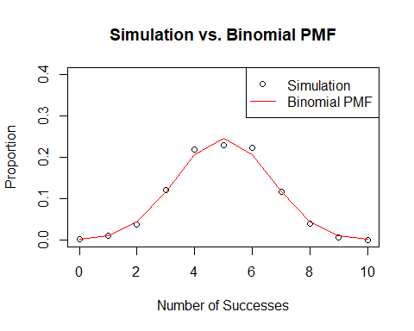

Python
import matplotlib.pyplot as plt
import numpy as np
def binom_pmf(x, n, pi):
return np.math.comb(n, x) * pi**x * (1 - pi)**(n - x)
Successes = np.array(Successes) / 1000
x = np.arange(0, 11)
theoretical = [binom_pmf(i, n=10, pi=0.5) for i in x]
## <string>:3: DeprecationWarning: `np.math` is a deprecated alias for the standard library `math` module (Deprecated Numpy 1.25). Replace usages of `np.math` with `math`
plt.plot(x, Successes, 'o', label='Simulation')
plt.plot(x, theoretical, 'r-', label='Binomial PMF')
plt.ylim(0, 0.4)
## (0.0, 0.4)
plt.xlabel('Number of Successes')
plt.ylabel('Proportion')
plt.title('Simulation vs. Binomial PMF')
plt.legend(loc='upper right')
plt.show()
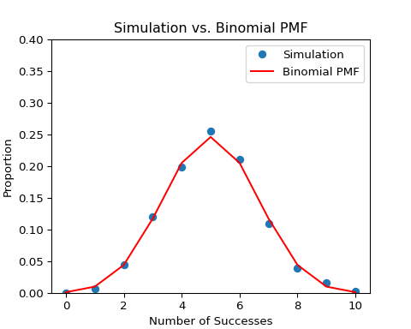

Julia
using Plots
function binom_pmf(x, n, pi)
binomial_coefficient = binomial(n, x)
return binomial_coefficient * pi^x * (1 - pi)^(n - x)
end
## binom_pmf (generic function with 1 method)
Successes = Successes / 1000
## 11-element Vector{Float64}:
## 0.0
## 0.008
## 0.038
## 0.126
## 0.191
## 0.274
## 0.189
## 0.122
## 0.039
## 0.012
## 0.001
x = 0:10
## 0:10
theoretical = [binom_pmf(i, 10, 0.5) for i in x]
## 11-element Vector{Float64}:
## 0.0009765625
## 0.009765625
## 0.0439453125
## 0.1171875
## 0.205078125
## 0.24609375
## 0.205078125
## 0.1171875
## 0.0439453125
## 0.009765625
## 0.0009765625
plot(x, Successes, seriestype = :scatter, ylims = (0, 0.4), xlabel = "Number of Successes", ylabel = "Proportion", title = "Simulation vs. Binomial PMF")
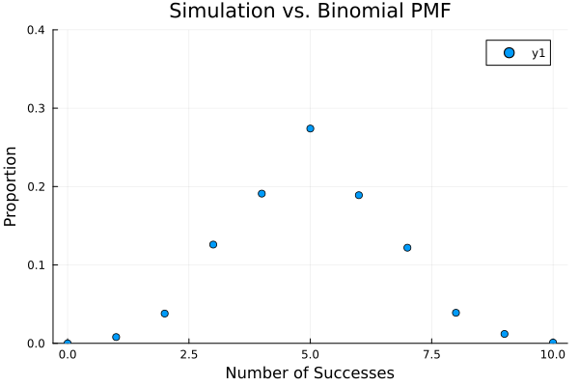
plot!(x, theoretical, color = :red, linestyle = :solid, label = "Binomial PMF")
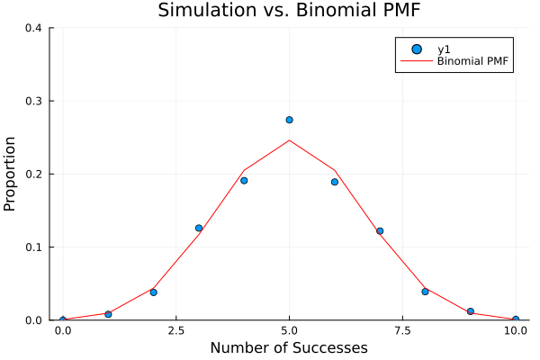
plot!(legend = :topright)


