8 Processing Text Homework
sai Ram Vodnala
7/18/2024

Instructions
There are four exercises below. Three exercises are worth 10 points each, and are labelled (Either R, Python or Julia). For these exercises, you can implement a solution in the language of your choice. I’ve included code chunk templates for all three languages, but you only need to fill in the chunks for one language.
One exercise is labelled (R, Python and Julia). This exercise is worth 20 points, and you must provide a solution using all three languages. This exercise also includes code chunk templates for all three languages.
Some of the exercises have questions relating to the results. Write your answers in the narrative part of the text, formatted as italicized text, bold text or
quoted text.
Submit both Rmd and typeset results using file name formats as in previous exercises.
Do not use libraries in R that are not part of the base R installation (with one exception as stated below); this includes popular libraries for data tables like data.table or tidyverse libraries like dplyr and tidyr, with the exception of sqldf library. You may use any Python or Julia libraries introduced in lecture, except for graphs. You are free to use any Python or Julia graphics library, as long as I can install it on my machine if necessary.

Exercise 1.
Write a loop or a function to convert a matrix to a CSV compatible string. For example, given a matrix of the form
$$\left(\begin{matrix}1 & 2 & 3 \\ 4 & 5 & 6 \\ \end{matrix}\right)$$
produce a string of the form
1,2,3\n4,5,6
where \n is the newline character. Use the matrix below as a test case.

R
Wansink <- matrix(c(268.1, 271.1, 280.9, 294.7, 285.6, 288.6, 384.4,
124.8, 124.2, 116.2, 117.7, 118.3, 122.0, 168.3),ncol=2)
matrixCSV=function(n.matrix){
s=noquote(n.matrix)
csv.s={}
for (i in 1:nrow(s))
{
for(j in 1:ncol(s))
{
if(j!=ncol(s))
csv.s=append(csv.s,noquote(paste((noquote(s[i,j])),sep=",")))
else
if(i==nrow(s))
{csv.s=append(csv.s,paste(noquote(s[i,j]),sep=""))
break}
else
csv.s=append(csv.s,paste(noquote(s[i,j]),"\n",sep=""))
}
}
csv.s=do.call(paste, c(as.list(csv.s),sep=",",collapse="\n"))
return(csv.s)
}
n.matrix = matrix(1:9,
nrow=2,
ncol=2, byrow = TRUE)
## Warning in matrix(1:9, nrow = 2, ncol = 2, byrow = TRUE): data length [9] is
## not a sub-multiple or multiple of the number of rows [2]
gsub("\n,","\n",noquote(matrixCSV(n.matrix)))
## [1] 1,2\n3,4
gsub("\n,","\n",noquote(matrixCSV(as.matrix(Wansink))))
## [1] 268.1,124.8\n271.1,124.2\n280.9,116.2\n294.7,117.7\n285.6,118.3\n288.6,122\n384.4,168.3

Python
Wansink = [[268.1, 271.1, 280.9, 294.7, 285.6, 288.6, 384.4],
[124.8, 124.2, 116.2, 117.7, 118.3, 122.0, 168.3]]

Julia
Wansink = [268.1 271.1 280.9 294.7 285.6 288.6 384.4;
124.8 124.2 116.2 117.7 118.3 122.0 168.3]
## 2×7 Matrix{Float64}:
## 268.1 271.1 280.9 294.7 285.6 288.6 384.4
## 124.8 124.2 116.2 117.7 118.3 122.0 168.3
I found I could finish this exercise in one line in R, with judicious use of apply and paste. Similarly, I was able to write one line of code in Python with nested calls to join and use of list comprehensions. In Julia, I was able to use list comprehensions and the join function, but comprehension required use of the eachrow function. However, you may write for loops if you choose.

Exercise 2.
Calculate MSW, MSB, $F$ and $p$ for the data from Wansink Table 1 (Homework 4, Exercise 3) where
MSB=i​nixi−x2k−1
MSW=i​ni−1si2N−k
and $F=MSB/MSW$.
Start with the string:

R
WansinkString <- "268.1,271.1,280.9,294.7,285.6,288.6,384.4\n124.8,124.2,116.2,117.7,118.3,122.0,168.3\n18,18,18,18,18,18,18"

Python
WansinkString = "268.1,271.1,280.9,294.7,285.6,288.6,384.4\n124.8,124.2,116.2,117.7,118.3,122.0,168.3\n18,18,18,18,18,18,18"

Julia
WansinkString = "268.1,271.1,280.9,294.7,285.6,288.6,384.4\n124.8,124.2,116.2,117.7,118.3,122.0,168.3\n18,18,18,18,18,18,18";
Split this string into 3 substrings based on the newline character ('\n'). Next, tokenize the strings based on the ',' character and convert the tokens to a create vectors of numeric values (i.e. CaloriesPerServingMean, CaloriesPerServingSD, n). Note this is roughly the reverse process from Exercise 1. The first vector will correspond to $x$, the second to $s$ and the third to $n$
Use these vectors to compute and print $MSW$, $MSB$, $F$ and $p$.

R
a<- unlist(strsplit(WansinkString, '\n'))
e<-NULL
CaloriesPerServingMean<-NULL
CaloriesPerServingSD<-NULL
n<-NULL
for(i in seq(1:length(a))){
e[i]<-strsplit(a[i], split=',')
}
CaloriesPerServingMean<-as.numeric(unlist(e[1]))
CaloriesPerServingSD<-as.numeric(unlist(e[2]))
n<-as.numeric(unlist(e[3]))
print(CaloriesPerServingMean)
## [1] 268.1 271.1 280.9 294.7 285.6 288.6 384.4
print(CaloriesPerServingSD)
## [1] 124.8 124.2 116.2 117.7 118.3 122.0 168.3
print(n)
## [1] 18 18 18 18 18 18 18
k <-length(CaloriesPerServingMean)
N <- sum(n)
MSW <- sum((n-1)*(CaloriesPerServingSD^2))/(N - k)
print(MSW)
## [1] 16508.6
bar_x <- (sum(n*CaloriesPerServingMean))/(N)
MSB <- (sum(n*((CaloriesPerServingMean - bar_x)^2)))/(k - 1)
print(MSB)
## [1] 28815.96
F<-MSB/MSW
print(F)
## [1] 1.745512
p <-pf(F,k-1, N-k, lower.tail = FALSE)
print(p)
## [1] 0.1163133

Python

Julia
Compare your results from previous homework, or to the resource given in previous homework, to confirm that the text was correctly converted to numeric values. I compared results from previous homework 4, the results are same, so text was correctly converted to numeric values.

Exercise 3.
Load the file openmat2015.csv into a data table or data frame. We wish to know how many went on to compete in the national championship in 2019, so we will merge this table with the data from Homework 7, ncaa2019.csv. Join the data on First and Last names. The openmat2015.csv data contains only a single column, Name. You will need to split the text in this column to create the columns First and Last required to merge with ncaa2019.csv.
For example, the ${22}^{nd}$ wrestler in openmat2015.csv, Danny Vega will be split into Danny and Vega. Danny did not wrestle in the 2019 NCAA tournament, but he did wrestle the 2021 tournament for SDSU. The ${43}^{t}h$ wrestler in openmat2015.csv will be be split into Yianni, Diakomihalis. Yianni was the national champion in 2019 at 141 pounds. Thus, the merged data set will contain Yianni, Diakomihalis, but not Danny, Vega. Do not print these tables in the submitted work
What is the relationship between high school (openmat2015.csv) and college weight classes (ncaa2019.csv)? Print a contingency table comparing Weight from openmat2015.csv and Weight from ncaa2019.csv, or produce a scatter plot, using high school weight class as the independent variable. The relationship between high school and college wrestling weight classes shows a general trend where wrestlers tend to compete in heavier weight classes in college than they did in high school. and wrestlers in the higher high school weight classes generally remain in the same or slightly heavier classes in college.

R
ncaa2019 <- read.csv("C:/Users/sairam/Desktop/Stat600/0.files/HOMEWORKS/HW8/ncaa2019.csv")
openmat2015 <- read.csv("C:/Users/sairam/Desktop/Stat600/0.files/HOMEWORKS/HW8/openmat2015.csv")
name <-unlist(strsplit(as.character(openmat2015$Name), split =' ', fixed = T))
Last <- rep(NA, 280)
First <- rep(NA, 280)
for (i in 1:length(name)) {
if (i/2 - as.integer(i/2) == 0){
Last[i/2] = name[i]
}else{
First[i/2 + 0.5] = name[i]
}
}
openmat2015$Last <- Last
openmat2015$First <- First
Mergedata <- merge(openmat2015, ncaa2019, by = c("First", "Last"), suffixes = c(2019, 2015))
weight <- table(Mergedata$Weight2019,Mergedata$Weight2015, dnn = c("ncaa2019 weight", "openmat 2015 weight"))
weight
## openmat 2015 weight
## ncaa2019 weight 125 133 141 149 157 165 174 184 197 285
## 106 2 1 0 0 1 0 0 0 0 0
## 113 1 1 1 0 0 0 0 0 0 0
## 120 5 3 1 1 0 0 0 0 0 0
## 126 0 1 1 0 0 0 0 0 0 0
## 132 2 2 4 1 0 0 0 0 0 0
## 138 0 0 2 1 1 0 0 0 0 0
## 145 0 0 1 1 4 0 0 0 0 0
## 152 0 0 0 1 1 2 2 0 0 0
## 160 0 0 0 0 0 4 4 0 0 0
## 170 0 0 0 0 0 2 2 2 0 0
## 182 0 0 0 0 0 0 2 2 3 1
## 195 0 0 0 0 0 0 0 2 1 1
## 220 0 0 0 0 0 0 0 0 0 5
## 285 0 0 0 0 0 0 0 0 0 1
plot(x = Mergedata$Weight2019, y = Mergedata$Weight2015,
xlab = "Weight2019",
ylab = "Weight2015",
main = "Weight2019 vs Weight2015"
)
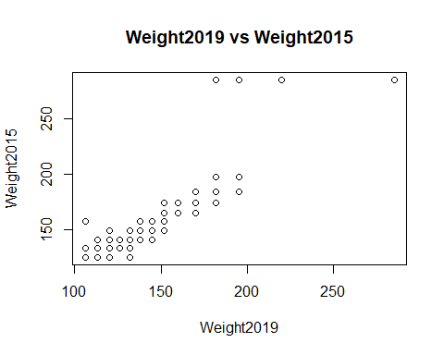

Python

Julia

Exercise 4
Use the file vehicles.csv. These data were downloaded and modified from https://www.fueleconomy.gov/feg/download.shtml.
Read the data into a data table. This file has ~35000 rows; we will reduce the size of this data by filtering for text or numeric values in different columns. You can use pattern matching (i.e. regular expressions) for the filters on string data columns. At each step, you may need to save the results of a filter to the original data table variable; this will reduce the size of the data table at each step. Alternatively, if available, you may use an inplace argument. Do not print these tables in the submitted work
It may help debugging if you print the number of rows in the table after each step. You will be required to produce plots for parts e and f, but it may also help you to produce box-whisker plots at each step, using the selection column for each plot (i.e. plot(UHighway ~ factor(VClass), data=vehicles) after part a). You should also print the dimensions of the data table at each step; you will be given some estimates of the size of the data table after each filter process.

R
vehicles <- read.csv("C:/Users/sairam/Desktop/Stat600/0.files/HOMEWORKS/HW8/vehicles.csv")

Python
import pandas as pd
vehicles = pd.read_csv("C:/Users/sairam/Desktop/Stat600/0.files/HOMEWORKS/HW8/vehicles.csv")

Julia
using CSV
using DataFrames
vehicles = CSV.File("C:/Users/sairam/Desktop/Stat600/0.files/HOMEWORKS/HW8/vehicles.csv") |> DataFrame;

Part a.
Select only rows with data with cars (not vans, etc.) To do this, match Cars in the VClass column. This should remove ~17000 rows.

R
data <- grepl("Cars", vehicles$VClass)
vehicles <- vehicles[data,]
dim(vehicles)
## [1] 17969 15

Python
data = vehicles['VClass'].str.contains("Cars")
vehicles = vehicles[data]
print(vehicles.shape)
## (17969, 15)

Julia
data = occursin.("Cars", vehicles[:, "VClass"]);
vehicles = vehicles[data, :];
size(vehicles)
## (17969, 15)

Part b.
Select only rows with data for regular or premium gasoline. You can match Gasoline in the fuelType1 column and exclude rows with Midgrade in that column.

R
data <- (grepl("Gasoline", vehicles$fuelType1) & !grepl("Midgrade", vehicles$fuelType1))
vehicles <- vehicles[data,]
dim(vehicles)
## [1] 17451 15

Python
data = (vehicles["fuelType1"].str.contains("Gasoline") & ~(vehicles["fuelType1"].str.contains("Midgrade")))
vehicles = vehicles[data]
print(vehicles.shape)
## (17451, 15)

Julia
data = occursin.("Gasoline", vehicles[:, "fuelType1"]) .& .!(occursin.("Midgrade", vehicles[:, "fuelType1"]));
vehicles = vehicles[data, :];
size(vehicles)
## (17451, 15)

Part c.
Select for certain classes of transmissions. Match for the pattern *-spd in the trany column and exclude rows with Doubled in that column. There should be ~13000 rows remaining at this step.

R
data <- (grepl("*-spd", vehicles$trany) & !grepl("Doubled", vehicles$trany))
vehicles <- vehicles[data,]
dim(vehicles)
## [1] 13106 15

Python
data = (vehicles["trany"].str.contains(r"-spd") &
~(vehicles["trany"].str.contains("Doubled")))
vehicles = vehicles[data]
print(vehicles.shape)
## (13106, 15)

Julia
data = occursin.("-spd", vehicles[:, "trany"]) .& .!(occursin.("Doubled", vehicles[:, "trany"]));
vehicles = vehicles[data, :];
size(vehicles)
## (13106, 15)

Part d.
Select only rows with values of $4,6,8$ in the cylinders column. Eliminate any rows with missing cylinders values.

R
data <- (vehicles$cylinders %in% c(4,6,8) & !is.na(vehicles$cylinders))
vehicles <- vehicles[data,]
dim(vehicles)
## [1] 12514 15

Python
data = (vehicles["cylinders"].isin([4, 6, 8]) & ~vehicles["cylinders"].isna())
vehicles = vehicles[data]
print(vehicles.shape)
## (12514, 15)

Julia
data = [(!ismissing(x)) && (x in [4, 6, 8]) for x in vehicles[:, "cylinders"]];
vehicles = vehicles[data, :];
size(vehicles)
## (12514, 15)

Part e.
Select only rows with year before 2020. Produce a box-whisker plot of fuel efficiency (UHighway) with year as the independent variable. There should be <12500 rows remaining at this step.

R
data <- (vehicles$year < 2020)
vehicles <- vehicles[data,]
dim(vehicles)
## [1] 12363 15
boxplot(UHighway ~ year, data = vehicles, main = "Fuel Efficiency")
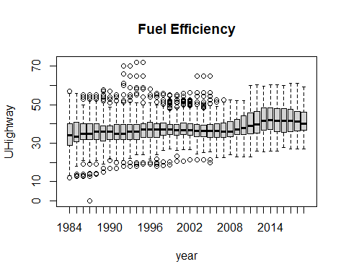

Python
import matplotlib.pyplot as plt
data = ((vehicles["year"]) < 2020)
vehicles = vehicles[data]
print(vehicles.shape)
## (12363, 15)
plt.figure(1)
pyplot = vehicles.boxplot(column="UHighway", by="year")
plt.title("Fuel Efficiency")
plt.ylabel('UHighway')
plt.show()
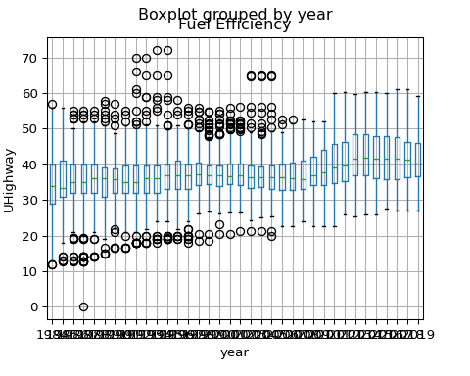

Julia
data = vehicles.year .< 2020;
vehicles = vehicles[data, :];
size(vehicles);
using StatsPlots;
@df vehicles boxplot(:year, :UHighway, title = "Fuel Efficiency")
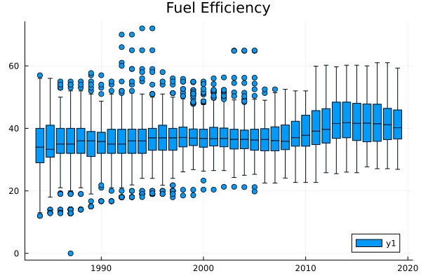

Part f.
Tokenize the strings in the trany column into two substrings. The first will identify the type of transmission (Manual or Automatic) and the second will identify the number of gears (3-spd, 4-spd), etc. Use first substring for each row to create new string data column transmission, with values Manual or Automatic. Tokenize the second substring and convert the integer characters to integer values; add this as a new numeric data column gears.
Produce two box-whisker plots of fuel efficiency (UHighway) as the dependent variable, with transmission and gears as the independent variables.

R
trany_col <- strsplit(as.character(vehicles$trany), split = " ")
transmission <- unlist(lapply(trany_col, function(x) x[grepl("Automatic|Manual", x)]))
num_of_gears <- (lapply(trany_col, function(x) x[grepl("*-spd", x)]))
gear_tokens <- strsplit(as.character(num_of_gears), split = "-")
gears <- as.integer(unlist(lapply(gear_tokens, function(x) x[grepl("[0-9]", x)])))
vehicles$transmission <- transmission
vehicles$gears <- gears
dim(vehicles)
## [1] 12363 17
boxplot(UHighway ~ transmission, data = vehicles, main = "Fuel Efficiency: UHighway ~ transmission ")
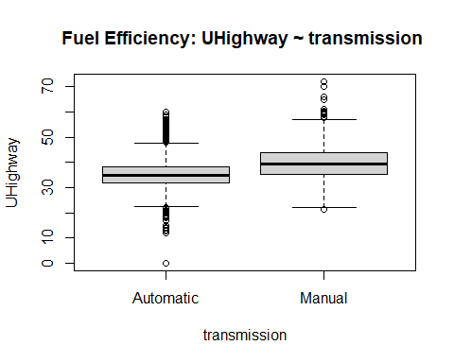
boxplot(UHighway ~ gears, data = vehicles, main = "Fuel Efficiency: UHighway ~ gears ")
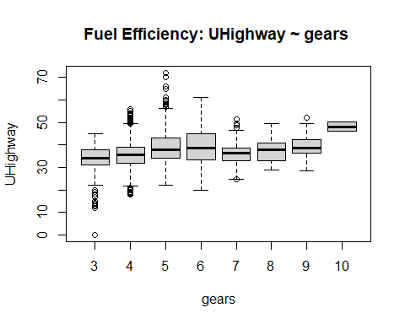

Python
import matplotlib.pyplot as plt
vehicles[['transmission', 'gears_col']] = vehicles.trany.str.split(" ", expand=True)
gears_col = vehicles["gears_col"].str.split("-", expand=True)
vehicles.loc[:, "gears"] = gears_col[0]
plt.figure(100)
plt.boxplot([vehicles.loc[vehicles['transmission'] == t, 'UHighway'] for t in vehicles['transmission'].unique()],
labels=vehicles['transmission'].unique())
## <string>:1: MatplotlibDeprecationWarning: The 'labels' parameter of boxplot() has been renamed 'tick_labels' since Matplotlib 3.9; support for the old name will be dropped in 3.11.
## {'whiskers': [<matplotlib.lines.Line2D object at 0x000001ADD5DDC2B0>, <matplotlib.lines.Line2D object at 0x000001ADD5DDC550>, <matplotlib.lines.Line2D object at 0x000001ADD5DDD510>, <matplotlib.lines.Line2D object at 0x000001ADD5DDD7B0>], 'caps': [<matplotlib.lines.Line2D object at 0x000001ADD5DDC7F0>, <matplotlib.lines.Line2D object at 0x000001ADD5DDCA90>, <matplotlib.lines.Line2D object at 0x000001ADD5DDDA50>, <matplotlib.lines.Line2D object at 0x000001ADD5DDDCF0>], 'boxes': [<matplotlib.lines.Line2D object at 0x000001ADD5D13FD0>, <matplotlib.lines.Line2D object at 0x000001ADD5DDD270>], 'medians': [<matplotlib.lines.Line2D object at 0x000001ADD5DDCD30>, <matplotlib.lines.Line2D object at 0x000001ADD5DDDF90>], 'fliers': [<matplotlib.lines.Line2D object at 0x000001ADD5DDCFD0>, <matplotlib.lines.Line2D object at 0x000001ADD5DDE230>], 'means': []}
plt.title("Fuel Efficiency: UHighway vs transmission")
plt.ylabel('UHighway')
plt.xlabel('Transmission')
plt.xticks(rotation=45)
## (array([1, 2]), [Text(1, 0, 'Manual'), Text(2, 0, 'Automatic')])
plt.show()
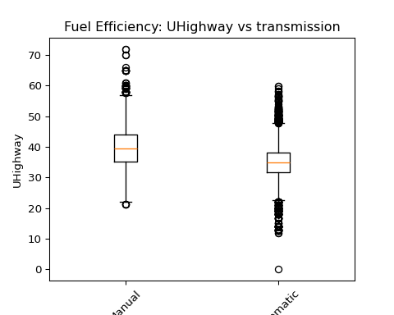
plt.figure(101)
vehicles.boxplot(column='UHighway', by='gears')
plt.title("Fuel Efficiency: UHighway vs Gears")
plt.suptitle('')
plt.ylabel('UHighway')
plt.xlabel('Gears')
plt.xticks(rotation=45)
## (array([1, 2, 3, 4, 5, 6, 7, 8]), [Text(1, 0, '10'), Text(2, 0, '3'), Text(3, 0, '4'), Text(4, 0, '5'), Text(5, 0, '6'), Text(6, 0, '7'), Text(7, 0, '8'), Text(8, 0, '9')])
plt.show()
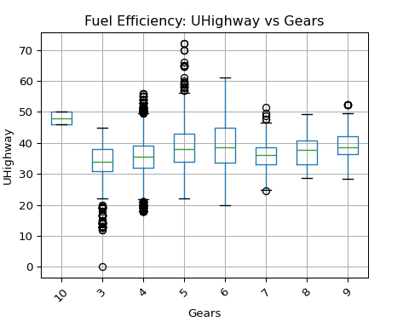

Julia
using StatsPlots;
trany_col = split.(vehicles.trany);
insertcols!(vehicles, [n => getindex.(trany_col, i) for (i, n) in enumerate([:transmission, :gear_col])]...);
gear = [parse(Int, match(r"\d+", x).match) for x in vehicles.gear_col];
vehicles[!,:gear] = gear;
@df vehicles boxplot(:transmission, :UHighway, title = "Fuel Efficiency: UHighway vs transmission")
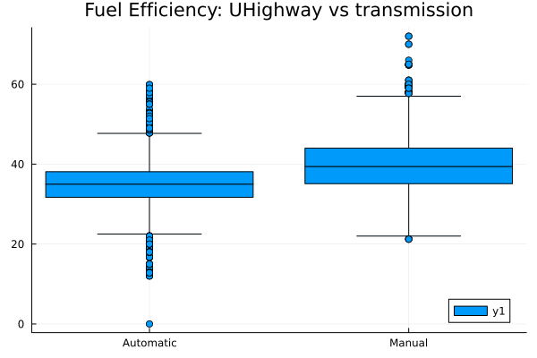
@df vehicles boxplot(:gear, :UHighway, title = "Fuel Efficiency: UHighway vs gears")
