Project 2: Passcode (Model Building)
- Introduction:
This project addresses the task of identifying individuals based on their typing patterns of a fixed passcode ".tie5Roanl". Data were collected from 51 users over 8 sessions, with each session including 50 repetitions of the passcode. The objective is to build Classification Technique models that can accurately classify the user from a single passcode entry, focusing on data from later repetitions (after users have learned the passcode), and also a summary of the method’s accuracy.
- Data Description:
We began the project by loading and summarizing the dataset while performing checks for missing values. The dataset contains 20,400 observations and 34 variables, providing a robust foundation for analysis.
Dataset Variables were concluded as:
H.period: The amount of time that the "." is held down.
DD.period.t: The time between pressing down the "." key to the time to press down the "t" key.
UD.period.t: The time between the "." key coming up to the time to press down the "t" key.
H.t: The amount of time that the "t" is held down.
DD.t.i: The time between pressing down the "t" key to the time to press down the "i" key.
UD.t.i: The time between the "t" key coming up to the time to press down the "i" key.
H.i: The amount of time that the "i" is held down.
DD.i.e: The time between pressing down the "i" key to the time to press down the "e" key.
UD.i.e: The time between the "i" key coming up to the time to press down the "e" key.
H.e: The amount of time that the "e" is held down.
DD.e.five: The time between pressing down the "e" key to the time to press down the "5" key.
UD.e.five: The time between the "e" key coming up to the time to press down the "5" key.
H.five: The amount of time that the "5" is held down.
DD.five.Shift.r: The time between pressing down the "5" key to the time to press down the "shift+r" key combination.
UD.five.Shift.r: The time between the "5" key coming up to the time to press down the "shift+r" key combination.
H.Shift.r: The amount of time that the "shift+r" key combination is held down.
DD.Shift.r.o: The time between pressing down the "shift+r" key combination to the time to press down the "o" key.
UD.Shift.r.o: The time between the "shift+r" key combination coming up to the time to press down the "o" key.
H.o: The amount of time that the "o" is held down.
DD.o.a: The time between pressing down the "o" key to the time to press down the "a" key.
UD.o.a: The time between the "o" key coming up to the time to press down the "a" key.
H.a: The amount of time that the "a" is held down.
DD.a.n: The time between pressing down the "a" key to the time to press down the "n" key.
UD.a.n: The time between the "a" key coming up to the time to press down the "n" key.
H.n: The amount of time that the "n" is held down.
DD.n.l: The time between pressing down the "n" key to the time to press down the "l" key.
UD.n.l: The time between the "n" key coming up to the time to press down the "l" key.
H.l: The amount of time that the "l" is held down.
DD.l.Return: The time between pressing down the "l" key to the time to press down the "return" key.
UD.l.Return: The time between the "l" key coming up to the time to press down the "return" key.
H.Return: The amount of time that the "return" is held down key.
The data collection group included:
• 51 subject participants
• 8 data collection sessions
• 50 passcode entries per session
• Sessions were one day apart
• Passcode: .tie5Roanl
• Source: DSL-StrongPasswordData.csv
• Filtering: Only the last 20 repetitions per session (i.e., rep > 30) were used to ensure users had become familiar with the passcode.
• Final Dataset Size: 8160 entries

- Feature Engineering:
Three aggregate timing features were engineered:
- total_h_time: Sum of all key Hold times (H.)
- total_dd_time: Sum of all Down-Down times (DD.)
- total_ud_time: Sum of all Up-Down times (UD.)
- Data Preprocessing:
Standardizing all numeric columns (except subject) (It is used for PCA (4 Models), XGBoost, and SVM)

- Data Splitting:
- Data was randomly split per-entry into training (80%) and testing (20%) sets.
- Splitting was stratified across subjects to preserve distribution.

- Models and Methods:
We evaluated eight supervised classification Models/Techniques:
Baseline (using only 3 total_ features):
- Multinomial Logistic Regression
- LDA
- QDA
- MClustDA
- Decision Tree
- Random Forest
- XGBoost
- SVM

Summary Table — Baseline Model Comparison
Model  <chr> | Features  <chr> | Accuracy  <dbl>
Multinomial Logistic | 3 total_features | 0.3308824
LDA | 3 total_features | 0.3253676
QDA | 3 total_features | 0.3590686
MClustDA | 3 total_features | 0.3835784
Decision Tree | 3 total_features | 0.1838235
Random Forest | 3 total_features | 0.2616422
XGBoost | 3 total_features | 0.2665441
SVM | 3 total_features | 0.2224265

Advanced Models:
Performing PCA on training data (excluding subject) here. Choosing the top 17 PCs because 17 is the maximum components that Logistic Regression, LDA, QDA, and MClustDA can handle
- PCA applied to full scaled feature set (top 17 components, PCs) for Logistic, LDA, QDA, and MClustDA
- Full raw features used for Decision Tree, Random Forest, XGBoost, and SVM

Summary Table — Advanced Model Comparison
Model  <chr> | Features  <chr> | Accuracy  <dbl>
Multinomial Logistic (PCA) | Top 17 PCs | 0.8033088
LDA (PCA) | Top 17 PCs | 0.7218137
QDA (PCA) | Top 17 PCs | 0.7628676
MClustDA (PCA) | Top 17 PCs | 0.7904412
Decision Tree (Full) | ALL Features | 0.4944853
Random Forest (Full) | ALL Features | 0.9368873
XGBoost (Full) | ALL Features | 0.9099265
SVM (Full) | ALL Features | 0.8750000

- Model Tuning:
Random Forest Tuned Accuracy: 0.9381127
Note: mtry: The number of predictors that will be randomly sampled at each split when creating the tree models
(It took a lot of time to run.)

- Model Evaluation:
Considering the Random Forest is the best model
Result:
Overall Accuracy
- Accuracy: 93.81%
- 95% Confidence Interval: (92.53%, 94.93%)
- Kappa: 0.9369 (very strong agreement)
- P-value [Acc > NIR]: < 2.2e-16 — significantly better than random

Confusion Matrix Insights
- Most subjects were classified perfectly or nearly perfectly
- Misclassifications were rare and usually between very similar subjects (likely with similar typing styles)
Example:
s007 → s051: some confusion (4 entries misclassified)
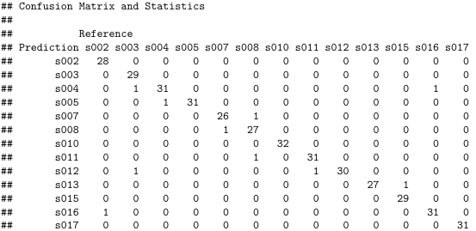
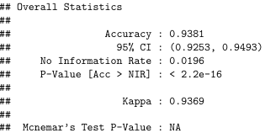

Figure: Snapshot of the confusion matrix for cross-validation.

Figure: Snapshot of the overall statistics of the random forest model.

Subjects with Perfect Scores (Model is Confident & Correct)
Subject | Precision | Recall | F1 Score
s022 | 1.0 | 1.0 | 1.0
s027 | 1.0 | 1.0 | 1.0
s033 | 1.0 | 1.0 | 1.0
s036 | 1.0 | 1.0 | 1.0
s042 | 1.0 | 1.0 | 1.0
s043 | 1.0 | 1.0 | 1.0
Interpretation:
- The model consistently identified these users perfectly
- Indicates their typing behaviour is:
  - Distinct (non-overlapping features)
  - Consistent (low intra-user variability)
- These subjects likely have unique timing patterns or distributions
Highest F1 Scores:
- s022, s027, s033, etc. achieved perfect F1 = 1.0.
- These users exhibit highly distinct and consistent typing patterns, making them easy for the model to classify.

Although the Random Forest model achieved 93.8% accuracy, misclassifications occurred most frequently between the following subject pairs:
- s051 → s007 (4 times)
- s032 ↔ s037, s031 ↔ s044, and s013 → s057 (3 times each)

Top Confused Subject Pairs
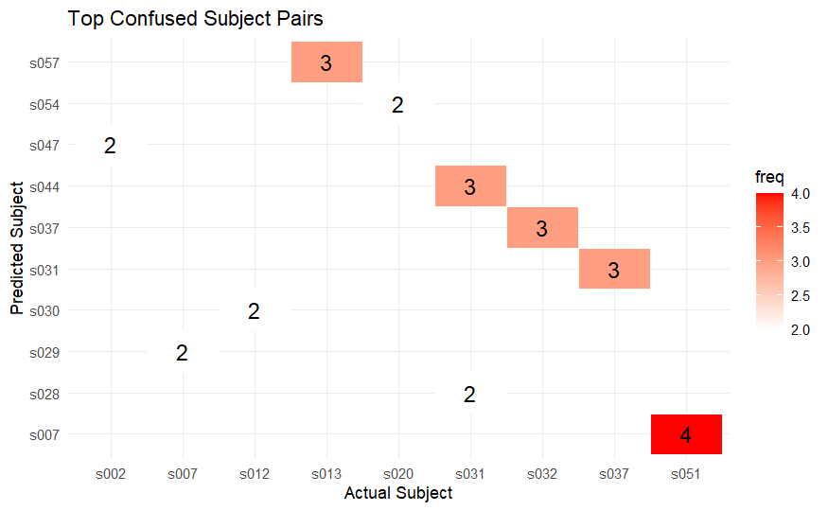
Figure: Top confusion subject pairs.
These errors occurred primarily between users with very similar total timing distributions, making it difficult for the model to differentiate.
Interpretation of Typing Behavior (s007 vs s051)
This suggests these users have nearly indistinguishable keystroke dynamics, explaining the misclassifications.
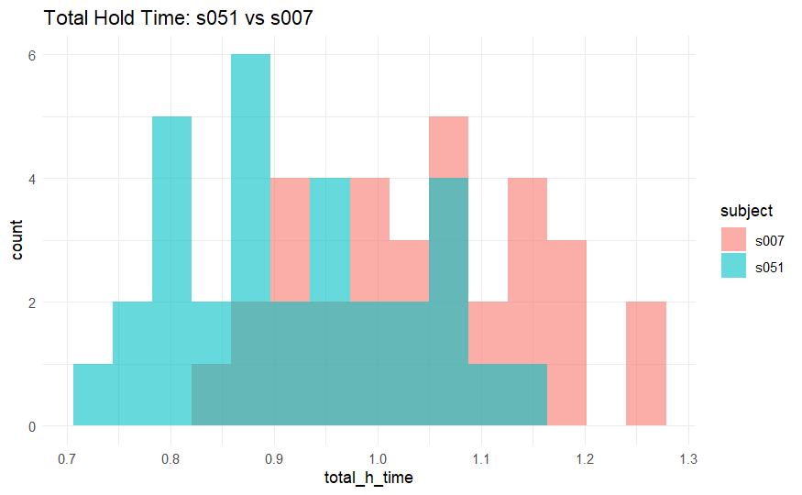
Total Hold Time
Figure: Comparison of the total hold time between s051 and s007.
- Both subjects have overlapping distributions in the 0.85–1.1s range.
- This makes it hard for the model to separate them based on how long they hold keys.
- Slight difference at the tails s007 has longer total hold times overall.
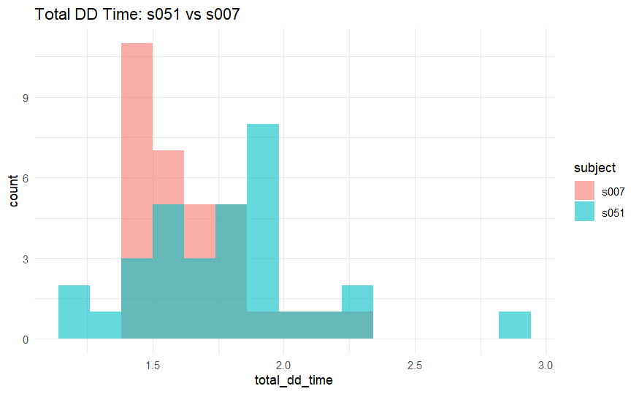
Total DD Time (key-to-key press)
Figure: Comparison of the total down-down time between s051 and s007.
- The distributions overlap significantly in the 1.4–2.0s region.
- s051 has slightly more variability, but not enough for clear separation.
- Both users seem to type at similar speeds between keys.

Total UD Time (key release to next press)
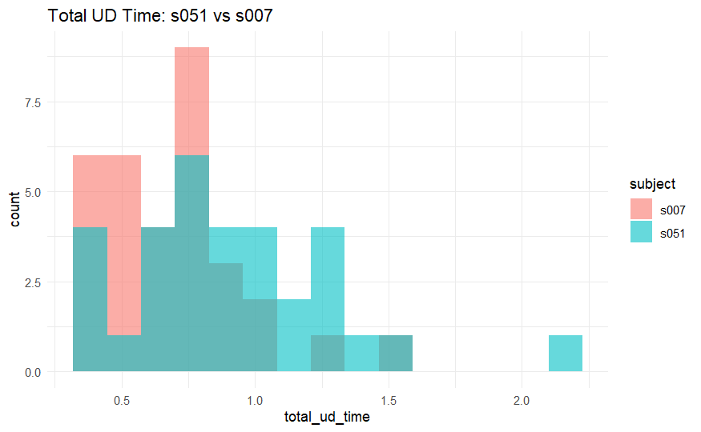
Figure: Comparison of the total up-down time between s051 and s007.
- Again, there's strong overlap, especially in the 0.4–1.0s region.
- This feature also doesn’t provide a strong separation between the two.

- Conclusion:
- The Random Forest model achieved the best performance with 93.81% accuracy.
- Most misclassifications arose between users with overlapping typing behaviors.
- Feature engineering (total timings) helped create interpretable inputs.
- PCA helped reduce dimensionality for simpler models.

- Recommendation:
Random Forest is well-suited for this task due to its robustness and ability to handle high-dimensional, complex feature interactions without requiring aggressive preprocessing.

References
Lecture Notes and Resources (STAT 541, STAT 600, STAT 601, STAT 602)
Killourhy, K. S., & Maxion, R. A. (2009). Comparing anomaly-detection algorithms for keystroke dynamics.
Hothorn, T., & Everitt, B. S. (2014). A Handbook of Statistical Analyses using R. In Chapman and Hall/CRCeBooks. https://doi.org/10.1201/b17081
ChatGPT. (02/2025). Used for debugging and code cleaning. Retrieved from OpenAI

