Project 3: Passcode (Model Building)
- Introduction:
The purpose of this project is to identify the typist behind a full session of typing the passcode .tie5Roanl, using biometric keystroke dynamics. Each of the 51 subjects completed 8 sessions of typing the same password 50 times. The goal is to predict the typist using as few repetitions as possible (from rep 1 to rep 50) while maintaining high classification accuracy and confidence so the objective is to Build a model to predict which individual typed an entire session using as few repetitions as possible and also to summarize model performance with respect to classification accuracy and confidence over repetition counts.
- Data Description:
We began the project by loading and summarizing the dataset while performing checks for missing values. The dataset contains 20,400 observations and 34 variables, providing a robust foundation for analysis.
Dataset Variables were concluded as:
H.period: The amount of time that the "." is held down.
DD.period.t: The time between pressing down the "." key to the time to press down the "t" key.
UD.period.t: The time between the "." key coming up to the time to press down the "t" key.
H.t: The amount of time that the "t" is held down.
DD.t.i: The time between pressing down the "t" key to the time to press down the "i" key.
UD.t.i: The time between the "t" key coming up to the time to press down the "i" key.
H.i: The amount of time that the "i" is held down.
DD.i.e: The time between pressing down the "i" key to the time to press down the "e" key.
UD.i.e: The time between the "i" key coming up to the time to press down the "e" key.
H.e: The amount of time that the "e" is held down.
DD.e.five: The time between pressing down the "e" key to the time to press down the "5" key.
UD.e.five: The time between the "e" key coming up to the time to press down the "5" key.
H.five: The amount of time that the "5" is held down.
DD.five.Shift.r: The time between pressing down the "5" key to the time to press down the "shift+r" key combination.
UD.five.Shift.r: The time between the "5" key coming up to the time to press down the "shift+r" key combination.
H.Shift.r: The amount of time that the "shift+r" key combination is held down.
DD.Shift.r.o: The time between pressing down the "shift+r" key combination to the time to press down the "o" key.
UD.Shift.r.o: The time between the "shift+r" key combination coming up to the time to press down the "o" key.
H.o: The amount of time that the "o" is held down.
DD.o.a: The time between pressing down the "o" key to the time to press down the "a" key.
UD.o.a: The time between the "o" key coming up to the time to press down the "a" key.
H.a: The amount of time that the "a" is held down.
DD.a.n: The time between pressing down the "a" key to the time to press down the "n" key.
UD.a.n: The time between the "a" key coming up to the time to press down the "n" key.
H.n: The amount of time that the "n" is held down.
DD.n.l: The time between pressing down the "n" key to the time to press down the "l" key.
UD.n.l: The time between the "n" key coming up to the time to press down the "l" key.
H.l: The amount of time that the "l" is held down.
DD.l.Return: The time between pressing down the "l" key to the time to press down the "return" key.
UD.l.Return: The time between the "l" key coming up to the time to press down the "return" key.
H.Return: The amount of time that the "return" is held down key.

- Feature Engineering:
Four aggregate timing features were engineered:
- total_h_time: Sum of all key Hold times (H.)
- total_dd_time: Sum of all Down-Down times (DD.)
- total_ud_time: Sum of all Up-Down times (UD.)
- We also created a typing count for each subject as variable typing_count.
- So for Baseline Model: typing_count, total_h_time, total_dd_time, total_ud_time
- And Extended (Full Features): Included all raw keystroke metrics (H, DD, UD) totals and four session-level aggregates.

- Data Preprocessing:
Filtered the best 10 typists from Project 1 and Project 2 (Subjects with Perfect Scores where the Model is Confident & Correct)
top_10_users <- c("s002", "s020", "s040", "s057", "s022", "s027", "s033", "s036", "s042", "s043")
Created and saved session datasets for 1 to 50 reps and stored the data for reuse.

- Models and Methods:
We evaluated eight supervised classification Models/Techniques:
Baseline (using only 4 total_ features):
- LDA
- MClustDA
- Decision Tree
- Random Forest
- XGBoost
- SVM
We used Evaluation Strategy of 5-fold cross-validation:
- Split 80 sessions (10 users × 8 sessions) into 5 folds
- For each fold:
  - Train on 4/5 of the data
  - Test on 1/5
  - Record accuracy and average confidence
I used reps_to_run <- c(1, 5, 10, 15, 20, 25, 30, 35, 40, 45, 50)
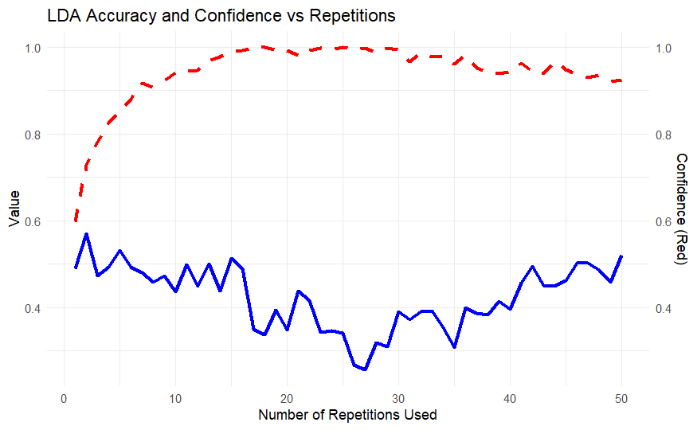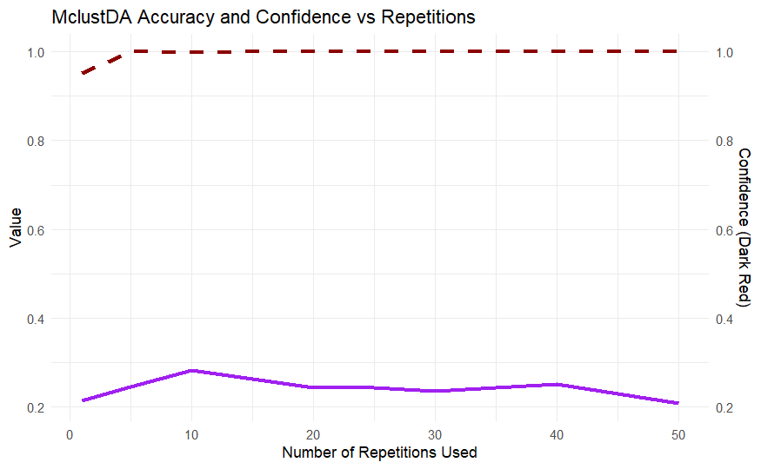

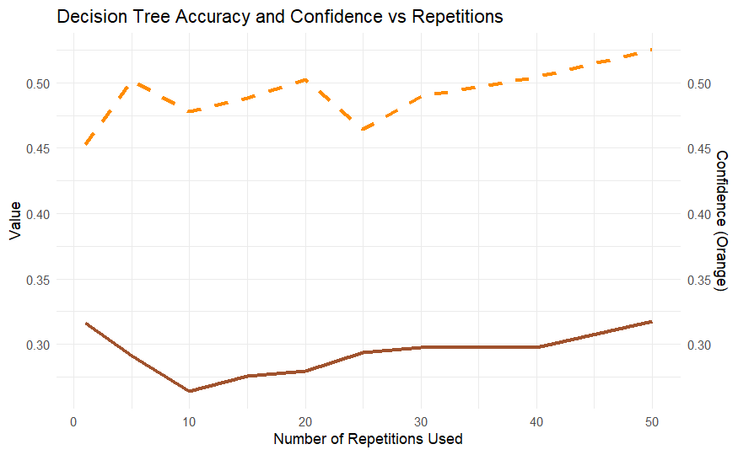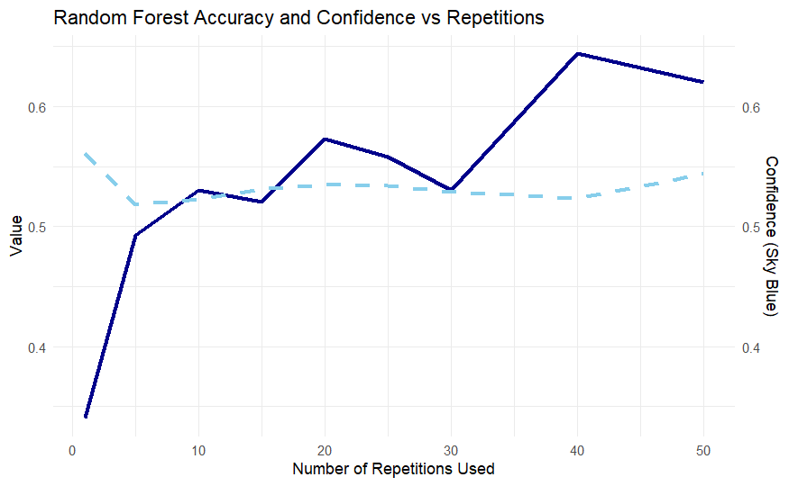
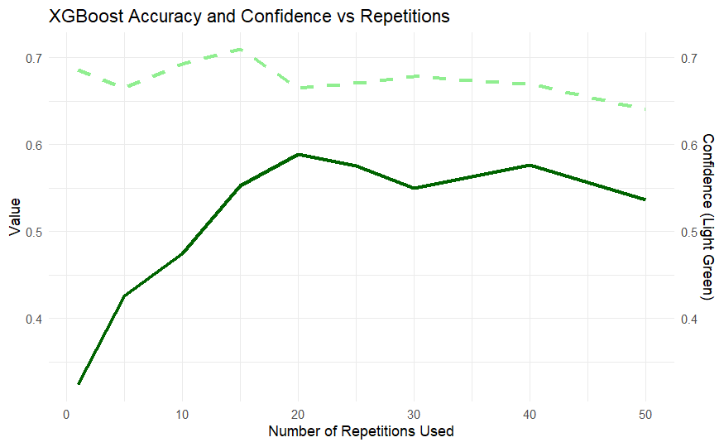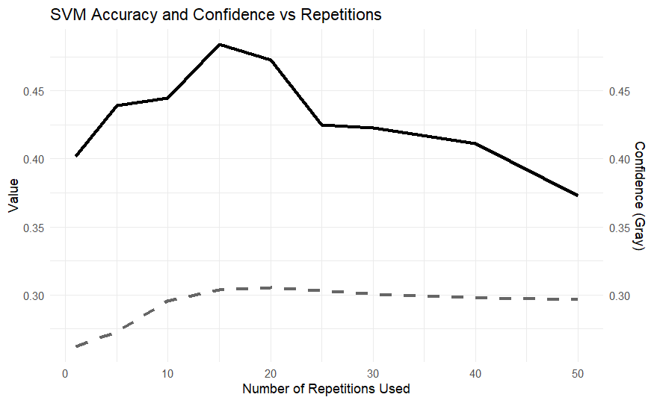

Summary of Model Performances:
Model | Best Accuracy Reached | Repetition Level | Confidence Trend
LDA | ~0.50 | ~5–10 reps | High, very early
MclustDA | ~0.30 | ~10 reps | Very high confidence
Decision Tree | ~0.32 | 50 reps | Moderate
Random Forest | ~0.65 | 40–50 reps | Moderate
XGBoost | ~0.59 | ~20 reps | Strong and stable
SVM | ~0.47 | 15 reps | Low & flat

Based on both accuracy and confidence:
XGBoost (Best trade-off of performance and confidence) and Random Forest (Strongest raw accuracy at 40 reps) so considering these two are the best performing models.

Advanced Models: Considering full features + four features, Same Evaluation Strategy of 5-fold cross-validation with same reps_to_run <- c(1, 5, 10, 15, 20, 25, 30, 35, 40, 45, 50)
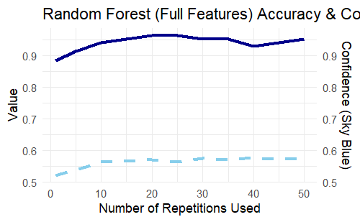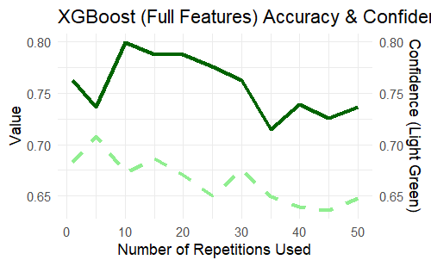

- Model Evaluation
Summary of Model Performances:
Metric | Random Forest | XGBoost
Best Accuracy | ~96% at 20–25 reps | ~80% at 10–15 reps
Confidence Trend | Stable (~0.58) | Moderate (~0.65–0.70) but fluctuates
Performance at Low Reps | High (0.88 at rep 1) | Good (0.77 at rep 1)
Performance at 50 Reps | Still ~95% | Drops to ~74%

- Conclusion:

- Random Forest (with full features) is clearly the best model with 96% Accuracy at 20 reps with stable confidence Trend of 58%.
- It consistently delivers high accuracy with stable confidence, even at lower rep counts.
- XGBoost is a good alternative but less stable with this feature set.

- Recommendation:
Random Forest is well-suited for this task due to its robustness and ability to handle high-dimensional, complex feature interactions without requiring aggressive preprocessing.

References
Lecture Notes and Resources (STAT 541, STAT 600, STAT 601, STAT 602)
Killourhy, K. S., & Maxion, R. A. (2009). Comparing anomaly-detection algorithms for keystroke dynamics.
Hothorn, T., & Everitt, B. S. (2014). A Handbook of Statistical Analyses using R. In Chapman and Hall/CRCeBooks. https://doi.org/10.1201/b17081
ChatGPT. (02/2025). Used for debugging and code cleaning. Retrieved from OpenAI

