Ranjitha Assignment-2  
  
Tables:  
 create table customer(

customer_id serial primary key,

customer_name varchar(30) unique,

birthdate date,

address varchar(50),

email varchar(30) unique,

mobile numeric(10) CHECK (mobile>0)

);  
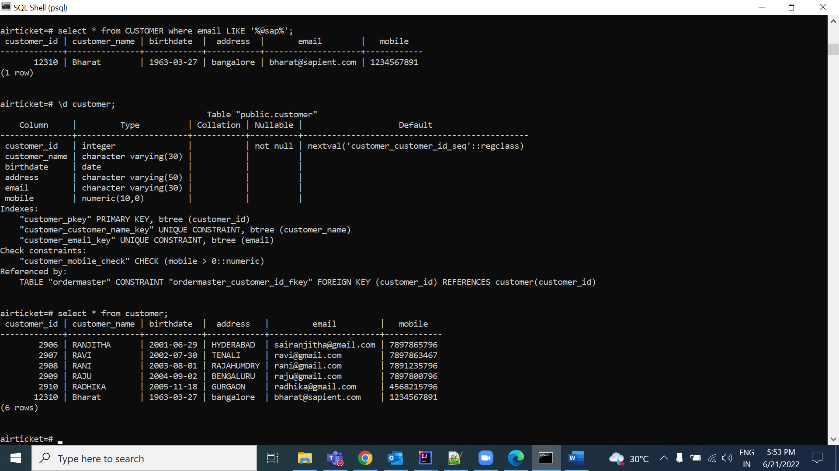  
  
  
  
create table order_master(

order_id serial primary key,

order_date date not null,

total_order_amount numeric(10),

status varchar(30),

constraint fk_customer_id foreign key(customer_id) references customer(customer_id)

);  
  
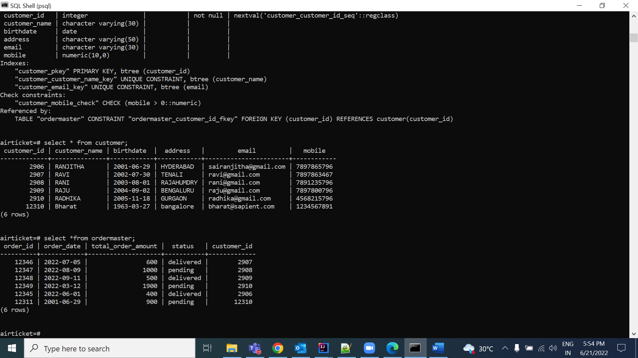  
  
  
  
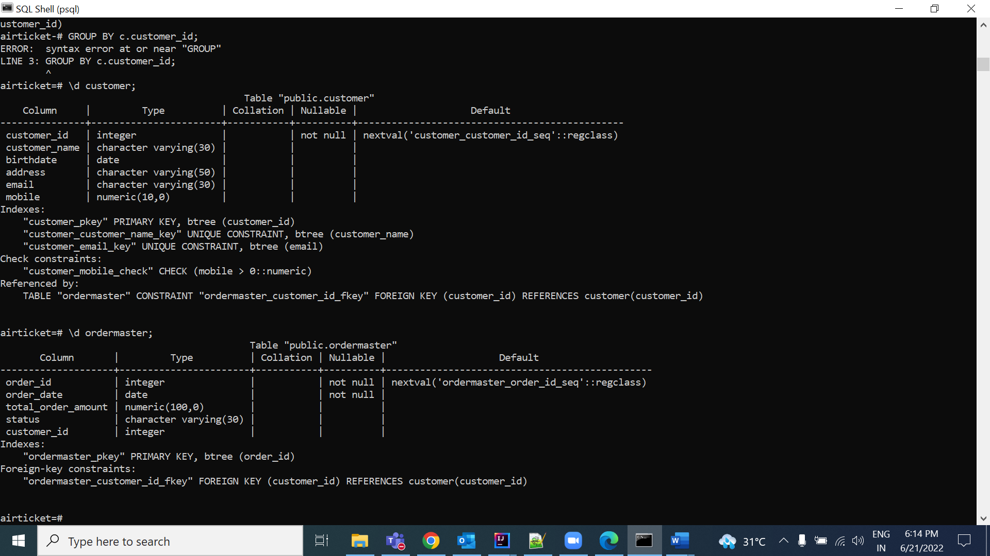  
  
  
  
  
1)  
  
a. Display the customers with domain names of their email ids beginning with “sap”  
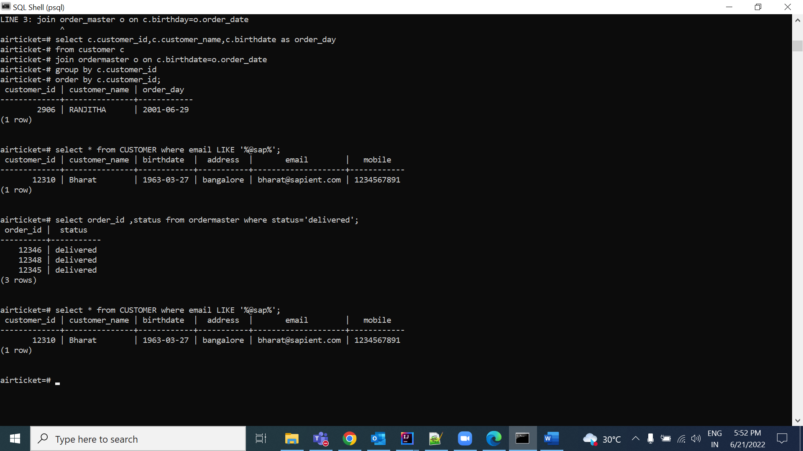  
  
  
2) . Display orders whose status is “delivered”  
  
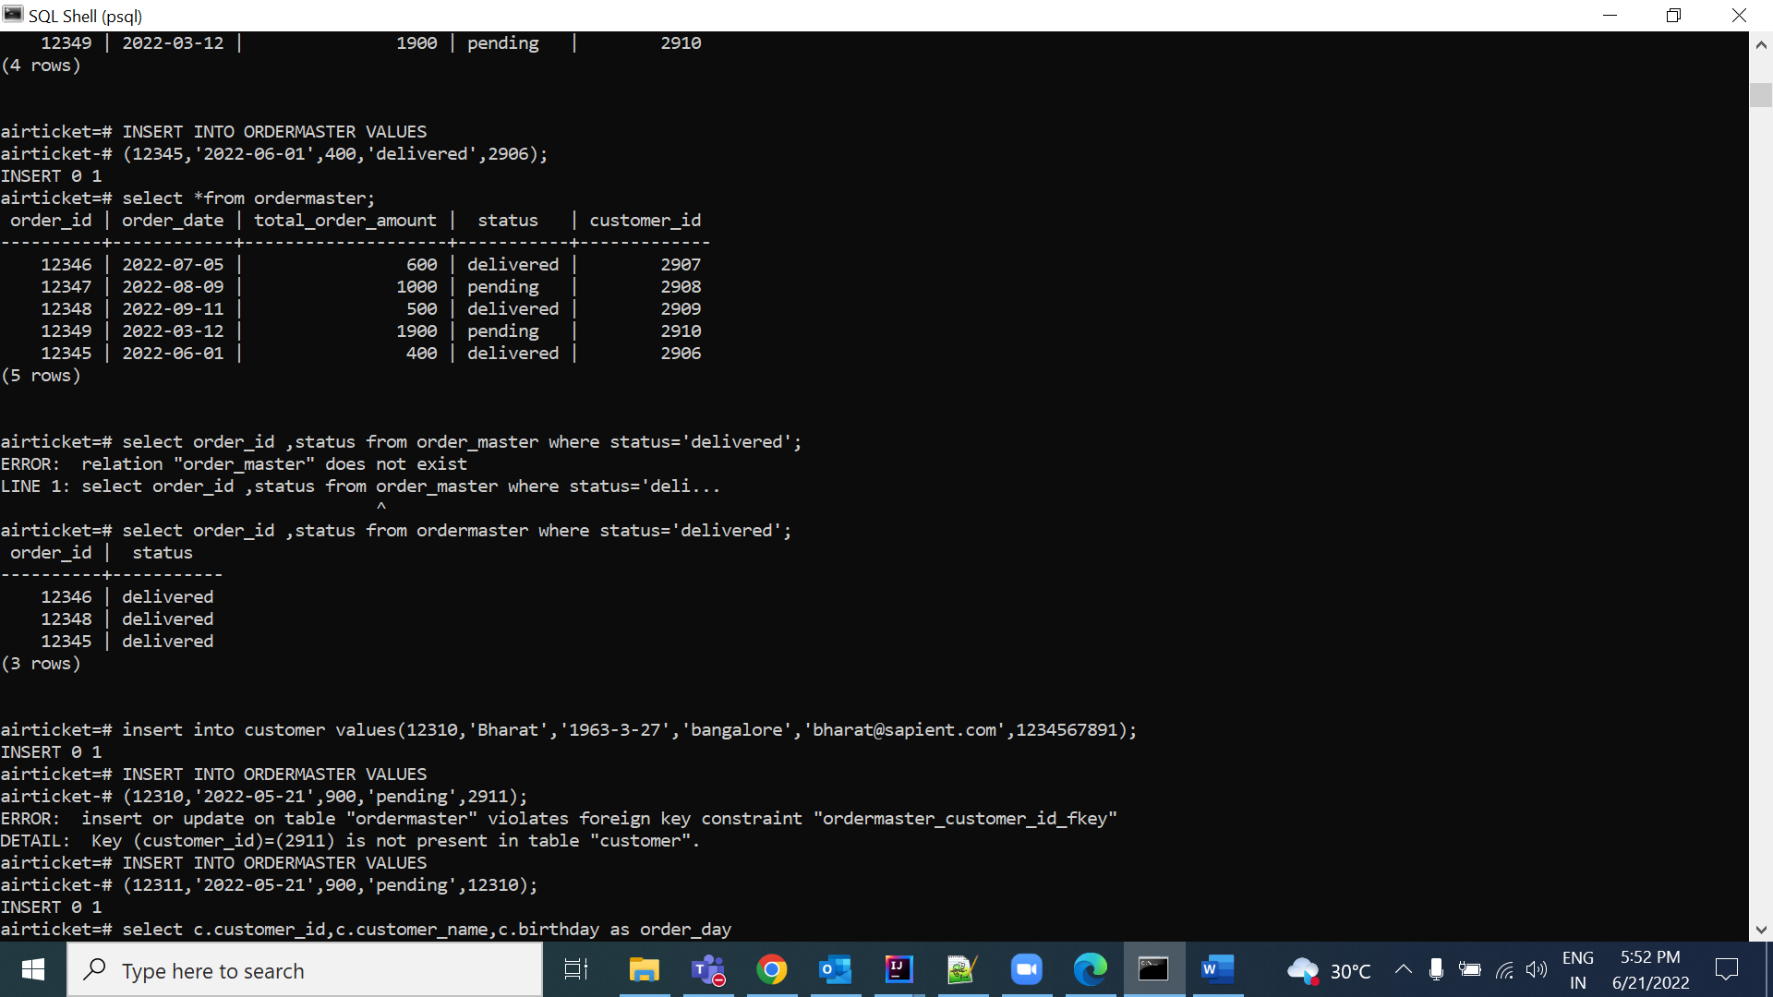  
  
  
  
3) display customers who placed orders on their birthdates  
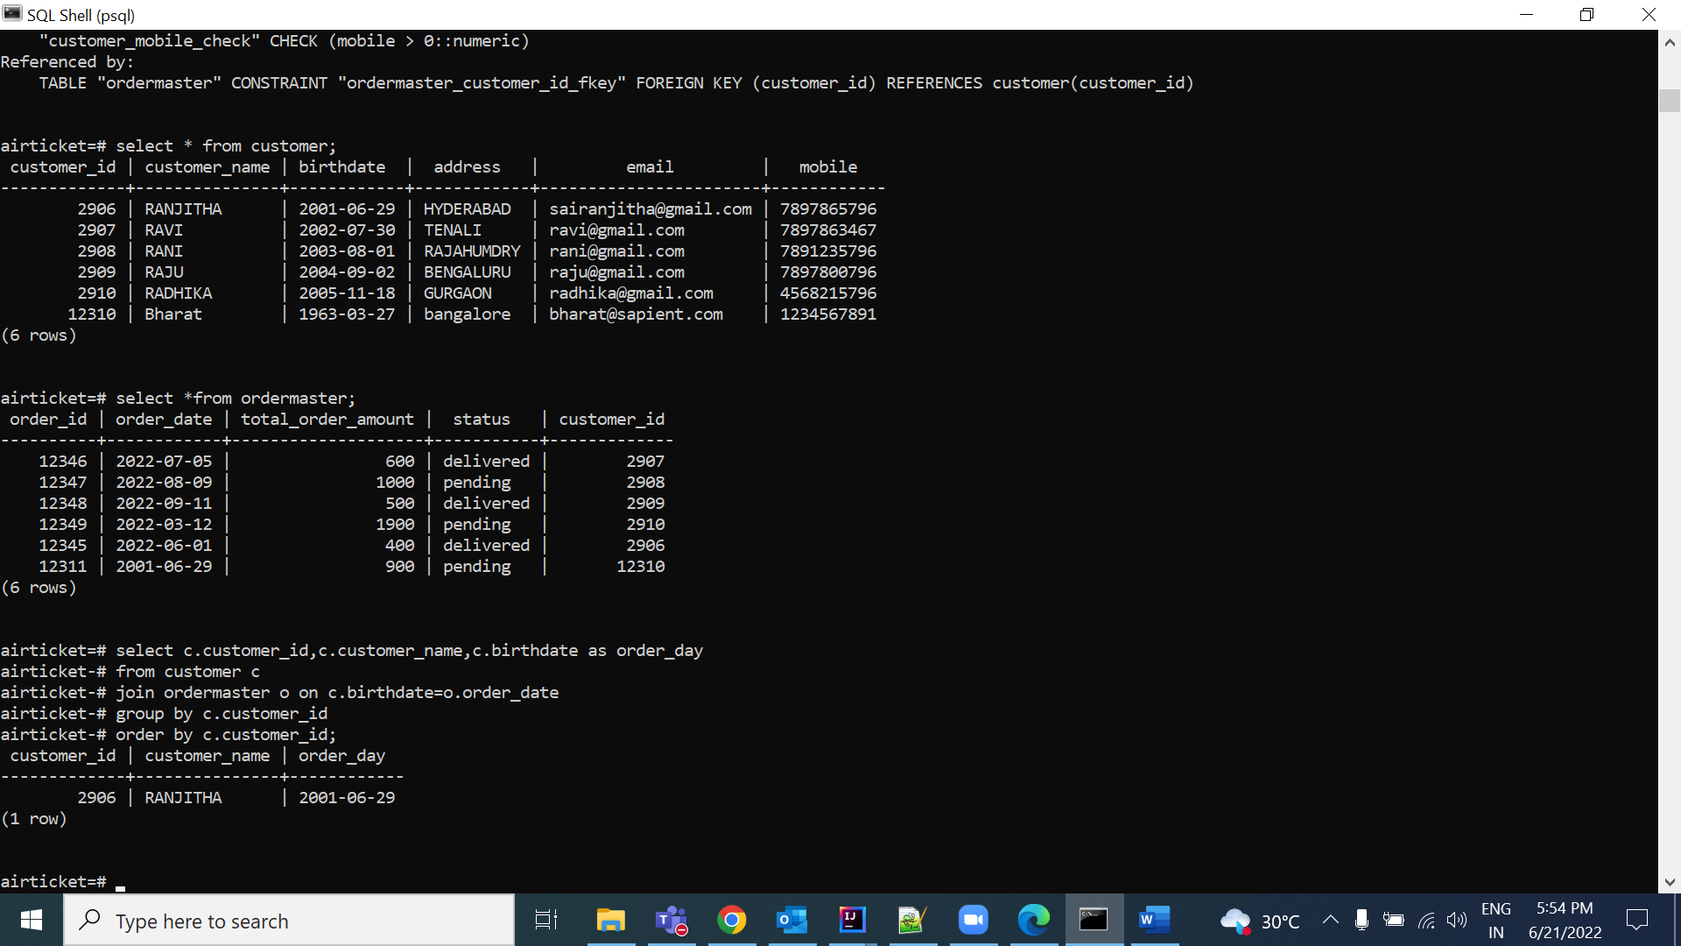  
  
  
  
  
  
4) Display sum of total order amounts placed by each customer  
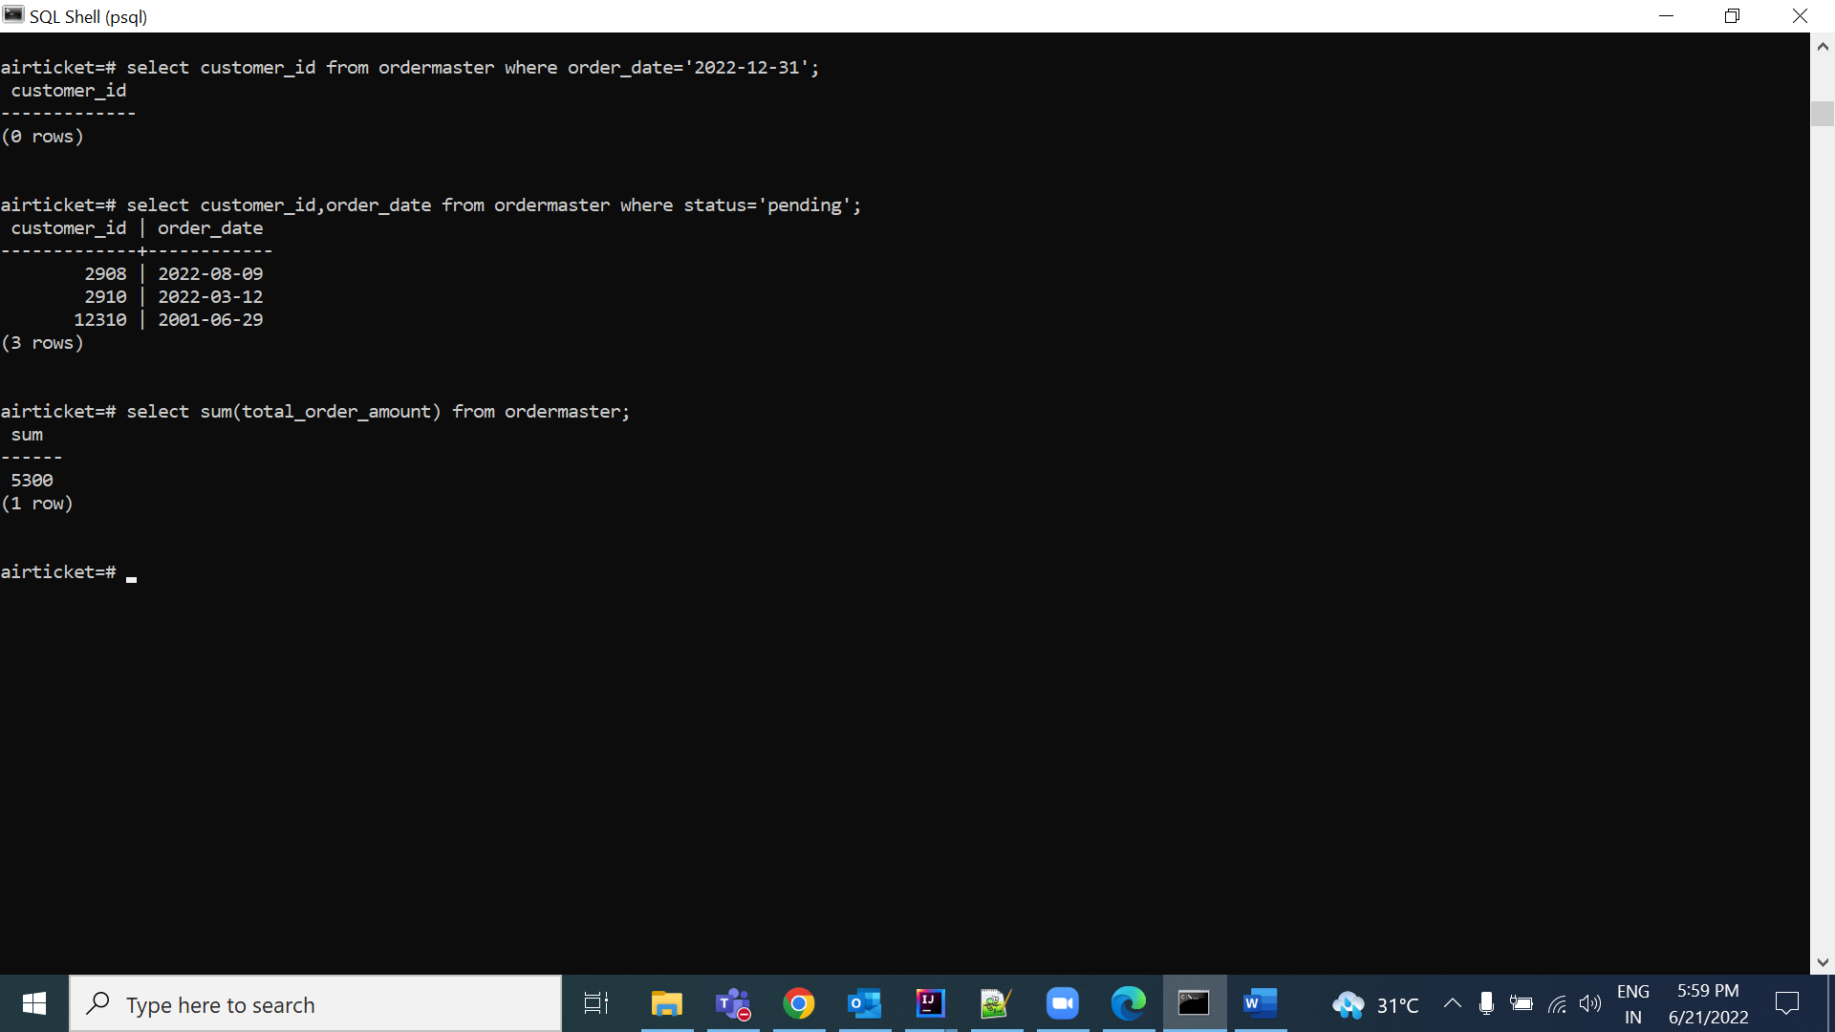  
  
5) Display sum of total order amounts placed by each customer  
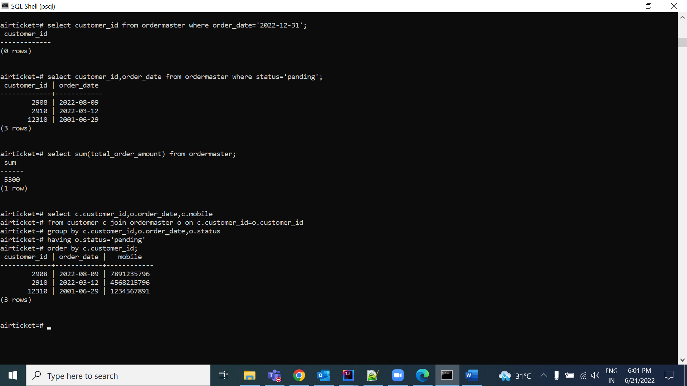

6)

7) . Display Customer details who has placed highest order amount.  
Display customerId, customer name and number of orders placed by each customer  
  
SELECT c.customer_id,c.cutomer_name,c.birthdate,c.address,c.email,c.mobile FROM customer c JOIN ordermaster om ON c.customer_id = om.customer_id

HAVING SUM(om.total_order_amount) >= ALL (SELECT SUM(om.total_order_amount) FROM customer c JOIN ordermaster om ON c.customer_id = om.customer_id GROUP BY c.customer_id)

GROUP BY c.customer_id;

8) Display customers who have placed orders on 31st December 2021.  
