ASSIGNMENT

___________

Ben Johnson

ST .Alberts college Eranakulam

Bvoc sports Nutrition and Physiotheraphy

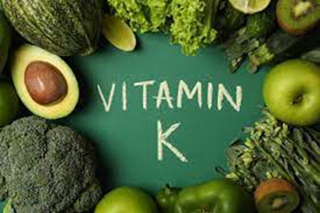

# **VITAMIN-K**

*Vitamin k is family of structurally similar,fat-soluble vitamers found in food and marketed as dietary supplements. The human body requires vitamin k for post-synthesis modification of certain protein that are required for blood coagulation or for controlling binding of calcium in bones and other tissues.*

# **VITAMIB-K-SOURCES**

# ***1).Sinach***

# *2).Broccoli*

# *3).Brussels sprouts*

# *4).Collard green*

# *5).kiwi*

# *6).kale*

# *7).lettuce*

# *8).leafy*

# *9).green vegetables …… etc*

# **vitamin-k-deficiency**

*Vitamin k deficiency can contribute to significant bleeding ,poor bone development, osteoporosis ,and increased risk of cardiovascular disease.*

*Lack of vitamin k in the diet. A very low fat diet because vitamin k is best absorbed when eaten with some fat. Disorders that impair fat absorption and that thus reduce the absorption of vitamin k (such as blockage of the bile ducts.)*

*s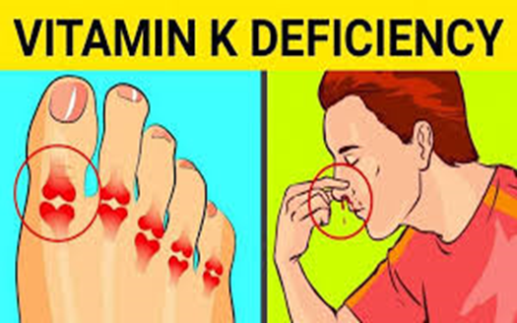*

# vitamin -k-function

*Vitamin k helps to make various protein that are needed for blood clotting and the building of bones. Prothrombin is a vitamin k -dependent protein directly involved with blood clotting. Osteocalcin is another protein that requires vitamin k to produce healthy bone tissue.*

# VITAMIN- K -REQUIREMENT

*1microgram a day is vitamin k for each kilogram of their body weight.*

**THANK YOU**