CO1 – CO1 – Java Fundamentals and Object-Oriented Programming
AT1 – Low – Coding Challenge

Q1 – University Admission System using Method Overloading

Code
import java.util.*;

class Admission {
double calculateFee(int credits, double rate) {
return credits * rate; // Undergraduate
}

double calculateFee(int credits, double rate, double labFee) {
return credits * rate + labFee; // Postgraduate
}

double calculateFee(double fee, int scholarshipPercent) {
return fee - (fee * scholarshipPercent / 100.0); // Scholarship
}
}

public class Main {
public static void main(String[] args) {
Scanner sc = new Scanner(System.in);
Admission a = new Admission();

System.out.print("Enter undergraduate credits and rate: ");
int ugCredits = sc.nextInt();
double ugRate = sc.nextDouble();

System.out.print("Enter postgraduate credits, rate and lab fee: ");
int pgCredits = sc.nextInt();
double pgRate = sc.nextDouble();
double labFee = sc.nextDouble();

System.out.print("Enter scholarship fee and percentage: ");
double fee = sc.nextDouble();
int percent = sc.nextInt();

System.out.printf("Undergraduate Fee: %.2f%n", a.calculateFee(ugCredits, ugRate));
System.out.printf("Postgraduate Fee: %.2f%n", a.calculateFee(pgCredits, pgRate, labFee));
System.out.printf("Scholarship Fee: %.2f%n", a.calculateFee(fee, percent));
}
}

Output Screenshot
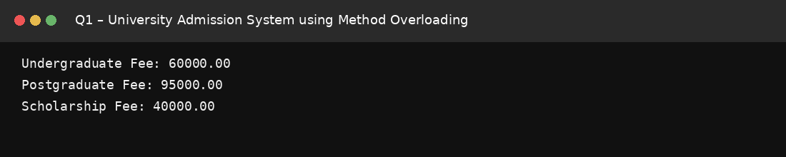

Q2 – Library Book Management

Code
class Book {
private String title, author, isbn;
private boolean isAvailable;

Book(String title, String author, String isbn) {
this.title = title;
this.author = author;
this.isbn = isbn;
this.isAvailable = true;
}

void issueBook() {
if (isAvailable) {
isAvailable = false;
System.out.println(title + " issued.");
} else {
System.out.println(title + " is already issued.");
}
}

void returnBook() {
isAvailable = true;
System.out.println(title + " returned.");
}

String getTitle() { return title; }
String getAuthor() { return author; }
String getIsbn() { return isbn; }
boolean getAvailability() { return isAvailable; }

void display() {
System.out.println(getTitle() + " | " + getAuthor() + " | " +
getIsbn() + " | Available: " + getAvailability());
}
}

public class Main {
public static void main(String[] args) {
Book b1 = new Book("Java Basics", "James", "ISBN101");
Book b2 = new Book("Data Structures", "Robert", "ISBN102");
Book b3 = new Book("OOP in Java", "Smith", "ISBN103");

b1.issueBook();
b2.issueBook();
b1.returnBook();

b1.display();
b2.display();
b3.display();
}
}

Output Screenshot
