CO2 – CO2 – Collection Framework, Iterators and Generics
AT1 – Medium – Scenario Based Assessment

Q1 – Student Registration System

Code
import java.util.*;

public class Main {
public static void main(String[] args) {
HashSet<String> students = new HashSet<>();
HashMap<String, ArrayList<String>> courses = new HashMap<>();

students.add("Arun");
students.add("Bhavya");
students.add("Arun");

courses.put("Arun", new ArrayList<>(Arrays.asList("Java", "DBMS")));
courses.put("Bhavya", new ArrayList<>(Arrays.asList("Python", "Networks")));

Iterator<String> it = students.iterator();
while (it.hasNext()) {
String student = it.next();
System.out.println(student + " -> " + courses.get(student));
}
}
}

Output Screenshot
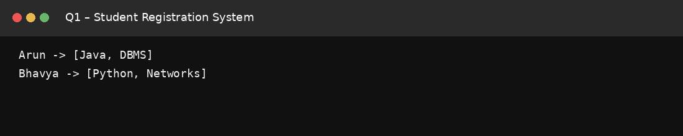

Q2 – E-Commerce Cart System

Code
import java.util.*;

public class Main {
public static void main(String[] args) {
ArrayList<String> cart = new ArrayList<>();
cart.add("Laptop");
cart.add("Mouse");
cart.add("Keyboard");
cart.remove("Mouse");

Iterator<String> it = cart.iterator();
while (it.hasNext())
System.out.println(it.next());
}
}

Output Screenshot
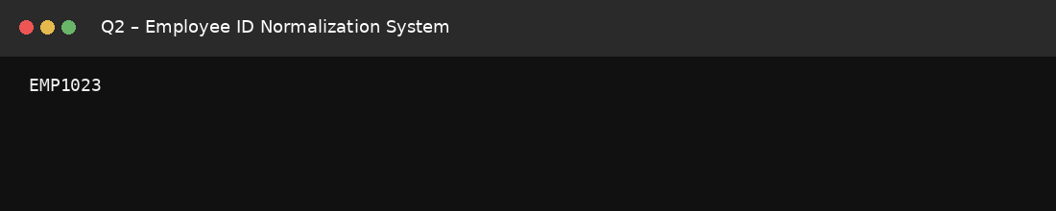

Q3 – Library Management System

Code
import java.util.*;

public class Main {
public static void main(String[] args) {
HashMap<String, String> books = new HashMap<>();
books.put("97801", "Java Programming");
books.put("97802", "Data Structures");
books.put("97803", "Computer Networks");

System.out.println("Retrieved: " + books.get("97802"));
for (Map.Entry<String, String> e : books.entrySet())
System.out.println(e.getKey() + " -> " + e.getValue());
}
}

Output Screenshot
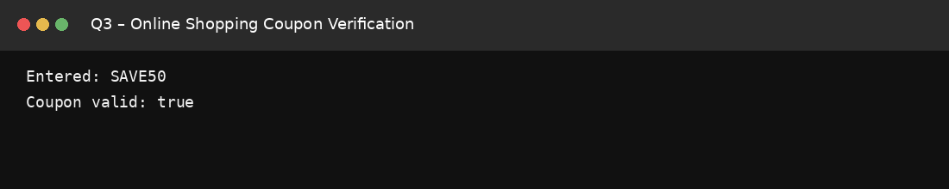

Q4 – Employee Data Processing

Code
import java.util.*;

class Employee {
String name;
double salary;
Employee(String name, double salary) {
this.name = name;
this.salary = salary;
}
}

public class Main {
public static void main(String[] args) {
List<Employee> employees = new ArrayList<>();
employees.add(new Employee("Arun", 45000));
employees.add(new Employee("Bhavya", 65000));
employees.add(new Employee("Charan", 80000));

Iterator<Employee> it = employees.iterator();
while (it.hasNext()) {
Employee e = it.next();
if (e.salary > 50000)
System.out.println(e.name + " : " + e.salary);
}
}
}

Output Screenshot
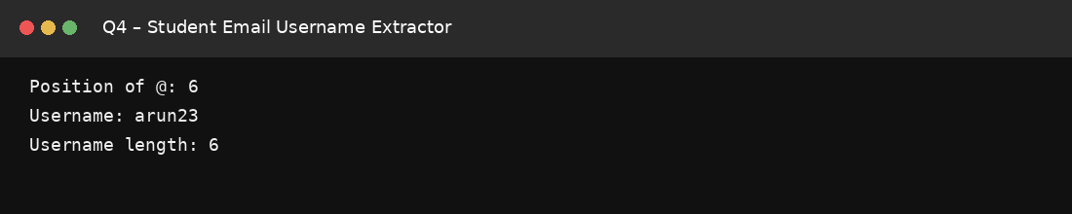

Q5 – Online Voting

Code
import java.util.*;

public class Main {
public static void main(String[] args) {
HashSet<String> voters = new HashSet<>();
HashMap<String, Integer> votes = new HashMap<>();

recordVote("U101", "Alice", voters, votes);
recordVote("U102", "Bob", voters, votes);
recordVote("U101", "Bob", voters, votes);

System.out.println("Results:");
for (Map.Entry<String, Integer> e : votes.entrySet())
System.out.println(e.getKey() + " -> " + e.getValue());
}

static void recordVote(String user, String candidate,
HashSet<String> voters,
HashMap<String, Integer> votes) {
if (voters.add(user))
votes.put(candidate, votes.getOrDefault(candidate, 0) + 1);
else
System.out.println("Duplicate vote rejected for " + user);
}
}

Output Screenshot
