CO2 – CO2 – Collection Framework, Iterators and Generics
AT2 – Medium – Assignment

Q1 – ATM PIN Security Validator

Code
import java.util.*;
public class Main {
public static void main(String[] args) {
Scanner sc = new Scanner(System.in);
String pin = sc.nextLine().trim();
System.out.println("PIN: " + pin);
System.out.println("Valid: " + pin.matches("\\d{4}"));
System.out.println("Length: " + pin.length());
}
}

Output Screenshot
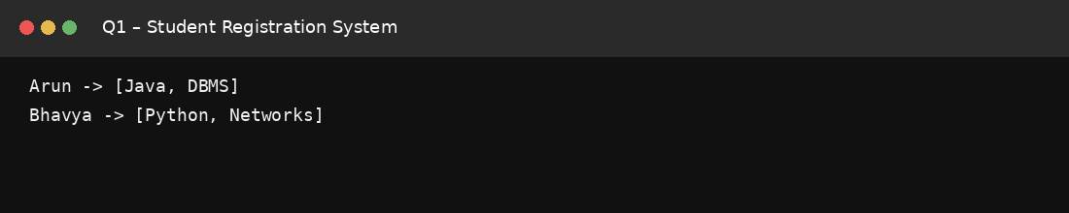

Q2 – Employee ID Normalization System

Code
import java.util.*;
public class Main {
public static void main(String[] args) {
String id = " emp1023 ".trim();
int i = 0;
while (i < id.length() && Character.isLetter(id.charAt(i))) i++;
String prefix = id.substring(0, i).toUpperCase();
String number = id.substring(i);
System.out.println(prefix.concat(number));
}
}

Output Screenshot
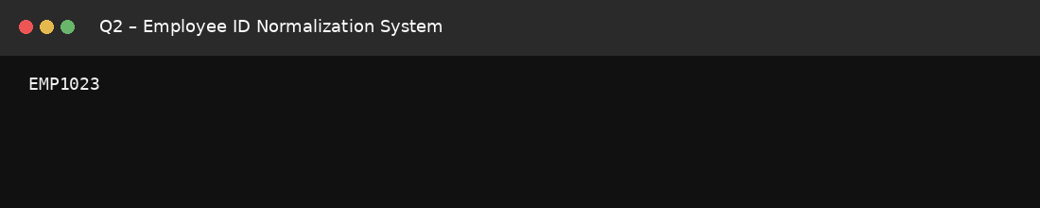

Q3 – Online Shopping Coupon Verification

Code
import java.util.*;
public class Main {
public static void main(String[] args) {
String entered = " save50 ".trim().toUpperCase();
String original = "SAVE50";
System.out.println("Entered: " + entered);
System.out.println("Coupon valid: " + entered.equalsIgnoreCase(original));
}
}

Output Screenshot
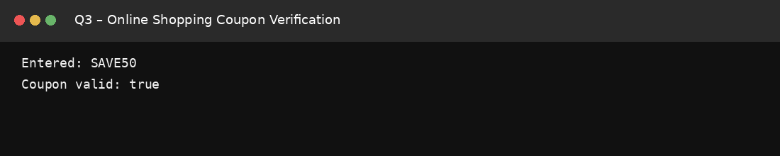

Q4 – Student Email Username Extractor

Code
public class Main {
public static void main(String[] args) {
String email = "arun23@college.edu";
int pos = email.indexOf('@');
String username = email.substring(0, pos);
System.out.println("Position of @: " + pos);
System.out.println("Username: " + username);
System.out.println("Username length: " + username.length());
}
}

Output Screenshot
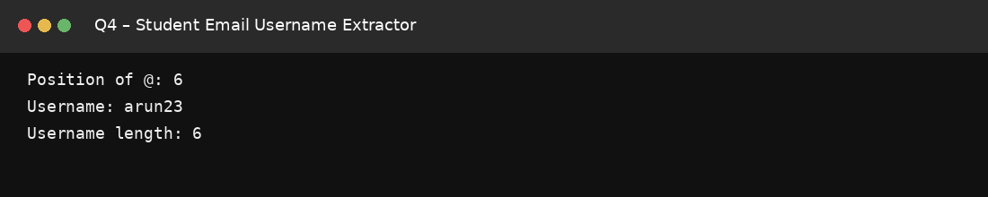

Q5 – Restaurant Digital Order Analyzer

Code
public class Main {
public static void main(String[] args) {
String order = "DOSA-3-IDLY-2-VADA-1";
String[] parts = order.split("-");
System.out.println("Food items:");
for (int i = 0; i < parts.length; i += 2)
System.out.println(parts[i].toUpperCase() + " x " + parts[i + 1]);
System.out.println("Number of food items: " + (parts.length / 2));
}
}

Output Screenshot
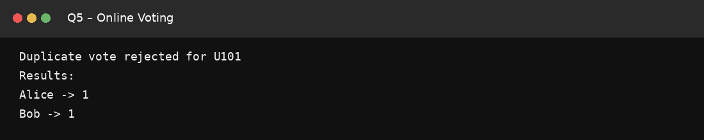

Q6 – Railway Coach and Seat Parser

Code
public class Main {
public static void main(String[] args) {
String ticket = "S5-43";
String[] p = ticket.split("-");
String coach = p[0];
System.out.println("Coach number: " + coach.substring(1));
System.out.println("Coach type: " + coach.charAt(0));
System.out.println("Seat number: " + p[1]);
}
}

Output Screenshot
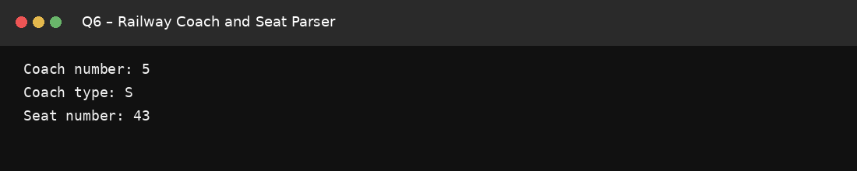

Q7 – Inventory Product Search System

Code
import java.util.*;
public class Main {
public static void main(String[] args) {
String[] products = {"Milk", "Bread", "Rice"};
String search = "rice";
String s = search.toLowerCase();

for (String p : products) {
String lower = p.toLowerCase();
if (lower.contains(s))
System.out.println("Contains: " + p);
if (p.equalsIgnoreCase(search))
System.out.println("Exact match: " + p);
}
}
}

Output Screenshot
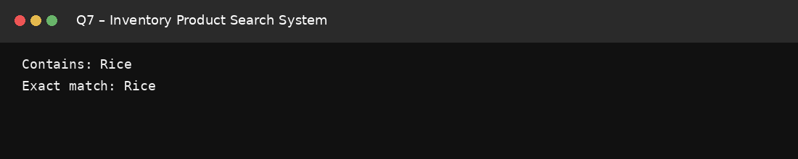

Q8 – Grocery Shopping Cart Management System

Code
import java.util.*;
public class Main {
public static void main(String[] args) {
ArrayList<String> cart = new ArrayList<>();
cart.add("Milk");
cart.add("Bread");
cart.add("Rice");
cart.remove("Bread");

System.out.println("Cart: " + cart);
System.out.println("Rice exists: " + cart.contains("Rice"));
System.out.println("Number of products: " + cart.size());
}
}

Output Screenshot
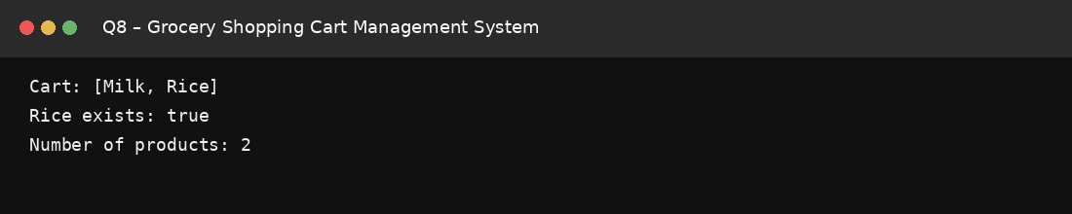

Q9 – Bank Token Queue Management System

Code
import java.util.*;
public class Main {
public static void main(String[] args) {
Queue<Integer> q = new LinkedList<>();
q.offer(101);
q.offer(102);
q.offer(103);

System.out.println("Serving token: " + q.poll());
System.out.println("Upcoming token: " + q.peek());
System.out.println("Queue: " + q);
}
}

Output Screenshot
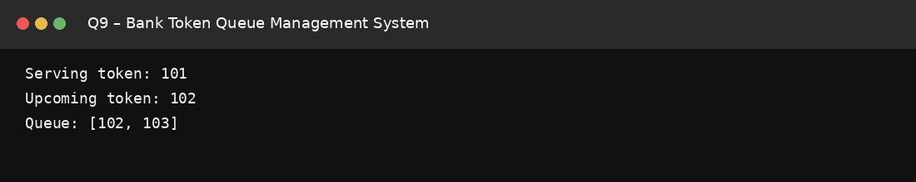

Q10 – Railway Parcel Dispatch Tracking System

Code
import java.util.*;
public class Main {
public static void main(String[] args) {
Stack<String> stack = new Stack<>();
HashMap<String, String> destination = new HashMap<>();

stack.push("P101"); destination.put("P101", "Chennai");
stack.push("P102"); destination.put("P102", "Bengaluru");
stack.push("P103"); destination.put("P103", "Hyderabad");

String id = stack.pop();
System.out.println("Unloaded parcel: " + id);
System.out.println("Destination: " + destination.get(id));
}
}

Output Screenshot
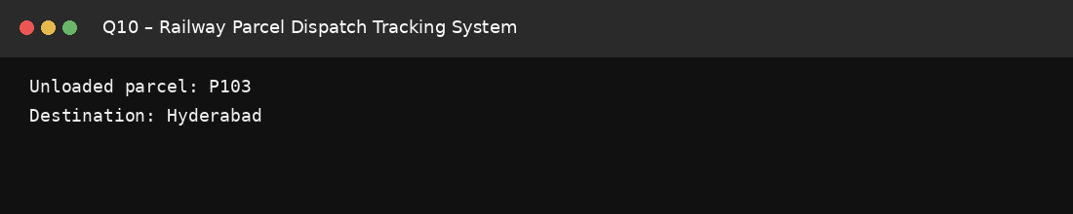

Q11 – Hospital Appointment Scheduling System

Code
import java.util.*;
public class Main {
public static void main(String[] args) {
Queue<Integer> q = new LinkedList<>();
HashMap<Integer, String> patients = new HashMap<>();

q.offer(1); patients.put(1, "Arun");
q.offer(2); patients.put(2, "Bhavya");
q.offer(3); patients.put(3, "Charan");

int token = q.poll();
System.out.println("Serving token: " + token);
System.out.println("Patient: " + patients.get(token));
}
}

Output Screenshot
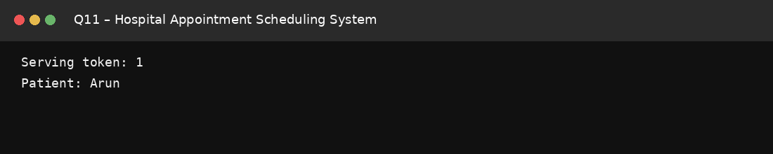

Q12 – University Course Enrollment Manager

Code
import java.util.*;
public class Main {
public static void main(String[] args) {
ArrayList<String> students = new ArrayList<>(
Arrays.asList("Arun", "Bhavya", "Charan", "Divya"));

Iterator<String> it = students.iterator();
while (it.hasNext()) {
if (it.next().equals("Charan"))
it.remove();
}
System.out.println("Updated enrollment: " + students);
}
}

Output Screenshot
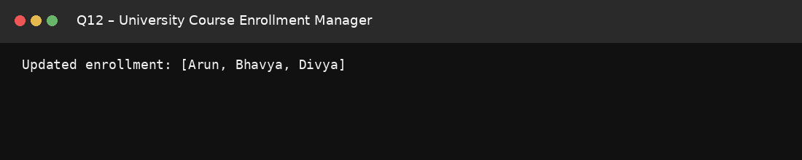

Q13 – Warehouse Damaged Item Removal

Code
import java.util.*;
public class Main {
public static void main(String[] args) {
ArrayList<String> inventory = new ArrayList<>(
Arrays.asList("Laptop", "Damaged-Phone", "Keyboard", "Damaged-Mouse"));

Iterator<String> it = inventory.iterator();
while (it.hasNext()) {
if (it.next().startsWith("Damaged"))
it.remove();
}
System.out.println("Remaining inventory: " + inventory);
}
}

Output Screenshot
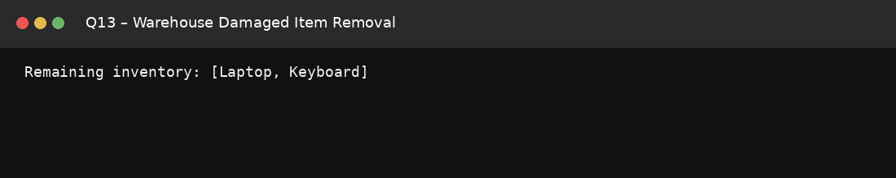

Q14 – Bank Token Management System

Code
import java.util.*;
public class Main {
public static void main(String[] args) {
Queue<Integer> q = new LinkedList<>();
q.offer(1); q.offer(2); q.offer(3); q.offer(4);

System.out.println("Serving: " + q.poll());
System.out.println("Next: " + q.peek());
System.out.println("Remaining queue: " + q);
}
}

Output Screenshot
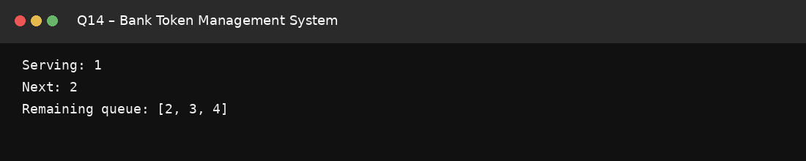

Q15 – Web Browser Back Navigation

Code
import java.util.*;
public class Main {
public static void main(String[] args) {
Stack<String> history = new Stack<>();
history.push("google.com");
history.push("college.edu");
history.push("library.org");

history.pop();
System.out.println("Current page: " + history.peek());
}
}

Output Screenshot
